**Led.h**

#ifndef LED_H

#define LED_H

#include <Arduino.h>

class Led {

private:

byte tmpPin;

public:

Led(byte pin);

void on();

void off();

};

#endif

**Led.cpp**

#include "Led.h"

Led::Led(byte pin) {

tmpPin = pin;

pinMode(tmpPin, OUTPUT);

off();

}

void Led::on() {

digitalWrite(tmpPin, HIGH);

}

void Led::off() {

digitalWrite(tmpPin, LOW);

}

**Sample Sketch using Led Library (Arduino IDE)**

#include <Led.h>

Led led1 = Led(13);

void setup(){}

void loop() {

led1.on();

delay(1000);

led1.off();

delay(1000);

}

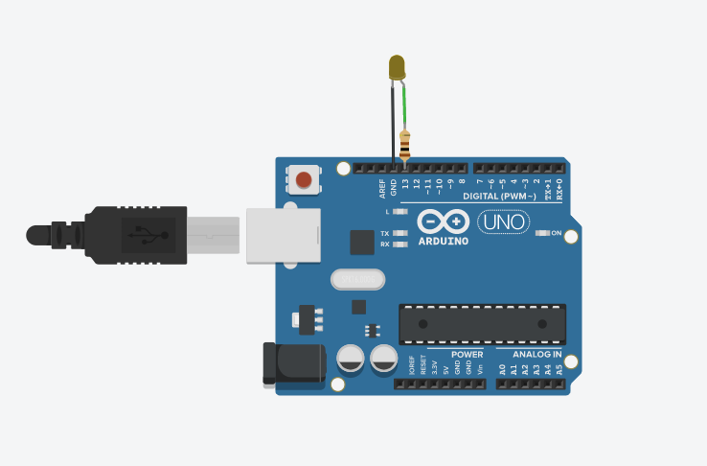

**Sample Sketch using Led Library (TinkerCAD)**

<https://www.tinkercad.com/things/7TTbooBFtm4>

// Led.h file  
class Led {   
 private:  
 byte tmpPin;  
 public:  
 Led(byte pin);  
 void on();  
 void off();  
};

//Led.cpp file  
Led::Led(byte pin) {  
 tmpPin = pin;  
 pinMode(tmpPin, OUTPUT);  
 off();  
}  
void Led::on() {  
 digitalWrite(tmpPin, HIGH);  
}  
void Led::off() {  
 digitalWrite(tmpPin, LOW);  
}

//Arduino sketch file  
Led led1 = Led(13);  
void setup(){}  
void loop() {  
 led1.on();  
 delay(1000);  
 led1.off();  
 delay(1000);  
}