Prairie dog burrow detection from UAS

**Notes**

* Could try downscaling only the tiles, but using original model
* Could try rebuilding best model but using training dataset that randomly resamples down to coarsest scale

**Results**

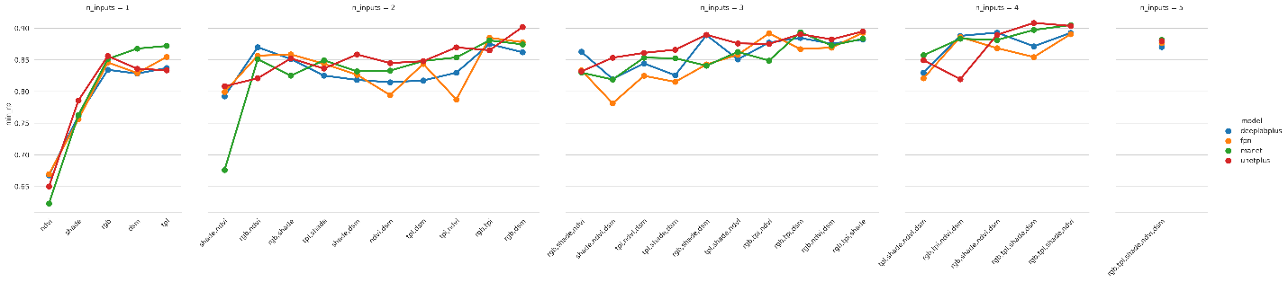

*Unet tended to have a higher minimum of precision/recall for a given f-score compared to the other models. Thus chose to look at only Unet models for subsequent analysis.*

*Top model*

* RGB, TPI, Hillshade, DSM
* Pixel-scale test validation
  + 'mccloss': 0.59,
  + 'iou_score': 0.7,
  + 'accuracy': 0.99,
  + 'precision': 0.84,
  + 'recall': 0.83,
  + 'fscore': 0.78
* Burrow-scale test validation
  + precision: 0.75
  + recall: 0.84
  + f-score: 0.79
  + burrow count correlation: 0.91

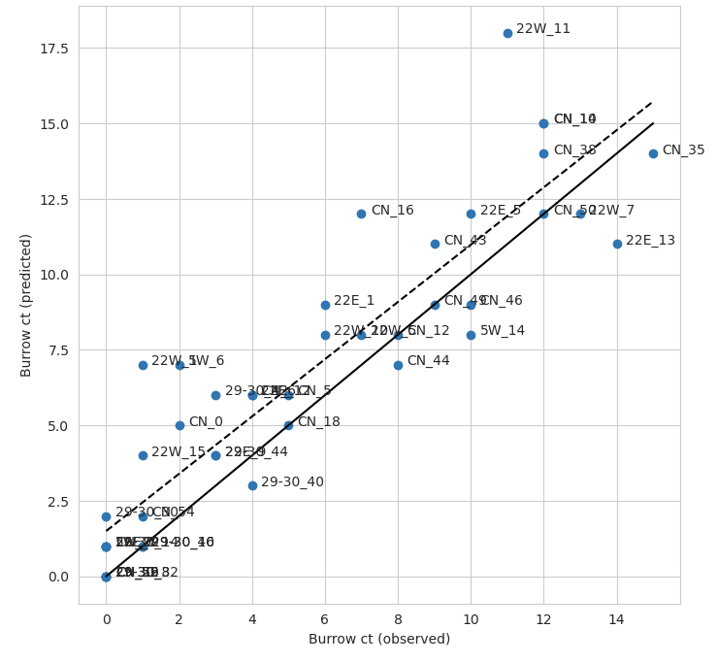

*Best model with NDVI*

* RGB, TPI, NDVI
* Pixel-scale test validation
  + 'mccloss': 0.62,
  + 'iou_score': 0.69,
  + 'accuracy': 0.99,
  + 'precision': 0.82,
  + 'recall': 0.84,
  + 'fscore': 0.76
* Burrow-scale test validation
  + precision: 0.76
  + recall: 0.86
  + f-score: 0.81
  + burrow count correlation: 0.93

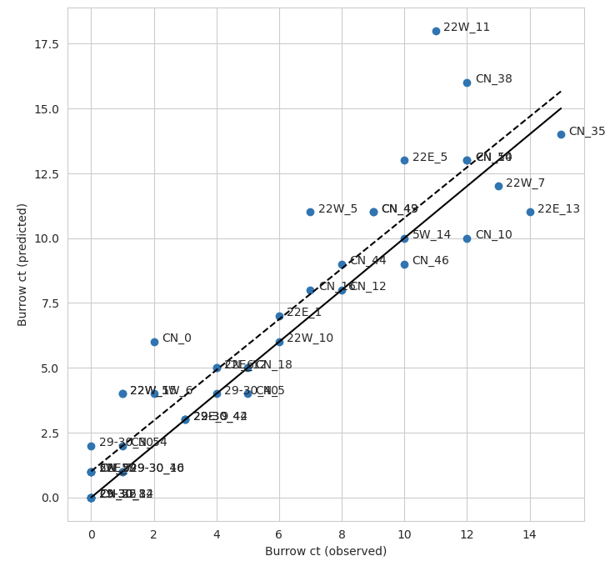

*Best model with all 5 variables*

* RGB, TPI, Hillshade, NDVI, DSM
* Pixel-scale test validation
  + 'mccloss': 0.67,
  + 'iou_score': 0.68,
  + 'accuracy': 0.99,
  + 'precision': 0.83,
  + 'recall': 0.81,
  + 'fscore': 0.75
* Burrow-scale test validation
  + precision: 0.8
  + recall: 0.74
  + f-score: 0.77
  + burrow count correlation: 0.91

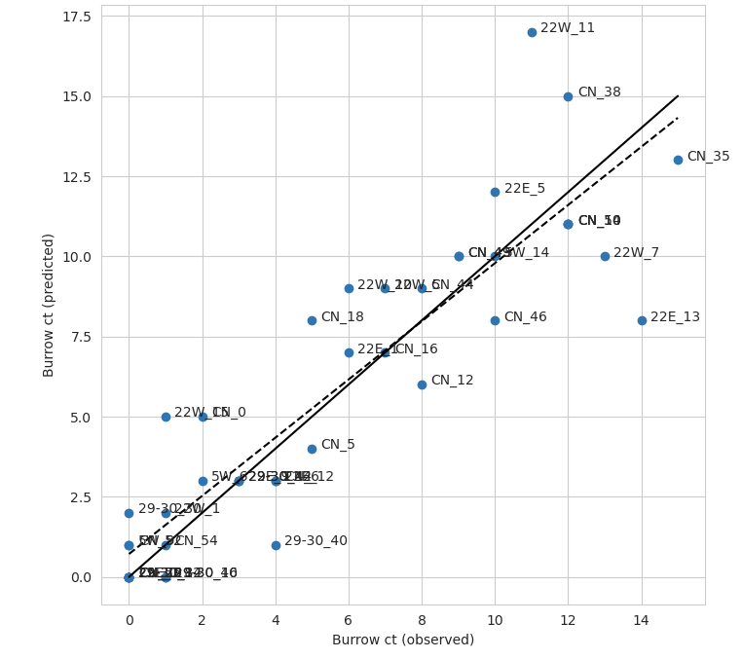

*Best with 3 variables:*

* RGB, TPI, Hillshade
* Pixel-scale test validation
  + 'mccloss': 0.61,
  + 'iou_score': 0.7,
  + 'accuracy': 0.99,
  + 'precision': 0.87,
  + 'recall': 0.8,
  + 'fscore': 0.76
* Burrow-scale test validation
  + precision: 0.78
  + recall: 0.8
  + f-score: 0.79
  + burrow count correlation: 0.89

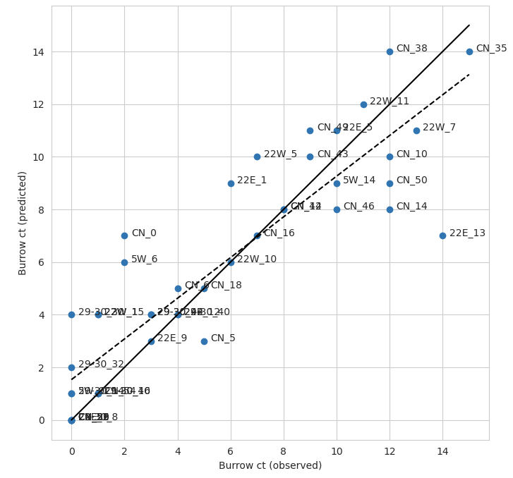

*Best with 2 variables*

* TPI
* Pixel-scale test validation
  + 'mccloss': 0.63,
  + 'iou_score': 0.69,
  + 'accuracy': 0.99,
  + 'precision': 0.84,
  + 'recall': 0.82,
  + 'fscore': 0.76
* Burrow-scale test validation
  + precision: 0.79
  + recall: 0.75
  + f-score: 0.77
  + burrow count correlation: 0.92

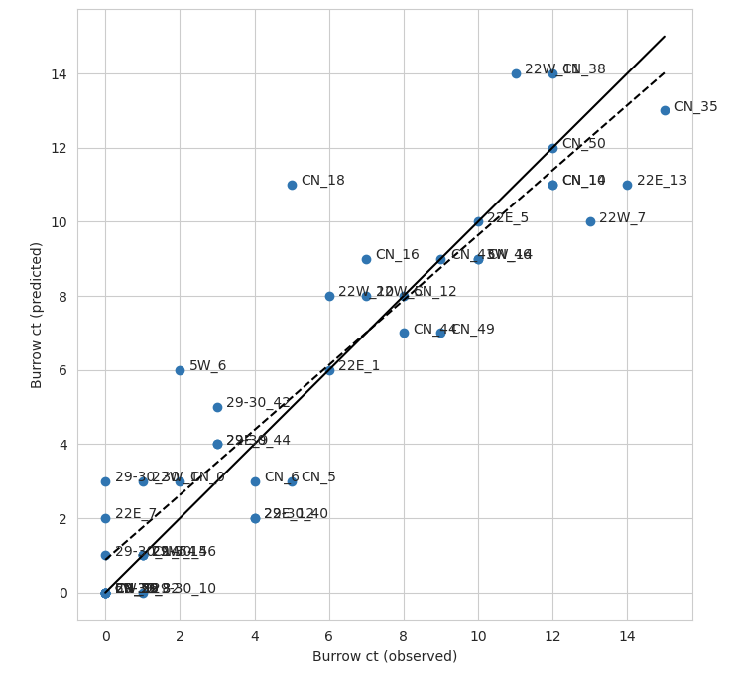

*Best with 1 variable*

* DSM
* Pixel-scale test validation:
  + 'mccloss': 0.66,
  + 'iou_score': 0.65,
  + 'accuracy': 0.99,
  + 'precision': 0.85,
  + 'recall': 0.76,
  + 'fscore': 0.71
* Burrow-scale test validation:
  + precision: 0.73
  + recall: 0.64
  + f-score: 0.68
  + burrow count correlation: 0.9

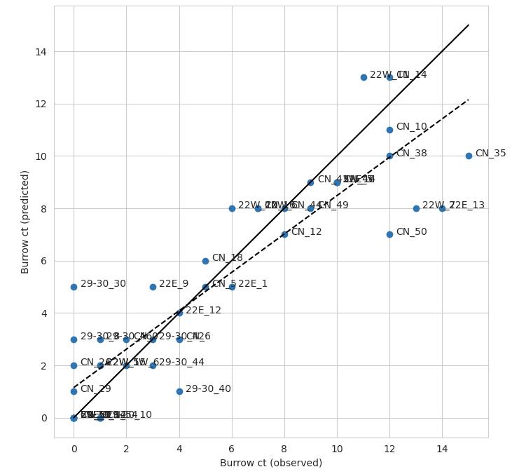

*1 variable RGB*

* Pixel-scale test validation:
  + 'mccloss': 0.67,
  + 'iou_score': 0.62,
  + 'accuracy': 0.98,
  + 'precision': 0.79,
  + 'recall': 0.79,
  + 'fscore': 0.69
* Burrow-scale test validation:
  + precision: 0.59
  + recall: 0.71
  + f-score: 0.65
  + burrow count correlation: 0.75

