Data Analytics as a Service (DAaaS): Automated & Intelligent Imputation Methods for Supervised Machine Learning

Shahid Barkat, Joseph Kearney

June, 2019

# Introduction

The researchers develop and maintain an open-source, Python-based package named Autoimpute to address one of the most common nuisances in machine learning – datasets with missing values. The package implements numerous imputation algorithms and extends common supervised machine learning methods to handle multiply imputed datasets. Autoimpute treats missing data as a first-class citizen in the Python world, making imputation familiar to Python developers and easy to use for those new to the language. Ultimately, the package provides users an end-to-end framework that covers missing data exploration to imputation analysis.

## Problem Statement

Machine learning models rely entirely on the data they are provided, and most require that the underlying dataset be complete. In reality, however, many real-world datasets are incomplete, containing missing values for the response variable and one or more of the features collected. As a result, the machine learning practitioner must decide what to do about missing data. The way in which the practitioner handles missing data greatly affects the interpretability of and results from the machine learning models the practitioner builds and deploys.

The challenge of handling missing data has inspired numerous imputation methods, each of which has its advantages and disadvantages depending on the nature of the missing data and the machine learning task at hand. Unfortunately, the existence of multiple imputation methods does not get the machine learning practitioner any closer to handling missing data. First, imputation methods can be challenging to understand and computationally expensive to implement. Next, no global criteria or metric exists to select the optimal imputation method given a dataset with missing values. Even if a practitioner successfully implements imputation methods, he or she has no structured way to evaluate how well imputation performs or how imputation affects supervised models downstream built upon imputed data.

Because handling missing data is quite complex, most statistical packages simply remove records with missing data so that machine learning models can execute. While this option is simple to implement and enables models to run, it generally comes with numerous undesirable side effects if data is not missing completely at random (MCAR). This subject is explored further in the background section of this paper. However, in practice, real-world data is rarely MCAR, so models should generally avoid discarding missing records. Extensions in software packages do exist to implement imputation methods automatically. That being said, the practitioner still must decide which method to implement, explain why an imputation method is optimal, and evaluate how the optimal imputation method affects models trained on imputed data.

## Research Purpose

This research aids the machine learning practitioner by bringing more clarity to the imputation process, making imputation methods more accessible and comparable, and measuring the impact imputation methods have in supervised regression and classification models. This research strives to not just automate imputation but also develop an open-source framework to structure and evaluate imputation methods within a supervised machine learning process.

To address this purpose, this research specifies four objectives:

1. Assess the extent of the missing data problem with descriptive and visual measures
2. Examine the factors related to the missingness of data
3. Deploy imputation methods and select the most appropriate methodology
4. Measure the impact of imputation to the fit, stability, bias, and variance of parameters derived from supervised models built on imputed data

The researchers meet these objectives by developing an open-source Python package that can generalize across cross-sectional and time-series datasets. Any data science professional can deploy or reuse components of the package itself. Eventually, the researchers will accept contributions from the open source community as well.

# Background

One must understand what missingness means and why it exists before one decides how to handle it. The authors explore concepts related to missingness using a motivating example. For an experiment, assume that a random sample of measurements is collected from thousands of weigh scales. Also assume each weigh scale in the experiment may fail to produce measurements for three separate reasons. First, a scale might run out of batteries, in which case all measurements from that scale cease for a given period of time. Next, a scale may fail more frequently for heavier objects or items over a certain weight threshhold. And finally, a scale may stop reporting measurements when placed on a soft surface instead of a hard one (Van Buuren, 2018, ch. 1.2).

As a result of these scenarios, the random sample collected likely has many instances in which weight measurements are unobserved. How missingness in this sample is handled moving forward will depend on characteristics of the missing data itself and the process that generated missingess. The authors devote the rest of this section to exploring missingness and how to deal with it.

## Basic Terminology and Notation

Before diving into concepts related to missingness, the authors establish notation used throughout this text. In doing so, the authors also introduce some basic terminology.

In the introductory example, weigh scales produce a set of measurements, some of which may be missing weight. denotes the x matrix that contains the measurements and the variables recorded along with the measurements. The surface of the scale (hard or soft) is an example of a discrete variable in , while the weight measurement itself is a continuous variable in . We can retrieve an observation within by specifying the row and column index corresponding to the observation’s cell. To do so, we use the notation , where represents the row and represents the column associated with a scalar in matrix .

itself represents the hypothetically complete data (Van Buuren, 2018, ch. 2.2.3), which is comprised of and . represents each row out of records that have known values for each column in . , on the other hand, contains records with missing observations across any of column in . Note that - the hypothetically complete data equals the conjoined observed and missing data matrices.

It is convenient to store whether or not a cell in is missing in a separate matrix . Therefore, is an by matrix where all entries . Any observation corresponds to a known value for . On the contrary, any observation corresponds to a missing value for . is commonly referred to as the **missing indicator matrix**, while is the **complete data matrix** (Van Buuren, 2018, ch. 2.2.3).

This research follows the notation Van Buuren uses in the second edition of his book, Flexible Imputation of Missing Data. For more information, refer to Appendix B, which collects and summarizes the notation seen throughout this research.

## Missing Data Mechanism

Each of the three scenarios discussed above causes a given weigh scale to produce missing data, but the underlying reason for missingness is quite different in each case. Donald Rubin describes the ways in which data can be missing (Rubin, 1976). According to Rubin (as cited in Van Buuren, 2018, ch. 1.2), every observation in a dataset has some probability of being missing. The process that governs these probabilities is called the **missing data mechanism** (Rubin, as cited in Van Buuren, 2018, ch. 1.2). As a process, the missing data mechanism generates a statistical relationship between observations and the probability of missing data (Nakagawa, 2015, pg. 83). The **missing data model** is the function that formalizes that statistical relationship (Van Buuren, 2018, ch. 2.2.4). These statistical relationships fall into one of three categories, each of which represents a different missing data mechanism (Rubin, as cited in Van Buuren, 2018, ch. 1.2).

The general expression for the missing data model is defined as:

cointains the parameters of the missing data model. Therefore, this equation notes that the probability of missingness within a dataset depends on the observed data, the missing data, and the missing data model’s parameters. (Van Buuren, 2018, ch. 2.2.4). From another lense, this equation states that the distribution of missingness is conditional on the observed data, the missing data, and the parameters of the missing data model.

The missing data model is the function that formalizes the statistical relationship governed by a missing data mechanism. The next section examines the manifestation of the missing data model under each mechanism.

### MCAR, MAR, and MNAR

Rubin popularized names for the three categories that represent the main missing data mechanisms:

* **Missing Completely at Random (MCAR)**
* **Missing at Random (MAR)**
* **Missing Not at Random (MNAR)**

In this research, the authors refer to each category by its abbreviated label. The sections below examine each category in more detail.

#### Missing Completely at Random (MCAR)

MCAR is the first of the three missing data mechanisms. MCAR assumes missing values in the underlying dataset have the same probability of missingness for all cases (Gelman & Hill, 2017, pg. 530). Thus, MCAR implies that the probability of missingness within a dataset is completely unrelated to the data in question or any other observed or unobserved data. The missing data model associated with MCAR is defined as:

Note that the general expression of the missing data model reduces to a much simpler form. Under MCAR, the probability of data being missing depends on the parameters of the missing data only and not on the values of missing data itself or the value of any of the observed data (Van Buuren, 2018, ch. 2.2.4).

From the weigh scale example, MCAR governs the probability of values being missing from a scale that runs out of batteries at some point in time (Van Buuren, 2018, ch. 1.2). For simplicity, assume time is not a latent variable nor of interest in the data collection process. In this case then, the missing values produced from the scale do not depend on the weight of the object in question nor the surface used for the scale, so the probability a value is missing does not depend on any of the missing or observed data. Although MCAR is convenient, it is very restrictive and generally unrealistic, so datasets with missing values are often not MCAR in the real world (Van Buuren, 2018, ch. 2.2.4).

#### Missing at Random (MAR)

MAR is the second missing data mechanism. MAR occurs when the probability a given variable is missing depends on available and observed information only (Gelman & Hill, 2017, pg. 530). Therefore, MAR is a weaker and more general classification of missingness than MCAR (Allison, 2012). The missing data model associated with MAR is defined as:

For MAR, the missing data model reduces because the probability of data being missing depends on the missing data model and the observed data only. Therefore, does not affect the probability of missingness under MAR.

In the case of the weigh scale, MAR describes missing data that arises from the scale’s placement on hard or soft surfaces. If information about the surface (hard or soft) is fully observed for each attempted weight measurement, the probability of missing measurements then depends on available data - surface type - and thus falls under MAR (Van Buuren, 2018, ch. 1.2). Since MAR is a more general assumption than MCAR, it is more realistic to encounter in real-world datasets.

#### Missing Not at Random (MNAR)

Missing not at random (MNAR) is the final missing data mechanism. MNAR suggests data’s “probability of being missing varies for reasons that are unknown to us” (Van Buuren, 2018, ch. 1.2). As a result, the missing data model for MNAR does not reduce:

Missing data under MNAR may depend on observed and unobserved data, so the missing data model does not simplify at all. There are two major sub-categories that capture “unobserved” within MNAR. First, missingness may depend on the actual missing values themselves (Gelman & Hill, 2017, pg. 530). When the weight of an object itself is to blame for a scale’s failure to report measurements, the underlying process falls under this sub-category of MNAR because the probability of weight being missing is related to weight itself (Van Buuren, 2018, ch. 1.2). The second type of MNAR covers missingness that depends on unobserved measurements or latent variables (Gelman & Hill, 2017, pg. 530). The weigh scale example proposes three reasons a scale may generate missing measurements. These reasons do not cover countless other possibilities for why missing data may occur, such as the brand or age of a given scale. If the brand or age of a scale contributes to the probability of missing measurements but data is not available regarding a scale’s brand or age, then the missing data mechanism falls under the second sub-category of MNAR.

### Ignorability

The missing data mechanism determines the assumptions one can make when handling missing data. The most important assumption is that of ignorability. Missingness is ignorable “if it is missing at random and the probability of a missingness does not depend on the missing information itself” (Introduction to SAS, 2017). Therefore, MCAR and MAR fit this definition and have ignorable missingness. On the other hand, MNAR is considered non-ignorable because one must account for not only the missingness in data but also why the data is missing. In the context of imputation, ignorability determines whether one can ignore the way in which data are missing prior to imputing missing data through an imputation model (Nakagawa, 2015, Pg. 85). As stated in Introduction to SAS, “the assumption of ignorability is needed for optimal estimation of missing information and is a required assumption” (2017). Thus, in practice, professionals generally begin with the MAR assumption when dealing with missing data because it is the most general missing data mechanism that satisfies ignorability.

## Missing Data Methods for Single Imputation

Missing data mechanisms that satisfy ignorability provide the foundation for the missing data methods explored throughout this research. With an understanding of these concepts, one can now examine the methods built upon these assumptions. Methods for missing data fall into two broad categories - deletion and imputation.

### Deletion

One of the most popular approaches data practitioners use when dealing with missing data is listwise deletion or complete-case analysis, which is the deletion of any observation that has at least one missing value in any feature (Van Buuren, 2018, ch. 1.3.1). Complete-case analysis (CCA) is relatively easy to implement and enables analysis models to run without generating errors that result from missing data. However, CCA also has its flaws. As Gelman & Hill (2017) describe, two problems arise with CCA:

1. If the units with missing values differ systematically from the completely observed cases, this could bias the complete-case analysis.
2. If many variables are included in a model, there may be very few complete cases, so that most of the data would be discarded for the sake of a simple analysis. (p. 531)

### Imputation

Because of these problems, researchers are cautious with listwise deletion and employ CCA as a benchmark or in specific cases where the effect from deletion is negligible. Instead, researchers turn to imputation in favor of deletion to solve for these challenges. “Imputation is a procedure for entering a value for a specific data item where the response is missing or unusable” (UNECE, 2000). Instead of discarding data, imputation retains potentially important information in the data by substituting missing values with plausible ones produced from an imputation model. While this process seems straightforward, numerous imputation options exist and range from quite simple methods to very complex models. Furthermore, no universal evaluation metric exists to judge the accuracy or success of an imputation technique. Because of these reasons, practitioners must fully understand the different imputation options available to them and perform imputation analysis to discern which method serves their use case to best meet their objectives. The next section explores the fundamentals behind different imputation methods and examines their respective strengths and weaknesses.

In general, there are two major categories of imputation methods - univariate and multivariate. Univariate imputation techniques focus on a single incomplete variable known as the target variable (Van Buuren, 2018, ch. 3). Univariate methods utilize observed values in the target variable to determine how to fill in missing values in the same target. Mean imputation is a popular example of a univariate method. When applied, mean imputation takes the mean of the observed features within a target variable and imputes missing values with the mean. This imputation method extends to any descriptive statistic that one can calculate from the target variable’s observed data. Additional examples include median and mode imputation, which follow a similar process but use a different statistic for imputation.

#### Univariate

Univariate measures do not have to impute a single value. For example, linear interpolation employs linear curve fitting to construct new values as imputations between two observed data points. Therefore, imputations from linear interpolation depend upon the closest observed values, so the value of an imputation will differ from one portion of the data to another. The only requirement for univariate methods is that they use information contained within the observed values of the same variable they are designed to impute. Appendix B.1 goes into greater detail of all the univariate methods that the researchers support in Autoimpute.

#### Multivariate

The second major category of imputation methods is multivariate imputation. Multivariate imputation methods rely on one or more available features to predict plausible imputations for the target variable. When an imputation model has access to multiple features within a dataset, the method can preserve the relationships between the features and the target variable (Van Buuren, 2018, ch. 4.1). While this preservation is beneficial, it is not always clear which features one should use in a multivariate imputation model. In this case, the missing data pattern becomes useful to know. Van Buuren (2018) states:

The missing data pattern influences the amount of information that can be transferred between variables. Imputation can be more precise if other variables are non-missing for those cases that are to be imputed. The reverse is also true. Predictors are potentially more powerful if they have are non-missing in rows that are vastly incomplete. (ch. 4.1.2)

Since the missing data pattern shows how information can be transferred between variables, we can now calculate quantitative statistics to determine further how each variable connects to one another. Van Buuren (2018) names the first of these statistics Influx. The influx coefficient is defined as:

Influx represents the number of variable pairs (,) with missing and observed, divided by the total number of observed data points. Its value depends on the proportion of missing data of the variable, where when a variable is completely observed and when a variable is completely missing (Van Buuren, 2018, ch. 4.1.3). As Van Buuren notes, “for two variables with the same proportion of missing data, the variable with higher influx is better connected to the observed data, and might thus be easier to impute” (2018, ch. 4.1.3). Thus, influx is an important statistic to find as it can tell the practitioner which variables in the dataset are good candidates to be imputed using the other variables as predictors.

Van Buuren (2018) names the next coefficient of interest Outflux. Outflux coefficient is defined as:

The outflux coefficient is the number of variable pairs with (,) with observed and missing, divided by the total number of incomplete data points. Its value indicates the potential usefulness of for imputing other variables. As with influx, outflux depends on the proportion of missing data of the variable. Unlike influx, when a variable is completely observed, and when a variable is completely missing (Van Buuren, 2018, ch. 4.1.3). Van Buuren describes outflux in a similar manner to influx: “For two variables having the same proportion of missing data, the variable with higher outflux is better connected to the missing data, and thus potentially more useful for imputing other variables” (ch. 4.1.3). Accordingly, outflux assists the practitioner in determining the variables that are potentially more useful as predictors when imputing missing value variables in a multivariate missing dataset.

Practitioners use the above statistics to understand the importance of and relationships between variables in a dataset. Once the set of variables is identified, a multivariate imputation model can be specified, and predictions from that model fill in missing values. A few examples of multivariate imputation methods are:

* Linear and Logistic Regression Imputation
* Bayesian Regression Imputation
* Predictive Mean Matching (PMM)
* Local Residual Draws (LRD)

Appendix B.2 provides more information regarding multivariate imputation methods available in Autoimpute and detail behind each method. Autoimpute implements regressions as seen in Van Buuren and implements PMM & LRD as seen in Morris et. al.

## Multiple Imputation

With univariate and multivariate imputation methods, practitioners now have the ability to impute missing values in a dataset. These methods impute missing values once, however, and provide a single point estimate - the imputation - for each missing value. Gelman & Hill (2017) argue “whenever a single imputation strategy is used, the standard errors of estimates tend to be too low. The intuition here is that we have substantial uncertainty about the missing values, but by choosing a single imputation we in essence pretend that we know the true value with certainty” (p. 532). To account for this issue, researchers developed a procedure called multiple imputation.

As noted in the Introduction to SAS:

Multiple imputation is essentially an iterative form of stochastic imputation. However, instead of filling in a single value, the distribution of the observed data is used to estimate multiple values that reflect the uncertainty around the true value. These values are then used in the analysis of interest, such as in a OLS model, and the results combined. Each imputed value includes a random component whose magnitude reflects the extent to which other variables in the imputation model cannot predict it’s true values (Johnson and Young, 2011; White et al, 2010). Thus, building into the imputed values a level of uncertainty around the “truthfulness” of the imputed values. (2017)

Therefore, multiple imputation provides a solution to the definite nature of single imputation point estimates. Specifically, multiple imputation includes three major steps in developing a multiply imputed datasets (Allison, 2012):

1. Introduce random variation into the process of imputing missing values, and generate several data sets, each with slightly different imputed values.
2. Perform an analysis on each of the data sets using the analysis model one would have used had the dataset been complete.
3. Combine the results into a single set of parameter estimates, standard errors, and test statistics using parameter pooling techniques.

Figure 1 below visualizes the workflow described in the three steps above (Van Buuren, 2018, ch. 1.4.1).

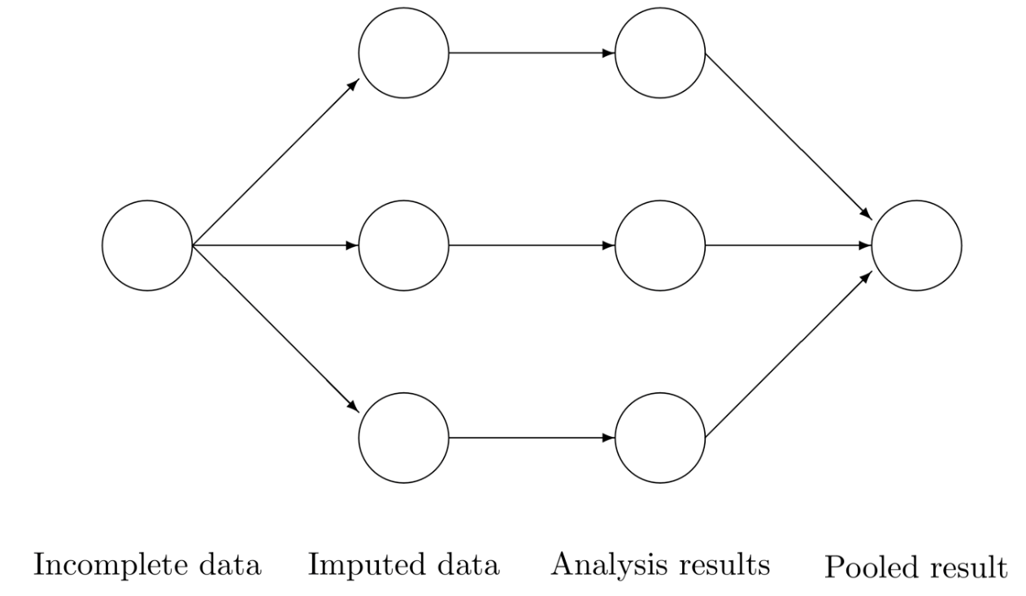

Figure 1 Multiple Imputation Workflow

Based on the data, use-case, and desired outcome, practitioners should choose an imputation method that adds some random variation. Then multiple imputation results in multiple copies of imputed datasets with different imputed values. Each imputed dataset is analyzed separately and then parameters from those analyses are pooled together to get combined diagnostics on the performance of the multiple imputation process and the specified imputation model. This method “solves the standard error problem by calculating the variance of each parameter estimate across the several data sets” (Allison, 2012). The pooled parameters replace those from the supervised machine learning model of interest. The pooled parameters not only produce the coefficient estimate but also the properly account for the increase in standard error due to uncertainty introduced from imputing missing data.

## Missing Data and Autoimpute

Ultimately, this background details the concepts and theory that are the foundation for the Autoimpute package. Understanding the process that generates missingness in a dataset - the missing data mechanism - is imperative prior to applying any deletion or imputation method. The missing data mechanism and missing data pattern should inform which strategy to use to handle missing data. At that point, the researcher performs either univariate or multivariate imputation using the method that fits best a given dataset, use case, or goal. If the researcher is interested in analysis, then he or she should deploy the selected imputation method in multiple imputations. Each imputed dataset within the multiple imputation framework can then be analyzed separately with the supervised learning model of interest. Finally, the researcher can pool parameters together to produce parameters of the multiply imputed analysis model and use this model to make predictions when new data arrives.

Anyone interested can utilize Autoimpute, the Python package created by the authors, to perform all of the steps described above. The next section discusses how to use Autoimpute from end-to-end to explore and analyze missing data. It also demonstrates the impact different missing data mechanisms have on the results produced from multiple imputation and subsequent analysis. All results are generated using the Autoimpute package.

# Methodology

In this section, the researchers use Autoimpute to demonstrate its capabilities as an end-to-end framework for analyzing datasets with missing values. The researchers showcase the package’s features on two datasets with different types of missingness.

The researchers begin by simulating a dataset with no missingness. A simple linear regression is performed on this simulated dataset and its coefficients are stored as benchmarks for comparison of all future analysis models. Then, in each example, the researchers introduce missingness within the given dataset using a predefined missingness mechanism. This dataset with missing values becomes the source of truth for deletion and imputation methods performed on the simulated missing data.

In each example, the researchers then explore missingness patterns within the dataset. After exploration, they employ complete-case analysis or listwise deletion. Following this procedure, they use the missing value dataset to create imputations based on a number of imputation methods. They use univariate imputation methods including mean imputation and multivariate methods including least squares and predictive mean matching. They then run the processed missing value datasets through a simple linear regression and gather the respective coefficients and feature variance for comparison. Lastly, they compare the results to see the impact of deletion and imputation on the analytical model under the circumstances described in each example.

## The Full Dataset

The full dataset contains 500 observations for feature and response . Both datasets come from a joint multivariate normal distribution, and the correlation between and is . The mean of each distribution is zero.

The figure below describes each feature within the distribution:

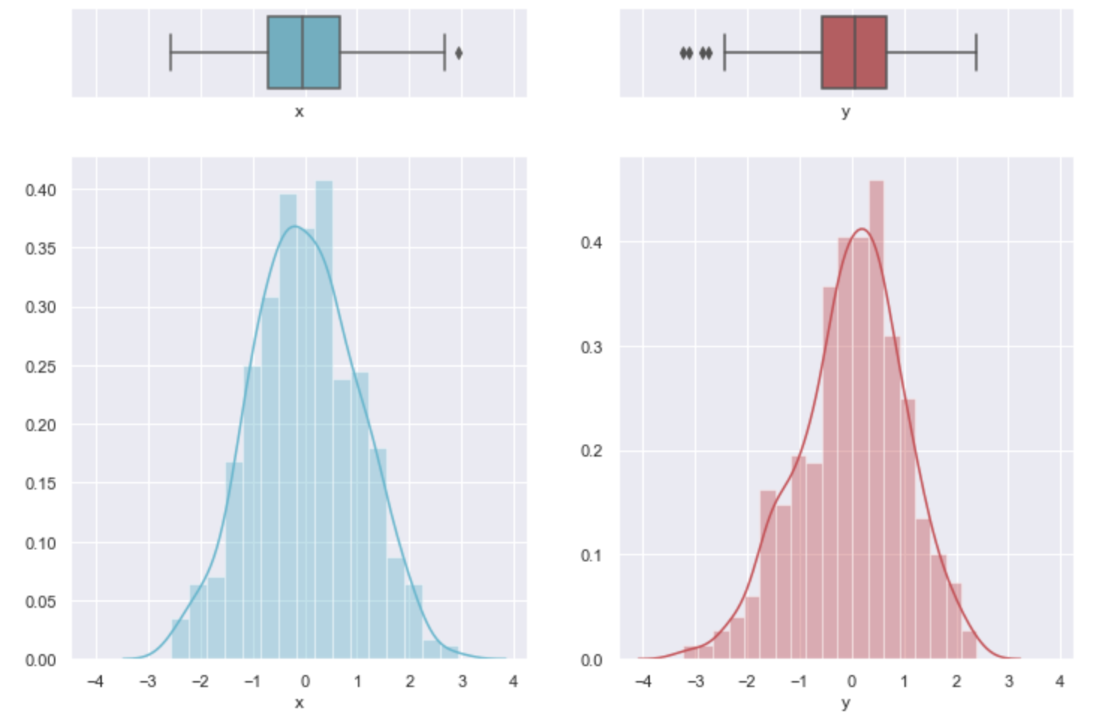

Figure 2 Distribution of Full x and y

The next figure demonstrates the joint relationship between each feature, with the marginals plotted as well:

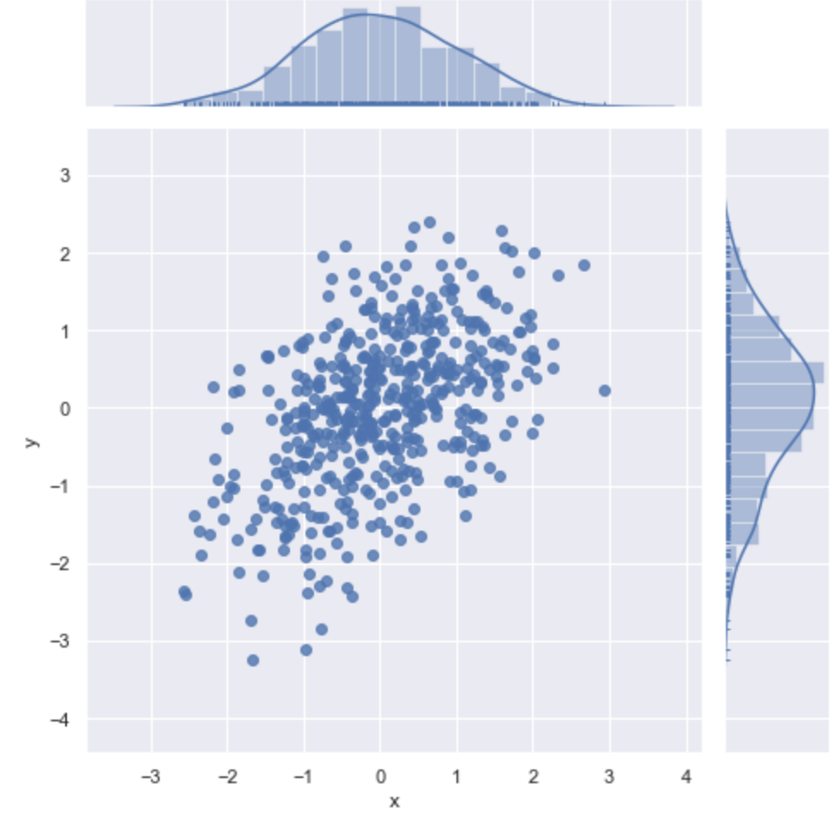

Figure 3 Joint and Marginals of Full x and y

The full dataset does not contain any missing values. Therefore, we do not have to perform any imputation before we conduct analysis. Using Autoimpute, the researchers perform linear regression on the full dataset. The results appear below:

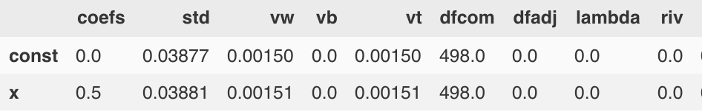

Figure 4 Linear Regression Results: Full

The results from linear regression on the full dataset serve as the golden source.

The output above displays for each variable the following:

* coefs - Linear regression coefficients for each variable
* std - The standard error of the coefficient estimate
* vw - The variance of the coefficient within each complete-data sample
* vb - The variance between each complete-data sample
* vt - The total variance including vw, vb & extra simulation variance
* dfcom - The degrees of freedom for the hypothetically complete dataset
* dfadj - Adapted degrees of freedom for smaller sample sizes
* lambda - The proportion of variance due to nonresponse
* riv - The relative increase in variance

Observe that vb, lambda, and riv are all equal to 0. This result occurs because no imputation is necessary and no multiple imputation takes place. Therefore, we focus mainly on the coefs and std results from above as benchmarks for comparison in the analysis from each example below. These additional metrics become important when we observe examples that contain multiple imputations.

## Example 1: MCAR with Missingness in the Response

In the first example, the researchers generate MCAR missingness within the response, . Response contains 40% missing values. Feature remains fully observed. The two plots below showcase how to use Autoimpute to explore missingness within a given dataset. The plots are quite simple in this case, but they can help detect patterns in missing data when multiple features are present with different levels of missingness.

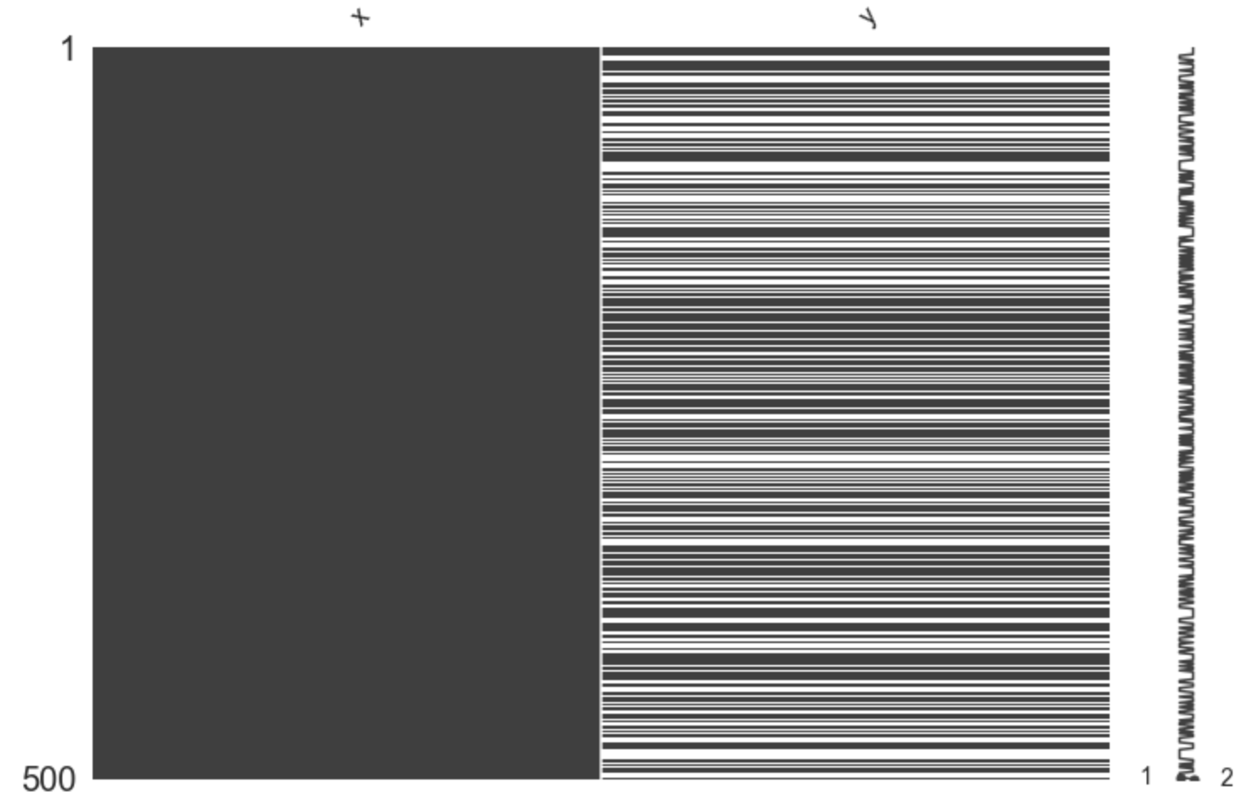

Figure 5 Missingness Locations

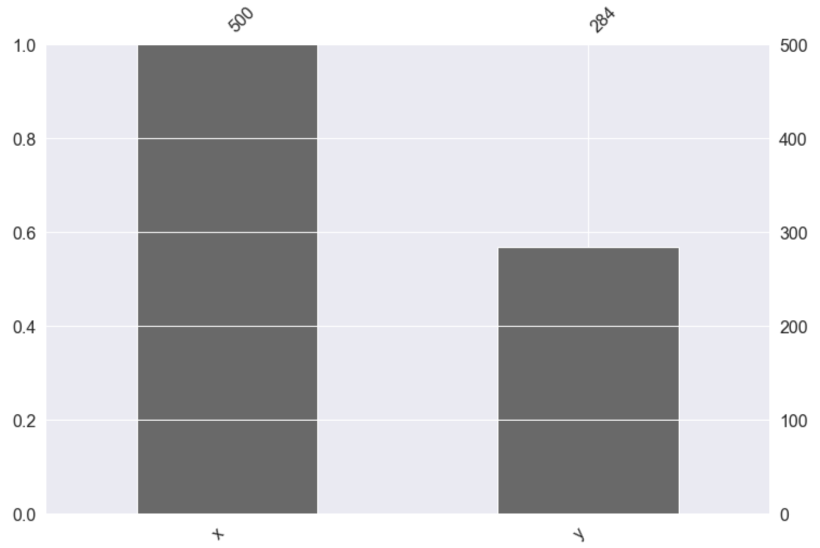

Figure 6 Missingness Percentage

Next, the researchers employ missing data methods to handle missing data. In this case, missing data methods must find plausible imputations for the 40% of that is missing. The imputation methods used include mean, linear regression, and pmm. The researchers also use listwise deletion, although there is no visualization within Autoimpute for complete-case analysis because no imputations are performed. For imputation methods, the researchers deploy each strategy within the multiple imputation framework. The number of imputations performed for each method is 5.

The visualizations below show the impact of mean, linear regression, and pmm. For each strategy, there are two respective plots. The first plot is the new multivariate distribution between and after imputation. The second plot is a swarm plot that shows the imputations for against other, observed values for for each of the imputations performed.

Let’s start with mean imputation:

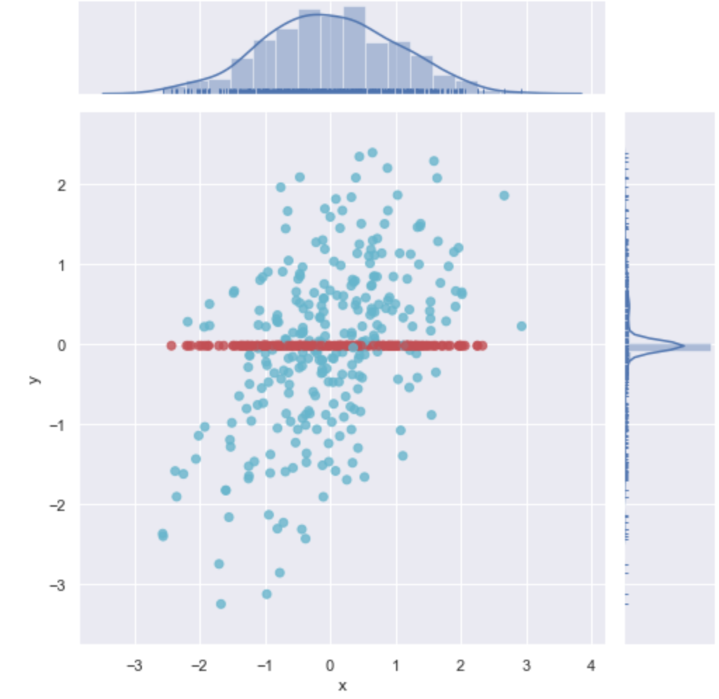

Figure 7 Joint and Marginals with Mean Imputation

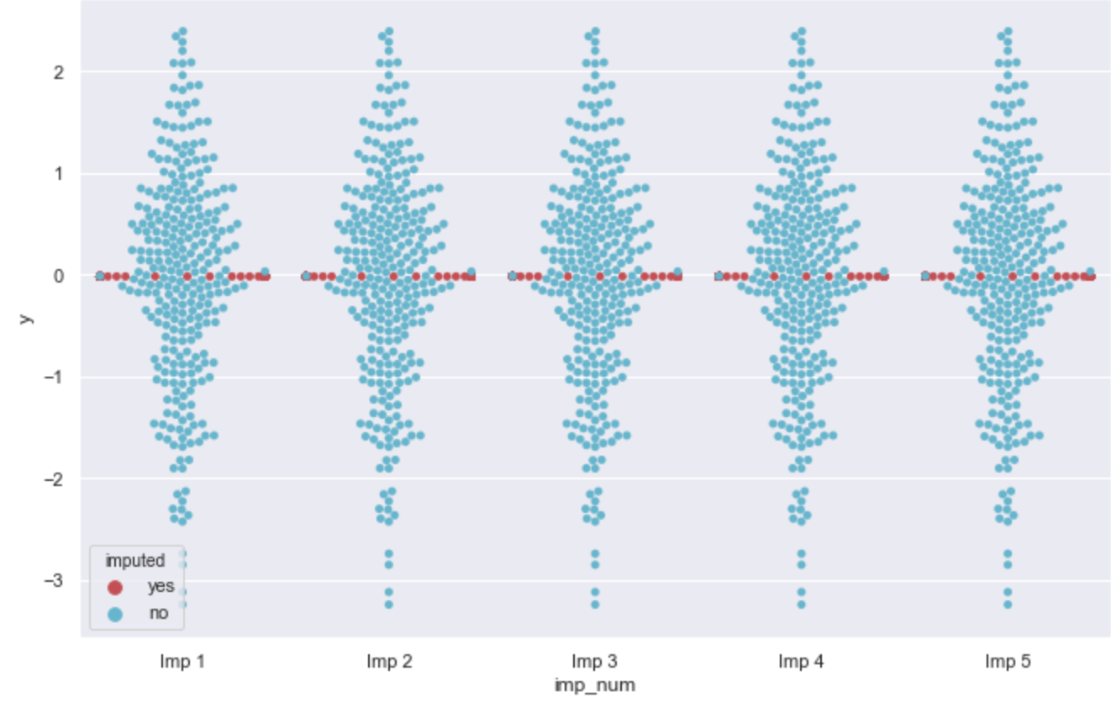

Figure 8 Swarm Plot: Mean Imputation

Note that for mean imputation, the imputations do not depend on the value of , and the relationship between and is ignored. This result makes sense, as mean imputation is a univariate method. Also note that the imputation values in the swarm plot are the same for each imputation. This occurs because the mean of the observed values of do not change from imputation to imputation within the multiple imputation framework. Therefore, the imputation values within each imputed dataset are the same, and the imputation values accross each imputed dataset are the same.

Next, observe imputation via least squares:

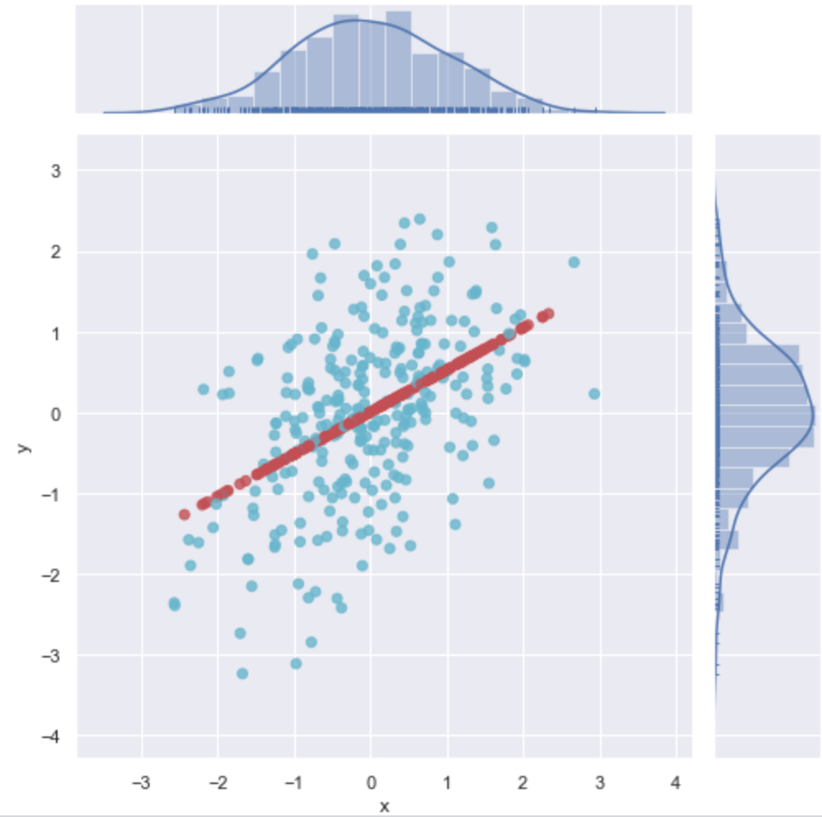

Figure 9 Joint and Marginals with Least Squares Imputation

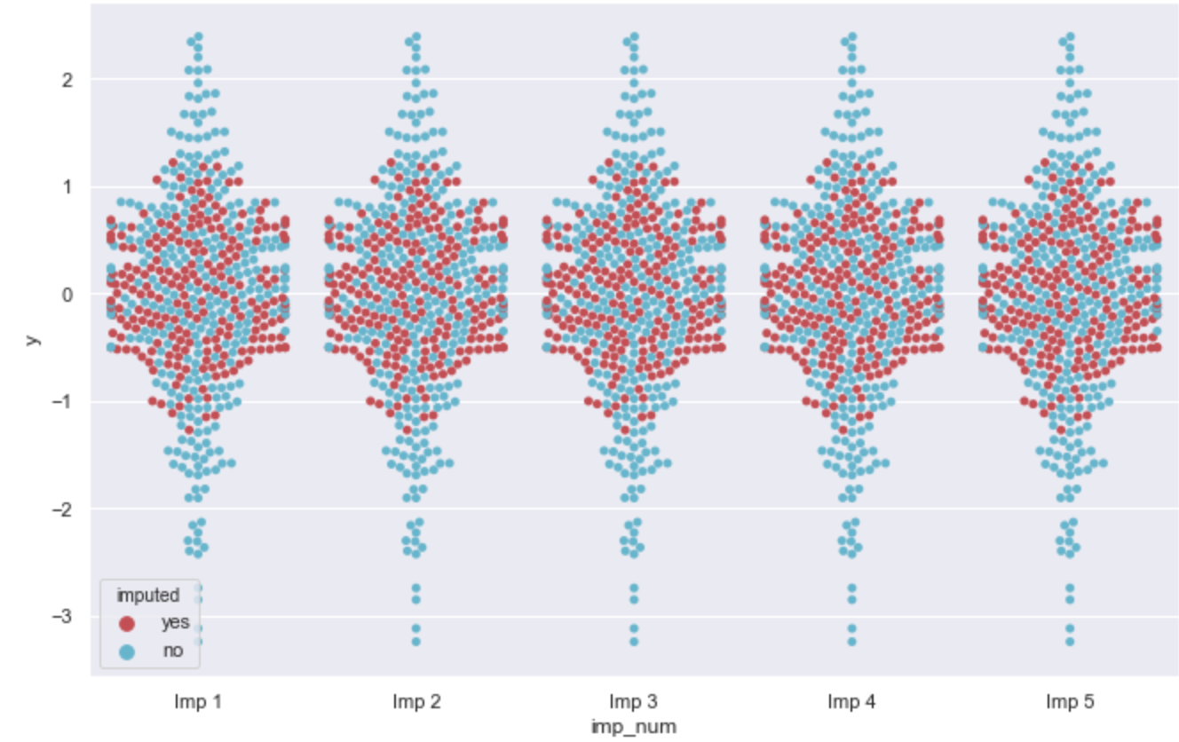

Figure 10 Swarm Plot: Least Squares Imputation

The plots for linear regression now take into account the relationship between and . As a result, the imputed values are different within imputations but the same across imputations. Within imputations, the linear model produces different results, which depend on the value of . But across imputations, the linear model is the same because it is fit to the same data and no random error is added to imputations.

Finally, observe pmm imputation:

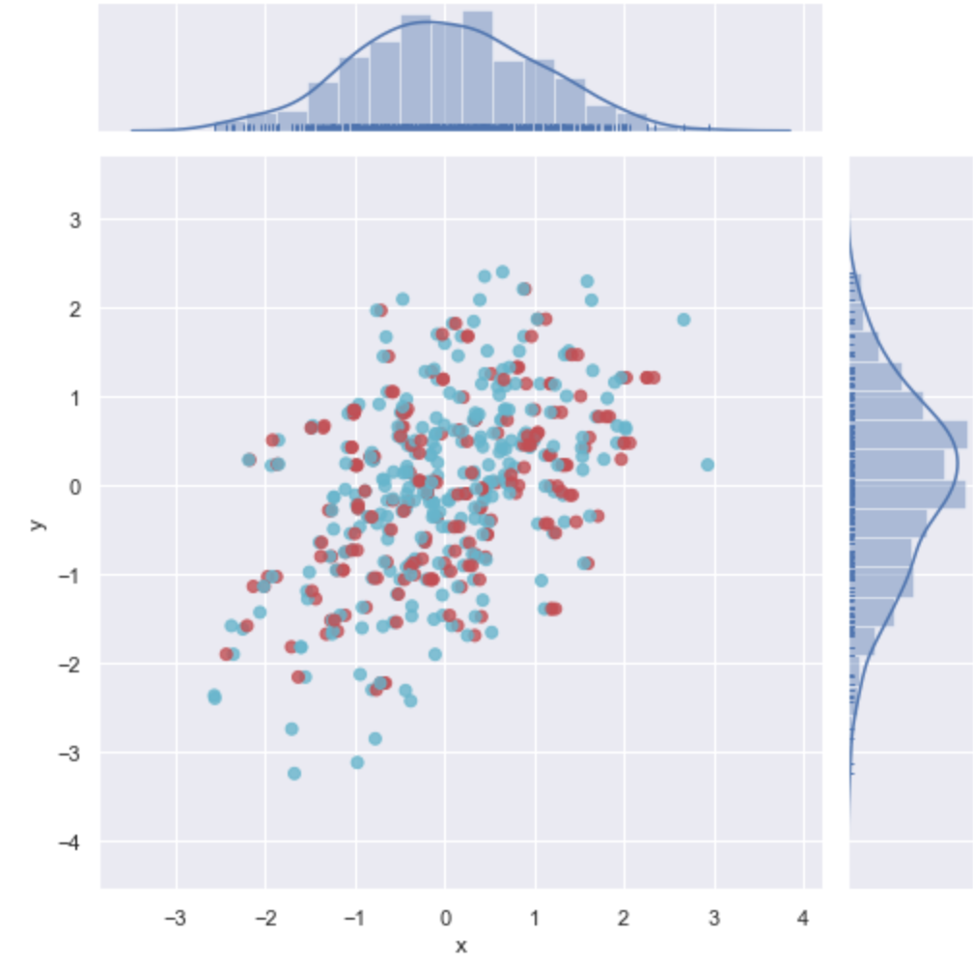

Figure 11 Joint and Marginals with PMM Imputation

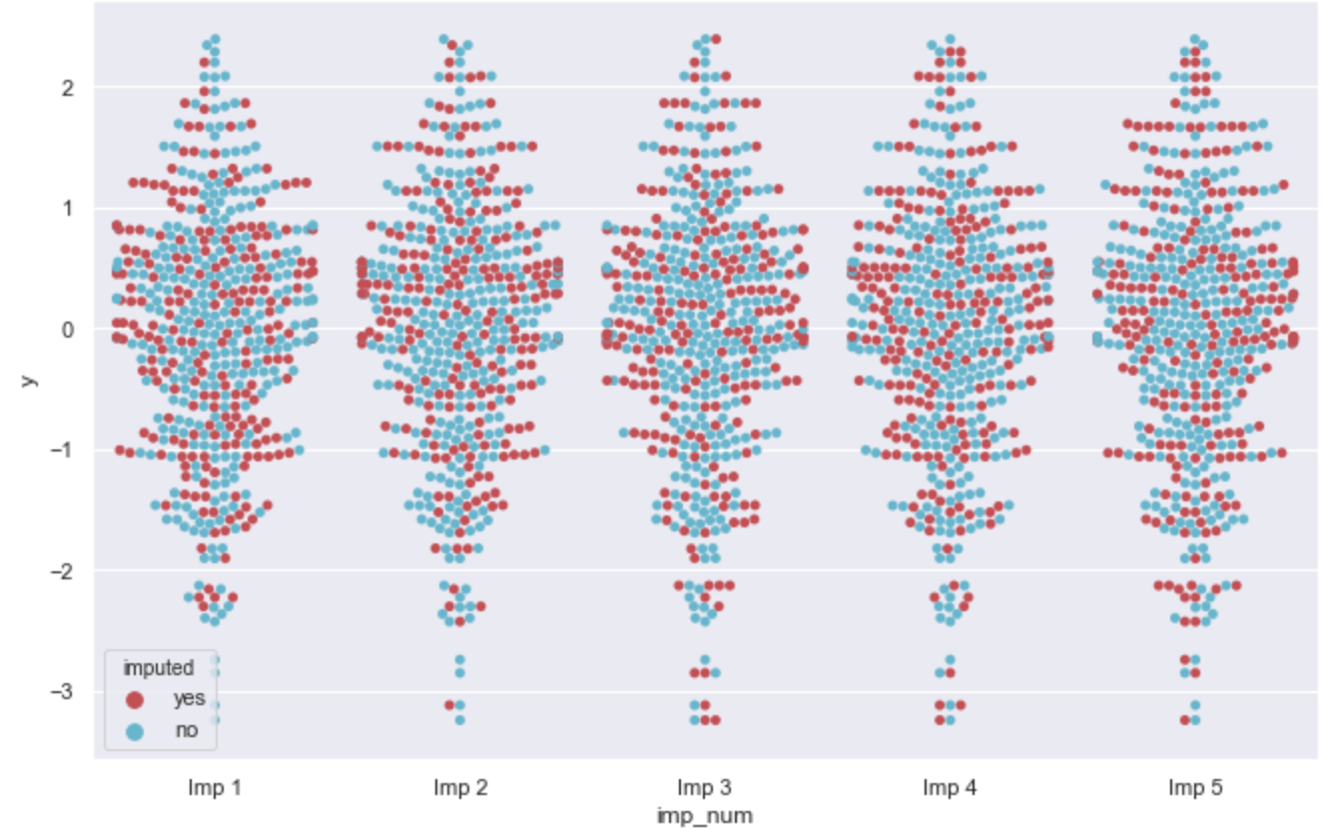

Figure 12 Swarm Plot: PMM Imputation

PMM Imputation respects not only the relationship between and but also the variance between the features. Imputations are no longer from the “line of best fit” as they are with linear regression. Additionally, imputations are different within and across imputations. Therefore, PMM does the best job at respecting the structure of the data and adding variance between / across imputed datasets.

## Example 2: MAR with Missingness in the Predictor

In the second example, the researchers generate MAR missingness within the predictor, . Predictor contains 40% missing values. Response remains fully observed. To keep this section concise, we will not generate the same plots that we did above, but we will apply the exact same methods. Autoimpute can impute both features and predictors, and it can examine missingness anywhere it exists within a dataset.

The researchers take the same approach to Example 2 as they do to Example 1. Multiple imputation is performed, with the number of imputations equal to 5. The same methods are applied as well (listwise delete, mean, least squares, and pmm).

## Analysis Models on each Example

The sections above take the user through the data exploration phase and multiple imputation phase of Autoimpute. The next section, Findings, demonstrates how the nature of missingness affected the results of linear regression on our mulitply imputed data.

# Findings

## Full Model Recap

We begin this section with a recap of linear regression on the full dataset. The results below serve as the benchmark for comparison. They are considered the golden standard. Therefore, we seek to examine how our imputation methods perform and if they produce a dataset that significantly affects the results from linear regression. If the results are skewed, we know that the imputation model used is significantly affected by the nature of missingness within the data, and we may have to do more to account for the missingness.

The results for the full model are displayed below:



Figure 13 Linear Regression Results: Full

## Results from Example 1

Next, we examine the results from a linear regression on the imputed dataset from Example 1. Recall that Example 1 contains 40% missingness in the response , and the missingness mechanism is MCAR.

First, listwise delete:

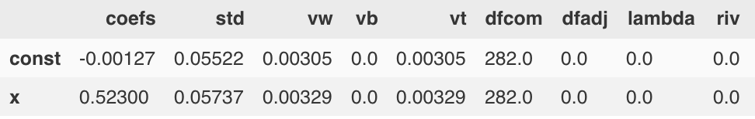

Figure 14 Linear Regression Results: Listwise Delete

Next, mean imputation:

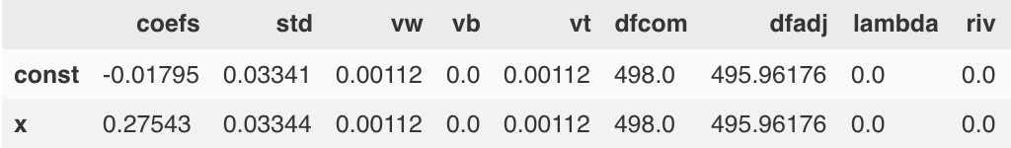

Figure 15 Linear Regression Results: Mean Imputation

Next, least squares imputation:

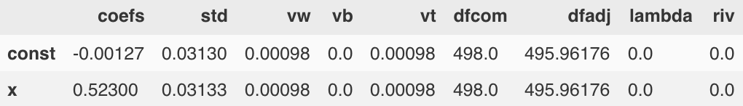

Figure 16 Linear Regression Results: Least Squares Imputation

Finally, pmm imputation:

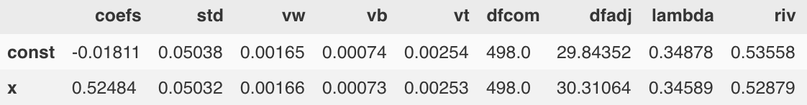

Figure 17 Linear Regression Results: PMM Imputation

## Results from Example 2

Next, we examine the results from a linear regression on the imputed dataset from Example 2. Recall that Example 2 contains 40% missingness in the predictor , and the missingness mechanism is MAR.

First, listwise delete:

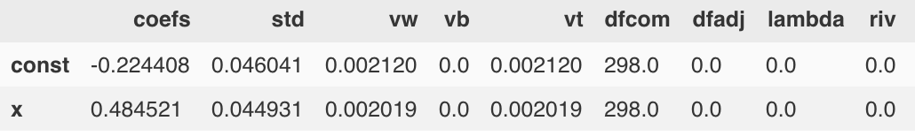

Figure 18 Linear Regression Results: Listwise Delete

Next, mean imputation:

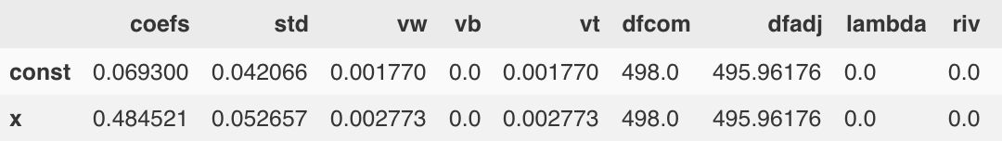

Figure 19 Linear Regression Results: Mean Imputation

Next, least squares imputation:

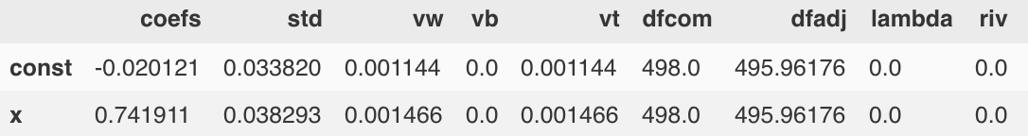

Figure 20 Linear Regression Results: Least Squares Imputation

Finally, pmm imputation:

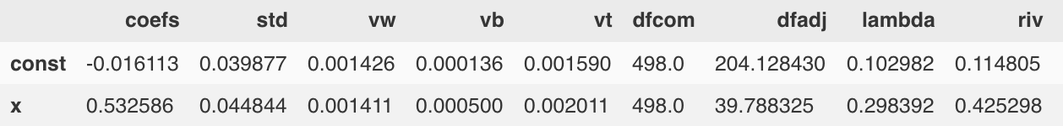

Figure 21 Linear Regression Results: PMM Imputation

## Analysis of Results

We see that regardless of the missing data mechanism, mean and least squares imputation significantly reduce the variance in the coefficient estimates. Therefore, these methods should be avoided regardless because they significantly overstate the confidence we have in an estimate’s coefficient. When missingness is in the predictor, least squares is quite biased. When missingness is in the response, mean is biased downward as well. When data is MCAR, listwise deletion is the most efficient and therefore preferred. When data is MAR, listwise deletion becomes slightly biased, and PMM is the most robust.

# Conclusion

In summary, this project examines the nature of missingness and provides an end-to-end methodology for missing data & imputation analysis. It focuses on four key objectives: describe and visualize the extent of the missing value problem; examine factors related to missingness; develop methods to impute missing data; and measure the impact of imputation on inference derived from supervised learning, specifically linear regression. The researchers create a open-source, Python-based package called Autoimpute to accomplish these objectives. The Autoimpute package provides methods to explore missingness, implement imputation methods, and analyze their impact on analytical models in a flexible way. This report specifically focuses on establishing a solid foundation around the concepts missing data & imputation and demonstrates examples of missing data analysis with different types of missing data. Ultimately, this research provides python-focused data practitioners a tool to use to explore missingness in their datasets, perform imputation methods, and assess the impact of imputation on analytical models downstream.

# Recommendations

This research explores missingness and outlines a framework through which a data practitioner can conduct missing data and imputation analysis. The researchers recommend data practitioners use the flexibility, simplicity, and granularity of the Autoimpute package to conduct their own missing data analyses. To start, data practitioners should review the Autoimpute package tutorials (See Appendix A.0) and get a better understanding of how the package works. This will help data practitioners follow best practices when utilizing the package. Once that is clear, data practitioners should clone the publicly available package from GitHub (See Appendix A.0) and start their analyses. If issues arise during your analyses, please contact the researchers. Lastly, the researchers ask that you share your feedback about the Autoimpute package or any interesting results you find in your analyses.

# (APPENDIX) Appendix

# Autoimpute References

# Notation Cheatsheet

# Concepts Related to Missingness

# Univariate Imputation Methods

# Multivariate Imputation Methods

# References

Allison, P. D. (2012). Handling Missing Data by Maximum Likelihood. SAS Global Forum 2012. Retrieved April 23, 2019, from  
<https://statisticalhorizons.com/wp-content/uploads/MissingDataByML.pdf>.

Economic Commission for Europe of the United Nations (UNECE) (2000), “Glossary of Terms on Statistical Data Editing”, Conference of European Statisticians Methodological material, Geneva.

Gelman, A., & Hill, J. (2017). Data analysis using regression and multilevel/hierarchical models. Cambridge: Cambridge University Press.

Introduction to SAS (2017). UCLA: Statistical Consulting Group. From <https://stats.idre.ucla.edu/sas/modules/sas-learning-moduleintroduction-to-the-features-of-sas/> (accessed April, 21, 2019).

Morris, T. P., White, I. R., & Royston, P. (2014). Tuning multiple imputation by predictive mean matching and local residual draws. BMC Medical Research Methodology, 14(1). <https://doi.org/10.1186/1471-2288-14-75>

Nakagawa, S. (2015). CHAPTER 4 Missing data : mechanisms , methods , and messages.

Rubin, D. B. (1976)., Inference and missing data, Biometrika, Volume 63, Issue 3, Pages 581–592, <https://doi.org/10.1093/biomet/63.3.581>

Van Buuren, S. (2018). Flexible imputation of missing data. Boca Raton: Chapman & Hall/CRC.

Yu, A., Wagner, J. T., & Murugesan, M. (2017). Comparative Evaluation of Recent ML Based Missing Data Imputation Methods with NORC’s Survey of Consumer Finances. University of Chicago Graham School. Retrieved November 1, 2018.