HOMEWORK 2 – FINAL PROJECT REPORT
CI/CD with Jenkins, GitHub, Docker & Docker Swarm on AWS
Project: IQA Office Management System | Student: VIBOL | Academic Year: 2026

1. Project Overview
This project implements a web-based IQA Office Management System and demonstrates an automated container delivery workflow. The application uses HTML, CSS, JavaScript and PHP, PDO for database access, and MariaDB 11.4. Docker packages the application and database; Jenkins automates image build, publication to Amazon Elastic Container Registry (ECR), and deployment to Docker Swarm on AWS EC2.

2. Architecture and Deployment
The solution uses a Jenkins EC2 instance for CI/CD orchestration, a Docker Swarm Manager for cluster management and the MariaDB service, and a Swarm Worker for the PHP/Apache web service. The web and database services communicate over a Docker overlay network. Database credentials are supplied through a Docker Swarm secret; MariaDB is not exposed as a public database endpoint.
Component | Environment / identifier | Purpose
Jenkins | EC2: 13.218.241.63; job: ACT-HW2-CI-CD | Checkout, validate, build, push and deploy
Swarm Manager | Private IP: 172.31.19.179 | Cluster manager; MariaDB service iqa_db
Swarm Worker | Private IP: 172.31.28.139 | PHP/Apache service iqa_web
Amazon ECR | us-east-1 / act_hw2_iqa_system | Private Docker image registry

3. CI/CD Workflow and Verification
The pipeline is defined in the repository's Jenkinsfile. Successful Jenkins Build #10 shows all eight stages completed: Declarative Checkout SCM, Checkout, Validate Project Files, Build Docker Image, Login to Amazon ECR, Push Image to Amazon ECR, Deploy to Docker Swarm, and Declarative Post Actions. The application was verified at http://3.88.106.186:9002. The dashboard, employee page and department page loaded successfully, and a PHP PDO test from the web container returned “DB connection OK”.
GitHub repository: https://github.com/keasokvibol/act_hw2. Pull Request #1, “Document GitHub feature branch workflow”, is open from feature/github-pr-workflow into main. The updated README was committed as 103cf72 and appears in the PR's seven-commit history.

4. Amazon ECR Evidence
The supplied AWS Console screenshot confirms the private ECR repository act_hw2_iqa_system exists in US East (N. Virginia), region us-east-1. Repository URI: 148676267942.dkr.ecr.us-east-1.amazonaws.com/act_hw2_iqa_system.
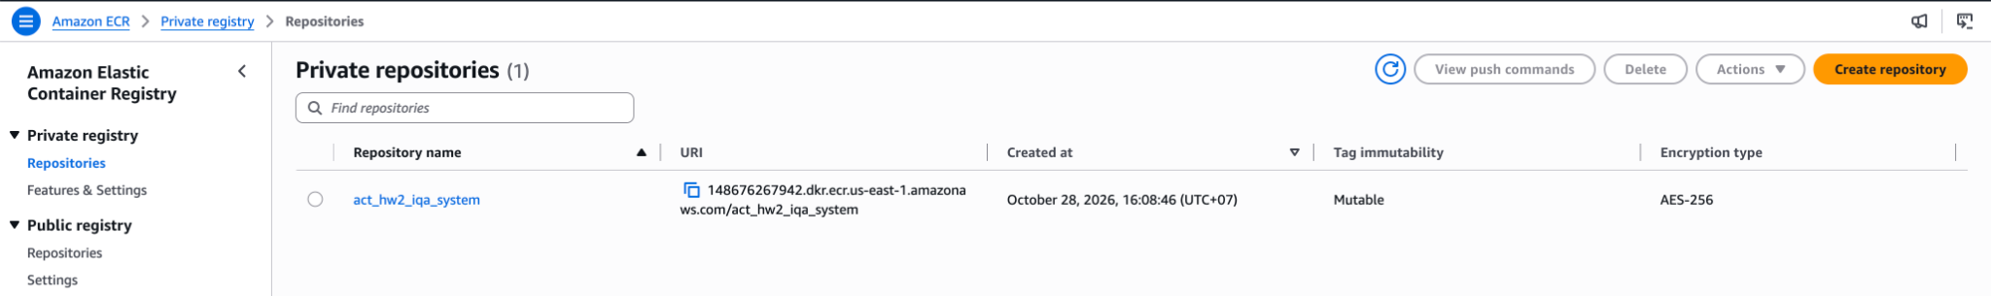
Figure 1. Amazon ECR private repository listing; repository name and URI are visible.

5. Challenges and Solutions
During validation, the public application route initially failed because Swarm ingress routing rules were not registered as expected. Refreshing the web service caused the ingress/IPVS registration and forwarding rule to appear, after which the public homepage became reachable. The MariaDB service was also stopped; it was restarted without removing its persistent data volume. The web task ran on the Worker while the database ran on the Manager; a PDO connection test confirmed overlay-network connectivity and valid database credentials.

6. Conclusion and Submission Evidence
The application is deployed and operational on a two-node Docker Swarm cluster. Jenkins Build #10, the GitHub pull request, ECR repository, public application pages, and web-to-database connectivity provide evidence that the main CI/CD and deployment workflow is functioning.
Before submission: Attach the three application screenshots (dashboard, employees, departments), Jenkins Build #10 evidence, GitHub PR screenshot, and ECR screenshot. The supplied ECR screenshot shows the repository listing but not image tags; if tag evidence is required, capture the repository Images page showing tag 10 and latest. Confirm the public endpoint remains reachable during the grading window because the EC2 public IP may change.

7. Submission Links
- GitHub : https://github.com/keasokvibol/act_hw2
- Jenkins : http://13.218.241.63:9090/
- Application : http://3.88.106.186:9002/
- ECR URI : 148676267942.dkr.ecr.us-east-1.amazonaws.com/act_hw2_iqa_system

