KYLE EASY
33828156

Outline
The application I have built is a health app aimed to track the users workouts. The way the data is displayed is configurable in another database to be accessed by staff. In this app, users can search for people by username and add them as a friend. Once the other person has accepted their friend request, they will be able to see each other’s most recent 5 workouts. There is also frameworks in place for achievements and user preferences but I wasn’t able to implement these in time.
Architecture
- Top level Browser
- express.js web server using middlewares Auth and input validation
- Routes of: /users, /workouts, /friends and /main
- EJS templates provide dynamic html
- MySQL database named ‘health’ containing tables: users, workouts, workout_types, achievements, user_achievements, user_preferences and frieneds
This application uses Node.js with express.js as the application server and EJS for dynamic HTML rendering. I have created middleware that handles authentication, redirection and input validation. The system reads off of conditions from the database (mainly friends and workout_types) to understand how to display different types of user or workouts.
Data Model
The users table stores hashed passwords and personal information. The workouts table logs all workouts, each linked to the user_id of the user who recorded it. The friends table tracks all friendship requests with a status column showing pending or accepted. Once a request is accepted, users can view each other’s workouts. Relationships: workouts.user_id is linked to users.id, both friends.user_id and friends.friend_id are linked to users.id. This structure allows for personal information to be kept safe through only storing hashed passwords.
User Functionality
This app allows users to track their workouts, displaying dynamic information about each workout depending on it’s type. They can add and delete workouts with easy buttons and fields provided by the app.
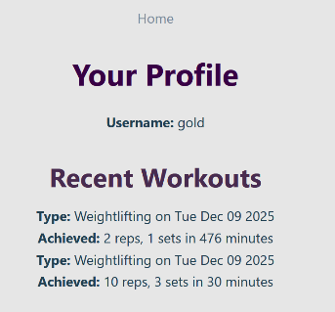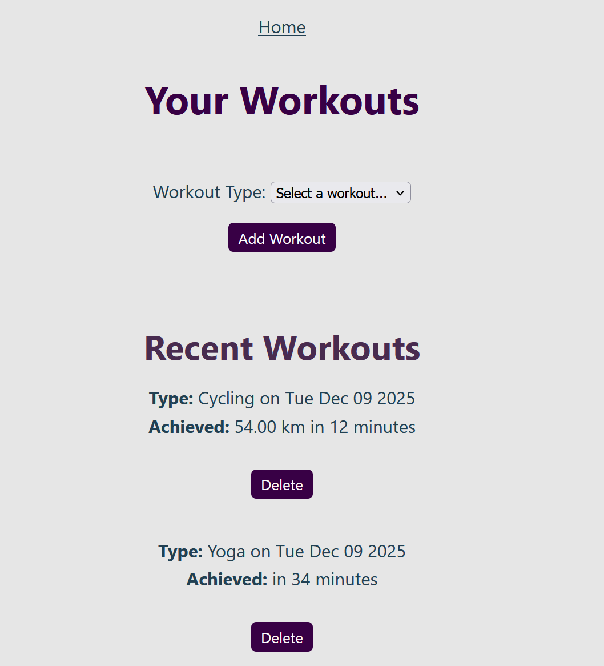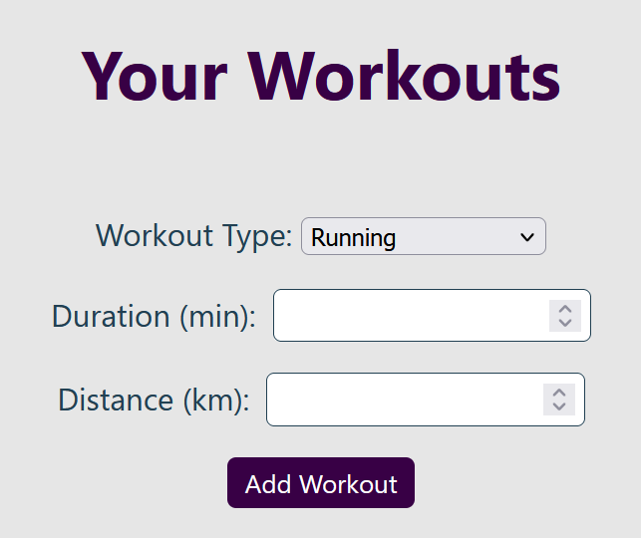
The app also allows for users to search for their friends usernames so that they can view their friends profiles and add them as a friend
- 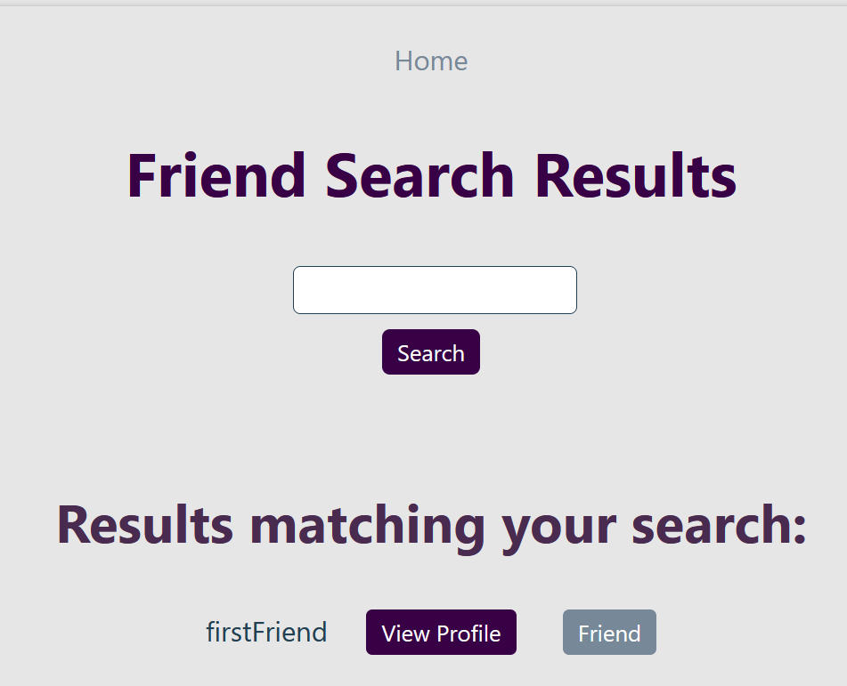
This page reflects the status of friendship with the user. When the users aren’t already friends, the button will either give the option to add or reflect the pending status. The other user who has been added has the option to accept.
The view profile button opens that user’s profile. If the users aren’t friends, then their recent workouts will not be visible.
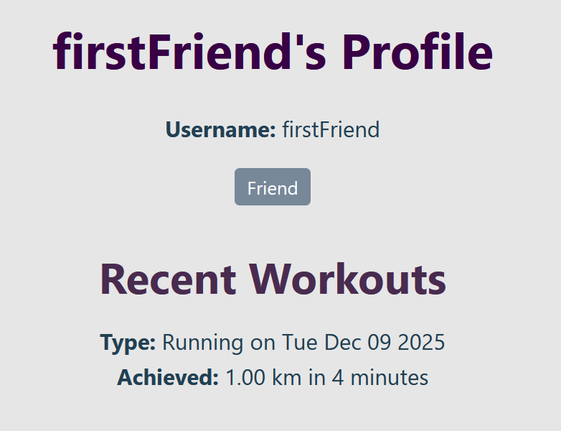
The user is also able to view the about page for the website from their dashboard, which serves as a landing page with all features for logged-in users.
Advanced Techniques
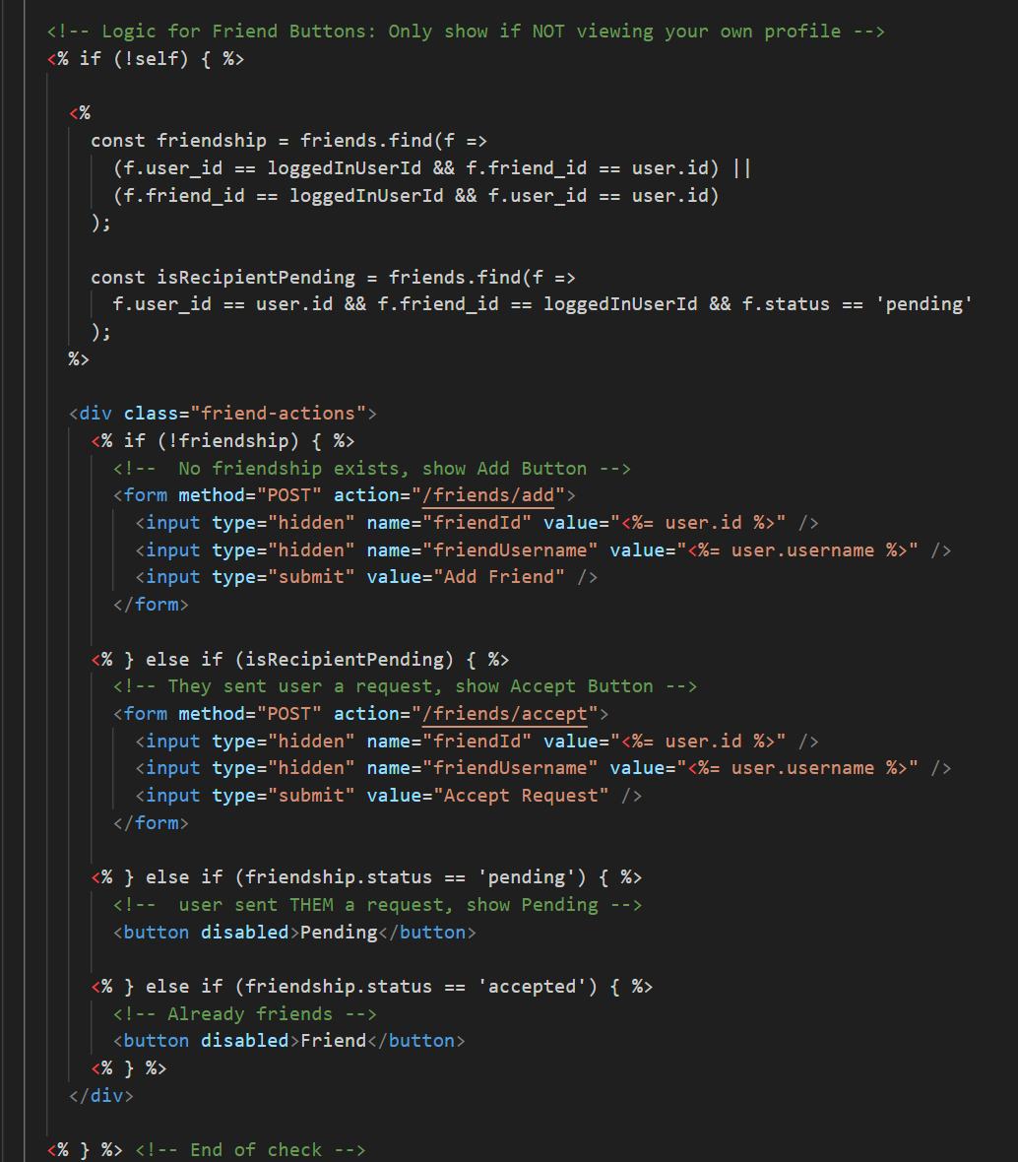
For my friends system, I wrote inline code to show or hide buttons based on the contents of the friends database.
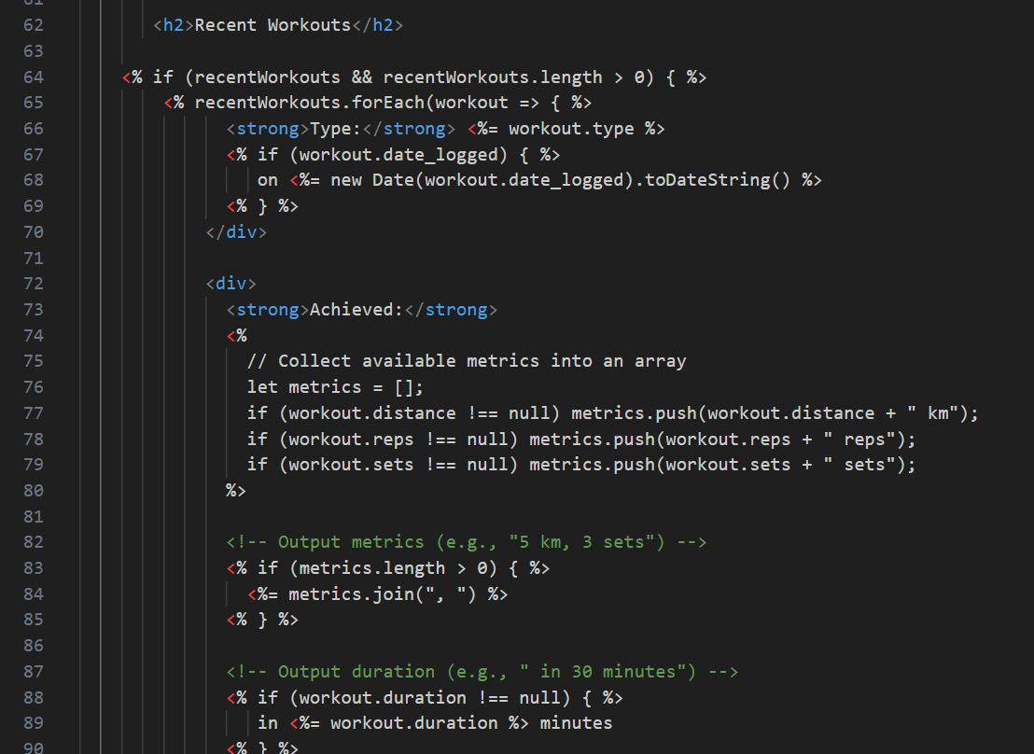
I have also written a script to dynamically display the non-null values of a workout. This script joins strings together so they can be displayed like so:
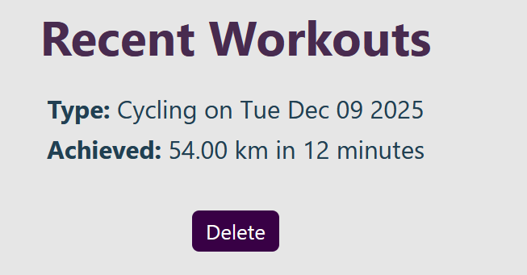
I have also written robust helper functions in order to make the code more readable in the routes. This script accepts the friend request between two users, and if it fails, it tries again the other way round:
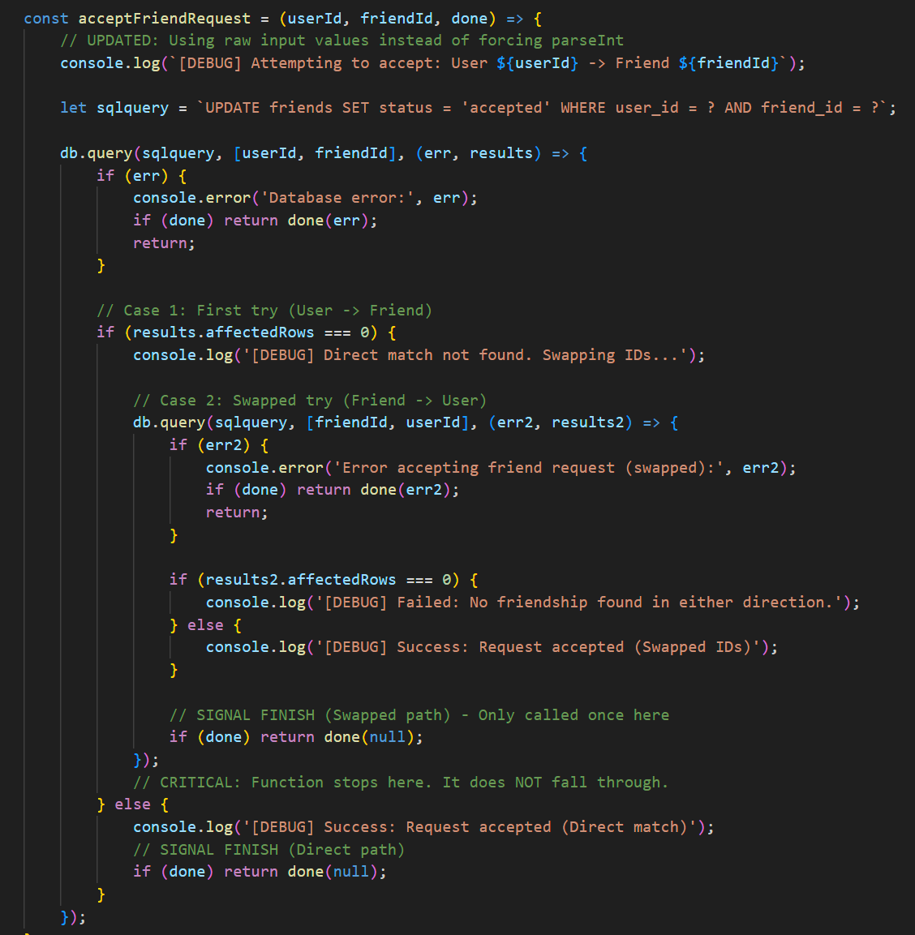
My validate function also returns errors, which can be displayed by the register page. This is helpful as the user can better understand what is expected of them. 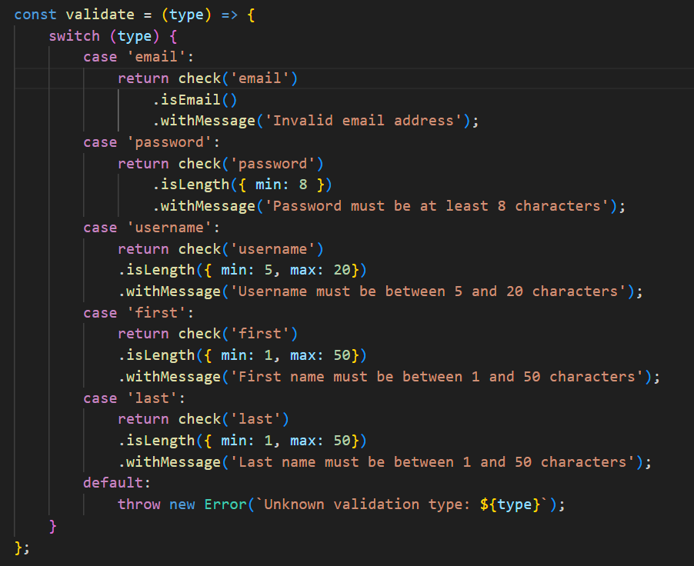
AI Declaration
AI was used to assist my programming in this module. I used ChatGPT to help with writing the CSS as well as help deploying and testing this script on the Virtual machine. I knew what I wanted to do but it was faster to realise using ChatGPT than reading documentation.
I also used ChatGPT to clarify on the instructions for this writeup. I didn’t allow it to generate any text that has been used in this assessment. It simply helped me understand more of the nuance in the task.

