- Outline
The application I have built is a health app aimed to track the users workouts. The way the data is displayed is configurable in another database to be accessed by staff. In this app, users can search for people by username and add them as a friend. Once the other person has accepted their friend request, they will be able to see each other’s most recent 5 workouts. There is also frameworks in place for achievements and user preferences but I wasn’t able to implement these in time.
- Architecture
- Top level Browser
- express.js web server using middlewares Auth and input validation
- Routes of: /users, /workouts, /friends and /main
- EJS templates provide dynamic html
- MySQL database named ‘health’ containing tables: users, workouts, workout_types, achievements, user_achievements, user_preferences and frieneds
This application uses Node.js with express.js as the application server and EJS for dynamic HTML rendering. I have created middleware that handles authentication, redirection and input validation. The system reads off of conditions from the database (mainly friends and workout_types) to understand how to display different types of user or workouts.
- Data Model
The users table stores hashed passwords and personal information. The workouts table logs all workouts, each linked to the user_id of the user who recorded it. The friends table tracks all friendship requests with a status column showing pending or accepted. Once a request is accepted, users can view each other’s workouts. Relationships: workouts.user_id is linked to users.id, both friends.user_id and friends.friend_id are linked to users.id. This structure allows for personal information to be kept safe through only storing hashed passwords.
- User Functionality
This app allows users to track their workouts, displaying dynamic information about each workout depending on it’s type. They can add and delete workouts with easy buttons and fields provided by the app.
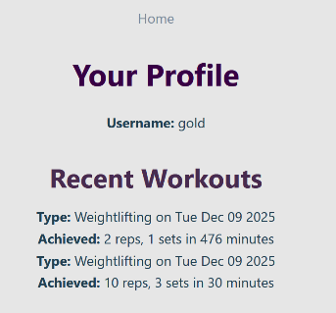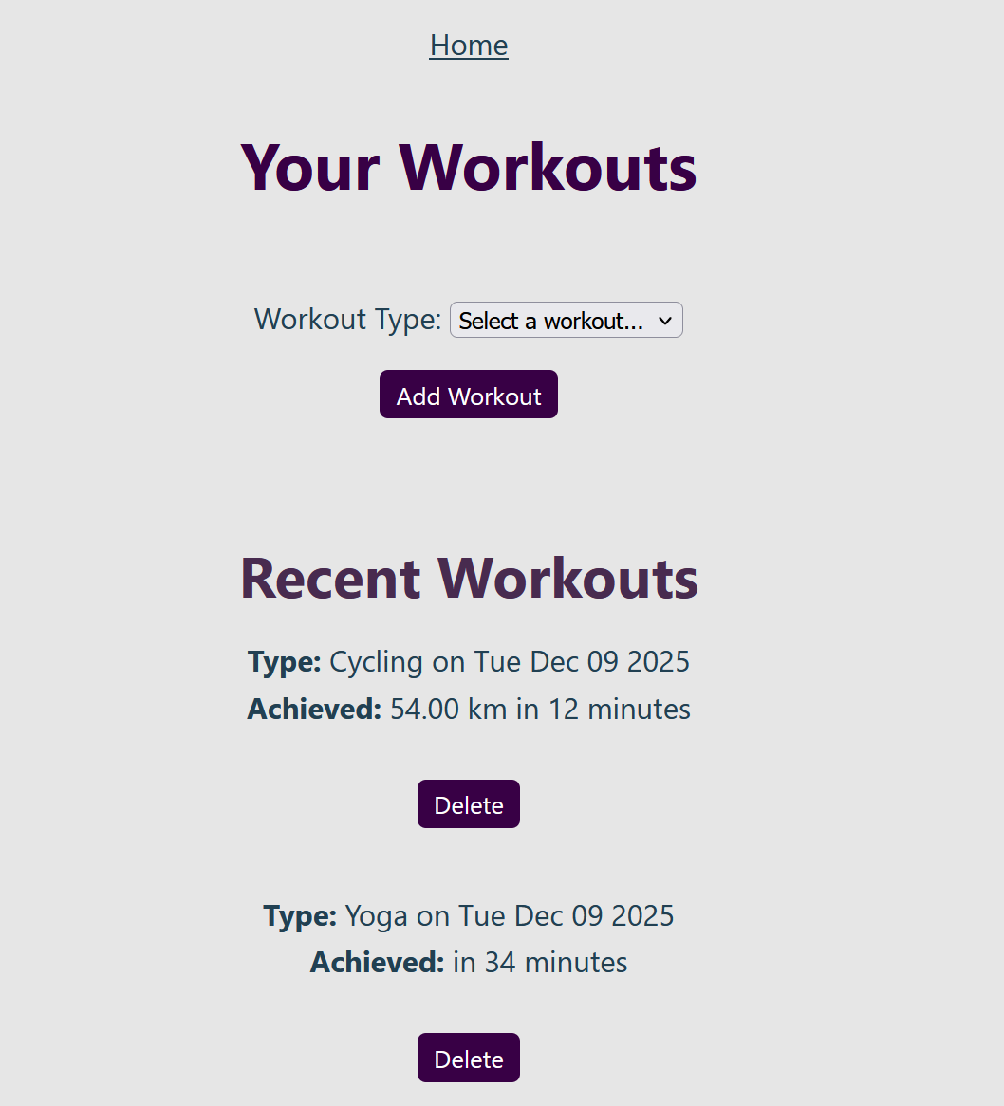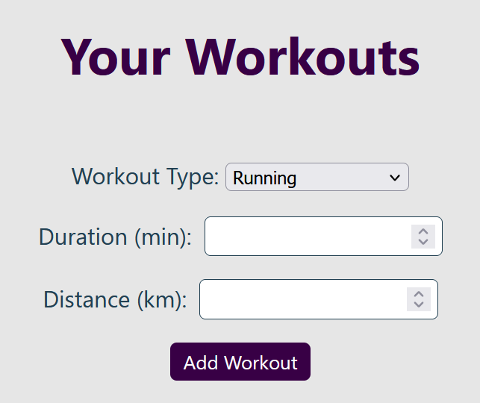
The app also allows for users to search for their friends usernames so that they can view their friends profiles and add them as a friend
- 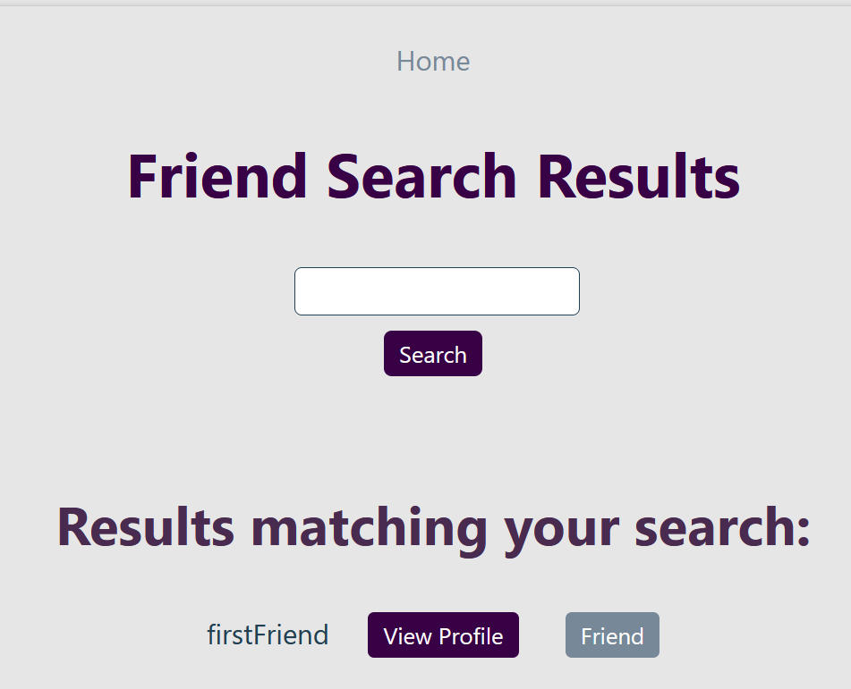
This page reflects the status of friendship with the user. When the users aren’t already friends, the button will either give the option to add or reflect the pending status. The other user who has been added has the option to accept.
The view profile button opens that user’s profile. If the users aren’t friends, then their recent workouts will not be visible.
- 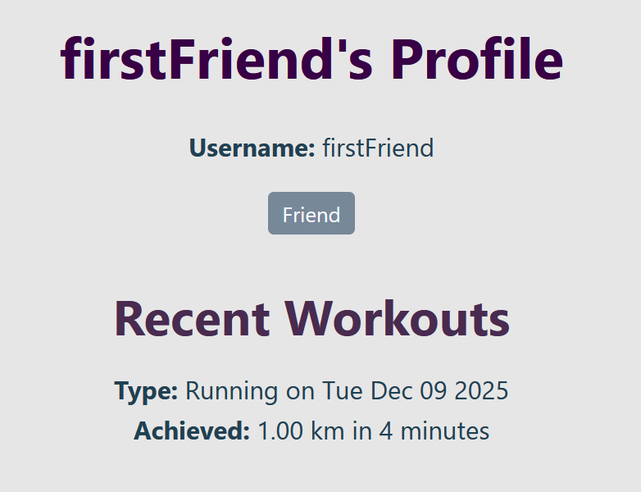
- Advanced Techniques
- AI Declaration

