A CASE-STUDY BASED REPORT
ON
Smart Crop Recommendation and Farm Advisory System Using Machine Learning
submitted in partial fulfilment of the requirements for the Course
MACHINE LEARNING
BACHELOR OF TECHNOLOGY
in Computer Science and Information Technology
A.Y.: 2026-27
by
Lahari Namala – Roll No: 2520090226
K. Keathana Vikashini – Roll No: 2520090236
Under the Esteemed guidance of
Ch.Haritha
Asst.Professor, Dept. of CS&IT




INDEX
Abstract 3
Introduction 3
Background 3
Motivation for the Project 3
Overview of the Work Carried Out 4
Scope and Responsible-Use Statement 4
Problem Statement 4
Case-Study Scenario 4
Central Case-Study Question 5
Formal Problem Definition 5
Objectives that Guide the Study 5
Assumptions and Limitations 6
Dataset and Exploratory Data Analysis 6
About the Dataset 6
Purpose of EDA 6
Preparation Steps Actually Performed 7
EDA Exploration - Implementation 7
Summary of EDA Findings 7
Algorithm Selection and Implementation 8

Conclusion 12

Abstract
Choosing the right crop for a field is difficult for many small farmers, because soil nutrients, rainfall, temperature, humidity and soil pH differ from field to field and from season to season. This case study presents Smart Crop AI, a Smart Crop Recommendation and Farm Advisory System that uses machine learning to recommend a suitable crop and a simple fertilizer plan from seven soil and climate values.
The Crop Recommendation dataset (2,200 records, 22 crops, 100 records per crop) was checked for missing values and duplicates, scaled where needed and split 80/20 with stratification. Five classifiers, namely Multinomial Logistic Regression, Random Forest, Support Vector Machine, K-Nearest Neighbors and Decision Tree, were trained and compared on 440 unseen test records using accuracy, precision, recall and macro F1-score. Random Forest (200 trees) was selected as the best model with 99.55% accuracy, 99.57% precision, 99.55% recall and 99.55% F1-score, classifying 438 of the 440 test records correctly.
The saved model is served through a Flask REST API (POST /api/predict) and used by a web dashboard that shows the best crop, the top three crops with confidence scores, fertilizer advice, weather and market updates, and prediction history. The very high accuracy partly reflects a clean and balanced dataset, and the weather and market screens currently use sample data; real field data and live feeds are identified as future work.
Keywords: crop recommendation, precision agriculture, machine learning, Random Forest, fertilizer advice, Flask.

Introduction

Background
In farming, every season begins with a decision: which crop should be grown on a given piece of land. The answer depends on soil nutrients such as nitrogen (N), phosphorus (P) and potassium (K), on soil pH, and on climate factors such as temperature, humidity and rainfall. These values are different for every field and keep changing, so the decision is rarely simple.
Precision agriculture is the idea of using measured data, instead of guesswork, to make farming decisions for each field. Crop recommendation is one of its basic tasks: suggesting the most suitable crop for a field from its soil nutrients and local climate.
Machine learning fits this task well. A model can study thousands of past records and learn which conditions suit which crop, and once trained it gives a fast and consistent answer to every farmer. This case study builds such a model on the Crop Recommendation dataset (2,200 records, 22 crops) and wraps it in a farmer-friendly website named Smart Crop AI.

Motivation for the Project
The project was chosen because it addresses a real problem with a practical, low-cost solution:
- Real-world need: most small farmers cannot easily reach soil scientists or agronomists for advice.
- Better yield: matching the crop to soil and climate improves the chance of a healthy harvest.
- Less fertilizer waste: nutrient-based advice avoids overusing urea, DAP and potash, which saves money and protects the soil.
- Data-driven farming: decisions are backed by measured values, and a trained model is cheap to run on any device.

Overview of the Work Carried Out
The work followed a seven-step machine learning workflow, from data to a working website:
- Dataset collection: the Crop Recommendation CSV (2,200 rows) was collected.
- Preprocessing: the data was checked for nulls and duplicates, and features were scaled for the algorithms that need it.
- Model training: five algorithms were trained with an 80/20 stratified split.
- Evaluation: the models were compared using accuracy, precision, recall and F1-score.
- Model saving: the best model was saved with Joblib.
- Flask deployment: the model was exposed through the REST endpoint /api/predict.
- UI display: the website shows the best crop, the top 3 crops, fertilizer advice and prediction history.
Training was done in Google Colab and the web application was built in Visual Studio Code with Flask. The model with the highest macro F1-score was chosen as the final model.

Scope and Responsible-Use Statement
Smart Crop AI is intended as a low-cost, data-driven decision aid for precision agriculture. It supports a farmer's decision; it does not replace the advice of an agriculture officer or soil expert. The following points define how the results should be read:
- The model can recommend only the 22 crops present in the training data.
- A recommendation is only as good as the soil test and weather values entered. Wrong inputs lead to wrong recommendations.
- The 99.55% accuracy was measured on a public, clean and balanced dataset. Real field data will be noisier, so field accuracy may be lower.
- The weather and market screens use sample data, not live feeds, and prediction history is kept only while the page is open.
- Fertilizer advice is a simple comparison of N, P, K and pH values with crop needs and should be treated as guidance.

Problem Statement

Case-Study Scenario
Consider a small farmer who must decide what to plant next season. In the existing system the farmer repeats last season's crop, follows what the neighbours are growing, relies on knowledge passed down in the family, or asks the local agriculture officer or fertilizer dealer. None of these approaches uses measured soil or weather data, and an expert is not always available in a village.
Four factors make the decision hard because each differs from field to field and changes from season to season:
Table 1: Factors that make crop choice difficult
Factor | What varies
Soil nutrients | N, P, K levels differ between fields
Rainfall | Uneven every season
Climate | Temperature and humidity shift
Soil pH | Ranges from acidic to alkaline

A wrong crop choice leads to low yield, wasted fertilizer and money loss. Small farmers with no access to soil experts are affected the most. The existing approaches share clear limitations: they are subjective and inconsistent, ignore measured soil and weather data, give no nutrient-based fertilizer guidance, and are slow to adapt to changing climate.

Central Case-Study Question
Can a machine learning model trained on seven soil and climate measurements recommend the most suitable crop reliably, and can the result be delivered, with simple fertilizer advice, in a form that a small farmer can use without technical skill?

Formal Problem Definition
The task is a multi-class classification problem. Each field is described by a feature vector x = (N, P, K, temperature, humidity, pH, rainfall) with seven values. The goal is to learn a function f that maps x to one of 22 crop classes y, using the 2,200 labelled records of the Crop Recommendation dataset. The best of five candidate classifiers is selected by its macro-averaged F1-score on 440 unseen test records.
For each input the system must return (i) the best crop, (ii) the top 3 crops with confidence scores taken from the model's predicted probabilities, and (iii) a fertilizer plan obtained by comparing the N, P, K and pH values with the needs of the recommended crop.

Objectives that Guide the Study
Main objective: build a web system that recommends the best crop and a fertilizer plan from soil and climate values using machine learning.
The specific objectives are:
- Collect and preprocess the Crop Recommendation dataset (2,200 records, 22 crops).
- Train and compare five ML classifiers and select the best one.
- Show the top 3 suitable crops with confidence scores.
- Give simple fertilizer advice based on N, P, K and soil pH.
- Deploy the model in a Flask web app with dashboard, updates and history.

Assumptions and Limitations
Assumptions
- The seven features (N, P, K, temperature, humidity, pH and rainfall) are sufficient to describe the conditions that decide crop suitability.
- The farmer enters accurate soil test and weather values.
- The Crop Recommendation dataset is representative of the conditions the system will be used in.
Limitations
- Depends on dataset quality: the model was trained on one public dataset of 2,200 records; crops outside the 22 classes cannot be predicted.
- Needs accurate inputs: wrong soil test or weather values lead to wrong recommendations.
- Sample-based updates: the weather and market screens use sample data, not live feeds.
- Clean data effect: the very high accuracy partly reflects a clean, balanced dataset; real field data will be noisier.
- Evaluation depth: a single stratified train-test split was used; cross-validation and hyperparameter search were not carried out.

Dataset and Exploratory Data Analysis

About the Dataset
The study uses the Crop Recommendation dataset, a CSV file with 2,200 records and 22 crop classes (for example rice, maize, cotton and coffee). Every crop has exactly 100 rows, so the classes are perfectly balanced. Each record has seven input features, and the target column, called label, holds the crop name.
Table 2: Input features of the dataset
Feature | Meaning | Unit
N | Nitrogen in soil | ratio
P | Phosphorus in soil | ratio
K | Potassium in soil | ratio
temperature | Air temperature | °C
humidity | Relative humidity | %
ph | Soil pH value | 0–14
rainfall | Rainfall | mm

Purpose of EDA
Exploratory data analysis was carried out before modelling to confirm that the data is fit for training. It was used to check the size and structure of the data, to look for missing values and duplicate rows, to see whether all crops are equally represented, and to understand the range of each feature so that the right preprocessing could be chosen for each algorithm.

Preparation Steps Actually Performed
- Missing values: the data was checked for null values; none were found.
- Duplicates: the data was checked for duplicate rows; none were found.
- Feature scaling: StandardScaler was applied for Logistic Regression, SVM and KNN, because these algorithms are sensitive to the size of numbers. Random Forest and Decision Tree were trained on the unscaled values.
- Train-test split: the data was split 80% for training and 20% for testing with a stratified split, so all crops stay equally represented. The test set therefore has 440 records.

EDA Exploration - Implementation
The exploration was implemented in Google Colab with Pandas and NumPy for loading and checking the data, and Matplotlib and Seaborn for graphs. Table 3 lists the checks that were made and what each one showed.
Table 3: EDA checks and outcomes
Check | Outcome
Size of the dataset | 2,200 records; 7 input features and 1 label column
Number of crop classes | 22 classes
Class balance | Exactly 100 rows for every crop (perfectly balanced)
Missing values | 0 missing values
Duplicate rows | 0 duplicates
Feature scales | Features are on different scales (for example pH 0–14 against rainfall in mm), so scaling is needed for distance- and margin-based models
Feature importance (Random Forest) | Rainfall, humidity and potassium (K) matter most

Summary of EDA Findings
- The dataset is clean: no missing values and no duplicate rows, so no records had to be removed or imputed.
- The dataset is perfectly balanced (100 rows per crop), so accuracy is not distorted by a dominant class and a stratified split keeps all 22 crops in the test set.
- The features are on different scales, so StandardScaler is applied for Logistic Regression, SVM and KNN.
- After training, the Random Forest feature importance shows that rainfall, humidity and potassium (K) are the most influential inputs.
These findings also explain why accuracy is very high: the data is clean and balanced. Real field data is expected to be noisier.

Algorithm Selection and Implementation

Candidate Algorithms
Five classifiers with different ways of separating the 22 crops were selected so that linear, margin-based, instance-based and tree-based methods could be compared on the same data and the same split.
Table 4: Candidate models and settings
Model | Simple idea | Setting
Multinomial Logistic Regression | Draws linear boundaries and gives a probability for each of the 22 crops | lbfgs, C = 1.0, L2 regularisation
Random Forest | Many decision trees vote; the majority wins, which reduces overfitting | 200 trees
Support Vector Machine | Finds the widest gap between crops using a curved (RBF) boundary | RBF kernel
K-Nearest Neighbors | Looks at the 5 most similar farms in the data and takes their crop | k = 5
Decision Tree | Asks yes/no questions like "rainfall > 150 mm?" to reach a crop | single tree

Model Selection
All five models were trained on the same 80% training split (scaled inputs for Logistic Regression, SVM and KNN) and evaluated on the same 440 unseen test records. Accuracy, precision, recall and F1-score were computed; precision, recall and F1 are macro-averaged over the 22 crops. The selection rule is the highest macro F1-score, and the best model is saved automatically with Joblib.
Table 5: Test performance of the five models (values in %)
Model | Accuracy | Precision | Recall | F1-score
Random Forest | 99.55 | 99.57 | 99.55 | 99.55
SVM (RBF) | 98.41 | 98.56 | 98.41 | 98.40
KNN | 97.95 | 98.04 | 97.95 | 97.93
Decision Tree | 97.95 | 98.06 | 97.95 | 97.94
Logistic Regression | 97.27 | 97.40 | 97.27 | 97.25

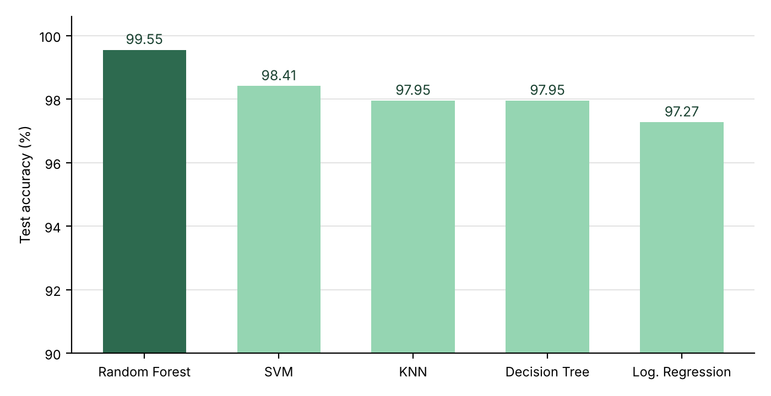
Figure 1: Test accuracy by model (the axis starts at 90% to show the differences)
Random Forest is the clear winner and was selected as the final model. All five models performed well because the dataset is clean and balanced, but Random Forest was the most reliable. It classified 438 of the 440 test records correctly; its only two mistakes were one blackgram predicted as maize and one rice predicted as jute, which are crops with similar conditions.

System Architecture and Workflow
The system has three layers, shown in Figure 2. The presentation layer (HTML, CSS and JavaScript) contains the login, input form, result and dashboard screens. The application layer is a Flask REST API: POST /api/predict validates the 7 inputs and calls the model. The ML layer holds the Random Forest (200 trees) loaded from crop_model.joblib, which returns the top 3 crops and the data used for the fertilizer plan.
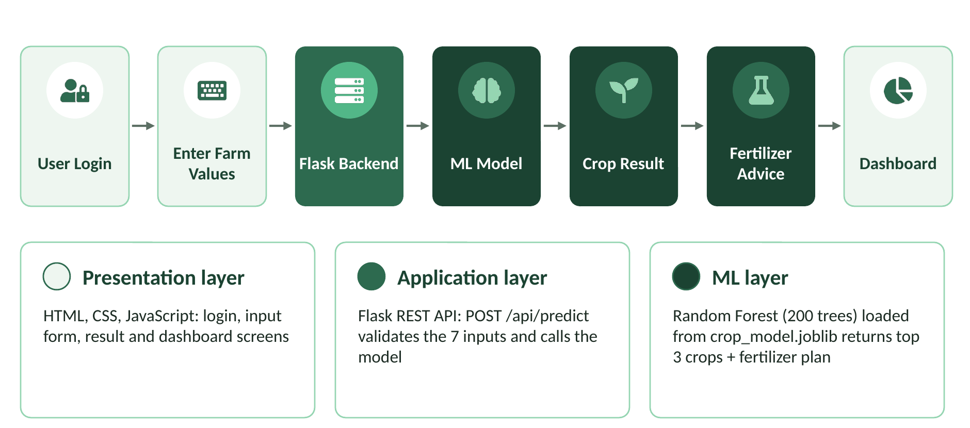
Figure 2: System architecture of Smart Crop AI
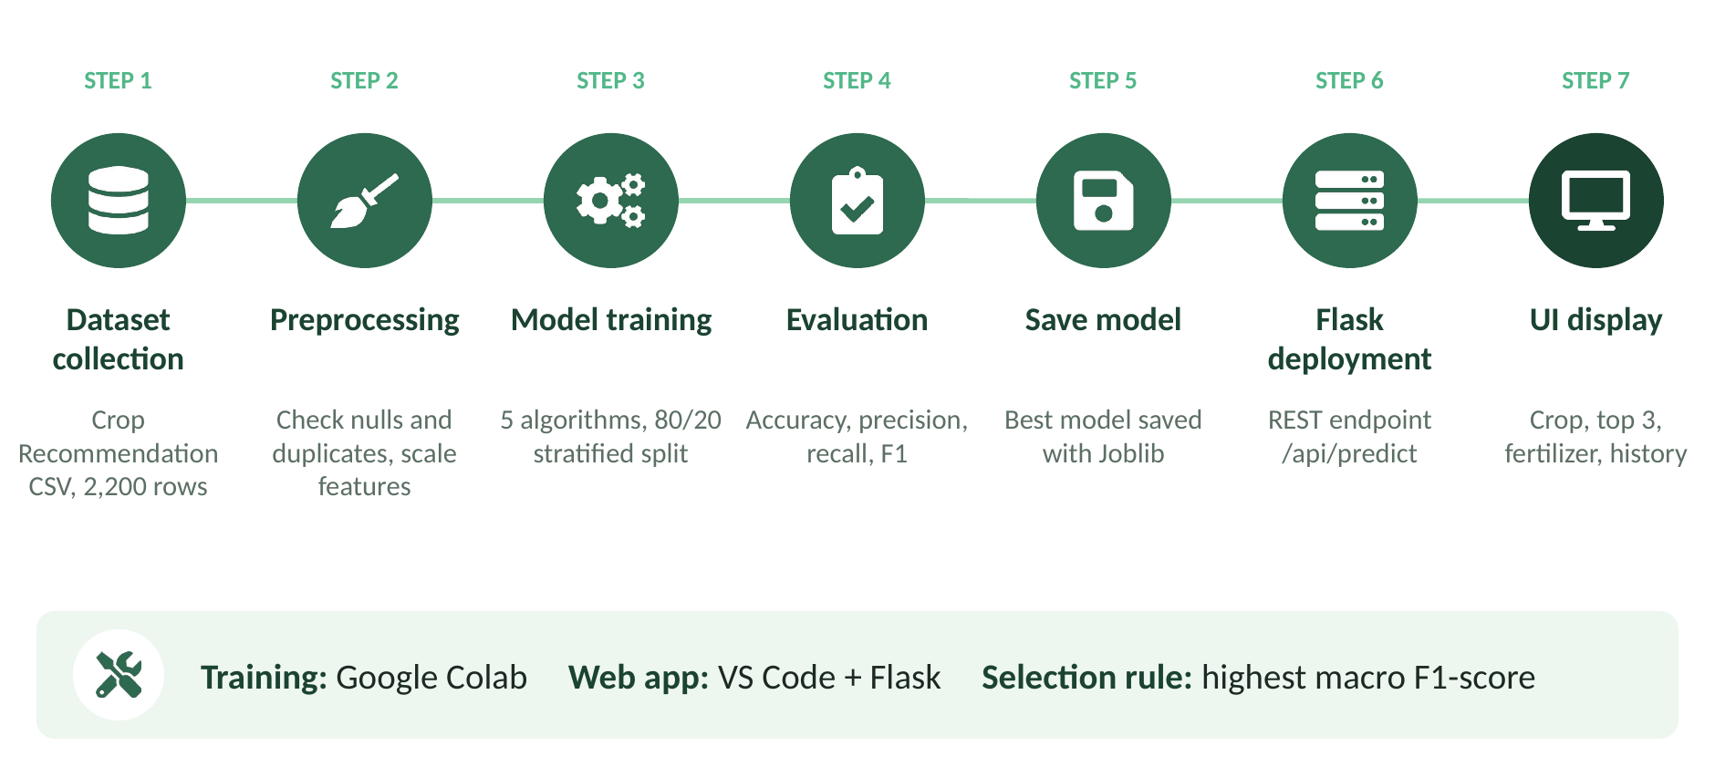
Figure 3: Methodology and workflow of the project

Technology Stack
Table 6: Technology stack
Component | Technology
Frontend | HTML5, CSS3, JavaScript
Backend | Python, Flask 3.0
ML libraries | Pandas, NumPy, Scikit-learn, Joblib
Dataset | Crop Recommendation CSV (2,200 rows)
Tools | Google Colab, Matplotlib, Seaborn
IDE | Visual Studio Code, Chrome browser

System Modules
Table 7: Modules of the web application
Module | Function
Login module | Farmer signs in before using the dashboard
Crop recommendation | Takes 7 inputs, returns the best crop and the top 3
Fertilizer advice | Compares N, P, K and pH with crop needs
Update module | Weather and market price updates (sample data)
History module | Saves past predictions to review later
Profile module | Farmer details, location and land area

Sample Prediction and Output
For the inputs N = 80, P = 45, K = 40, temperature 24 °C, humidity 80%, pH 6.5 and rainfall 170 mm, the trained model recommends the crops in Table 8. The fertilizer module reports that the N, P and K levels are good and that pH 6.5 is suitable, and advises using organic manure and avoiding over-fertilizing.
Table 8: Top 3 crops for the sample input (model confidence)
Rank | Crop | Confidence
1 | Jute | 94.0%
2 | Rice | 5.5%
3 | Watermelon | 0.5%

Figures 4 to 7 show the running website. The login page takes the farmer name, mobile number and region. The crop recommendation screen was tested with N = 90, P = 42, K = 43, temperature 20.8, humidity 82, pH 6.5, rainfall 202.9 and land area 2 acres; it recommends rice and shows jute and coffee as the second and third options, with reasons such as rainfall supporting rice cultivation. On the fertilizer screen the farmer selects the crop, growth stage, soil type and irrigation method, and the system reports whether nitrogen, phosphorus and potassium are good or low, followed by a final fertilizer plan.
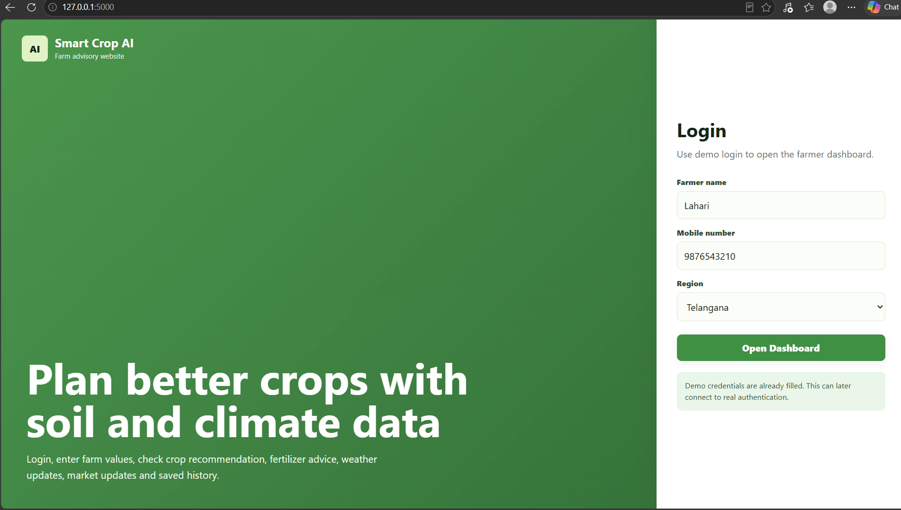
Figure 4: Login page
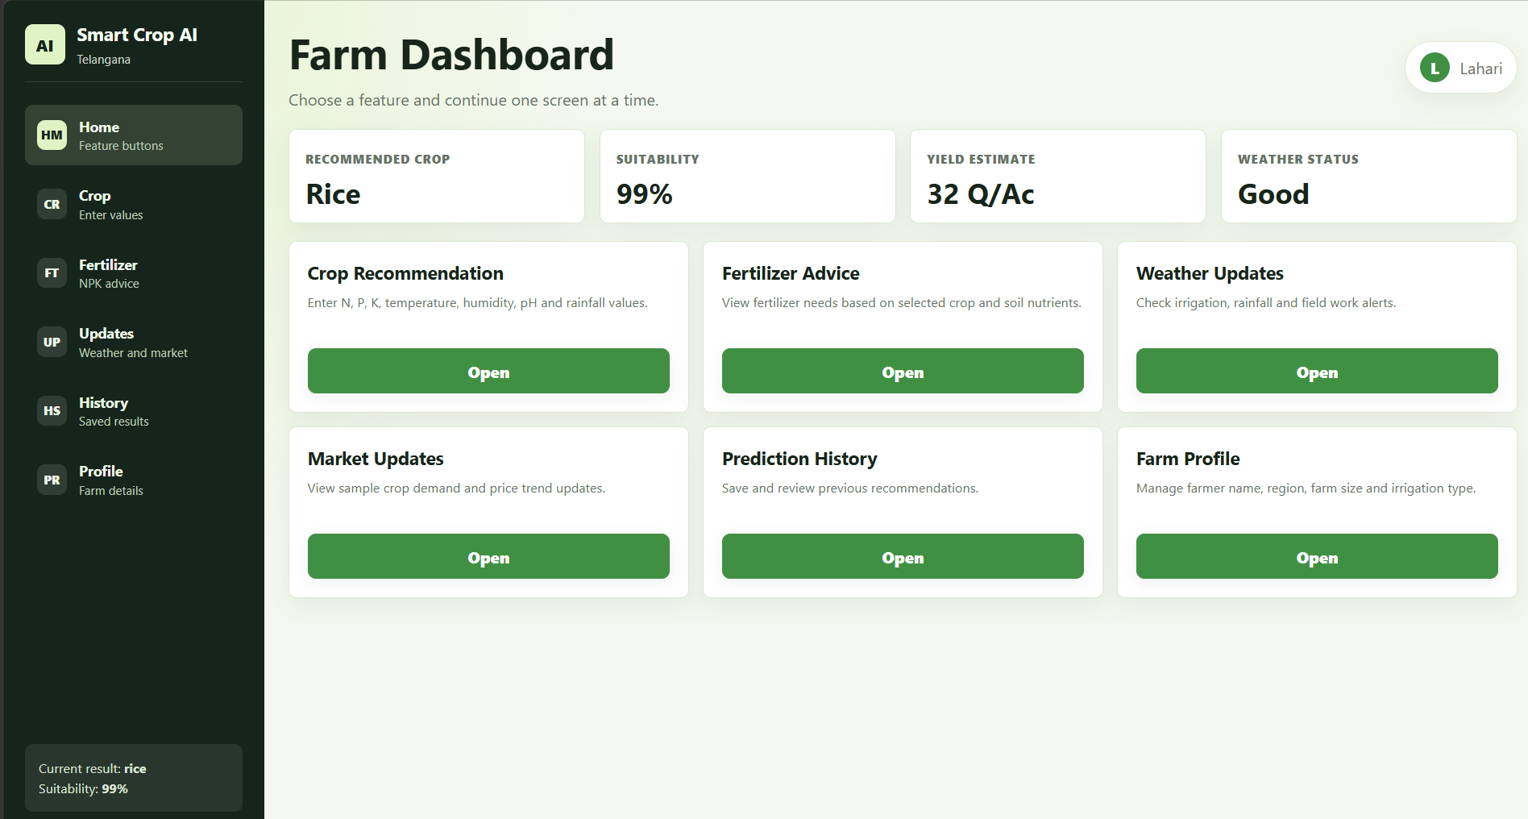
Figure 5: Farm dashboard
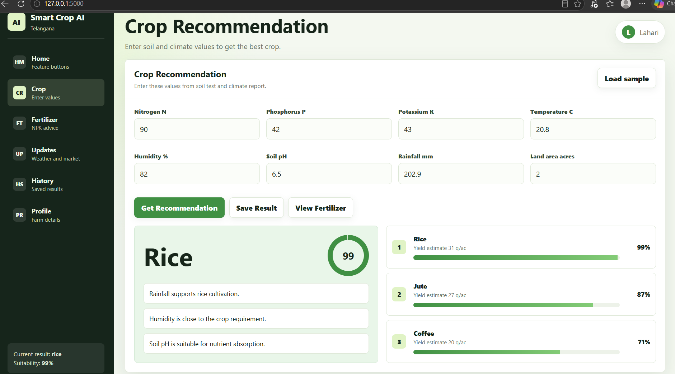
Figure 6: Crop recommendation screen with top 3 crops and reasons
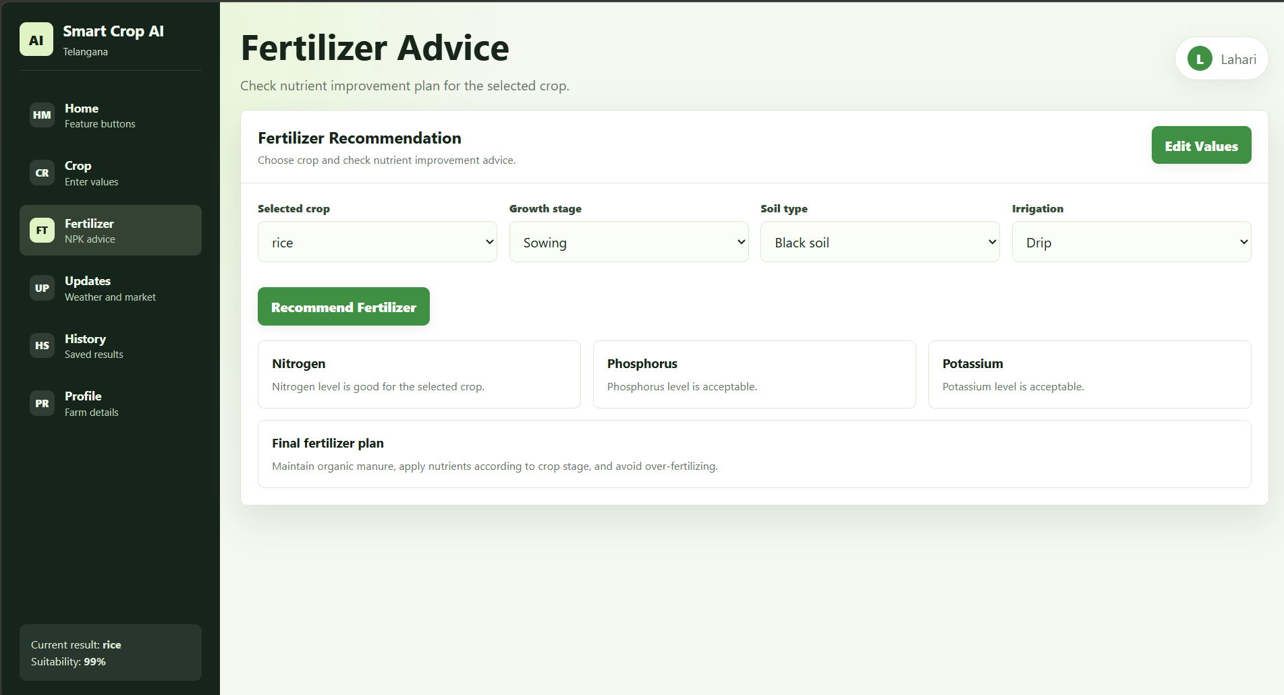
Figure 7: Fertilizer advice screen

Conclusion
This case study built an end-to-end machine learning system, from dataset to five trained models, to the best model, to a working Flask website. Random Forest gave the best result, with 99.55% accuracy on 440 unseen test records (438 correct), and it was ahead of SVM (98.41%), KNN (97.95%), Decision Tree (97.95%) and Logistic Regression (97.27%).
Farmers get the best crop, the top 3 options with confidence scores, and fertilizer advice in one dashboard. The overall contribution is a low-cost, data-driven decision aid for precision agriculture that replaces guesswork with a consistent prediction that is available at any time.
The results should be read with care. The accuracy partly reflects a clean, balanced public dataset, the system depends on accurate inputs, and the weather and market screens use sample data. Future work includes a live weather API, a market price API, a mobile app, regional languages (Telugu, Hindi and Tamil, with voice input) and IoT soil sensors that read N, P, K, pH and moisture automatically.

Signature of the Team members
Lahari Namala (2520090226)
K. Keathana Vikashini (2520090236)

