Cambodian Geosites and Potential Geoparks
Illustrated research findings and annotated document catalogue
Prepared for Keat Lenarith
22 October 2026

Introduction and Methods

Principal findings
There is a substantial documentary basis for investigating Cambodian geoheritage, although the sources differ greatly in scientific scope and formal status. Particularly useful discoveries are Sitha Kong’s GDMR conference abstract on aspiring Cambodian geoparks, the 2026 Cambodian cave-management guidelines in Khmer and English, Cambodian university studies of Kulen sandstone (including ITC’s comprehensive 948 km² geopark candidate assessment) and northeastern basalts, recent breakthroughs in vertebrate paleontology including Cambodia’s first dinosaur from Koh Kong and Mesozoic non-marine fossil-bearing formations, organic petrological investigations of black shales in the Bokor Formation, botanical endemism studies of the Bokor Plateau, and older taxonomic work on Permian fossils from Sisophon. Their citations and access links appear below as D01–D44.
The three regional themes proposed by the user are suitable starting points for a national investigation. However, the present evidence suggests four practical study areas: Nam Lea and its surrounding Mondulkiri landscape; Kulen–Angkor; the Banteay Meanchey–Battambang fossil and cave localities; and the southern and southwestern coast. This is a research recommendation, not a proposed legal boundary. In particular, the fossil hills near Sisophon should have their own inventory before any decision to connect them administratively to Kulen.
The coastal area named in the request is southern and southwestern Cambodia. Kampot and Kep form a well-documented karst focus. Preah Sihanouk, also referred to in this literature as Sihanoukville or Kampong Som, and Koh Kong introduce additional coastal, sedimentary, forest and waterfall themes. They should not all be described as a single tower-karst landscape. The geological literature uses Kampot Fold Belt; this does not imply a single fault called the Kampot fault belt [D22–D24].
UNESCO’s Global Geopark directory was checked during this search. Cambodia was not listed. Phnom Kulen’s World Heritage Tentative List entry is a different designation process, while Angkor is an inscribed cultural World Heritage property. A reported geopark initiative, a conference field trip to a candidate area, and a UNESCO Global Geopark inscription must be distinguished [D02, D14, D15].

Search scope and reliability
This is an annotated document-finding review, not a systematic literature review or a completed geosite evaluation. Searches covered Consensus, journal and university websites, UNESCO, conservation organizations, Cambodian institutional sources and reports. Full PDFs were retrieved where accessible. Other entries are explicitly linked as online documents, publisher records, abstracts, catalogue records or reporting.
Consensus returned useful international assessment and governance literature, but its candidate-area synthesis did not provide adequate Cambodian citations for several local geological claims. Those unsupported local assertions are excluded from this catalogue. The Cambodian findings below are instead grounded in the identified primary papers and site-specific documents. No scientific significance score, new geological map or new graphics have been generated.
The uploaded presentation, Karst Landscapes to Geoparks, was read as the user’s working context. It is not treated as independent proof of the geological interpretations or numerical area estimates it contains. The accompanying document pack contains original publication PDFs and clearly named articles or abstract extracts, rather than reconstructed figures or tables.

Published maps and landscape photographs
These plates connect the regional findings to published landscape evidence. Each figure retains its source identity. They illustrate research localities and regional context; none defines an approved geopark boundary. Coordinates in the following register refer to named sites or surveyed areas, not necessarily the camera positions.
Two archaeological maps carry an explicit CC BY 4.0 article license. Other photographs and figures are reproduced here for source-based research review; public website reuse requires checking the rights indicated under each plate. Separately credited courtesy photographs require particular attention. Publication dates should be retained when historical images are used to discuss changing landscapes.
All figures below are original publication extracts. No AI images, newly drawn maps or reconstructed graphs are introduced. The Fauna & Flora karst photographs are taken from the cited reference guide rather than a journal article.
The full location register contains 21 entries, including 19 source-located positions and two unresolved fossil-site locations. Geographic coordinates use X for east longitude and Y for north latitude in decimal degrees. Research-range midpoints provide indicative markers only.
X is longitude and Y is latitude in decimal degrees. Positions are indicative WGS84 geographic references, not UTM coordinates or surveyed visitor-route instructions. The original source expressions and their interpretation are retained below. The datum of the Phnom Sampeu report coordinate requires confirmation.

Part 1 — Siem Reap and Banteay Meanchey

Kulen and Angkor
The integrated visual atlas includes published archaeological and geological maps, outcrop imagery, plateau views, waterfalls and sandstone carvings. The location register identifies Kbal Spean, the Kulen waterfall and other named research localities separately.
A strong documented theme. The clearest narrative connects sandstone and its sedimentary structures, landscape and water, ancient quarrying, construction and the archaeological city. Choon and colleagues studied three Kulen-area outcrop zones. Their observations support lithological and sedimentological interpretation, without establishing uniform rock properties across the entire plateau [D09].
The quarry studies provide direct links between geological material and Angkorian construction. Chevance and colleagues’ lidar work documents Mahendraparvata and its landscape organization. Together these are strong sources for educational routes connecting outcrops, quarry traces, water-management features and cultural heritage [D10–D13].
Evidence of candidate interest. The ITC EraGET 2025 programme explicitly advertised a field trip to a geopark candidate area including Kulen National Park, Angkor Wat and Bayon. This is useful evidence of an academic candidate concept, but it is not an approved boundary or UNESCO designation [D15].
Institutional candidate assessment by ITC. An authoritative geodiversity assessment led by Eng Chandoeun and the ITC Faculty of Geo-resources and Geotechnical Engineering establishes Phnom Kulen as Cambodia’s most advanced geopark candidate. The ITC study defines a candidate area of 948.02 km² encompassing 23 geosites, 14 cultural/historical sites, and 4 viewing spots. Petrographic analyses confirm that the plateau sandstones comprise quartz arenite and sub-litharenite with high silica cementation, cross-bedding, and channel facies. The study maps key ancient quarry sites (e.g., Tra Peang Cha, Rong Chen) and documents collaborative initiatives between ITC, the Ministry of Environment (MoE), APSARA National Authority, JICA, Waseda University, and the Japan Geopark Network (JGN) [D43].
National park management baseline. The Ministry of Environment’s Phnom Kulen National Park Management Program 2018–2027 is the official management framework for the plateau. It records that the park was established by Royal Decree in 1993 and covers 37,375 ha in Svay Leu, Banteay Srei and Varin districts. The sandstone range rises to 498 m above sea level. The programme stresses the park’s hydrological role: 36 waterways in Siem Reap Province originate there, and its groundwater helps stabilise the foundations of the Angkor temples. It also notes about 50 temples and sacred sites identified by ADF lidar survey. It proposes core, conservation, sustainable-use and community zones, which any geopark boundary or geotrail design should align with [D46].
Mae Ping fault. The search did not establish that a mapped Mae Ping fault trace passes through the specific Kulen sites. Regional structural interpretations can be discussed, but a field itinerary should not advertise a fault exposure without local mapping and structural evidence. The sandstone, quarry and water themes are already well supported without relying on that assertion.

Banteay Meanchey fossil localities
The location register retains Phnom Bak and Kang Va as unresolved fossil-site records and provides a published coordinate for the named Phnom Sampeu bat cave. Gazetteer village or hill centroids are not used as substitutes for fossil exposures.
The strongest scientific addition is Nakamura’s 1979 brachiopod paper. It records specimens from members of the Sisophon Limestone and names localities including Phn. Svai and Phn. Lang K Tom. This is direct palaeontological evidence, with published specimen plates, rather than tourism interpretation. Historical place names and specimen horizons must be reconciled with current maps before their use in a modern geosite inventory [D18].
Phnom Bak and Phnom Kang Va have accessible Cambodian field-report articles. These are useful locality leads and describe marine fossils, but their taxonomic identifications and broad ages should be checked against collected specimens and stratigraphy. Avoid repeating headlines such as “Cambodia’s oldest fossil” without a defensible comparison and age determination [D16, D17].

Kulen and Angkor regional archaeological map
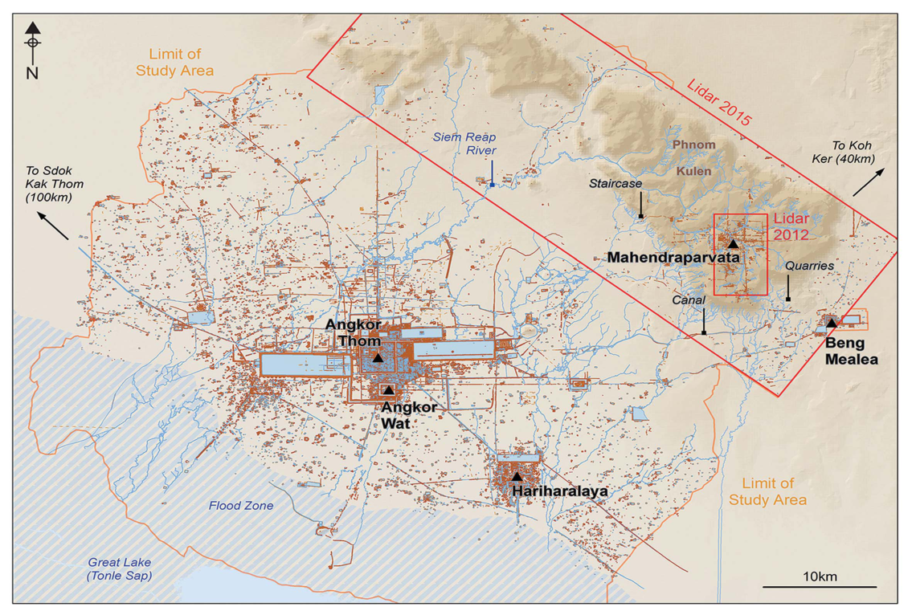
Figure 1. Published archaeological map of Greater Angkor and Phnom Kulen.
Source: Chevance et al. (2019), Antiquity 93, 1303–1321, Figure 1, PDF page 2. Credit: Chevance et al. 2019, Figure 1; CC BY 4.0.
Georeferenced survey map, not a geopark boundary. Rendered to preserve correct on-page orientation.

Mahendraparvata and its terrain
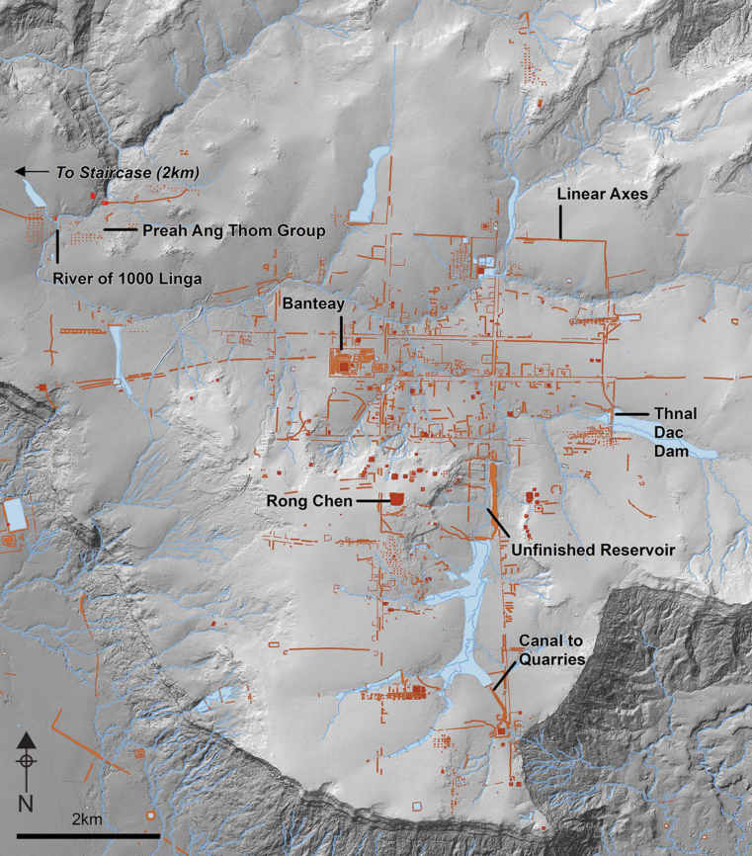
Figure 2. Mahendraparvata archaeological map over lidar hillshade.
Source: Chevance et al. (2019), Antiquity 93, 1303–1321, Figure 4, PDF page 8. Credit: Chevance et al. 2019, Figure 4; CC BY 4.0.

Kulen escarpment and cultural landscape
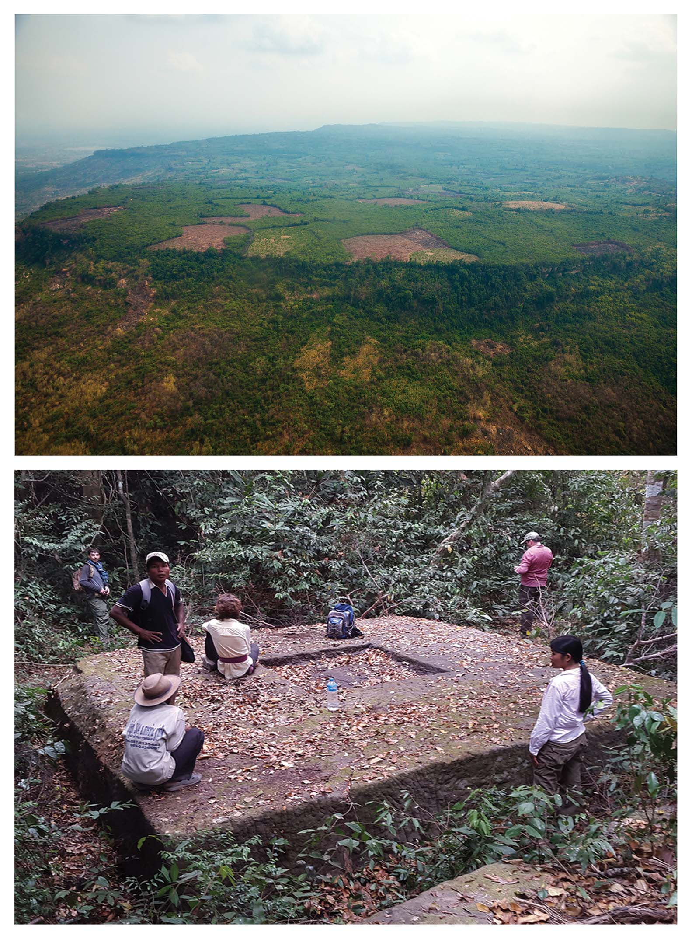
Figure 3. Aerial Kulen escarpment and forest temple composite.
Source: Chevance et al. (2019), Antiquity 93, 1303–1321, Figure 2, PDF page 4. Credit: Archaeology Development Foundation (top); Cambodian Archaeological Lidar Initiative (bottom); published in Chevance et al. 2019.

Kulen geological map and outcrop evidence
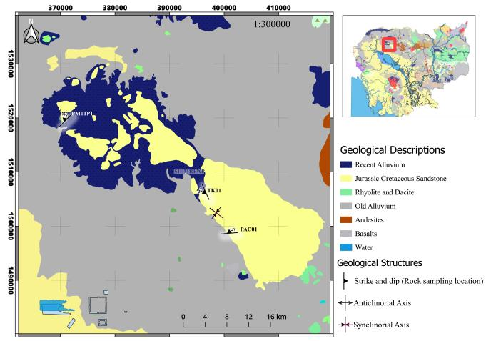
Figure 4. Published geological map and sandstone sampling sites in Kulen.
Source: Choon et al. (2022), Techno-Science Research Journal 10(2), 8–16, Figure 1, PDF page 2. Credit: Choon et al. 2022, Figure 1.
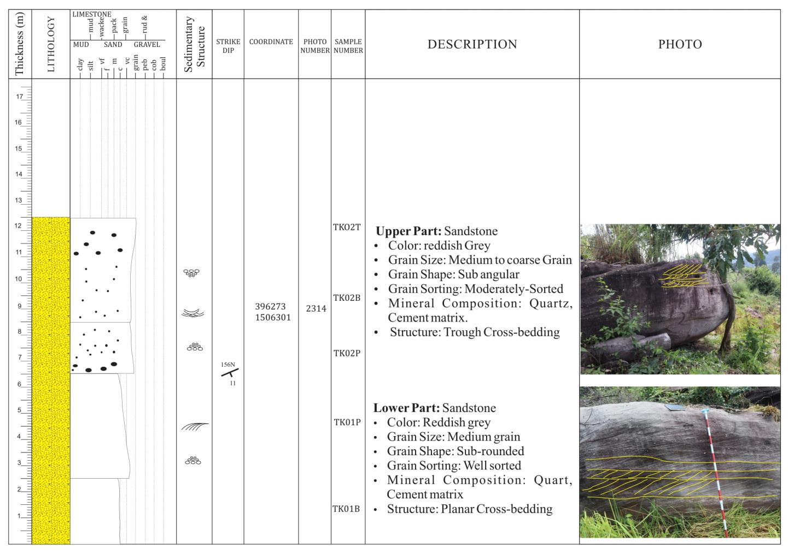
Figure 5. Kulen Takhok measured section and outcrop photographs.
Source: Choon et al. (2022), Techno-Science Research Journal 10(2), 8–16, Figure 2, PDF page 3. Credit: Choon et al. 2022, Figure 2.

Views of the Kulen plateau
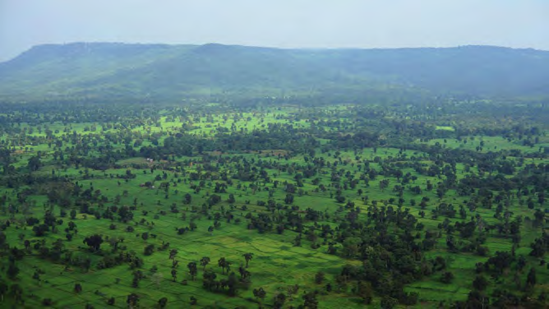
Figure 7. Phnom Kulen eastern plateau viewed from the south.
Source: Kosterin & Smith (2020), Odonata of Phnom Kulen Mts, IDF-Report 154, 99–184, Figure 2, PDF page 102. Credit: Eddie Smith; Kosterin & Smith 2020, Figure 2.
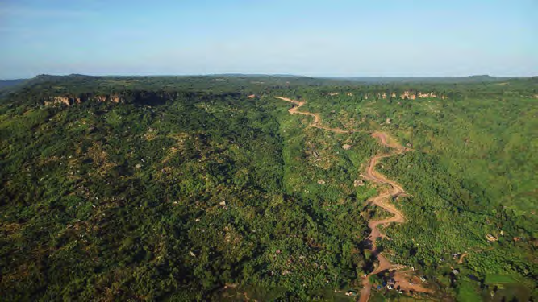
Figure 8. Phnom Kulen eastern plateau viewed from the east.
Source: Kosterin & Smith (2020), Odonata of Phnom Kulen Mts, IDF-Report 154, 99–184, Figure 3, PDF page 102. Credit: Eddie Smith; Kosterin & Smith 2020, Figure 3.

Kulen forest and waterfall
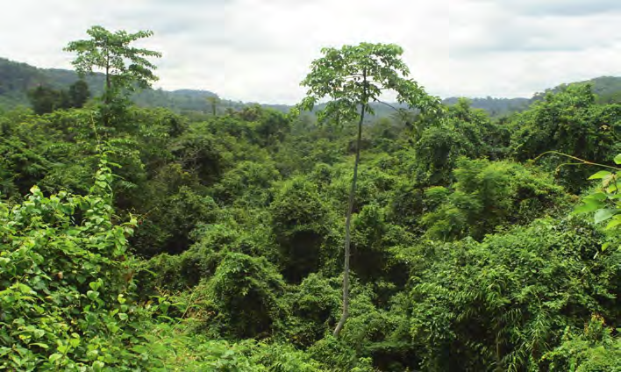
Figure 9. Evergreen forest on the western slope of the eastern Kulen plateau.
Source: Kosterin & Smith (2020), Odonata of Phnom Kulen Mts, IDF-Report 154, 99–184, Figure 5, PDF page 104. Credit: Oleg E. Kosterin; Kosterin & Smith 2020, Figure 5.
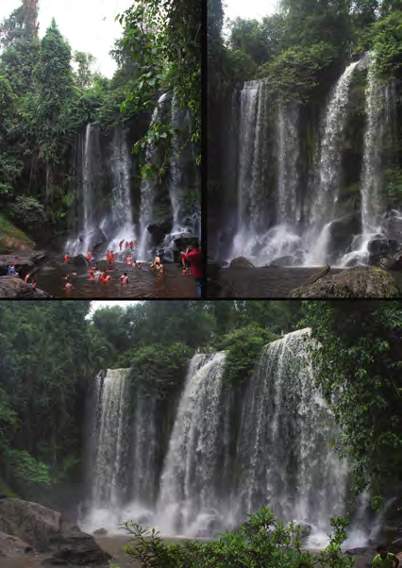
Figure 10. Phnom Kulen waterfall under contrasting water conditions.
Source: Kosterin & Smith (2020), Odonata of Phnom Kulen Mts, IDF-Report 154, 99–184, Figure 6, PDF page 104. Credit: Oleg E. Kosterin; Kosterin & Smith 2020, Figure 6.

Kulen wetlands and riverbed heritage
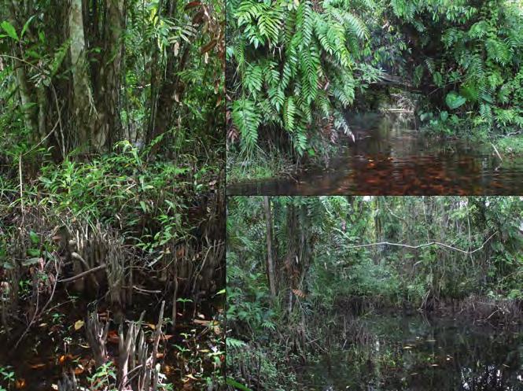
Figure 11. Swamp forest and pneumatophores at Tnal Mareh, Kulen.
Source: Kosterin & Smith (2020), Odonata of Phnom Kulen Mts, IDF-Report 154, 99–184, Figure 7, PDF page 105. Credit: Oleg E. Kosterin; Kosterin & Smith 2020, Figure 7.
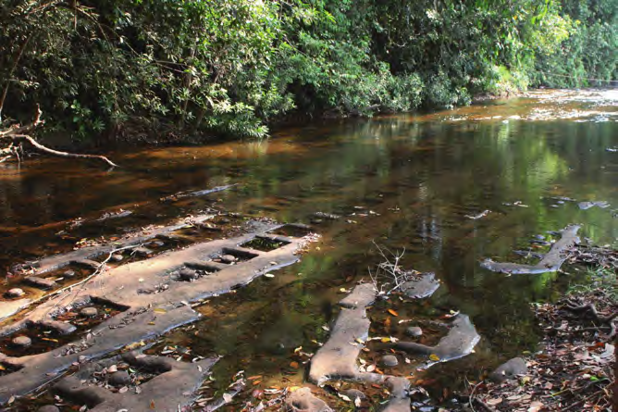
Figure 12. Linga carvings in the sandstone bed of the Kulen river.
Source: Kosterin & Smith (2020), Odonata of Phnom Kulen Mts, IDF-Report 154, 99–184, Figure 8, PDF page 106. Credit: Oleg E. Kosterin; Kosterin & Smith 2020, Figure 8.

Sandstone sculpture and Kbal Spean
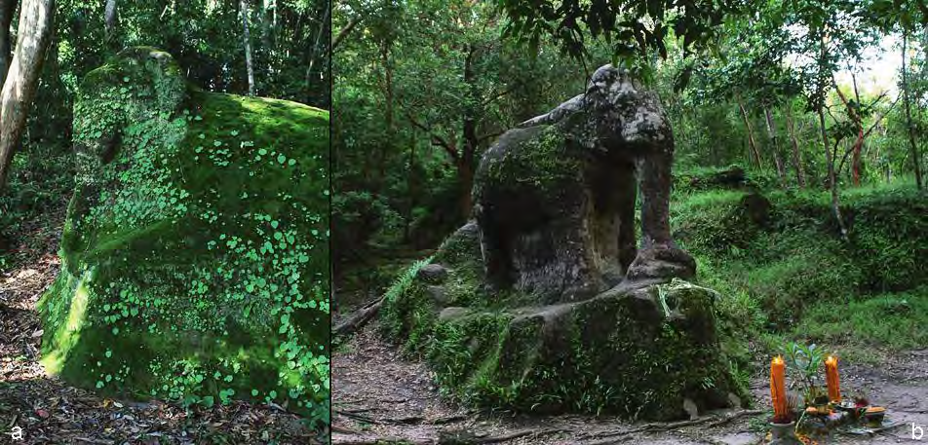
Figure 13. Sandstone elephant sculptures at Damrei Krab and Damrei Sras.
Source: Kosterin & Smith (2020), Odonata of Phnom Kulen Mts, IDF-Report 154, 99–184, Figure 9, PDF page 106. Credit: Oleg E. Kosterin; Kosterin & Smith 2020, Figure 9.
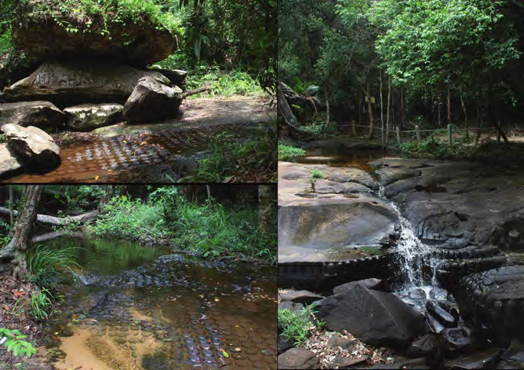
Figure 14. Sandstone riverbed carvings at Kbal Spean.
Source: Kosterin & Smith (2020), Odonata of Phnom Kulen Mts, IDF-Report 154, 99–184, Figure 12, PDF page 108. Credit: Oleg E. Kosterin; Kosterin & Smith 2020, Figure 12.

Kbal Spean forest river
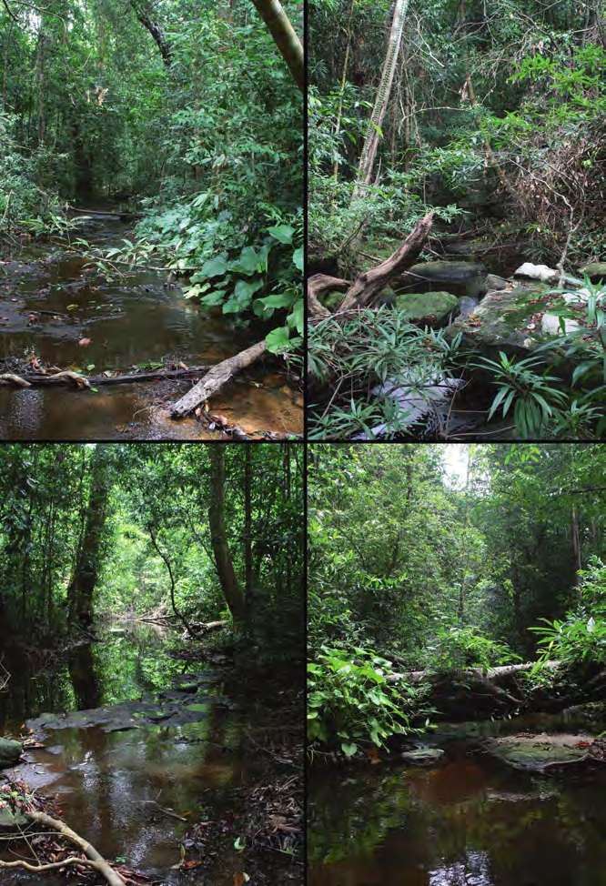
Figure 15. Forest river upstream of the Kbal Spean carvings.
Source: Kosterin & Smith (2020), Odonata of Phnom Kulen Mts, IDF-Report 154, 99–184, Figure 14, PDF page 110. Credit: Oleg E. Kosterin; Kosterin & Smith 2020, Figure 14.

Kulen sandstone and water landscapes
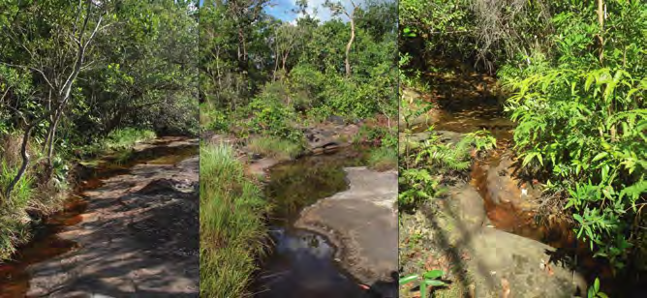
Figure 16. Exposed sandstone streambed and open veal landscape on Kulen.
Source: Kosterin & Smith (2020), Odonata of Phnom Kulen Mts, IDF-Report 154, 99–184, Figure 22, PDF page 117. Credit: Oleg E. Kosterin; Kosterin & Smith 2020, Figure 22.
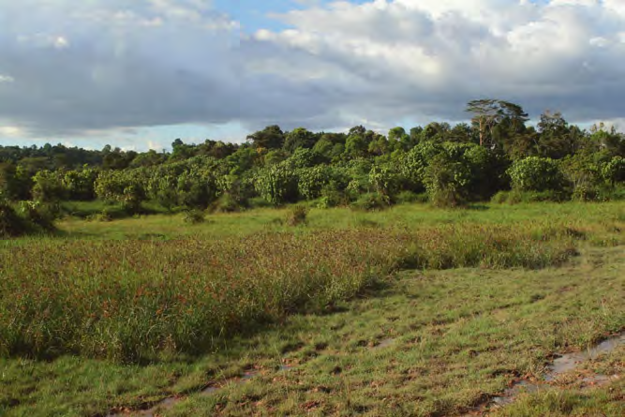
Figure 17. Wetland in the former Srae Tbong reservoir, Kulen.
Source: Kosterin & Smith (2020), Odonata of Phnom Kulen Mts, IDF-Report 154, 99–184, Figure 23, PDF page 117. Credit: Oleg E. Kosterin; Kosterin & Smith 2020, Figure 23.

Kulen Geopark candidate geosite inventory map
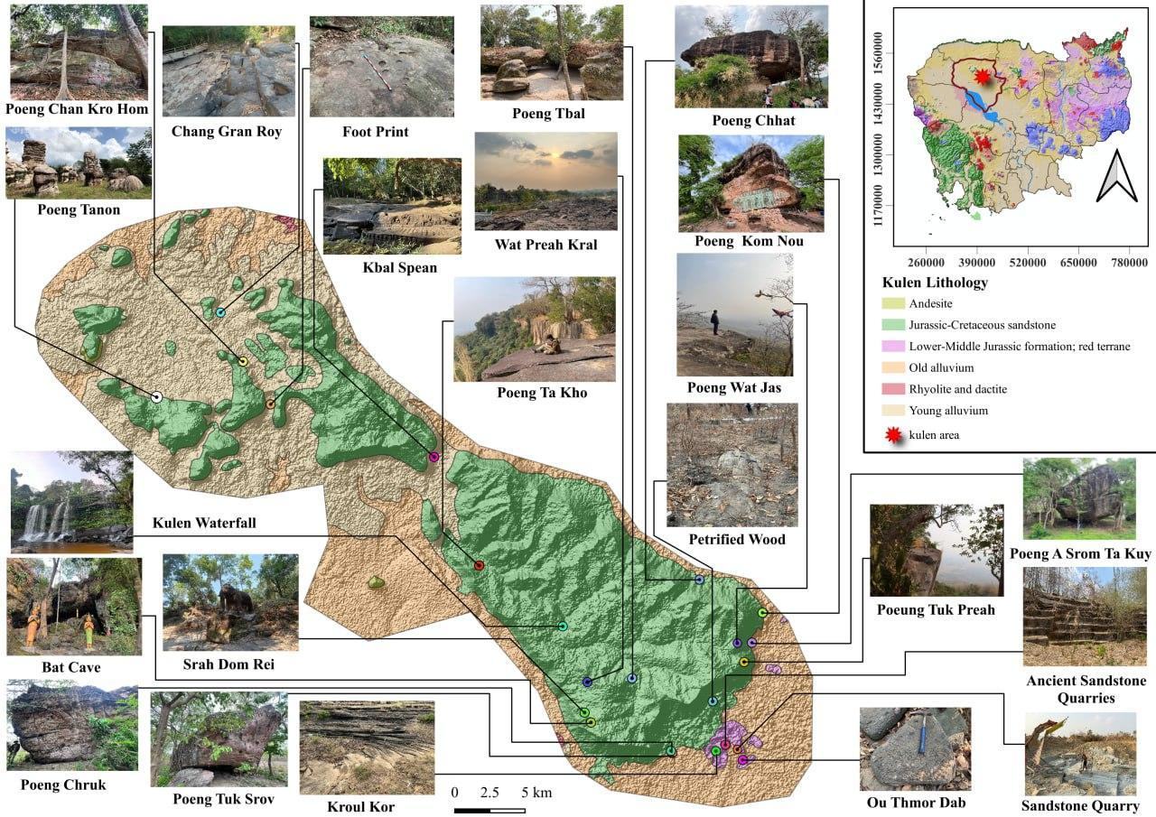
Figure 26. Published geosite inventory map of the Kulen candidate geopark area (23 geosites).
Source: Eng et al. (2025/2026), Assessing Geodiversity in the Kulen Area, Siem Reap Province, Cambodia: A Potential Geopark Candidate, ITC Faculty of Geo-resources and Geotechnical Engineering, Slide 8. Credit: ITC GGG Geoteam.
Delineates candidate geopark boundary (~948 km²) and 23 systematically inventoried geosites across Phnom Kulen.

Kulen cultural and historical heritage sites map
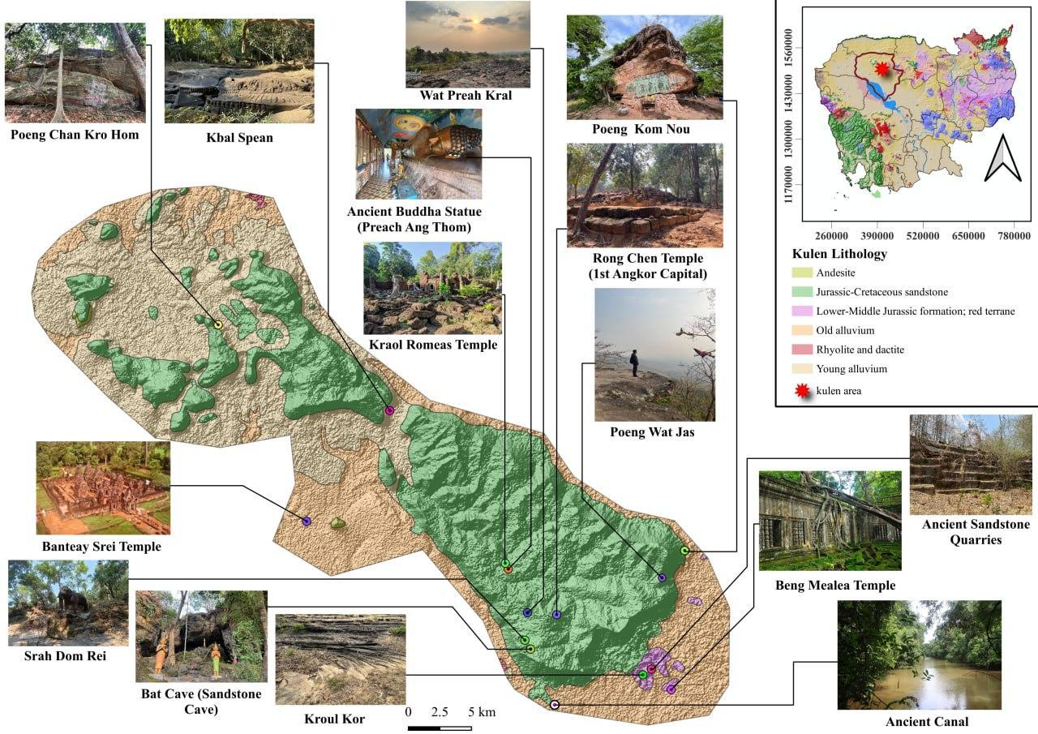
Figure 27. Published map of cultural and historical heritage sites in the Kulen candidate area (14 sites).
Source: Eng et al. (2025/2026), Assessing Geodiversity in the Kulen Area, ITC Faculty of Geo-resources and Geotechnical Engineering, Slide 9. Credit: ITC GGG Geoteam.
Geo-cultural network connecting Angkorian archaeological sites, riverbed lingas, and sandstone temples.

Kulen panoramic viewing spots map
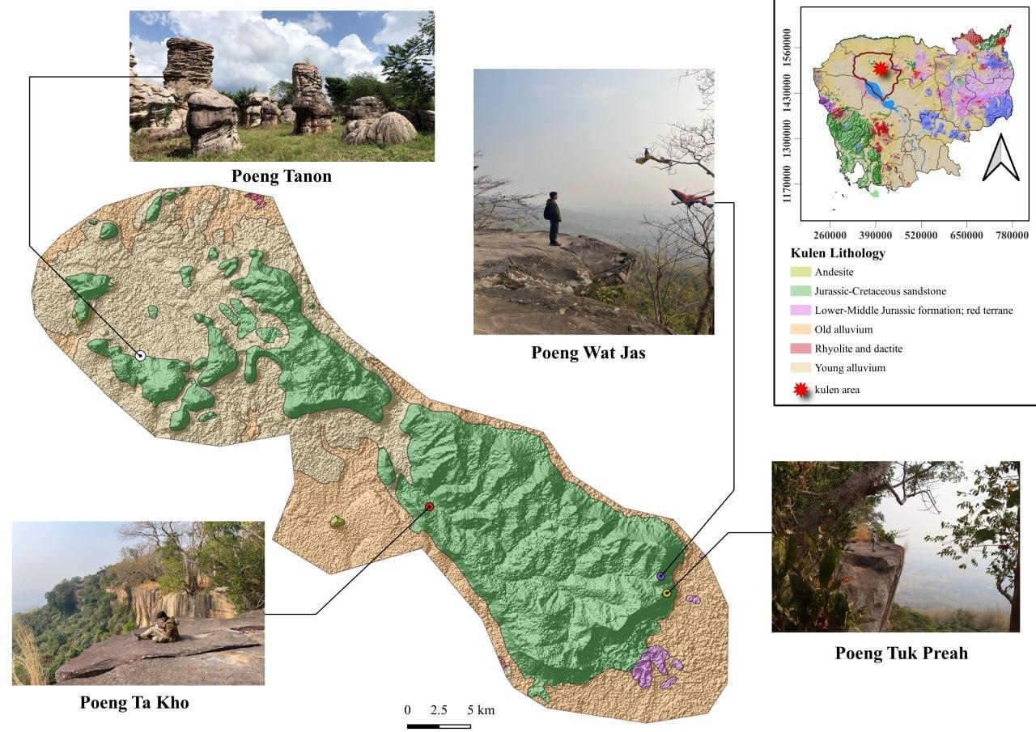
Figure 28. Published map of scenic viewing spots across the Kulen sandstone escarpment (4 viewing spots).
Source: Eng et al. (2025/2026), Assessing Geodiversity in the Kulen Area, ITC Faculty of Geo-resources and Geotechnical Engineering, Slide 10. Credit: ITC GGG Geoteam.
Panoramic viewpoints overlooking the sandstone plateau and lower plains (Poeung Wat Chas, Poeung Takho, Poeung Tuk Preah).

Kulen geological and lithological map
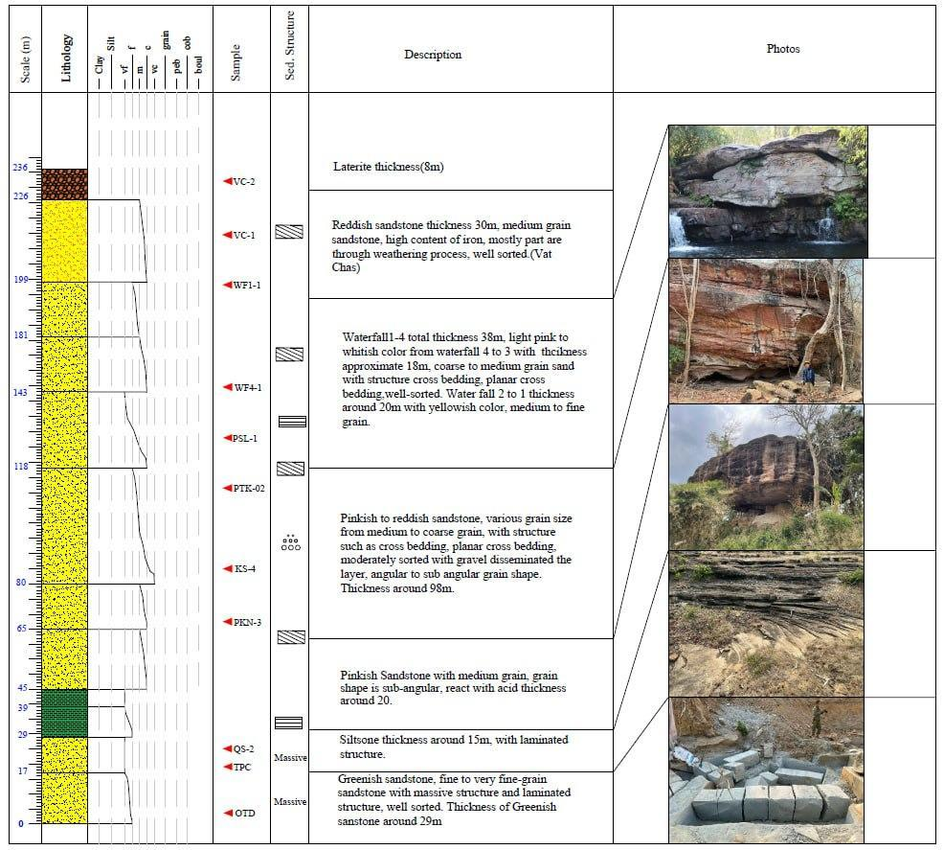
Figure 29. Published geological map illustrating Jurassic-Cretaceous sandstone distribution in the Kulen area.
Source: Eng et al. (2025/2026), Assessing Geodiversity in the Kulen Area, ITC Faculty of Geo-resources and Geotechnical Engineering, Slide 5. Credit: ITC GGG Geoteam.
Mesozoic continental sedimentary formations showing quartz arenite and sub-litharenite facies used in Angkor monuments.

Kulen sandstone quarries and field geosites
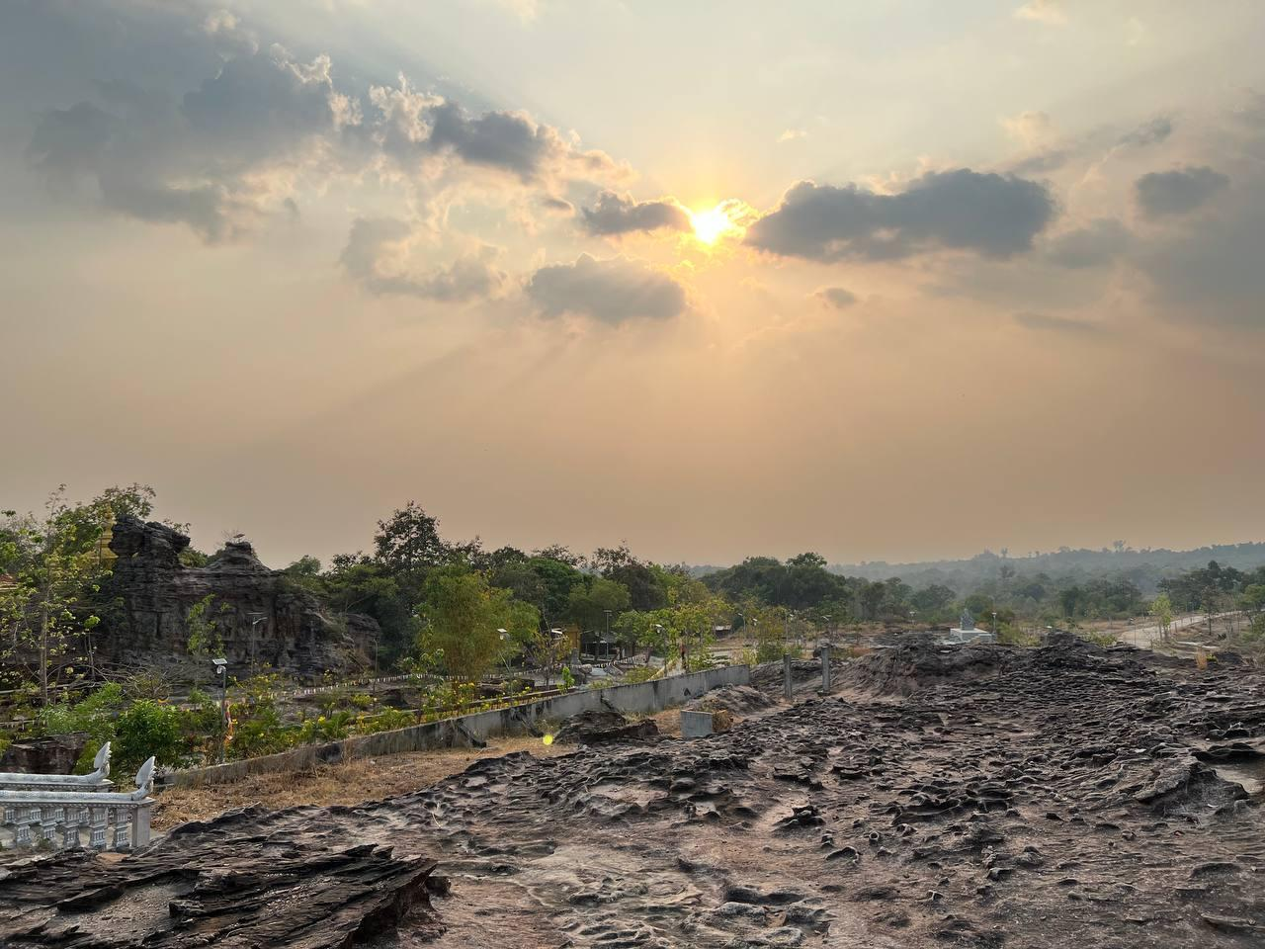
Figure 30. Field photographs of current and ancient sandstone quarry sites at Tra Peang Cha and Wat Preah Kral.
Source: Eng et al. (2025/2026), Assessing Geodiversity in the Kulen Area, ITC Faculty of Geo-resources and Geotechnical Engineering, Slide 12. Credit: ITC GGG Geoteam.
Outcrops illustrating quarry extraction trenches, bedrock jointing, and sandstone pavements.
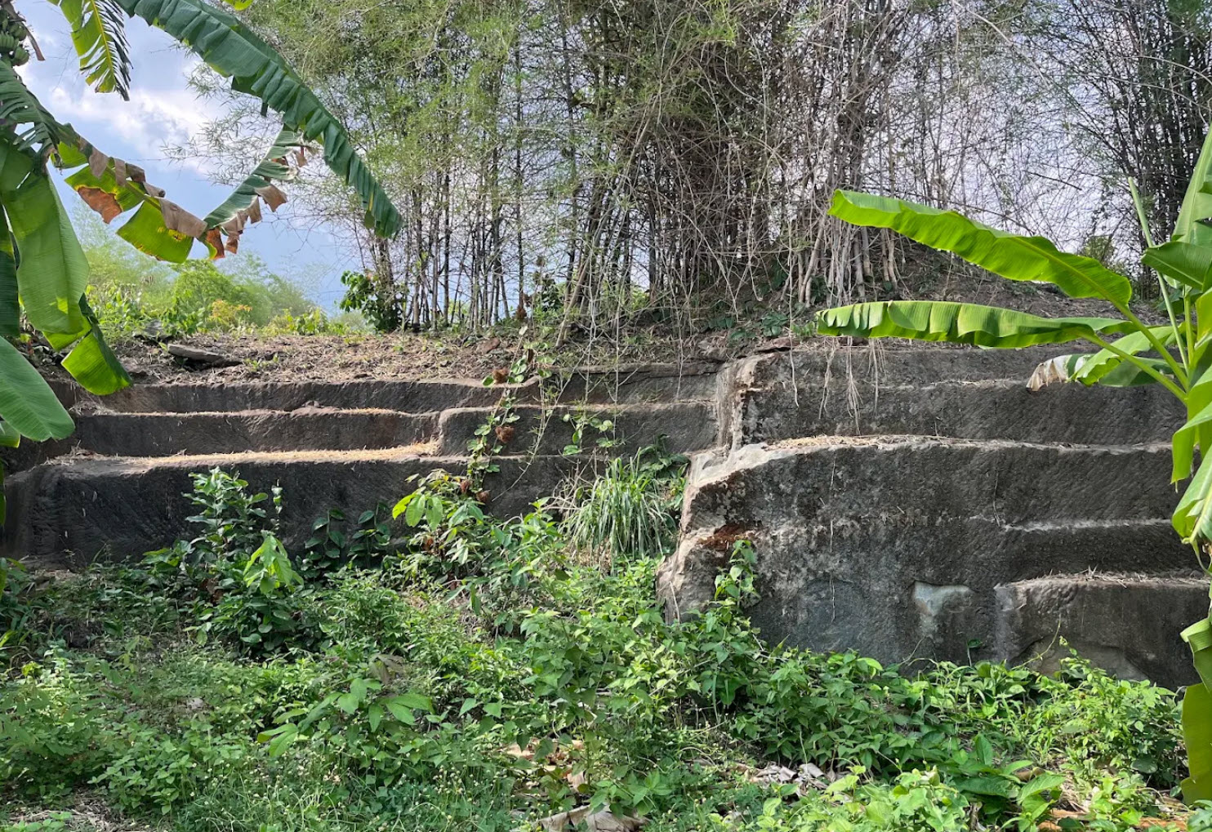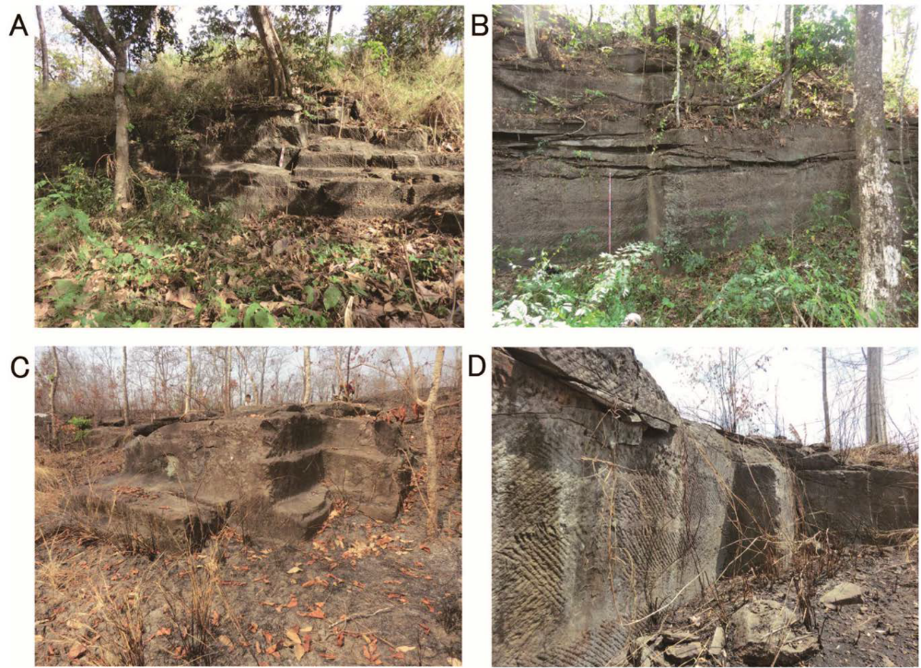
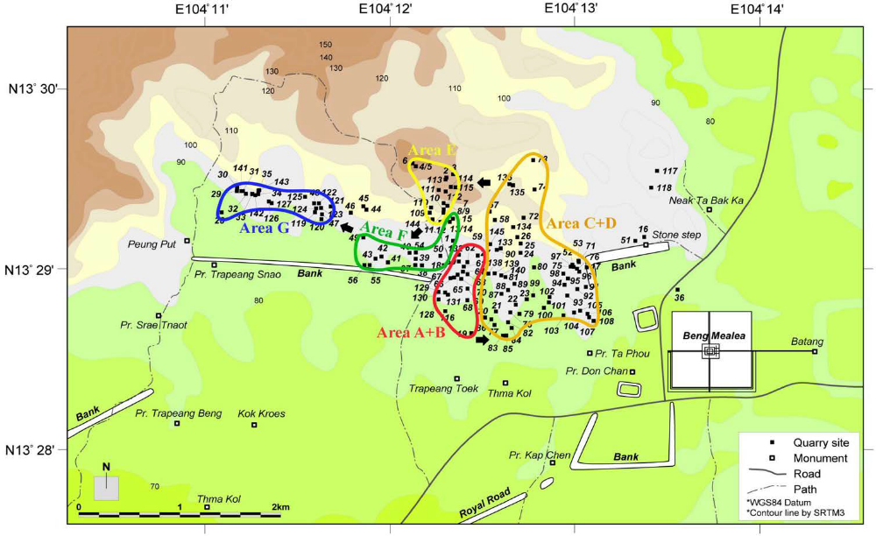
The Angkor monuments in Cambodia were designated as a UNESCO World Heritage Cultural Site and consist of Buddhist or Hindu temples built mainly of sandstone and laterite. We surveyed the area around a 2 km east-west bank in Kulen Mountain’s southeastern foothills for Angkor’s sandstone quarries and confirmed 145 locations. Because the magnetic susceptibilities and size of sandstone blocks at Angkor changed systematically over time, we measured these aspects at each quarry. Based on this data, we identified seven Angkor quarrying areas (Areas A to G). The results clarified that in the Angkor period, sandstone block quarrying began near the bank’s eastern end, then moved counterclockwise to the north side of the bank. Because quarries are important Angkor period heritage sites, they should be designated as conservation areas for their protection.
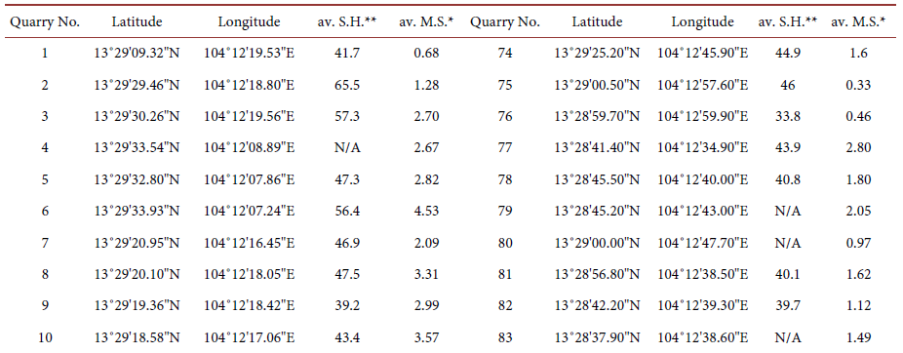

Kulen archaeological monuments and sandstone carvings
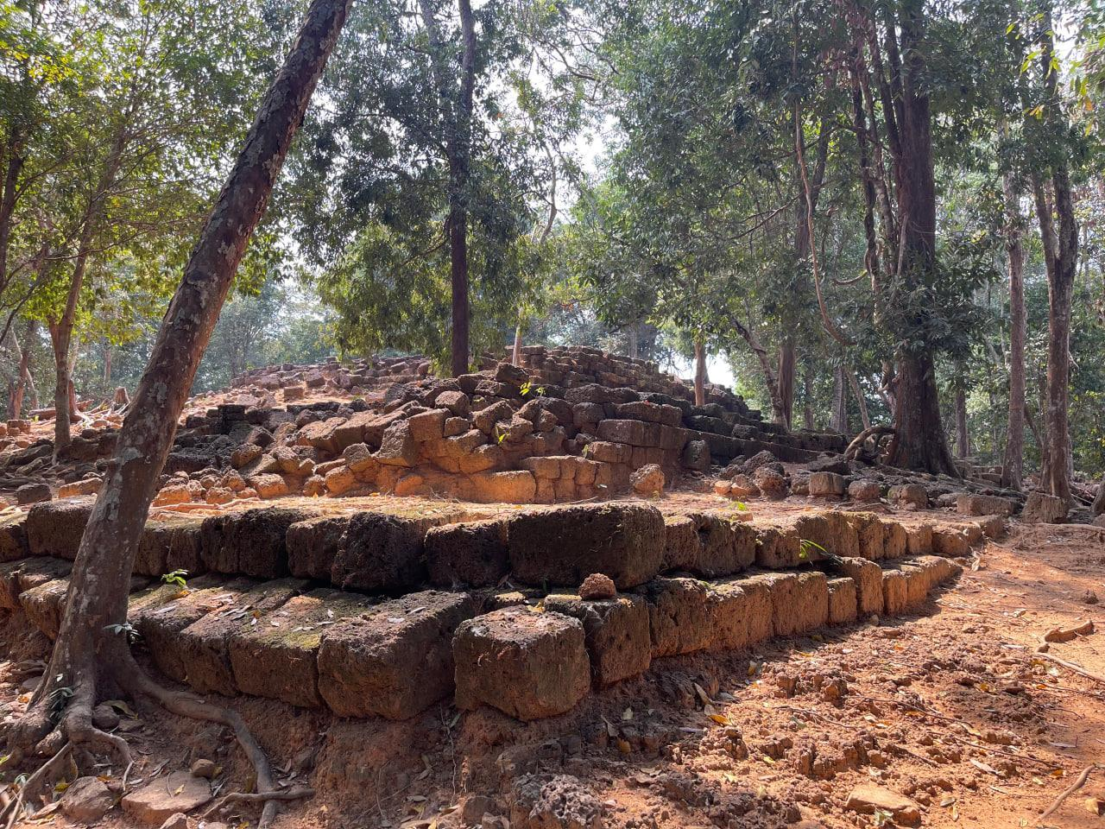
Figure 31. Field photographs of Kulen geo-cultural monuments: Sras Domrey, Rong Chen Temple, and Preah Ang Thom.
Source: Eng et al. (2025/2026), Assessing Geodiversity in the Kulen Area, ITC Faculty of Geo-resources and Geotechnical Engineering, Slide 13. Credit: ITC GGG Geoteam.
Tangible geo-cultural linkage where ancient Khmer architects carved monumental art directly into bedrock sandstone.

Phnom Kulen National Park official map and proposed zoning
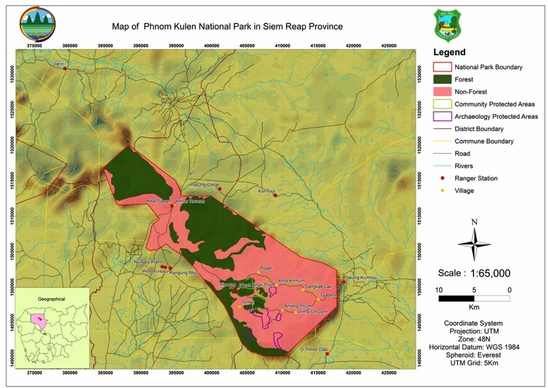
Figure 52. Official map of Phnom Kulen National Park, Siem Reap Province, showing the park boundary, forest and non-forest cover, community and archaeological protected areas, ranger stations and villages (1:65,000).
Source: Ministry of Environment (2017), Management Program for Preah Chey Voraman–Norodom “Phnom Kulen” National Park 2018–2027, Annex 1, p. 36.
Shows the extent of forest loss inside the boundary; the programme reports forest cover falling from 86.9% in 2003 to about 55.5%.
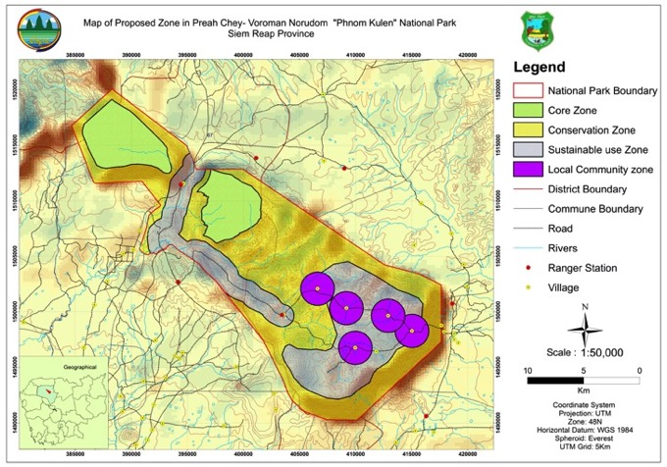
Figure 53. Proposed management zoning of Phnom Kulen National Park: core, conservation, sustainable-use and local-community zones (1:50,000).
Source: Ministry of Environment (2017), Management Program for Preah Chey Voraman–Norodom “Phnom Kulen” National Park 2018–2027, Annex 2, p. 37.
The zoning is the statutory frame a geopark would need to respect: geosites and geotrails in the core zones require strict protection, while visitor infrastructure belongs in the sustainable-use zone.

Ecotourism, culture, food, agriculture and biodiversity in Siem Reap and Banteay Meanchey
Phnom Kulen waterfall and Preah Ang Thom. The road to Phnom Kulen climbs out of the rice plain north of Siem Reap and onto a sandstone tableland about fifty kilometres from town. At the top, pilgrims and picnickers share the same routine: first a climb to Preah Ang Thom, where a great reclining Buddha has been carved directly into a sandstone boulder, then a descent to the waterfall, where families swim in the plunge pool beneath a curtain of water falling over a ledge of bedded sandstone. At weekends and during Khmer New Year the forest fills with hammocks, food stalls and the smell of grilled fish. For many Cambodians this is the sacred mountain where, in 802, Jayavarman II declared the birth of the Khmer Empire.
Srah Damrei, the stone elephant. Deeper in the forest, on a quiet ridge of the plateau, a life-size elephant stands in the shade of the trees. It was not built but carved where it stood, released from a single outcrop of bedrock, and stone lions keep it company. Few visitors make the trek, and the silence is part of the experience. Here, more clearly than anywhere else on Kulen, the plateau’s sandstone becomes sculpture, and the boundary between geology and art disappears.
Kbal Spean, the River of a Thousand Lingas. A forest path of roughly 1.5 kilometres leads uphill to Kbal Spean, where a clear stream runs over a sandstone bed carved during the Angkorian period with rows of lingas and images of Vishnu, Brahma and Shiva. The water flowing over the carvings was believed to be sanctified before it continued down to the Angkor plain. In the dry season the river runs low and the carvings stand out sharply; in the wet season they shimmer beneath the current. Guides explain that the stream is the head of the Siem Reap River, and visitors leave understanding that the temples downstream depend on this plateau for their water.
Kulen orchards and villages. Along the plateau roads, villagers sell bags of lychee in May and June, cashew nuts, palm sugar and wild honey from wooden stalls. Orchards of lychee and cashew have spread across what was once forest, and the Ministry of Environment’s management programme records forest cover falling from 86.9% in 2003 to about 55.5% [D46]. Farmers say the orchards are their main income. A geopark built with these communities could turn orchard visits, homestays and guided walks into earnings that reward keeping forest around the geosites.
Angkor Archaeological Park. On the plain below, the temples of Angkor, inscribed on the UNESCO World Heritage List in 1992, draw visitors from around the world. At dawn, crowds gather at the reflecting ponds of Angkor Wat; by midday, cyclists and tuk-tuks weave between the Bayon, Ta Prohm and the great reservoirs. Less often told is the geological story: the temples are built of sandstone quarried at the foot of Kulen and moved along canals, set on foundations of laterite, and kept stable by groundwater recharged from the plateau. Sra Srang and the barays are as much a story of water management as of religion.
Kampong Phluk and the Tonle Sap. South of Siem Reap, the road ends at the edge of the great lake. In the dry season the stilt houses of Kampong Phluk stand on poles up to ten metres high; in the wet season the water rises almost to their floors, and boats replace motorbikes. Visitors glide through a flooded forest in small wooden boats paddled by local women, past fish traps and floating schools. The Tonle Sap pulse, the annual reversal of flow from the Mekong, feeds one of the most productive freshwater fisheries in the world, and the fish on every Siem Reap plate begins here.
Ang Trapeang Thmor. In Banteay Meanchey, a long earthen dike built on an Angkorian embankment holds back the Ang Trapeang Thmor reservoir. In the dry season its grassy margins attract the sarus crane (Antigone antigone), Cambodia’s tallest bird, along with storks, ibises and egrets. Birdwatchers arrive before sunrise to watch the cranes feed in the shallows while farmers bring cattle down to the water. The site shows how an ancient hydraulic structure has become a modern wetland refuge.
Banteay Chhmar. Far from the crowds of Angkor, the temple complex of Banteay Chhmar lies partly collapsed under trees, its galleries carved with bas-reliefs of armies, processions and many-armed Avalokiteshvara. A community-based tourism programme lets visitors sleep in village homestays, eat home-cooked meals and walk around the temple with local guides. The sandstone blocks scattered around the site, and the laterite in its walls, tell the same geological story as Angkor, but here visitors can hear it from the villagers whose ancestors lived beside the temple.
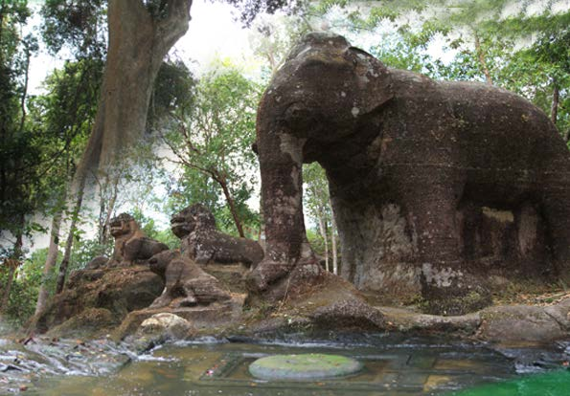
Figure 54. Srah Damrei, the life-size sandstone elephant and lions carved from bedrock on Phnom Kulen, a geo-cultural monument where the plateau’s sandstone becomes sculpture.
Source: Ministry of Environment (2017), Phnom Kulen National Park Management Program 2018–2027, front cover photograph [D46].
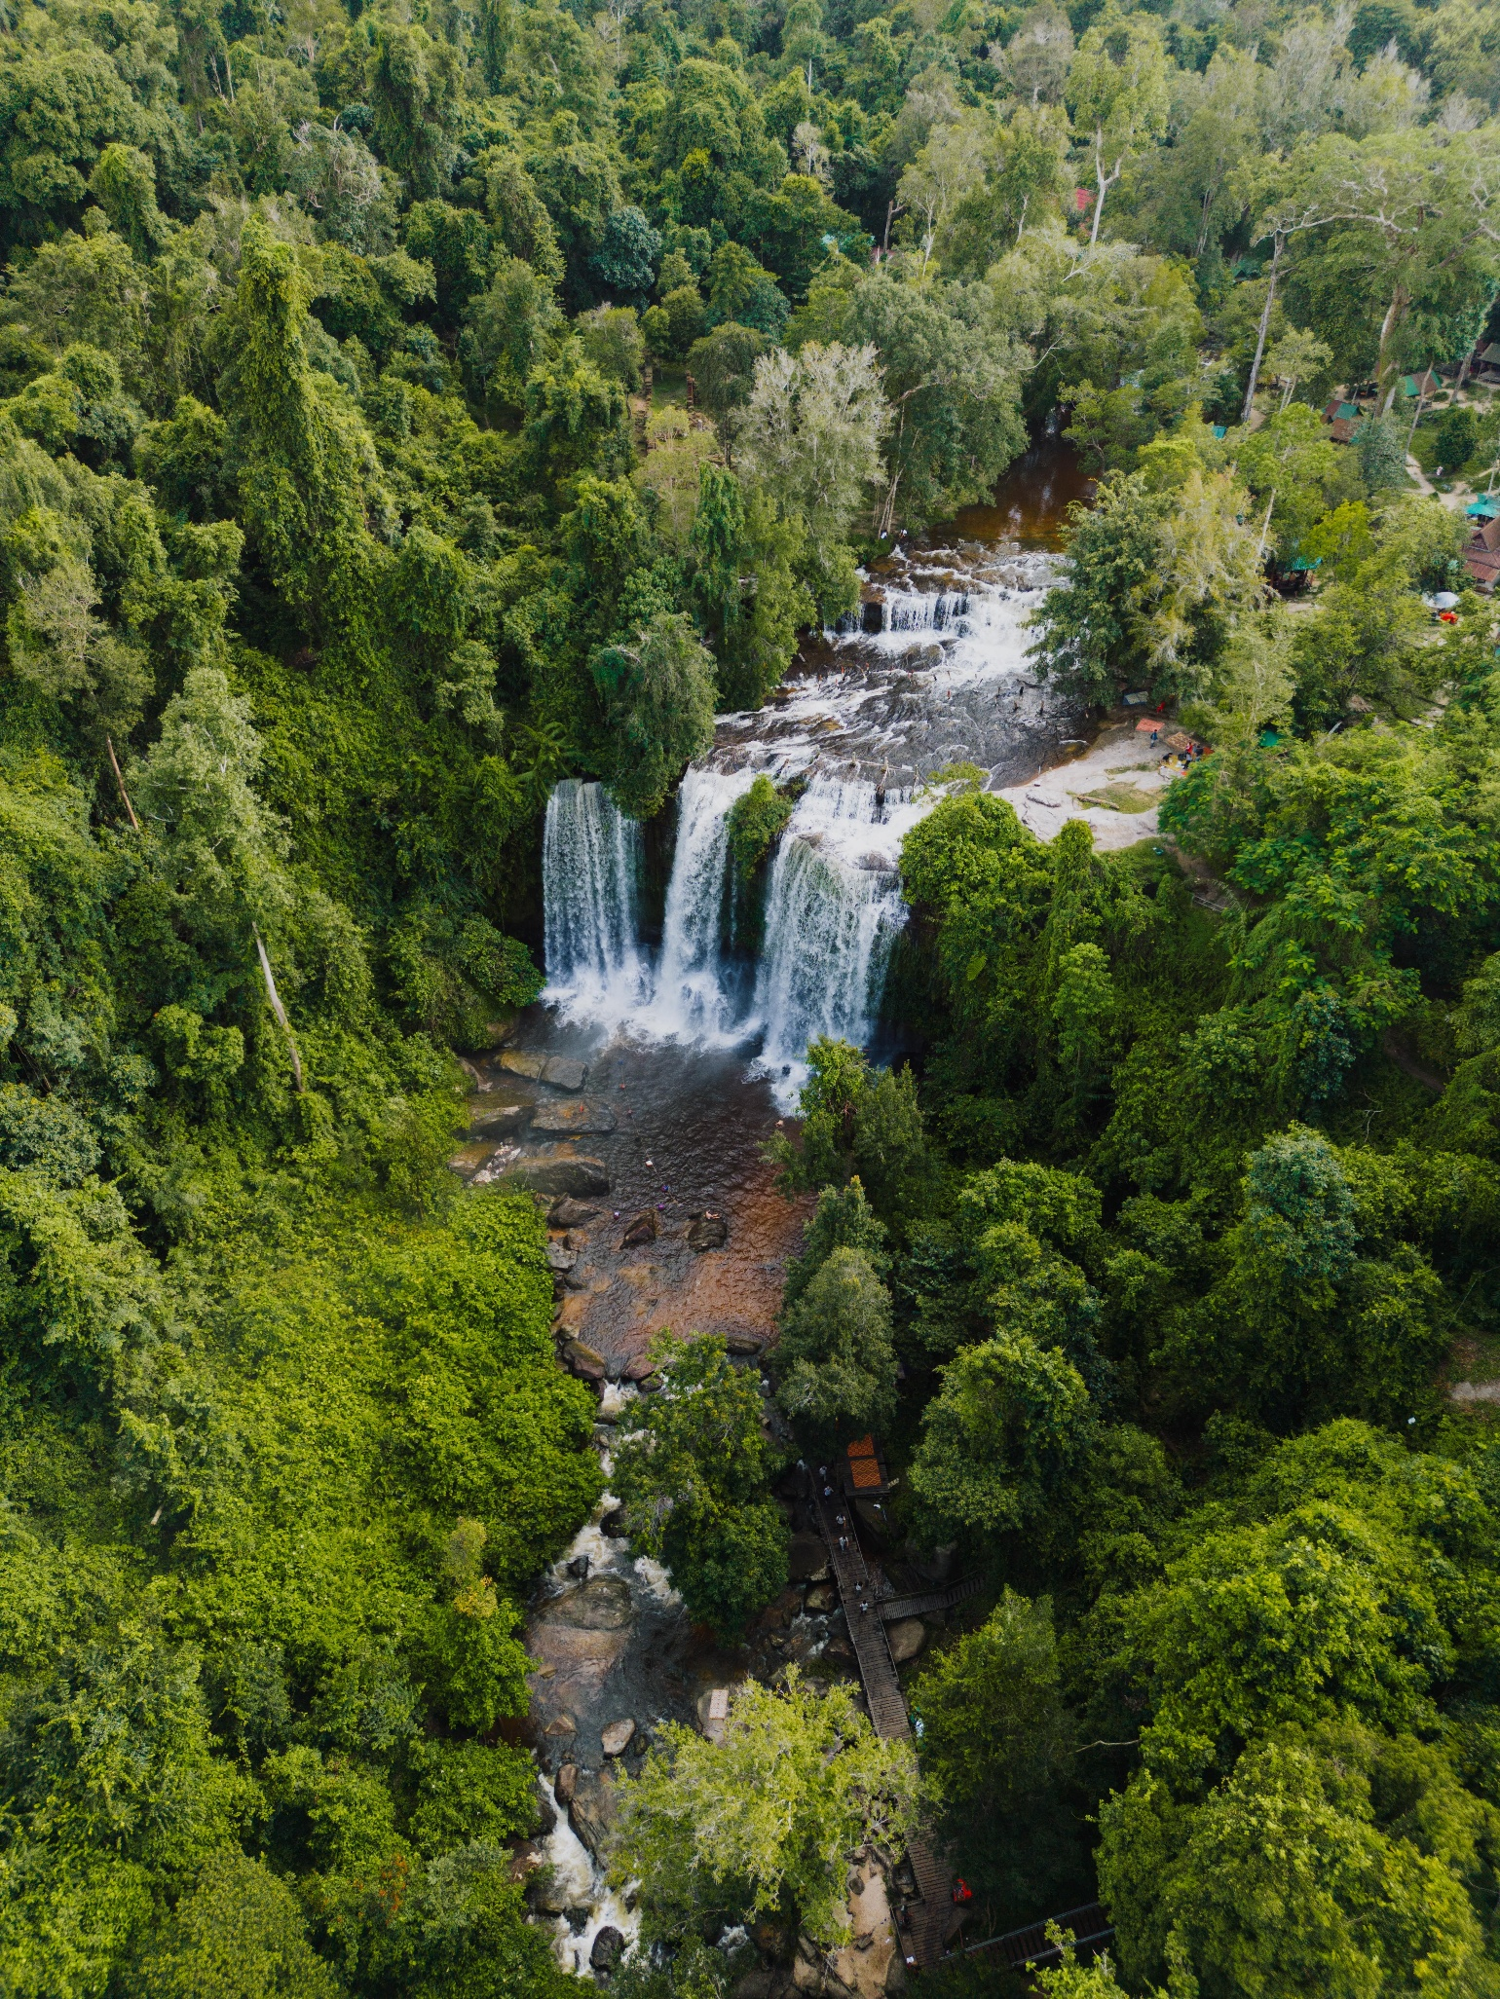
Figure 55. The Kulen waterfall, the plateau’s main visitor attraction for swimming and picnics.
Source: Ministry of Environment (2017), Phnom Kulen National Park Management Program 2018–2027, back cover photograph [D46].
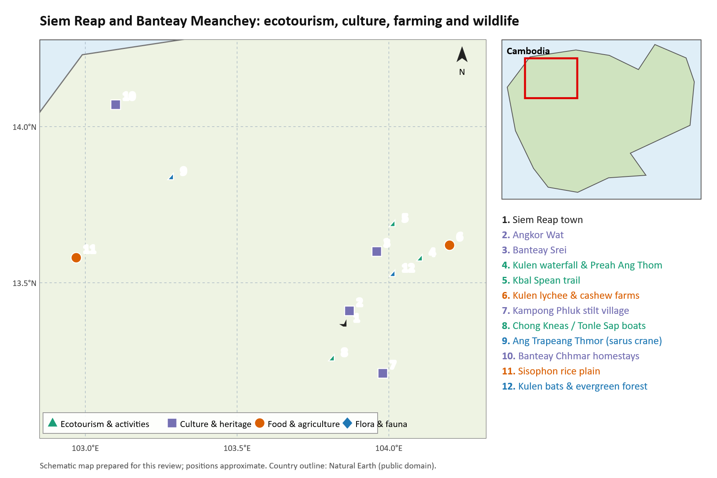
Figure 56. Ecotourism, culture, food and agriculture, and flora and fauna sites in Siem Reap and Banteay Meanchey.
Source: schematic map prepared for this review from published site descriptions; positions approximate.

Geosite location register

Phnom Kulen waterfall in Siem Reap
X longitude 104.107000 E Y latitude 13.568500 N
Basis: Calculated midpoint of published survey coordinate range. Source: Kosterin & Smith 2020, p.111, Locality 8.
Original coordinate expression: 13.568–569 N; 104.106–108 E.
Area reference, not exact waterfall lip or entrance.
Location source

Kbal Spean carvings and upstream river in Siem Reap
X longitude 104.015000 E Y latitude 13.689000 N
Basis: Calculated midpoint of published survey coordinate range. Source: Kosterin & Smith 2020, p.109, Locality 4.
Original coordinate expression: 13.686–692 N; 104.013–017 E.
Survey reach midpoint; downstream waterfall is a separate reach.
Location source

Kulen River of 1000 Lingas in Siem Reap
X longitude 104.103500 E Y latitude 13.566000 N
Basis: Calculated midpoint of published survey coordinate range. Source: Kosterin & Smith 2020, p.111, Locality 7.
Original coordinate expression: 13.565–567 N; 104.102–105 E.
Distinct from Kbal Spean.
Location source

Tnal Mareh floating forest in Siem Reap
X longitude 104.158500 E Y latitude 13.529000 N
Basis: Calculated midpoint of published survey coordinate range. Source: Kosterin & Smith 2020, p.118, Locality 17.
Original coordinate expression: 13.528–530 N; 104.157–160 E.
Research locality; not verified as a public visitor attraction.
Location source

Kulen sandstone veal stream in Siem Reap
X longitude 104.120000 E Y latitude 13.523500 N
Basis: Calculated midpoint of published survey coordinate range. Source: Kosterin & Smith 2020, pp.115–118, Locality 13.
Original coordinate expression: 13.523–524 N; 104.119–121 E.
Research locality; local guide and access confirmation needed.
Location source

Srae Tbong former reservoir wetland in Siem Reap
X longitude 104.157800 E Y latitude 13.523700 N
Basis: Calculated midpoint of published survey coordinate range. Source: Kosterin & Smith 2020, p.118, Locality 15.
Original coordinate expression: 13.5234–5240 N; 104.1574–1582 E.
Reference point within the surveyed eastern margin.
Location source

Sra Srang reservoir, Angkor in Siem Reap
X longitude 103.903500 E Y latitude 13.430000 N
Basis: Calculated midpoint of published survey coordinate range. Source: Kosterin 2020, Miscellaneous faunal data, p.188, SR3.
Original coordinate expression: 13.429–431 N; 103.903–904 E.
Cultural water heritage reference point.
Location source

Phnom Bak fossil / natural heritage site in Banteay Meanchey
Coordinates unresolved. No public map pin is assigned.
Basis: Unresolved location identity. Source: Sub-decree 71 annex contains official map and coordinate table.
Multiple nearby Phnom Bak hill/peak records disagree; use official annex to identify the protected fossil site before placing a public pin.
Location source

Phnom Kang Va fossil site in Banteay Meanchey
Coordinates unresolved. No public map pin is assigned.
Basis: Exact fossil hill / exposure not verified. Source: Fossils at Kang Va mountain.
Do not substitute Kang Va village or reservoir coordinates for the fossil exposure.
Location source

Tra Peang Cha Sandstone Quarry Geosite in Siem Reap
X longitude 104.112000 E Y latitude 13.578000 N
Basis: Published geosite inventory. Source: ITC Kulen Geopark Assessment 2026.
Original coordinate expression: Tra Peang Cha, Phnom Kulen.
Ancient Angkorian sandstone quarry outcrop with visible block extraction marks and tool channels.
Location source

Poeung Takho Viewpoint and Escarpment in Siem Reap
X longitude 104.095000 E Y latitude 13.553000 N
Basis: Published geosite inventory. Source: ITC Kulen Geopark Assessment 2026.
Original coordinate expression: Poeung Takho, Phnom Kulen.
Panoramic cliff viewpoint exposing thick beds of Jurassic-Cretaceous quartz arenite.
Location source

Annotated document catalogue

Kulen and Angkor
D09 Choon Pidao and colleagues 2022. Lithofacies and Petrology of Sandstones from Outcrops at Kulen Area, Siem Reap Province, Cambodia. Techno-Science Research Journal 10(2), 8–16. Direct study of outcrop zones, sedimentary structures and thin sections. Especially useful for selecting scientifically interpretable exposures. Original nine-page PDF retrieved from ITC.
Publisher record · Original PDF
D10 Chevance Jean-Baptiste and colleagues 2019. Mahendraparvata: an early Angkor-period capital defined through airborne laser scanning at Phnom Kulen. Antiquity 93(371), 1303–1321. DOI 10.15184/aqy.2019.133. Open-access primary archaeology with maps and lidar interpretation. Strong support for linking terrain, water infrastructure and cultural heritage. PDF retrieved from Cambridge.
DOI and full article
D11 Uchida Etsuo and Shimoda Ichita 2013. Quarries and transportation routes of Angkor monument sandstone blocks. Journal of Archaeological Science 40, 1158–1164. DOI 10.1016/j.jas.2012.09.036. Quarry field investigations and evidence for transport connections make this a central Kulen–Angkor geocultural source. Seven-page original PDF retrieved.
DOI · Accessible PDF copy
D12 Uchida Etsuo and colleagues 2020. The Sandstone Quarries of the Angkor Monuments in the Southeastern Foothills of Kulen Mountain. Archaeological Discovery 8, 207–227. DOI 10.4236/ad.2020.83012. Adds mapped quarry locations and a large photographic appendix. A useful source of existing publication graphics and coordinates, to be checked against site access and current conditions.
Open article
D13 Carò Federico and Im Sokrithy 2012. Khmer sandstone quarries of Kulen Mountain and Koh Ker: a petrographic and geochemical study. Journal of Archaeological Science 39, 1445–1454. Primary material-characterization study. Publisher abstract inspected; full text may require institutional access.
Publisher record
D14 Cambodia submission to UNESCO 2020. Phnom Kulen: Archeological Site/Ancient Site of Mahendraparvata. World Heritage Tentative List, reference 6460, submission dated 27 March 2020. Authoritative for the submitted cultural-heritage case and its quarry and water themes. It is a Tentative List entry, not Global Geopark recognition. Historical protected-area figures in it should be compared with later boundary instruments.
Official submission
D15 ITC Faculty of Geo-resources and Geotechnical Engineering 2025. Fourth EraGET programme and post-conference field trip. The faculty programme describes Kulen National Park, Angkor Wat and Bayon as a candidate-geopark field-trip area. This is a useful institutional lead for obtaining field guides and unpublished assessments. It does not establish an approved boundary.
Faculty programme
D46 Ministry of Environment, Kingdom of Cambodia 2017. Management Program for Preah Chey Voraman–Norodom “Phnom Kulen” National Park 2018–2027. Khmer-language official programme prepared by the MoE technical working group with UNDP support. Describes the park’s natural and cultural values, threats, four strategic programmes, a five-year budget, and annex maps of forest cover and proposed management zoning. Useful as the legal and management baseline for any Kulen geopark boundary, zoning or geotrail proposal.
Uploaded PDF (Khmer, 54 pages)

Northwestern fossil and cave sites
D16 AMS Khmer Civilization 2021. Fossils found at Phnom Bak. Cambodian field-report article, updated July 2021, with locality photographs. Useful for finding the site and the reported natural-heritage instrument. The reported fossil identifications and mapping-based Permian age need specimen-level verification.
Article in Khmer with English introduction
D17 AMS Khmer Civilization 2021. Fossils at Kang Va mountain. Preliminary Cambodian field-report article describing visits in 2018–2019 and a marine-fossil locality near Serey Sophorn. This provides a practical inventory lead, not a modern taxonomic revision.
Article
D18 Nakamura Koji 1979. Additional Occurrences of Urushtenoidea (Brachiopoda) from the Permian of Asia. Journal of the Faculty of Science, Hokkaido University, Series IV, 19(1–2), 221–233. Directly documents Sisophon Limestone specimens and historical locality names. Contains fossil plates and stratigraphic discussion. Original repository PDF retrieved, including its metadata cover.
Repository PDF

Additional references

D35 Kosterin and Smith 2020
Odonata of Phnom Kulen Mts Cambodia a preliminary checklist. International Dragonfly Fund Report 154, 99–184. Landscape photographs are credited in the paper to Oleg E. Kosterin or Eddie Smith. Locality coordinate ranges and original figure numbers are cited on the plates and in the register.
Reference link

Part 2 — Ratanakiri

Lake Yeak Laom volcanic maar crater lake
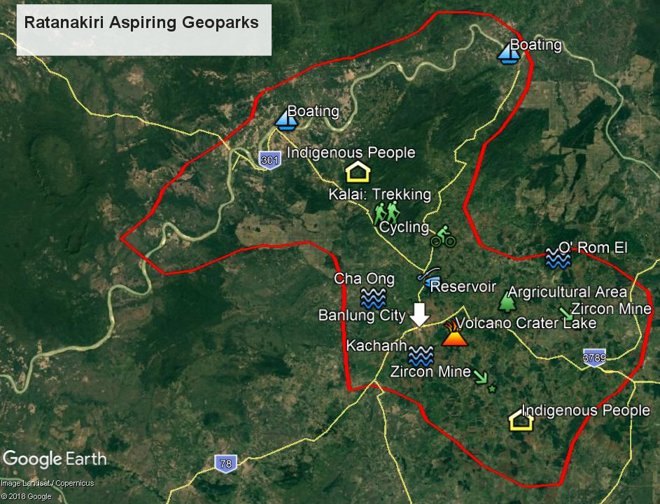
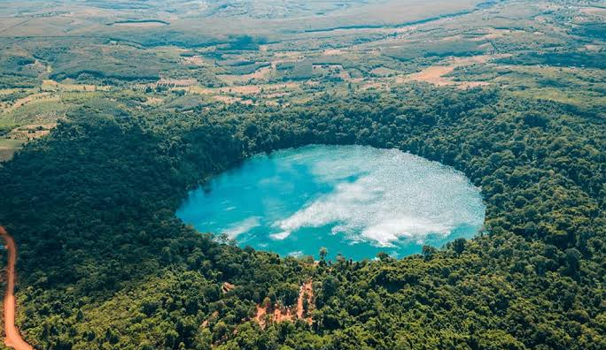
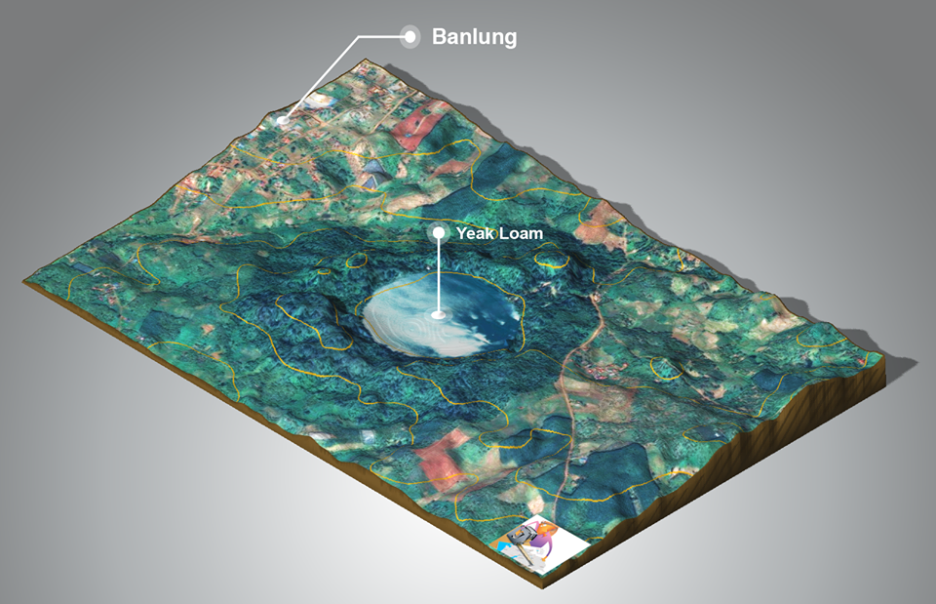
Figure 49. Aerial photograph of Lake Yeak Laom volcanic maar crater lake in Banlung, Ratanakiri Province.
Source: General Department of Mineral Resources (GDMR), Country Report of Cambodia, CCOP Annual Session 2018. Credit: GDMR.
Near-circular 4,000-year-old basaltic explosion crater lake, showcasing Cenozoic volcanism and indigenous Punong/Tampuen heritage.

Ratanakiri zircon gemstone mining pits
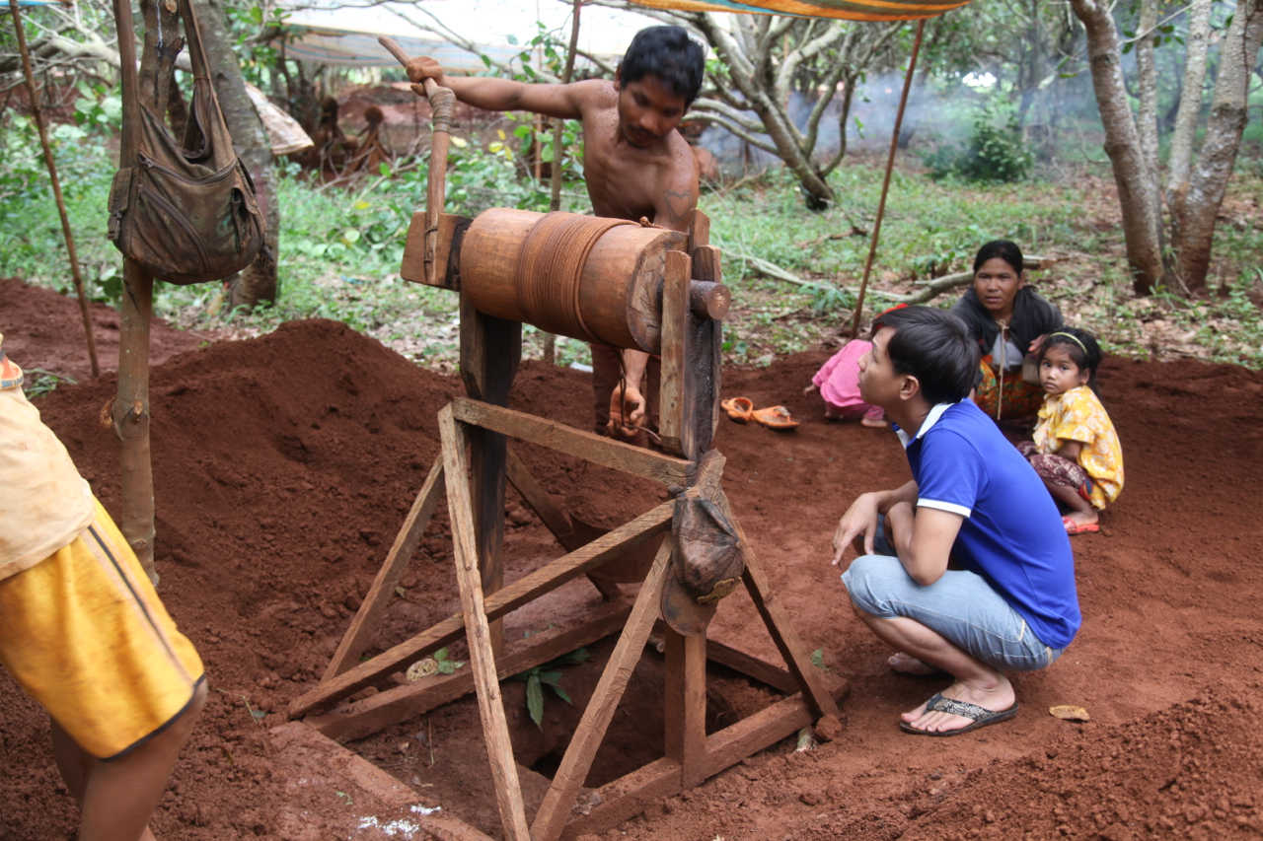

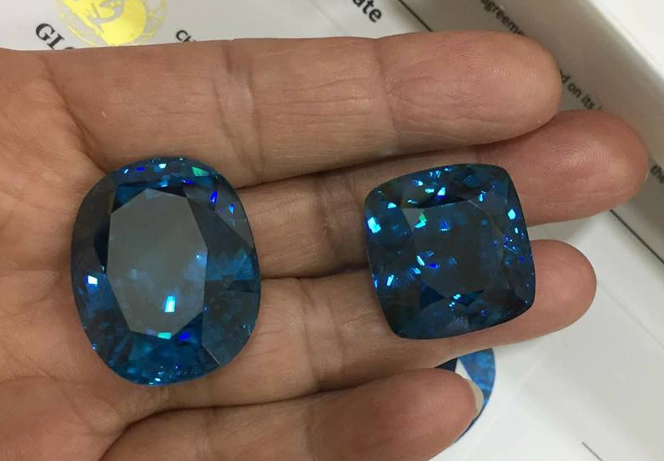
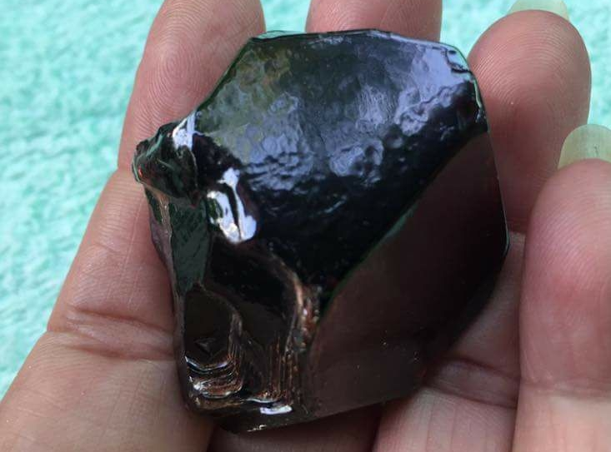
Figure 50. Artisanal zircon gemstone mining pits excavated in the basaltic weathering mantle of Ratanakiri Province.
Source: General Department of Mineral Resources (GDMR), Country Report of Cambodia, CCOP Annual Session 2018. Credit: GDMR.
Alluvial and eluvial gemstone extraction from weathered Cenozoic alkali basalt flows near Banlung.
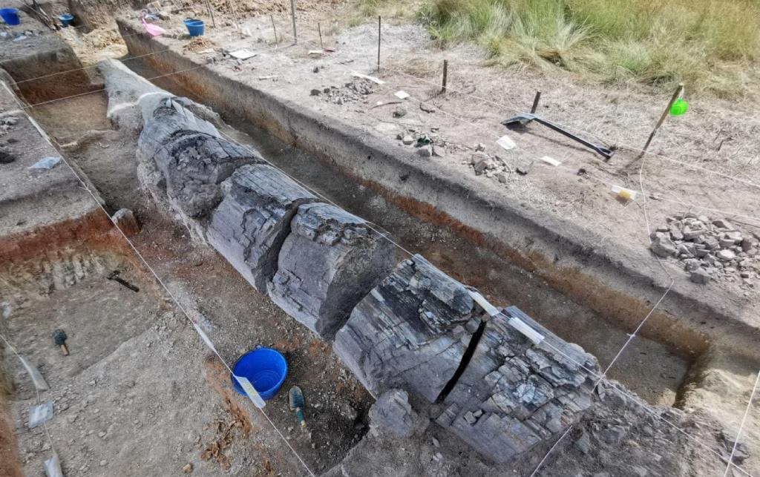
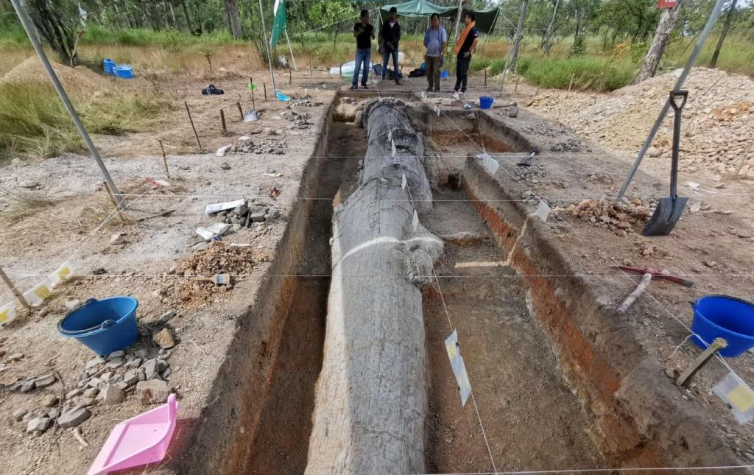
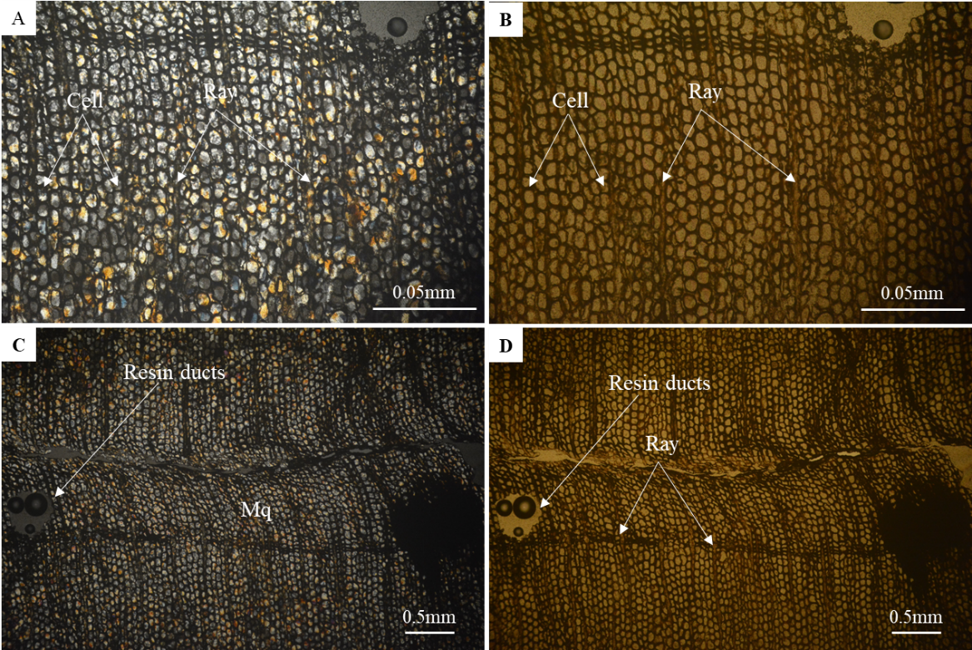
The primary petrified wood site in Ratanakiri province is located in Sayos village, Kaleng commune, Lomphat district (within the Lumphat Wildlife Sanctuary), approximately 50 kilometers from the provincial capital of Banlung.
- Approximate WGS1984 Coordinates for Lomphat area: 720755 E, 1482844 N (UTM Zone 48N)
- Geographic Coordinates for Lomphat District: 13°44′N 107°0′E
- Site Details: The petrified/fossilized trees (identified largely as Mesozoic-era palm trees) were discovered along the Srepok River at an elevation of about 100 meters above sea level.

Katieng waterfall over columnar basalt
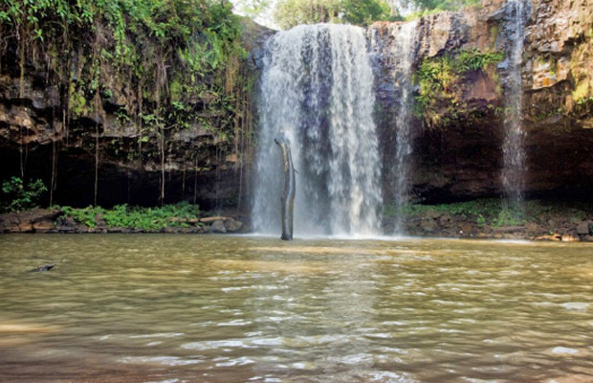
Figure 51. Katieng waterfall cascading over columnar jointed Neogene plateau basalt, Ratanakiri Province.
Source: General Department of Mineral Resources (GDMR), Country Report of Cambodia, CCOP Annual Session 2018. Credit: GDMR.
Structural waterfall illustrating cooling fractures and columnar jointing in Southeast Asian basaltic volcanic flows.

Ecotourism, culture, food, agriculture and biodiversity in Ratanakiri
Lake Yeak Laom. Five kilometres south of Banlung, a forest track ends at the rim of an almost perfectly round lake, about 800 metres across and some 50 metres deep, sitting in an old volcanic crater. Wooden jetties reach out over the jade-green water, and on hot afternoons children leap from them while families picnic in the shade. The lake is managed by the Tampuen communities who live around it, under an agreement first signed with the province in 1998; the ticket fee pays for rangers, trail upkeep and a small cultural centre. Tampuen legend says a giant dug the crater to recover his daughter; geologists see it as one of the clearest volcanic landforms in Cambodia.
Katieng and Ka Chanh waterfalls. West of Banlung, the red dirt roads lead down into gullies where streams spill over dark basalt. At Katieng, the water falls over a ledge of lava rock, and visitors can walk behind the curtain into a hollow worn into the cliff. At Ka Chanh, the river drops in a broad step through the forest. In the wet season the falls thunder; by the end of the dry season they thin to ribbons, revealing the layered and jointed basalt that records the region’s volcanic past.
Kachon and the Tampuen cemetery. Upstream along the Sesan River, the village of Kachon keeps one of the most striking burial traditions in Cambodia. In the forest cemetery, small roofed tombs are guarded by carved wooden effigies of the dead and their possessions, made by family members after the funeral. Visitors are asked to come with a guide and to treat the site with respect. The carvings, weathered grey by rain and sun, are a powerful record of Indigenous belief in a landscape that is changing quickly.
Kreung and Jarai villages. In the hills around Banlung and O Chum, Kreung, Jarai and Tampuen villages still build tall bachelor houses, practise rotational upland rice farming and hold buffalo-sacrifice ceremonies accompanied by gongs and jar rice wine. Homestays organised through community groups let visitors share a meal of rice, forest vegetables and smoked fish and walk to the family farm. These visits are among the most personal experiences in north-east Cambodia, and they work best when villagers set the terms.
Veun Sai and Virachey forests. North of the Sesan River, the forests of Veun Sai and the Virachey National Park stretch towards the borders of Laos and Vietnam. Before dawn, guided treks set out from riverside camps to listen for the song of the northern yellow-cheeked crested gibbon echoing through the canopy; with luck, visitors may glimpse the gibbons swinging through the trees. Hornbills, langurs and wild pigs share the forest. The trips are small, demanding and run with local rangers, so that tourism income helps pay for protection.
Cashew and rubber country. Driving across Ratanakiri, visitors pass mile after mile of cashew orchards and rubber plantations on deep red soils weathered from basalt. In the harvest season families gather cashew apples and nuts by hand, and small roadside workshops roast and shell them. The same fertile soils that make the province rich in crops have also driven the rapid clearance of forest, a tension any geopark plan for the region will need to address openly.
The Sesan River. The Sesan flows wide and brown past Indigenous villages, sandbanks and remaining forest. Boat trips from Veun Sai or Ta Veng travel between Lao, Chinese-Khmer and Indigenous communities and reach the gateways to the national park. In recent years hydropower dams upstream and downstream have changed fish migrations and water levels, and fishermen speak about falling catches. The river is both a route for visitors and a living record of how development is reshaping the north-east.
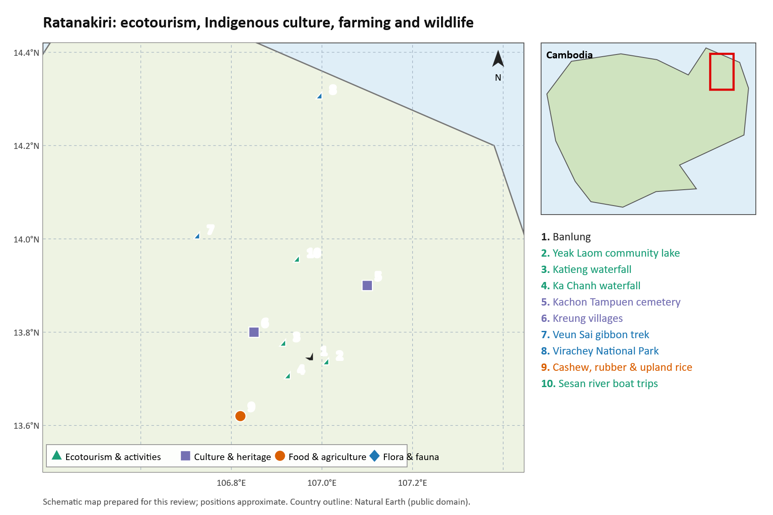
Figure 57. Ecotourism, Indigenous culture, food and agriculture, and flora and fauna sites in Ratanakiri.
Source: schematic map prepared for this review from published site descriptions; positions approximate.

Geosite location register

Lake Yeak Laom Volcanic Maar in Ratanakiri
X longitude 107.018000 E Y latitude 13.725000 N
Basis: Official national geopark register. Source: Cambodia CCOP Country Report 2018.
Original coordinate expression: 13.725 N, 107.018 E.
Near-circular 4,000-year-old basaltic volcanic maar crater lake of high cultural and geomorphological significance.
Location source

Part 3 — Mondulkiri

Nam Lea and the Mondulkiri landscape
The integrated visual atlas reproduces the published regional basalt and waterfall figure. The location register gives separate indicative markers for Nam Lea and Bou Sra; no Nam Lea dome photograph from a research publication is substituted.
Documented starting point. Nam Lear, Nam Lyr and Nam Lea are search variants for the prominent rock formation in the Bou Sra–Pech Chreada area. Reporting from April 2022 describes Ministry of Environment biodiversity investigations intended to support geopark development. This demonstrates a history of institutional interest, not successful UNESCO designation [D04].
Geological interpretation. Tourism sources often call the formation a basalt dome. The retrieved regional basalt study documents Mondulkiri and Ratanakiri basalt samples and include waterfall photographs, but it does not, on that basis alone, establish the lithology, emplacement mechanism or age of the Nam Lea monolith. It would be premature to label it a volcanic crater or assign its exposed rock to the Dalat–Kratie belt without a mapped contact and sample-specific evidence [D06]. Regional Mesozoic tectonic context and younger volcanic landforms are different levels of interpretation.
Culture and livelihoods. The Punong cultural landscape is central to a credible proposal. The Bou Sra thesis documents relationships between land use, community concerns and plantation development. Plantations should therefore be investigated as part of landscape history and livelihoods, with community participation, rather than assumed to provide an uncomplicated tourism benefit [D07]. The provincial spatial plan and CAMPAS documentation provide broader planning and conservation context [D05, D08].
Most useful next documents. Obtain the 2022 Nam Lea biodiversity survey, any subsequent geological assessment, the community protected-area documents and the current candidate study boundary from the responsible agencies. These were identified as information needs; this search did not retrieve a complete Nam Lea geopark dossier. A field investigation should distinguish lithology, weathering morphology, fractures, any volcanic structures and the actual connection to surrounding waterfalls.
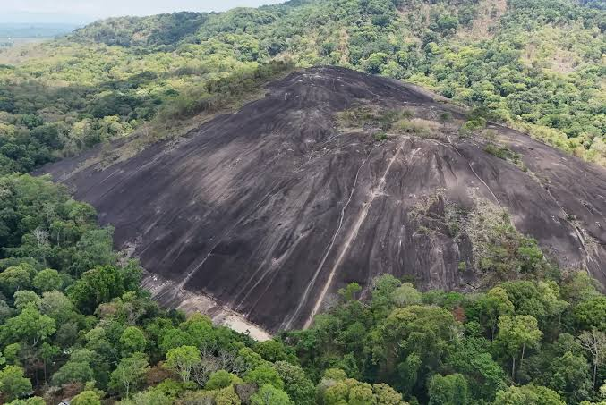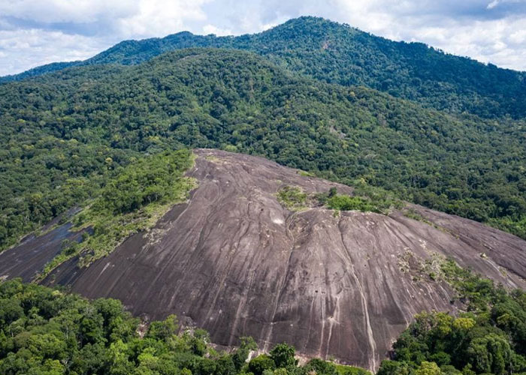

Mondulkiri basalt and waterfall context
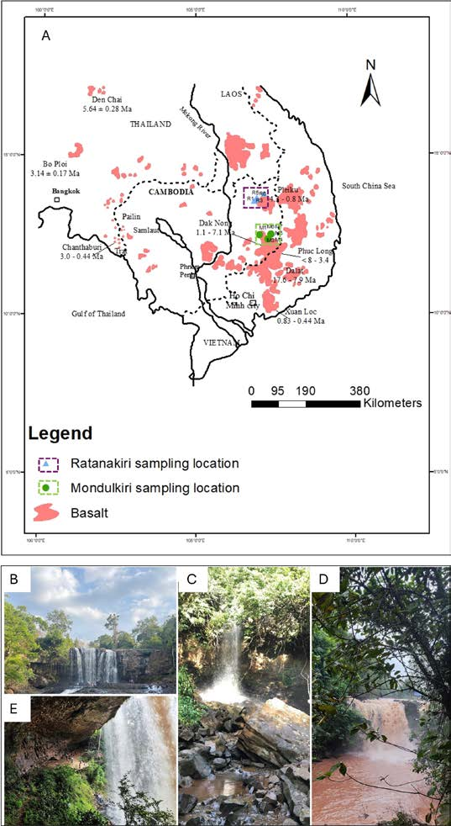
Figure 6. Regional basalt map with Bou Sra, Dakdam, Ka Chanh and Cha Ong waterfall photographs.
Source: Seng et al. (2024), Techno-Science Research Journal 12 Special Issue, 126–133, Figure 1, PDF page 2. Credit: Seng et al. 2024, Figure 1; map panel adapted by original authors from their reference 10.
Bou Sra is panel B, Dakdam C; D and E are in Ratanakiri. Map has upstream third-party provenance. Do not call every panel Mondulkiri.
The location of this study area is situated in northeastern of Cambodia. It is named as Sre pork forest WGS1984(765847-1437406),
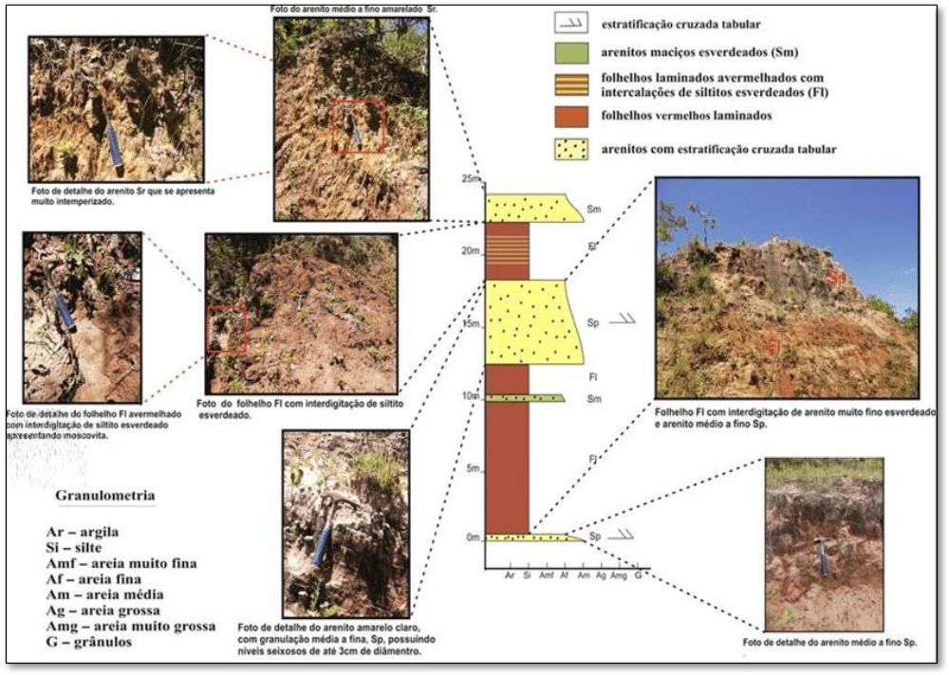
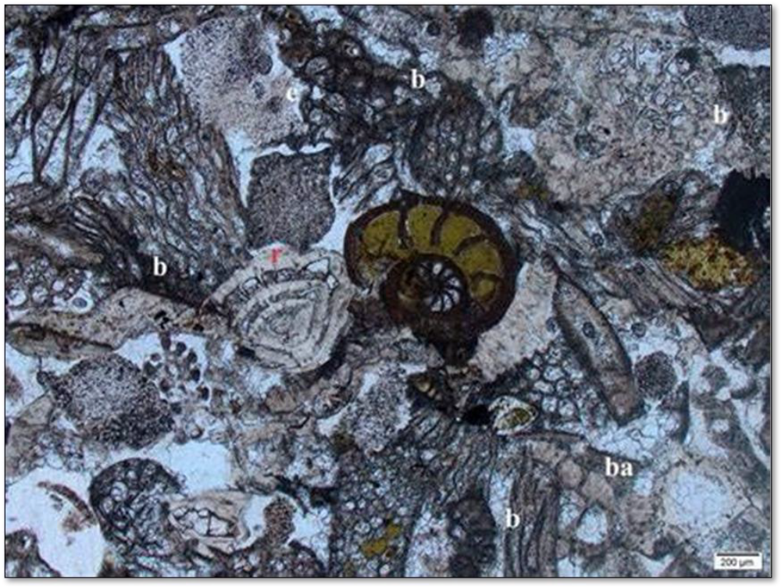

Ecotourism, culture, food, agriculture and biodiversity in Mondulkiri
Sen Monorom and the Sea of Forest. After the long climb from the lowlands, the air in Sen Monorom turns cool and the land opens into rolling grassy hills dotted with pine. The provincial town is the base for most journeys in Mondulkiri, with guesthouses, coffee shops and motorbike rental. At dawn, visitors ride a few kilometres out of town to the ‘Sea of Forest’ viewpoint, where mist lies in the valleys below and ridges of evergreen forest roll away towards Vietnam.
Bou Sra waterfall. About forty kilometres east of Sen Monorom, the Bou Sra River drops over two broad tiers of volcanic rock into a pool ringed by forest. It is the province’s most visited waterfall, busy with families at weekends and during holidays, and nearby Punong villages sell coffee, honey and woven baskets. In the wet season the spray carries far into the trees; in the dry season visitors can climb across the rock ledges and see the hard basalt that holds up the falls.
Elephant Valley Project. In a forested valley close to Sen Monorom, elderly elephants that once hauled logs or carried tourists now spend their days in the forest with their Punong mahouts. Visitors do not ride them. Instead, small groups walk behind the elephants as they feed, bathe in the river and push through bamboo, while staff explain the animals’ histories. The project pays local families to care for the elephants and protect the forest, keeping alive a relationship between Punong people and elephants that goes back generations.
Jahoo Gibbon Camp, Keo Seima. Deep in the Keo Seima Wildlife Sanctuary, the Punong village of Andoung Kraloeng runs a small forest camp. Guests rise before dawn and follow village guides to the trees where habituated groups of southern yellow-cheeked crested gibbons begin their morning song. Later in the day, black-shanked douc langurs, with their brightly coloured faces, may appear in the canopy. Income from each visit goes to the community and supports patrols against illegal logging and poaching.
Punong villages and spirit forests. Around Pu Trom and the villages near Sen Monorom, Punong families still keep spirit forests and burial forests that are never cleared, and they hold ceremonies with gongs, jar rice wine and offerings to the spirits of the land. Visitors with local guides can see traditional thatched houses, backstrap-loom weaving and basket making, and share a bowl of Punong ‘jungle’ soup of forest vegetables thickened with ground rice.
Coffee and avocado farms. On the red basalt soils around Sen Monorom, small farms grow coffee, avocado, pepper and durian. Farm visits let travelers watch coffee cherries being picked and roasted, taste fresh avocados in season and buy wild honey. The fertile red earth on these farms is the direct product of the plateau’s volcanic past, which makes farm visits a natural stop on any geotrail.
Nam Lea stone dome. Towards the Vietnamese border, the forested hills of the Nam Lea area hide a rounded dome of bare rock rising above the canopy. Reaching it takes a long motorbike ride and a forest walk, and the effort is rewarded by wide views over the frontier hills. Local guides tell stories linked to the rock, and researchers see it as a strong candidate geosite at the heart of a future Mondulkiri geopark.
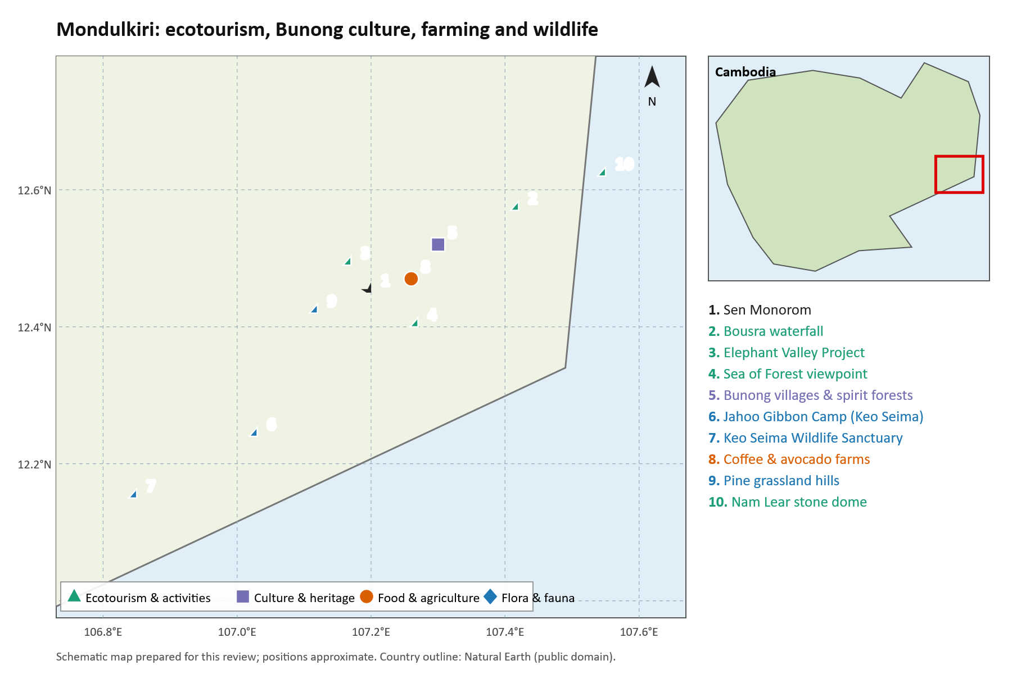
Figure 58. Ecotourism, Punong culture, food and agriculture, and flora and fauna sites in Mondulkiri.
Source: schematic map prepared for this review from published site descriptions; positions approximate.

Geosite location register

Nam Lea / Rom El stone dome in Mondulkiri
X longitude 107.535720 E Y latitude 12.537970 N
Basis: Published local-operator marker. Source: Rom El (Nam Lear) Stone Mountain.
Original coordinate expression: 12.53797, 107.53572.
Dome marker, not sanctuary centroid. No verified site-specific rock identification or age from the reviewed papers.
Location source

Bou Sra waterfall in Mondulkiri
X longitude 107.418300 E Y latitude 12.567020 N
Basis: Published local-operator marker. Source: Bu Sra Waterfall.
Original coordinate expression: 12.56702, 107.4183.
Seng et al. 2024 Figure 1B provides published site photograph; marker accuracy not surveyed here.
Location source

Pulung waterfall in Mondulkiri
X longitude 107.279200 E Y latitude 12.505630 N
Basis: Published local-operator marker. Source: Pulung Waterfall.
Original coordinate expression: 12.50563, 107.2792.
Location source

Leng Kun waterfall and cave area in Mondulkiri
X longitude 107.127960 E Y latitude 12.377870 N
Basis: Published local-operator marker. Source: Leng Kun Waterfall and Bat Cave.
Original coordinate expression: 12.37787, 107.12796.
Public access and specific cave entrance require local confirmation.
Location source

Annotated document catalogue

Nam Lea and Mondulkiri
D04 Voun Dara 2022. Phnom Nam Lear seeking UNESCO geopark status. The Phnom Penh Post, 12 April 2022; French partner version published 13 April. Reporting identifies an MoE-supported biodiversity investigation in the sanctuary and its geopark objective. It establishes reported activity at that time, rather than the completion or current standing of an application.
English report · Accessible French partner version
D05 Provincial Committee for Land Management and Urban Planning 2021. Technical Report on Mondul Kiri Provincial Spatial Plan 2020–2040. Planning document. Useful for land use, settlement, connectivity and development context. The record provides a source-PDF link; this search inspected the repository record rather than conducting a full audit of the plan.
Repository record and source link
D06 Seng Chandara and colleagues 2024. Petrography and Geochemistry of Basaltic Rock in Mondulkiri, and Ratanakiri Province, Northeast Cambodia. Techno-Science Research Journal 12, Special Issue, 126–133. Direct Cambodian petrography and geochemistry, with a regional map and waterfall photographs. The pack contains the eight original article pages extracted from the ITC issue. This is regional evidence, not confirmation of the Nam Lea monolith’s composition.
Publisher issue PDF · Author-uploaded article record
D07 Andreas van der Eynden 2011. Rubber and Soul: Moral Economy, Development and Resistance in the Bousraa villages, Mondulkiri, Cambodia. NTNU thesis. Relevant to Punong relationships with land, plantation development and community perspectives. Thesis metadata were identified; a complete thesis PDF was not downloaded during this search.
University research listing · Persistent thesis identifier
D08 CAMPAS project documentation. Strengthening National Biodiversity and Forest Carbon Stock Conservation through Landscape-Based Collaborative Management of Cambodia’s Protected Area System. Project record associated with the Eastern Plains landscape. Useful institutional background for conservation and livelihoods, rather than site-specific petrology.
Project record

Additional references

D37 Nature Lodge Mondulkiri sightseeing map
Local operator source for the Nam Lea stone dome and selected Mondulkiri waterfall markers. These are published location leads and do not establish geological age, lithology, land ownership or access rights.
Reference link

Part 4 — Southwestern Region: Kampot, Kep, Koh Kong and Kampong Som

Kampot and Kep with the wider southwestern coast
The integrated visual atlas includes reference photographs of Kampot karst, Tatai, Kbal Chhay, Bokor and mangroves. The location register records specific cave entrances or historical survey localities and identifies their coordinate limitations.
Karst core. Kampong Trach, Chhngauk, Kbal Romeas, La’Ang and associated limestone hills provide leads for a geosite inventory. Conservation and community sources explicitly address several of these localities [D31]. Published studies add cave religion, bat ecology and regional geological history [D22, D23, D25, D28].
Wider landscape. Bokor and the coastal sedimentary landscape, and Koh Kong’s forest and waterfall areas, require their own geological and geomorphological descriptions. Carter and colleagues’ report provides a planning framework spanning all four coastal provinces, including karst protection and links with agricultural livelihoods. It is a 2013 advisory report, so its statements about protection and tourism conditions must not be presented as current law or current conditions [D24].
Mesozoic vertebrate paleontology and Cambodia’s first dinosaur. The southern and southwestern coastal belt has emerged as an internationally significant continental Mesozoic paleontological province. Field investigations on Koh Paur island in Koh Kong Province discovered Cambodia’s first confirmed dinosaur fossil: a left fibula (catalogue number MOEC-1) belonging to a Lower Cretaceous sauropod dinosaur (somphospondylan titanosauriform, cf. Euhelopodidae) [D39]. Further research across the thick non-marine "Grès Supérieurs" (Upper Sandstone) sequences of southwestern Cambodia has yielded plant remains, freshwater mollusks and turtles (Koh Moul). These beds may be age-equivalent to parts of the Khorat Group of Thailand, but they appear to have been deposited in a separate basin, so direct correlation is difficult. They still provide vital clues to the Mesozoic ecosystems of Southeast Asia [D42].
Sedimentary source rocks and plateau geo-ecology. In the Kampong Som Basin of Kampot Province, organic petrological studies of the Bokor Formation black shales at Phnom Khley, Phnom Monprey, and Phnom Chakrey reveal dominant macerals of alginite, bituminite, micrinite, and vitrinite alongside cubic pyrite. The macerals indicate deposition under periodically oxygenated bottom water in a sulfidic marine setting and suggest a thermally mature petroleum source rock [D40]. On the high-altitude Bokor Plateau (up to 1,080 m asl), extreme coastal orographic precipitation (>5,000 mm/year) interacting with nutrient-poor, acidic quartz sandstone substrates has created unique stunted evergreen cloud forests, peat bogs, and open sandstone heathlands. A dedicated botanical inventory documents 359 vascular plant species, of which 22 are strict endemics restricted to the Bokor Plateau, exemplifying how local geodiversity directly governs rare biodiversity [D41].
Caves and climate. Hua and colleagues’ study concerns a southern Cambodian speleothem and climate interpretation relevant to Angkor. The geographic location of a climate archive is not necessarily the same as the region whose history it helps interpret [D26]. The separate 2024 Tonle Sap basin speleothem paper is an additional lead, rather than proof that the sampled cave lies within the proposed coastal core [D27].
Management implications. The 2026 cave guidelines are immediately useful for access, lighting, bat disturbance, guano use and cultural values. Quarrying conflicts, cave hydrology and species restricted to individual hills should be evaluated before visitor infrastructure or boundaries are selected. The western Cambodian biodiversity papers and survey report provide relevant evidence, while their results must remain tied to their actual sampled sites [D03, D29, D30].

Coastal mangroves and Koh Por waterfall
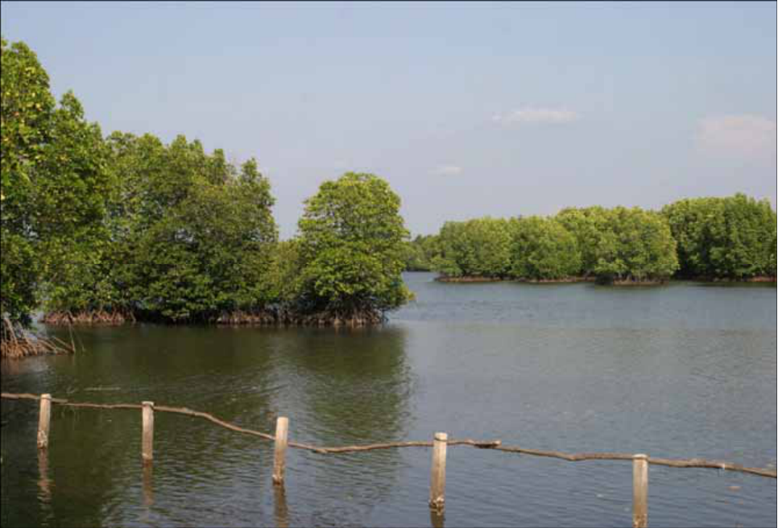
Figure 18. Mangrove landscape at Peam Krasaop.
Source: Kosterin (2010), IDF-Report 29, 1–75, Figure 1, PDF page 10. Credit: Oleg E. Kosterin; Kosterin 2010, Figure 1.
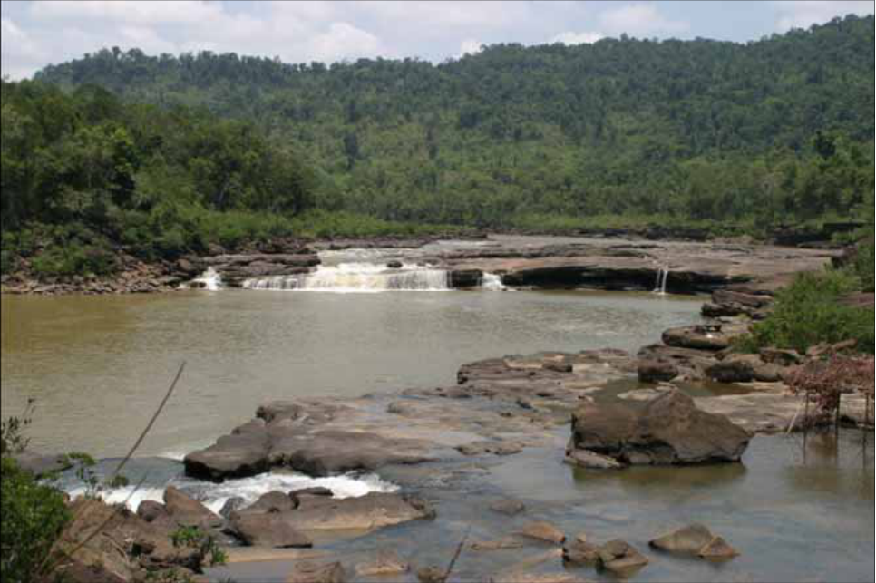
Figure 19. Lower Koh Por waterfall.
Source: Kosterin (2010), IDF-Report 29, 1–75, Figure 5, PDF page 15. Credit: Oleg E. Kosterin; Kosterin 2010, Figure 5.

Tatai waterfall and river landscapes
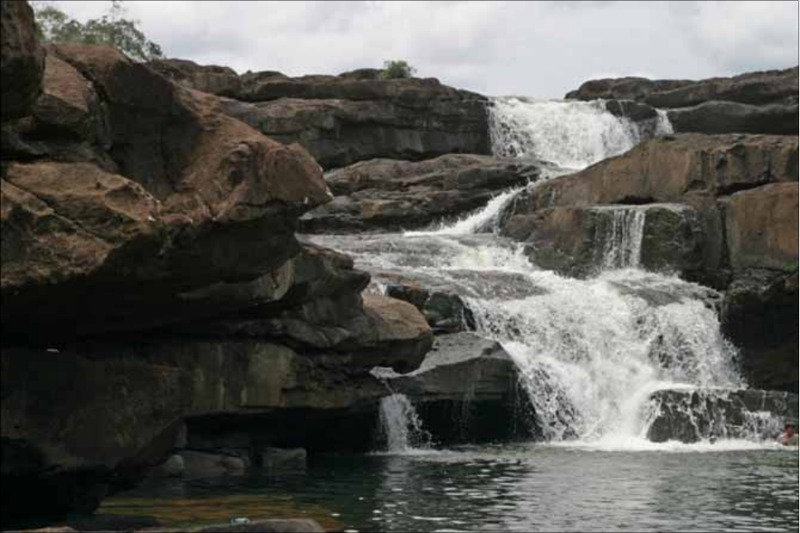
Figure 20. Tatai waterfall over exposed bedrock.
Source: Kosterin (2010), IDF-Report 29, 1–75, Figure 12, PDF page 21. Credit: Oleg E. Kosterin; Kosterin 2010, Figure 12.
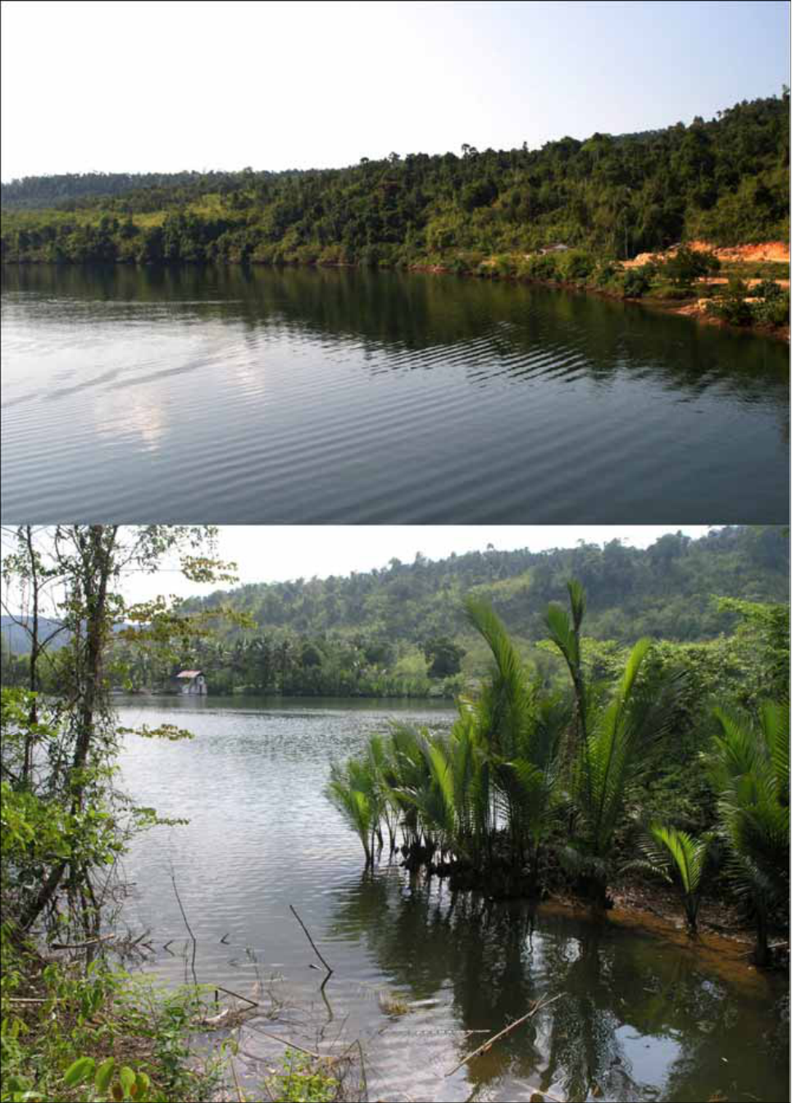
Figure 21. Tatai river landscapes at Phnom Doung bridge.
Source: Kosterin (2010), IDF-Report 29, 1–75, Figure 16, PDF page 26. Credit: Oleg E. Kosterin; Kosterin 2010, Figure 16.

Kbal Chhay and Bokor
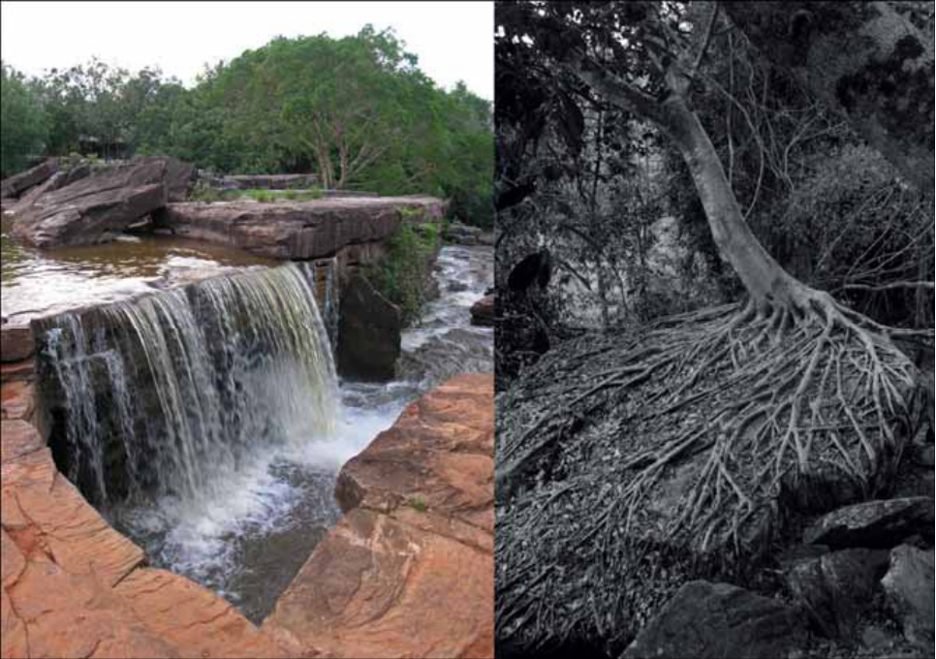
Figure 22. Kbal Chhay cascades near Sihanoukville.
Source: Kosterin (2010), IDF-Report 29, 1–75, Figure 27, PDF page 37. Credit: Oleg E. Kosterin; Kosterin 2010, Figure 27.
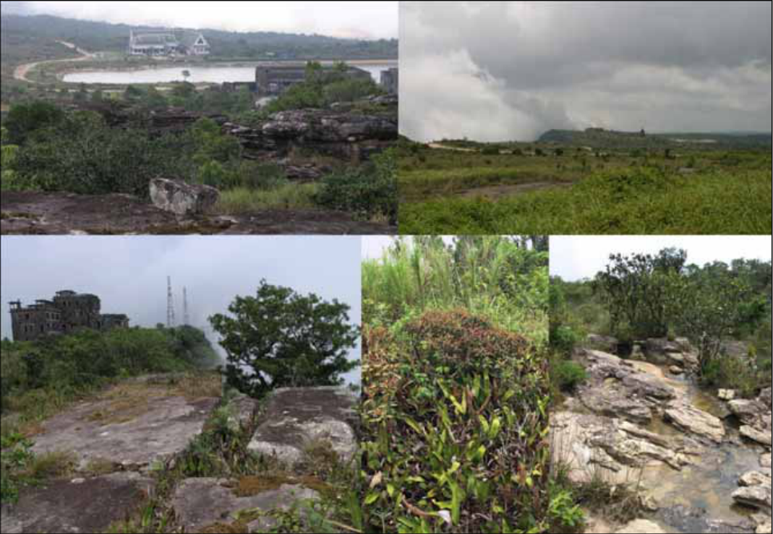
Figure 23. Bokor hill station landscape photographed in 2010.
Source: Kosterin (2010), IDF-Report 29, 1–75, Figure 31, PDF page 42. Credit: Oleg E. Kosterin; Kosterin 2010, Figure 31.

Kampot karst and a Cambodian karst sunset
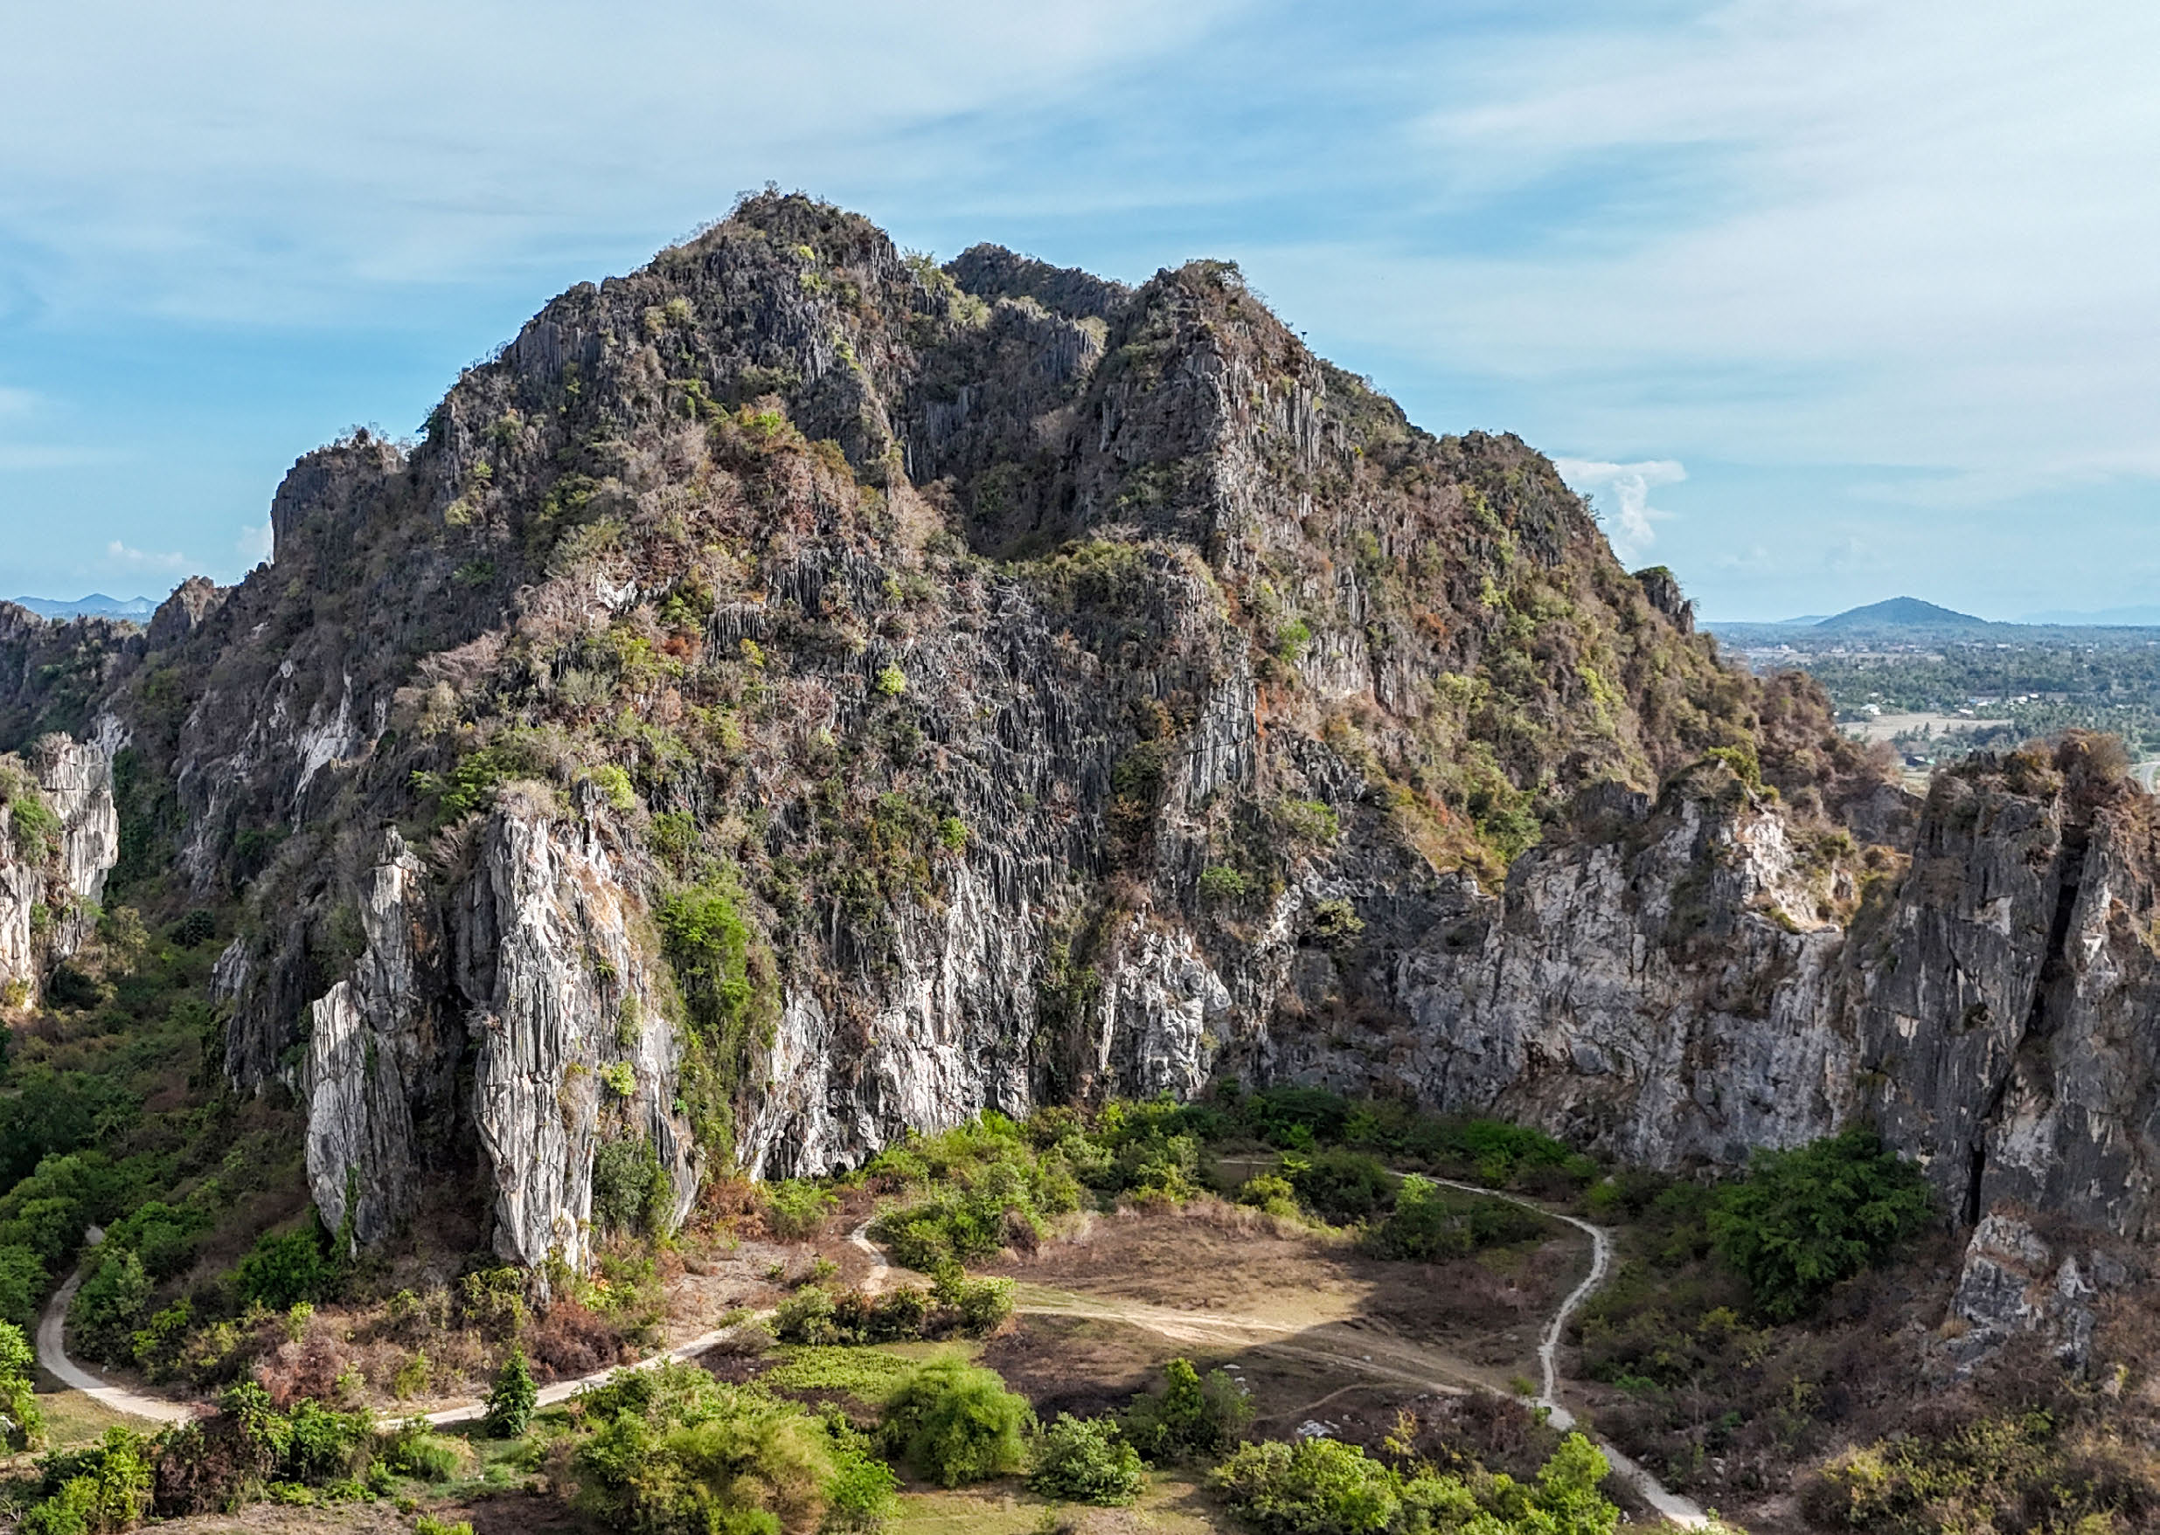
Figure 24. Isolated limestone karst hill in Kampot Province.
Source: Furey / Fauna & Flora (©2025; released 2026), Cambodian Caves: Guidelines for Sustainable Development and Management, Photograph, printed p. 8, PDF page 7. Credit: Nehru Pry; Fauna & Flora, Cambodian Caves.
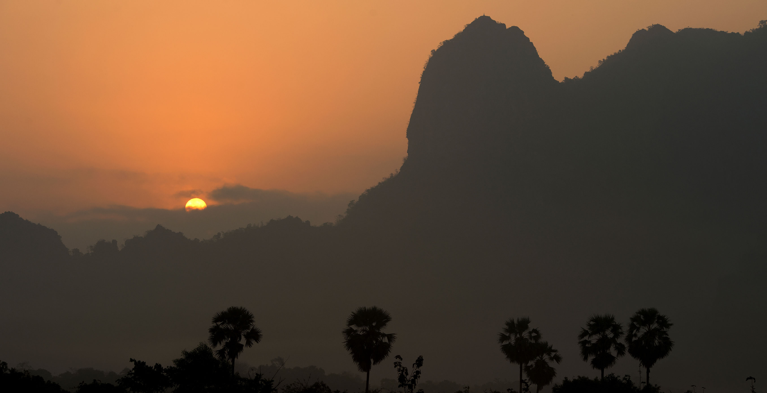
Figure 25. Sunset behind Cambodian karst and sugar palms.
Source: Furey / Fauna & Flora (©2025; released 2026), Cambodian Caves: Guidelines for Sustainable Development and Management, Background photograph, printed pp. 5–6, PDF page 6. Credit: Fauna & Flora; individual photographer not identified on this spread.

Kampot black shale study locations
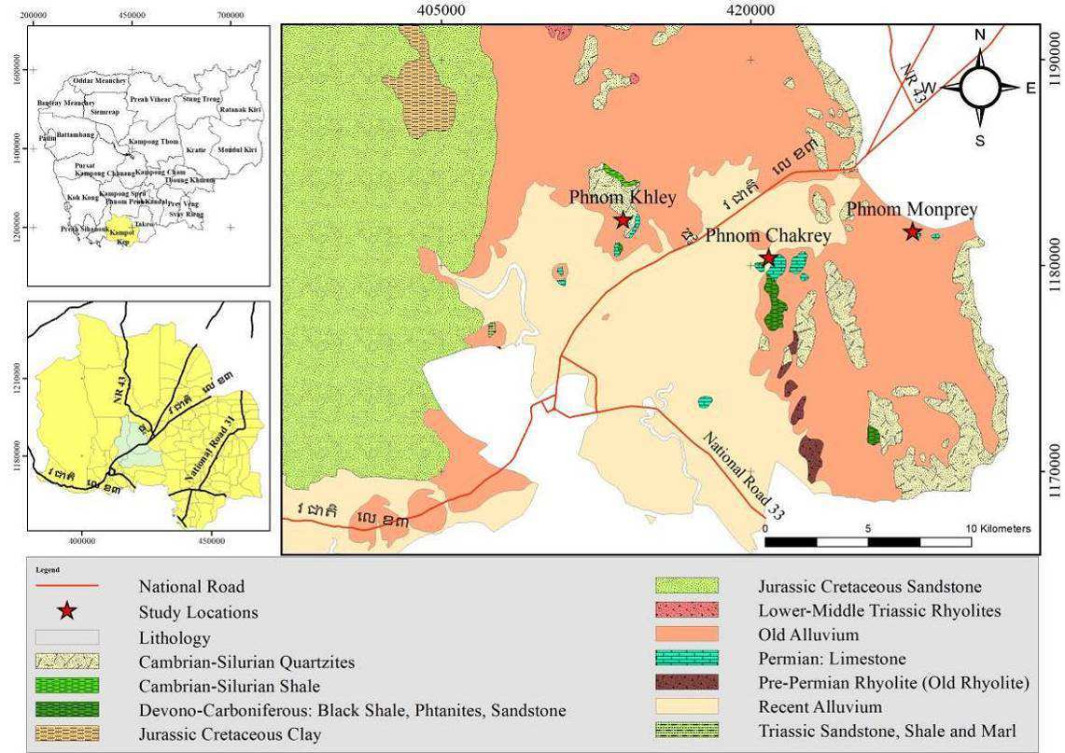
Figure 32. Published study location map of black shale outcrops in Kampot Province, southern Cambodia.
Source: Heng et al. (2022), International Journal of Oil, Gas and Coal Engineering 10(4), 90–96, Figure 1. Credit: Heng et al. 2022.
Locations of investigated sections at Phnom Khley, Phnom Monprey, and Phnom Chakrey within the Kampong Som Basin.

Bokor Formation shale outcrops and fossils
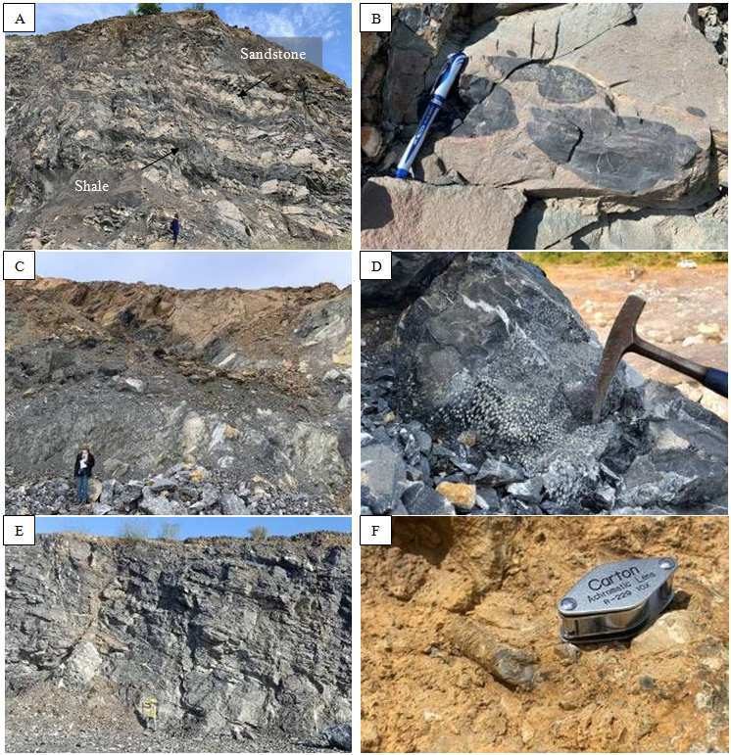
Figure 33. Outcrop photographs of Bokor Formation shale, interbedded sandstones, and marine invertebrate fossils.
Source: Heng et al. (2022), International Journal of Oil, Gas and Coal Engineering 10(4), 90–96, Figure 2. Credit: Heng et al. 2022.
(A-B) Phnom Khley section with shale lenses; (C-D) Phnom Monprey section with Syringopora corals; (E-F) Phnom Chakrey crinoids.

Bokor Formation organic petrology and macerals
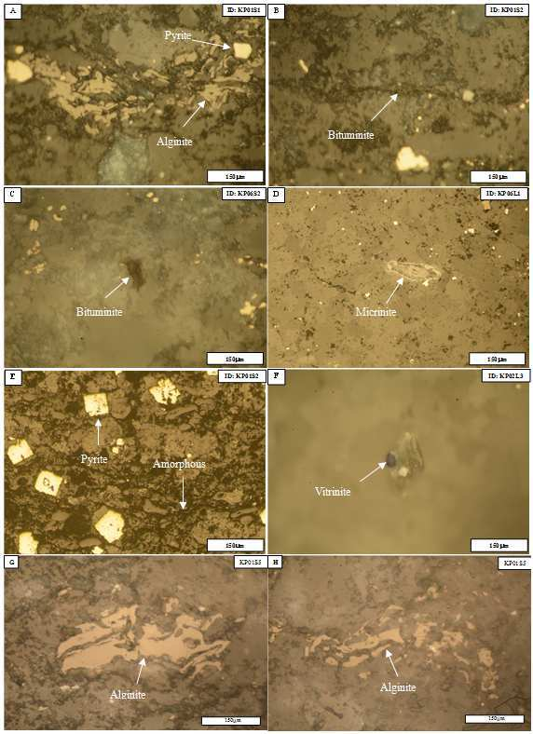
Figure 34. Photomicrographs of shale macerals in the Bokor Formation taken under reflected white light.
Source: Heng et al. (2022), International Journal of Oil, Gas and Coal Engineering 10(4), 90–96, Figure 4. Credit: Heng et al. 2022.
Dominant macerals: alginite (A), bituminite (B-C), micrinite (D), cubic pyrite (E), and vitrinite (F), proving thermal maturity.

Bokor Formation stratigraphic columns
Figure 35. Stratigraphic columns of the Bokor Formation outcrop sections in Kampot Province: (A) Phnom Khley, (B) Phnom Chakrey and (C) Phnom Monprey. Red stars mark the stratigraphic positions of the analysed samples.
Source: Heng et al. (2022), International Journal of Oil, Gas and Coal Engineering 10(4), 90–96, Figure 3. Credit: Heng et al. 2022.
The western section (Phnom Khley) shows repeated thin laminated shale layers interbedded with massive sandstone, whereas the eastern sections preserve thick, fossiliferous shale deposited in a low-energy environment. The columns provide the stratigraphic framework for the black shale geosites.

Bokor Plateau escarpment and stunted forest
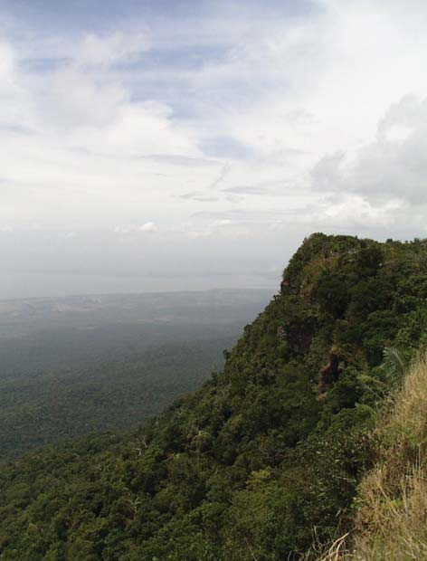
Figure 36. South-facing sandstone escarpment of the Bokor Plateau looking out to the Gulf of Thailand, with Phu Quoc Island (Vietnam) in the distance, March 2001.
Source: Rundel & Middleton (2017), Cambodian Journal of Natural History 2017(1), 17–37, Figure 1. Credit: © Rasoul Sharifi.
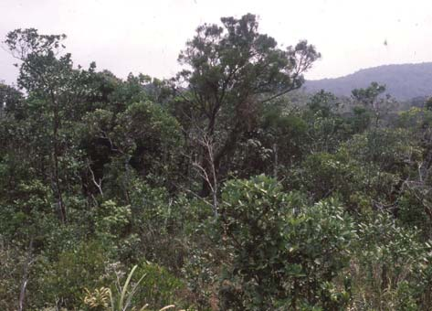
Figure 37. Stunted forest of the Bokor Plateau with emergent trees of Dacrydium elatum, March 2001.
Source: Rundel & Middleton (2017), Cambodian Journal of Natural History 2017(1), 17–37, Figure 2. Credit: © Philip Rundel.
The steep escarpment of the Elephant Mountains sandstone massif rises from the coastal plain to about 1,080 m. On the plateau, shallow acidic sandy soils, strong winds and very high rainfall produce a stunted forest whose canopy rarely exceeds 4 m except for emergent conifers.

Bokor Plateau forest transition and sphagnum bog
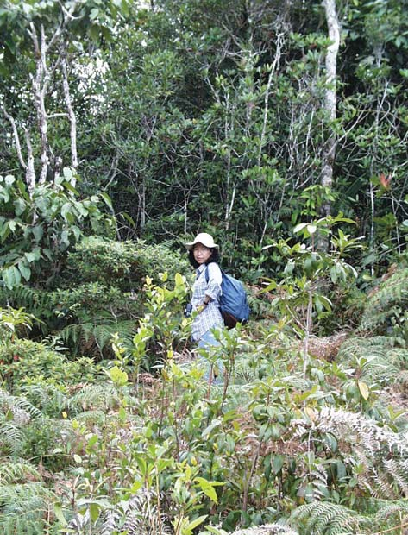
Figure 38. Transition from montane wet evergreen forest to stunted forest near Popokvil Waterfall on the Bokor Plateau, March 2001.
Source: Rundel & Middleton (2017), Cambodian Journal of Natural History 2017(1), 17–37, Figure 3. Credit: © Rasoul Sharifi.
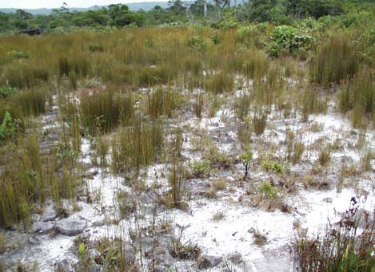
Figure 39. Sphagnum bog and seasonally waterlogged wetland on white sandy soil in poorly drained areas of the Bokor Plateau, March 2001.
Source: Rundel & Middleton (2017), Cambodian Journal of Natural History 2017(1), 17–37, Figure 4. Credit: © Rasoul Sharifi.
These vegetation mosaics reflect the control of the weathered sandstone on soil depth and drainage. The plateau flora comprises 359 recorded vascular plant species, 22 of them endemic to Bokor, which supports the geodiversity–biodiversity theme of a Bokor geopark.

Grès Supérieurs sandstone and clay succession at Koh Kong
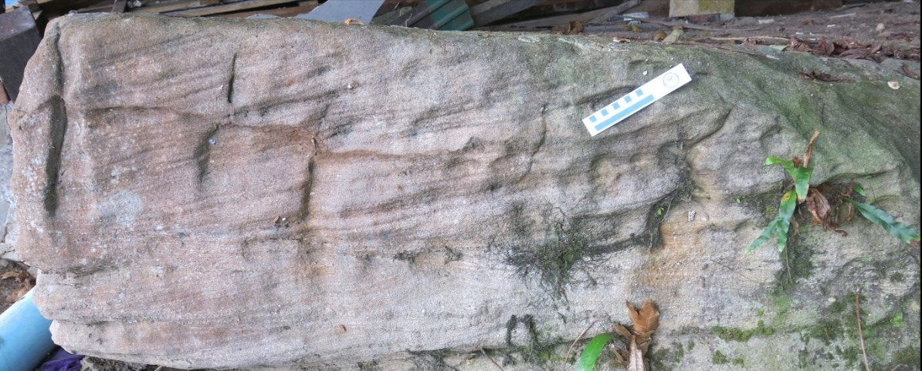
Figure 40. Cross-bedded sandstone in the lower part of the Grès Supérieurs on Koh Paur Island, Koh Kong Province.
Source: Buffetaut et al. (2024), Fossil-bearing non-marine Mesozoic formations of south-western Cambodia, Proceedings of GEOSEA 2024, Khon Kaen, 55–63, Figure 1. Credit: Buffetaut et al. 2024.
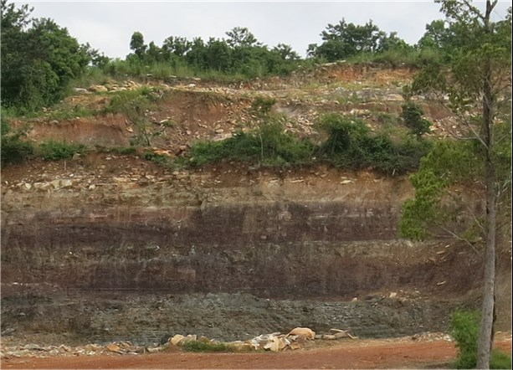
Figure 41. Grey, greenish and purple clay layers in the middle part of the Grès Supérieurs, overlain by sandstone beds, in a quarry near Koh Kong. Plant remains occur in one of the green layers and freshwater molluscs in a greenish mudstone bed at the top of the clayey series.
Source: Buffetaut et al. (2024), Fossil-bearing non-marine Mesozoic formations of south-western Cambodia, Proceedings of GEOSEA 2024, Khon Kaen, 55–63, Figure 2. Credit: Buffetaut et al. 2024.
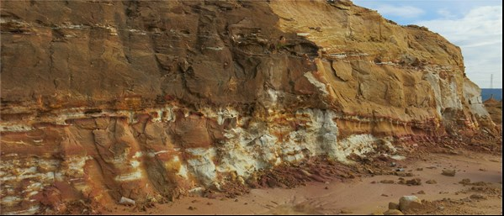
Figure 42. White saccharoid sandstones overlain by more compact brown sandstones near the top of the Grès Supérieurs near Koh Kong.
Source: Buffetaut et al. (2024), Fossil-bearing non-marine Mesozoic formations of south-western Cambodia, Proceedings of GEOSEA 2024, Khon Kaen, 55–63, Figure 3. Credit: Buffetaut et al. 2024.
Together these exposures show the lower sandstone, middle clay and upper sandstone units of the non-marine Mesozoic succession that underlies the Koh Kong coast and the Bokor–Elephant Mountains massif. The quarry and coastal outcrops are candidate stratigraphic geosites.

Early Cretaceous plant fossils between Kampot and Bokor
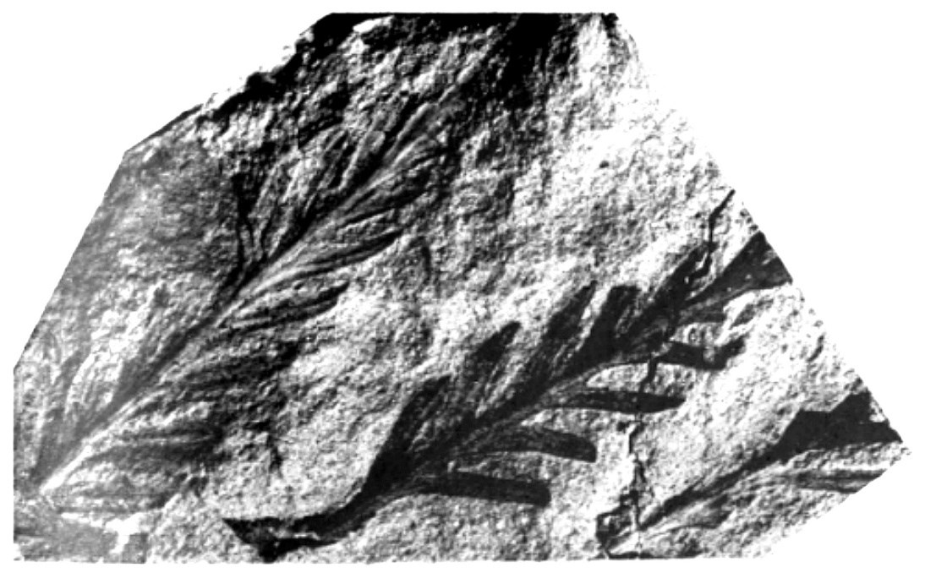
Figure 43. Early Cretaceous plant fossils (the fern Gleichenoides, enlarged) from grey-green silty clays of the Grès Supérieurs between Kampot and Bokor, modified after Corsin and Desreumaux (1972).
Source: Buffetaut et al. (2024), Fossil-bearing non-marine Mesozoic formations of south-western Cambodia, Proceedings of GEOSEA 2024, Khon Kaen, 55–63, Figure 4. Credit: Buffetaut et al. 2024.
This plant bed provides the main age evidence for the Grès Supérieurs on the Bokor road and links the Bokor Plateau directly to the Mesozoic fossil record of south-western Cambodia.

Koh Paur sauropod dinosaur fibula
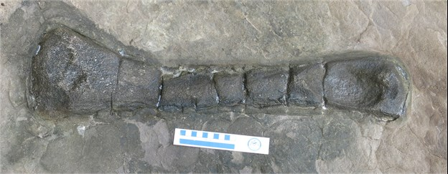
Figure 44. Sauropod dinosaur fibula in situ in greyish-brown sandstone of the lower part of the Grès Supérieurs at Koh Paur Island, Koh Kong Province.
Source: Buffetaut et al. (2024), Fossil-bearing non-marine Mesozoic formations of south-western Cambodia, Proceedings of GEOSEA 2024, Khon Kaen, 55–63, Figure 5. Credit: Buffetaut et al. 2024.
The specimen (MOEC-1), found in 2021 and extracted in 2022, is the first dinosaur bone reported from Cambodia and is referred to a euhelopodid titanosauriform of Early Cretaceous age (Lim et al. 2023).

Koh Moul fossil site location map and turtle remains
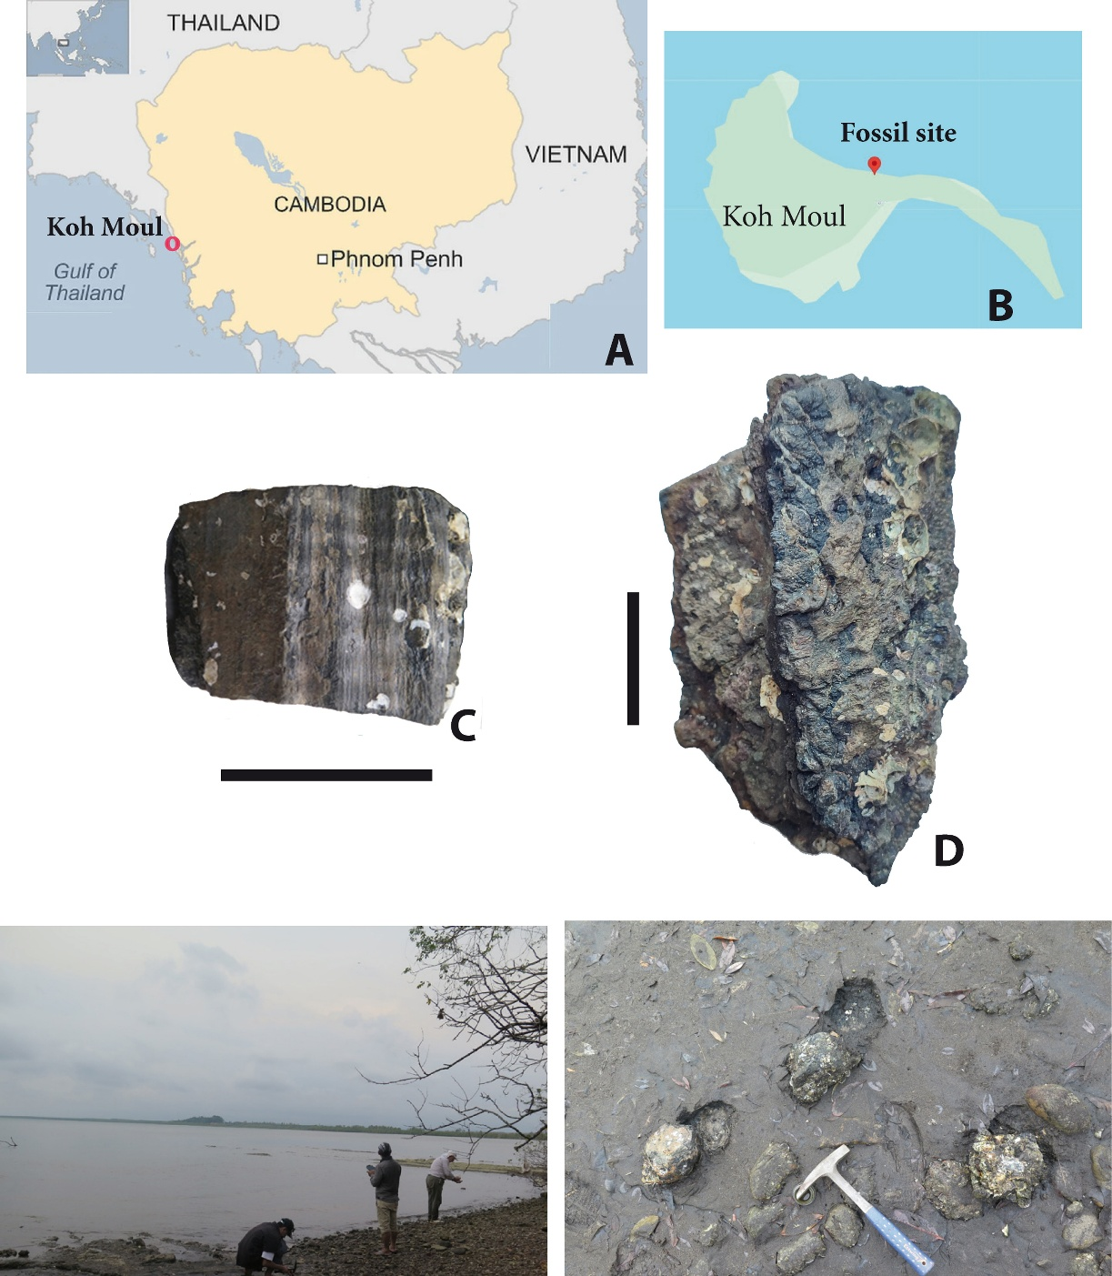
Figure 45. (A) Geographical position of Koh Moul in south-western Cambodia; (B) location of the fossil site on Koh Moul; (C) conifer-type fossil wood (tracheidoxyl); (D) turtle bridge peripherals (MOEC-4) before preparation; (E, F) beach outcrop of the fossil site at low tide. Scale bar = 5 cm.
Source: Tong et al. (2026), Turtle remains from Koh Moul (SW Cambodia) and their stratigraphical implications, Diversity 18(5), 249, Figure 1. Credit: Tong et al. 2026 (CC BY 4.0).
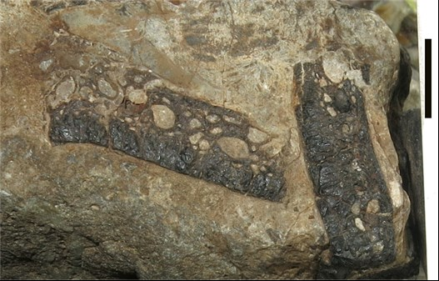
Figure 46. Turtle shell fragments in cross-section in greenish-grey sandstone in the lower part of the Grès Supérieurs, Koh Moul Island, Koh Kong Province. Scale bar = 10 mm.
Source: Buffetaut et al. (2024), Proceedings of GEOSEA 2024, Khon Kaen, 55–63, Figure 6. Credit: Buffetaut et al. 2024.
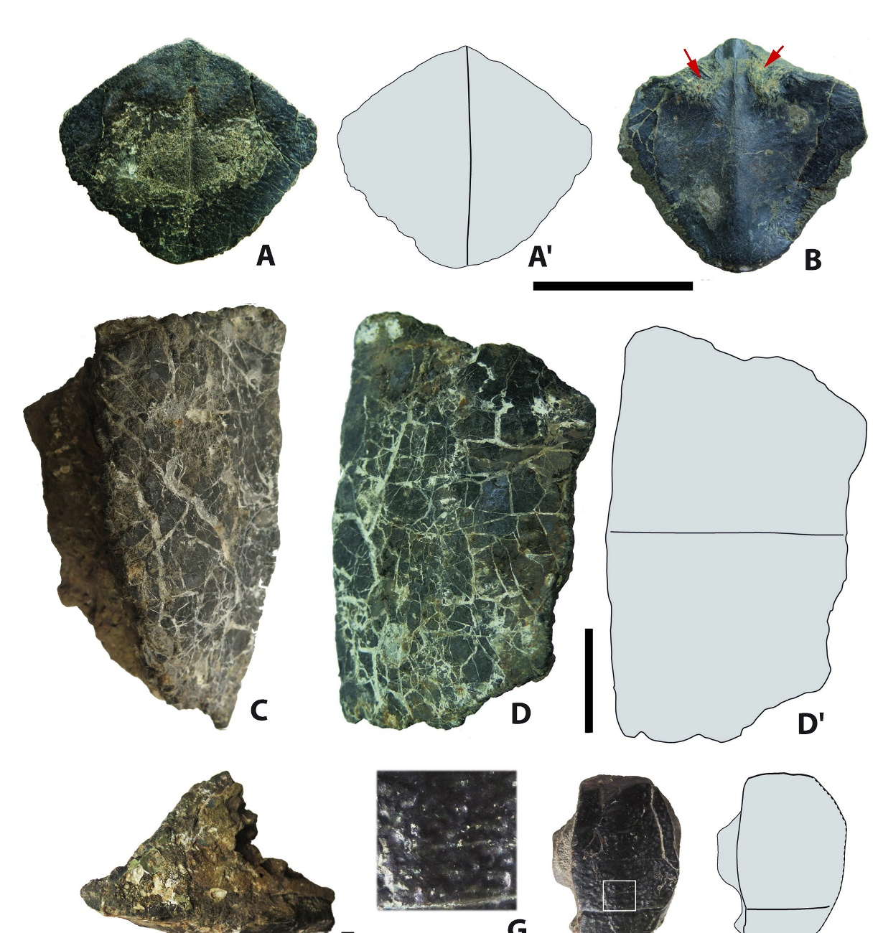
Figure 47. Turtle specimens from Koh Moul: (A, B) entoplastron (MOEC-2) in ventral and dorsal views; (C–E) bridge peripherals (MOEC-4) in dorsal, ventral and anterior views; (F, G) costal fragment (MOEC-3) and close-up of its ornamentation. Red arrows indicate scars. Scale bar = 5 cm.
Source: Tong et al. (2026), Turtle remains from Koh Moul (SW Cambodia) and their stratigraphical implications, Diversity 18(5), 249, Figure 2. Credit: Tong et al. 2026 (CC BY 4.0).
The Koh Moul site, about 30 km south of Koh Kong city, lies on a beach that is exposed only at low tide. The siltstones and mudstones yield fossil conifer wood and the remains of a large basal trionychoid turtle with an estimated carapace length of about 80 cm. By comparison with the Khorat Group of Thailand, this suggests an Early Cretaceous age, consistent with the plant and dinosaur evidence from elsewhere in south-western Cambodia.

Freshwater bivalves of the Grès Supérieurs
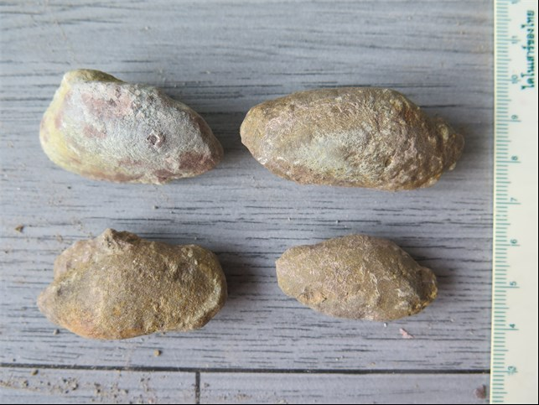
Figure 48. Unionid bivalves from a greenish-brown claystone layer at the top of the clayey part of the Grès Supérieurs, in a quarry east of Koh Kong city.
Source: Buffetaut et al. (2024), Proceedings of GEOSEA 2024, Khon Kaen, 55–63, Figure 7. Credit: Buffetaut et al. 2024.
The freshwater molluscs confirm the non-marine, fluvial–lacustrine setting of the Grès Supérieurs and make the Koh Kong quarry a further candidate paleontological geosite.

Ecotourism, culture, food, agriculture and biodiversity in Kampot, Kep, Koh Kong and Kampong Som
Bokor plateau. The road up Bokor Mountain winds through forest for some thirty kilometres before reaching the cool, cloud-wrapped summit, about a thousand metres above the sea. At the top stand the ruins of the French hill station of the 1920s: the shell of the old Bokor Palace hotel, a weathered stone church and the former royal residence, often half-hidden in drifting mist. Nearby, the Popokvil waterfall pours over sandstone ledges, and Wat Sampov Pram looks out over the Gulf of Thailand. Stunted cloud forest and sphagnum bog cover the plateau, home to endemic plants such as the pitcher plant Nepenthes bokorensis.
Kampot town and river. Kampot spreads along the banks of the Teuk Chhou river, where faded French shophouses face the water and fishing boats set out at dusk. Visitors kayak upstream past mangroves and limestone hills, or take sunset boat trips to watch fireflies glitter in the riverside trees. In the evenings, the riverfront fills with food stalls and cafés, and the Bokor massif stands dark against the sky across the water.
Phnom Chhngok cave temple. A short ride east of Kampot, a path crosses rice fields to the foot of a limestone hill. Inside, a cave opens into a natural chamber where a small brick temple from the pre-Angkorian period stands among stalactites, lit by shafts of light from above. Local children guide visitors through the darkness with torches. The site shows, in a single view, how the karst landscape of Kampot has shaped belief and worship for more than a thousand years.
Kampot pepper farms. In the foothills around Kampong Trach and along the Kep border, rows of pepper vines climb wooden posts under shade cloth. Kampot pepper has been a protected geographical indication in Cambodia since 2010 and in the European Union since 2016. On farm visits, growers explain how green berries are picked by hand and turned into black, red and white pepper, and how the quartz-rich soils of the Elephant Mountain foothills give the spice its distinctive flavour. Visitors leave with small bags of pepper and a clear sense of how soil and rock become taste.
Kampot salt fields. East of Kampot town, a flat patchwork of shallow ponds stretches towards the sea. In the dry season, workers in wide hats rake crystallising salt into white mounds and carry it in baskets to wooden sheds. The salt fields are among the oldest working landscapes on the coast, and the sight of the white piles under a hard blue sky is one of the most photographed scenes in the province.
Kep crab market and Koh Tonsay. In Kep, women wade into the shallows to haul up bamboo crab traps, and within minutes the catch is sold at the market and stir-fried with fresh green Kampot pepper in the open-air restaurants behind. From the nearby pier, wooden boats cross to Koh Tonsay, or Rabbit Island, where simple bungalows line a quiet beach. Behind the town, Kep National Park offers a forest trail around the hill with views across the sea to Vietnam’s Phu Quoc island.
Ream National Park and Koh Rong. Near Sihanoukville (Kampong Som), Ream National Park protects mangrove channels, beaches and offshore islands. Boat trips with park rangers glide through the mangroves towards quiet bays where dolphins are sometimes seen. Further offshore, the Koh Rong islands draw visitors to white-sand beaches, snorkelling over coral and night swims among glowing plankton.
Peam Krasaop and Tatai, Koh Kong. In Koh Kong, a wooden boardwalk winds through the Peam Krasaop mangrove forest, among the largest remaining on Cambodia’s coast, where mudskippers, crabs and monkeys share the roots. Inland, the Tatai River runs out of the Cardamom Mountains past floating lodges, and visitors kayak to the Tatai waterfall, where the river drops over broad rock ledges in the forest.
Chi Phat and the Areng Valley. On the edge of the Cardamom Mountains, the village of Chi Phat runs one of Cambodia’s longest-established community ecotourism programmes. Former hunters now work as guides, leading treks, mountain-bike rides and overnight forest camps. Further west, the remote Areng Valley shelters one of the last wild populations of the critically endangered Siamese crocodile, and the forest is home to Asian elephants and hornbills. Here, tourism income is helping to make protection pay.
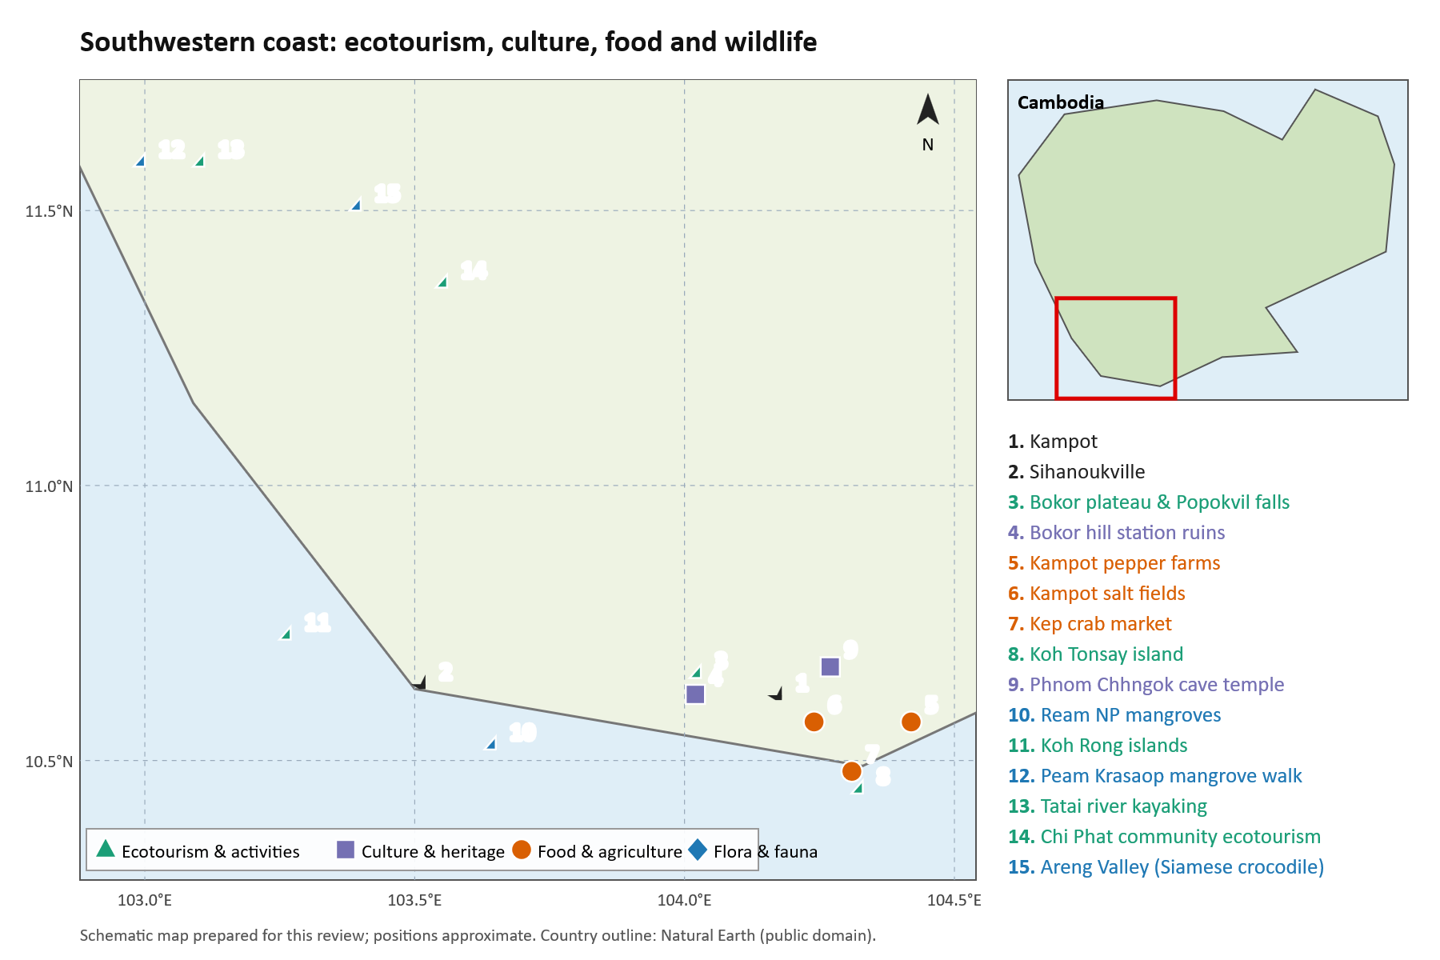
Figure 59. Ecotourism, culture, food and agriculture, and flora and fauna sites in Kampot, Kep, Koh Kong and Kampong Som.
Source: schematic map prepared for this review from published site descriptions; positions approximate.

Geosite location register

Phnom Chhngok cave entrance in Kampot
X longitude 104.269640 E Y latitude 10.642240 N
Basis: OpenStreetMap cave entrance via Mapcarta. Source: OSM node 3971467859.
Original coordinate expression: 10.64224 N; 104.26964 E.
Coordinate data: © OpenStreetMap contributors, ODbL. Cave spelling varies: Chhnork / Chhngauk.
Location source

Kampong Trach Water Pond Cave in Kampot
X longitude 104.471220 E Y latitude 10.579930 N
Basis: OpenStreetMap cave entrance via Mapcarta. Source: OSM node 5047121248.
Original coordinate expression: 10.57993 N; 104.47122 E.
Specific named cave, not the whole karst complex. Coordinate data: © OpenStreetMap contributors, ODbL.
Location source

Tatai waterfall in Koh Kong
X longitude 103.095833 E Y latitude 11.586944 N
Basis: Converted published DMS coordinate. Source: Kosterin 2010, p.53.
Original coordinate expression: 11°35′13″ N; 103°05′45″ E.
Research point differs by about 150 m from current OSM waterfall marker; use as site vicinity until checked.
Location source

Kbal Chhay cascades in Preah Sihanouk
X longitude 103.608611 E Y latitude 10.675694 N
Basis: Calculated midpoint of published DMS coordinate range. Source: Kosterin 2010, p.55.
Original coordinate expression: 10°40′29–36″ N; 103°36′30–32″ E.
Survey reach midpoint; not a car park.
Location source

Bokor hill station survey area in Kampot
X longitude 104.024444 E Y latitude 10.626944 N
Basis: Calculated midpoint of published DMS coordinate range. Source: Kosterin 2010, p.56.
Original coordinate expression: 10°37′19–55″ N; 104°01′18–38″ E.
Historical survey area midpoint; not summit, hotel or park gate.
Location source

Kep National Park eastern forest edge in Kep
X longitude 104.303611 E Y latitude 10.490278 N
Basis: Converted published DMS coordinate. Source: Kosterin 2010, p.56.
Original coordinate expression: 10°29′25″ N; 104°18′13″ E.
Historical biodiversity sampling locality; not park headquarters.
Location source

Ream recreation centre survey area in Preah Sihanouk
X longitude 103.617222 E Y latitude 10.515833 N
Basis: Converted published DMS coordinate. Source: Kosterin 2010, p.55.
Original coordinate expression: 10°30′57″ N; 103°37′02″ E.
Historical survey location from 2010; confirm current access and landscape.
Location source

Koh Paur Dinosaur Fossil Site in Koh Kong
X longitude 103.024500 E Y latitude 11.536800 N
Basis: Published discovery site coordinates and island location. Source: Lim et al. 2023.
Original coordinate expression: Koh Paur island, Koh Kong Province.
Discovery locality of Cambodia’s first dinosaur (Lower Cretaceous sauropod fibula MOEC-1).
Location source

Koh Moul Mesozoic Fossil Horizon in Koh Kong
X longitude 103.008000 E Y latitude 11.712000 N
Basis: Published geological survey locality. Source: Buffetaut et al. 2024.
Original coordinate expression: Koh Moul island, Koh Kong Province.
Continental Mesozoic sandstone exposures yielding fossil freshwater turtles and fossil wood.
Location source

Phnom Khley Black Shale Section in Kampot
X longitude 104.385000 E Y latitude 10.612000 N
Basis: Published measured section. Source: Heng et al. 2022.
Original coordinate expression: Phnom Khley, Kampot Province.
100 m long by 50 m high section of interbedded sandstone and organic black shale in Bokor Formation.
Location source

Phnom Monprey Section in Kampot
X longitude 104.421000 E Y latitude 10.635000 N
Basis: Published outcrop section. Source: Heng et al. 2022.
Original coordinate expression: Phnom Monprey, Kampot Province.
Dark grey limestone and shale section preserving fossil Syringopora tabulate corals.
Location source

Bokor Plateau Sandstone and Cloud Forest in Kampot
X longitude 104.025000 E Y latitude 10.627000 N
Basis: Published botanical and geomorphological survey midpoint. Source: Rundel & Middleton 2017.
Original coordinate expression: Bokor Plateau, Preah Monivong National Park.
High-altitude (~1,000 m) quartz sandstone plateau with stunted cloud forest and 22 endemic plant species.
Location source

Annotated document catalogue

Southern and southwestern geology and livelihoods
D22 Fyhn Michael B W and colleagues 2016. Cenozoic deformation and exhumation of the Kampot Fold Belt and implications for south Indochina tectonics. Journal of Geophysical Research: Solid Earth 121, 5278–5307. DOI 10.1002/2016JB012847. The principal regional tectonic source. It supports geological context, not automatic designation of particular visitor sites.
DOI · GEUS record
D23 Waight Tod and colleagues 2021. Permian to Cretaceous granites and felsic volcanics from SW Vietnam and S Cambodia: Implications for tectonic development of Indochina. Journal of Asian Earth Sciences 219, 104902. DOI 10.1016/j.jseaes.2021.104902. Provides published maps, outcrop photographs, analytical data and competing tectonic models. Original repository PDF is included in the pack.
DOI · University repository
D24 Carter R W and colleagues 2013. Strategic guidelines for sustainable tourism on the Khmer coast. University of the Sunshine Coast report to Cambodia’s Ministry of Tourism. Covers Koh Kong, Preah Sihanouk, Kampot and Kep. Especially relevant sections address karst conservation, community interpretation and agricultural tourism. Original PDF retrieved. Its historical recommendations are not statements of current legal protection.
Report PDF
D25 Les aménagements cultuels des grottes de la région de Kampot 1997. Bulletin de l’École française d’Extrême-Orient, volume 84. French scholarly article on cave religious installations, including relationships with natural concretions. Useful cultural evidence for Kampot cave interpretation. Full bibliographic details should be taken from the scanned article before formal citation.
Persée article
D26 Hua Quan and colleagues 2017. Radiocarbon Dating of a Speleothem Record of Paleoclimate for Angkor, Cambodia. Radiocarbon 59(6), 1873–1890. DOI 10.1017/RDC.2017.115. A southern Cambodian cave archive relevant to Angkor-period climate. Publisher abstract and metadata inspected; full text not retrieved.
DOI
D27 Hydroclimate and Paleoenvironmental Variability from the Tonle Sap Lake Basin during the Angkor Period 2024. Minerals 14, article 581. A second climate-archive lead with full-text availability through the publisher. Confirm the sampled cave and its catchment before assigning the record to any candidate area.
Publisher article
D28 The Diet of the Cave Nectar Bat (Eonycteris spelaea Dobson) Suggests it Pollinates Economically and Ecologically Significant Plants in Southern Cambodia 2017. Primary ecological paper, publicly indexed full text. Directly useful for explaining the relationship between caves, bats and agricultural plants. Article record identifies sampling at Chhngauk hill in Kampot. Check complete author and journal metadata before formal bibliography submission.
Full-text record
D29 Quah Evan S H and colleagues 2025. Geographically structured genetic and morphological variation in a new species of Cyrtodactylus from a karstic archipelago in western Cambodia. ZooKeys 1240, 73–115. DOI 10.3897/zookeys.1240.139691. Primary evidence for localised biodiversity in western karst landscapes. Relevant to comparative conservation, not proof of the same species or patterns at every coastal hill.
DOI · Open full text
D30 Fauna & Flora 2026. Karst Biodiversity Report: Battambang and Stung Treng Provinces, Cambodia, November 2023–July 2025. Published 23 March 2026. Relevant to karst conservation in its two survey provinces, rather than a complete national inventory. Full 165-page PDF retrieved.
Report PDF · Organisation’s Cambodia publications
D31 Mlup Baitong. Livelihoods and Kampot karst conservation project description. Describes a conservation initiative involving five named karst hills and livelihoods. A useful local implementation lead; a project webpage does not establish that a protected area has been legally gazetted.
Organisation’s project description
D32 Cambodia Sustainable Landscape and Ecotourism Project. Zoning report Tatai wildlife sanctuary 2024. Report repository record. Useful for Koh Kong zoning and tourism context, rather than the petrology or age of a particular waterfall exposure. Obtain the actual zoning maps and current instruments before boundary design.
Report record
D33 UNEP International Ecosystem Management Partnership. Ecosystem assessment with Phnom Kulen National Park as a Cambodian pilot site. Online assessment document. Relevant to ecosystem services and community planning; geological significance must be supported separately.
Assessment PDF
D34 Archaeology and Development Foundation. Phnom Kulen programme and publications. Primary project resources for archaeology, conservation and community relationships. Its updated park-area statement differs from the older Tentative List description, illustrating why boundaries need a dated legal source. Useful route to local reports and partnerships.
Kulen programme · Publications

New additions to southern geology, Mesozoic paleontology and national geopark dossiers
D39 Lim Vanchan and colleagues 2023. The First Dinosaur from the Kingdom of Cambodia: A Sauropod Fibula from the Lower Cretaceous of Koh Kong Province, South-Western Cambodia. Fossil Studies 1(1), 49–59. Directly documents specimen MOEC-1 discovered in Lower Cretaceous continental sandstones on Koh Paur island. Morphological analysis identifies a somphospondylian titanosauriform (cf. Euhelopodidae) from the non-marine Grès Supérieurs, found in July 2021 on a rocky tidal-estuary beach on the island’s eastern shore and extracted in November 2022, establishing Cambodia’s first verified Mesozoic dinosaur fossil.
DOI / Publisher article · MDPI article
D40 Heng Ratha and colleagues 2022. Study on Organic Identification of Black Shale in Bokor Formation, Kampot Province, Cambodia. International Journal of Oil, Gas and Coal Engineering 10(4), 90–96. Direct organic petrological investigation of black shale outcrops in the Kampong Som Basin (Phnom Khley, Phnom Monprey, Phnom Chakrey). The western section shows thin laminated shale interbedded with massive sandstone, while the eastern sections carry thick shale beds with Syringopora, crinoid and foraminifera fossils. Alginite and bituminite dominate at Phnom Khley, macrinite at Phnom Monprey and vitrinite at Phnom Chakrey, indicating periodically oxygenated to sulfidic marine bottom waters and a thermally mature petroleum source rock.
DOI / Publisher article · ResearchGate record
D41 Rundel Philip W and Middleton David J 2017. The flora of the Bokor Plateau, southeastern Cambodia: a homage to Pauline Dy Phon. Cambodian Journal of Natural History 2017(1), 17–37. Comprehensive vascular plant checklist for the Bokor Plateau, documenting 359 species and 22 strict endemics. Analyzes the extreme orographic precipitation (>5,000 mm/year) and nutrient-poor quartz arenite sandstone soils that produce unique stunted evergreen cloud forests, peat bogs, and open heathlands.
Angkor Database PDF
D42 Buffetaut Eric and colleagues 2024. Fossil-bearing non-marine Mesozoic formations of south-western Cambodia. Proceedings of the 18th Regional Geoscience Conference of Southeast Asia (GEOSEA 2024), Khon Kaen, Thailand, 55–63; ResearchGate publication 379404387. Review of the non-marine Mesozoic "Grès Supérieurs" that cover vast areas of south-western Cambodia, based on the literature and new fieldwork. Records plant remains and freshwater molluscs in clay beds of a quarry near Koh Kong, Early Cretaceous plants (including the fern Gleichenoides) between Kampot and Bokor, and the Koh Paur sauropod fibula, and argues that these beds were deposited in a basin separate from the Khorat Group of north-eastern Thailand.
ResearchGate record
D43 Eng Chandoeun and ITC Faculty of Geo-resources and Geotechnical Engineering 2025/2026. Assessing Geodiversity in the Kulen Area, Siem Reap Province, Cambodia: A Potential Geopark Candidate. Faculty project presentation and report. Authoritative institutional assessment delineating a candidate boundary of 948.02 km², cataloguing 23 geosites, 14 cultural/historical sites, and 4 viewpoints. Documents quartz arenite and sub-litharenite petrology, ancient Angkorian quarries (Tra Peang Cha, Rong Chen), and multi-agency cooperation with MoE, APSARA, JICA, Waseda, and JGN.
ITC Faculty presentation dossier
D44 General Department of Mineral Resources (GDMR) / CCOP 2018. Country Report of Cambodia: Geopark and Geoheritage Potential. Presented at the CCOP Annual Session, Daejeon, Korea. National administrative report surveying prospective Cambodian geopark and geosite assets, highlighting Ratanakiri volcanic landforms (Lake Yeak Laom maar crater, zircon fields), Phnom Kulen sandstone quarries, and the Preah Sihanouk and Koh Rong coastal ecosystems.
CCOP meeting archive
D45 Tong Haiyan, Buffetaut Eric, Lim Vanchan, Philippe Marc, Boonchai Nareerat and Claude Julien 2026. Turtle remains from Koh Moul (SW Cambodia) and their stratigraphical implications. Diversity 18(5), 249; doi:10.3390/d18050249 (open access, CC BY 4.0). Describes an entoplastron, bridge peripherals and a costal fragment of a large basal trionychoid turtle (estimated carapace length about 80 cm), with conifer fossil wood, from intertidal siltstones and mudstones at Koh Moul, about 30 km south of Koh Kong city. Correlation with the Khorat Group suggests an Early Cretaceous age. The paper supplies the site location map and specimen plates used in Figures 45 and 47, and supports Koh Moul as a paleontological geosite.
MDPI Diversity article

Additional references

D36 Kosterin 2010
A glance at the Odonata of the Cambodian coastal mountainous regions end of dry season in 2010. International Dragonfly Fund Report 29, 1–75. Source of the coastal landscape photographs and historical survey coordinates.
Reference link

D38 OpenStreetMap cave entrance records
Phnom Chhngok node 3971467859 and Kampong Trach Water Pond Cave node 5047121248, accessed through Mapcarta. Coordinate data credit OpenStreetMap contributors under ODbL. Map-page satellite imagery has separate rights and is not reproduced.
Reference link
Photographic gap for Nam Lea. A verified paper-based photograph of the stone dome was not located. The regional waterfall composite must not be captioned as the Nam Lea dome. Original photographer leads and fossil-exposure photographs should be checked and cleared before use in public website material.
Nam Lea original photographer lead

Priority of the Four Southwestern Fossil and Bokor Locations
This section ranks the four localities documented in sources D39–D42 against the same criteria used above: geological value, links with culture and biodiversity, coherence of the territory, existing protection and management, and vulnerability. The aim is to decide which locality can carry a National Geopark and which should be protected as individual geosites inside or alongside it.

Promising location for a National Geopark
Priority 1 — BOKOR PLATEAU AND THE GRÈS SUPÉRIEURS SANDSTONE MASSIF (KAMPOT)
• Classification: Promising core territory for a Bokor–Kampot National Geopark.
• Geological value: The plateau is the sandstone massif of the Elephant Mountains, rising steeply from the coastal plain to about 1,080 m. The same non-marine Mesozoic succession yields Early Cretaceous plant fossils on the Kampot–Bokor road (Buffetaut et al. 2024), so the massif carries the region’s main geological storyline (D41, D42).
• Biodiversity and landscape: The sandstone weathers to acidic white sand (pH about 4.6). Together with rainfall of more than 5,000 mm a year, this produces stunted forest and sclerophyllous heathland and a flora of 359 recorded species, 22 of them endemic to Bokor (Rundel & Middleton 2017).
• Coherence and management: It is the only one of the four localities that is already a large, contiguous, legally protected area (Preah Monivong / Bokor National Park), with road access, visitor infrastructure and the historic hill station. A geopark can therefore be built on an existing management unit rather than a new boundary.
• Caveat: Development pressure on the southern plateau must be addressed in the geopark zoning plan.

Locations to be protected as Geosites
Priority 2 — KOH PAUR DINOSAUR FOSSIL SITE (KOH KONG)
• Classification: National Geosite / Geo-monument of the highest scientific priority, with urgent statutory protection.
• Justification: Koh Paur yielded Cambodia’s first dinosaur bone, a sauropod fibula (MOEC-1) referred to a euhelopodid titanosauriform, from Early Cretaceous Grès Supérieurs sandstone (Lim et al. 2023). Its scientific value is exceptional, but the bone came from a small sandstone outcrop of limited extent on a tidal-estuary beach. It is a single point locality, not a territory, and it is exposed to tides, erosion and unauthorised collecting.
• Action: Gazette and monitor the outcrop, curate MOEC-1 with a public replica, and survey the surrounding beds for further material. Link the site to the Bokor–Kampot geopark as a Phase 2 satellite geosite.
Priority 3 — FOSSIL-BEARING NON-MARINE MESOZOIC FORMATIONS OF SOUTH-WESTERN CAMBODIA (KOH KONG QUARRY, KOH MOUL AND THE KAMPOT–BOKOR PLANT BED)
• Classification: A thematic network of paleontological geosites, not a stand-alone geopark.
• Justification: The Grès Supérieurs cover vast areas of south-western Cambodia, but their fossils occur at scattered points. These include plant remains and freshwater molluscs in a quarry near Koh Kong, Early Cretaceous ferns between Kampot and Bokor, and the Koh Paur sauropod (Buffetaut et al. 2024). The formation supplies the scientific framework that unifies the geopark. The individual fossil beds are best protected as geosites, and quarry sites need agreements with operators.
• Action: Map, register and protect each fossil horizon. Use the Kampot–Bokor plant bed as an interpretive geosite inside the geopark.
Priority 4 — BOKOR FORMATION BLACK SHALE SECTIONS (PHNOM KHLEY, PHNOM CHAKREY AND PHNOM MONPREY, KAMPOT)
• Classification: Scientific and educational geosites (stratigraphic reference sections).
• Justification: The three outcrop sections record laminated shale–sandstone alternations in the west and thick fossiliferous shale with Syringopora, crinoids and foraminifera in the east. Organic petrology shows alginite, bituminite, macrinite and vitrinite and a thermally mature source rock (Heng et al. 2022). Their value is mainly for research and teaching rather than landscape or tourism, and they are small, separate outcrops.
• Action: Protect them as reference sections with information panels and include them in university field-training routes within the geopark.
Overall verdict: Only the Bokor Plateau combines outstanding geology, endemic biodiversity, cultural history and an existing protected-area boundary, so it is the promising location for a National Geopark. Koh Paur, the Grès Supérieurs fossil horizons and the Bokor Formation black shale sections should be designated as individual geosites, ranked in that order. They should be managed as satellite or inner geosites of a phased Bokor–Kampot–Koh Kong geopark. Within the national ranking above, this cluster remains second to Phnom Kulen.

Part 5 — Other Localities: Battambang

Battambang cave localities
Battambang adds Laang Spean’s archaeological sequence and a substantial cave-survey literature. The published speleological catalogues cover both this region and Kulen, making them useful for a comparative inventory. They do not establish that all sites belong in one contiguous geopark [D19–D21].

Ecotourism, culture, food, agriculture and biodiversity in Battambang
Battambang old town and Phare Ponleu Selpak. Battambang wakes slowly along the Sangker River. In the old town, rows of French colonial shophouses with tall shutters line the streets near the central market, and small galleries and cafés have opened behind their faded façades. In the evening, crowds gather under the big top of Phare Ponleu Selpak, the arts school founded after the war, where young performers combine circus, dance and theatre to tell Cambodian stories. The town has become one of the country’s most important centres for contemporary art.
The bamboo train. Outside town, a light bamboo platform set on two pairs of wheels and driven by a small engine rattles along a single track through rice fields. When two ‘norry’ meet, one is lifted off the rails by hand so the other can pass. Once a lifeline for villagers on the old railway, it now runs as a short ride for visitors and remains one of the province’s best-loved experiences.
Phnom Sampeu. About twelve kilometres south-west of town, a limestone hill rises sharply from the plain. A path climbs past pagodas to the summit and to the caves where the Khmer Rouge killed many people, now marked by a memorial. At dusk, visitors gather at the foot of the hill to watch millions of wrinkle-lipped free-tailed bats pour out of a cave mouth in a long, twisting ribbon that can last for half an hour. The bats fly out over the rice fields to feed on insects, providing natural pest control for farmers.
Wat Banan and the Banan vineyard. South of town, a long stone stairway leads up a hill to Wat Banan, an Angkorian temple with five towers, sometimes described as a smaller cousin of Angkor Wat. From the top, the plain spreads out in every direction. At the foot of the hill, a family vineyard produces Cambodian wine, brandy and grape juice, a surprising sight in a land of rice and palms.
Ek Phnom. North of town, the ruined sandstone temple of Ek Phnom sits beside a modern pagoda and a huge seated Buddha. Its carved lintels and broken galleries, built in the eleventh century, are quiet enough to explore alone, and the surrounding villages make rice paper and fish paste by hand along the roadside.
Prek Toal bird sanctuary. At the northern edge of Battambang, where the Sangker meets the Tonle Sap, the flooded forest of Prek Toal is home to one of Southeast Asia’s most important colonies of large waterbirds. Visitors leave before dawn by boat from the floating village and climb observation platforms in the treetops to watch spot-billed pelicans, painted and milky storks, adjutants and Oriental darters at their nests. Rangers, many of them former egg collectors, now protect the colonies.
Rice and orange country. Across the province, the flat landscape is a patchwork of rice paddies irrigated from the Sangker River and its reservoirs, which is why Battambang is called Cambodia’s rice bowl. Fragrant jasmine rice and Battambang oranges are its proudest products. Farm and orchard visits, combined with trips to the limestone hills, offer a ‘rice, rock and river’ story that links the province’s geology, water and food.
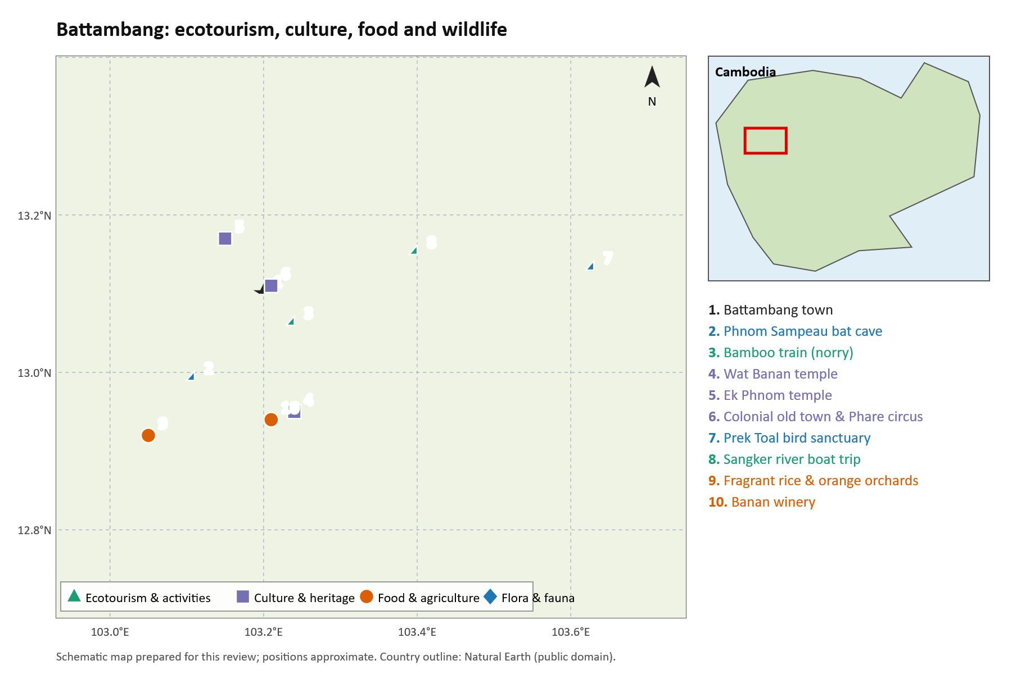
Figure 60. Ecotourism, culture, food and agriculture, and flora and fauna sites in Battambang.
Source: schematic map prepared for this review from published site descriptions; positions approximate.

Geosite location register

Phnom Sampeu La Ang Pracheu bat cave in Battambang
X longitude 103.099832 E Y latitude 13.026548 N
Basis: Published GPS observation. Source: Karst Biodiversity Report 2026, p.17, Table 1, C-32.
Original coordinate expression: 13.026548 N, 103.099832 E.
A named cave record, not entire hill boundary. Report coordinate datum not explicitly verified; WGS84 interpretation requires confirmation.
Location source

Annotated document catalogue
D19 Heng Sophady and colleagues 2016. Laang Spean cave (Battambang province): A tale of occupation in Cambodia from the Late Upper Pleistocene to Holocene. Quaternary International 416, 162–176. DOI 10.1016/j.quaint.2015.07.049. Primary cave archaeology and chronology. Relevant to a western cave-heritage inventory; it must not be confused with similarly named Kampot limestone hills.
DOI · University record
D20 Laumanns Michael 2019. International Speleological Projects to Cambodia 1995/96–2017. Berliner Höhlenkundliche Berichte 77, 271 pages. Covers Kampot, Siem Reap, Kampong Speu, Stoeng Treng, Banteay Meanchey, Odda Meanchey and Battambang. Valuable survey and bibliography source. Publisher catalogue verified; book not downloaded.
Publisher catalogue
D21 Laumanns Michael and Hamilton Abbe 2018. International Speleological Projects to Cambodia 2017 and 2018 (Kampot and Battambang provinces). Berliner Höhlenkundliche Berichte 76, 78 pages. Cave surveys and biospeleology. Publisher catalogue verified; book not downloaded. The catalogue also identifies older Kulen and northwestern expedition volumes now incorporated into volume 77.
Publisher catalogue

National Synthesis and Conclusions

Annotated document catalogue

Cambodian geopark policy and national resources
D01 Kong Sitha 2018. Building Aspiring Geoparks in Cambodia: A New Window to Geosciences, Local Community Development, Tourism and Education. Conference abstract, 8th International Conference on UNESCO Global Geoparks. Printed page 74, PDF page 74 in the retrieved abstract book. The original title contains the spelling “Geoparks.” This is a directly relevant GDMR contribution proposing national parks as a starting point. It is an abstract, not a full feasibility study. The pack includes the original one-page extract.
GGN abstract book
D02 UNESCO. List of UNESCO Global Geoparks and Regional Networks. Official status-checking directory, accessed 22 October 2026. Cambodia was absent from the country list checked. Use it to distinguish designation from expressions of interest.
Official directory
D03 Furey Neil M. Cambodian Caves: Guidelines for sustainable development and management. Fauna & Flora publication, copyright 2025 and publicly released 12 January 2026; Khmer and English editions. Directly relevant to cave management and community use. The publisher describes expert review and collaboration with Cambodian institutions. It is management guidance, not a geological inventory or UNESCO nomination.
Publication and both editions

Implications for the uploaded presentation
Keep the argument linking geology, biodiversity, cultural heritage and livelihoods, but attach each claim to a named source and actual locality. The strongest immediate additions are D01, D03, D09–D12, D18 and D24. D06 supports a broader volcanic-landscape theme in Mondulkiri, with a clear statement that Nam Lea itself still requires site-specific confirmation.
Treat exposed-karst area, mapped carbonate terrain, number of hills and number of caves as different measures. The slide claims of 3.5 percent carbonate terrain, more than 95 outcrops and roughly 120 square kilometres cannot be combined or used interchangeably without the original datasets, date and mapping definitions. This search did not independently validate those national totals. Likewise, avoid presenting all Cambodian limestone as recording one uniform tectonic margin without stratigraphic evidence.
The presentation explicitly labels its proposed regional map as AI-generated. Consistent with the user’s requirement, replace that map with a properly credited published or official map before using it as scientific evidence. Any future image, graph or table should retain its original source, figure or table number and caption. The source documents in the pack provide material for that purpose; the plates integrated in this report reproduce published material with source and reuse notes.

Priority documents to obtain next
For Nam Lea, request the MoE biodiversity survey and current geopark study reports, plus community governance and land-use documents. For Kulen, request the EraGET field guide and any current assessment or geophysical reports from ITC and the responsible authorities. The MoE Phnom Kulen National Park Management Program 2018–2027 has now been obtained [D46]; request its boundary and zoning maps as GIS layers so they can be overlaid on the ITC geosite inventory. For Banteay Meanchey, obtain specimen catalogues, measured sections and current heritage-site maps, then reconcile historical fossil localities with modern names. For the coastal area, assemble cave surveys, geological map sheets, groundwater information, quarry boundaries, biodiversity inventories and existing community agreements.
These are requests for evidence needed to evaluate proposals. They are not assertions that complete dossiers already exist. International geological significance, a coherent territory and functioning management arrangements remain matters for a formal assessment.

Conclusion and Priority Assessment of Candidate Locations
The documentary and field evidence assembled across this investigation establishes that Cambodia possesses extraordinary geodiversity of international scientific, educational, and cultural value. However, the four candidate regions differ sharply in their territorial coherence, geological maturity, governance structures, and conservation needs. To guide national policy, the four study areas are ranked below to identify the strongest candidate for Cambodia’s first National Geopark (and aspiring UNESCO Global Geopark), and the locations better gazetted and managed as individual geosites and national geo-monuments.

Multi-Criteria Comparative Assessment
Each candidate region was evaluated against UNESCO Global Geopark guidelines and national conservation criteria: (1) Geological Rarity & International Scientific Value; (2) Geo-Cultural & Archaeological Linkages; (3) Territorial Coherence & Contiguous Boundary Definition; (4) Institutional Preparedness & Stakeholder Governance; and (5) Vulnerability & Urgent Protection Requirements.

Promising Candidates for National Geopark Status
1. Priority Rank 1 (Primary National Geopark Candidate): PHNOM KULEN (KULEN–ANGKOR GEOPARK)
Phnom Kulen is overwhelmingly the most mature and promising candidate for designation as Cambodia’s first National Geopark and subsequent nomination as a UNESCO Global Geopark.
• Comprehensive Mapped Dossier: Supported by ITC’s dedicated geodiversity assessment (Eng Chandoeun et al., 2026), Kulen has a proposed candidate territory of 948.02 km² containing 23 inventoried geosites, 14 cultural/historical monuments, and 4 scenic viewing spots.
• Unrivaled Geo-Cultural Narrative: Kulen embodies the quintessential geopark mandate by linking earth history directly to human civilization. The Jurassic–Cretaceous sandstone formations (quartz arenite and sub-litharenite) provided the exact building stones for the Angkorian temples (quarried at Tra Peang Cha, Rong Chen, and the southeastern foothills). Furthermore, the plateau’s hydrological system feeds the sacred carved riverbeds of Kbal Spean and the River of 1000 Lingas, recharging the ancient water reservoirs of Angkor and the Tonle Sap basin.
• Institutional Architecture: An active working coalition is already operational, uniting the Ministry of Environment, APSARA National Authority, the Institute of Technology of Cambodia, JICA, Waseda University, and the Japan Geopark Network (JGN).
• Statutory Management Baseline: The core of the candidate territory already lies within Phnom Kulen National Park (37,375 ha, Royal Decree 1993), which has an approved MoE Management Program for 2018–2027 with core, conservation, sustainable-use and community zones. Geosite protection and geotrail planning can be built on this existing zoning rather than a new legal framework, although the programme also records forest cover falling from 86.9% in 2003 to about 55.5%, a pressure the geopark plan must address [D46].
2. Priority Rank 2 (Strategic Trans-Provincial Landscape Candidate): SOUTHERN & SOUTHWESTERN COASTAL BELT (KAMPOT–KEP–BOKOR–KOH KONG)
The southern and southwestern coastal belt represents Cambodia’s second most promising geopark concept, functioning ideally as a large-scale National Landscape Geopark or a phased Coastal-Marine Geopark.
• World-Class Geoscientific Phenomena: The region combines four exceptional themes: (1) Cambodia’s first dinosaur bone (a Lower Cretaceous sauropod fibula from Koh Paur) and Mesozoic non-marine horizons yielding plants, freshwater molluscs and turtles (Lim et al. 2023; Buffetaut et al. 2024); (2) organic-rich black shales of the Bokor Formation in the Kampong Som Basin, interpreted as thermally mature petroleum source rocks (Heng et al. 2022); (3) the high-altitude Bokor Plateau (up to 1,080 m asl), where extreme orographic rainfall on acidic sandstone-derived soils supports 22 endemic plant species and stunted cloud forests (Rundel & Middleton 2017); and (4) the Permian tower karst and sacred cave shrines of Kampot and Kep.
• Strategic Phasing: Because this territory spans four distinct coastal provinces, creating a unified administrative boundary requires complex cross-jurisdictional coordination. The immediate priority is to gazette a "Bokor–Kampot Coastal National Geopark" cluster as Phase 1, followed by western expansion to incorporate the Koh Kong dinosaur fossil island complex as Phase 2.

Locations Designated as Individual Geosites and Geo-Monuments
3. NORTHWESTERN FOSSIL AND KARST SITES (BANTEAY MEANCHEY & BATTAMBANG)
• Strategic Classification: High-Priority Protected Geosites and Paleontological Nature Reserves (Not a Contiguous Geopark).
• Justification: The Sisophon Limestone hills (Phnom Bak, Phnom Kang Va, Phnom Svai) and Battambang karst (Phnom Sampeu, Laang Spean) do not form a single contiguous landscape; rather, they comprise an isolated archipelago of relict karst towers surrounded by flat agricultural land.
• Acute Threat & Statutory Protection: These hills face intense, irreversible destruction from commercial aggregate extraction and cement quarrying. Attempting to manage them as a sprawling regional geopark is impractical. Instead, each hill must be gazetted as an individual National Geosite / Natural Heritage Site under targeted statutory instruments (such as Sub-decree 71 for Phnom Bak), establishing strict protection perimeters around Permian marine fossil beds and prehistoric cave deposits while developing localized visitor interpretation centers.
4. EASTERN PLAINS VOLCANIC & MONOLITH LOCALITIES (MONDULKIRI & RATANAKIRI)
• Strategic Classification: Individual National Geosites and Provincial Geo-Monuments.
• Justification: Outstanding volcanic landforms—such as the near-circular Lake Yeak Laom Maar Crater (Ratanakiri), the Bou Sra stepped basalt waterfall, and the isolated Phnom Nam Lea monolith—are geographically dispersed across dozens of kilometers of plantation land and secondary forest.
• Scientific Verification Need: The geological origin of Phnom Nam Lea remains scientifically unresolved; popular references to a "basalt dome" lack petrological proof, and it requires rigorous thin-section and geochemical analysis to confirm whether it represents an intrusive granitoid or an exhumed volcanic neck. These sites are therefore best protected, interpreted, and promoted as premier individual National Geosites and ecotourism monuments, centered on indigenous Punong (Mondulkiri) and Tampuen (Ratanakiri) cultural heritage, until a unified provincial master plan is formulated.

Strategic Implementation Roadmap
- Immediate Term (Months 1–12): Formally gazette the 948.02 km² Kulen Area Geopark boundary and its 23 geosites; enact urgent statutory protection orders for the Koh Paur dinosaur fossil horizon (Koh Kong) and the Phnom Bak Permian marine fossil beds (Banteay Meanchey) to prevent habitat loss or commercial extraction.
- Medium Term (Years 1–3): Submit the Phnom Kulen application dossier to the UNESCO Global Geoparks Network; complete site-specific geochemical characterization of Phnom Nam Lea; and formulate the Bokor–Kampot coastal geopark master plan.
Long Term (Years 3–5): Establish the Cambodian National Geosite Network (CNGN) to interconnect, monitor, and promote all individual geo-monuments across the kingdom under a standardized national geo-interpretation program.

Appendix A — Regional inventory of ecotourism, culture, food, agriculture, activities and biodiversity
This appendix lists, region by region, the ecotourism sites, cultural places, food and farming landscapes, visitor activities and flora and fauna (biobotany) described in Parts 1 to 5. Each entry has an image. Where a photograph already appears in this report, it is reused and its figure number is given. Where no licensed photograph could be obtained, a locator map showing the site’s position in Cambodia is provided instead, and a field photograph should be added later.
Theme codes: ECO = ecotourism and activities; CUL = culture and heritage; FOOD = food; AGR = agriculture; BIO = flora and fauna (biobotany).

A.1 Siem Reap and Banteay Meanchey
No. | Site and province | Themes | Description | Image
1 | Phnom Kulen waterfall and Preah Ang Thom (Siem Reap) | ECO, CUL, BIO | Swimming and picnics below a waterfall over bedded sandstone; pilgrimage to the reclining Buddha carved into a sandstone boulder; sacred mountain of Jayavarman II (802). | 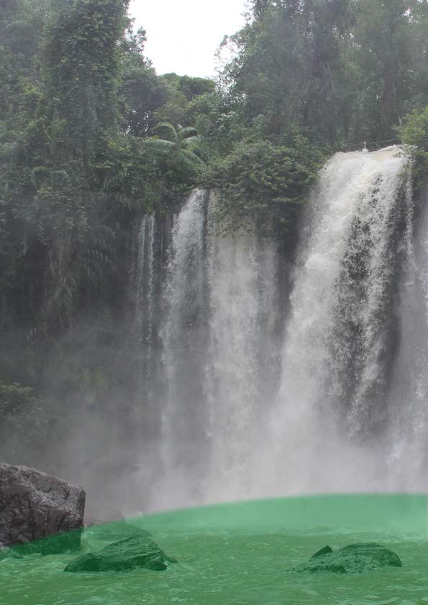Photo: Figure 55, MoE 2017 [D46]  Photo: Figure 55, MoE 2017 [D46]
2 | Srah Damrei stone elephant (Siem Reap) | CUL, ECO | Life-size elephant and lions carved in place from bedrock in quiet forest; forest trek; a geo-cultural monument where sandstone becomes sculpture. | 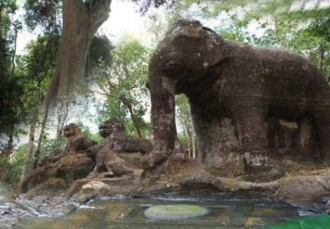Photo: Figure 54, MoE 2017 [D46]  Photo: Figure 54, MoE 2017 [D46]
3 | Kbal Spean, River of a Thousand Lingas (Siem Reap) | CUL, ECO, BIO | Forest walk of about 1.5 km to Angkorian carvings of lingas and Hindu deities in a sandstone riverbed at the head of the Siem Reap River. | 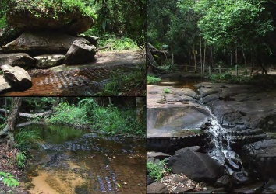Photo: Figure 14  Photo: Figure 14
4 | Kulen orchards and villages (Siem Reap) | AGR, FOOD | Lychee, cashew, palm sugar and wild honey sold at roadside stalls; orchards are the main income and a driver of forest loss (86.9% to about 55.5%) [D46]. | Locator map (photo to be added)
5 | Kulen evergreen and swamp forest (Siem Reap) | BIO | Semi-evergreen and dipterocarp forest with swamp forest at Tnal Mareh; 25 bat species and 28 IUCN-listed plant species recorded [D46]. | 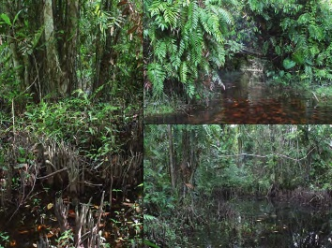Photo: Figure 11  Photo: Figure 11
6 | Angkor Archaeological Park (Siem Reap) | CUL, ECO | UNESCO World Heritage site (1992); sunrise at Angkor Wat, cycling between temples; sandstone from Kulen, laterite foundations and Angkorian reservoirs. | Locator map (photo to be added)
7 | Kampong Phluk and the Tonle Sap (Siem Reap) | ECO, CUL, FOOD, BIO | Stilt houses up to 10 m high, boat trips through flooded forest, fish traps and floating schools; fish amok, prahok and grilled lake fish. | Locator map (photo to be added)
8 | Ang Trapeang Thmor (Banteay Meanchey) | BIO, ECO | Reservoir on an Angkorian embankment; dry-season feeding ground of the sarus crane (Antigone antigone), storks, ibises and egrets; dawn birdwatching. | Locator map (photo to be added)
9 | Banteay Chhmar (Banteay Meanchey) | CUL, ECO, FOOD | Partly collapsed Angkorian temple with bas-reliefs; community-based tourism with village homestays, home-cooked meals and local guides. | Locator map (photo to be added)

A.2 Ratanakiri
No. | Site and province | Themes | Description | Image
1 | Lake Yeak Laom (Ratanakiri) | ECO, CUL, BIO | Round volcanic crater lake about 800 m across and 50 m deep; swimming from jetties; managed by Tampuen communities under a 1998 agreement. | 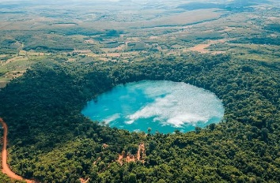Photo: Figure 49  Photo: Part 2, Lake Yeak Laom section
2 | Katieng and Ka Chanh waterfalls (Ratanakiri) | ECO | Streams falling over columnar-jointed basalt; walk behind the Katieng curtain; strongest flow in the wet season. | 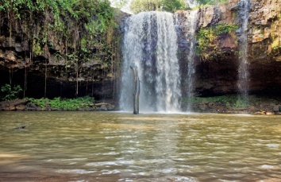Photo: Figure 51  Photo: Figure 51
3 | Kachon Tampuen cemetery (Ratanakiri) | CUL | Forest burial ground on the Sesan with roofed tombs guarded by carved wooden effigies; visit only with a guide. | Locator map (photo to be added)
4 | Kreung, Jarai and Tampuen villages (Ratanakiri) | CUL, FOOD, AGR | Bachelor houses, gong and jar rice wine ceremonies, rotational upland rice; homestay meals of rice, forest vegetables and smoked fish. | Locator map (photo to be added)
5 | Veun Sai and Virachey forests (Ratanakiri) | BIO, ECO | Dawn treks to hear northern yellow-cheeked crested gibbons; hornbills and langurs; small groups with local rangers. | Locator map (photo to be added)
6 | Cashew and rubber country (Ratanakiri) | AGR, FOOD | Cashew orchards and rubber plantations on red basaltic soils; hand harvesting and roadside roasting of cashew nuts. | Locator map (photo to be added)
7 | Sesan River (Ratanakiri) | ECO, CUL, BIO | Boat trips between Lao, Chinese-Khmer and Indigenous villages; changing fisheries and water levels downstream of hydropower dams. | Locator map (photo to be added)

A.3 Mondulkiri
No. | Site and province | Themes | Description | Image
1 | Sen Monorom and the Sea of Forest (Mondulkiri) | ECO | Cool grassland and pine hills; base town for the province; dawn views over mist-filled forest valleys towards Vietnam. | Locator map (photo to be added)
2 | Bou Sra waterfall (Mondulkiri) | ECO, FOOD | Two broad tiers of volcanic rock; busy family picnic site; nearby Punong villages sell coffee, honey and baskets. | 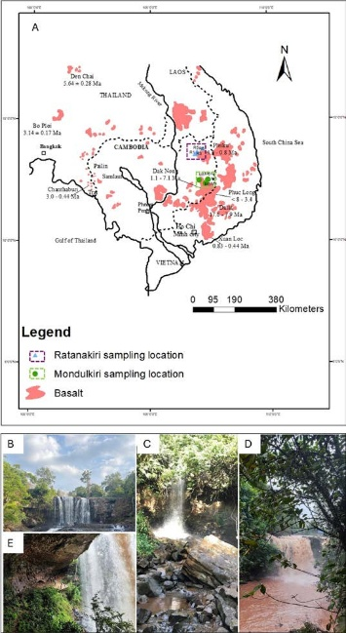Photo: Figure 6 (panel B)  Photo: Figure 6, panel B (Bou Sra)
3 | Elephant Valley Project (Mondulkiri) | ECO, CUL, BIO | Retired working elephants live in forest with Punong mahouts; visitors walk with them rather than ride. | Locator map (photo to be added)
4 | Jahoo Gibbon Camp, Keo Seima (Mondulkiri) | BIO, ECO | Punong-run camp at Andoung Kraloeng; habituated southern yellow-cheeked crested gibbons and black-shanked douc langurs; income funds patrols. | Locator map (photo to be added)
5 | Punong villages and spirit forests (Mondulkiri) | CUL, FOOD | Spirit and burial forests, gong and rice wine ceremonies, thatched houses, weaving and basketry; Punong ‘jungle’ soup. | Locator map (photo to be added)
6 | Coffee and avocado farms (Mondulkiri) | AGR, FOOD | Coffee, avocado, pepper and durian on red basaltic soils; farm visits, roasting and tasting. | Locator map (photo to be added)
7 | Nam Lea stone dome (Mondulkiri) | ECO, BIO | Bare rock dome above forest near the Vietnamese border; long ride and forest walk; candidate geosite. | Locator map (photo to be added)

A.4 Kampot, Kep, Koh Kong and Kampong Som
No. | Site and province | Themes | Description | Image
1 | Bokor plateau and hill station (Kampot) | ECO, CUL, BIO | 1920s French hill station ruins, Popokvil waterfall and Wat Sampov Pram; cloud forest and sphagnum bog with Nepenthes bokorensis. | 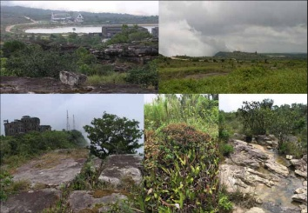Photo: Figure 23  Photo: Figure 23
2 | Bokor stunted forest (Kampot) | BIO | Stunted forest and emergent conifers on the sandstone plateau above about 900 m. | Photo: Figure 36  Photo: Figure 37
3 | Kampot town and Teuk Chhou river (Kampot) | ECO, CUL, FOOD | French shophouses on the riverfront; kayaking, sunset and firefly boat trips; evening food stalls. | Locator map (photo to be added)
4 | Phnom Chhngok cave temple (Kampot) | CUL, ECO | Pre-Angkorian brick temple inside a limestone cave among stalactites, reached across rice fields. | Locator map (photo to be added)
5 | Kampot pepper farms (Kampot) | AGR, FOOD, ECO | GI pepper (Cambodia 2010, EU 2016) grown on posts; green, black, red and white pepper; farm tours and tasting. | Locator map (photo to be added)
6 | Kampot salt fields (Kampot) | AGR, CUL | Dry-season solar salt ponds east of town; workers rake salt into white mounds. | Locator map (photo to be added)
7 | Kep crab market and Koh Tonsay (Kep) | FOOD, ECO | Crab stir-fried with green Kampot pepper; boats to Rabbit Island; Kep National Park forest trail. | Locator map (photo to be added)
8 | Ream National Park and Koh Rong (Preah Sihanouk) | BIO, ECO | Mangrove boat trips with rangers, beaches and islands; snorkelling and bioluminescent plankton at Koh Rong. | Locator map (photo to be added)
9 | Peam Krasaop and Tatai (Koh Kong) | BIO, ECO | Mangrove boardwalk with mudskippers and crabs; kayaking on the Tatai River to the waterfall. | 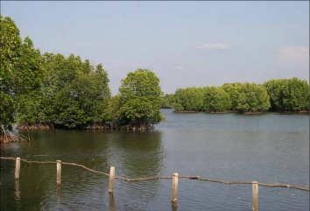Photo: Figure 18  Photo: Figure 18
10 | Chi Phat and the Areng Valley (Koh Kong) | ECO, BIO, CUL | Community ecotourism with former hunters as guides; Cardamom forest with Siamese crocodile, Asian elephant and hornbills. | Locator map (photo to be added)

A.5 Battambang
No. | Site and province | Themes | Description | Image
1 | Battambang old town and Phare Ponleu Selpak (Battambang) | CUL, ECO | French colonial shophouses, galleries and cafés along the Sangker River; Phare circus performances. | Locator map (photo to be added)
2 | Bamboo train (Battambang) | ECO, CUL | Short ride on a bamboo ‘norry’ platform through rice fields; platforms lifted off the track to pass. | Locator map (photo to be added)
3 | Phnom Sampeu (Battambang) | BIO, CUL, ECO | Limestone hill with pagodas and the killing caves memorial; dusk emergence of wrinkle-lipped free-tailed bats. | Locator map (photo to be added)
4 | Wat Banan and Banan vineyard (Battambang) | CUL, FOOD, AGR | Five-towered Angkorian hilltop temple; family vineyard producing wine, brandy and grape juice. | Locator map (photo to be added)
5 | Ek Phnom (Battambang) | CUL, FOOD | Eleventh-century sandstone temple beside a modern pagoda; roadside rice-paper and fish-paste making. | Locator map (photo to be added)
6 | Prek Toal bird sanctuary (Battambang) | BIO, ECO | Flooded forest colonies of spot-billed pelican, painted and milky storks, adjutants and Oriental darter; dawn boat trips. | Locator map (photo to be added)
7 | Rice and orange country (Battambang) | AGR, FOOD | Irrigated jasmine rice paddies and Battambang orange orchards; farm and orchard visits. | Locator map (photo to be added)

