Overview of Geological Features and Resource Potential of Karst in Cambodia
(Focusing on Karst Landforms and Distribution)
1. Introduction
Karst is a distinctive landscape formed by the dissolution of carbonate rocks such as limestone, dolomite and other calcareous rocks. Its development is controlled by lithology, structure, hydrology, and tropical weathering. According to regional assessments, approximately 3.5% (~6,300 km²) of Cambodia’s land surface is characterized by exposed, surface karst terrain developed over carbonate rocks, with significant geological, hydrological, ecological, and cultural importance. Additional subsurface carbonate sequences may exist beneath younger cover, but they are not expressed as surface karst.
This report highlights the geological features, karst landforms, and distribution of karst areas in Cambodia.
2. Geological Features of Karst in Cambodia
- Lithology
  - Predominantly Carboniferous–Permian limestones with dolostone, calcareous shale, and marl.
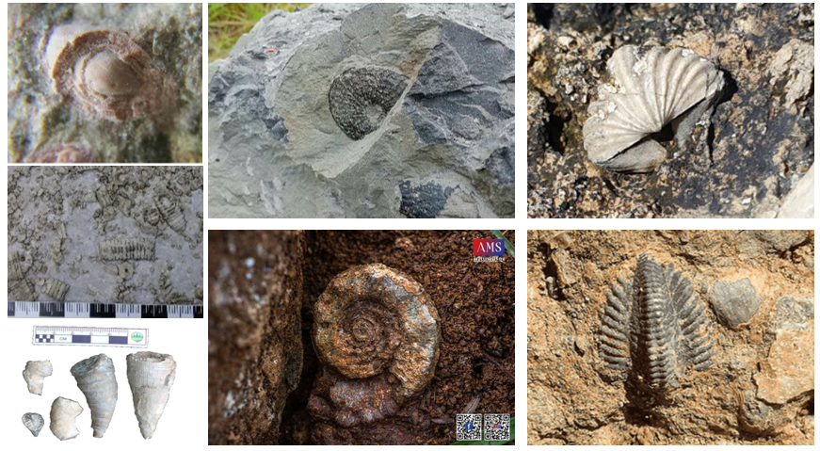
  - Fossils (fusulinids, brachiopods, corals, bivalves) confirm shallow marine carbonate platform origin along the Paleo-Tethys margin.
Figure 1: Fossils confirm shallow marine carbonate platform

- Tectonic Setting
Karst terrains in Cambodia are distributed across several provinces, primarily where Carboniferous–Permian limestone and dolostone are exposed at the surface. These carbonate rocks were deposited in shallow marine environments along the Paleo-Tethys Ocean margin and later uplifted and deformed during the Indosinian Orogeny (Triassic).
  - Indosinian Orogeny (Triassic) uplifted and deformed carbonate platforms, creating faults and fractures that accelerated dissolution.
  - Cenozoic tropical weathering enhanced karstification, producing tower karst, pavements, and caves.
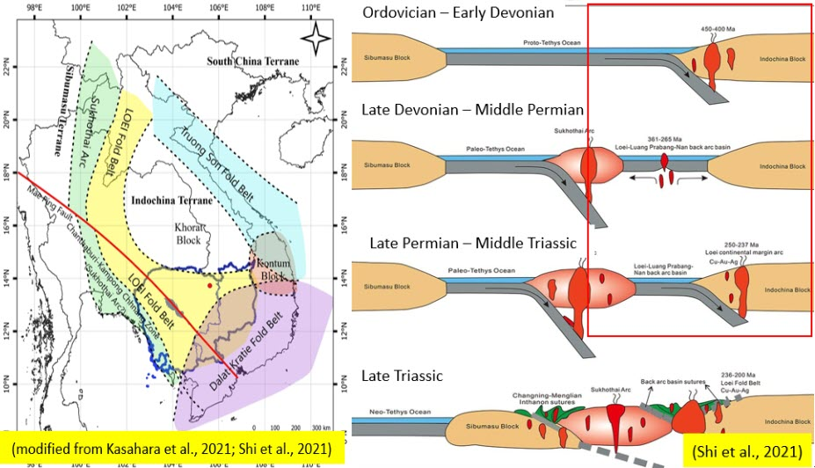
Figure 2: sketch of tectonic setting and evolution of cambodia

3. Distribution and Covering Area of Karst in Cambodia
Karst terrains are found in scattered regions across the country:
- Southern Cambodia
  - Kampot & Takeo: Tower karst, caves, speleothems (e.g., Kampong Trach, Phnom Chhngok).
- Western Cambodia
  - Battambang & Pursat: Isolated limestone hills (Phnom Sampov, Phnom Laang Spean, Phnom Preok); caves with archaeological significance.
- Central Cambodia
  - Kampong Speu & Kampong Thom: Smaller karst outcrops (Phnom Chas, Kampong Speu) with localized aquifers.
- Northern Cambodia
  - Preah Vihear & Stung Treng: Larger limestone ridges and collapse dolines (Phnom Thom Nori, Ramsar Mekong wetlands).
- Northeastern Cambodia
  - Kratie: Dominated by limestone pavements and karren surfaces; important for aquifer recharge and geomorphological study.
  - Ratanakiri & Mondulkiri: Dominated by limestone pavements and scattered small limestone outcrops, underexplored but of geological interest.

Figure 3: Distribution of karstifiable rocks or potential karst aquifers

4. Karst Landforms of Cambodia
Cambodia exhibits a variety of tropical karst landforms developed under humid climatic conditions, influenced by lithology, structure, and long-term weathering. These landforms range from tower and to pavements and caves, reflecting different stages of karstification.
Table 1: summary of karstification features
Feature | Description
Solution Caves | Underground caves formed by dissolution; abundant in Kampot (Phnom Chhngok, Kampong Trach) and Battambang (Phnom Sampov, Phnom Laang Spean). Many host shrines and archaeological sites.
Cenotes | Natural water-filled depressions linked to groundwater; less common, but localized pools observed in Stung Treng and Kratie karst zones.
Sinkholes | Depressions caused by limestone collapse or dissolution; reported in Battambang and Stung Treng.
Dolines / Collapse Dolines | Geological term for sinkholes, often from roof collapse; found in Stung Treng, Preah Vihear, and Battambang.
Springs | Karst aquifers discharge at springs; key water source in Battambang.
Disappearing Streams | Surface streams that sink into underground conduits; seen in Kampot and Stung Treng karst systems.
Provores / Cave Openings | Horizontal entrances to caves; common at Phnom Sampov and Phnom Chhngok, historically used as shelters.
Speleothems | Stalactites, stalagmites, and flowstones; well developed in Kampot caves and Battambang caves, also used for paleoclimate studies.
Limestone Pavement & Karren Surfaces | Exposed flat limestone with grooves, pits, and solution channels; typical of Kratie karst areas.
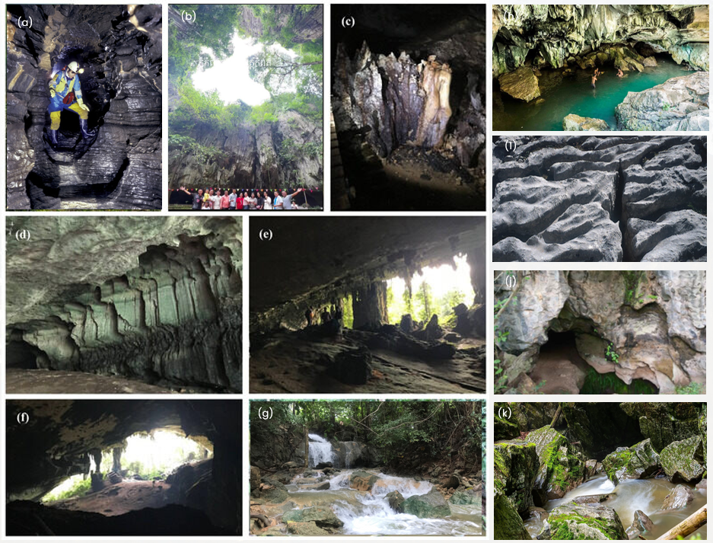

Figure 4: photos of karst features in Cambodia

5. Resource Potential of Karst in Cambodia
Cambodia’s karst terrains provide a wide range of economic, environmental, and cultural resources. Despite covering only about 3.5% of the country’s surface area, karst regions play a disproportionately large role in the national economy, water supply, tourism, and biodiversity conservation. The main resource potentials are summarized below.
- Industrial and Mineral Resources
Limestone for Cement and Industrial Use:
- The Kampot and Battambang karst regions host high-purity limestone (commonly >90% CaCO₃), making them the core of Cambodia’s cement industry.
- Major production centers include Kampot Cement and other plants in Touk Meas and Battambang, supplying domestic and regional markets.
- Limestone is also used in construction materials, lime production, glass, ceramics, fertilizers, and animal feed.
Other Carbonate-Hosted Minerals:
- Karstified carbonate rocks provide potential for base and precious metal deposits, particularly Pb-Zn, Cu, Au, and phosphate mineralization.
- Geochemical studies indicate possible carbonate-replacement type deposits in western and northern Cambodia, though exploration remains limited.
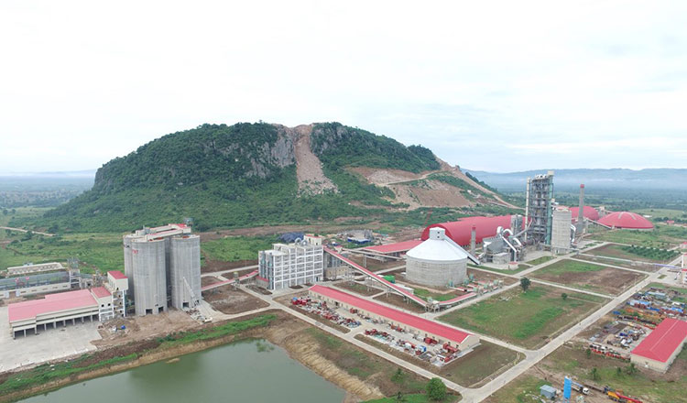
Figure 5: Cement factory in Battambang karst zone

- Water Resources
Karst Aquifers
- Karst aquifers are important groundwater reservoirs due to high secondary porosity from fractures and conduits.
- Springs and wells in Kampot, Battambang, Kratie, and Stung Treng provide essential water for domestic, agricultural, and industrial use.
- These aquifers exhibit high yield but are highly vulnerable to contamination due to rapid infiltration and lack of filtration.
Hydrological Importance
- Many karst areas function as natural groundwater recharge zones, especially limestone pavements in Kratie and collapse dolines in Stung Treng.
- Sustainable water resource management in karst terrains is crucial for maintaining dry-season water supply in rural areas.
- Tourism and Cultural Heritage
Tourism Development
- Karst landscapes are among Cambodia’s most scenic natural features.
- Attractions include:
  - Phnom Chhngok Cave (Kampot) – Buddhist shrine and speleothem formations.
  - Phnom Sampov (Battambang) – caves, cliff viewpoints, and bat colonies.
  - Kampong Trach Tower Karst (Kampot) – popular for cave exploration and climbing.
- Tourism activities include caving, motorbike and ox-cart tours, rock climbing, and bat watching at sunset.
Figure 6: Tourism potential of karst landscape

Cultural and Archaeological Value
- Caves preserve evidence of prehistoric human occupation, including stone tools and pottery (e.g., Phnom Laang Spean, Battambang).
- Some caves contain Buddhist shrines and meditation sites, forming an important part of local religious and cultural life.
- Speleothem records have been used for paleoclimate reconstruction, providing insight into climate variability during the Angkor period.

Figure 7: Cultural and archaeological heritages in karst zone

- Biodiversity and Ecosystem Services
Biological Diversity
- Karst ecosystems host a wide range of endemic and specialized species:
  - Bats (key for pollination and seed dispersal)
  - Cave invertebrates (e.g., spiders, crickets, beetles)
  - Cliff-dwelling birds (swifts, owls, raptors)
  - Limestone flora (orchids, ferns, and alkaline-soil-adapted plants)
Ecosystem Functions
- Karst forests regulate groundwater recharge, control soil erosion, and support carbon sequestration.
- Many karst areas are biodiversity refuges within otherwise intensively cultivated landscapes.
Conservation Issues
- Habitat loss from limestone quarrying, pollution, and land conversion threatens these ecosystems.
- Conservation of biological and cultural resources should be integrated into karst land-use planning.

Figure 8: Photos of animal species found in cambodia’s karst area
Table 2: summary of potential resources of karst land-use
Resource Type | Key Provinces | Main Features / Uses | Remarks
Industrial Limestone | Kampot, Battambang, Stung Treng | Cement, lime, glass, fertilizer | High purity (>90% CaCO₃)
Metal & Phosphate Potential | Western & Northern Cambodia | Pb-Zn, Au±Cu, phosphate | Limited exploration
Water Resources | Kampot, Battambang, Kratie | Springs, wells, recharge zones | High yield but pollution risk
Tourism & Culture | Kampot, Battambang, Takeo | Caves, towers, shrines, bat watching | Eco-tourism opportunities
Biodiversity & Ecology | All major karst regions | Bats, cave fauna, endemic plants | Need for conservation & management

Cambodia’s karst terrains represent multi-resource environments with overlapping industrial, hydrological, ecological, and cultural importance. However, uncontrolled quarrying, groundwater contamination, and loss of biodiversity pose increasing threats.
Sustainable management should integrate:
- Geological resource assessment and extraction zoning,
- Protection of karst aquifers and ecosystems,
- Promotion of geotourism and heritage conservation, and
- Community-based monitoring and land-use planning.
6. Conclusion
Cambodia’s karst landscapes are formed mainly from Paleozoic limestones uplifted during the Indosinian Orogeny and modified by tropical weathering. They host diverse landforms such as solution caves, tower karst, dolines, springs, karren surfaces, and speleothems, each with scientific, cultural, and resource significance.
Although karst areas cover a relatively small portion of Cambodia, they are critical for:
- Industrial use (cement raw materials, high-purity limestone).
- Water resources (karst aquifers, springs).
- Tourism and culture (caves, shrines, archaeological sites).
- Biodiversity conservation (habitats for bats, cave fauna, and unique flora).
Sustainable management is essential to balance resource extraction, water security, tourism development, and heritage conservation across Cambodia’s karst regions.

