**CLEMSON UNIVERSITY  
DEPARTMENT OF MECHANICAL ENGINEERING  
ME 4560/6560 Additive Manufacturing**

**Individual Project 1- Due February 26, 2020**

# Introduction

Several of the AM processes require planning the path of a tool head while it moves around depositing material. Generating the machine instructions to command the AM machine is one of the many challenges associated with AM. The toolpath chosen will significantly affect the overall quality and strength of the final manufactured object.

For FDM processes, a ***slicer*** software will slice a .stl file into layers and generate the Gcode (machine instructions) which specify the toolpath for each layer.

# Problem

Write a Matlab program (or any programming language) to generate the Gcode to build the object shown in the picture below on the FDM printer. The part should be 70% hollow on the inside. Use PLA filament. Test your Gcode on the printer until you are satisfied with the results. Dimensions are in mm. 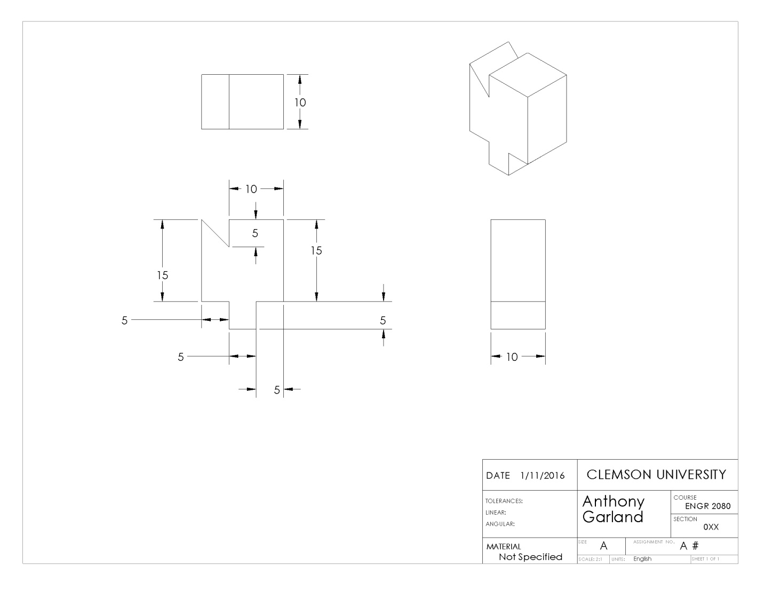

# Helpful information

* Printer website <http://builder3dprinters.com/>
  + <http://builder3dprinters.com/products/big-builder-dual-feed-overview/>
    - You can get more information about the printer specifications here.
  + <http://builder3dprinters.com/installation/>
* The firmware that reads the Gcodes is extremely similar to the Marlin Firmware
  + <http://reprap.org/wiki/Marlin>
  + List of Gcodes <http://reprap.org/wiki/G-code>
* You can look at existing slicer/Gcode generators
  + <http://slic3r.org/>
  + <https://ultimaker.com/en/products/cura-software>
  + Not a slicer, but a wrapper for the slicers can make things easier, also, it should let you simulate your Gcode if you open your Gcode file in the program: <http://www.repetier.com/>

# Advice

* Draw the object in CAD, slice it with one of the programs mentioned above, export the gcode generated by the slicer into an ASCI format, and view the Gcode. Try to understand the issues associated with slicing a .stl file.
* Simulate your Gcode with the Repetier software before running it on the printer.

# Warning

* Do not damage the printer!
* The printer will attempt to execute your command even if it goes beyond the range of the printer.
* While testing your code, ask a student to stand the printer in order to turn the printer off **IMMEDIATELY** if your code is not doing what you expect and may damage the printer.

# Deliverables

1. A Gcode generation program
   1. You must write it 100% yourself (sign the honor code)
   2. Submit the source code files (ie, the .m files)
2. A report
   1. Write a short professional report that includes the following sections
      1. Introduction
      2. Discussion
         1. How the program works.
         2. Issues faced while making the Gcode. This should include a description/justification for design decisions made.
         3. What were some of the most challenging parts of generating the Gcode.
         4. How do the dimensions of your printed object compare to the desired object?
         5. Did the layers bond together? Did side-by-side extrusions bond together?
      3. Conclusions
         1. Did the Gcode work like expected
         2. What could be modified to make it better
   2. The report should also include a pictures of
      1. The simulated gcode
      2. The final printed part
   3. Spelling and grammar mistakes are not acceptable.
   4. Format your report professionally. Use double spaced lines
   5. No more than 5 pages double spaced