Data Visualization Assessment Quiz 1

1. Which of the items below describe an aspect of the visualization to the right that is NOT problematic?
   1. The figure maps data in three dimensions
   2. Difficult to see levels of lemons and oranges in the back
   3. Figure has no caption and no axis labels
   4. Lemons and oranges should not be separated (both are citrus fruits)
2. 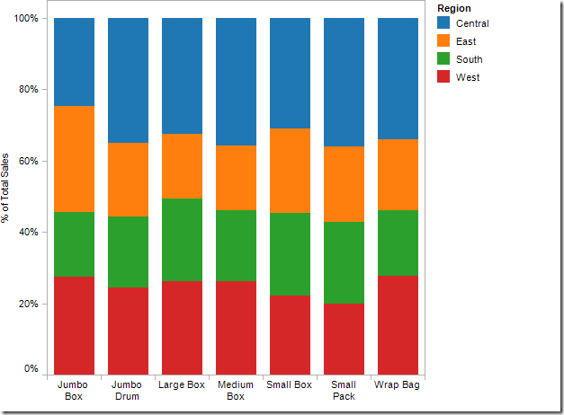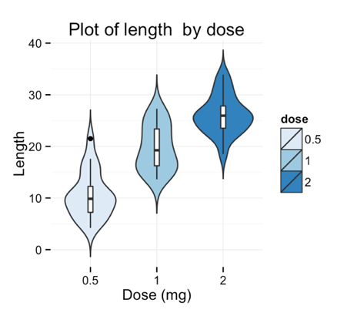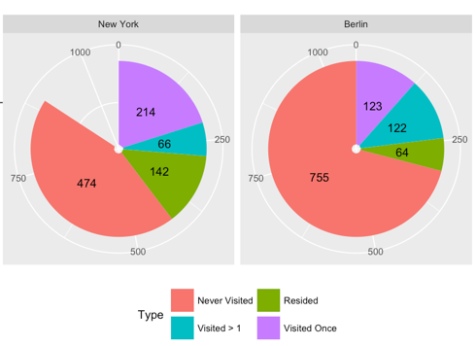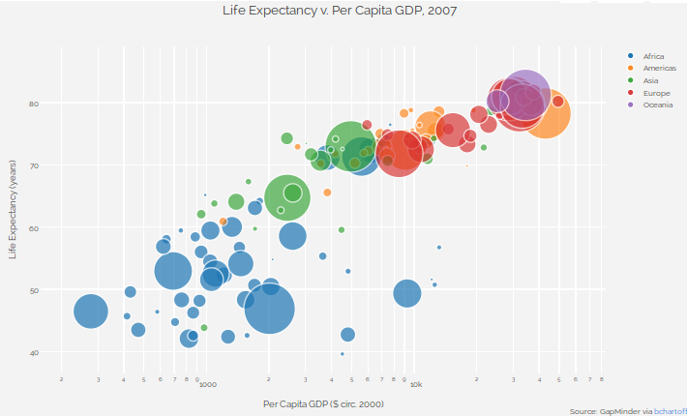Which plot type below offers the best option for plotting the following data: you examined the insect community composition in two habitat types (tall grass prairie and forest) in 6 experimental plots (3 in each habitat) for the summer. You measured the number of insects of five different types (chewing herbivores, sucking herbivores, airborne predators and ground-based predators) in each plot every week for 3 months.

A

D

C

B

1. Which statement below is NOT a good reason why boxplots are better than bar plots?
   1. Box plots provide less visual clutter and a clearer picture about differences among mean values
   2. Bar plots give the false impression of the presence of data beneath the mean or median
   3. Box plots give the reader information about outliers
   4. Box plots give the reader information about not just the mean, but also the distribution of the data
2. Draw the type of figure that the following code in R will produce (assume y is a vector with 100 or so randomly drawn integers whose mean is 5):

hist(y, breaks = 10, main = “A standard title”, xlab = “Tissue dry mass”, ylab = NULL)

1. The code to the right uses the ggplot2 framework to make the Figure below. Circle the part of the code that builds linear model geoms and connect it to the appropriate part of the figure below.

ggplot(rice, aes(x = RootDryMass, y = ShootDryMass, color = fert)) +

geom_point(size = 4, alpha = 0.5) +

geom_smooth(method = "lm", se = FALSE) +

labs(x = "Root Dry Mass (mg)",

y = "Shoot Dry Mass (mg)",

color = "Fertilizer Type") +

theme_classic()

1. Which of the following lines of code describe an aesthetic mapping?
   1. geom_point(color = “blue”)
   2. ggplot(data = rice)
   3. coord_fixed(expand = TRUE)
   4. geom_smooth(aes(group = fert))

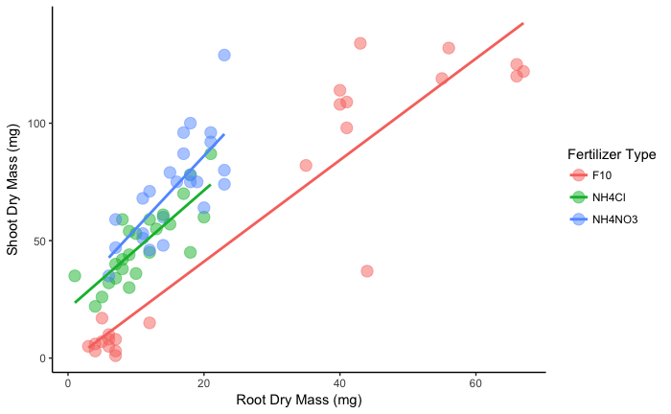

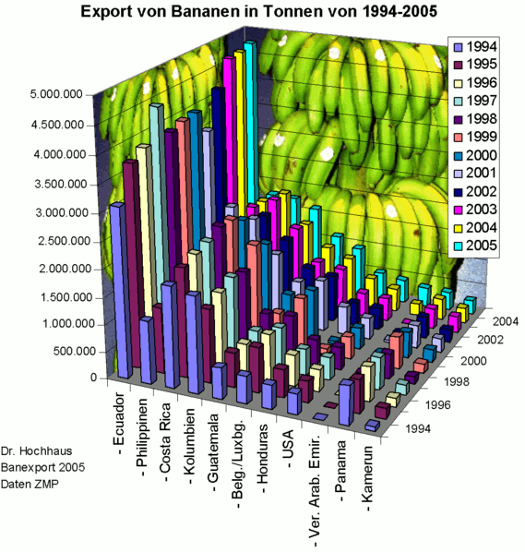

Data Visualization Assessment Quiz 2

1. Which of the items below describe an aspect of the visualization to the right that is NOT problematic?
   1. The figure maps data in three dimensions
   2. Countries are not organized by latitude
   3. Difficult to see levels of some years in the back
   4. Figure has no axis labels for the y-axis
2. Which plot type below offers the best option for plotting the following data: you design an experiment where you measure the expression level of a gene in *Drosophila melanogaster* (fruit fly) that you think contributes to heat tolerance. You want to compare average expression levels (and variability) across four experimental treatments: 1) a control treatment where flies are raised at normal temperatures, 2) a treatment where flies are raised at an increased temperature, 3) a treatment where flies are raised at a decreased temperature and 4) a treatment where you increase temperature throughout development.

B

C

D

A



1. Which statement below is NOT a good reason why boxplots are better than bar plots?
   1. Bar plots give the false impression of the presence of data beneath the mean or median
   2. Box plots provide less visual clutter and a clearer picture about differences among mean values
   3. Box plots give the reader information about not just the mean, but also the distribution of the data
   4. Box plots give the reader information about outliers
2. Draw the type of figure that the following code in R will produce (assume y is a vector with 100 or so randomly drawn integers whose mean is 5):

boxplot(y, breaks = 10, main = “A standard title”, xlab = “Tissue dry mass”, ylab = “No axis title”)

1. The code to the right uses the ggplot2 framework to make the Figure below. Circle all of the data in the code, and draw boxes around all of the geoms.

ggplot(rice, aes(x = RootDryMass, y = ShootDryMass, color = fert)) +

geom_point(size = 4, alpha = 0.5) +

geom_smooth(method = "lm", se = FALSE) +

labs(x = "Root Dry Mass (mg)",

y = "Shoot Dry Mass (mg)",

color = "Fertilizer Type") +

theme_classic()



1. Which of the following lines of code describe an aesthetic mapping?
   1. geom_smooth(aes(group = fert))
   2. coord_fixed(expand = TRUE)
   3. ggplot(data = rice)
   4. geom_point(color = “blue”)