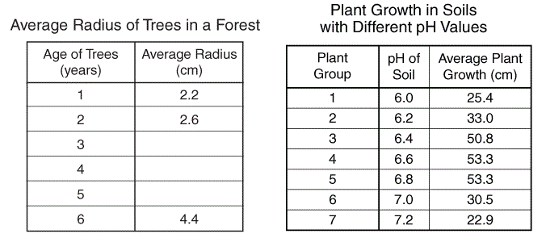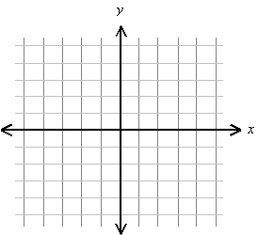

pH = Gradient color scale

Average radius = y axis

Age of Trees = x axis

Plant Group = point style

Average plant growth = size

Linear-model trendline = line

Finished Figure