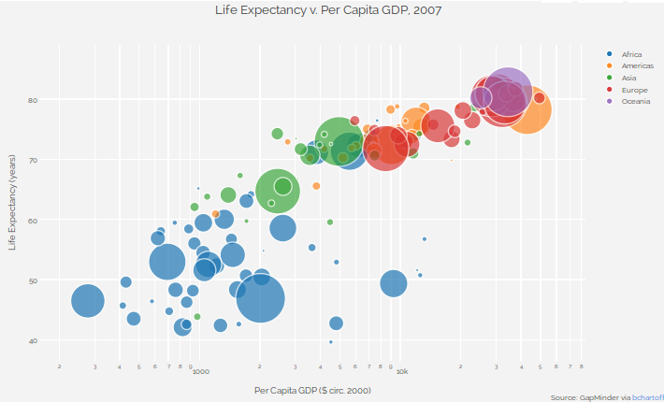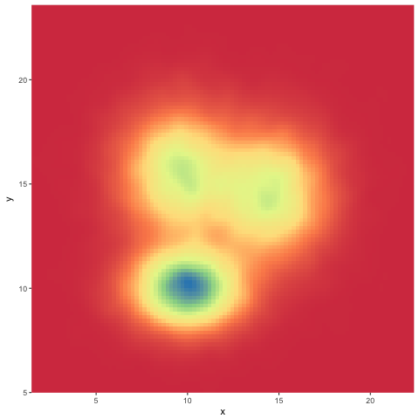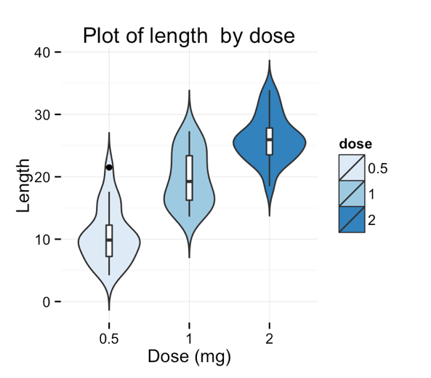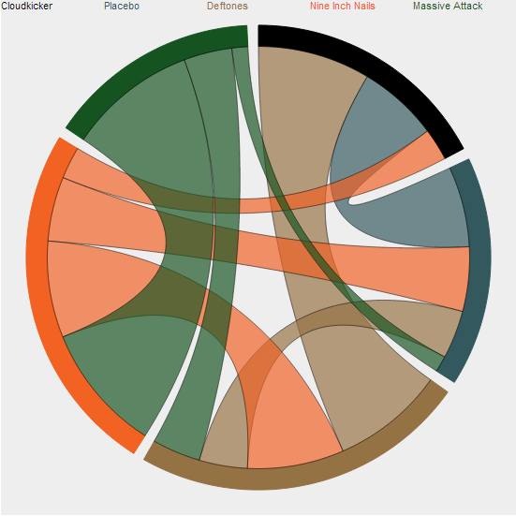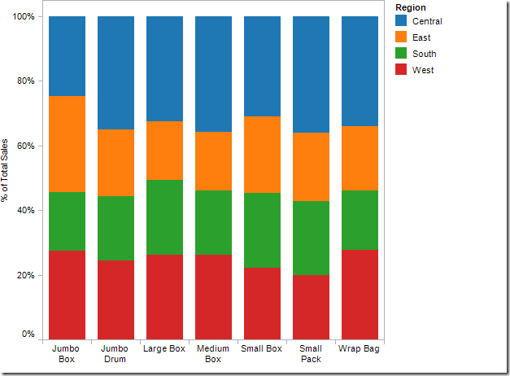

You want to visualize human migration patterns in and out of the countries of Syria, Western Africa and Myanmar.

You have data on the average amount of time visitors to a website spent on a particular page for three different layouts.

You’re comparing the growth rate of 3 types of genetically modified sorghum treated with 7 different fertilizers – in each treatment, you have a sample size of around 25.

You have spatial data within a city about related to crime rates, and want to show where the highest density is of activity is.

You have long-term data on multiple cities across Scandinavia about average household income, average family size and city population.