_{CA169 Assignment 1 Lab Report}

_{Submit these pages onwards.}

Date: | 12/03/2018
STUDENT NAME: | Aaron Keaveney
STUDENT NUMBER: | 17318003
PROJECT NUMBER: | 1
MODULE CODE: | CA169
DEGREE:  [CA EC ECSA PSSD] | CA
LECTURER: | Brian Stone

Declaration
In submitting this project, I declare that the project material, which I now submit, is my own work. Any assistance received by way of borrowing from the work of others has been cited and acknowledged within the work. I make this declaration in the knowledge that a breach of the rules pertaining to project submission may carry serious consequences.

Answer Sheets

Ipconfig exercise
IP address of the machine | 136.206.18.143
MAC address | 50-9A-4C-3D-AF-B2

Ping exercise 1
What is displayed?

When you type ping into the command prompt, you get a list of all the usages that is associated with ping. You can use this list in many different ways to help you find out information about a certain IP address or webpage.

Ping exercise 2

Ping localhost
Paste window here.
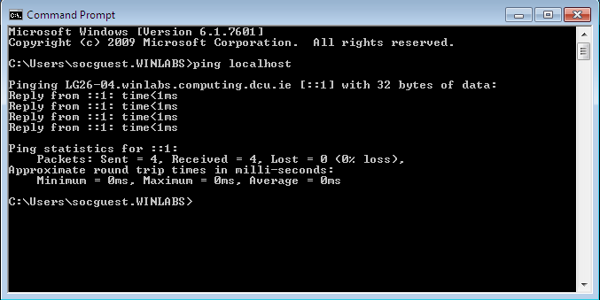
- What information is returned?
- What is the localhost?

Answer 1
The information that is returned is the information from sending packets to the localhost. This information tells us that when I pinged the localhost (this computer in other words) from this computer. This means I am sending information to myself on the computer. It took 0ms for the 4 packets to do round-trip around the computer.

Answer 2

The local host is a host name for this computer. It is used to test the network services that are running on the host. In this case LG26-04.winlabs.computing.dcu.ie .To test this, a loopback is used to test the localhost. Using a localhost means you can run a network service without requiring a physical network interface.

Additional marks

Additional Marks
Website 1:
IP Address :89.207.56.140 = www.rte.ie
Owner: RTE commercial enterprise limited
Contact Number: +353 23082636
Address: Donnybrook, Dublin 4, Ireland
Website 2:
IP Address : 173.194.34.120 = www.google.ie
216.58.211.163 = www.google.ie
Owner: Google LLC
Number: +1 855-836-3987
Address : 1600 Amphitheatre Parkway, Mountain View, CA 94043, USA

I used the website https://ipinfo.info/html/ip_checker.php to find out the websites information.

Ping the IP address 89.207.56.140 or the address 173.194.34.120
Paste window here

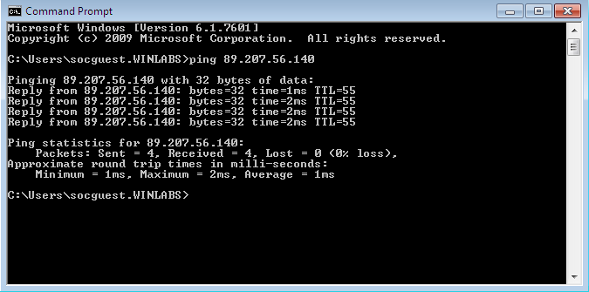

Explain output here, item by item.
Line 1: This line is telling us that we are pinging the IP address 89.240.56.140 with 32 bytes of data in the form of an ICMP echo request
Line 2-5: These lines tell us that we are receiving a reply from the website in a time of 2ms. We are also told the time-to-live of 55 which means that if the network takes too long, it will be discarded.
Line 8: This tells us the number of packets sent, received and lost and the percentage that was lost in this process.
Line 10: This tells us the time it took for the round trip. We get the quickest time, the slowest time and the average time. It is measured in milliseconds (ms)

Exercise 3
Paste window 1
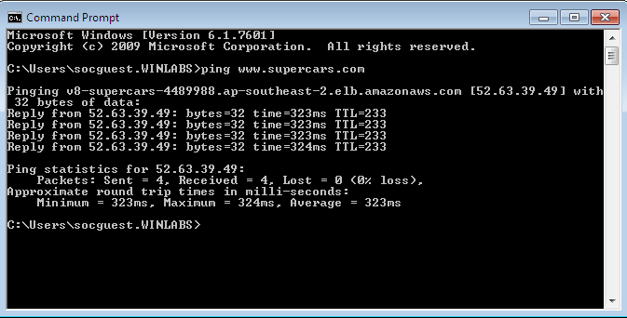

Paste window 2

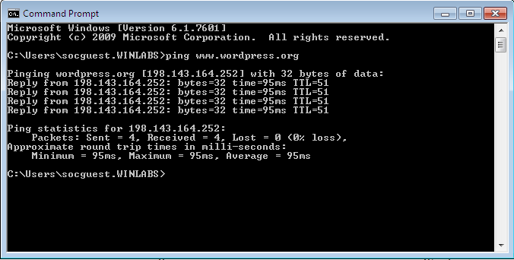

 | Website 1 | Website 2
Name of the website pinged | www.supercars.com | www.wordpress.org
What is the IP address returned? | 52.63.39.49 | 198.143.164.252
What is the TTL figure? | 233 | 51
Average round trip time | 324ms | 95ms

Your comments on administrative information that you found by searching on the Internet about the websites from experiment 3. Things like, who owns it, phone numbers, email addresses, registered addresses etc, anything at all that tells us about the website and its administration.
Website 1:
Owner: Amazon AWS Network Operations
Number: +1-206-266-4064
Address: Amazon Technologies Inc, 410 Ferry Avenue North, WA 98108-1226, USA

Website 2:
Owner: SingleHop LLC
Number: +1 312-447-2580
Address: SingleHop, LLC,125 S. Clark 19th Floor, Chicago, IL 60603, USA

Exercise 4: Netstat exercise

Number of packets received by workstation:
Number of IP packets = 153976551 bytes
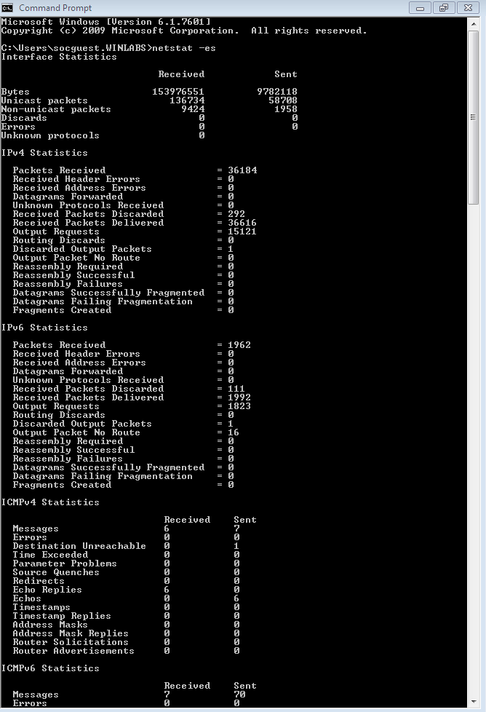

ICMP packets explained:

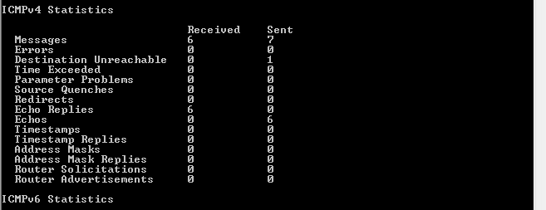
ICMP stands for Internet Control Message Protocol. ICMP is used by network devices, such as routers, to send packets of data that have informational data stored within them such as error messages. The above image has 7 sent ICMP packets which came from a pinging web server. As seen above, 6 out of the 7 packets received reached the final destination.

Discuss the connections opened by visiting the DCU website here.
Also, grab the window, showing connections opened as a result of visiting the DCU website.
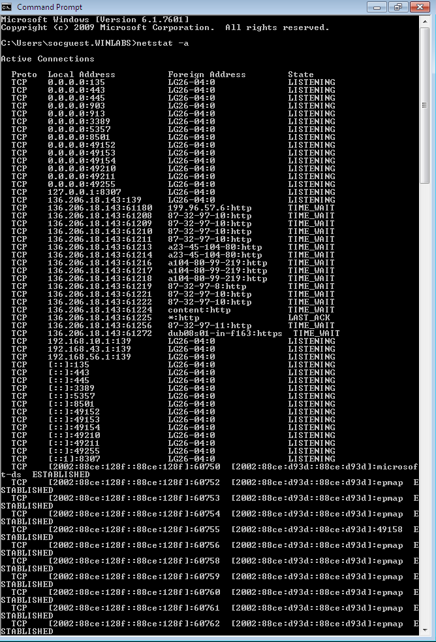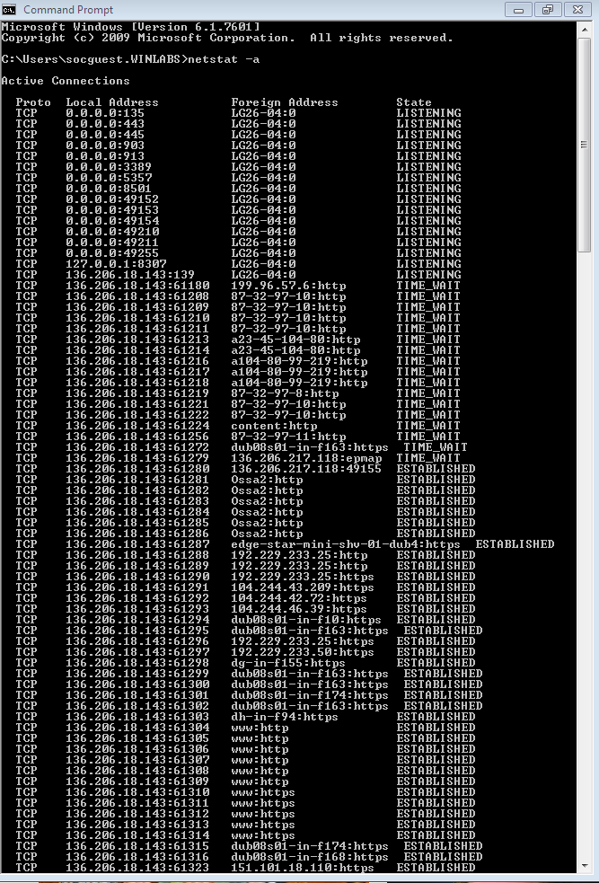
Before opening webpage After opening webpage

The connection opened after the opening web browser we the OSSA:http and some new www.http connections. They all have established mean meaning that they all connected to the webpage.

Netstat –r explained
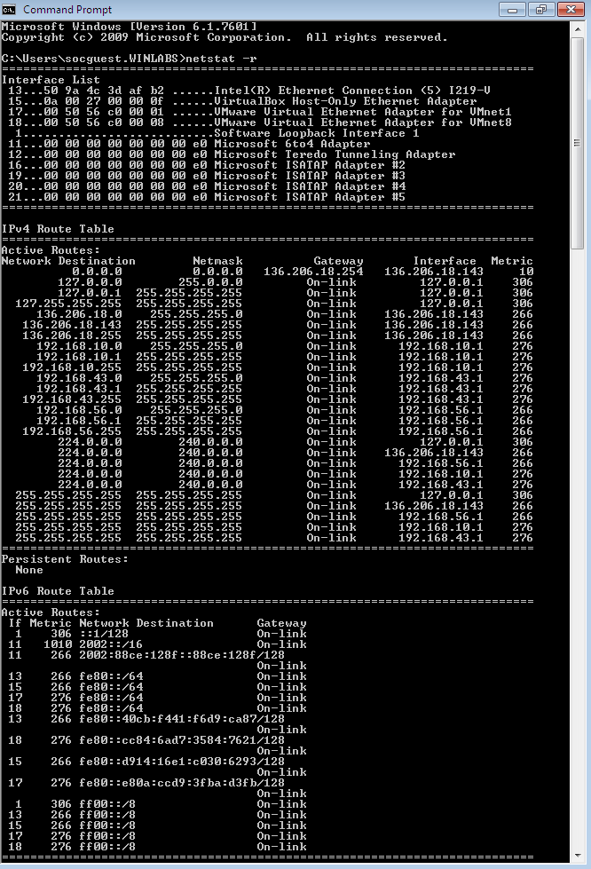
Netstat –r is a command displaying the routing table for the network adapters in the computer. It also shows a number of other addresses for other networks. This is constantly updated by the computer and often it shows the quickest connection for the computer.

