# Lab: Unit Testing

Problems for exercises and homework for the ["C# OOP" course @ SoftUni"](https://softuni.bg/trainings/3008/csharp-oop-october-2020).

## Part I: Unit Testing Basics

### Test Axe

Load provided solution in Visual Studio. Add new project **Tests**

Create a class AxeTests

Create the following tests:

* Test if weapon loses durability after each attack
* Test attacking with a broken weapon

#### Solution

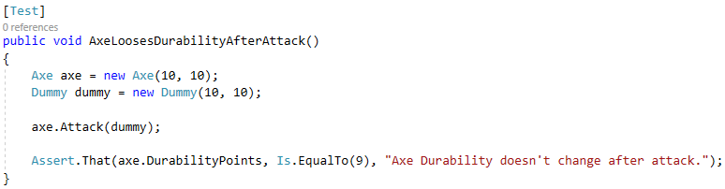

## Test Dummy

Create a class DummyTests

Create the following tests:

* Dummy loses health if attacked
* Dead Dummy throws exception if attacked
* Dead Dummy can give XP
* Alive Dummy can't give XP

### Hints

Follow the logic of the previous problem

## Refactor Tests

Refactor the tests for Axe and Dummy classes

Make sure that:

* **Names** of test methods are **descriptive**
* You use **appropriate** **assertions** (assert equals vs assert true)
* You use **assertion** **messages**
* There are **no magic numbers**
* There is **no code duplication** (Don’t Repeat Yourself)

### Hints

Extract constants and private fields for Axe class

Create a method that executes **before each test**

Make use of constants and private fields, as well as add assertion messages

Follow the same logic for other test methods and TestDummy class

## Part II: Dependencies and Mocking

*(Work on this part in the second unit-testing lecture – Mocking and test driven development)*

### Fake Axe and Dummy

Test if hero gains XP when target dies

To do this, you need to:

* Make **Hero** class **testable** (use **Dependency Injection**)
* Introduce **Interfaces** for Axe and Dummy
  + Interface Weapon
  + Interface Target

Create fake Weapon and fake Dummy for the test

#### Hints

Create **IWeapon and ITarget** interface. Modify implementation methods to **make use of interfaces.** Modify both **Axe** and **Dummy** classes.

Use **Dependency Injection** for Hero class

Create HeroTests class and test gaining XP functionality by faking Weapon and Target classes

## Mocking

Include Moq in the project dependencies, then:

* Mock fakes from previous problem Hints

Go to HeroTests and refactor the code, making use of Moq