Combivis 6 – Installation & Registration

1 – Installation

- After downloading the Combivis program, open the Setup_Combivis_studio_6.exe file

- Select the language to use during installation from the drop-down menu and click “OK” to continue.

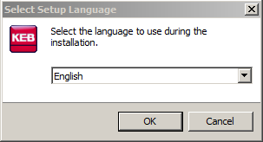

- Additional components may be needed and can be installed automatically. Click “OK” to continue.

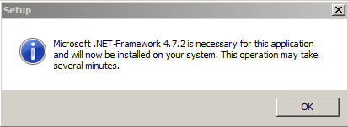

- Once the program is ready to install, a Welcome screen will be displayed. Click “Next” to continue.

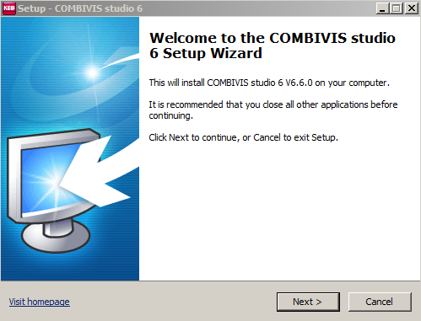

- A license agreement will then be displayed. Select “I accept the agreement” then click “Next” to continue.

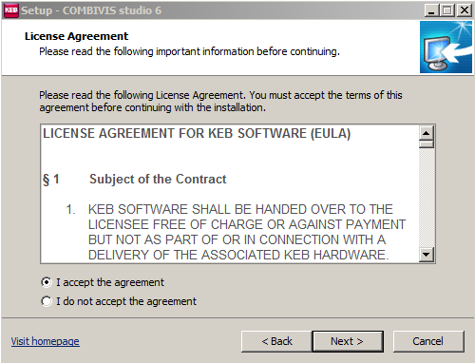

- Select the destination location on the computer for the installation. The default folder is C:\Program Files\KEB\COMBIVIS_6. Click “Next” to continue.

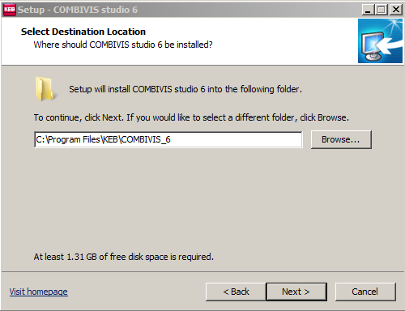

- Select the type of installation. This can be selected from the drop-down menu or the components can be manually selected/unselected. Select “Next” to continue.

Recommended is to select the “Compact Installation” (i.e. unselected Combivis Studio 6). Note: starting at v6.7, compact is the default; prior, studio was default.

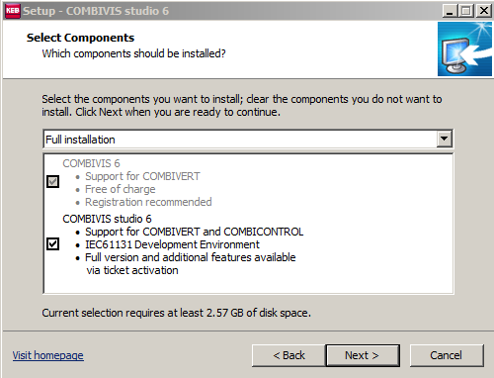

Description: Compact vs. Studio (full) installation

The Compact installation of Combivis 6 generally fulfills the requirements for the majority of needs. This is a free version. Registration is optional and provides access to the Documentation Database; otherwise, there are no limitations to use.

Features include: access to parameters, startup wizards, upload/download parameter lists, digital oscilloscope, remote support, etc.

The full Studio installation includes additional components for control products (e.g. C6 embedded controllers, HMIs). This installation would generally only be needed when creating a structured logic or bootable program (e.g. Codesys, IEC61131 Development Environment).

This can be installed for free, with limited access. Here, after 1 hour the user will be prompted to save their project and shutdown the program (can be restarted again). Additionally, a bootable project file cannot be saved.

Access without restriction requires activation of a purchased license.
- Select the Start Menu folder for the program’s shortcuts. The default is KEB\COMBIVIS\COMBIVS studio 6. Select “Next” to continue.

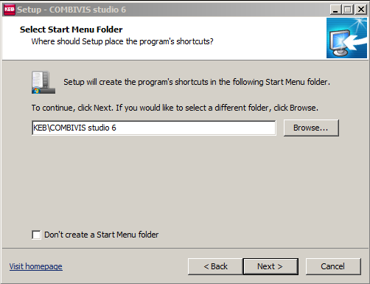

- Select which additional installations tasks should be performed.

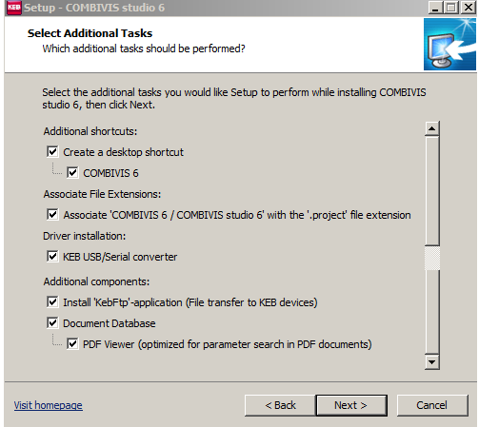

- The installation is now ready. To begin the installation, select “Install”.

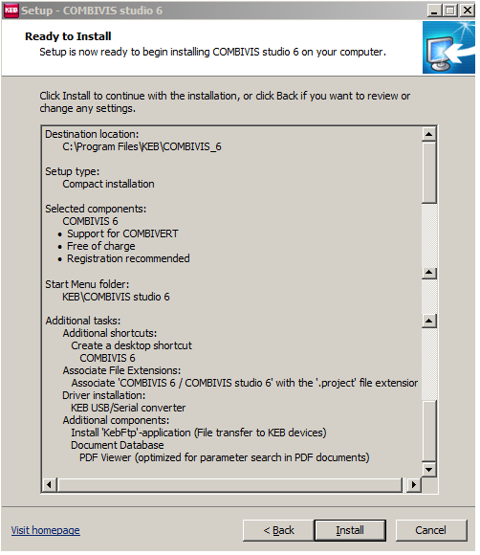

- The program will be installed.

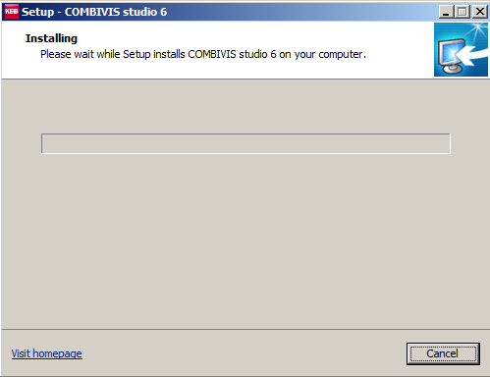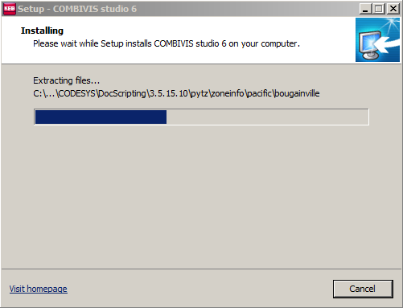

- When the process is complete, a computer restart will be needed to complete the installation. Select the option of when to do the restart, then click “Finish”.

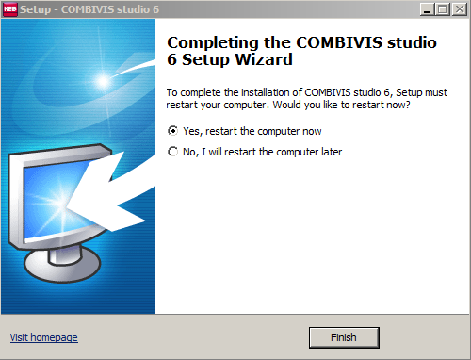

2 – Combivis Registration (Compact Installation)

Once Combivis has been installed, the program can be opened. The upper left-hand corner will display will display “unregistered demo version”. Registration is optional, but provides access to the Documentation Database.

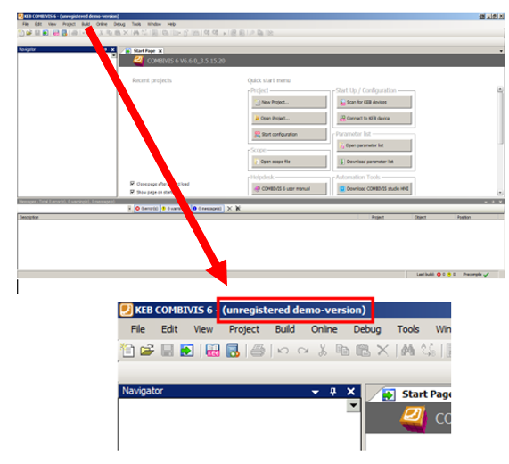

To register, select “Help” from the menu bar, then “Free customer registration”.

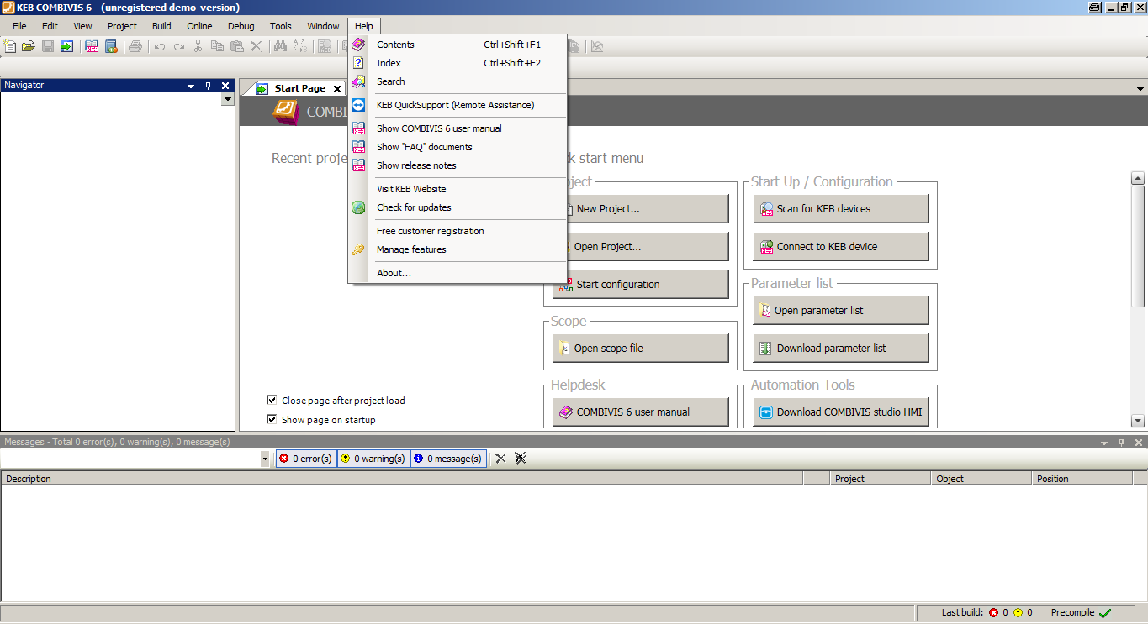

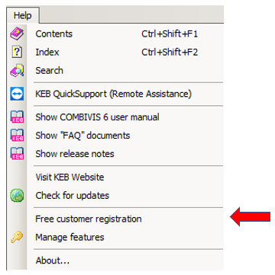

A prompt to enter the company name and registration key will appear.

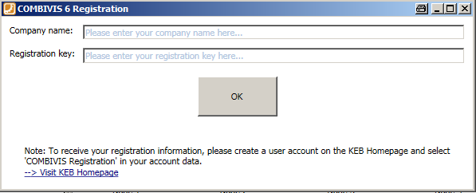

To obtain the registration key, either select the “Visit KEB Homepage” link in the prompt or alternatively go to the webpage at:

https://www.keb.co.uk/nc/my-account/combivis-registration

At the website, the user must log-in (or create an account as needed) to receive the Company and Registration key information.

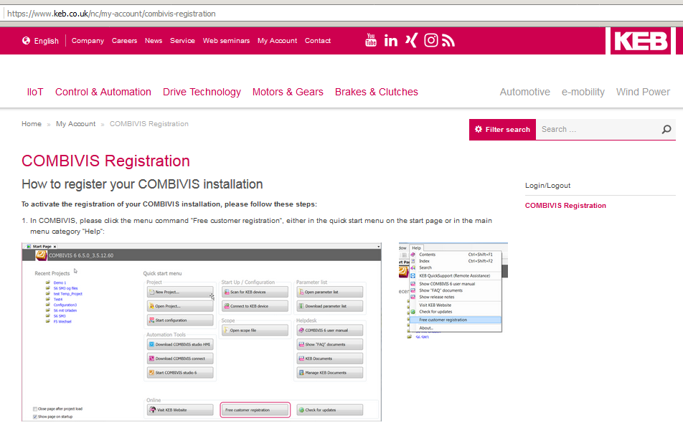
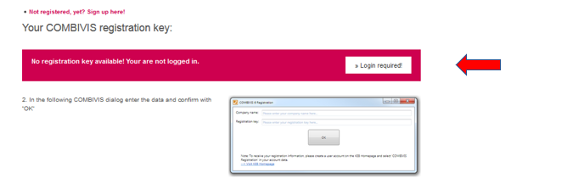

Once logged-in, the registration information will appear.

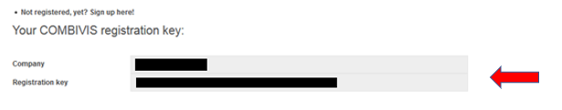

This information can then be entered into the registration prompt in Combivis. Then, click “OK” to continue.

The user will then receive a prompt that the registration was successful. Click “OK” to continue.

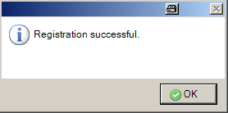

Then, the user will be prompted to restart Combivis.

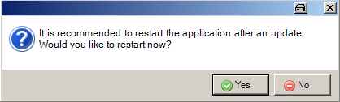

After Combivis has been restarted, the upper-left hand of the program will show the program registered to the company listed during registration.

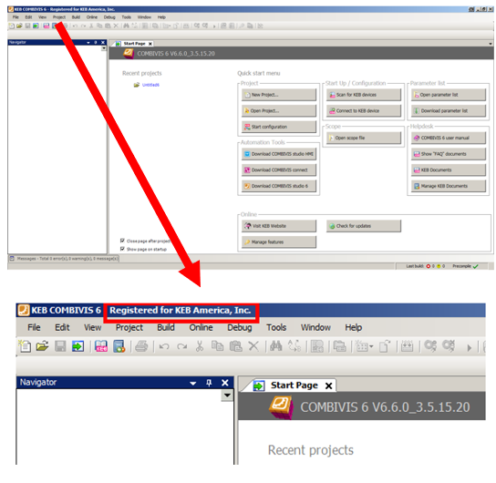

Registration will also allow the user to access the Documentation Database. With this feature, right-clicking a parameter will bring up the option “Find in documentation”.

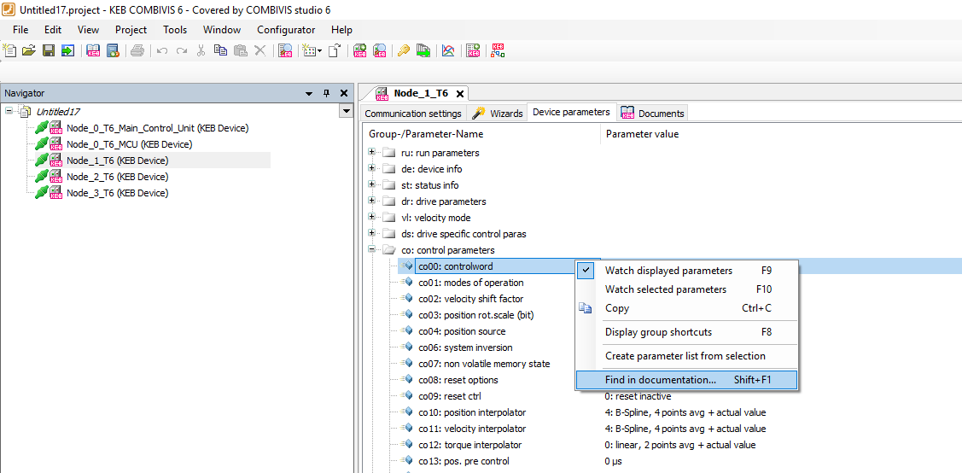

This will bring up the corresponding parameter manual and search the document for the selected parameter.

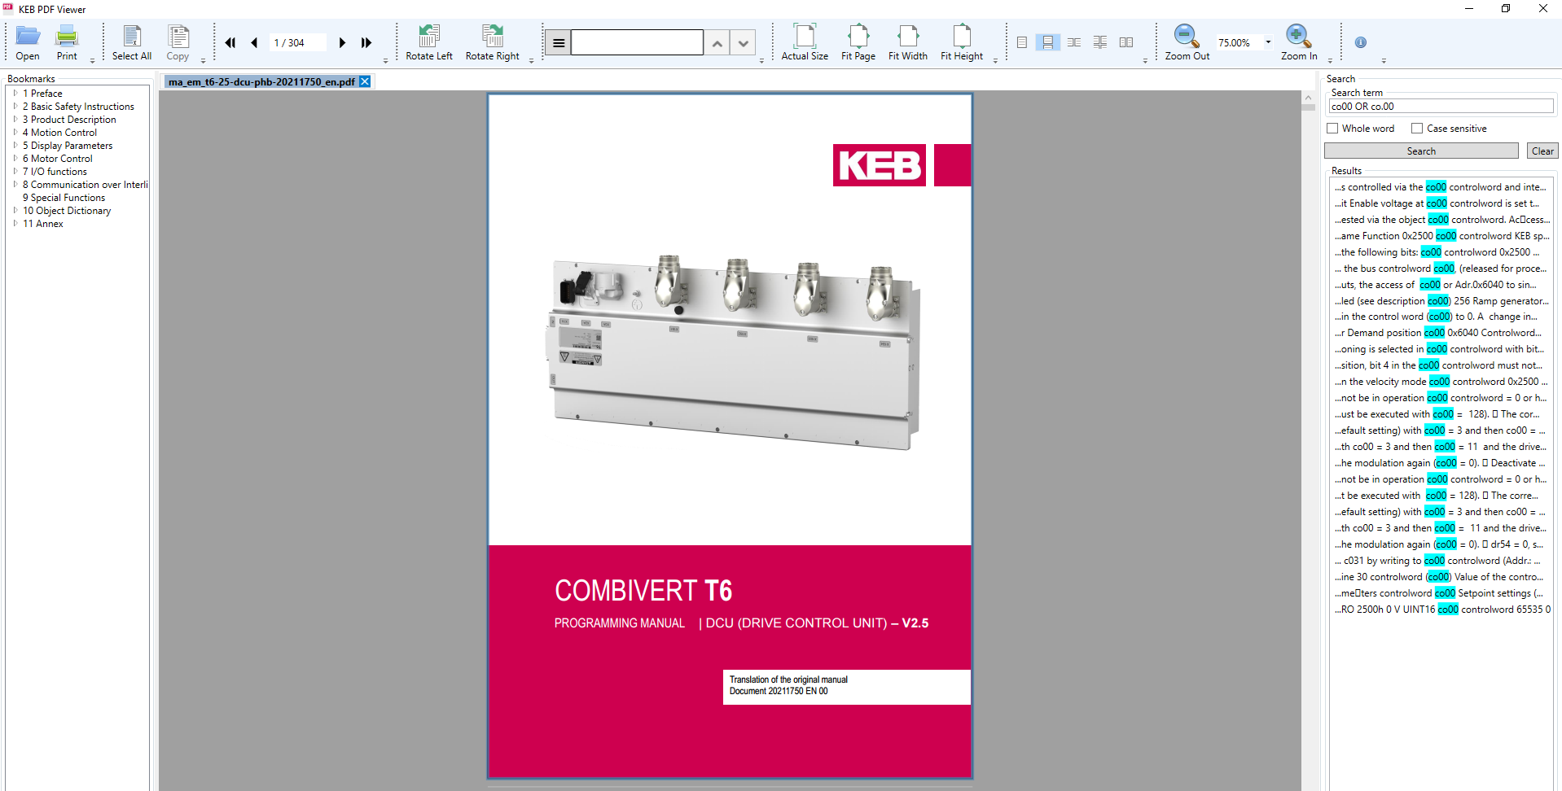

3 - Additional Information

3.1 – Check for Updates

After opening the Combivis, the program may prompt that updates are available.

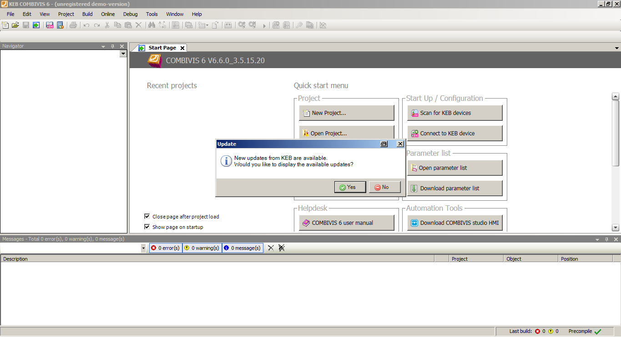

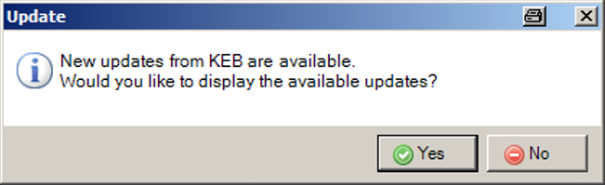

The user may also check for updates by selecting “Help” from the menu bar, then “Check for updates”.

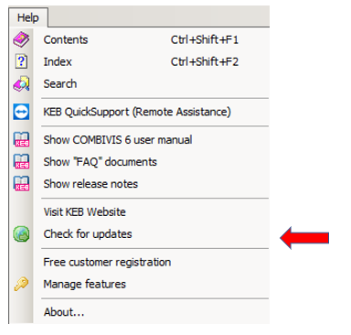

When selected, a menu will appear with available updates. Select “Start update” to continue.

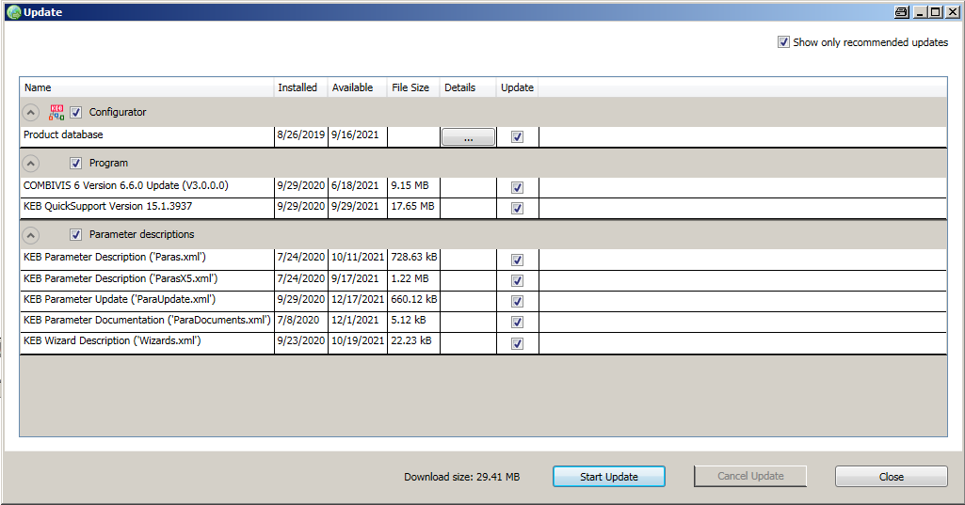

The updates will be downloaded and when complete a prompt indicating “Update complete” will be displayed. Click “OK” to continue.

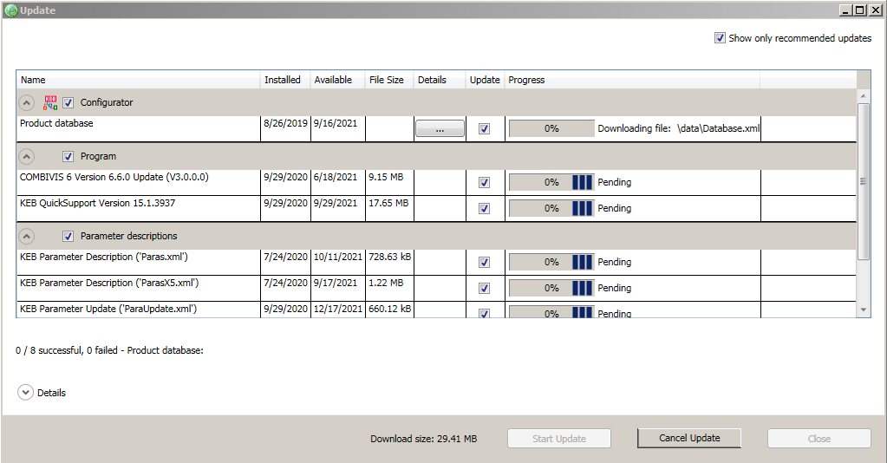

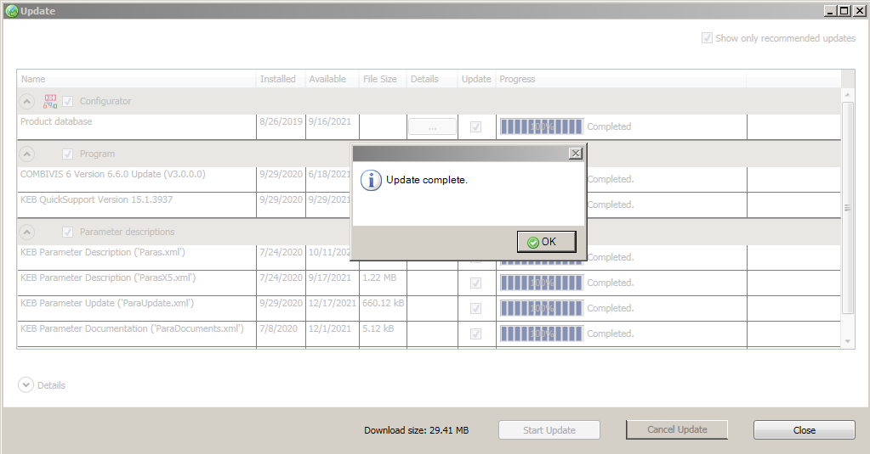

Afterwards, it may be necessary to restart the program and a prompt to restart will be given.

3.2 – Install additional Wizards

After installation of Combivis, additional Wizards not included in the installation package can be added.

In particular, this includes the wizard for the T6 MCU Utility App.

The wizard can be installed by checking for updates outlined in the previous section, unselecting “Show only recommended updates”, selecting “T6 Wizard” under the Programs section, then starting the update.

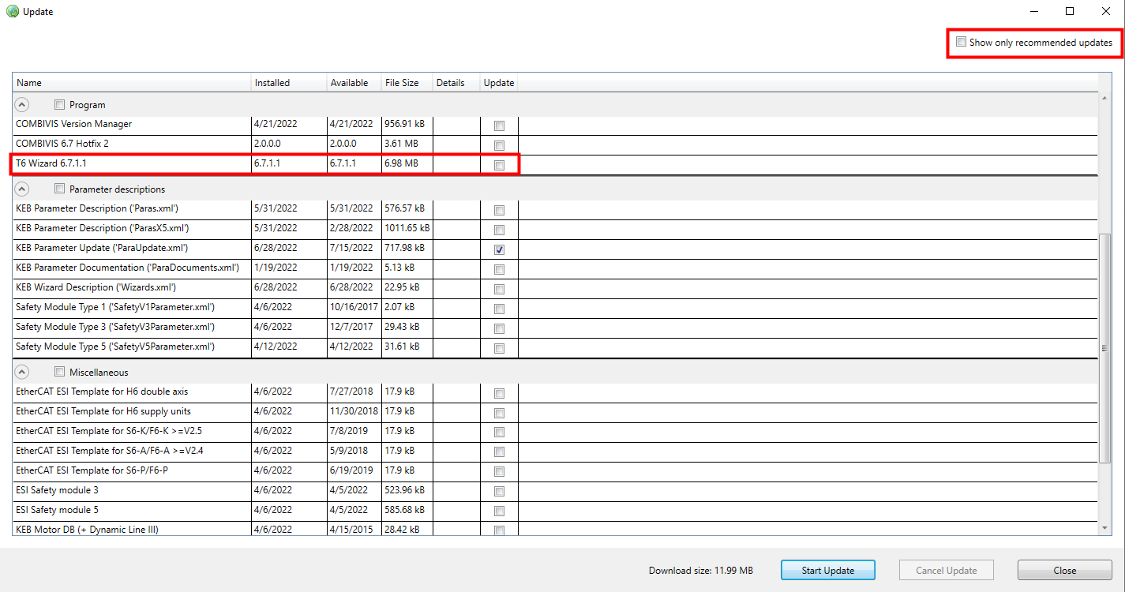

Once the installation process has been completed, shown below is the T6 MCU Utility App wizard (Node_0_T6_MCU).

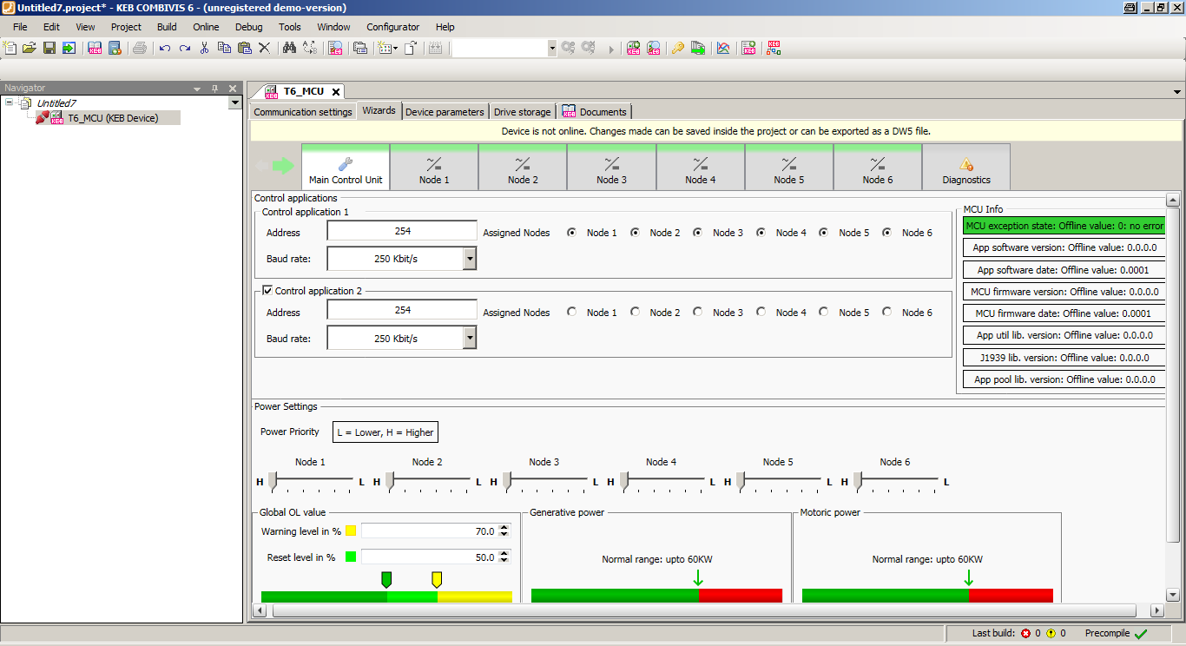
3.3 – Install additional Wizards (alternative method)

As an alternative method, wizards can be manually added.

To manually install a wizard, open Combivis. From the “Tools” menu, select “Package Manager”.

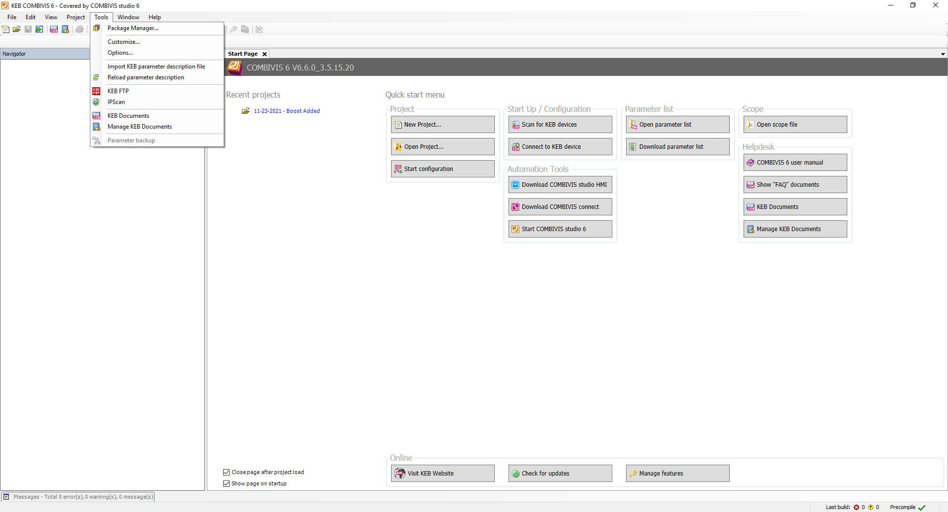

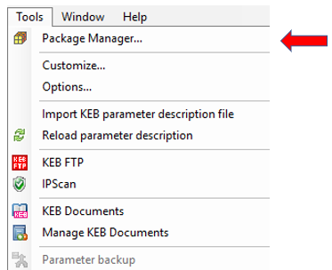
The package manager window will appear and display the installed packages. To add a package, click “Install”.

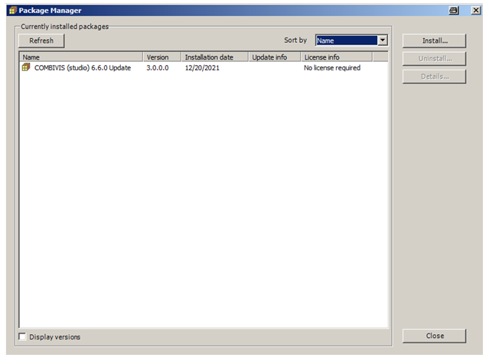
This will open up a file explorer and after the file is located and selected, click “Open” to continue.

In the case of the T6 MCU Utility App wizard, the filename will be T6Wizard.package.

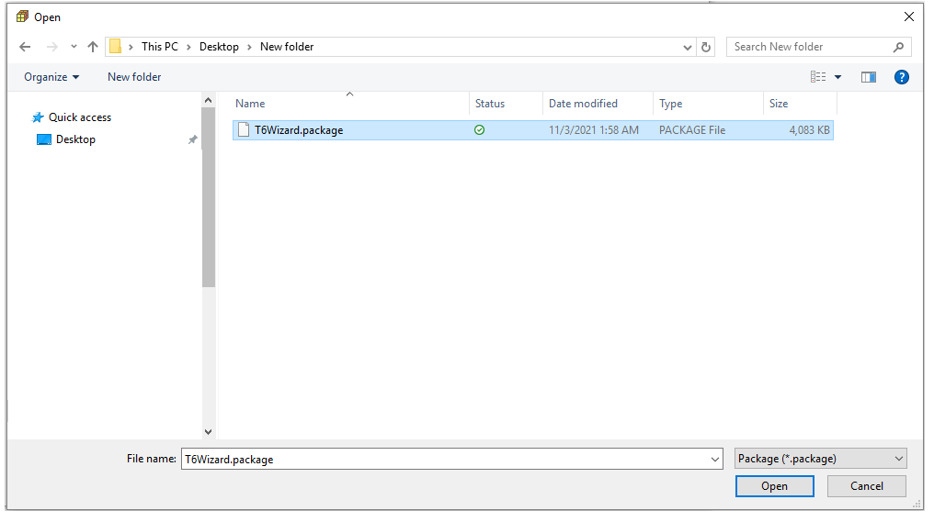
The user will then be prompted to select the installation type. “Typical setup” is recommended. Select “Next” to continue.

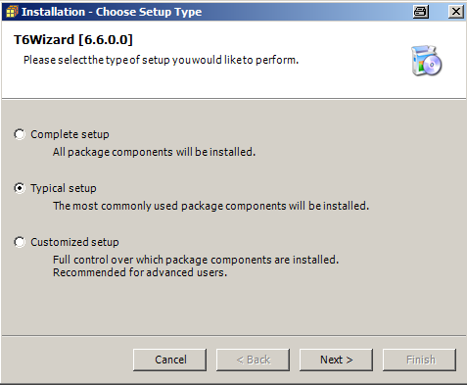

The user will then be prompted to select the program versions which the package installation should be applied to. Select the corresponding Combivis version and click “Next” to continue.

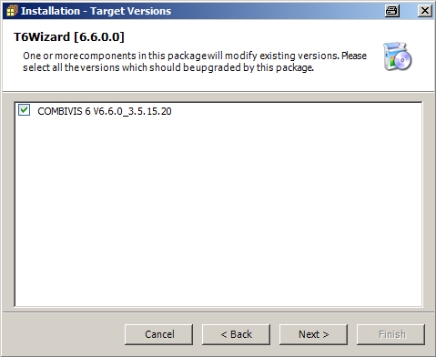

The installation will then start.

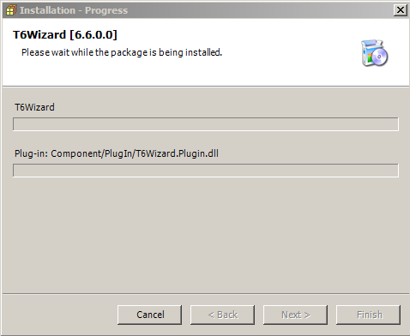

When the installation is complete, the user will be prompted to select Finish to exit the package installation wizard then restart the Combivis program. Click “Finish”, then select “Close” in the Package Manager window. Finally, close Combivis.

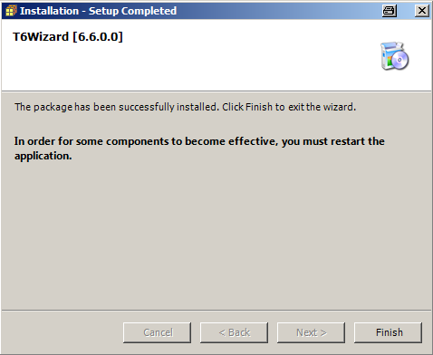

When Combivis is restarted, the user should be able to see a tab for the installed wizard when the corresponding device node is selected.

Shown below is the T6 MCU Utility App wizard.

