IST 263 Project Milestone 3 – Site Media
Name: Katharine Batista
Description (From Milestone 1):
My website is going to focus on different indie artists in the pop and r&b industry. It will include personal bios about each singer/ artist. It will focus on women in the industry specifically. Then, I will also be ranking their albums/releases and suggesting new artists based upon which songs you liked. It is more of a blog than anything else. This is a special interest of mine, which is why I wanted to create a website about it.
URL to Images on Github:
Login to github.com and navigate to your images folder for the project. Copy the URL and paste it here. | https://github.com/kebatist/ist263/tree/main/images
NOTE: You need to legally use all your images. The options for usage writes should be I own this, creative commons, free stock, or some other way you legally use the image. Embedded content gets the NA (not applicable).
Your turn! Enter your images below. FYI – the images you find need to be quite large to look good on your website. If the image you find is tiny, keep looking.
Media Thumbnails | Page | Usage Rights | Citation (if applicable)
 | Homepage | I own this image
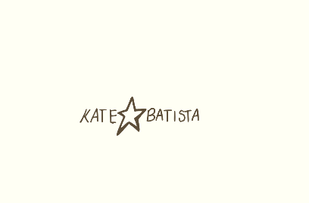 | Watermark for every page | I own this image
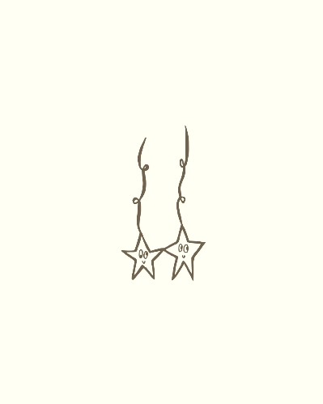 | Clairo bio page | I own this image
 | Homepage, clairo and Lizzy McAlpine review page | I own this image
 | Olivia dean review page | I own this image
 | All artists bio pages | I own this image
 |  | I own this image
 |  | I own this image
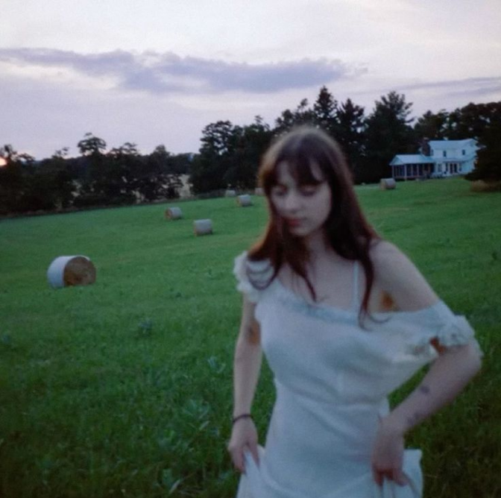 | Lizzy bio page | Fair Use
 | All review pages | I own this image
 | Clairo biography page | Fair Use
 | Lizzy McAlpine review page | I own this image
 | Lizzy McAlpine review page | I own this image
 | All review pages | I own this image
 | Lizzy McAlpine review page | I own this image
 | Olivia dean review page | I own this image
 | Olivia dean review page | I own this image
 | Olivia Dean review page | I own this image
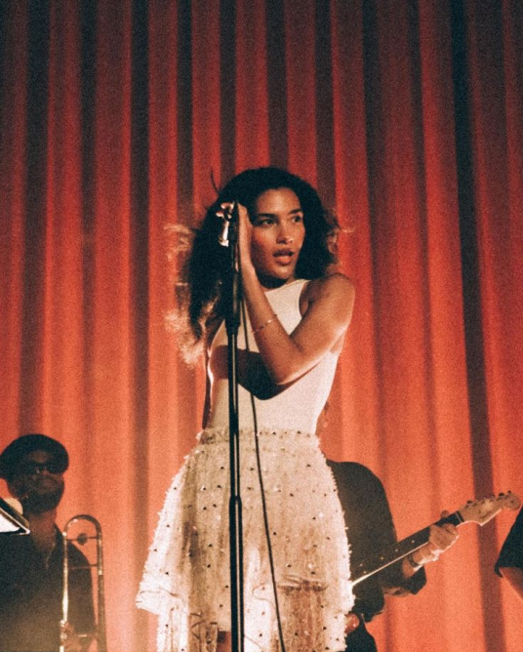 | Olivia dean bio page | Fair Use
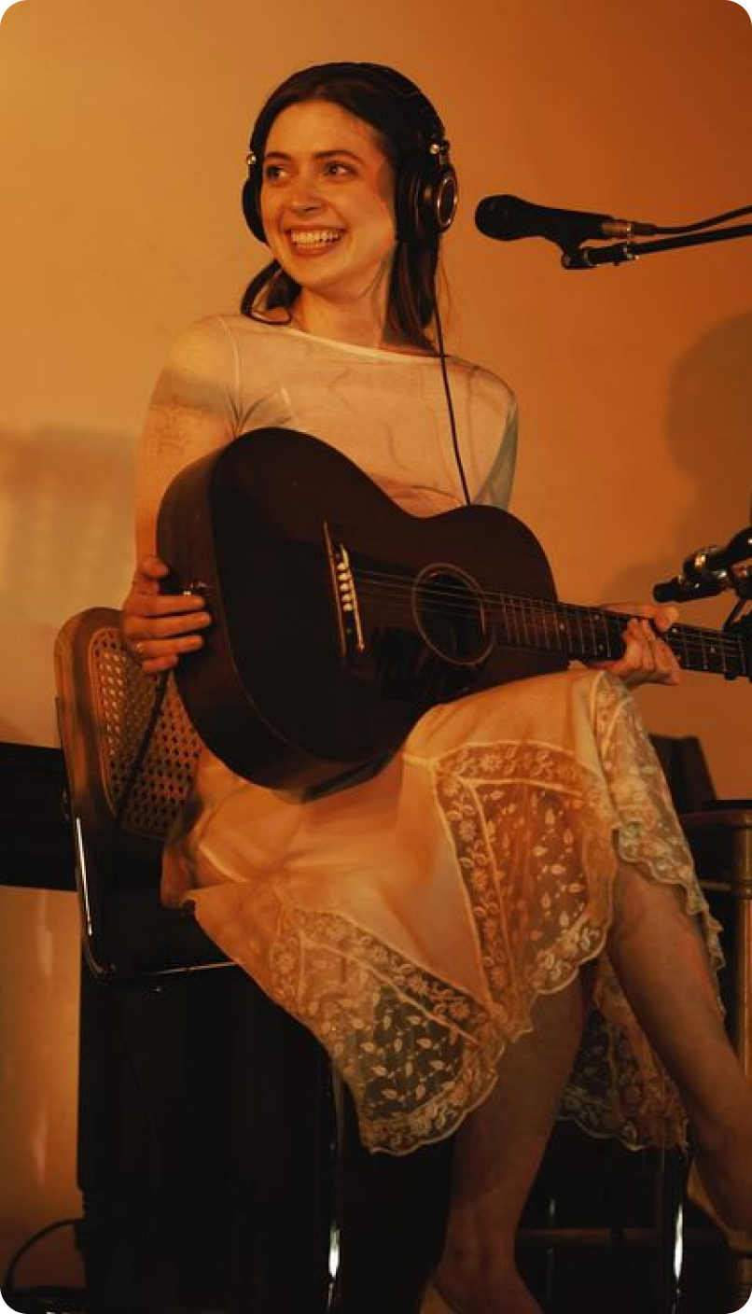 | Lizzy McAlpine bio page | Fair Use
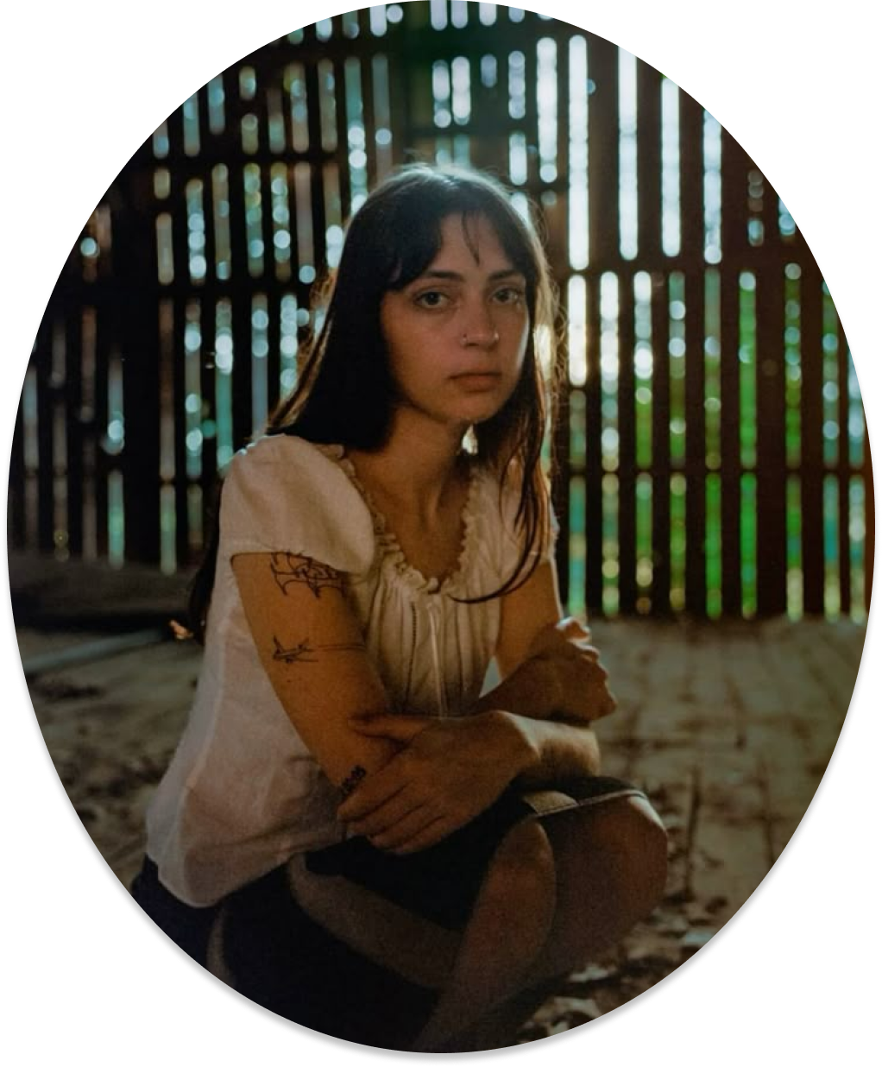 | Lizzy McAlpine bio page | Fair Use
 | Clairo bio page | Fair Use
 | Clairo bio page | Fair Use
 | Clairo review page | Fair Use
 | Clairo review page | Fair Use
 | Clairo review page | Fair Use
 | Clairo review page | Fair Use
 | Lizzy McAlpine review page | Fair Use
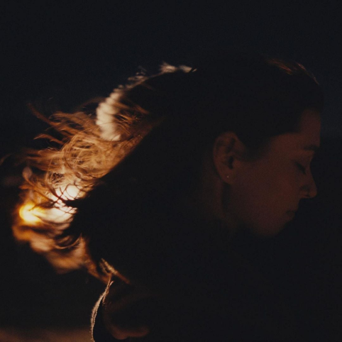 | Lizzy McAlpine review page | Fair Use
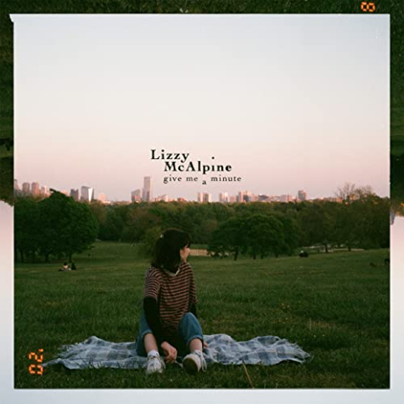 | Lizzy McAlpine review page | Fair Use
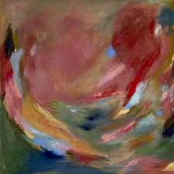 | Lizzy McAlpine review page | Fair Use

