IST 263 Project Milestone 4 – Wireframes
Name: Katharine Batista
Description:
My website is going to focus on different female indie artists in the pop and r&b industry. It will include personal bios about each singer/ artist. Then, I will also be ranking their albums/releases and suggesting new artists based upon which songs you liked. It is more of a blog than anything else. This is a special interest of mine, which is why I wanted to create a website about it.

Research:
Write down the urls of three websites you looked at to research layout for the type of site you are creating. For example, if I was creating an auction website, I might look at pages on https://www.ebay.com/.
url1 | https://www.netflix.com/browse
url2 | https://clairo.fandom.com/wiki/Clairo
url3 | https://www.albumoftheyear.org/ratings/6-highest-rated/2026/1
Wireframes:
Use MockFlow or another diagraming software to create layouts for your pages. Consider the following:
- Where is your navigation going to be located on every page.
- Will you need a footer?
- How can you make a layout that is visually interesting and helps communicate your site content?
- Don’t forget you must have at least 2 distinctly different page layouts.

Paste Your 3 Page Layouts Below
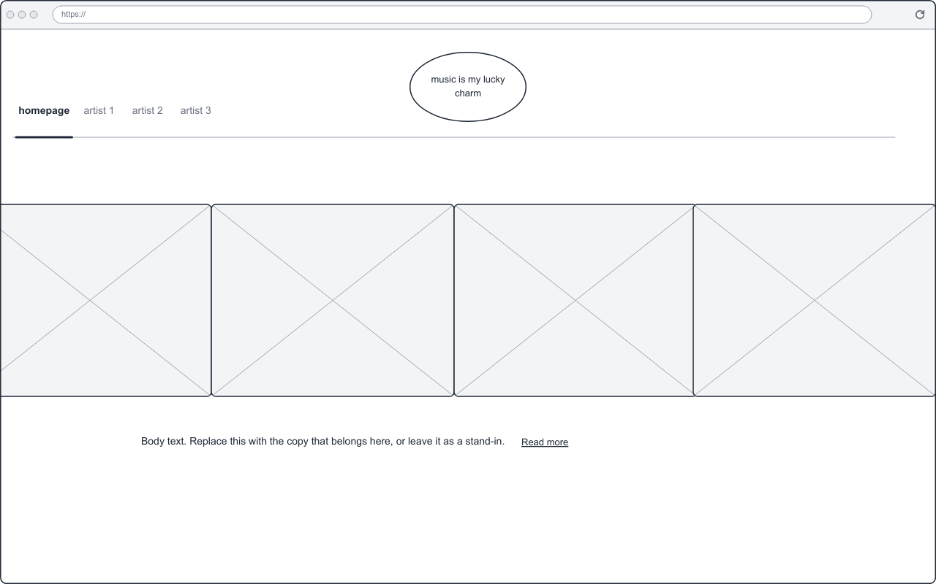
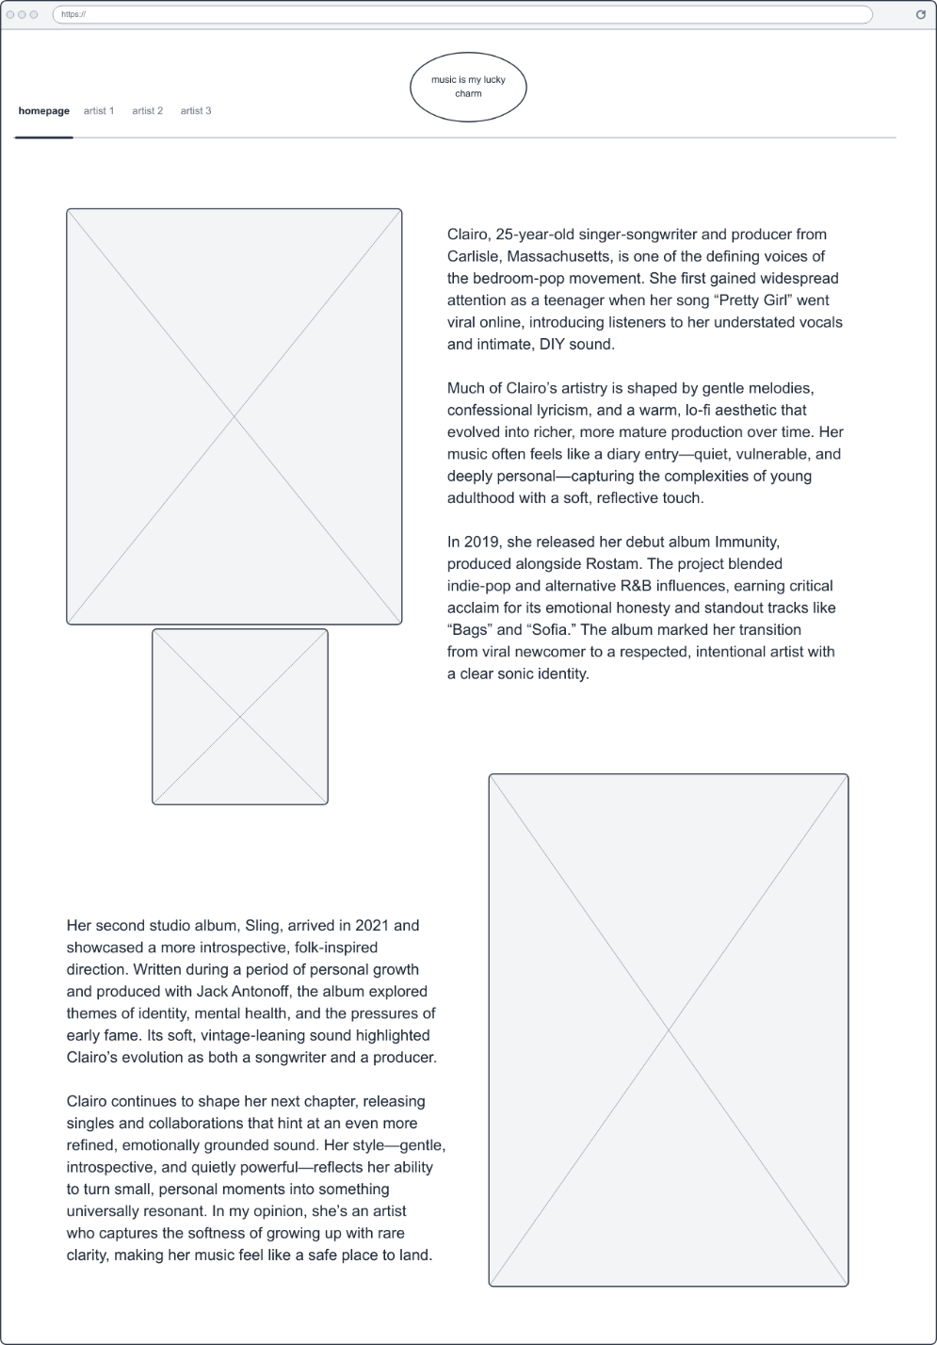 THERE ARE THREE ARTISTS AND I WILL INCLUDE BOTH PAGES FOR EACH OF THEM. REMEMBER THAT WHEN VIEWING WIREFRAMES 2 AND 3


