### Web tech

*Experiment 9 & 10*

Keshav Yadav

199302068

IT 4A

Experiment9.php

<!DOCTYPE html>

<html lang="en">

<head>

    <meta charset="UTF-8">

    <meta http-equiv="X-UA-Compatible" content="IE=edge">

    <meta name="viewport" content="width=device-width, initial-scale=1.0">

    <title>Printing functions in PHP</title>

</head>

<body>

    <h1>Lab Experiment 9</h1>

    <ol type="a" start="a">

        <li>

            Printing Functions in PHP

            <?php

            echo "<br><br>";

            //Using echo for print

            echo "This line was printed using echo.";

            echo "<br>";

            //Using print function

            print "This line was printed using print function.";

            print "<br>";

            //Using printf function

            printf("This line was printed using printf function.");

            print "<br>";

            //Using print_r function

            print "<br>";

            print("The following array is printed using print_r :");

            print "<br>";

            $arr = array("Keshav","Yadav","199302068");

            print_r($arr);

            print "<br>";

            //Using var_dump function

            print "<br>";

            print("The following array is printed using var_dump :");

            print "<br>";

            $name="Keshav";

            $age=21;

            var_dump($name);

            var_dump($age);

            print "<br><br><br>";

            ?>

        </li>

        <li>

            Printing Values in PHP

            <?php

                echo "<br><br>";

                $txt = "This is a string.";

                $x = 5;

                echo $txt;

                echo "<br>";

                echo "This is an integer :".$x;

                print "<br><br><br>";

            ?>

        </li>

        <li>

            Appending a string.

            <?php

                echo "<br><br>";

                $txt3 = "This string is concatenated with ..";

                $txt4 = ".. this string.";

                echo $txt3.$txt4;

                print "<br><br><br>";

            ?>

        </li>

        <li>

            Adding two numbers in PHP.

            <?php

                echo "<br><br>";

                $num1 = 1;

                $num2 = 2;

                printf("The sum of %d and %d is %d.", $num1, $num2, $num1+$num2);

                print "<br><br><br>";

            ?>

        </li>

        <li>

            Control and iteration statements.

            <?php

                echo "<br><br>";

                $cars = array("Honda" , "Tata" , "Maruti" , "Toyota" , "Volkswagen", "Mahindra" , "Kia");

                echo "Total elements in array : <br>";

                //Iterating using foreach

                foreach ($cars as $car){

                    echo $car;

                    echo "<br/>";

                }

                echo "<br>";

                //Controlling the output

                echo "Printing even indexed array values.<br>";

                for ($i=0 ; $i < sizeof($cars) ; $i++) {

                    if($i%2==0){

                        echo $cars[$i];

                        echo "<br>";

                    }

                }

            ?>

        </li>

    </ol>

</body>

</html>

Output :

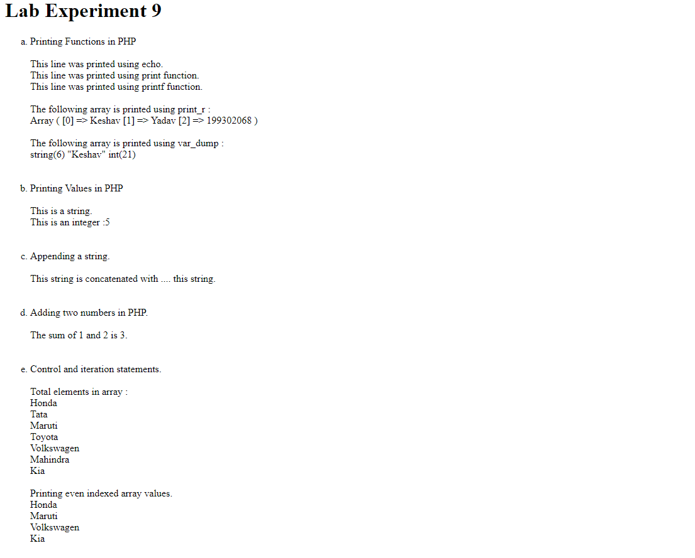

Experiment10.php

<!DOCTYPE html>

<html lang="en">

<head>

    <meta charset="UTF-8">

    <meta http-equiv="X-UA-Compatible" content="IE=edge">

    <meta name="viewport" content="width=device-width, initial-scale=1.0">

    <title>Printing functions in PHP</title>

</head>

<body>

    <h1>Lab Experiment 10</h1>

    <ol type="a" start="a">

        <li>

            Declaring and accessing array in PHP:

            <?php

                echo "<br><br>";

                $cars = array("Honda" , "Tata" , "Maruti" , "Toyota" , "Volkswagen", "Mahindra" , "Kia");

                echo "Elements in array : ";

                //Iterating using foreach

                foreach ($cars as $car){

                    echo $car;

                    echo "  ";

                }

                echo ".<br><br><br>";

            ?>

        </li>

        <li>

            Associative array in PHP :

            <?php

                echo "<br><br>";

                $webDev = array("HTML" => '1' , "CSS" => '2' , "JavaScript" => '3' ,

                "jQuery" => '4' , "Ajax" => '5' , "PHP" => '6');

                echo "Roadmap for Web Development: <br><br>";

                foreach ($webDev as $j => $j_value) {

                    echo "Topic : ". $j;

                    echo "<br>";

                    echo "Index : " . $j_value;

                    echo "<br><br>";

                }

                echo "<br><br>";

            ?>

        </li>

        <li>

            Functions in PHP :

            <?php

                echo "<br><br>";

                function getProduct($num1, $num2){

                    printf("%d times %d = %d", $num1, $num2, $num1*$num2);

                }

                getProduct(10,7);

            ?>

        </li>

    </ol>

</body>

</html>

Output :

