Analysis of Algorithms 2020/2021

Practice 1

Kevin de la Coba and Marcos Bernuy, group 1292, pair 2.

Code | Plots | Memory | Total

1. Introduction.
In this assignment we measured the behavior of the insert sort algorithm, for that we used C creating a data structure to store all the info related with the performance of the algorithm with different permutations that can have different size.
2. Objectives
2.1 Section 1
We built a function which can generate random numbers given the smallest and the biggest to generate.
2.2 Section 2
We built a function which can generate a permutation using the previous function that generates a random number.
2.3 Section 3
We built a function which basically generates an array of permutations.
2.4 Section 4
We built the insert sort function based on the pseudocode of the theory PowerPoint; we also return basic operations (in this case key comparisons) that the algorithm does to solve a given permutation.
2.5 Section 5
We built a module which measures the time that a given algorithm spends sorting an array and it measures the basic operations done.
2.6 Section 6
We built a modification of the insert sort function, in this case the algorithm sorts a permutation in reverse order, this means that the permutations ends having the biggest value at the beginning and the smallest one at the end.

3 Tools and Methodology
3.1 Section 1
We used Visual studio code and we tested the functions in ubuntu. In order to solve this section we built a function that given two limits (up and down limits), it generates random numbers between those 2 limits.
3.2 Section 2
Given a size N we create an array of that size and we fill it with numbers in ascending order (1, 2, …, N), then we use the function we created in the previous section and we swap every element with a random one (for example, i = 0, swapped with j = random_num), we swap every number with a random index of the array.
3.3 Section 3
For this section we just create an array of arrays that contains “n_perms” permutations.
3.4 Section 4
We took the algorithm insert_sort from the theory and we built the function that sorts using that algorithm.
3.5 Section 5
We built the functions that stores data in the TIME_AA structure and then it stores this data in a file.
3.6 Section 6
We just changed a “<” to “>”, so now the function sorts the array in reverse order.
4. Source code
4.1 Section 1
1  2  3  4  5  6  7  8  9  10  11  12  13  14  15 | int random_num(int inf, int sup) {  int random = 0;  if (inf < 0 || sup < 0 || inf > sup) return ERR;  random = rand();  if(random < 0) return ERR;  /* Taking the random number between 0 and rand_max */  random = inf + (int) (((sup - inf + 1.0) * random) / (RAND_MAX + 1.0));  if (random < inf || random > sup) return ERR;  return random;  }

4.2 Section 2
1  2  3  4  5  6  7  8  9  10  11  12  13  14  15  16  17  18  19  20  21  22  23  24  25  26  27  28  29  30  31  32  33 | int* generate_perm(int N) {  int i, random;  int *perm = NULL;  if(N <= 0)  return NULL;  /* Reserving memory for the permutation */  perm = (int*)malloc(N * sizeof(int));  if (perm == NULL)  return NULL;  /* Filling the documentation */  for(i = 0; i < N; i++){  perm[i] = i+1;  }  /* Swaping numbers in the permutation */  for(i = 0; i < N; i++) {  random = random_num(i, N-1);  if (random == ERR) {  free(perm);  return NULL;  }  if (swap(&perm[i], &perm[random]) != OK){  free(perm);  return NULL;  }  }  return perm;  }

4.3 Section 3
1  2  3  4  5  6  7  8  9  10  11  12  13  14  15  16  17  18  19  20  21  22 | int** generate_permutations(int n_perms, int N) {  int i = 0, n = 0, **perms = NULL;  if (n_perms <= 0 || N <= 0) return NULL;  /* Reserving memory for the permutations */  perms = (int**)malloc(n_perms*sizeof(int*));  if (perms == NULL) return NULL;  /* Loop for creating the permutations */  for (i = 0; i < n_perms; i++) {  perms[i] = generate_perm(N);  if (perms[i] == NULL) {  for(n = 0; n < i; n++) free(perms[n]);  free(perms);  return NULL;  }  }  return perms;  }

4.4 Section 4
1  2  3  4  5  6  7  8  9  10  11  12  13  14  15  16  17  18  19  20  21 | int InsertSort(int* table, int ip, int iu) {  int i = 0, j = 0, A = 0, counter = 0;  if (table == NULL || ip < 0 || iu < 0 || iu < ip) return ERR;  for (i = ip+1; i <= iu; i++) {  A = table[i];  j = i-1;  while(j >= ip) {  counter++;  if (table[j] > A) {  table[j+1] = table[j];  j--;  }  else break;  }  table[j+1] = A;  }  return counter;  }

4.5 Section 5
1  2  3  4  5  6  7  8  9  10  11  12  13  14  15  16  17  18  19  20  21  22  23  24  25  26  27  28  29  30  31  32  33  34  35  36  37  38  39  40  41  42  43  44  45  46  47  48  49  50  51  52  53  54  55  56  57  58  59 | short average_sorting_time(pfunc_sort method,  int n_perms,  int N,  PTIME_AA ptime) {  clock_t start = 0, end = 0;  double total = 0;  int **perms = NULL, i = 0, n = 0;  long BOs = 0, total_BOs = 0;  if (method == NULL || n_perms <= 0 || N <= 0 || ptime == NULL) return ERR;  /* Creating all the permutations */  perms = generate_permutations(n_perms, N);  if (perms == NULL) return ERR;  start = clock();  if (start == (clock_t) -1) {  for (i = 0; i < n_perms; n++) free(perms[i]);  free(perms);  return ERR;  }  /* Loop to sort all the permutations */  for (i = 0; i < n_perms; i++) {  /* Using the function to sort the array */  BOs = method(perms[i], 0, N-1);  if (BOs == ERR) {  for (n = 0; n < n_perms; n++) free(perms[n]);  free(perms);  return ERR;  }  /* Checking the maximum and minimum values of the structure */  if (ptime->min_ob == 0 || ptime->min_ob > BOs) ptime->min_ob = BOs;  if (ptime->max_ob == 0 || ptime->max_ob < BOs) ptime->max_ob = BOs;  total_BOs += BOs;  }  end = clock();  if (end == (clock_t) -1) {  for (i = 0; i < n_perms; n++) free(perms[i]);  free(perms);  return ERR;  }  /* Assingning the values to the structure */  total = ((double) (end - start)) / CLOCKS_PER_SEC;  ptime->time = total / n_perms;  ptime->N = N;  ptime->n_elems = n_perms;  ptime->average_ob = ((double) total_BOs)/n_perms;  for(i = 0; i < n_perms; i++) free(perms[i]);  free(perms);  return OK;  }

1  2  3  4  5  6  7  8  9  10  11  12  13  14  15  16  17  18  19  20  21  22  23  24  25  26  27  28  29  30  31  32  33  34  35  36  37  38  39  40  41  42  43 | short generate_sorting_times(pfunc_sort method, char* file,  int num_min, int num_max,  int incr, int n_perms) {  int i = 0, counter = 0, n = 0;  PTIME_AA ptime = NULL;  /* Checking arguments */  if (method == NULL || file == NULL || num_min < 0 || num_max < 0 || incr < 1 || n_perms < 1)  return ERR;  /* Allocating memory for the array of ptimes */  counter = ((num_max - num_min) / incr) + 1;  ptime = (PTIME_AA)malloc(counter * sizeof(TIME_AA));  if (ptime == NULL)  return ERR;  /* Initializing ptime */  for(i = 0; i < counter; i++) {  ptime[i].average_ob = 0;  ptime[i].max_ob = 0;  ptime[i].min_ob = 0;  ptime[i].N = 0;  ptime[i].n_elems = 0;  ptime[i].time = 0;  }  /* Calling the function to get the ptimes */  for(i=num_min; i <= num_max; i += incr, n++){  if(average_sorting_time(method, n_perms, i, &ptime[n]) == ERR){  free(ptime);  return ERR;  }  }  /* Calling save_time_table so the information is displayed in the file */  if (save_time_table(file, ptime, counter) == ERR){  free(ptime);  return ERR;  }  free(ptime);  return OK;  }

1  2  3  4  5  6  7  8  9  10  11  12  13  14  15  16  17  18  19  20  21  22  23  24  25  26  27  28 | short save_time_table(char* file, PTIME_AA ptime, int n_times) {  int i = 0;  FILE *fp = NULL;  /* Checking arguments */  if (file == NULL || ptime == NULL || n_times < 0) return ERR;  /* Opening the file */  fp = fopen(file, "w");  if (fp == NULL) return ERR;  /* Printing all the ptimes */  for (i = 0; i < n_times; i++){  fprintf(fp, "Number of elements: %d\t"  "Size of each element: %d\t"  "Average clock time: %e\t"  "Average OB executed: %f\t"  "Minimun OB executed: %d\t"  "Maximun OB executed: %d\t\n", ptime[i].n_elems, ptime[i].N, ptime[i].time, ptime[i].average_ob, ptime[i].min_ob, ptime[i].max_ob);  }  /* Closing the file */  fclose(fp);  return OK;  }
4.6 Section 6
1  2  3  4  5  6  7  8  9  10  11  12  13  14  15  16  17  18  19  20  21  22 | int InsertSortInv(int* table, int ip, int iu) {  int i = 0, j = 0, A = 0, counter = 0;  if (table == NULL || ip < 0 || iu < 0 || iu < ip)  return ERR;  for (i = ip + 1; i <= iu; i++){  A = table[i];  j = i - 1;  while (j >= ip){  if(table[j] < A){  counter++;  table[j+1] = table[j];  j--;  } else break;  }  counter++;  table[j+1] = A;  }  return counter;  }

5. Results, Plots
5.1 Section 1
The console output is this one:
./exercise1 -limInf 1 -limSup 20 -numN 20
Running exercise1
Practice no 1, Section 1
Done by: Kevin de la Coba and Marcos Bernuy
Grupo: 1292 - T02
17
9
8
20
16
14
11
19
17
6
19
7
6
19
12
2
14
18
4
1
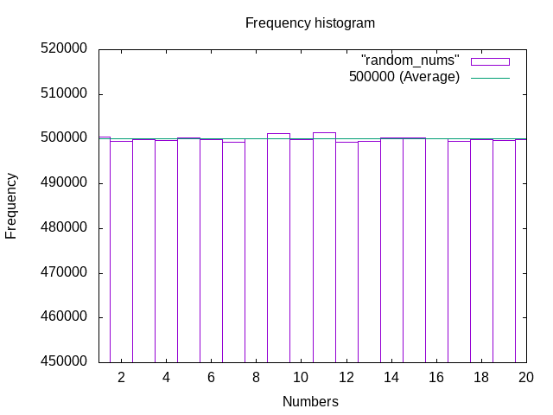
This is the plot after we executed the exercise1 with the following arguments:
-limInf 1 -limSup 20 -numN 10000000
As we can see in the plot every number is generated the same amount of times. So we can conclude that all the numbers are going to be generated:
“times generated/numbers”
That is the same as the average, this confirms the law of big numbers.
5.2 Section 2
./exercise2 -size 15 -numP 10
Running exercise2
Practice number 1, section 2
Done by: Kevin de la Coba and Marcos Bernuy
Grupo: 1292 - T02
8 3 1 13 11 10 5 9 4 14 12 6 2 7 15
1 2 4 6 14 7 13 12 9 11 8 15 10 5 3
14 12 2 7 11 9 13 8 3 6 15 5 4 1 10
6 4 2 9 8 15 11 5 12 13 3 1 14 10 7
3 15 13 14 8 10 9 5 12 4 1 11 2 7 6
13 14 11 15 8 4 2 6 9 12 1 3 10 7 5
6 4 7 1 5 12 2 10 13 8 11 3 9 15 14
12 1 11 8 2 15 10 5 6 4 9 13 14 7 3
1 11 10 8 14 12 7 2 15 5 13 6 9 4 3
9 10 13 6 15 2 8 4 1 7 14 12 11 3 5
5.3 Section 3
./exercise3 -size 15 -numP 10
Running exercise3
Practice number 1, section 3
Done by: Kevin de la Coba and Marcos Bernuy
Grupo: 1292 - T02
4 9 3 8 11 6 2 1 14 15 5 12 10 13 7
13 15 3 9 1 5 4 7 10 6 14 11 8 12 2
14 6 4 1 12 5 15 8 3 9 7 11 2 13 10
5 9 10 7 15 2 8 3 12 6 1 4 11 14 13
9 2 1 11 14 7 3 5 10 6 8 12 15 4 13
9 12 6 5 4 8 11 1 2 15 13 14 7 10 3
4 3 11 12 1 2 15 8 6 10 9 7 13 14 5
13 11 4 5 14 8 10 7 2 15 9 6 3 1 12
2 9 10 13 7 8 1 5 11 14 12 4 3 6 15
1 4 5 6 8 2 10 13 11 14 7 9 15 12 3
5.4 Section 4
./exercise4 -size 5
Running exercise4
Practice number 1, section 4
Done by: Kevin de la Coba and Marcos Bernuy
Grupo: 1292 - T02
5 4 3 2 1
BO: 10
1 2 3 4 5
5.5 Section 5
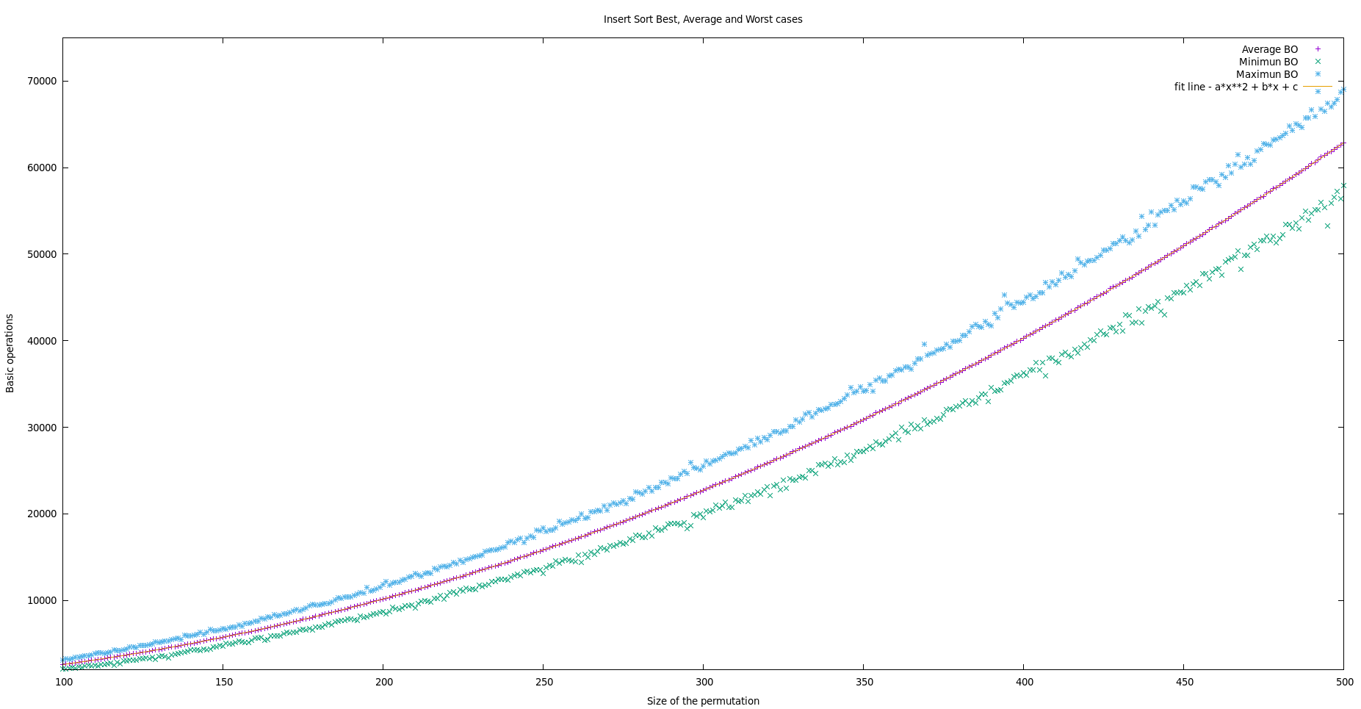
Here we can see the plot generated after executing the exercise5 with the following arguments:
@./exercise5 -num_min 100 -num_max 500 -incr 1 -numP 1000 -outputFile exercise5.log
We can see that the behavior of the growth of the basic operations is not linear, is quadratic. We can also see that the best case is always below the average case and that the worst case is always above the average case. We can also see that the average case fits a quadratic behavior so well that we can barely see the fit line under the data of the average basic operations.
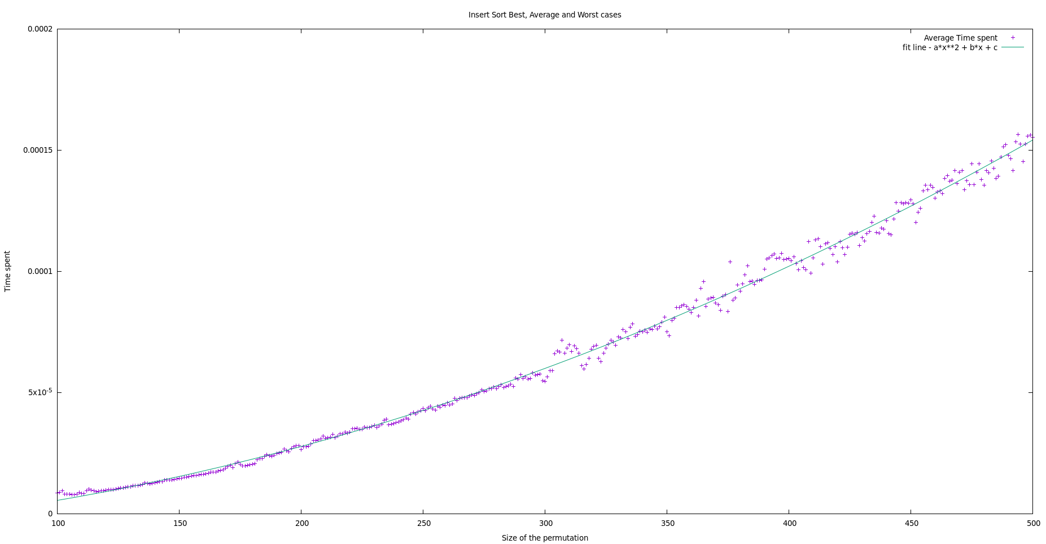
In this plot we can see that the way that the time grows is also quadratic but, in this plot the data is more “separated” that is because the CPU may do another tasks while we ran our program. The important thing is that the time growths also in a quadratic way.
5.6 Section 6
Results for section 6.
Plot comparing the best, worst and average OB times for InsertSortInv, plot comments.
Plot with the average clock time for InsertSortInv, plots comments.
5. Answers to theoretical Questions.
Here you answer to the thoretical questions in the practice.
5.1 Question 1
5.2 Question 2
5.3 Question 3
5.4 Question 4
5.5 Question 5
5.5 Question 6
6. Final Conclusions.
To conclude this report, we can say that we are applying the scientific method and we are measuring the performance of insert sort. Checking the results, we can confirm what we learnt in theory, the insert sort time and basic operations that the algorithm needs to sort a permutation grows with the size of the array, and it does in a quadratic way O(n²).

