QUESTION 4.1

Kemal Efe Çırakoğlu 23111012001

#include <stdio.h>

float area(float a,float b){

    return(a*b);

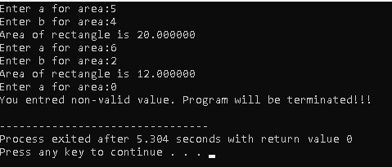}

int main(){

    float a,b;

    while(1){

        printf("Enter a for area:");

        scanf("%f",&a);

        if(a<=0){

            printf("You entred non-valid value. Program will be terminated!!!\n");

            break;

        }

        printf("Enter b for area:");

        scanf("%f",&b);

        if(b<=0){

            printf("You entred non-valid value. Program will be terminated!!!\n");

            break;

        }

        printf("Area of rectangle is %f\n",area(a,b));

    }

    return 0;

}

QUESTION 4.2

#include <stdio.h>

#include <math.h>

double rad(double degree){return degree*M_PI/180.0;}

double dgr(double radyan){return radyan * 180.0 / M_PI;}

double maxfunc(double arr[],int len){

    int i;

    double max = arr[len-1];

    for(i = len - 1;i>= 0; i--){

        if(arr[i]>max){

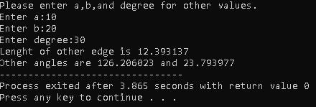            max = arr[i];

        }

    }

    return max;

}

void costhrm(double a,double b,double degree){

    degree = rad(degree);

    double c = sqrt(a*a + b*b -2*a*b*cos(degree));

    double k = c / sin(degree);

    double lenghts[3] = {a,b,c};

    double degree1 = dgr(asin(b/k));

    double degree2 = dgr(asin(a/k));

    double maxlenght = maxfunc(lenghts,3);

    if(maxlenght == a){

        if(degree1+degree<90){

            degree2 = 180 - degree2;

        }

    }else if(maxlenght == b){

        if(degree2+degree<90){

            degree1 = 180 - degree1;

        }

    }

    printf("Lenght of other edge is %lf\n",c);

    printf("Other angles are %lf and %lf",degree1,degree2);

}

int main(){

    double a,b,degree;

    printf("Please enter a,b,and degree for other values.\n");

    printf("Enter a:");

    scanf("%lf",&a);

    printf("Enter b:");

    scanf("%lf",&b);

    printf("Enter degree:");

    scanf("%lf",&degree);

    costhrm(a,b,degree);

    return 0;

}

QUESTION 4.3

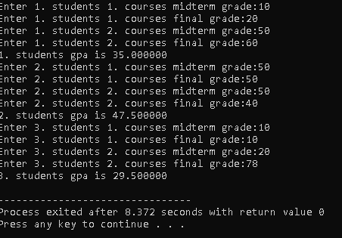#include <stdio.h>

double gpa(double mid1,double final1){

    return (mid1+ final1)/50.0;

}

int main(){

    int i,j;

    double mid1,final1,mid2,final2;

    for(i = 1; i<4;i++){

        printf("Enter %d. students 1. courses midterm grade:",i);

        scanf("%lf",&mid1);

        printf("Enter %d. students 1. courses final grade:",i);

        scanf("%lf",&final1);

        printf("Enter %d. students 2. courses midterm grade:",i);

        scanf("%lf",&mid2);

        printf("Enter %d. students 2. courses final grade:",i);

        scanf("%lf",&final2);

        printf("%d. students 1. courses gpa is %lf\n",i,gpa(mid1,final1));

        printf("%d. students 2. courses gpa is %lf\n",i,gpa(mid2,final2));

    }

    return 0;

}

QUESTION 4.4

#include <stdio.h>

#include <math.h>

int isPrime(double n){

    int i;

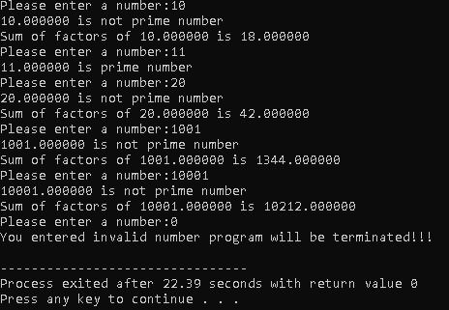    if(n<=1){return 0;}

    for(i = 2;i<=sqrt(n);i++){

        if((int)(n)%i==0){

            return 0;

        }

    }

    return 1;

}

double sumoffactors(int n){

    double sum  = 0;

    int i;

    for(i=1;i<=sqrt(n);i++){

        if(n%i==0){

            if(i*i == n){

                sum+=i;

            }else{

             sum += i + n/i;

            }

        }

    }

    if(n==1)sum=1;

    return sum;

}

int main(){

    double input;

    while(1){

        printf("Please enter a number:");

        scanf("%lf",&input);

        if(input<=0){

            break;

        }

        if(isPrime(input)==1){

            printf("%lf is prime number\n",input);

        }else{

            printf("%lf is not prime number\n",input);

            printf("Sum of factors of %lf is %lf\n",input,sumoffactors(input));

        }

    }

    printf("You entered invalid number program will be terminated!!!\n");

    return 0;

}

QUESTION 4.5

#include <stdio.h>

double calculatepayment(double h_in){

    double payment;

    if(h_in<=3){

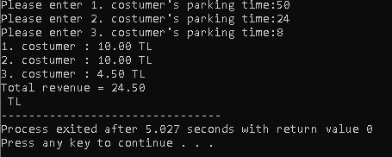        return 2;

    }else if(h_in>=24){

        return 10;

    }else{

        payment = 2 + (h_in-3)*0.5;

        return (payment>=10?10:payment);

    }

}

int main(){

    double sum = 0,time[3];

    int i;

    for(i = 0 ; i < 3 ; i++){

        printf("Please enter %d. costumer's parking time:",i+1);

        scanf("%lf",&time[i]);

    }

    for(i = 0 ; i < 3 ; i++){

        printf("%d. costumer : %.2lf TL\n",i+1,calculatepayment(time[i]));

        sum += calculatepayment(time[i]);

    }

    printf("Total revenue = %.2lf\n TL",sum);

    return 0;

}

QUESTION 4.6

#include <stdio.h>

int sum_of_odds(int start, int stop){

    int sum=0;

    for(start = (start % 2 == 0 ? start + 1 : start);start <= stop;start+=2){

        sum += start;

    }

    return sum;

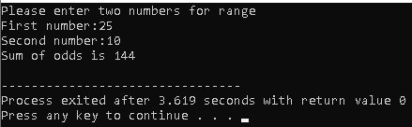}

int main(){

    int first,second;

    printf("Please enter two numbers for range\n");

    printf("First number:");

    scanf("%d",&first);

    printf("Second number:");

    scanf("%d",&second);

    if(first<=second){

        printf("Sum of odds is %d\n",sum_of_odds(first,second));

    }else{

        printf("Sum of odds is %d\n",sum_of_odds(second,first));

    }

    return 0;

}

QUESTION 4.7

#include <stdio.h>

#include <math.h>

double rad(double degree){return degree*M_PI/180.0;}

double mainmeasure(double x){

    return fmod(x,2*M_PI);

}

double fac(int n){

    double mult = 1;

    int i;

    for(i = 2;i<=n;i++){

        mult *= i;

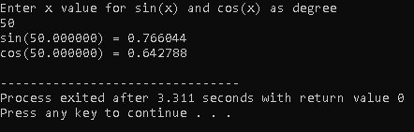    }

    return mult;

}

double sinx(double x){

    x = mainmeasure(x);

    if(x<-M_PI/2 || x>M_PI/2){

        x = M_PI - x;

    }

    int n;

    double sum=0;

    for(n=0;n<=5;n++){

        sum+=pow(-1,n)*pow(x,2*n+1)/fac(2*n+1);

    }

    return sum;

}

double cosx(double x){

    x = mainmeasure(x);

    if(x < 0 || x > M_PI){

        x = 2*M_PI - x;

    }

    int n;

    double sum=0;

    for(n=0;n<=6;n++){

        sum+=pow(-1,n)*pow(x,2*n)/fac(2*n);

    }

    return sum;

}

int main(){

    double x;

    printf("Enter x value for sin(x) and cos(x) as degree\n");

    scanf("%lf",&x);

    printf("sin(%lf) = %lf\n",x,sinx(rad(x)));

    printf("cos(%lf) = %lf\n",x,cosx(rad(x)));

    return 0;

}

Kemal Efe Çırakoğlu 23111012001