class04.R
kenny
2026-01-16
x <- 1:50
plot(x)
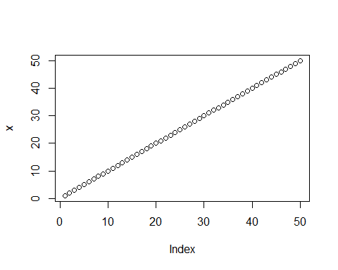
plot(x,sin(x), typ="o", col="green", lwd=3, xlab = "Is it lunch time yet?")
