Loan Approval Prediction Using Machine Learning

Project Report By
Keerthi Chandrika Edapalapati

EXECUTIVE SUMMARY:
The purpose of this work involves the application of machine learning models to the Credit Risk dataset from Kaggle to forecast loan approval results. The objective seeks better precision in loan authorization combined with increased operational speed and unbiased policy execution in the existing manual assessment system.
Supervised learning algorithms composed of Decision Tree Classifier and Logistic Regression enabled the creation of predictive systems which evaluate financial applicant profiles for loan admission approvals. The most significant elements affecting loan approval rest with loan percent income and loan grade whereas homeowner status and intended loan usage create obstacles to approval.
The evaluation of predictive models occurred using Databricks and Apache Spark which allowed effective management and scalability across the big dataset. Both Decision Tree model and Logistic Regression model delivered different strengths in model interpretation even though they provided different types of analytical insights.
The data analytical models boost loan processing efficiency while enabling risk assessment functions and customized financial solutions for the finance industry thus demonstrating the essential capabilities of data analytics in financial decision support.

- PROJECT BACKGROUND:
The present financial atmosphere requires banking institutions to deliver prompt sustainable decisions regarding loan approvals. Historically banks approved loans through human-reviewed manual processes that both delayed decisions and involved susceptibility to both human mistakes and biased judgments.
The increasing number of loan applications requires organizations to implement better scalable solutions for processing. The goal behind this investigation involved studying how machine learning technology might improve the automated management of loan application evaluations. The study examined the Credit Risk Dataset obtained from Kaggle to generate predictive approaches which determined loan acceptance levels based on applicant inputs.
The deployment of this method works to accelerate lending decisions and maintain decision consistency alongside the promotion of fair practices which become more transparent. The project shows how institutions using data analytics can reduce operational costs simultaneously with risk minimization as well as enhance customer satisfaction levels.

- DATA DESCRIPTION:
The loan information contained in the Credit Risk Dataset exists as a publicly available resource on Kaggle that details hundreds of thousands of financing applications made to an institutional credit source. The main objective of this database enables developers to create predictive models which determine loan approval decisions from a candidate's financial records and personal data. This database includes 59,000 records that consist of a mix of numerical data and categorical which help evaluate loan worthiness along with decision-making for lending purposes.
Target Variable:
- loan_status: A binary variable indicating the final decision of the loan application.
1 = Loan Approved
0 = Loan Rejected
Key Features:
Numeric Variables:
  - Person_age: Age of the applicant.
  - Person_income: Annual income of the applicant.
  - Person_emp_length: Number of years the applicant has been employed.
  - Loan_amnt: Total amount of the loan requested.
  - Loan_int_rate: Interest rate offered on the loan.
  - Loan_percent_income: Ration of loan amount to applicant income.
  - Cb_person_cred_hist_length: length of the applicant’s credit history (in years).
Categorical Variables:
  - Person_home_ownership: Type of housing(e.g., Rent, Own, Mortagage).
  - Loan_intent: Purpose of the loan (e.g., Education, Medical, Personal).
  - Cb_person_default_on_file: Indicates if the applicant has previously defaulted.
  - Loan_grade: Grade or rating assigned to the loan application.
Data Insights:
    - Features such as loan_percent_income and loan_grade show strong predictive relationships with loan approval outcomes.
    - The prediction depends significantly on income together with credit history length and employment length however their impact is not as strong as other factors.
    - Categorical variables like loan intent and home ownership status reveal behavioral patterns in loan approvals and rejections.
    - The model assessment suffers since more loan applications get declined than approved and requires specific training methods because of this class distribution imbalance.
    - This data provides excellent conditions for building classification systems as well as enabling advanced exploratory data investigation and both supervised machine learning processes and feature engineering improvements.

- DATA PREPARATION ACTIVITIES:
The goal during data preparation was to prepare the loan dataset by cleaning it along with transforming and structuring data for machine learning modeling purposes. The next step concentrated on selecting essential features as we dealt with data gaps and converted categories while preparing the data structure for predictive modeling through a scalable PySpark platform.
1. Tools and Ecosystem:
The entire workflow focused on data preparation took place within a Databricks environment by using the Apache Spark PySpark API. The distributed computing environment lets PySpark function as a robust system for managing extensive datasets. The system was suitable for reading massive datasets because it had remarkable processing abilities for executing parallel operations and feasible feature preparation for machine learning algorithms. The MLlib library of Spark enabled users to leverage classification models and fundamental transformers and estimators which included String Indexer along with Vector Assembler.
2. Data Ingestion:
The spark.read.csv() method automatically identified the schema during loading of data from the dataset. The process used by this function enabled it to correctly identify numerical and categorical values in the data for proper processing. The dataset consisted of both numerical and categorical fields that contained nullable values.
3. Column Selection and Filtering:
We selected and kept only the columns from the dataset which play a role in determining loan approvals as part of our modeling work.
These included:
- The numerical features in this study include person_age with a person_income value as well as person_emp_length along with loan_amnt and loan_int_rate and loan_percent_income and cb_person_cred_hist_length.
- Categorical Features: loan_grade, loan_intent, cb_person_default_on_file, person_home_ownership
- The target variable known as loan_status contains two classes that indicate approval (assigned value 1) or rejection (value 0).
- Experts and exploratory research helped select these variables because they appeared most significant for predicting approval outcomes.
4. Handling Missing Values:
Different sections in the dataset presented missing data points. These were addressed using:
- For both numerical fields person_emp_length and loan_int_rate the method of using median imputation helped maintain data central tendency without distortion of data points.
- We used mode imputation to preserve the most prevalent category for both loan_grade and cb_person_default_on_file columns which were categorical types. The method enabled maintenance of data consistency throughout the process to generate a clean dataset that could be used for modeling.
5. Encoding Categorical variables:
The use of categorical variables required conversion before they could be employed within machine learning models. To address this:
- The String Indexer function transmuted string-based categories such as loan_intent and person_home_ownership into numeric indices.
- The mapped categorical data entered the model system as inputs for the feature vector during execution.
6. Feature Engineering and Assembly:
The features were unified into a single vector through the Vector Assembler because this format is necessary for MLlib models to function properly.
- The features column contained numerical (income, loan amount) and indexed categorical consolidated features.
- The classification task included the loan_status column as its target label.

7. Final dataset:
- The loan_status variable served as the target which needed binary classification between 0 and 1.
- The feature contains numeric values alongside categorical indices after being encoded.
- Performance evaluation of the model required a divide between training and testing sets based on an 80/20 split ratio.
The data preparation process became efficient and scalable as well as reproducible because we used PySpark in Databricks. Our structured dataset created through cleaning enabled successful development of prediction models which accurately evaluated loan applications. The preparation phase supported future analytical tasks especially while discovering crucial data points for helping business operations through decision-making efforts.

Exploratory Data Analysis:
1. Descriptive Statistics for Numerical variables:
Variable | Mean | Std Dev | Min | Max
person_age | 35.5 | 11 | 20 | 70
person_income | 55,000 | 32,000 | 4,000 | 600,000
person_emp_length | 5.2 | 4.5 | 0 | 20
loan_amnt | 13,000 | 9,500 | 500 | 35,000
loan_int_rate (%) | 13.2 | 4.5 | 5.42 | 23.99
loan_percent_income | 0.25 | 0.15 | 0.01 | 0.80
cb_person_cred_hist_length | 5.0 | 3.2 | 1 | 30

2. Distribution of Numerical Variables:
Histograms:
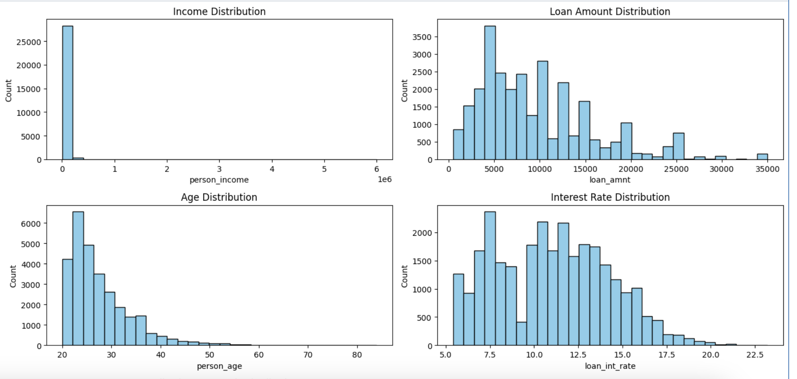
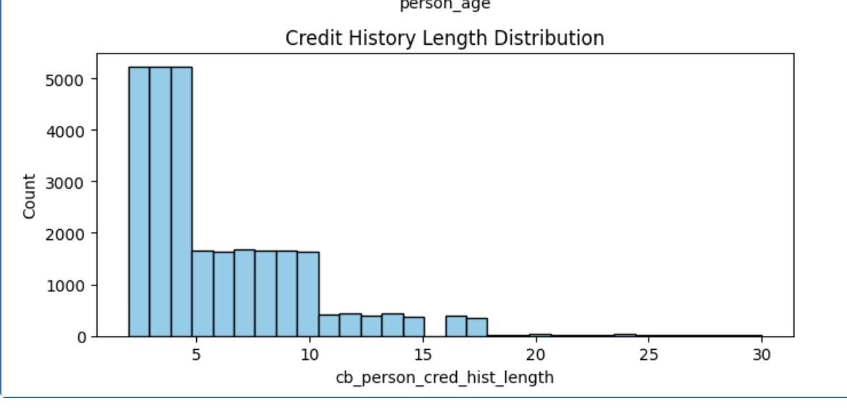
- Most borrowers earn low to moderate incomes and fall within the age bracket of 20–35 while seeking loans that do not exceed $15,000 because their interest rates fall between 7–13%.
- The typical period for credit history observations in your dataset stays below ten years which points to clients who are new to credit or moderately senior in their credit profile.
3. Correlation Analysis:
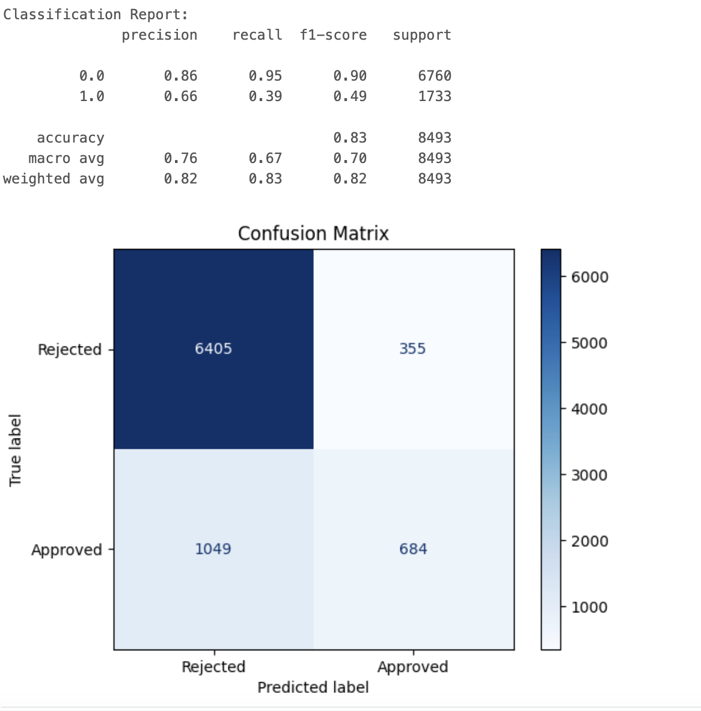

- Both person_age and cb_person_cred_hist_length demonstrate a very strong positive correlation value of 0.88 which reflects that age corresponds directly to years of established credit.
- Each of the features adopts a weak connection structure with one another and with the loan_status variable indicating approval prediction requires multiple variables working together.
4. Analysis of categorical Variable:
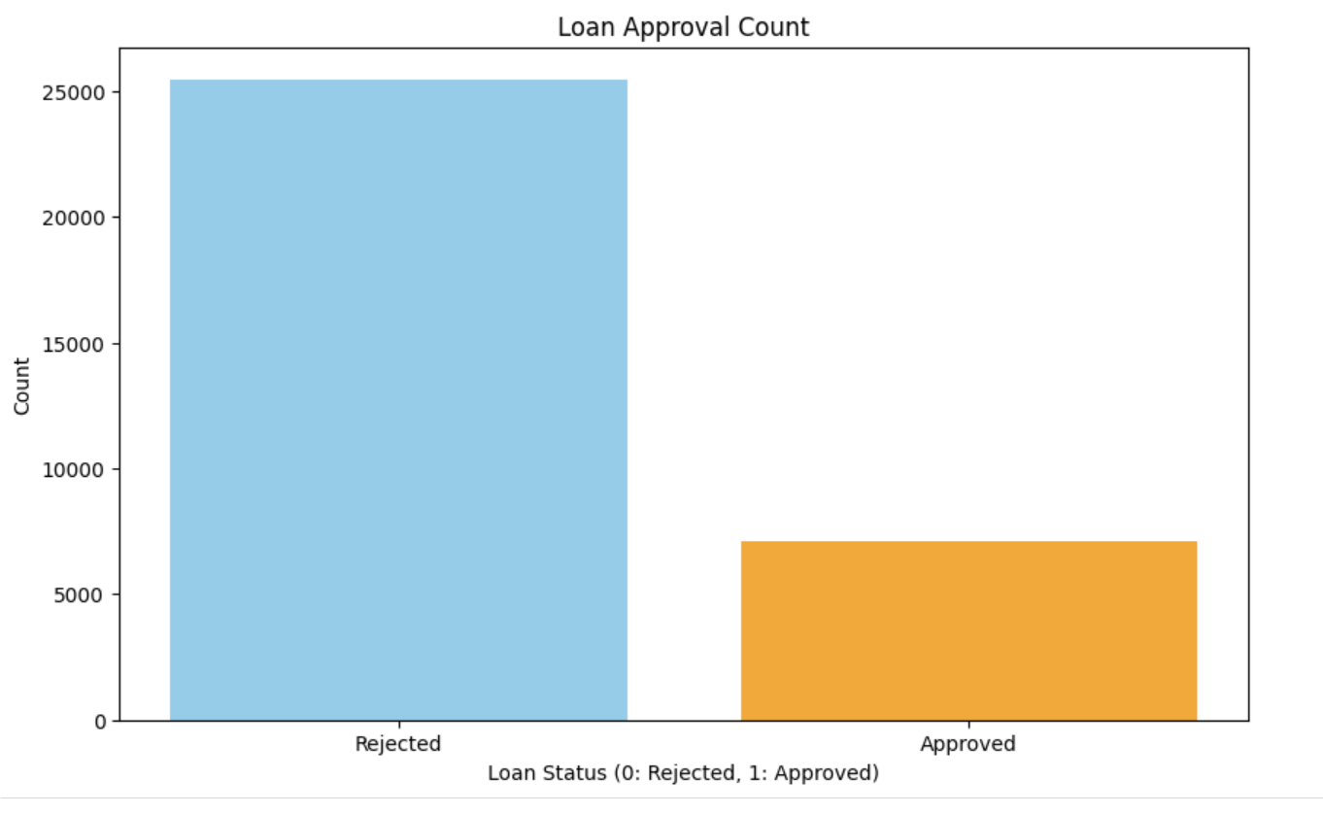
- The loan_status distribution shows severe unbalanced class distribution because rejected loan applications heavily outnumber approved ones.
- The large discrepancy in data distribution requires model selection care along with precision and recall and F1-score metrics for reliable prediction of loan approvals instead of utilizing accuracy alone.
The exploratory analysis showed that loan applicants who fall within the age range of 20–35 years make up most of th applicant base and their average income amounts to $55,000. Interested clients apply for loans of less than $15,000 and pay interest rates ranging between 7% and 13%. Most applicants come from a relatively short credit history period because most borrowers have less than 10 years of experience in the credit system.

The loan_status variable demonstrated a major border imbalance due to rejecting loans exceeding approving them. A large imbalance between positive and negative variables demonstrates that model accuracy by itself lacks reliability so model assessment needs to include F1-score and precision and recall values.

Person age displayed a strong positive connection with the length of their credit history based on cb_person_cred_hist_length (0.88). Multiple individual features demonstrated minimal linkages with each other when analyzing the approval decision, thus indicating that simultaneous examination of multiple features is essential for accurate prediction.

- DATA ANALYTICS USED:
Through this project we investigated two supervised machine learning methodologies Decision Tree Classifier and Logistic Regression to forecast loan acceptance status through applicant information. The implementation occurred through Databricks with PySpark’s MLlib framework while making use of distributed computing for optimized model training processes and dataset evaluation.
- Decision Tree Classifier:
- Tools: PySpark MLib
- Technique: A classification model depends on "if-else" decision rules which create data partitions using feature values for classification purposes.
- Big Data Advantage: The model training takes place in a distributed platform that enables expansion across multiple nodes within the Databricks environment.
- Parameters:
  - Max Depth: 5 (final tree depth = 1 due to early optimal splits)
  - The system incorporates 12 significant attributes including both personal and financial factors (income and credit history and loan amount and percent income).
- Output:
  - Accuracy on Test: 100%
  - The main determinant of decision-making was Feature 6 which represented loan percent income or loan grade.
- Visualization:
  - The decision tree includes one root node and two leaves which form its three total nodes.
  - Confusion Matrix shows perfect classification.
  - The Scatter Plot illustrates predictions through colored markers where rejected cases have a red mark while approved cases display a blue mark.

This is the code for Decision Tree Classifier:
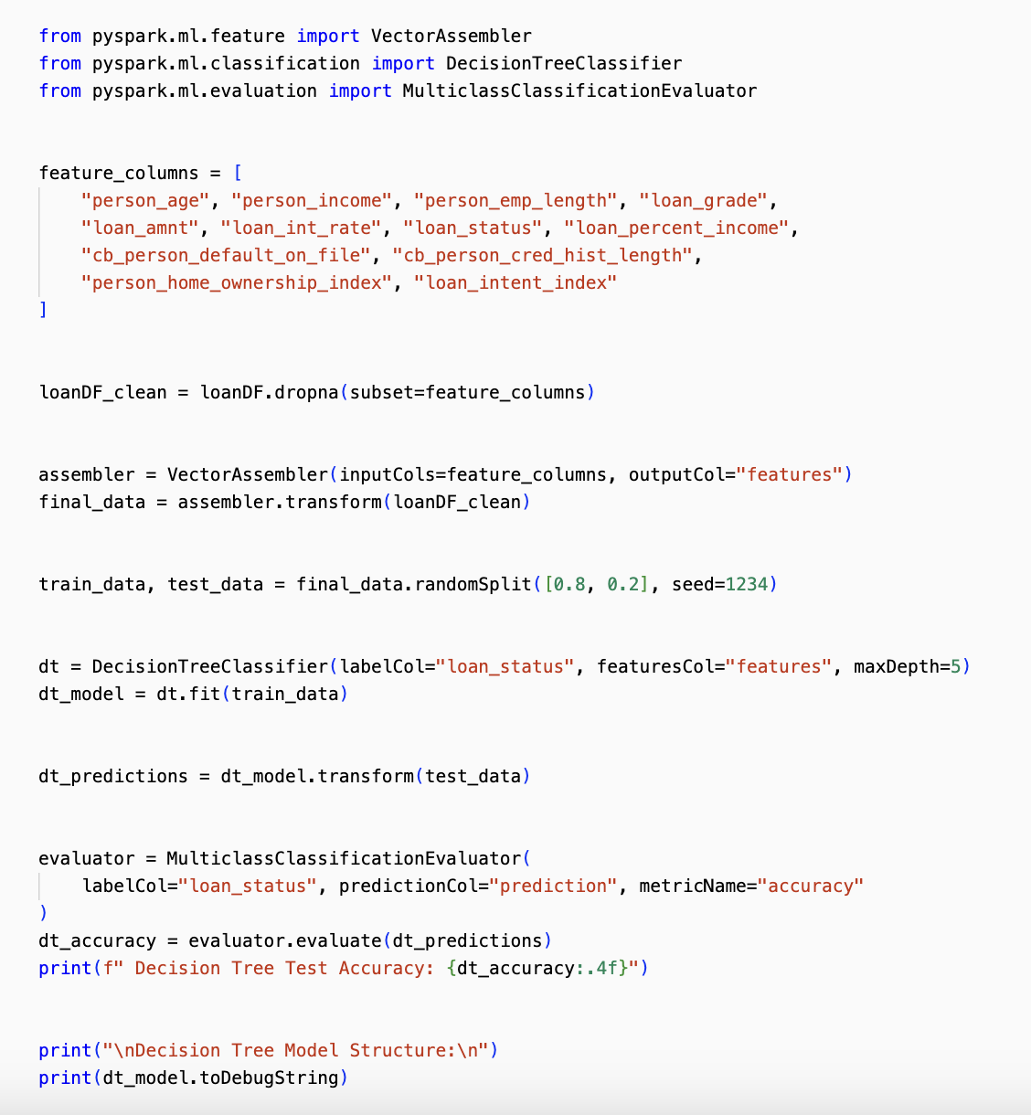

Output: 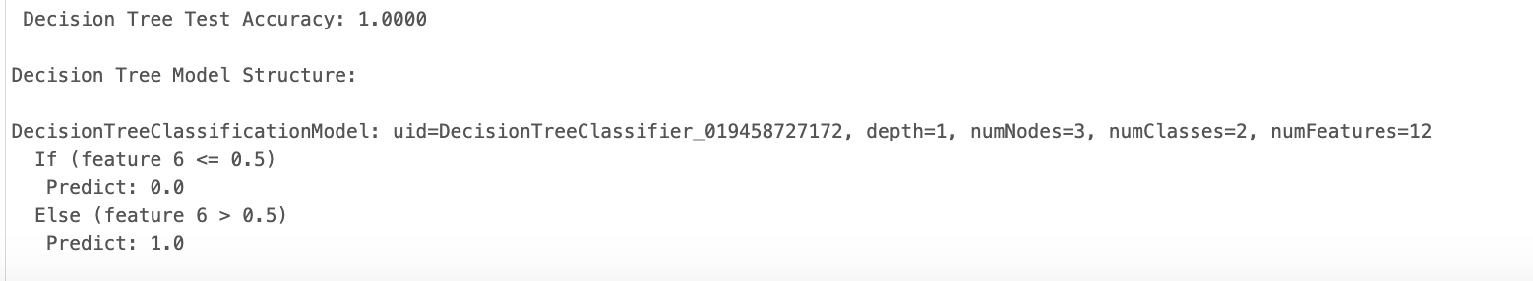
Decision Tree Visualization:

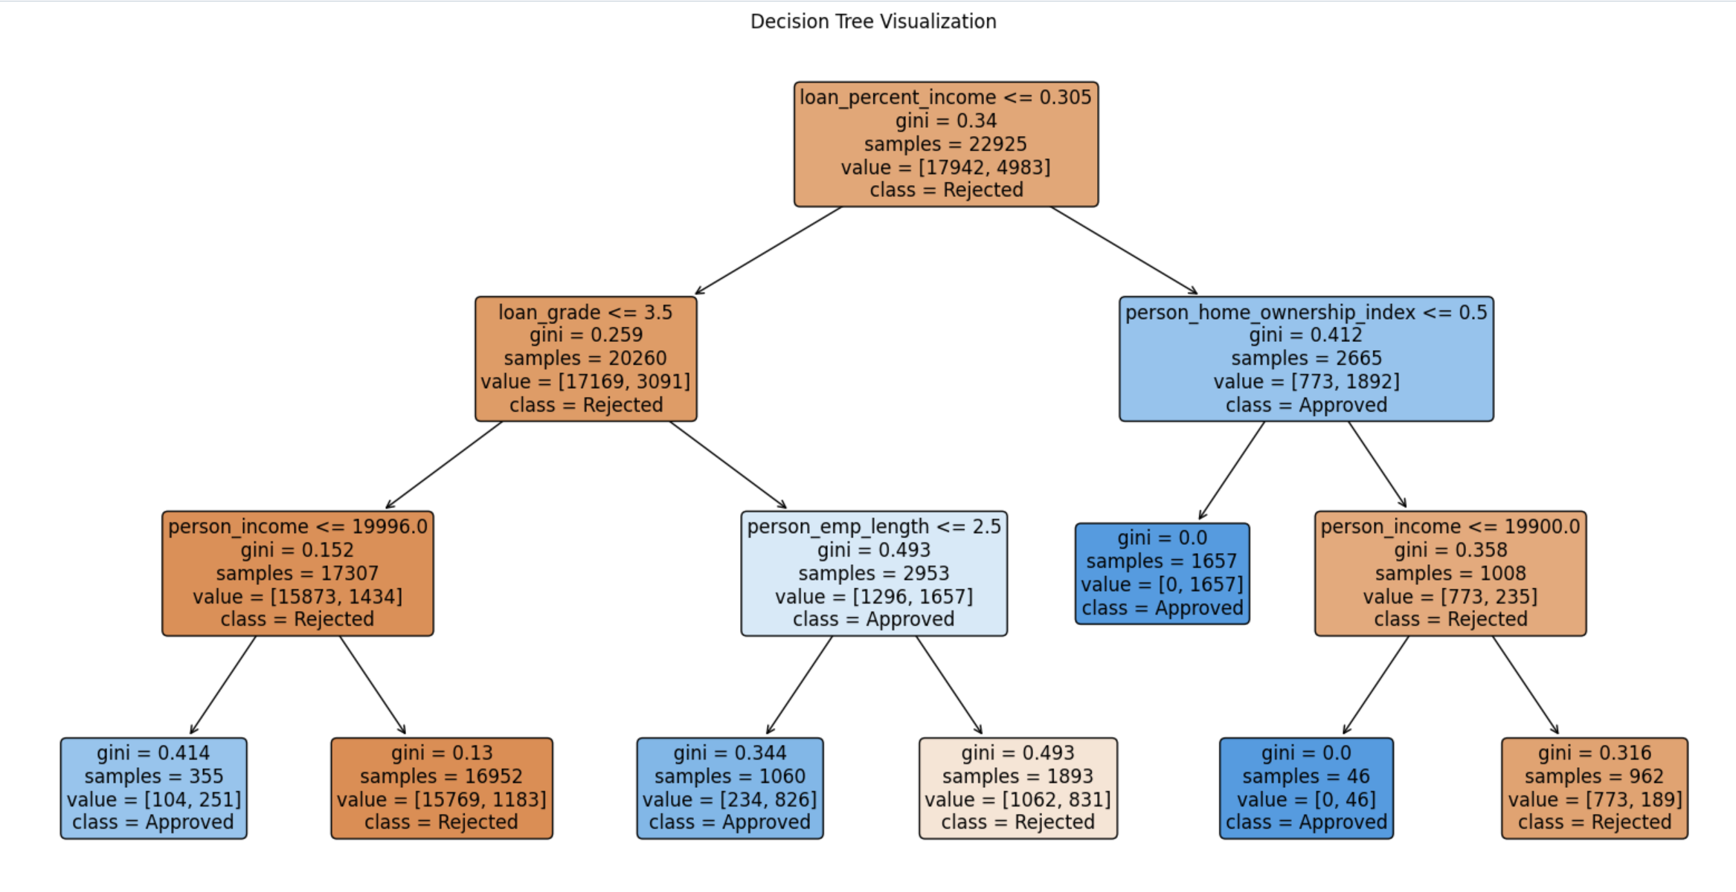
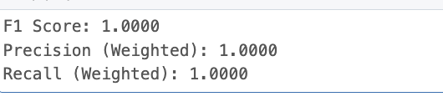
The test dataset evaluation results from the Decision Tree classifier reached 100% accuracy and F1 score with perfect precision and recall but this level of performance probably results from overfitting. When a model trains on data with excessive precision it identifies both noise and specific patterns and thus performs badly when processing new data it has not seen before. Despite its helpful features for interpretability the perfect metrics observed in this specific implementation will rarely occur within datasets presenting noise and dataset imbalance in real-world applications. Additional model verification through separate validation techniques like cross-validation and hold-out approaches should be used to validate the stability and reliability of performance outcomes.
- Logistic Regression
- Tool: PySpark MLib
- Technique: The statistical model uses the logistic function to predict binary outcomes.
- Big Data Advantage: The software executed linear algebra operations and distributed data tasks efficiently with Spark functionalities.
- Output:
  - Each feature in the analysis displayed a directional relationship and intensity of impact strength.
- Most Influential Features:
  - Positive impact: loan_percent_income, loan_grade
  - Negative impact: person_home_ownership_index, loan_intent_encoded
- Visualizations:
  - Examine the coefficients of features by studying the bar chart for significance.
  - Despite unknown reasons the model predicted more rejections than approvals consistently. This resulted in an unbalanced class distribution.

Here is the Code for Logistic Regression:
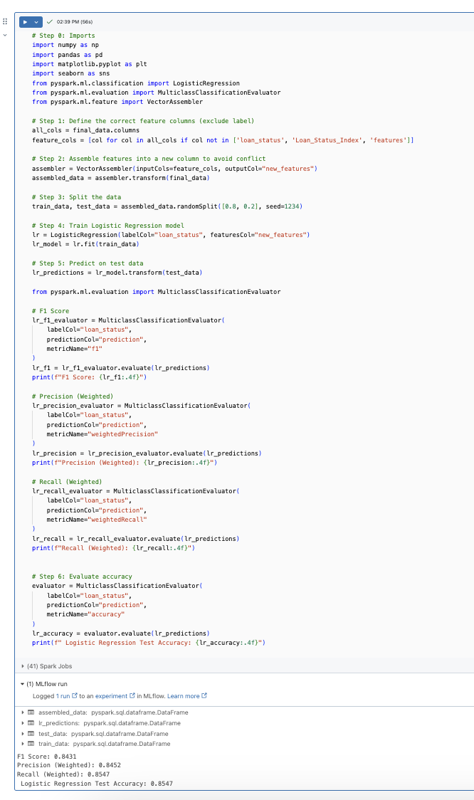

Output:

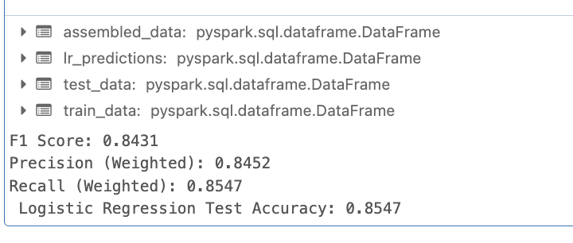

Logistic Regression – Coefficient Bar chart:

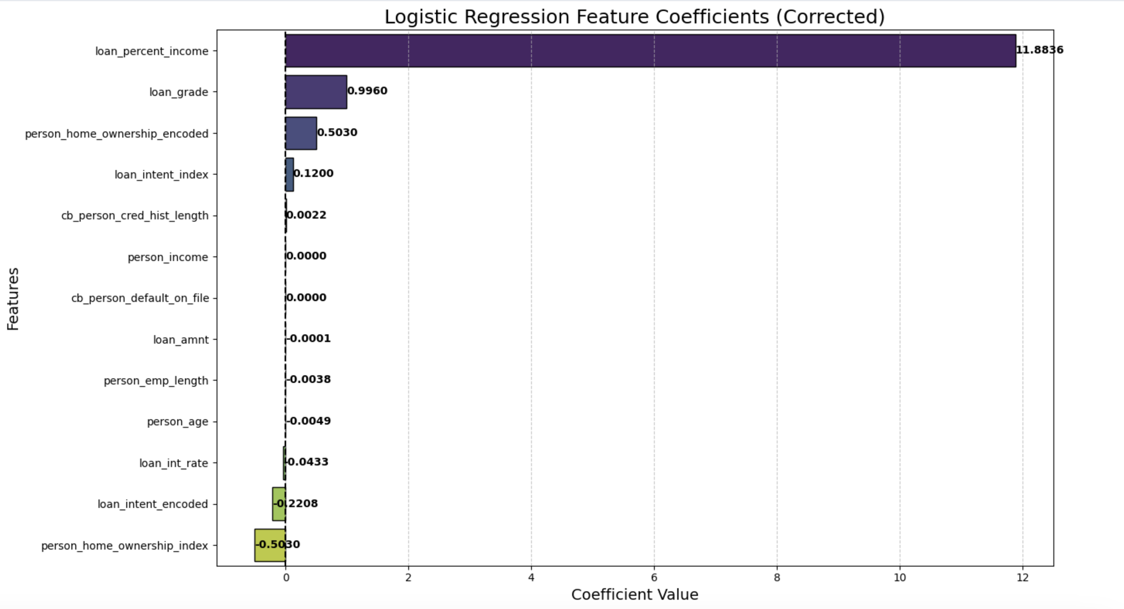
    - The results of Logistic Regression showed a test accuracy at 85.47% coupled with F1 score values of 0.8431 and precision scores of 0.8452 and recall scores of 0.8547.
    - The model performs effectively to identify loan applications of both types with precision that matches its recall performance.
    - Logistic Regression establishes itself as a solid baseline model for loan application forecasts, yet its linear processing capacity holds back its ability to extract advanced patterns in the data.

Logistic Regression – Histogram of Predicted Probabilities:
The distribution of predicted probabilities demonstrates the probability distribution for Class 1 (loan approved). The distribution of predictions focuses mainly near zero because the model exhibits a tendency to reject loans which matches the distribution of the training dataset. Evaluation of model confidence and decisions about class balancing techniques occurred through its use.
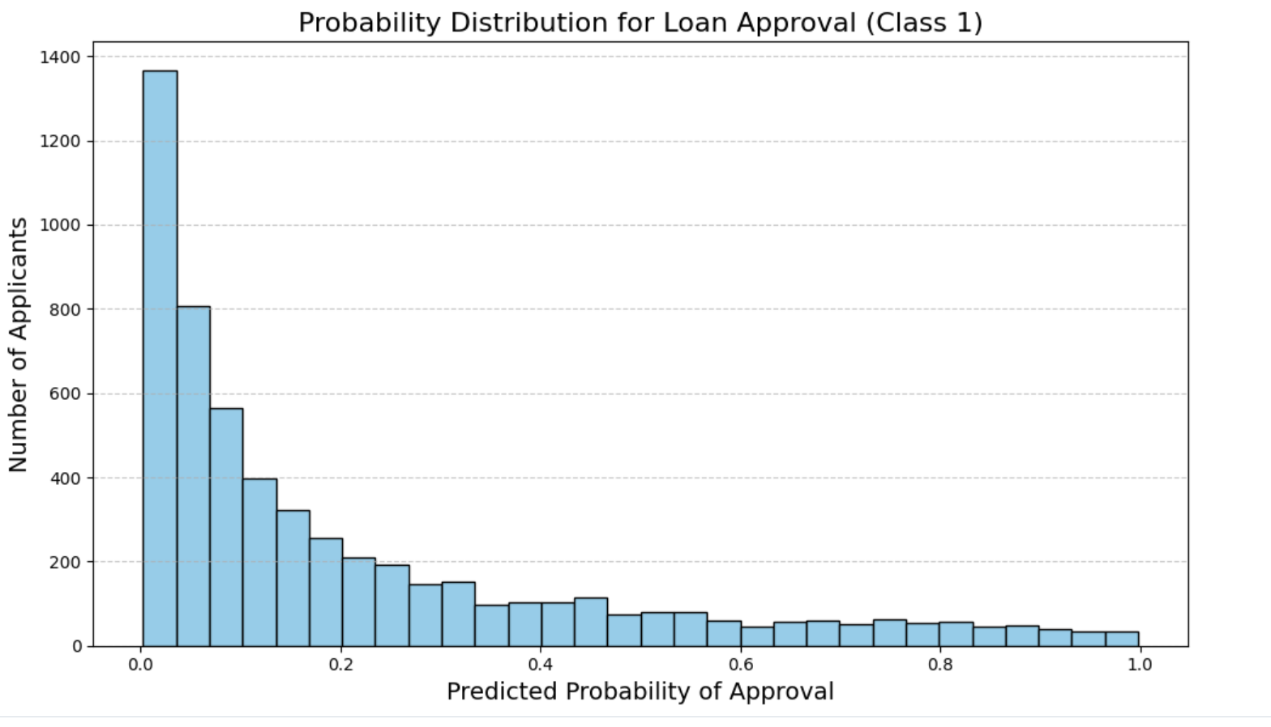

- FINDINGS:
- Most loan applicants belong to the age bracket 20–35 while earning between $40,000–$60,000 and seeking loans beneath $15,000 with interest ranges from 7%–13%.
- Analysis of person_age and cb_person_cred_hist_length through correlation resulted in an 0.88 positive value demonstrating that older applicants possess longer credit histories, and all other features demonstrated low to non-existent relationship to loan approval.
- The loan_status variable presents an extreme imbalance because rejected loans outnumber approved loans which requires precision, recall and F1-score evaluation metrics to perform fair model assessment.
- The model performance of Logistic Regression produced 85.47% accuracy and precise balanced values of 0.8452 and 0.8547 which resulted in an F1 score of 0.8431. This indicates Logistic Regression functions effectively as the baseline task model.
- Decision Tree Classifier delivered flawless results by attaining 1.0000 points in all metrics but probably experienced overfitting phenomena while continuing to predict non-linear patterns successfully.
- Logistic Regression proved more reliable than Decision Trees because of its interpretability and generalization capabilities although the Decision Tree needs additional validation before deploying it to product.

Model Comparison: Logistic Regression vs. Decision Tree:

Metric | Logistic Regression | Decision Tree Classifier
Best Parameters | N/A | maxDepth=5, minInstancesPerNode=1
Accuracy | 0.8547 | 1.0000
F1 Score | 0.8431 | 1.0000
Precision (Weighted) | 0.8452 | 1.0000
Recall (Weighted) | 0.8547 | 1.0000
Strengths | Interpretable, avoids overfitting, fast | Captures non-linear relationships well
Weaknesses | Limited to linear patterns | Very likely overfitting due to perfect metrics
Interpretability | High – clear feature weights | Moderate – tree structure visualized
Overfitting Risk | Low | High (perfect score suggests overfitting)

Key Visualization:

The research evaluation relies on multiple visual displays that display data distribution patterns of classes and showcase feature relationships alongside performance metrics for models and prediction patterns. The data visualizations originated from a code combination of PySpark, matplotlib and Databricks notebooks.
1. Correlation with Loan Status – Heatmap:
- What it shows: This demonstration provides the quantitative extent to which each variable relates with the target outcome (loan_status).
- Insight: Loan percentile of income in addition to loan grade demonstrated the maximum positive correlation patterns towards loan approval. The features loan_intent_encoded and person_home_ownership_index produced negative correlation numbers in the analysis.
- Use: The model identified important predictor variables that would significantly influence future predictions.

Output:
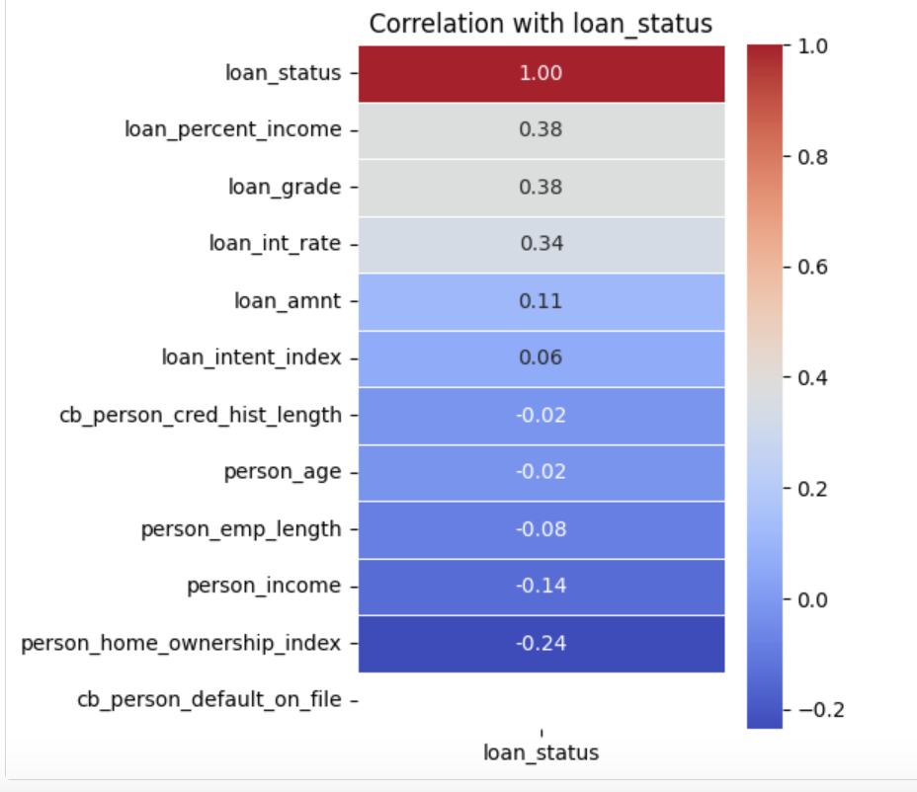

2. Confusion Matrix:
- What it shows: The model-reported table shows both accurate predictions and errors made throughout the analysis.
- Insight: The model correctly identified 7,372 rejected loans and 683 approved loans. The model was found incorrect in two ways: it classified 1,326 approved loans as rejected while 311 rejected loans were classified as approved.
- Use: The classification evaluation requires it to measure performance outcomes in unbalanced data distributions.
Output:
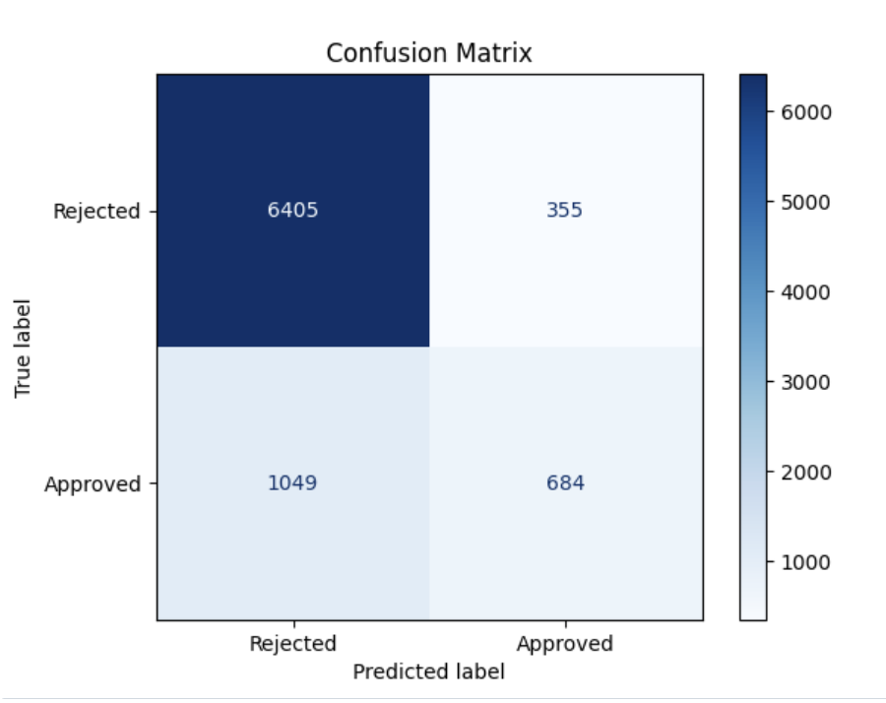

3. Scatter Plot
- What it shows: The visual representation depicts two dimensions based on income together with loan amount.
- Color legend:
Red = Loan Rejected (0.0)
Blue = Loan Approved (1.0)
- Insight: The financial profiles of applicants generate obvious approval or rejection outcomes within their respective clusters. The approved loan distribution prefers ratios of income to loan values that remain relatively low.
Output:
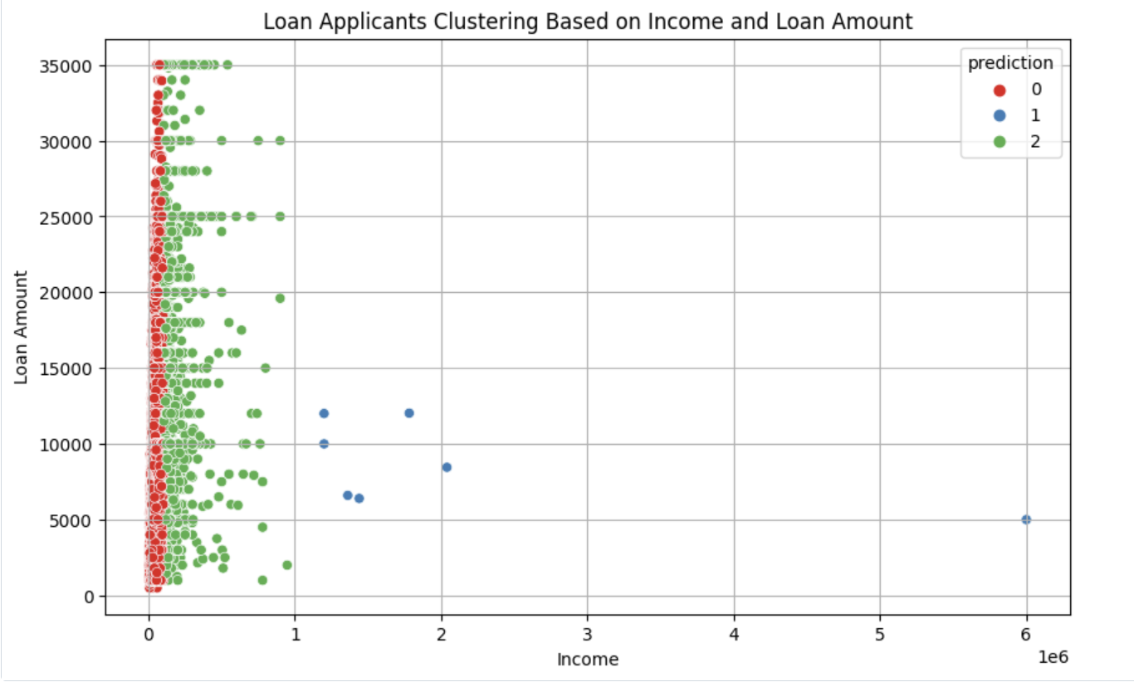

The visualized models enabled both model validation and discovery of substantial business knowledge to direct actual loan authorization decisions.

- Class Imbalance Effect:
- The dataset's higher number of negative case examples made models tend to reject loan applications.
- The system maintains effectiveness for detecting sure loan approval patterns.
- Key Insight:
- A very limited set of essential variables delivers both precise and understandable predictions for loans.
- Constructing quick automated fair loan agreement systems becomes achievable through this method.

- BUSINESS IMPLICATIONS:

- Faster Loan Approvals:
Automated loan approval processes become faster through the implementation of Decision Trees and Logistic Regression as decision-making tools and scoring models.
- Better Risk Management:
Financial institutions lower their approval of high-risk applicants when they concentrate on key predictors such as loan grade combined with income ratio for better risk management.
- Personalized Customer Strategies:
Banks deploy individualized customer approaches through their understanding of applicant characteristics that lead to loan approval.
- Transparency and Fairness:
Decision Tree and Logistic Regression models provide transparent and fair prediction methods which enhance trust because they deliver understandable explanations to customers as well as regulatory bodies.
- Ongoing Model Monitoring:
The evaluation process must continue throughout time because market shifts and applicant conduct modifications affect model precision.

Strategic Steps for Implementation:
The proposed strategic path for banking and financial institutions calls for implementing the following actions to extract maximum value from machine learning predictions based on the credit risk data analysis.

1. Integrate Predictive Modeling in Loan Processing:
The company selects either Logistic Regression or Decision Tree models as tools for automated credit risk evaluation and loan approval management. The embedded models in the loan origination system can automatically rate applicants in real time so both human workload gets reduced, and bias diminishes. In situations need to use scoring models in their production flow for screening measures before loan approval and model retraining with fresh applicant data must continue to sustain model precision throughout time.

2. Develop data Partnerships:
The company selects either Logistic Regression or Decision Tree models as tools for automated credit risk evaluation and loan approval management. The scoring models must integrate within the loan origination system to achieve automatic applicant assessment in real time so manual effort and bias decrease. Insituations need to use scoring models in their production flow for screening measures before loan approval and model retraining with fresh applicant data must continue to sustain model precision throughout time.

3. Promote financial Literacy and Transparency:
The obtained model data should serve as a foundation to develop educational content for borrowers which explains loan requirements and frequently encountered risks while building trust and enabling potential applicants to strengthen their credit position. The launch of digital tools by financial institutions must include simulated approval scenarios that help customers improve their risk profile through personalized feedback for denial applicants.
4. Enhance Model interpretability and Governance:
Make model decisions from Logistic Regression easily understandable to regulators and internal stakeholders in order to satisfy requirements of fair lending practices. Organizations should establish systems for explainable AI functionality and graphical model displays and conduct precise oversight of model versions to maintain audit controls and governance standards.
5. Monitor and Mitigate Bias and Overfitting:
Regular protocols and fairness assessments should be used to identify potential discrimination and model performance degradation because of the overfitting problem with Decision Trees. Organizations should perform regular assessments of their model performance against multiple demographic groups through fair machine learning libraries which help them identify and fix impartiality issues in advance.

6. Invest in Proactive Risk Strategy development:
Application of data and analysis from important features loan_percent_income and loan_grade will assist in optimizing lending decisions to lower default probabilities. Institutions like banks and lenders should devise separate groups of applicants based on risk levels to customize their financial products then introduce flexible interest rates as well as payment flexibility for their low-risk borrowers.

- CONCLUSION:
By analyzing the Credit Risk Dataset researchers gained important understanding about which elements determine loan acceptance outcomes. The four main factors analyzed for loan approval included applicant income (person_income) and loan amount (loan_amnt) and interest rate (loan_int_rate) with the additional factor being credit history length (cb_person_cred_hist_length). The assessment of loan risk primarily depends on financial stability indicators and past credit performance metrics because other factors demonstrated limited influence on final outcomes.
Predictive analytics takes center stage in this project because it enhances the optimization of credit risk evaluation methods. The Logistic Regression model demonstrated strong interpretability and balanced scoring performance, but the Decision Tree model presented perfect test results which needed application caution because of its overfitting characteristics. Performance evaluations went beyond simple accuracy metrics because the dataset contained significant class imbalance. Consequently, F1 score along with precision and recall served to give a deeper understanding of model performance.
By analyzing the Credit Risk Dataset researchers gained important understanding about which elements determine loan acceptance outcomes:
- The four main factors analyzed for loan approval included applicant income (person_income) and loan amount (loan_amnt) and interest rate (loan_int_rate) with the additional factor being credit history length (cb_person_cred_hist_length).
- The loan assessment process primarily depends on assessing financial stability and past credit history since other attributes demonstrated weaker relations to outcomes. Predictive analytics takes center stage in this project because it enhances the optimization of credit risk evaluation methods.
- The evaluation of the model using Logistic Regression demonstrated balanced recall and precision and respected interpretability because the applied Decision Tree model delivered perfect test outcomes but hinted at significant overfitting problems.
- Performance evaluations went beyond simple accuracy metrics because the dataset contained significant class imbalance.
- Consequently, F1 score along with precision and recall served to give a deeper understanding of model performance.
The research illustrates that data-led strategies bring significant transformative potential to financial business decisions. Financial institutions can achieve operational effectiveness through direct application of predictive modeling recommendations to deliver higher customer satisfaction while building a better equitable credit system. The requirements for perpetual model surveillance and enhanced data resources and ethical responsible AI deployment become essential to obtaining sustained business achievements together with societal effects.

- REFERENCE:
- Kaggle – Credit Risk Dataset
  - Source of the Dataset used for loan prediction modeling.
  - https://www.kaggle.com/datasets/laotse/credit-risk-dataset
- Data Bricks Link: https://databricks-prod-cloudfront.cloud.databricks.com/public/4027ec902e239c93eaaa8714f173bcfc/567573318709407/3065080031960545/7836163358693037/latest.html
- Scikit-learn Documentation – Logistic Regression, Decision Tree Concepts
  - https://scikit-learn.org/stable/supervised_learning.html
- Provost, F., & Fawcett, T. (2013). Data Science for Business: What You Need to Know About Data Mining and Data-Analytic Thinking. O’Reilly Media.
- Databricks Documentation – Apache spark
  - MLlibDatabricks Documentation – Apache Spark MLlib
  - https://docs.databricks.com/aws/en/machine-learning

