**Students collection:**

1. Create a database “Student” with the following attributes Rollno, Age, ContactNo, Email-Id.

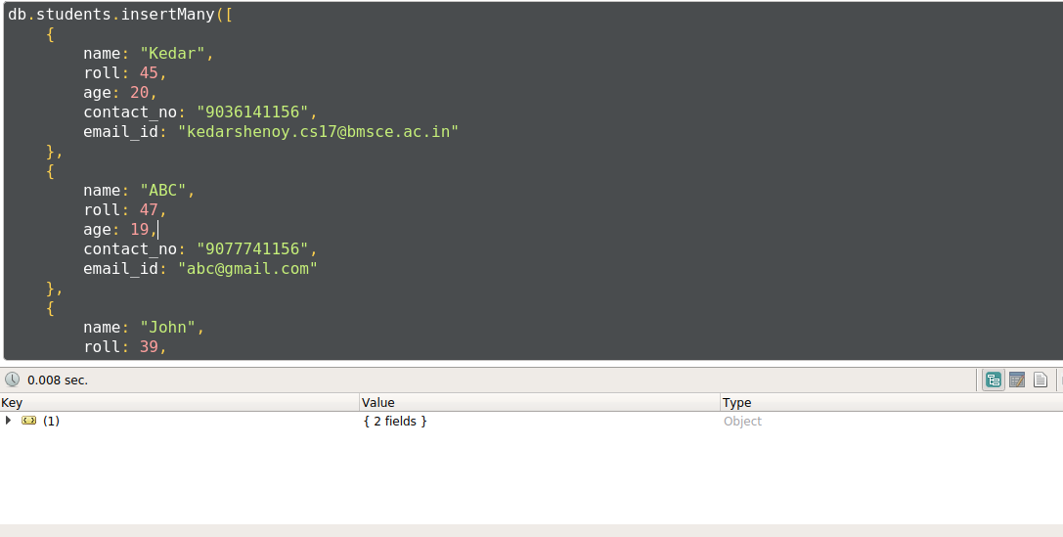

1. Write query to update Email-Id of a student with rollno 10.

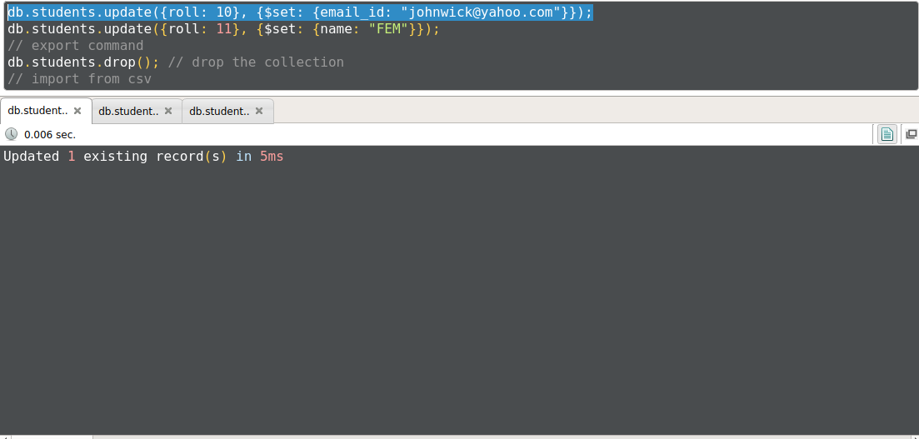

1. Replace the student name from “ABC” to “FEM” of rollno 11.

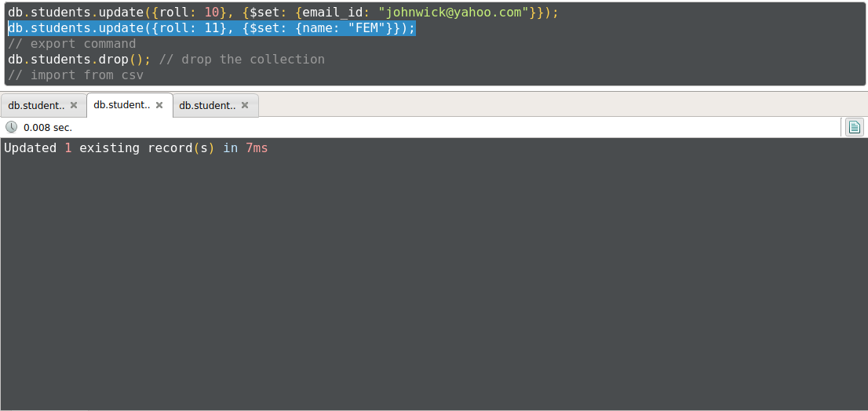

1. Export the created table into local file system

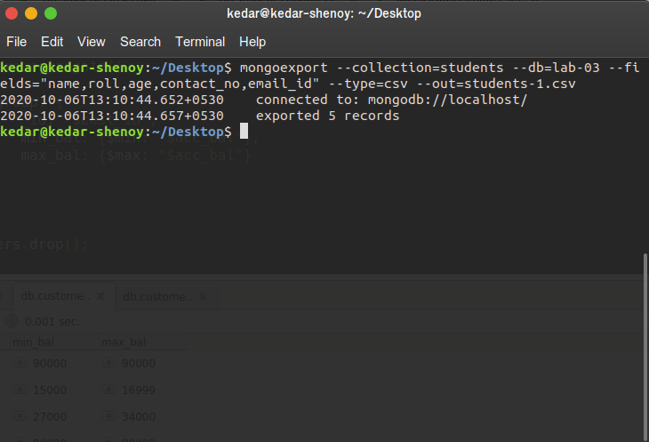

1. Drop the table

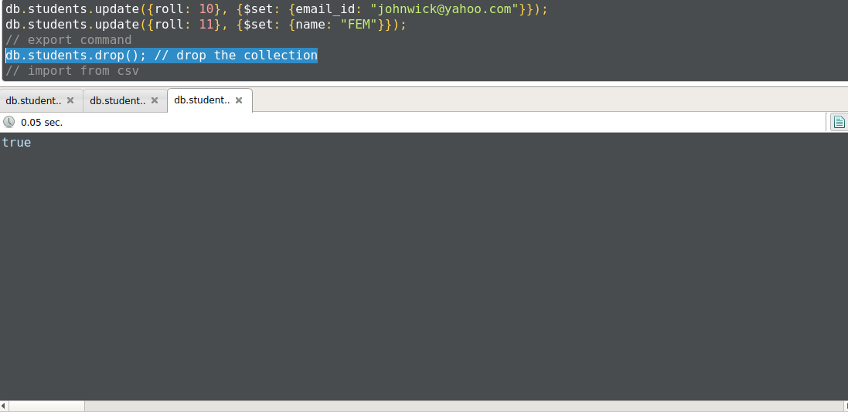

1. Import a given csv dataset from local file system into mongodb collection.

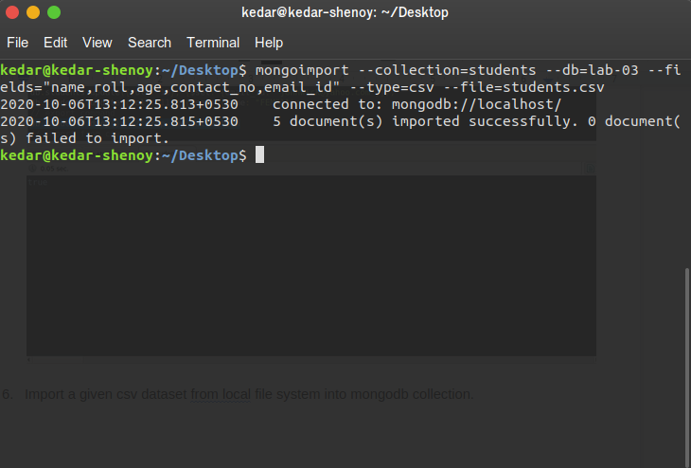

**Customers collection:**

1. Write a query to display those records whose total account balance is greater than 1200 of account type ‘Z’ for each customer_id.

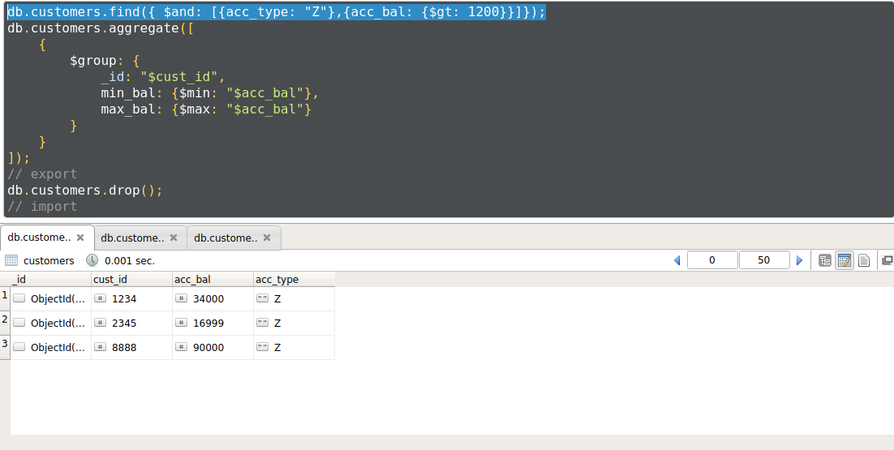

1. Determine Minimum and Maximum account balance for each customer_id.

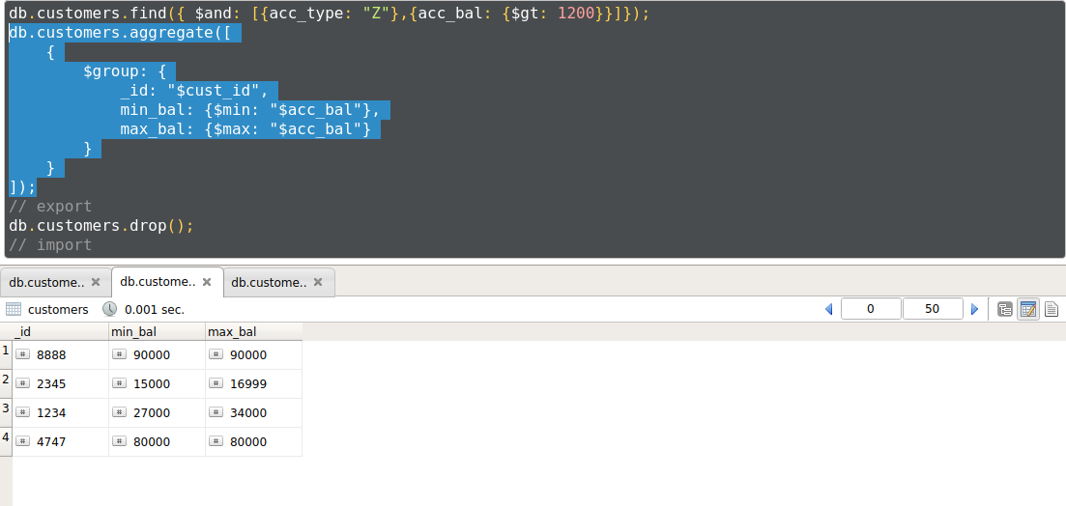

1. Export the created collection into local file system

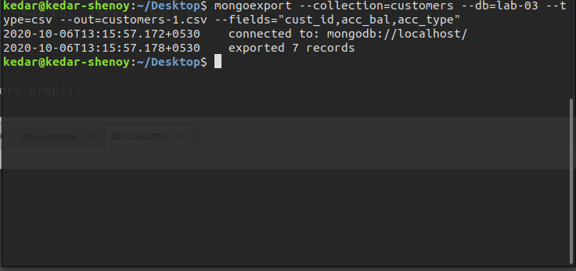

4. Drop the table

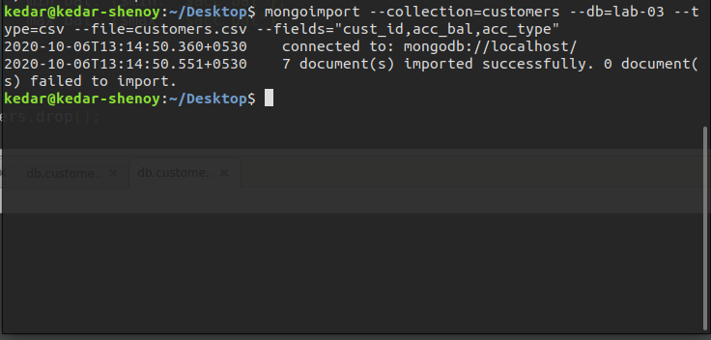

5. Import a given csv dataset from local file system into mongodb collection.

