A

PROJECT REPORT
ON
DIGITAL HEALTH CARD (AAROGYA CARD)

Submitted in partial fulfillment for the award of

Post Graduate Diploma in Advance Computing

(PG-DAC) from

INSTITUTE OF EMERGING TECHNOLOGIES

Authorized Training Centre


Under the Guidance of
Mrs. Savita Vaidya
BY
Chandrakant Palandurkar (PRN: 250845920015)
Kedar Mane (PRN: 250845920032)
Poonam Agrawal (PRN: 250845920050)
Puja Wagh (PRN: 250845920063)
Waghmode Vaibhavi (PRN: 250245920095)



CERTIFICATE
This is to certify that the project report entitled “DIGITAL HEALTH CARD” is a bonafide work carried out by Chandrakant Palandurkar, Kedar Mane, Poonam Agrawal, Puja Wagh, Waghmode Vaibhavi and submitted in partial fulfilment of the requirement for the C-DAC ACTS, DAC course in Institute of Emerging Technologies in the batch of Aug 2025.

Course Coordinator External Examiner

Mr. Manoj Deshmukh

ACKNOWLEDGEMENT
This project titled “DIGITAL HEALTH CARD” was a great learning experience for us and we are submitting this work to Advanced Computing Training School (C-DAC).
We are very glad to mention Mrs. Savita Vaidya for her valuable guidance and continuous support throughout the project work. Her guidance helped us to understand the project requirements clearly and overcome various challenges faced during the development and documentation of this project.
Our heartfelt thanks go to Mr. Sangram Patil (Director, IET) for providing the necessary infrastructure, resources, and support to successfully complete this project. His encouragement and coordination made it possible for us to work efficiently during the course period.
We are also thankful to all the faculty members and staff of the institute for their cooperation and support during the entire course duration.
Finally, we would like to express our sincere gratitude to C-DAC ACTS, Pune, for providing us with the opportunity and platform to enhance our technical knowledge and practical skills.

Name | PRN | Signature
Chandrakant Palandurkar | 250845920015 | ____________
Kedar Mane | 250845920032 | ____________
Poonam Agrawal | 250845920050 | ____________
Puja Wagh | 250845920063 | ____________
Waghmode Vaibhavi | 250245920095 | ____________

Abstract

The project titled “Digital Health Card (Aarogya Card)” is a web-based healthcare information management system designed to digitally store and manage an individual’s essential medical records in a secure and centralized manner. The system aims to overcome the limitations of traditional paper-based health records, which are often difficult to maintain, access, and retrieve during medical emergencies.
The Digital Health Card system allows users to store personal details, medical history, prescriptions, allergies, vaccination records, and emergency contact information. In case of an emergency, critical health information can be accessed quickly, enabling healthcare providers to take timely and informed medical decisions. The system also supports secure authentication to ensure privacy and data protection of sensitive health information.
This project focuses on ease of use, data accuracy, and secure access while providing a reliable platform for both patients and healthcare professionals. By digitizing health records, the Digital Health Card (Aarogya Card) helps reduce paperwork, improve healthcare efficiency, and enhance emergency response. The system is scalable and can be extended in the future to integrate with hospitals, laboratories, and government healthcare services.
Index

Sr. No. | Title | Page No.
1 | Introduction
2 | Problem Definition & Scope
2.1 | Problem Definition
2.2 | Goals & Objectives
2.3 | Major Constraints& Outcomes
3 | Software Requirement Specification
3.1 | Purposed System
3.2 | Scope
4 | System Modules
5 | Performance-Requirements
5.1 | H/W Requirements & S/W Requirements
6 | UML Diagram
6.1 | DFD
6.2 | ERD
6.3 | Use case diagram
6.4 | Class Diagram
6.5 | Sequence diagram
6.6 | Activity Diagram
6.7 | Deployment diagram
6.8 | System Architecture
7 | Test Cases
8 | Screenshots
9 | References

1. Introduction
The Digital Health Card (Aarogya Card) project is an innovative web-based solution designed to digitize and streamline the management of personal health records. Traditionally, health records are maintained in physical form, which can be misplaced, damaged, or difficult to access in urgent situations. This leads to delays in medical care and inefficiencies in healthcare management.
This system provides a centralized and secure digital platform where users can store their medical history, prescriptions, vaccination records, allergies, and emergency contact information. In critical situations, the system enables real-time alerts to registered contacts, ensuring timely response and improved patient safety.
The Digital Health Card (Aarogya Card) is designed to be user-friendly, scalable, and reliable, aiming to reduce paperwork, improve accessibility of critical medical data, and enhance communication between patients and healthcare providers. By offering a centralized repository of health information, it significantly improves healthcare efficiency and emergency preparedness.

2. Problem Definition & Scope

2.1 Problem Definition
In the existing healthcare ecosystem, patient medical records are often scattered across multiple hospitals, clinics, and diagnostic centers. Most health-related information is maintained in physical or semi-digital form, making it vulnerable to loss, damage, or misplacement. As a result, accessing accurate and complete medical information at the time of consultation or during emergencies becomes difficult.
During critical situations, delays in retrieving essential details such as medical history, allergies, previous prescriptions, or ongoing treatments can negatively impact the quality and speed of medical care. Manual record-keeping is also time-consuming, prone to human errors, and lacks real-time accessibility. Furthermore, there is limited provision for notifying family members or caregivers during emergencies.
These challenges highlight the need for a centralized, digital, and secure healthcare information system that enables easy access to medical records, ensures data reliability, and supports real-time emergency notifications for patients, caregivers, and healthcare professionals.

2.2 Goals & Objectives
The main goal of the Digital Health Card project is to create a comprehensive, secure, and accessible platform for managing personal health data. The specific objectives include:
- Centralized Health Record Management: Store all medical history, prescriptions, vaccination records, and laboratory reports digitally in one platform.
- Secure Access: Implement user authentication and role-based access to protect sensitive health data.
- Emergency Notification: Provide real-time alerts to family members or registered contacts in case of emergencies.
- Data Accessibility: Ensure patients and authorized healthcare providers can access records anytime, anywhere.
- Reduce Paperwork: Minimize dependency on physical documents, improving efficiency in healthcare workflows.
- Scalable Architecture: Design the system to accommodate growing data and users without compromising performance.

2.3 Major Constraints & Outcomes
Constraints:
- Data Privacy & Security: Ensuring compliance with healthcare data regulations and securing sensitive patient information.
- User Adoption: Some users may have limited technical knowledge, requiring an intuitive and simple interface.

- System Availability: Real-time alerts and access require high system uptime and reliability.
- Integration Challenges: Integrating data from multiple healthcare sources may require standardization of formats.
Expected Outcomes:
- A secure, digital platform for storing and managing personal health records.
- Quick retrieval of patient information during emergencies.
- Automated notifications to family or caregivers in critical situations.
- Improved efficiency in healthcare management, reducing paperwork and errors.
- A scalable and maintainable system that can be extended with new features in the future.

3. Software Requirement Specification (SRS)

3.1 Proposed System
The Digital Health Card (Aarogya Card) is a web-based healthcare information management system developed using React.js as the frontend framework. The system provides a secure and centralized platform for managing personal health records and enables controlled access to different stakeholders involved in healthcare delivery.
The proposed system supports multiple user roles, each with clearly defined responsibilities:
- Patient:
Patients can access their digital health records using Aadhaar number and OTP-based authentication, ensuring secure and user-friendly login. Patients can view their medical history, prescriptions, test reports, and personal health information.
- Doctor:
Doctors can log in using email and password authentication. They can view patient health records, update medical observations, add prescriptions, and access nominee contact details in case of emergencies.
- Laboratory Technician:
Lab technicians can securely log in using email and password to upload diagnostic test reports and update laboratory results associated with patient records.
- Admin:
The hospital administrator logs in using username and password authentication. The admin manages users, oversees system operations, and ensures smooth coordination between different roles.
- Nominee:
The nominee role does not require login credentials. Nominee contact information is registered within the system and is visible only to authorized users such as doctors, enabling communication during emergencies.
The system communicates with the backend through RESTful APIs using Axios, ensuring efficient data exchange between frontend and backend services. Role-based access control and protected routes are implemented to prevent unauthorized access and maintain data confidentiality.
Overall, the proposed system replaces traditional paper-based health records with a secure, scalable, and efficient digital solution, improving accessibility, data accuracy, and emergency response in healthcare management.

3.2 Scope
The scope of the Digital Health Card (Aarogya Card) project defines the functional boundaries and capabilities of the system in its current implementation.

In-Scope Features
- Web-based healthcare application accessible through a browser.
- Aadhaar number and OTP-based authentication for patients.
- Email/password-based authentication for doctors and laboratory technicians.
- Role-based access control for patients, doctors, lab technicians, and admin.
- Secure storage and retrieval of patient medical records.
- Upload and management of laboratory test reports.
- Viewing and updating of prescriptions and medical details by doctors.
- Visibility of nominee contact details to authorized medical personnel.
- Secure API-based communication between frontend and backend.

Out-of-Scope Features
- Mobile application support.
- Online appointment booking system.
- Payment or billing integration.
- Direct government database integration.
- AI-based diagnosis or recommendation features.
The scope is intentionally limited to ensure security, reliability, and clarity of functionality, while allowing future enhancements such as mobile application support, hospital system integration, and advanced analytics.

4. System Modules
The Digital Health Card (Aarogya Card) system is designed as a role-based web application, where each user role is provided with specific functionalities according to their responsibilities. The system modules are structured role-wise to ensure clarity, security, and controlled access to sensitive healthcare information.

4.1 Patient Module
The Patient Module allows registered patients to securely access and manage their personal health information.
Key functionalities:
- Patient authentication using Aadhaar number and OTP.
- Viewing personal health details such as medical history, prescriptions, vaccination records, and laboratory reports.
- Access to previously uploaded diagnostic test results.
- Viewing nominee contact details registered in the system.
- Secure logout functionality to prevent unauthorized access.
This module ensures that patients have easy and secure access to their health records while maintaining data privacy.

4.2 Doctor Module
The Doctor Module provides healthcare professionals with controlled access to patient medical information required for diagnosis and treatment.
Key functionalities:
- Secure login using email and password authentication.
- Viewing patient health records and medical history.
- Adding prescriptions and medical observations.
- Accessing laboratory test reports uploaded by laboratory technicians.
- Viewing nominee contact details for emergency communication.
- Ensuring patient data confidentiality through role-based access control.
This module enables doctors to make informed medical decisions efficiently.

4.3 Laboratory Technician Module
The Laboratory Technician Module is responsible for managing diagnostic test data related to patients.

Key functionalities:
- Secure login using email and password.
- Uploading laboratory test reports for patients.
- Ensuring accuracy and integrity of diagnostic information.
- Controlled access limited to laboratory-related operations only.
This module supports timely and accurate availability of diagnostic data within the system.

4.4 Administrator Module
The Administrator Module is responsible for overall system management and coordination.
Key functionalities:
- Authentication using username and password.
- Managing user accounts such as doctors and laboratory technicians.
- Monitoring system usage and access.
- Ensuring proper functioning of the platform.
- Maintaining data consistency and system reliability.
This module ensures smooth operation and administrative control of the Digital Health Card system.

4.5 Nominee Access Module
The Nominee Access Module handles emergency contact information within the system.
Key functionalities:
- No login or registration required for nominees.
- Nominee contact details are securely stored in the system.
- Nominee information is visible only to authorized roles such as doctors.
- Enables communication with family members or caregivers during emergencies.
This module enhances emergency response without compromising system security.

5. Performance Requirements
The performance requirements define the operational capabilities and environmental constraints of the Digital Health Card (Aarogya Card) system to ensure reliable and efficient functioning.

5.1 Hardware & Software Requirements

Hardware Requirements
The system is deployed on a cloud-based environment, allowing access from any location with an internet connection. The minimum hardware requirements for end users are as follows:
- Processor: Intel i3 processor or higher
- RAM: Minimum 4 GB
- Storage: Minimum 100 GB HDD or SSD
- Network: Stable internet connection
Since the application is web-based, no high-end hardware is required on the client side.

Software Requirements
The software requirements specify the technologies and platforms required to run and access the system.
- Operating System: Any operating system (Windows, Linux, macOS)
- Frontend Technology: React.js, HTML, CSS(TailwindCSS)
- Backend Technology: ASP.NET Core Web App
- Database: MySQL
- Web Server: Cloud-hosted server
- Browser: Google Chrome / Mozilla Firefox / Microsoft Edge
- API Communication: Axios (HTTP client)

Performance Considerations
- The system supports multiple concurrent users without significant performance degradation.
- Role-based access ensures optimized data retrieval based on user permissions.
- Cloud deployment enables scalability and high availability.
- Secure authentication mechanisms ensure minimal latency while maintaining data protection.
Summary:
The Digital Health Card system is optimized for efficient performance, reliable access, and secure handling of sensitive health data, ensuring it meets the demands of patients, caregivers, and healthcare providers.

6. UML Diagrams
UML (Unified Modeling Language) diagrams help visualize, design, and document the system architecture and workflows of the Digital Health Card project. The following diagrams represent the system structure, data flow, and interactions between modules.

6.1 Data Flow Diagram (DFD)
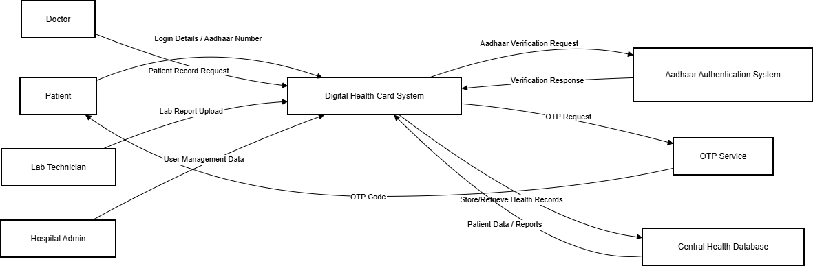
The Data Flow Diagram illustrates how various users interact with the Digital Health Card System and how data flows through the system. Patients log in using Aadhaar number and OTP verification. After successful authentication, patient data is retrieved from the centralized database. Doctors access medical records and update prescriptions, while laboratory technicians upload diagnostic reports. Administrators manage user accounts and system operations. All information is processed by the core system and stored securely in the central database, ensuring role-based access control and data integrity.

6.2 Entity-Relationship Diagram (ERD)
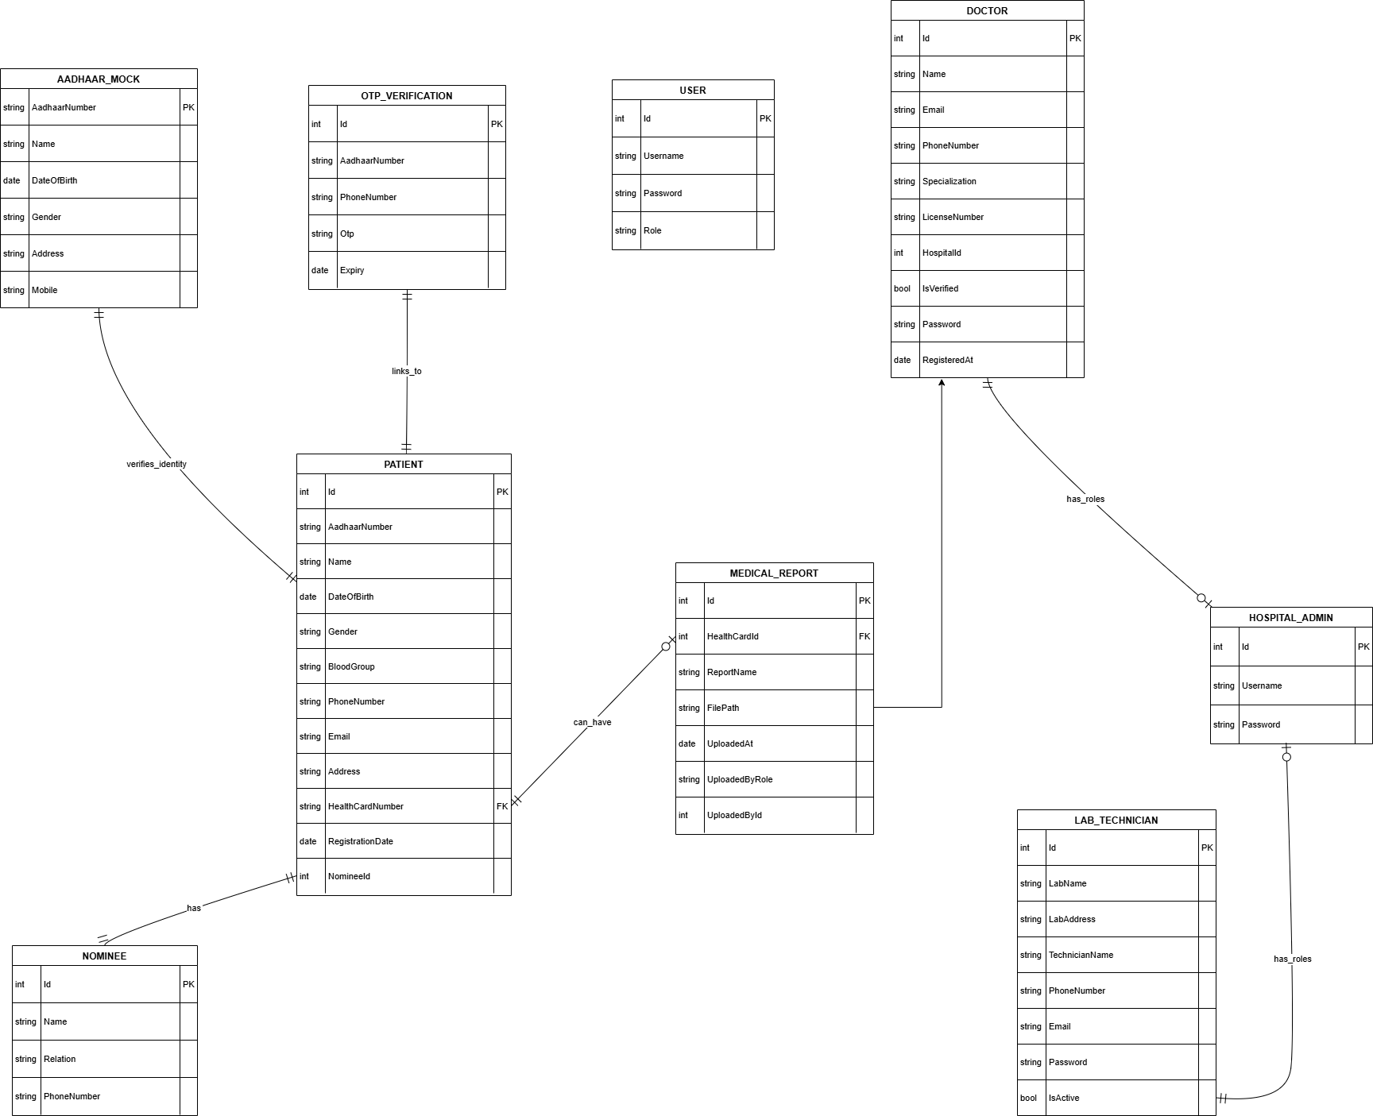
The ER diagram represents the database structure of the Digital Health Card system. The Patient entity stores personal and identification details, while the Doctor and LabTechnician entities manage medical and diagnostic activities. Prescriptions are linked to both Patient and Doctor, representing medical consultations. Laboratory reports are associated with Patients and uploaded by Lab Technicians. Each Patient has a Nominee entity that stores emergency contact information. The Admin entity is responsible for managing system users. These relationships ensure structured storage, data integrity, and efficient retrieval of healthcare information.

6.3 Use Case Diagram
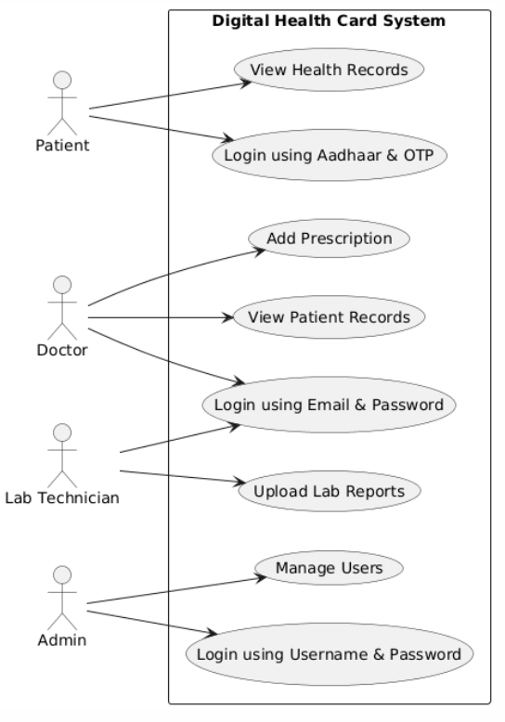
The Use Case Diagram represents the functional interactions between users and the Digital Health Card System. Patients log in using Aadhaar number and OTP authentication to view their medical records. Doctors log in using email and password to access patient records and add prescriptions. Laboratory technicians upload diagnostic reports after authentication. The hospital administrator logs in to manage users and monitor system operations. The diagram illustrates role-based functionality and controlled access within the healthcare platform.

6.4 Class Diagram
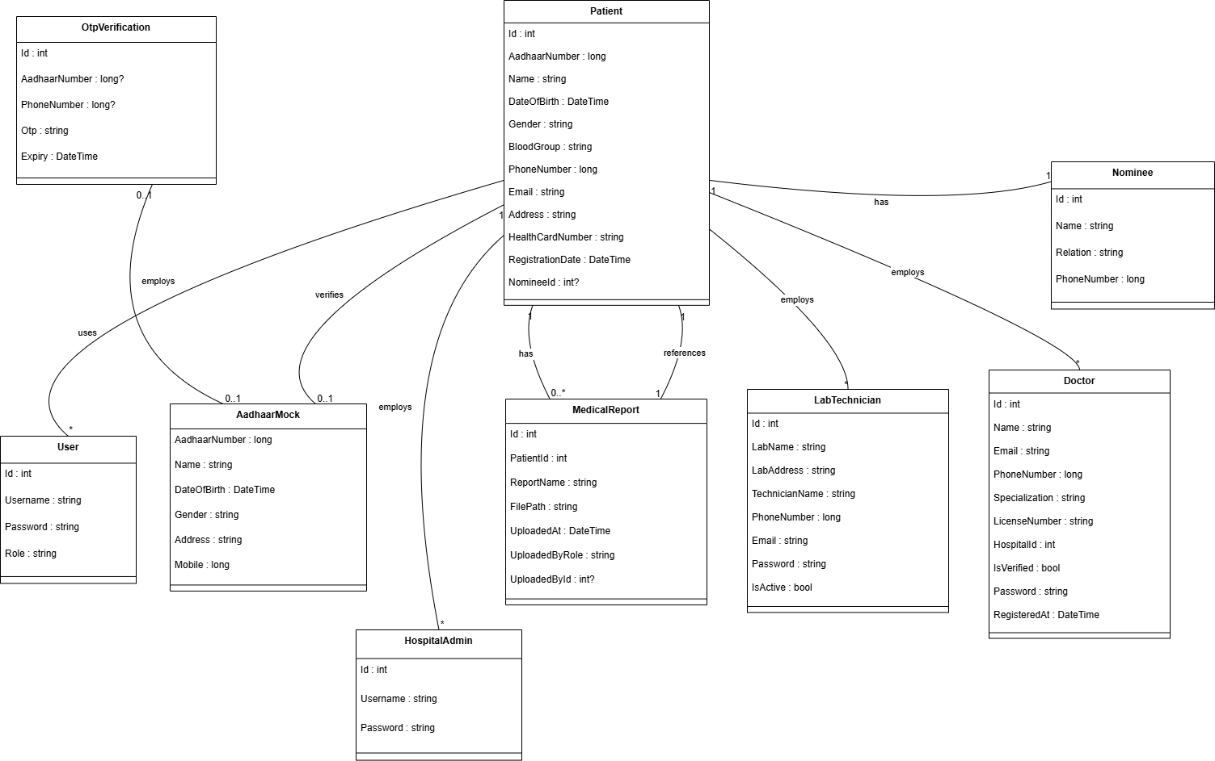
The Class Diagram represents the object-oriented structure of the Digital Health Card system. The Patient class is the central entity storing personal and health details. The Doctor and LabTechnician classes manage medical and diagnostic processes. Prescriptions are associated with both Patient and Doctor classes, representing medical consultations. LabReport is linked with Patient and LabTechnician classes to store diagnostic data. Each Patient has a Nominee class that stores emergency contact information. The Admin class manages system users. This structure reflects the backend implementation and ensures organized data handling.

6.5 Sequence Diagram

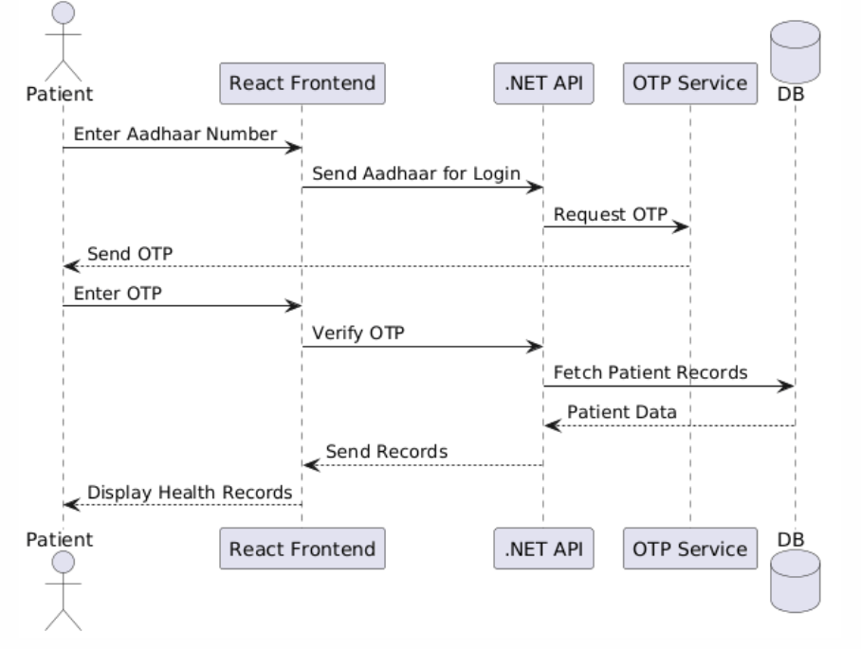
The Sequence Diagram shows the interaction flow when a patient logs into the system and accesses health records. The patient enters the Aadhaar number through the React frontend, which sends a login request to the .NET backend API. The backend communicates with the OTP service to generate and send an OTP to the patient. After OTP verification, the backend retrieves patient data from the database and returns it to the frontend. Finally, the records are displayed to the patient. This diagram demonstrates secure authentication and structured data retrieval.

6.6 Activity Diagram

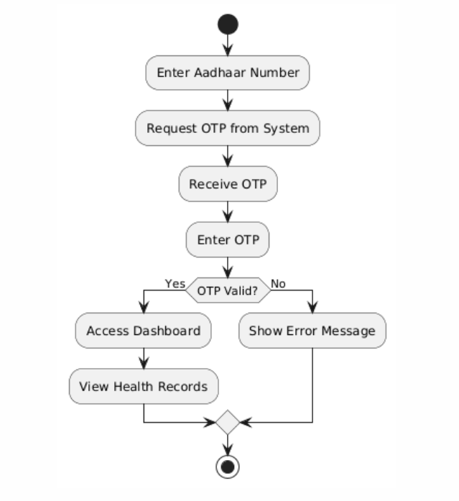

The Activity Diagram illustrates the workflow of patient authentication in the Digital Health Card system. The process begins with the patient entering the Aadhaar number, followed by OTP generation and verification. If the OTP is valid, the patient is granted access to the dashboard and can view health records. If verification fails, an error message is displayed. This diagram represents the logical flow of activities within the authentication module.

6.7 Deployment Diagram

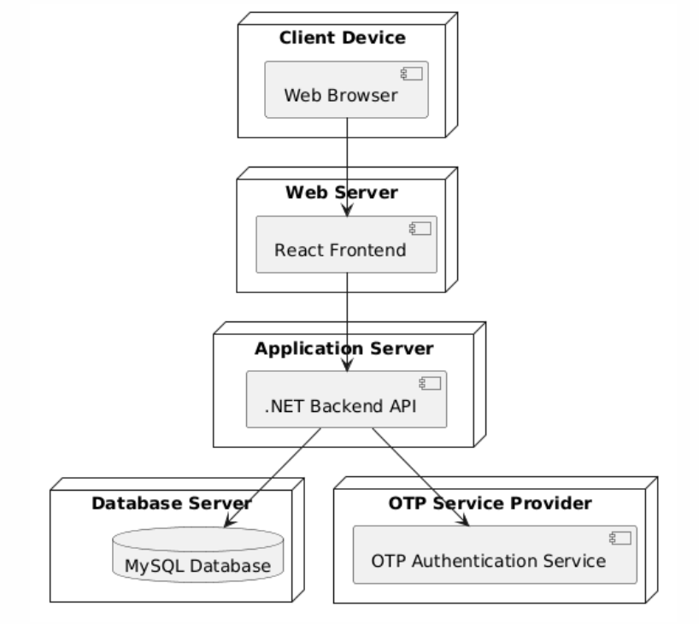
The Deployment Diagram illustrates the physical architecture of the Digital Health Card system. Users access the application through a web browser on a client device. The frontend application is hosted on a web server, which communicates with the .NET backend API hosted on an application server. The backend connects to a MySQL database server for storing patient records, prescriptions, and reports. The system also integrates with an external OTP authentication service for secure login. This deployment structure ensures scalability, security, and efficient data management.

6.8 System Architecture

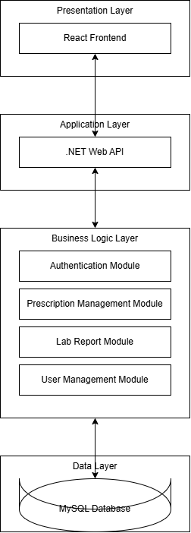

The System Architecture of the Digital Health Card application follows a layered design approach. The Presentation Layer consists of the React-based frontend, which provides the user interface. The Application Layer includes the .NET Web API that handles client requests and coordinates system operations. The Business Logic Layer contains modules such as authentication, prescription management, laboratory report handling, and user management. These modules implement core system functionality and enforce business rules. The Data Layer uses a MySQL database for secure storage of patient records, prescriptions, reports, and user information. This layered architecture ensures scalability, maintainability, and secure data processing.

7. Test Cases
Test Case ID | Module | Test Scenario | Input | Expected Output | Status
TC01 | Patient Login | Patient logs in using valid Aadhaar & OTP | Aadhaar No + Correct OTP | Patient dashboard displayed | Pass
TC02 | Patient Login | Invalid OTP entered | Aadhaar No + Wrong OTP | Error message displayed | Pass
TC03 | Doctor Login | Doctor logs in with valid credentials | Email + Password | Doctor dashboard displayed | Pass
TC04 | Doctor Module | Doctor adds prescription | Patient selected + Prescription details | Prescription saved successfully | Pass
TC05 | Lab Technician Login | Lab technician logs in | Email + Password | Lab dashboard displayed | Pass
TC06 | Lab Module | Upload lab report | Patient selected + Report data | Report stored and visible to doctor | Pass
TC07 | Admin Login | Admin logs in | Username + Password | Admin dashboard displayed | Pass
TC08 | Admin Module | Admin adds new doctor user | Doctor details | Doctor account created | Pass
TC09 | Patient Records | Patient views medical history | Login → View records | Records displayed correctly | Pass
TC10 | Security | Unauthorized access attempt | Direct URL access without login | Access denied / redirect to login | Pass

The test cases were executed to verify authentication, role-based access control, record management, and system security. All modules performed as expected, confirming the reliability and correctness of the Digital Health Card system.

8. Screenshots
The following screenshots illustrate the Digital Health Card system’s user interface and key functionalities. These snapshots demonstrate the system’s ease of use, accessibility, and core features.

8.1 Login Page
Description: Allows users to securely log in using their registered credentials based on their role.
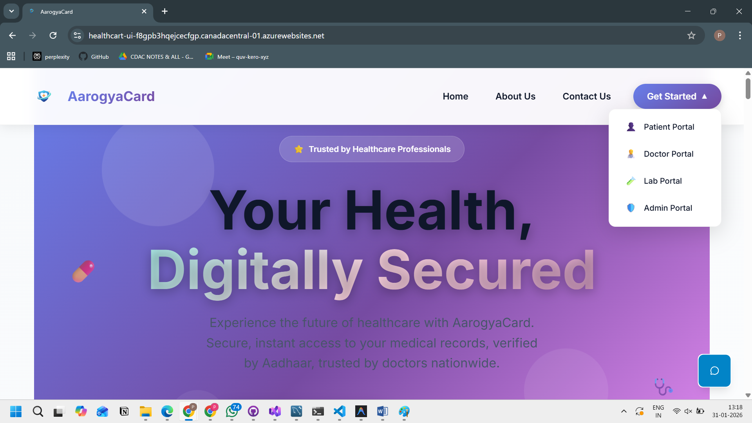

8.2 Patient Dashboard
Description: Displays an overview of the patient profile, medical summary, recent health records, notifications, and option to download Health Card.
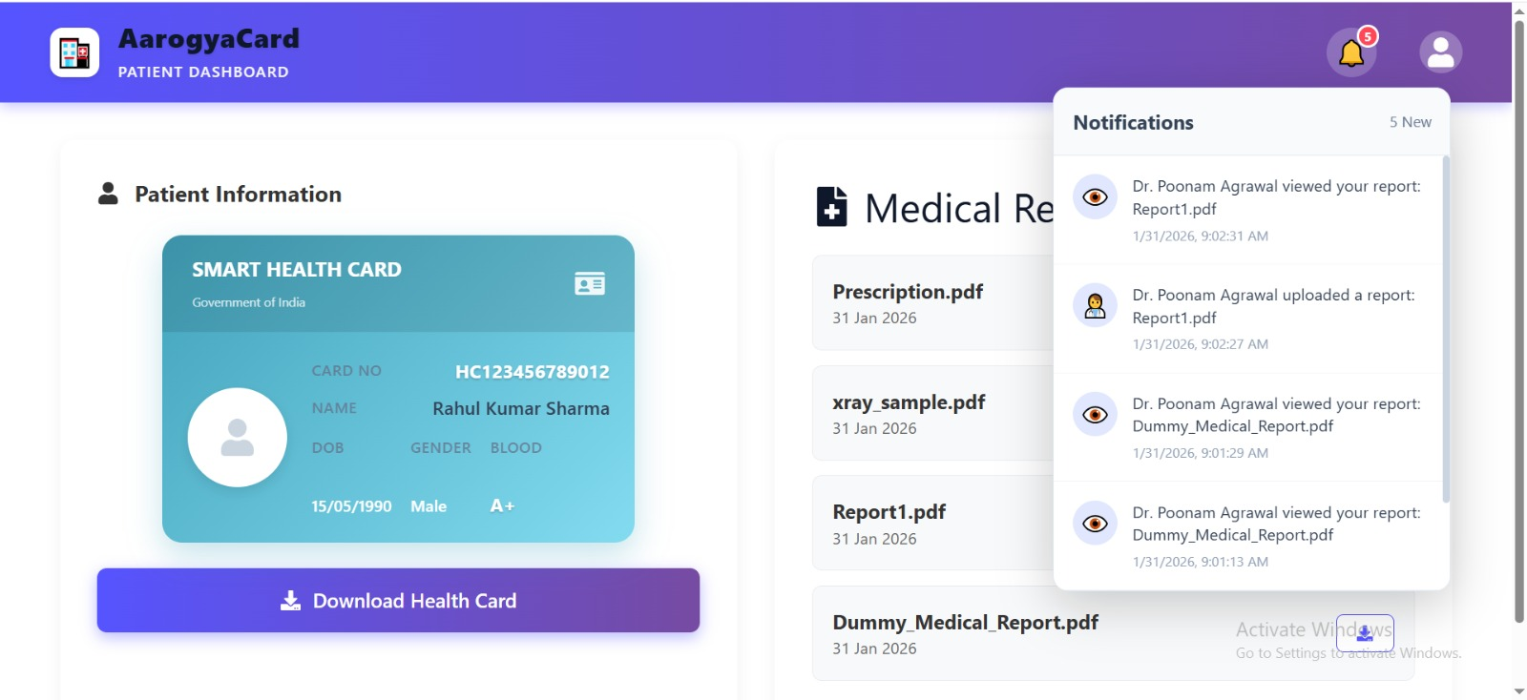

8.4 Doctor Dashboard
Description: Provides doctors with access to patient records and options to add medical prescriptions.
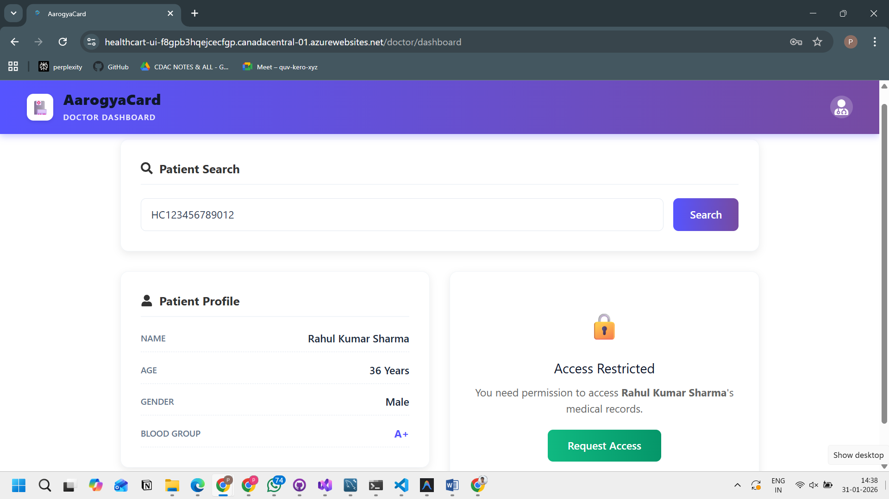

8.5 Add Prescription Page
Description: Allows doctors to enter diagnosis notes and prescribe medications for patients.
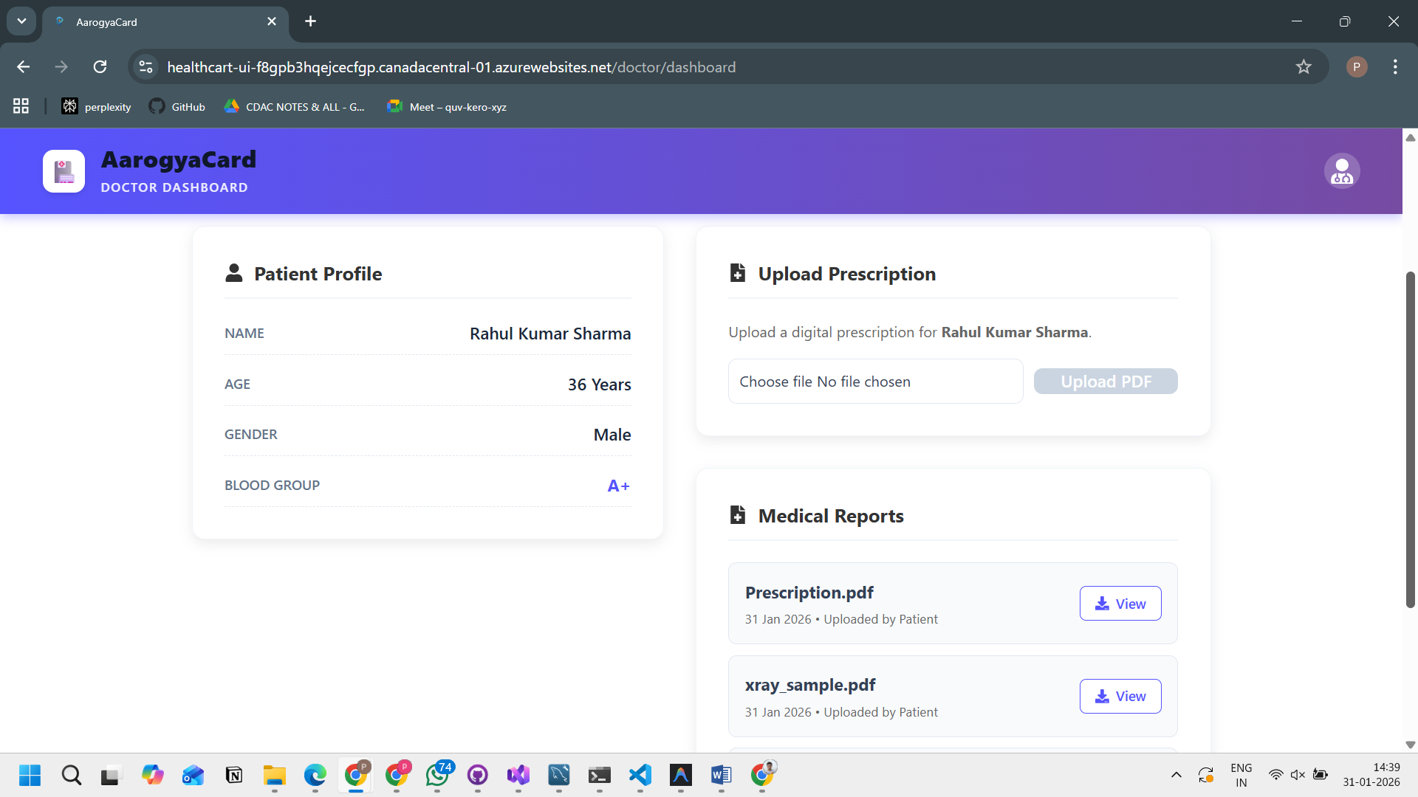

8.6 Laboratory Technician Dashboard
Description: Allows lab technicians to upload and manage diagnostic test reports.

8.7 Uploaded Lab Reports
Description: Displays laboratory test results associated with patient records.
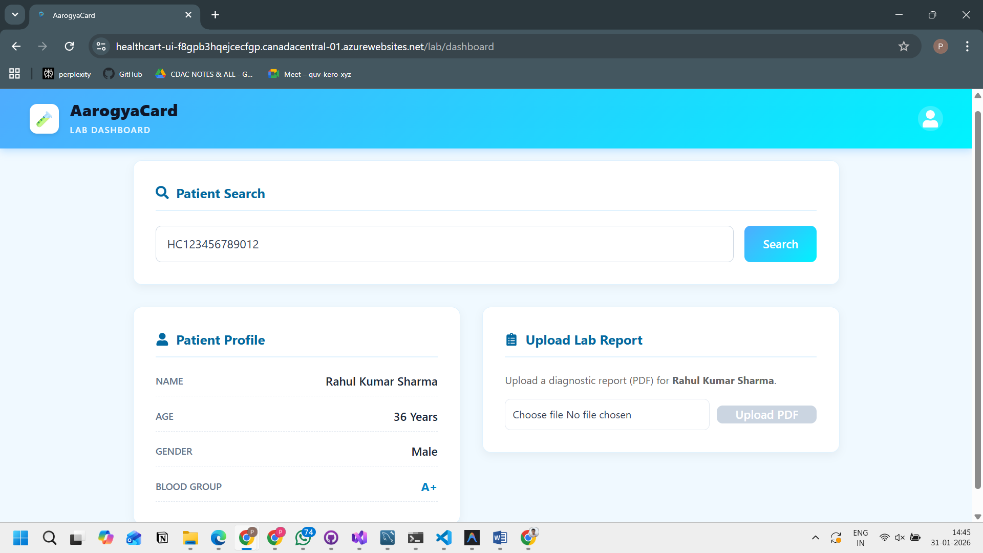

8.8 Admin Dashboard
Description: Enables administrators to manage users such as doctors and lab technicians.
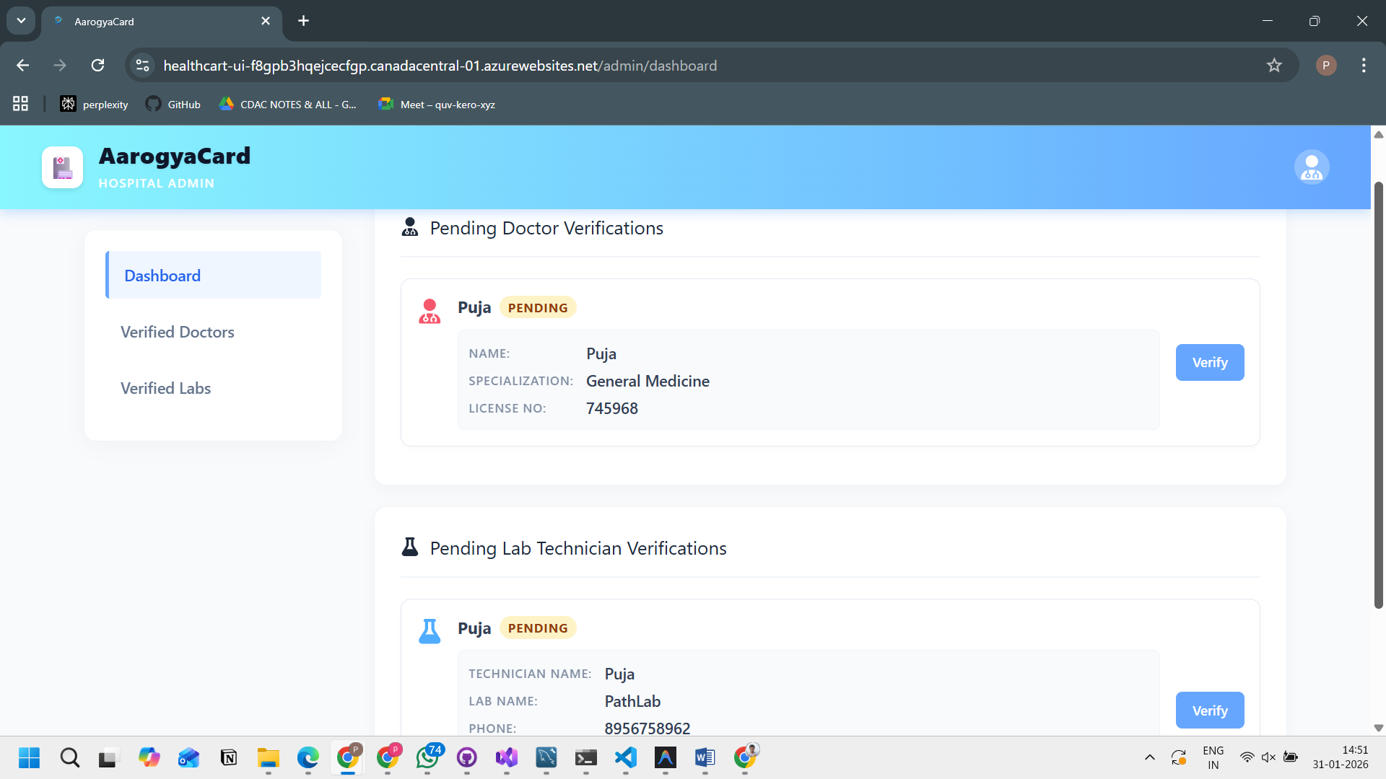

8.9 Emergency Nominee Details
Description: Shows nominee contact information accessible to authorized users during emergencies.
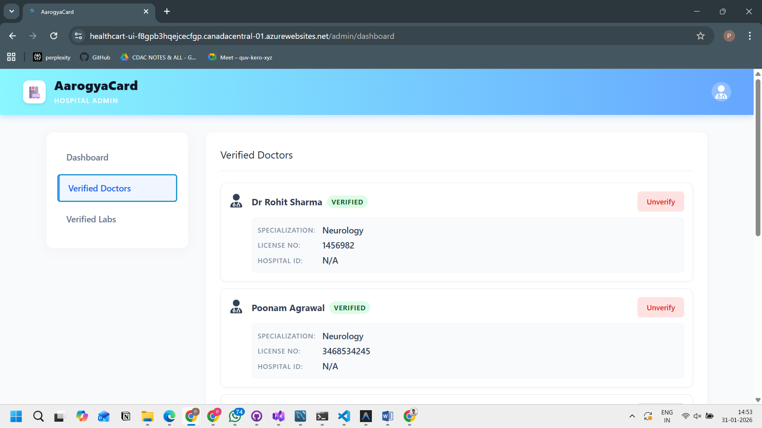

8.10 System Logout
Description: Ensures secure logout to prevent unauthorized access.
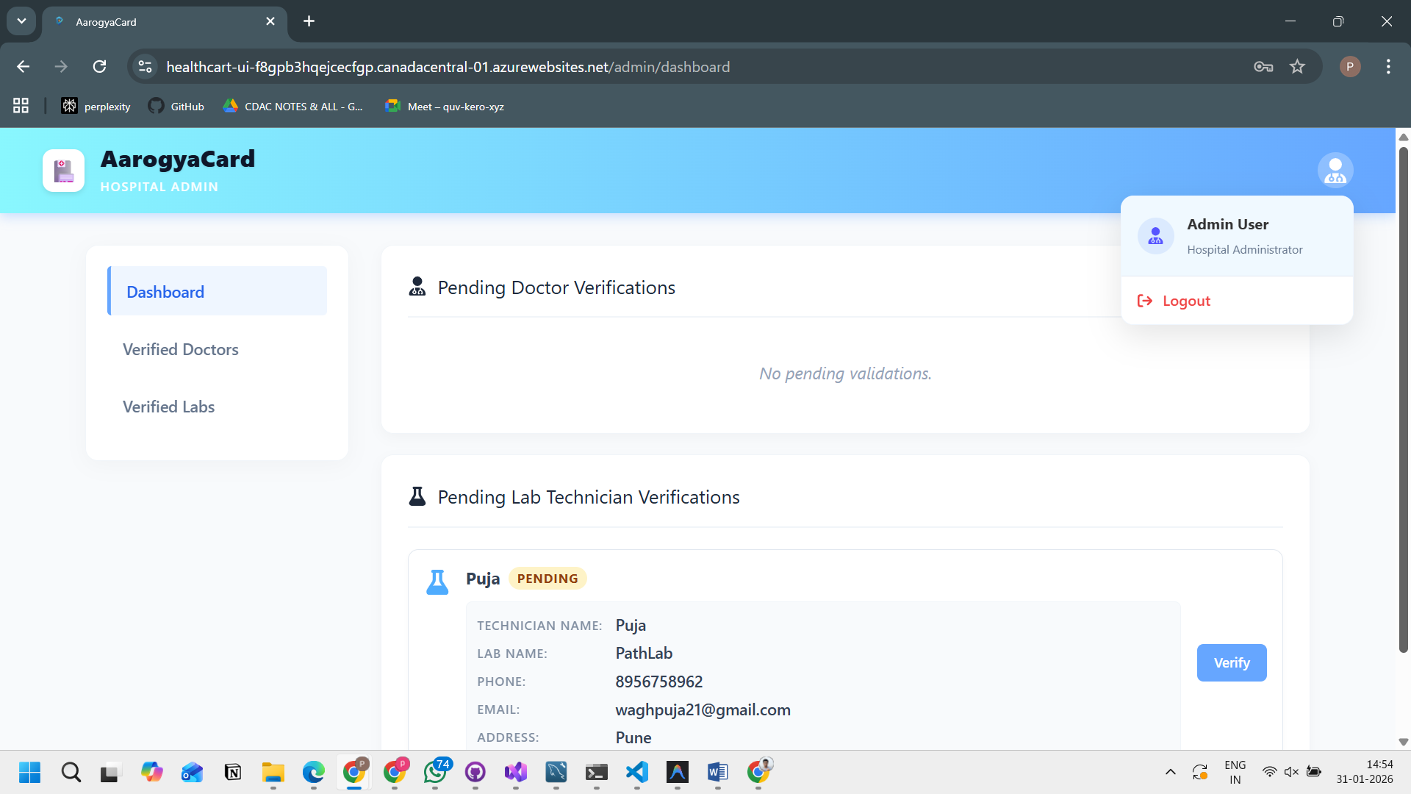

9. References
• React Documentation. Available at: https://reactjs.org — React JS documentation for frontend development and component-based architecture.
• Microsoft Learn. Available at: https://learn.microsoft.com — .NET Web API documentation for backend service development.
• W3Schools. Available at: https://www.w3schools.com — Web development references for HTML, CSS, and JavaScript concepts.
• MDN Web Docs. Available at: https://developer.mozilla.org — HTML, CSS, and JavaScript documentation and best practices.
• Bootstrap. Available at: https://getbootstrap.com — UI styling and responsive layout design.
• draw.io. Available at: https://draw.io — UML and system diagram creation.
• Google Fonts. Available at: https://fonts.google.com — Fonts used in UI design.
• Google. Available at: https://www.google.com — General research and technical references.

