The Assignment is mostly coded in HTML, CSS and JavaScript with PHP as Backend. All the info/details are stored in JSON files which are processed using PHP.

The assignment contains 3 pages:

* Login Page ( index.html )
* Admin page for Global Admins ( globaladmin.html )
* Admin page for Project Admins ( projectadmin.html )

1. **Login Page**

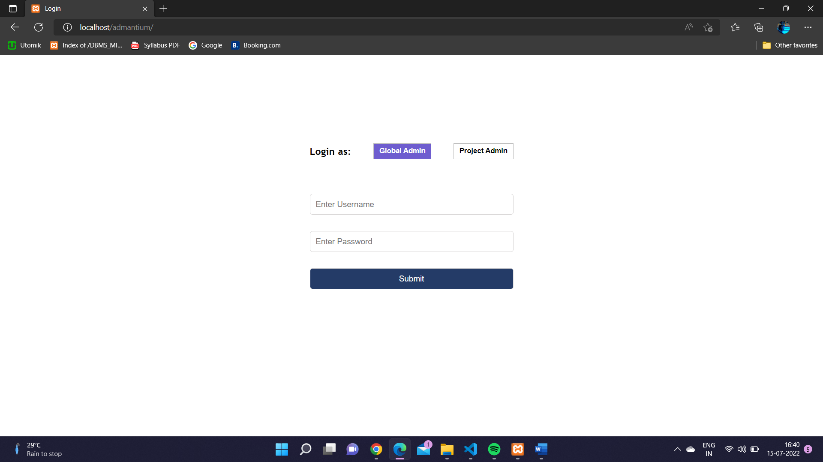

The login page is common for both Global and Project Admins. The form provides an option at the top to select the role.

The Login page also gives out error if the username/password field is left empty

1. **Global Admin Page**

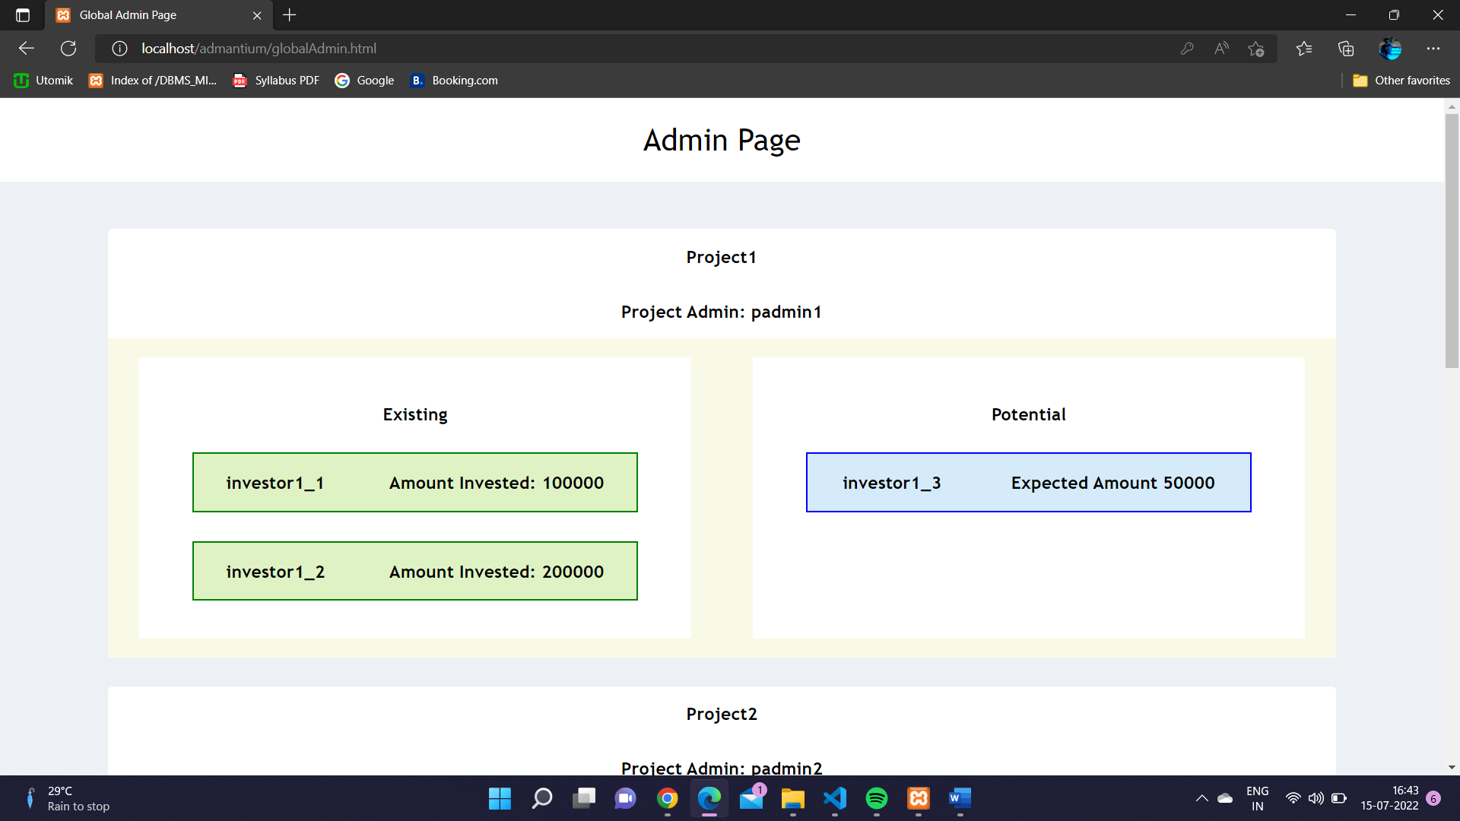

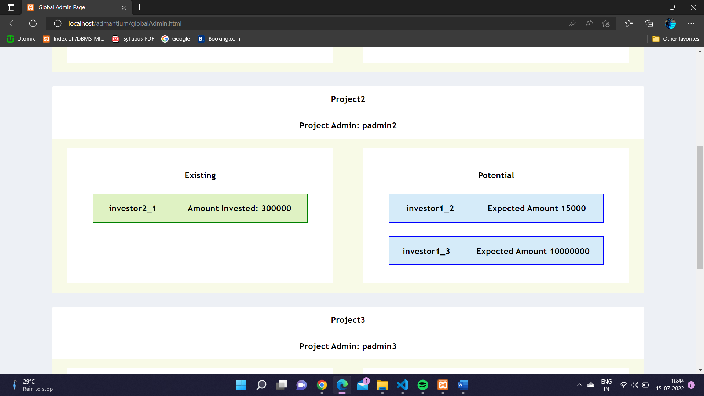

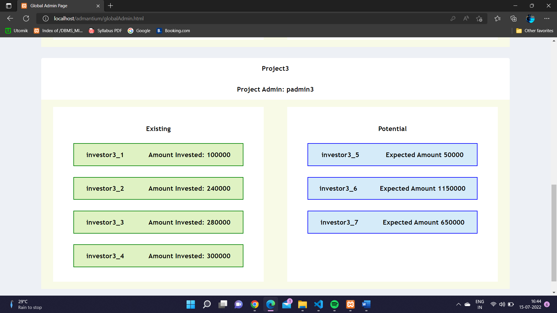

Global Admin Page displays details of all current projects with details of all Existing and Potential investors in 2 separate columns.

1. **Project Admin Page**

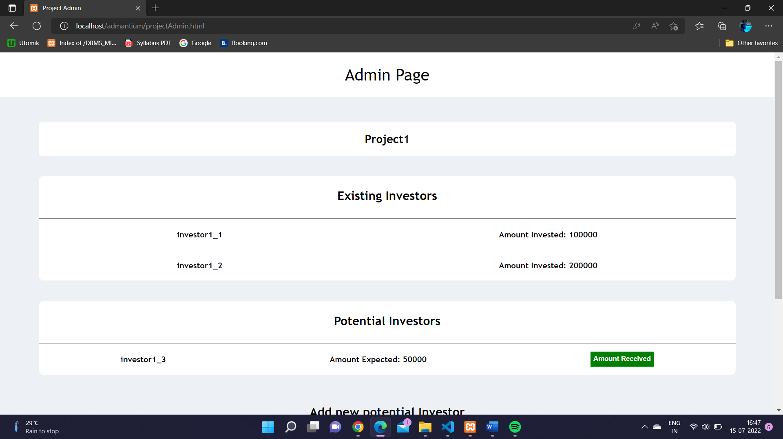

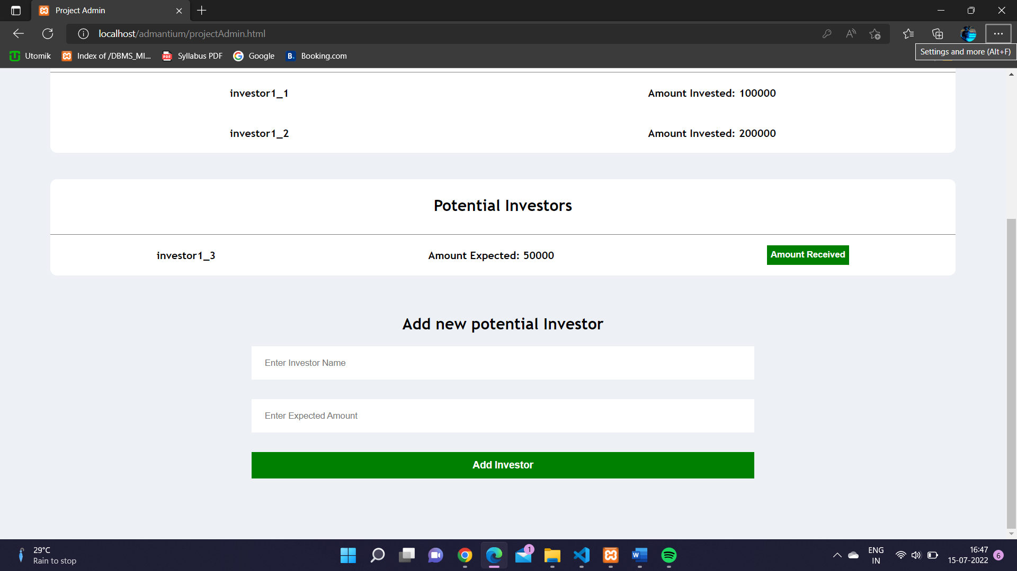

Project Admin Page displays all information handled but the project admin with list of all existing and potential investors. At the bottom of the page, the admin is provided with a simple for to add new potential investor.

The list of potential investors also has a button associated with every entry to migrate the investor from “potential” investors list to “existing” investors list.

A Snapshot of Details of a project are stored in JSON file

 "Project1": {

            "projectAdmin": "padmin1",

            "investors": {

                "existing": {

                    "investor1_1": {

                        "amount": "100000"

                    },

                    "investor1_2": {

                        "amount": "200000"

                    }

                },

                "potential": {

                    "investor1_3": {

                        "amount": "50000"

                    }

                }

            }

        },

The web app can be tested on a local server with PHP support by using credentials mentioned below:

* Global Admin:
  + Username: admin => Password: admin
* Project Admins:
  + Username: padmin1 => Password: admin
  + Username: padmin2 => Password: admin
  + Username: padmin3 => Password: admin