- The App consists of Three pages

1. Month View page – where every day of the month will have an individual card representing a particular day, the mood of the journal entries made by the user. On tapping on a particular card, the app will take your to the second page.

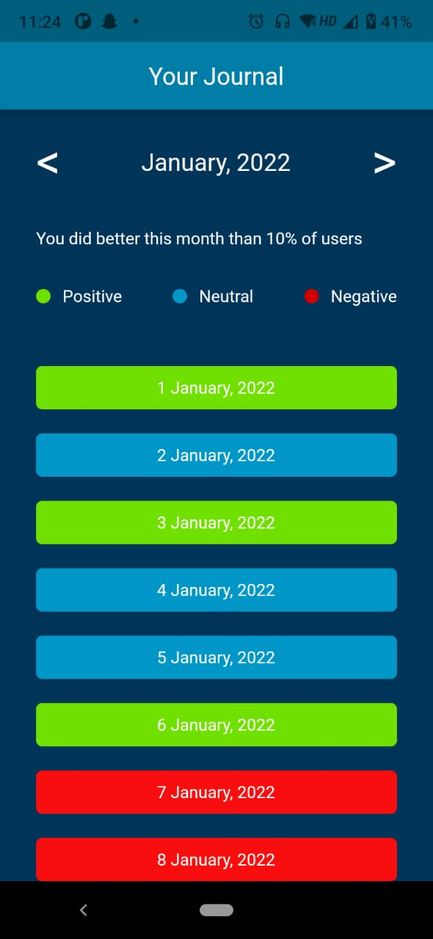

1. Month View Page

2. Daily Entry page – where user can have a look at entries made by him/her with timestamp. At bottom/end of all entries, user can also find a button to add new journal entry for that particular day.

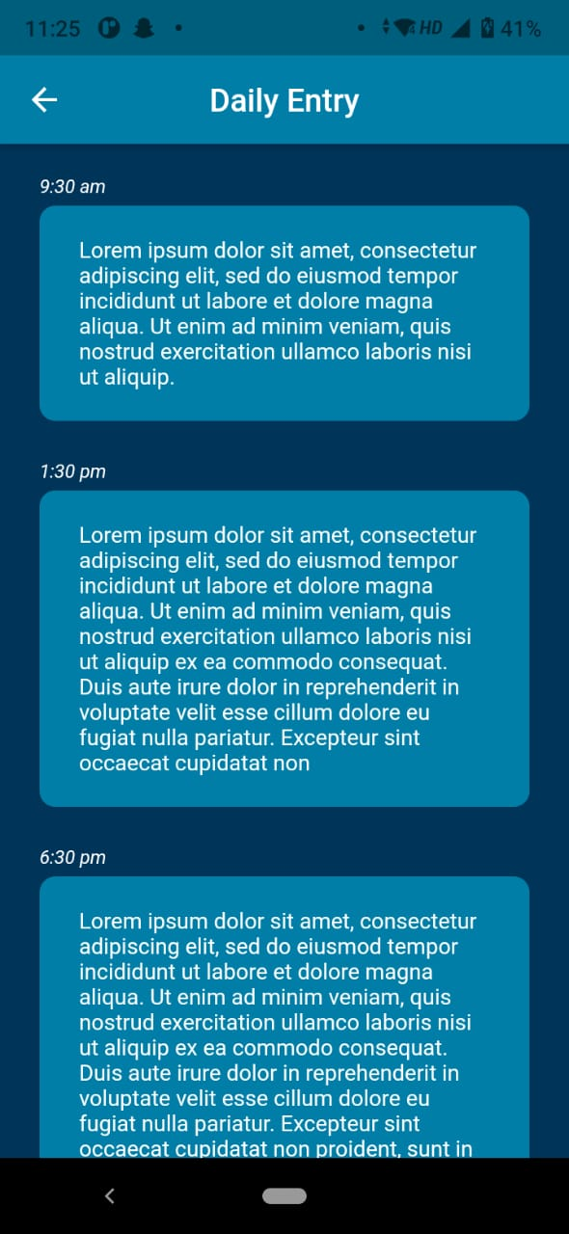

2. Day Entry page

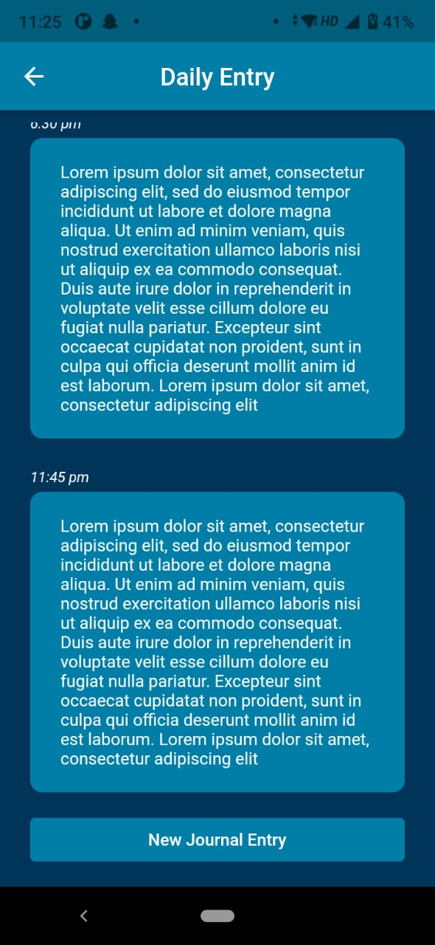

3. Day Entry Page with Button at bottom

3. New Entry Page – where user can select their mood while making the entry and also make the entry.

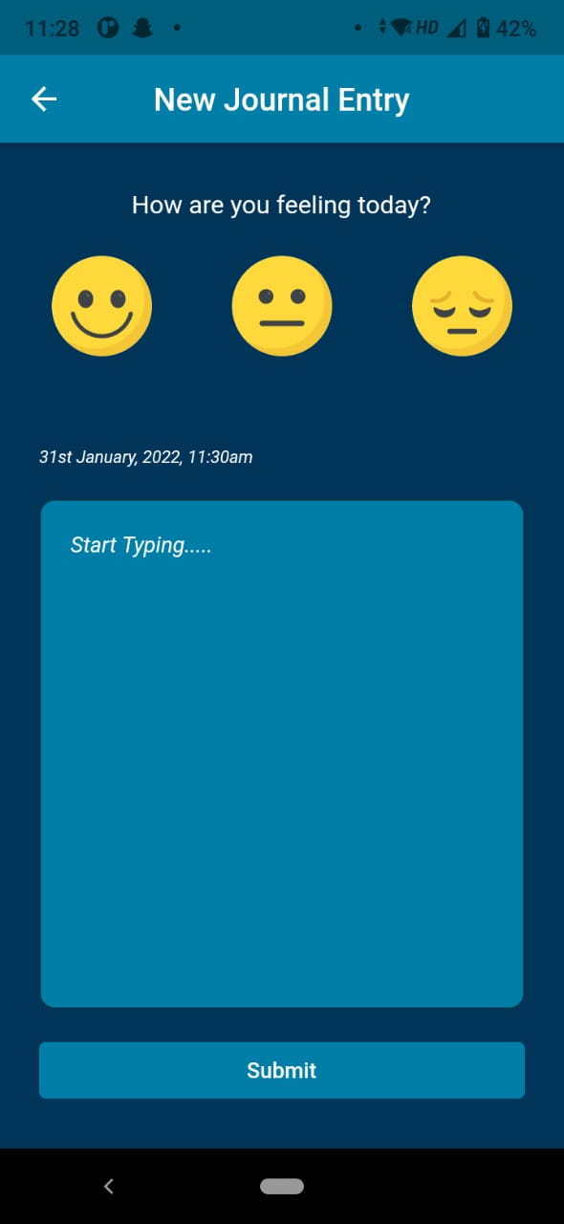 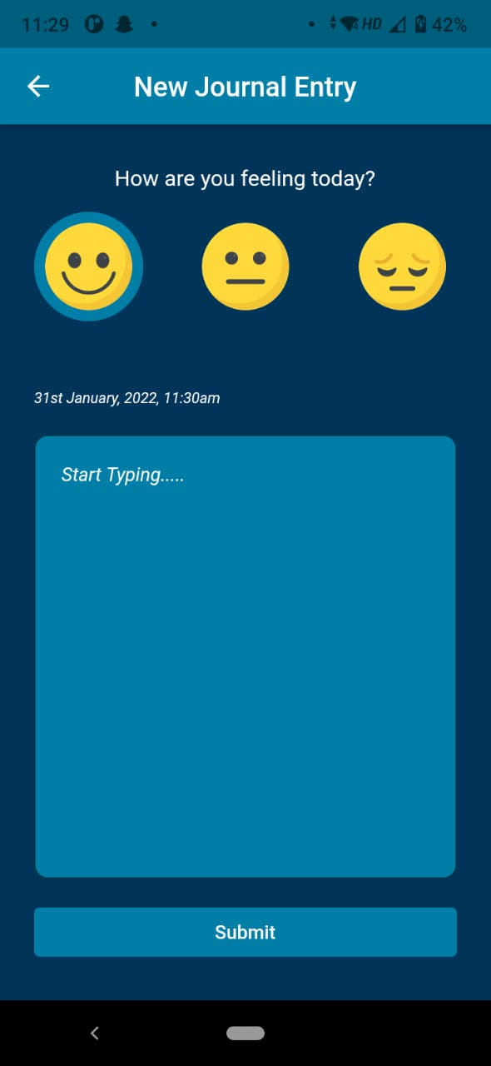

4. Before and After selecting mood