SOP Cloud Guardian
Azure Prowler
- Login to Microsoft Azure Cross-platform Command Line Interface:
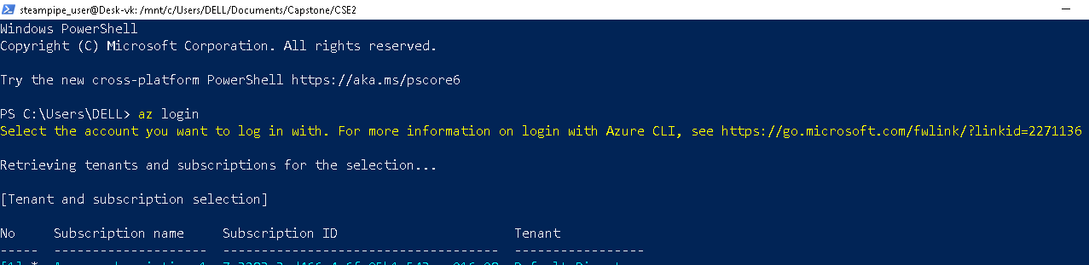
- Initiate WSL2 for Windows and Miniconda Environment:
- Launch Prowler:
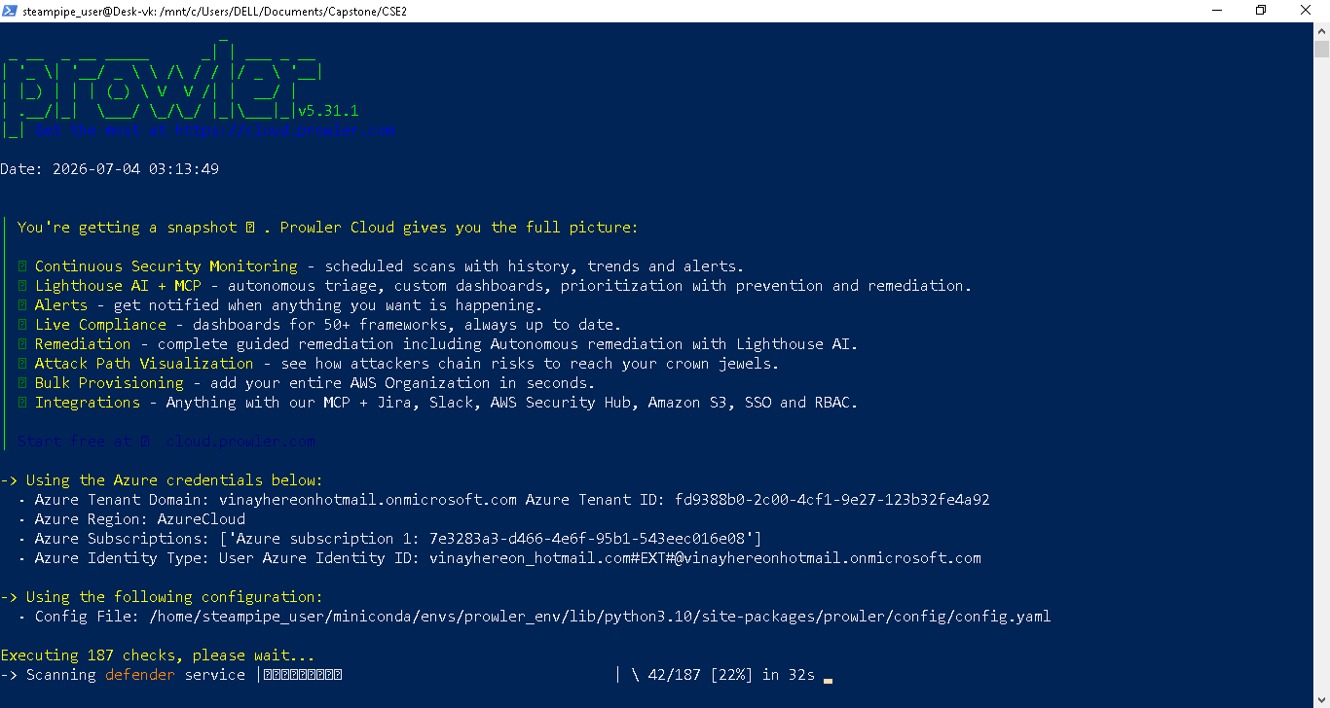

- Prowler overview results:
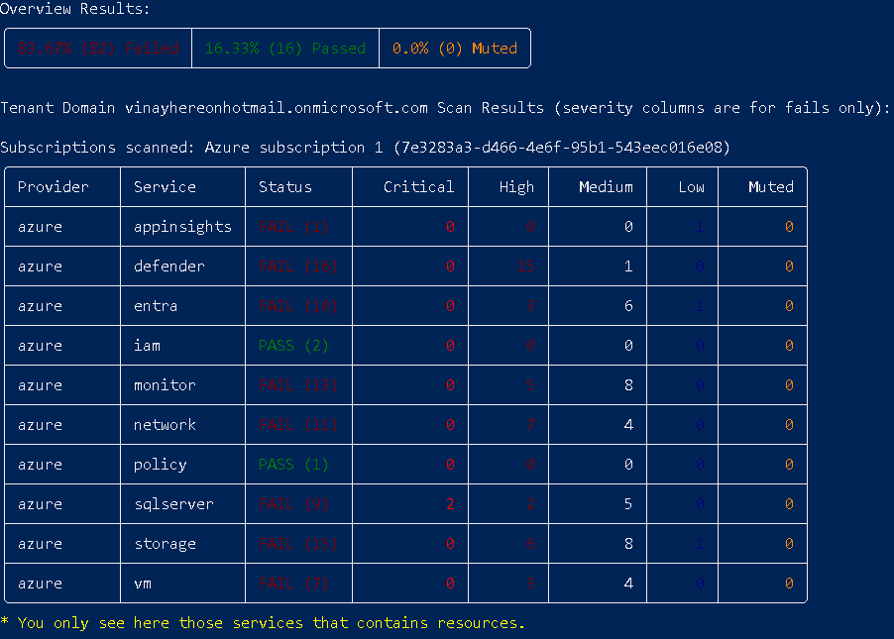
- Compliance status:
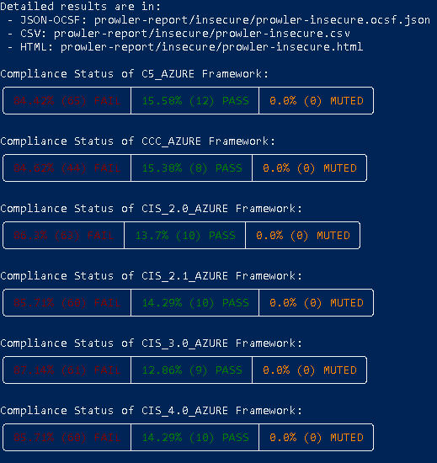
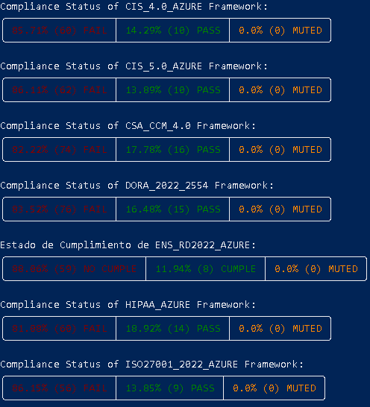
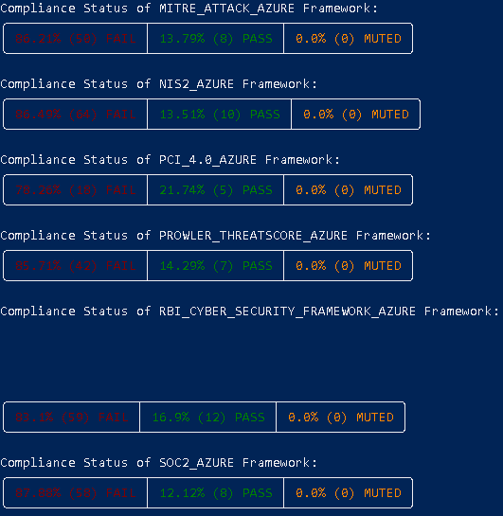
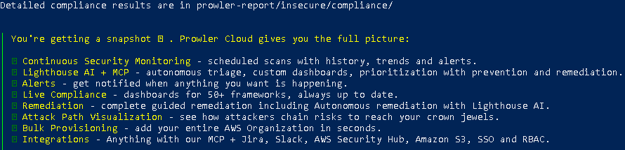
- Consolidate Findings:
