SOP: Cloud Guardian
Run Steampipe Queries for Azure Infra

Login to WSL2 Environment using Windows Powershell:
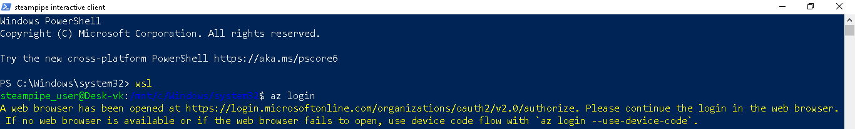
Login to Microsoft Azure Cross-platform Command Line Interface using Web Browser
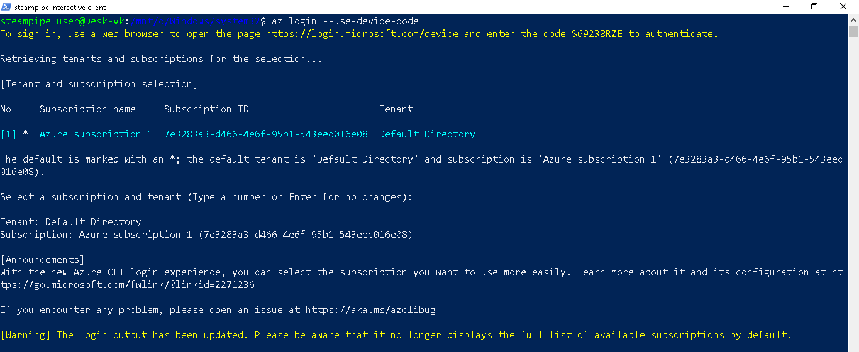

Run steampipe query
Query 1: Storage Account Security Settings
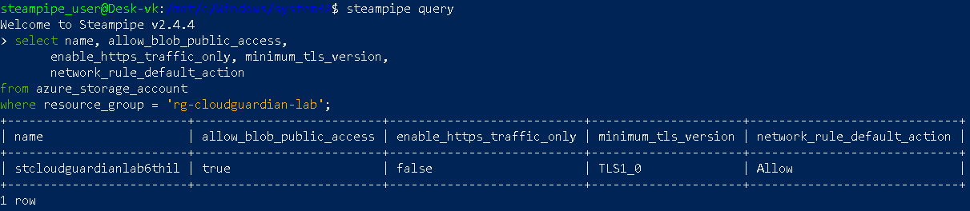

Query 2: Storage Container Public Access Level
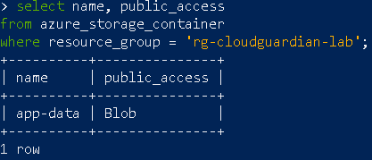
Query 3: IAM Over-Privileged Role Assignments
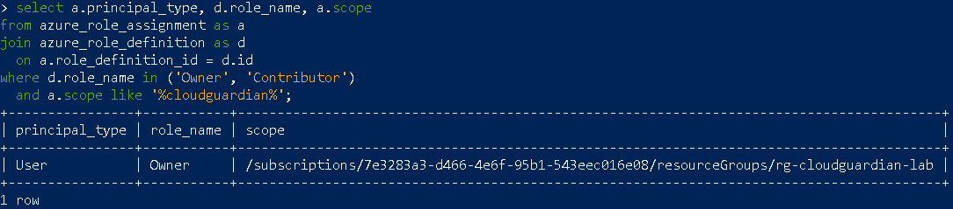
Query 4: SQL Server Firewall Rules
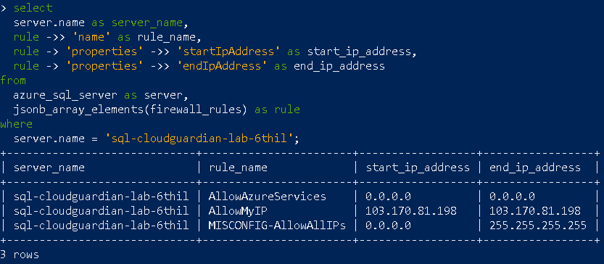

Query 5: NSG Security Rules
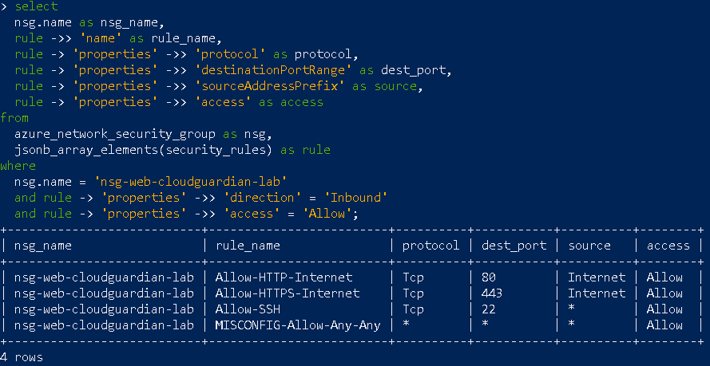
Query 6: VM Password Authentication
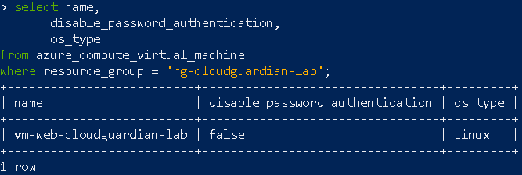
Query 7: OS Disk Encryption
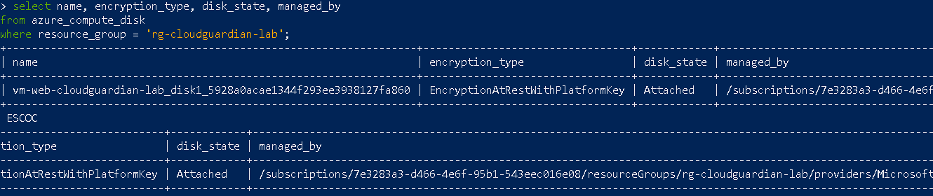

Query 8: Diagnostic Settings (Storage & SQL)
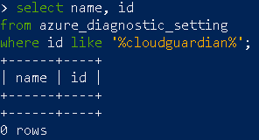
Query 9: Subnet NSG Associations
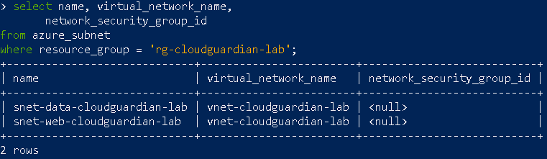
Query 10: SQL Server TLS & Auditing
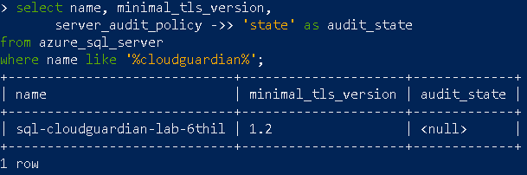
Query 11: Storage Account CORS & Auth Default
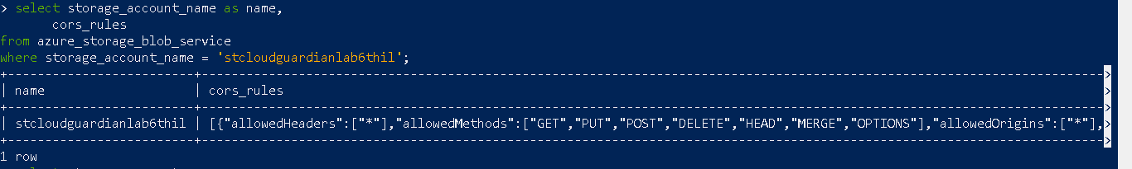
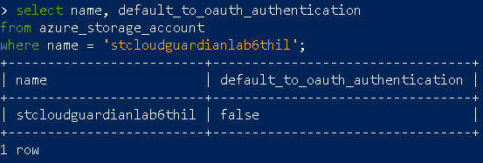

Query 12: Log Analytics Workspace Retention
