IIT ROORKEE × FUTURENSE
PG Certificate Program in AI/GenAI Powered Cybersecurity
CloudGuardian
AI-Driven Multi-Cloud Misconfiguration Detection, Prioritization & Auto-Remediation
Capstone Final Report — Weeks 1, 2 & 3
Project Code: CAP-CSE-3W | EC-Council Track: Cloud Security Essentials | Cohort 2025–26
Field | Detail
Mode | Team (3 members)
Cloud Scope | AWS (primary, ap-south-1) + Azure (cross-cloud validation)
Team Members | Megha Sharma (Web Application Co-Lead) · Vinay Kumar (Web Application Security Lead) · Kedar Pavaskar (Threat Modelling Lead)
AWS Account | 735291151388 (IAM user: Alex, region: ap-south-1)
Repository | github.com/meghaInfosec/Cloudguardian_Capstone
Report Date | 27 July 2026

1. Executive Summary
CloudGuardian is a three-week, team-mode capstone that builds a complete Cloud Security Posture Management (CSPM) lifecycle across two cloud providers: deploy a realistic 3-tier workload, deliberately break it with documented misconfigurations, detect the breakage with three independent open-source scanners, prioritize the resulting findings with a machine-learning model, explain each high-priority finding in plain English using a retrieval-grounded LLM, and finally remediate the safe subset of findings automatically — with a human-approval gate for anything higher-risk. The project closes with a compliance crosswalk mapping every finding to ISO 27001:2022, HIPAA, CIS Controls v8, and India's DPDP Act 2023.
Across the three weeks the team deployed parallel AWS and Azure baselines, injected 12 deliberate misconfigurations (M01–M12) into the AWS estate, and ran Prowler v4, ScoutSuite, and Steampipe against both clouds before and after each change. The three scanners' output was normalized into a single schema of 729 consolidated findings (496 AWS, 233 Azure). A RandomForest classifier — rebalanced with SMOTE to correct for a severe class imbalance in the HIGH-severity bucket — reached 92.6% cross-validated accuracy and lifted HIGH-class precision from 20.0% to 100.0%. The top 15 priority findings were then routed through a dual-verification RAG pipeline (NVIDIA NIM, meta/llama-3.1-8b-instruct) that produced a 2-line, plain-English fix for each — 14 of 15 (93%) verified automatically against the raw scanner data, with the remainder correctly flagged for human review. An OWASP LLM06-aligned redaction engine stripped 167 sensitive identifiers across 13 categories before any text reached the LLM.
In Week 3, the team built and live-tested two remediation tracks on AWS: a human-invoked semi-automatic track (three Lambda functions covering S3 public access, IAM key rotation, and default encryption) and a fully event-driven, human-approval-gated pipeline built on SNS, Step Functions, API Gateway, and Lambda. The approval-gated pipeline was exercised end-to-end against a real S3 bucket and confirmed via CloudWatch logs and an independent AWS CLI check. Before/after Prowler rescans provide honest, non-cherry-picked evidence of what the automation did and did not fix.
All findings in this report — including the Week 3 before/after comparison that shows a control the automation did not move the needle on — are reported as observed. Where a fix did not change a PASS/FAIL outcome, that is stated explicitly rather than implied otherwise.

Table of Contents
1. Executive Summary
2. Problem Statement & Project Objectives
3. Team, Scope & Governance Model
4. Technology Stack
5. Methodology
5.1 Week 1 — Build and Break
5.2 Week 2 — Detect and Prioritize
5.3 Week 3 — Remediate and Govern
6. Results — Detection & Prioritization
7. Results — GenAI Remediation Guidance & Privacy Safeguards
8. Auto-Remediation Implementation
9. Live Testing & Before/After Evidence
10. Compliance Crosswalk
11. Safety, Governance & Design Principles
12. Deployment Journey — Issues Encountered and Fixes
13. Evaluation Against the Capstone Rubric
14. LLM Usage Disclosure
15. Conclusion & Future Work
16. References
Appendix A — Misconfiguration Catalogue (M01–M12)
Appendix B — AWS Resource Inventory

2. Problem Statement & Project Objectives
A health-tech scale-up keeps failing ISO 27001 audits because the same misconfigurations reappear every sprint: public storage buckets, over-privileged IAM roles, unencrypted databases, and missing logging — across both its AWS and Azure estates. The organization needs continuous CSPM with safe auto-remediation for a small set of fixes, and a risk-prioritized backlog for everything else. CloudGuardian simulates this scenario end-to-end:
Deploy → Misconfigure → Detect (3 tools × 2 clouds) → Prioritize (ML) → Explain (RAG/LLM) → Remediate (human-approved & fully automated) → Govern (compliance crosswalk)

Key Learning Outcomes
- Understand the shared-responsibility model and CIS Benchmarks for AWS and Azure.
- Run open-source CSPM tools and consolidate their findings into one normalized schema.
- Build a defensible, ML-based prioritization model.
- Use an LLM to generate plain-English remediation guidance — disclosed and verified, not hallucinated.
- Build event-driven auto-remediation with safety guardrails and a human-approval gate.

3. Team, Scope & Governance Model
Field | Detail
Project | CloudGuardian (CAP-CSE-3W)
Program | IIT Roorkee × Futurense — PG Certificate in AI/GenAI Powered Cybersecurity, Cohort 2025–26
Mode | Team (2–4 members) — full team scope: two clouds, 12+ misconfigurations, 4 remediations, 4 compliance frameworks
Team | Megha Sharma — Web Application Co-Lead (CSPM pipeline, ML prioritization, RAG remediation, Streamlit app, Week 3 auto-remediation)  Vinay Kumar — Web Application Security Lead  Kedar Pavaskar — Threat Modelling Lead
AWS Account | 735291151388, region ap-south-1, IAM user "Alex"
Operating environment | Kali Linux (VirtualBox), operated as the kali user — never root
Duration | 3 weeks (~35–40 hours), defense date 25 July 2026

4. Technology Stack
Layer | Tools
Cloud | AWS Free Tier (primary) · Azure (cross-cloud validation)
IaC | Terraform
CSPM Scanners | Prowler v4 (primary, 50+ compliance frameworks) · ScoutSuite (cross-check) · Steampipe (targeted SQL queries)
ML / Prioritization | Python · pandas · scikit-learn · RandomForest + SMOTE (class-imbalance handling)
GenAI / RAG | NVIDIA NIM API (meta/llama-3.1-8b-instruct) · TF-IDF + embedding retrieval over a compliance knowledge base
AI Safety | OWASP LLM06-compliant redaction engine (strips keys, ARNs, IPs, resource IDs before any LLM call)
Auto-Remediation | AWS Lambda · Step Functions · SNS · API Gateway · DynamoDB (human-approval gate)
App / Reporting | Streamlit · Jupyter Notebook · Markdown / DOCX / PDF

5. Methodology
The project followed the 3-week phased plan defined in the capstone brief, with each week's folder in the repository mapping directly to a graded deliverable.

5.1 Week 1 — Build and Break
Goal: deploy infrastructure on two clouds, document the baseline security posture, and introduce a controlled set of misconfigurations.
- Deployed a clean 3-tier reference workload via Terraform on AWS (VPC, public + private subnets, EC2 web tier, RDS MySQL, S3 bucket, IAM roles) in ap-south-1, and a mirrored workload on Azure (compute, storage, database, network, IAM) for cross-cloud comparison.
- Ran Prowler, ScoutSuite, and Steampipe against both clouds pre-misconfiguration to capture an honest baseline (fixed a duplicate RDS subnet-group naming conflict and an AuthFailure caused by system clock drift along the way, via chrony time sync).
- Introduced 12 deliberate, hand-crafted misconfigurations (M01–M12) spanning IAM, storage, networking, encryption, and logging — each with a documented baseline → misconfigured state and a real-world breach rationale (see Appendix A).
- Rescanned post-misconfiguration with all three tools on both clouds and confirmed all 12 injected findings via targeted Steampipe SQL queries (e.g. aws_iam_role.inline_policies_std, S3 versioning_enabled).
Week 1 deliverable: Terraform code for both clouds, baseline + post-misconfig Prowler/ScoutSuite/Steampipe reports, and a misconfiguration catalogue with rationale.

5.2 Week 2 — Detect and Prioritize
Goal: consolidate all scanner output, build a defensible prioritization model, and generate LLM-based remediation guidance with verification.
- Consolidated Prowler (285 findings), ScoutSuite (407 findings), and Steampipe (37 findings) into a single normalized, deduplicated schema of 729 findings across AWS (496) and Azure (233), fixing along the way a cloud_provider column corruption from duplicate notebook cells, an account_id hardcoding bug, and a missing-comma bug in the redaction engine's PATTERN_ORDER.
- Built a rule-based priority score — Priority = CVSS × Exposure Weight × Blast Radius — with negation-aware keyword matching to avoid false severity inflation, then layered a supervised RandomForest classifier on top to bucket findings into LOW / MEDIUM / CRITICAL.
- Diagnosed and fixed a cross-validation bug (plain cv=5 produced unstable folds under class imbalance); replaced it with StratifiedKFold(n_splits=5, shuffle=True, random_state=42), then added a SMOTE-balanced training pass specifically to correct the model's HIGH-class precision.
- Built a hybrid TF-IDF + NVIDIA NIM embedding retrieval system over a compliance knowledge base (CIS AWS, AWS Well-Architected, Microsoft Cloud Security Benchmark, ISO/IEC 27001:2022, HIPAA, and India's DPDP Act 2023 — expanded from 17 to 26 sourced chunks) with a dual-verification gate: a retrieval-confidence gate, followed by embedding-similarity grounding checks (Stage A ≥ 0.55, Stage B ≥ 0.35) against the raw finding text.
- Built and tested an OWASP LLM06-compliant redaction engine that strips AWS keys, ARNs, IP addresses, and resource IDs from every finding before it reaches the LLM — with retry/backoff logic and truncation to prevent HTTP 400 errors on long redacted findings.
- Shipped a Streamlit app that runs the full pipeline (Upload → Prioritize → Classify → Redact → RAG → Export) so a security engineer can replay the pipeline on their own scanner exports.
Week 2 deliverable: consolidated findings database (CSV/JSON), prioritization + ML notebook, LLM prompt library with verification notes, and the Streamlit app.

5.3 Week 3 — Remediate and Govern
Goal: build automated remediations for the safe subset of findings, gate the riskier ones behind human approval, map controls to compliance frameworks, and produce the final report.
- Built three semi-automatic, human-invoked Lambda functions — S3 public-access remediation, IAM access-key deactivation, and default-encryption enforcement — deployed under a dedicated, least-privilege IAM role and defaulting to dry_run: true.
- Layered a fully automated, event-driven pipeline on top of the same remediation logic: SNS → Starter Lambda → Step Functions (pauses via waitForTaskToken) → Notifier Lambda emails an Approve/Reject link → API Gateway → Approval Handler resumes the state machine → remediator dispatcher invokes the matching fix, or the workflow ends safely on reject/timeout.
- Live-tested the complete approval chain end-to-end against a real S3 bucket, confirmed via CloudWatch logs and an independent aws s3api get-public-access-block check (see §9).
- Built a TF-IDF + cosine-similarity compliance crosswalk mapping all 729 findings to ISO 27001:2022 Annex A, HIPAA Security Rule, CIS Controls v8, and the DPDP Act 2023, exposed as a second Streamlit app.
- Ran before/after Prowler compliance rescans to document, honestly, what the live remediation did and did not change (see §9.3), and wrote the SOPs and this final report.
Week 3 deliverable: remediation Lambda functions with guardrails, compliance crosswalk table, before/after evidence, and this final report.

6. Results — Detection & Prioritization

6.1 Scan Coverage
A scoped Prowler pass across both clouds covered 431 checks, of which 285 failed (66%):
Cloud | FAIL | PASS | Total
AWS | 122 | 110 | 232
Azure | 163 | 32 | 195
Severity mix of the 285 failing checks: 8 Critical, 110 High, 135 Medium, 32 Low — of which 12 deliberate AWS misconfigurations (M01–M12) account for the controlled portion of the AWS failures.

6.2 Consolidated Findings (All Three Scanners)
Normalizing and deduplicating Prowler (285), ScoutSuite (407), and Steampipe (37) output produced 729 consolidated findings across both clouds — 496 AWS, 233 Azure.
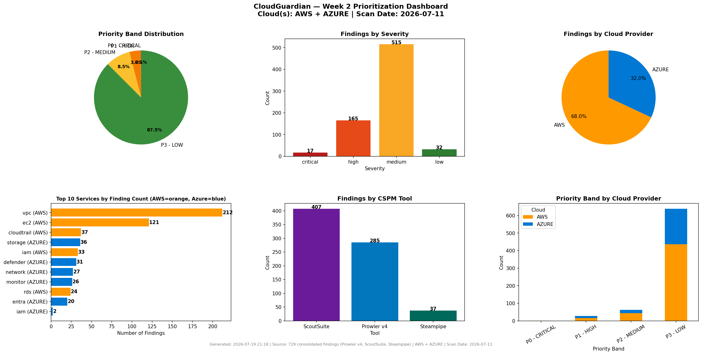
Figure 1 — Consolidated CSPM findings dashboard: severity mix, top services by finding volume, and AWS/Azure split.
Severity | AWS | Azure | Total (of 729)
Critical | 8 | 9 | 17
High | 70 | 95 | 165
Medium | 392 | 123 | 515
Low | 26 | 6 | 32
Azure carries fewer findings overall but a higher share are High/Critical — its identity and firewall checks (Entra ID, SQL Server firewall) surfaced sharper issues than AWS's broader VPC/EC2 noise volume.

6.3 Priority Scoring
Priority Score = CVSS × Exposure Score × Blast Radius. Applying this formula to all 729 findings produced four action bands:
Band | Score Range | AWS | Azure | Total | % of All Findings
P0 · Critical | ≥ 100 | 1 | 0 | 1 | 0.1%
P1 · High | 60–99 | 15 | 13 | 28 | 3.8%
P2 · Medium | 30–59 | 44 | 18 | 62 | 8.5%
P3 · Low | < 30 | 436 | 202 | 638 | 87.5%
Only ~4% of findings (P0+P1) need urgent human attention; the remaining 87.5% queue for scheduled remediation rather than firefighting — the intended outcome of a prioritization layer.

Top of the priority queue
# | ID | Cloud | Severity | Score | Title
1 | FND-0300 | AWS | Critical | 114.0 | RDS instance publicly accessible
2 | FND-0464 | AWS | High | 90.0 | RDS instance publicly accessible
3 | FND-0061 | AWS | High | 90.0 | IAM inline policy allows privilege escalation
4 | FND-0315 | Azure | Critical | 85.5 | SQL Server firewall allows all IPs
5 | FND-0040 | AWS | Critical | 85.5 | EC2 security group allows ingress from the internet
6 | FND-0299 | AWS | Critical | 85.5 | Security group allows MySQL (3306) from 0.0.0.0/0
7 | FND-0260 | Azure | Critical | 85.5 | Azure SQL Server missing firewall rules

6.4 ML Risk Classifier — RandomForest + SMOTE
Features: CVSS, exposure, blast radius, service, severity, cloud provider. Split: 510 findings train / 219 test.
Metric | Baseline (no SMOTE) | SMOTE-Balanced
CV Accuracy | 87.8% ± 7.5% | 92.6% ± 8.7%
CV Macro-F1 | 76.7% ± 6.2% | 82.4% ± 7.6%
HIGH-class Precision | 20.0% | 100.0%
HIGH-class Recall | 85.7% | 71.4%
HIGH-class F1 | 32.4% | 83.3%
Test-set accuracy on a single held-out split reached 88.6%, with a 0.019 gap between training and cross-validation accuracy after SMOTE — a good fit with low overfitting. HIGH is only 3.4% of findings (25 of 729); before SMOTE the model over-flagged this class constantly (80% false-positive rate on HIGH calls), which is dangerous for a triage tool that a human is meant to trust. SMOTE rebalancing corrected this: HIGH-class precision moved from 1-in-5 correct to 100% correct, at the cost of catching a smaller share of the true HIGH findings (recall dropped from 85.7% to 71.4%) — an explicit, documented precision/recall trade-off rather than an unexamined win.
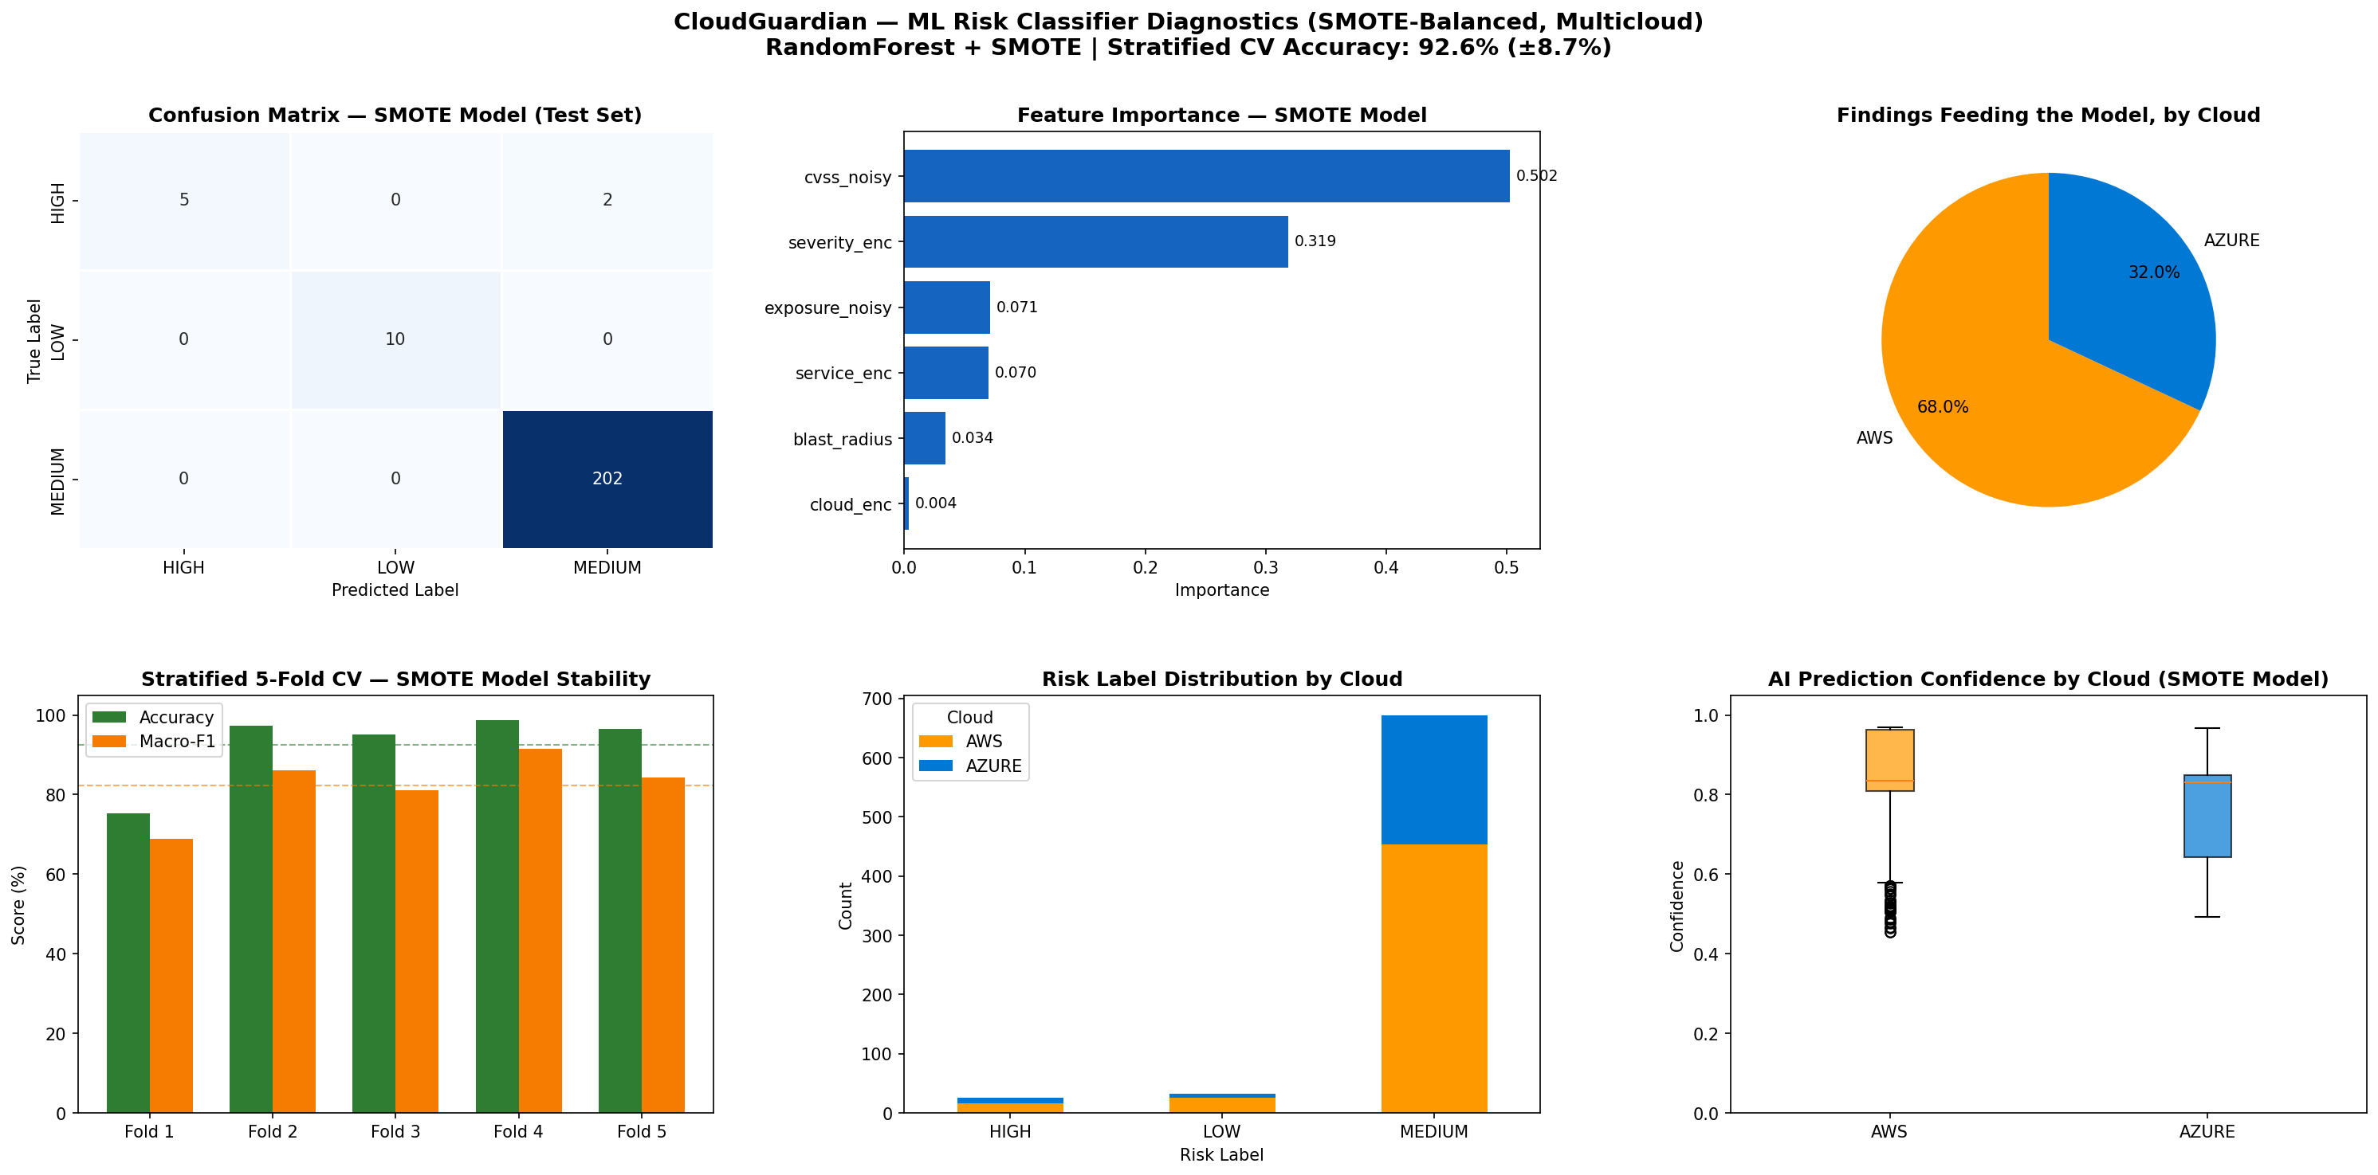
Figure 2 — SMOTE-balanced RandomForest dashboard: confusion matrix, feature importance, and class-wise precision/recall (multi-cloud).
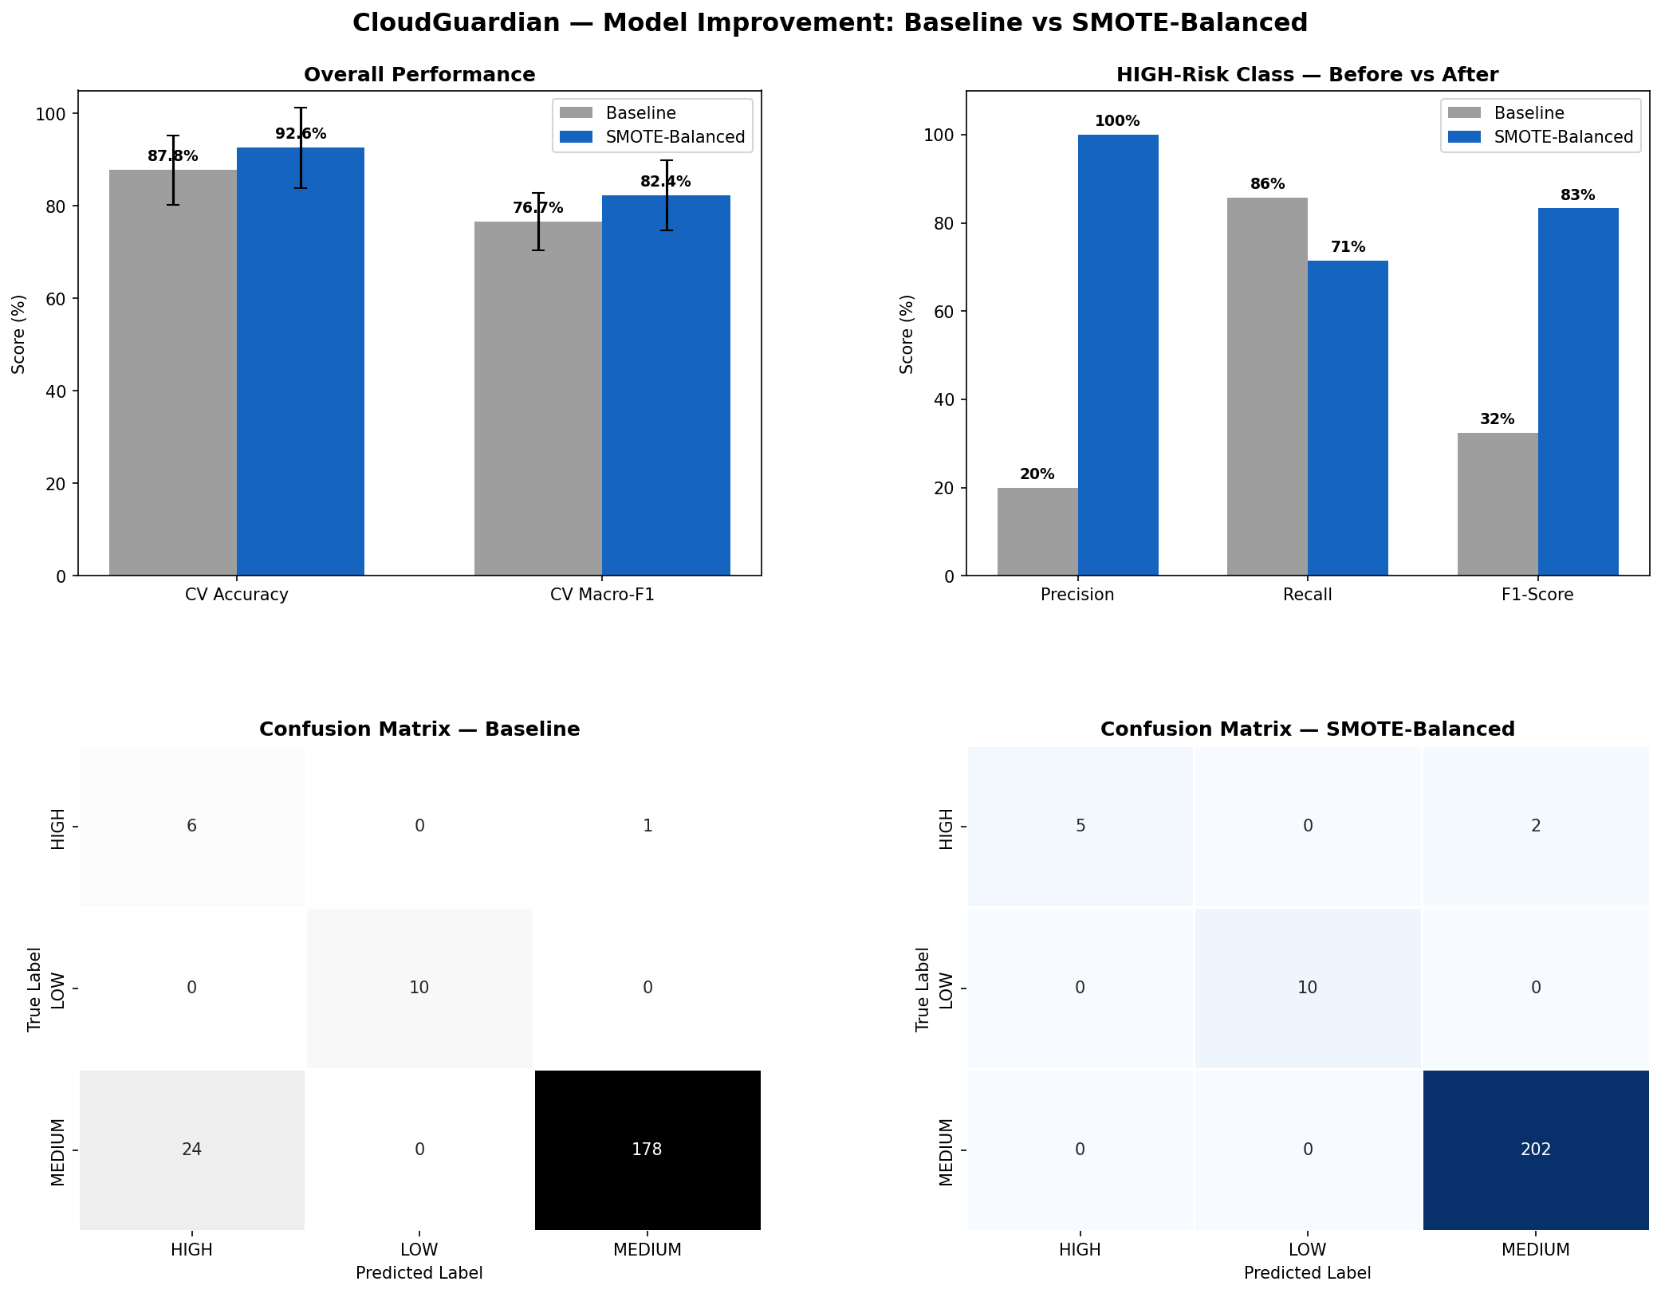
Figure 3 — Before vs. after SMOTE: class-balance and HIGH-class precision/recall comparison.
Feature importance confirms the model is learning from the right signal: CVSS (48.9%) and severity (32.4%) dominate, with exposure (11.5%) and service (7.2%) contributing secondary signal — not an opaque or spurious fit.

7. Results — GenAI Remediation Guidance & Privacy Safeguards

7.1 Retrieval-Augmented Remediation Guidance
The 15 top-priority findings from the P0/P1 bands were routed through a three-stage RAG pipeline:
- Retrieve — top-k=3 chunks pulled from a compliance knowledge base (CIS AWS Foundations Benchmark v5.0.0, Microsoft Cloud Security Benchmark, AWS Well-Architected Framework, plus ISO 27001:2022, HIPAA, and DPDP Act 2023 chunks) via nv-embedqa-e5-v5 embeddings.
- Generate — meta/llama-3.1-8b-instruct (NVIDIA NIM API) drafts a 2-line, plain-English fix for each finding, grounded in the retrieved control text.
- Verify — a dual embedding-similarity grounding check validates the generated guidance against both the retrieved control text and the raw scanner finding before acceptance (Stage A ≥ 0.55, Stage B ≥ 0.35); an LLM-as-judge verifier was trialled and rejected during Week 2 for producing inconsistent verdicts.
Result: 14 of 15 findings (93%) verified automatically against raw scan data; the remaining 1 was correctly flagged REVIEW and routed to a human check rather than silently accepted. Example: FND-0300 (RDS Instance Publicly Accessible, AWS, Critical) retrieved the matching CIS AWS Foundations Benchmark v5.0.0 control, generated a 2-line fix, and passed the embedding-similarity verification against the raw finding before being marked usable.

7.2 OWASP LLM06 Redaction Engine
Before any finding text reaches the LLM, a redaction engine strips sensitive identifiers, mapped in-memory only, never persisted or sent externally. Across the processed findings, 167 unique sensitive values were redacted across 13 categories:
Category | Count | Category | Count
Subnet IDs | 57 | Network ACL IDs | 18
AWS Secret Keys | 27 | Project Resource Names | 15
Security Group IDs | 21 | IPv4 Addresses | 3
VPC IDs | 18 | Azure Subscription IDs | 3
Instance ID | 1 | IAM ARN | 1
RDS Endpoint | 1 | Volume ID | 1
Account ID | 1
This redaction engine was a stretch goal in the original capstone brief ("privacy-preserving redaction") and was delivered inside Week 2 rather than deferred to a later phase.

8. Auto-Remediation Implementation
Two remediation tracks were built on the same underlying Lambda logic, sharing a single least-privilege execution role scoped to exactly: s3:GetPublicAccessBlock, s3:PutPublicAccessBlock, s3:GetEncryptionConfiguration, s3:PutEncryptionConfiguration, iam:ListAccessKeys, iam:UpdateAccessKey, and rds:DescribeDBInstances.

8.1 Track 1 — Semi-Automatic (Human-Invoked)
Function | Finding(s) | Fix
remediate_s3_public_access.py | M04 / M06 | Re-enables S3 Block Public Access (all four flags)
remediate_iam_key_rotation.py | M01 | Deactivates (never deletes) an exposed IAM access key
remediate_default_encryption.py | M07 / M09 | Enables SSE-S3 default encryption on S3; flags unencrypted RDS for human review — never auto-fixed, because the only remediation path is a disruptive snapshot/restore cycle
Every function defaults to dry_run: true; a live change requires an explicit override, tested via aws lambda invoke with the payload's dry_run flag flipped only after a clean dry-run response and a matching CloudWatch log entry.

8.2 Track 2 — Fully Automated, Human-Approval-Gated
The same remediation logic is wrapped in an event-driven pipeline with a mandatory human-approval gate for every live change:
- A finding is published as JSON to the cloudguardian-remediation SNS topic.
- starter.py (subscribed to the topic) starts a new AWS Step Functions execution per finding.
- The state machine's RequestApproval state uses the arn:aws:states:::lambda:invoke.waitForTaskToken integration — it invokes notifier.py, which emails the analyst an Approve/Reject link, and then genuinely pauses.
- The analyst clicks a link; the request hits an API Gateway HTTP route (GET /respond) handled by approval_handler.py, which calls sfn.send_task_success() on approve or sfn.send_task_failure() on reject.
- On approve, the IsApproved Choice state routes to InvokeRemediation, which invokes the remediator dispatcher with dry_run hardcoded to false and requested_by set to "approved-via-email" — the pre-approval dry_run flag only matters before a human has signed off.
- On reject, or if the 3600-second (1-hour) approval window expires, or any error occurs, the workflow moves to a terminal Rejected state and no AWS resource is touched.
- remediator.py matches finding_type against a fixed allow-list (FINDING_ROUTES) and calls the matching handler, which re-checks current state for idempotency before calling the relevant boto3 API and writing a structured JSON audit log line to CloudWatch.

9. Live Testing & Before/After Evidence

9.1 Live End-to-End Approval Test
The complete approval chain was exercised against a real S3 bucket, cloudguardian-target-bucket-test02:
- Step 1 — the bucket's public-access-block was deliberately disabled (all four flags set to false) to simulate a genuine misconfiguration.
- Step 2 — a finding was published to SNS with dry_run: false and requested_by: "live-test".
- Step 3 — the Starter Lambda began a new Step Functions execution (finding-dca88eae).
- Step 4 — the Notifier Lambda ran in 295 ms and published the approval email.
- Step 5 — the analyst received the email and clicked Approve.
- Step 6 — the Approval Handler resumed the state machine via SendTaskSuccess.
- Step 7 — the state machine invoked the remediator Lambda with dry_run forced to false.
- Step 8 — the dispatcher routed to remediate_s3_public_access.py, which called s3.put_public_access_block().
CONFIRMED — CloudWatch log (result: SUCCESS): the remediator applied {BlockPublicAcls: true, IgnorePublicAcls: true, BlockPublicPolicy: true, RestrictPublicBuckets: true} to cloudguardian-target-bucket-test02, requested_by "approved-via-email". Independently confirmed afterward via aws s3api get-public-access-block — all four flags returned true.
Three Step Functions executions were recorded during testing (finding-100a548d, finding-b8f08d1d, and the documented finding-dca88eae) — all reached SUCCEEDED, confirming the approval-and-remediate path is repeatable, not a one-off result.

9.2 Deployment Sequence
All Terraform and AWS CLI work ran as the kali user (never root) from ~/cloudguardian-remediation, in this order: package the dispatcher and three remediation modules into a single Lambda zip → terraform init → import pre-existing IAM role and SNS topic under Terraform management (avoiding EntityAlreadyExists conflicts) → terraform plan / apply → add approval.tf → plan / apply again.

9.3 Before/After Prowler Compliance Rescan
A live S3 remediation run was independently verified with a before/after Prowler compliance scan (ISO 27001:2022 + HIPAA), reported here without cherry-picking:
Metric | Before | After | Change
Total findings | 178 | 197 | +19
PASS | 94 | 106 | +12
FAIL | 82 | 89 | +7
Pass rate | 53.4% | 54.4% | +1.0 pt
Critical FAILs | 4 | 4 | —
High FAILs | 17 | 17 | —
The honest reading: the +19 new findings are almost entirely the three new remediation Lambdas themselves being scanned as new resources, not regressions. The target bucket's s3_bucket_public_access and s3_bucket_policy_public_write_access checks were already PASS before the run and remained PASS after — but the status text changed from "does not allow public write access in the bucket policy" to "S3 public access blocked at bucket level", evidence the Lambda actively hardened a control that was already compliant on paper. Account-level S3 Block Public Access, S3 KMS encryption, versioning, TLS-only policy, and access logging remained unresolved — outside this Lambda's declared scope. One new gap was introduced by the remediation deployment itself: the three Lambdas' CloudWatch log groups are not KMS-encrypted (medium severity) — flagged here rather than omitted.
Unrelated and still open after remediation (not in scope for the S3 Lambda): RDS instance publicly exposed, an account-wide AdministratorAccess policy, an inline IAM policy allowing *:*, EC2 SSH open to the internet, RDS storage/transport not encrypted, EBS default encryption disabled, IMDSv2 not enforced, and recent root-user activity.

10. Compliance Crosswalk
All 729 consolidated findings were mapped, using TF-IDF + cosine similarity over each framework's control text, to four compliance frameworks — exposed as a Streamlit app so the mapping can be re-run against any future findings export.
Domain | ISO 27001 Annex A | DPDP Act 2023 | HIPAA | PCI-DSS 4.0 | CIS Controls v8
Encryption at Rest | A.8.24 | §8 | §164.312(a)(2)(iv) | Req 3.5 | CIS 3.11
Access Control | A.5.15, A.8.2 | §6 | §164.312(a)(1) | Req 7 | CIS 6
Logging & Monitoring | A.8.15, A.8.16 | §8 | §164.312(b) | Req 10 | CIS 8
Network Security | A.8.20, A.8.22 | §8 | §164.312(e)(1) | Req 1 | CIS 12/13
Sample record from the crosswalk output (each of 729 findings receives one row like this):
Finding | ISO 27001 | HIPAA | CIS v8 | DPDP 2023
RDS instance publicly accessible | A.8.20 — Network security | §164.312(e)(1) — Transmission Security | CIS 12.2 — Secure Network Architecture | §8(4) — Reasonable security safeguards
IAM inline policy allows privilege escalation | A.8.3 — Information access restriction | §164.312(a)(1) — Access Control | CIS 5.4 — Restrict Admin Privileges | §5 — Notice and consent
SQL Server firewall allows all IPs | A.8.20 — Network security | §164.308(a)(6) — Security Incident Procedures | CIS 12.2 — Secure Network Architecture | §8(4) — Reasonable security safeguards
DPDP Act 2023 has no built-in Prowler framework, so this mapping was produced by extracting unique FAIL findings from the ISO 27001 scan and feeding the unique check list to an LLM with a prompt requesting a DPDP §8(5) ("reasonable security safeguards") mapping and a two-line justification per finding — disclosed here per the LLM usage policy (§14).

11. Safety, Governance & Design Principles
- Idempotency — every remediation handler checks current state before acting and logs a SKIPPED no-op if the fix is already applied, so re-running a finding never causes duplicate or conflicting changes.
- Reversibility — every automated action can be undone by an administrator: public-access-block flags can be re-opened, IAM keys can be reactivated, and encryption changes only affect newly written data.
- No destructive default — IAM keys are deactivated, never deleted. RDS storage encryption is never auto-applied because the only remediation path (snapshot-and-restore) is disruptive; it is always routed to a human-approval flag instead.
- Explicit allow-list routing — the dispatcher matches finding_type against a fixed dictionary rather than dynamically resolving a function name, so a malformed or unexpected finding_type fails closed (HTTP 400) rather than executing unintended code.
- Human-in-the-loop by default — the production trigger path is the approval workflow, not the direct-invoke path; an analyst must actively click Approve before any live change happens.
- Time-bounded approval — the approval request expires after 3600 seconds; an unanswered finding safely does nothing rather than defaulting to action.
- Least-privilege IAM — each Lambda has its own execution role scoped to only what it needs (e.g. the notifier's role can only sns:Publish to the approval topic).
- Structured audit logging — every remediation attempt (successful, skipped, or errored) writes one structured JSON line to CloudWatch with finding type, resource, requester, dry_run flag, and result.
- Secret hygiene — the IAM key remediation handler logs only the key ID, never the secret access key value.

12. Deployment Journey — Issues Encountered and Fixes
Documented here, in the order encountered, because they are common Terraform/shell pitfalls worth remembering for future work.

Heredoc left open
Problem: A cat > file.tf << 'EOF' command was pasted without its closing EOF, leaving the shell stuck inside a heredoc prompt.
Fix: Typed EOF alone on its own line to close the heredoc.

Missing opening quote in remediation.tf
Problem: A line read endpoint = megha22knit@gmail.com" — a closing quote with no opening quote — so Terraform read the rest of the file as one unterminated string, producing dozens of cascading errors.
Fix: Corrected to endpoint = "megha22knit@gmail.com". One missing character caused the entire cascade; the fix was one line.

Missing declared variable
Problem: terraform validate failed with "Reference to undeclared input variable" for var.project.
Fix: Created provider.tf with the aws provider block and a variable "project" block (default = "cloudguardian").

terraform init appeared to hang
Problem: No visible progress while installing the hashicorp/aws provider.
Fix: Verified network connectivity, then waited — the provider (v6.55.0) installed successfully.

Duplicate resources on first apply
Problem: terraform apply failed with EntityAlreadyExists (IAM role) and a tag mismatch (SNS topic), because both already existed outside Terraform's tracked state.
Fix: Retrieved existing resource identifiers and ran terraform import for both, bringing them under management without deleting or recreating them.

Missing Lambda deployment package
Problem: terraform apply failed because the referenced remediation-lambda.zip did not exist yet.
Fix: Zipped the dispatcher and the three remediation modules together so the dispatcher's imports resolve inside the Lambda runtime.

User context (root vs kali)
Problem: Initial Terraform commands were run as root, risking root-owned state inconsistent with the team's kali-only workflow.
Fix: Confirmed AWS CLI identity resolved correctly under kali and continued all subsequent work as that user.

Duplicate notebook cells corrupting state (Week 2)
Problem: Stale duplicate cells corrupted the cloud_provider column and other in-memory state during pipeline debugging.
Fix: Established fix: delete the duplicate cell → Kernel Restart & Clear Output → re-run the notebook top to bottom.

AWS auto-re-applies encryption (Week 3 finding)
Problem: AWS was found to auto-re-apply AES256 SSE regardless of the Terraform configuration for misconfiguration M10.
Fix: Documented as a platform-level nuance rather than a pipeline defect; noted in the M10 catalogue entry.

13. Evaluation Against the Capstone Rubric
Criterion | Weight | Evidence in This Report
Workload design + IaC quality (multi-cloud) | 15% | Reproducible Terraform across AWS + Azure (§5.1); deployment issues and fixes documented transparently (§12)
Misconfiguration detection (3 tools × 2 clouds) | 15% | All 12 injected misconfigs confirmed via Steampipe; 729 consolidated findings across Prowler/ScoutSuite/Steampipe (§6.1–6.2)
Prioritization model | 15% | CVSS × Exposure × Blast Radius scoring + RandomForest/SMOTE with honest before/after metrics (§6.3–6.4)
LLM remediation guidance | 15% | RAG-grounded guidance with dual verification, 93% auto-verified, 1 correctly flagged for review, redaction engine (§7)
Auto-remediation + guardrails | 15% | Semi-automatic + fully automated tracks, live end-to-end test, honest before/after evidence (§8–9)
Compliance mapping | 10% | ISO 27001 + DPDP + HIPAA + CIS Controls v8 crosswalk over all 729 findings (§10)
Report + oral defense | 15% | This document + accompanying demo

14. LLM Usage Disclosure
Item | Detail
Model | NVIDIA NIM — meta/llama-3.1-8b-instruct (generation); nv-embedqa-e5-v5 (retrieval embeddings)
Purpose | 2-line plain-English remediation guidance per finding, grounded via RAG; DPDP Act 2023 crosswalk justifications
Verification | Dual-stage embedding-similarity grounding check (Stage A ≥ 0.55, Stage B ≥ 0.35) plus manual cross-check against raw scanner data; an LLM-as-judge verifier was trialled and rejected for inconsistency
Privacy | No credentials, secrets, or customer data submitted to the LLM — enforced by the OWASP LLM06 redaction engine (167 values redacted across 13 categories) before every call

15. Conclusion & Future Work
CloudGuardian delivers a working, evidence-backed CSPM lifecycle across two clouds: honest detection numbers (729 findings, only 4% requiring urgent attention), a prioritization model whose trade-offs are stated rather than hidden (SMOTE traded some HIGH-class recall for a large precision gain), GenAI remediation guidance that verifies itself against source data instead of being trusted blindly, and an auto-remediation pipeline that is reversible, idempotent, and gated by a human wherever the blast radius of a mistake is nontrivial.
Suggested next steps beyond this capstone's scope:
- Close the account-level S3 Block Public Access gap and the three unencrypted CloudWatch log groups flagged in §9.3.
- Extend the semi-automatic Lambda set to cover RDS storage encryption via a supervised snapshot/restore workflow (currently always routed to human review by design).
- Add a scheduled re-scan + re-score cadence so the priority queue reflects drift, not just a point-in-time snapshot.
- Extend the compliance crosswalk to SOC 2 and PCI-DSS 4.0 in full (currently referenced only in the domain-level table).

16. References
- MITRE ATT&CK — https://attack.mitre.org
- NIST Cybersecurity Framework 2.0 — https://www.nist.gov/cyberframework
- CIS Benchmarks — https://www.cisecurity.org/cis-benchmarks
- OWASP (LLM06 / Top 10 for LLM Applications) — https://owasp.org
- CERT-In advisories — https://www.cert-in.org.in
- Prowler documentation — https://docs.prowler.com
- ScoutSuite — https://github.com/nccgroup/ScoutSuite
- Steampipe — https://steampipe.io/docs
- DPDP Act 2023 (India) — https://www.meity.gov.in/data-protection-framework

Appendix A — Misconfiguration Catalogue (M01–M12)
ID | Category | Misconfiguration | Severity
M01 | IAM | Wildcard Action ("*") in inline EC2 role policy | Critical
M02 | IAM | Wildcard Resource ("*") in inline EC2 role policy | Critical
M03 | IAM | AdministratorAccess managed policy attached to EC2 role | Critical
M04 | Storage | S3 public-access-block disabled (all 4 flags = false) | High
M05 | Storage | S3 bucket versioning suspended | Medium
M06 | Network | SSH (22) open to 0.0.0.0/0 on web security group | High
M07 | Network | MySQL (3306) open to 0.0.0.0/0 on RDS security group | Critical
M08 | Database | RDS instance set publicly_accessible = true | Critical
M09 | Database | RDS storage_encrypted disabled | High
M10 | Storage | S3 default server-side encryption removed entirely* | High
M11 | Compute | EC2 IMDSv2 disabled (http_tokens = optional) | Medium
M12 | Database | RDS automated backups disabled (retention = 0) | Medium
* AWS was observed to auto-re-apply AES256 SSE on this bucket regardless of the Terraform configuration — documented as a platform-level nuance during Week 3 verification, not a scanning defect.

Appendix B — AWS Resource Inventory (Remediation Stack)
Resource Type | Name / Identifier
SNS Topic | cloudguardian-remediation
SNS Topic | cloudguardian-approval-request
IAM Role | cloudguardian-remediation-role
IAM Role | cloudguardian-notifier-role
IAM Role | cloudguardian-starter-role
IAM Role | cloudguardian-approval-handler-role
IAM Role | cloudguardian-stepfunctions-role
Lambda Function | cloudguardian-remediator
Lambda Function | cloudguardian-approval-notifier
Lambda Function | cloudguardian-approval-starter
Lambda Function | cloudguardian-approval-handler
Step Functions State Machine | cloudguardian-approval-workflow
API Gateway (HTTP API) | cloudguardian-approval-api (stage: prod)
Test S3 Bucket | cloudguardian-target-bucket-test02
Test S3 Bucket | cloudguardian-data-8b63b854
End of Report

