**Linear quadrilateral element formulation**

A general approximation for  in terms of and  can be expressed as



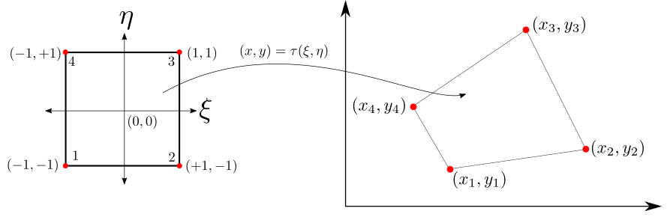

Figure 1: Geometrical Transformation

We have four nodes where we can evaluate the above equation as follows. In other words, takes four values of (-1, -1), (+1, -1), (+1, +1) and (-1, +1). Substituting these values, we arrive at four equations as shown below.









Representing the above equations in matrix form



or in a more compact form as



Thus, the coefficients can be calculated by inverting A as shown below



We find that



Substituting this we get





Further simplifying,



where







