Using Beam Elements in CalculiX

The following document details the use of beam elements in CalculiX. The problems have been verified with hand calculations.

Problem 1:

Calculate the maximum deflection, maximum bending moment and the maximum bending stress in a cantilever beam which is 10in long under the action of a concentrated force 1.25 lbf as shown below.

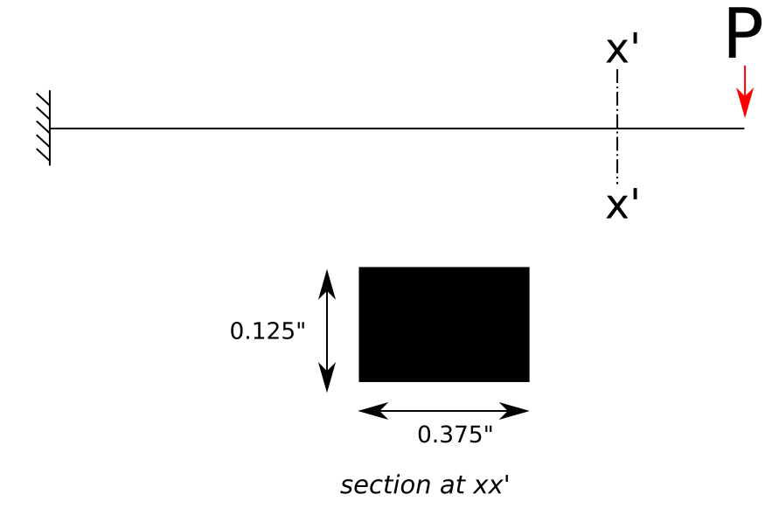Illustration 1: Loading and Beam Cross Section

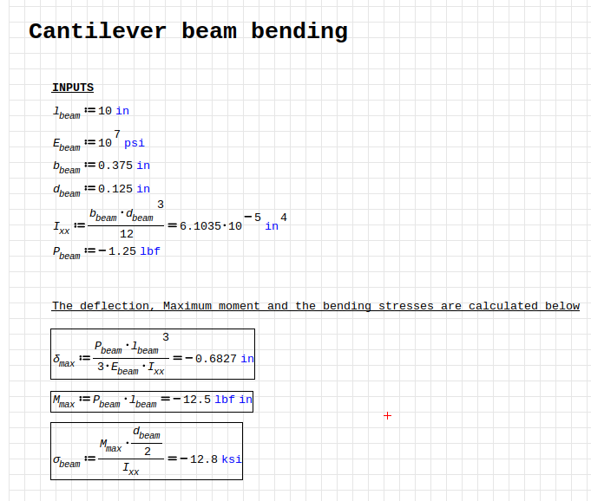

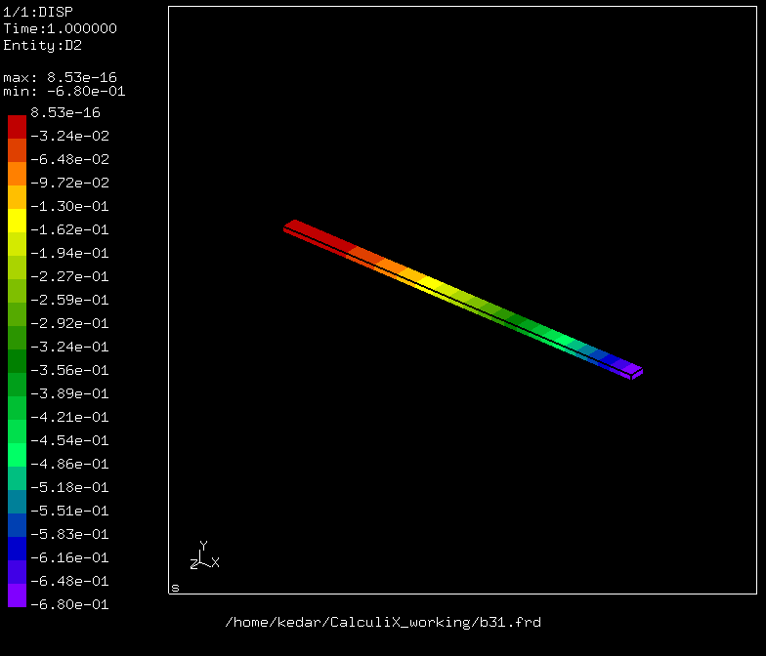
.
Matches deflection calculated above

