CUSTOMER ENGAGEMENT & PRODUCT UTILIZATION
ANALYTICS FOR RETENTION STRATEGY
Research Paper / Internship Project Report
Submitted by
K. Manasa
Financial Analyst Intern
Unified Mentor
2026

Executive Summary
This project examines customer churn from the perspective of customer engagement and product utilization. The analysis uses a banking customer dataset containing 10,000 records and focuses on activity status, number of products, account balance, credit card ownership, geography and churn.
The overall churn rate was 20.37%. Active customers recorded a churn rate of 14.27%, compared with 26.85% among inactive customers. Customers with two products recorded a churn rate of 7.58%.
A High-Value Disengaged segment was created using inactivity and a balance threshold of ₹97,198.54, the median balance. This segment contained 2,456 customers and had a churn rate of 32.33%.
The findings suggest that customer retention analysis should consider behavioural engagement and relationship depth together with financial indicators. Excel was used for calculations and Power BI for visualization.

Abstract
Customer retention is an important concern for banks because losing existing customers can affect long-term relationships and revenue. Customer churn cannot always be explained by financial information such as account balance or salary alone. Customer activity, product usage and relationship depth can also provide useful information about retention.
This project studies customer engagement and product utilization using a dataset of 10,000 banking customers. Excel and Power BI were used for analysis, KPI calculation, customer segmentation and visualization. The study compares churn across engagement levels, product counts, geographies and selected customer groups.
The overall churn rate was 20.37%. Active customers had a churn rate of 14.27%, while inactive customers had a churn rate of 26.85%. The High-Value Disengaged segment contained 2,456 customers and recorded a churn rate of 32.33%.
Keywords: Customer Churn; Customer Engagement; Product Utilization; Banking Analytics; Customer Retention; Excel; Power BI.

1. Introduction
Banks maintain customer relationships through a range of products and services. However, having a banking relationship does not necessarily mean that a customer will remain with the bank for a long period.
Customer churn occurs when customers leave or discontinue their relationship with a bank. Understanding the patterns associated with churn can help financial institutions identify customers who may require additional engagement.
This project focuses on customer engagement and product utilization and examines whether active customers, customers using multiple products and customers with stronger relationship profiles show different churn patterns.

2. Problem Statement
Banks may have large amounts of customer data but still face difficulty identifying behavioural patterns associated with customer churn.
The project aims to understand how customer engagement and product utilization are related to customer churn and to identify customer groups that may require retention-focused attention.

3. Objectives of the Study

3.1 Primary Objectives
- Examine the relationship between customer engagement and churn.
- Analyse churn according to the number of banking products used.
- Identify customers who are inactive but have relatively high account balances.
- Study the relationship between product depth and customer retention.
- Analyse churn patterns across different geographical locations.

3.2 Secondary Objectives
- Create customer segments based on engagement and product usage.
- Calculate customer-retention KPIs.
- Identify customer groups that may require additional engagement.
- Provide practical recommendations based on the analysis.

4. Dataset Description
The dataset contains information about 10,000 banking customers. The major fields used in the analysis are:
Variable | Description
CustomerId | Unique customer identification number
Geography | Customer's country
Gender | Customer gender
Age | Customer age
Tenure | Number of years with the bank
Balance | Customer account balance
NumOfProducts | Number of banking products used
HasCrCard | Whether the customer has a credit card
IsActiveMember | Customer activity indicator
EstimatedSalary | Estimated annual salary
Exited | Churn indicator

The Exited variable was treated as the churn indicator, where 1 represents a customer who exited and 0 represents a retained customer.

5. Analytical Methodology

5.1 Data Validation
The dataset was reviewed to understand the available fields and identify the variables relevant to engagement, product usage and churn.

5.2 Customer Engagement Analysis
Customers were classified as Active (IsActiveMember = 1) or Inactive (IsActiveMember = 0). Churn was compared between the two groups.

5.3 Product Utilization Analysis
Customer churn was analysed according to the number of products held, including one, two, three and four-product groups.

5.4 High-Value Disengaged Customer Analysis
The median account balance was calculated as ₹97,198.54. Customers who were inactive and had a balance greater than or equal to this value were classified as High-Value Disengaged.

5.5 Behavioural Segmentation
Segments were created using engagement and product usage: Engaged & Deep Relationship, Disengaged & Shallow Relationship, High-Value Disengaged, Active but Low Product and Other.

5.6 Dashboard Development
The analysis was visualized using Power BI through KPI cards, charts, segmentation analysis and a geography filter.

6. Key Findings

6.1 Overall Churn
Out of 10,000 customers, 7,963 were retained and 2,037 churned. The overall churn rate was 20.37%.

6.2 Customer Engagement and Churn
Customer Status | Churn Rate
Active | 14.27%
Inactive | 26.85%

Inactive customers had a churn rate approximately 12 percentage points higher than active customers. This makes activity status an important variable for retention analysis.

6.3 Product Utilization
Number of Products | Churn Rate
1 | 27.71%
2 | 7.58%
3 | 82.71%
4 | 100%

The two-product group recorded the lowest observed churn rate. The three- and four-product results should be interpreted with caution because those categories may contain fewer observations.

6.4 High-Value Disengaged Customers
Customers who were inactive and had a balance of at least ₹97,198.54 were classified as High-Value Disengaged.
Measure | Result
Customers | 2,456
Churn Rate | 32.33%
Overall Churn | 20.37%
Difference | 11.96 percentage points

This segment shows that financial value alone does not necessarily indicate an active or strong customer relationship.

6.5 Geography
Geography | Customers | Churn Rate
France | 5,014 | 16.15%
Spain | 2,477 | 16.67%
Germany | 2,509 | 32.44%

Germany recorded the highest churn rate among the three geographical groups in this dataset.

6.6 Credit Card Ownership
Credit Card | Customers | Churn Rate
No | 2,945 | 20.81%
Yes | 7,055 | 20.18%

The difference between the two groups was relatively small, suggesting that credit card ownership alone does not show a large difference in churn within this dataset.

6.7 Engagement and Product Combination
Customer Group | Churn Rate
Active + 2 Products | 5.56%
Inactive + 1 Product | 36.65%
Active + 1 Product | 18.92%
Inactive + 2 Products | 9.89%

Combining engagement status with product count provides additional information beyond looking at either variable separately.

7. Customer Segmentation
Segment | Customers | Churn Rate
Engaged & Deep Relationship | 2,588 | 9.66%
Disengaged & Shallow Relationship | 878 | 39.86%
High-Value Disengaged | 2,456 | 32.33%
Active but Low Product | 2,563 | 18.92%
Other | 1,515 | 10.43%

The behavioural segmentation highlights differences between customer groups. The disengaged and shallow-relationship segment recorded a higher churn rate than the engaged and deep-relationship segment.

8. Key Performance Indicators
KPI | Result
Overall Churn Rate | 20.37%
High-Value Disengagement Rate | 24.56%
High-Value Disengaged Churn Rate | 32.33%
Average Products per Customer | 1.53
Credit Card Retention Rate | Approximately 79.82%
Deep Relationship Customer Rate | 25.88%
Relationship Strength Index | 53.44%

9. Recommendations
Focus on inactive customers: Consider suitable engagement initiatives for customers who show reduced activity.
Monitor high-value disengaged customers: Create a separate monitoring group for customers with high balances but low activity.
Review product relationships: Examine the reasons behind differences in churn across product-count groups rather than assuming that more products always mean stronger retention.
Encourage relevant product usage: Explore suitable cross-selling opportunities for single-product customers based on their needs.
Investigate regional differences: Further study the factors behind the higher churn observed in Germany, including product mix and engagement.
Use behavioural segmentation: Use customer behaviour segments to support more targeted retention strategies.

10. Limitations of the Study
- The study is based on 10,000 customers and should not automatically be generalized to every banking population.
- The analysis identifies relationships between variables but does not establish direct causation.
- Three- and four-product groups may contain fewer observations and should therefore be interpreted with caution.
- The dataset does not include detailed information such as complaints, transaction frequency, digital banking usage or service quality.

11. Conclusion
This project analysed customer churn from the perspective of engagement and product utilization. The analysis found a clear difference between active and inactive customers, with inactive customers showing a higher churn rate.
Product usage also showed meaningful variation in churn. The identification of 2,456 High-Value Disengaged customers was another important outcome, with this segment recording a churn rate of 32.33%.
Overall, the findings indicate that customer retention analysis can benefit from combining engagement, product utilization and financial information. Behavioural segmentation can help banks identify different customer groups and develop more targeted retention approaches.

12. Project Outcome
- Customer churn analysis using 10,000 customer records
- Customer engagement analysis
- Product utilization analysis
- High-value disengaged customer identification
- Behavioural customer segmentation
- KPI calculation
- Excel-based analysis
- Power BI dashboard development
- Retention-focused recommendations

Appendix A – Power BI Dashboard Screenshots
The final version will include selected screenshots of the completed Power BI dashboard here, with short captions explaining the visuals.
Figure 1: Power BI Customer Churn Dashboard.
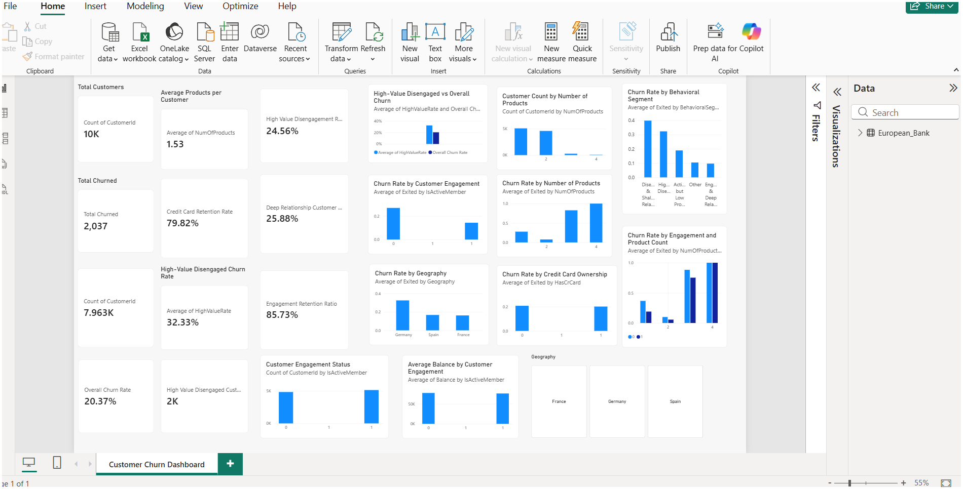

Figure 2: Churn Rate by Behavioral Segment
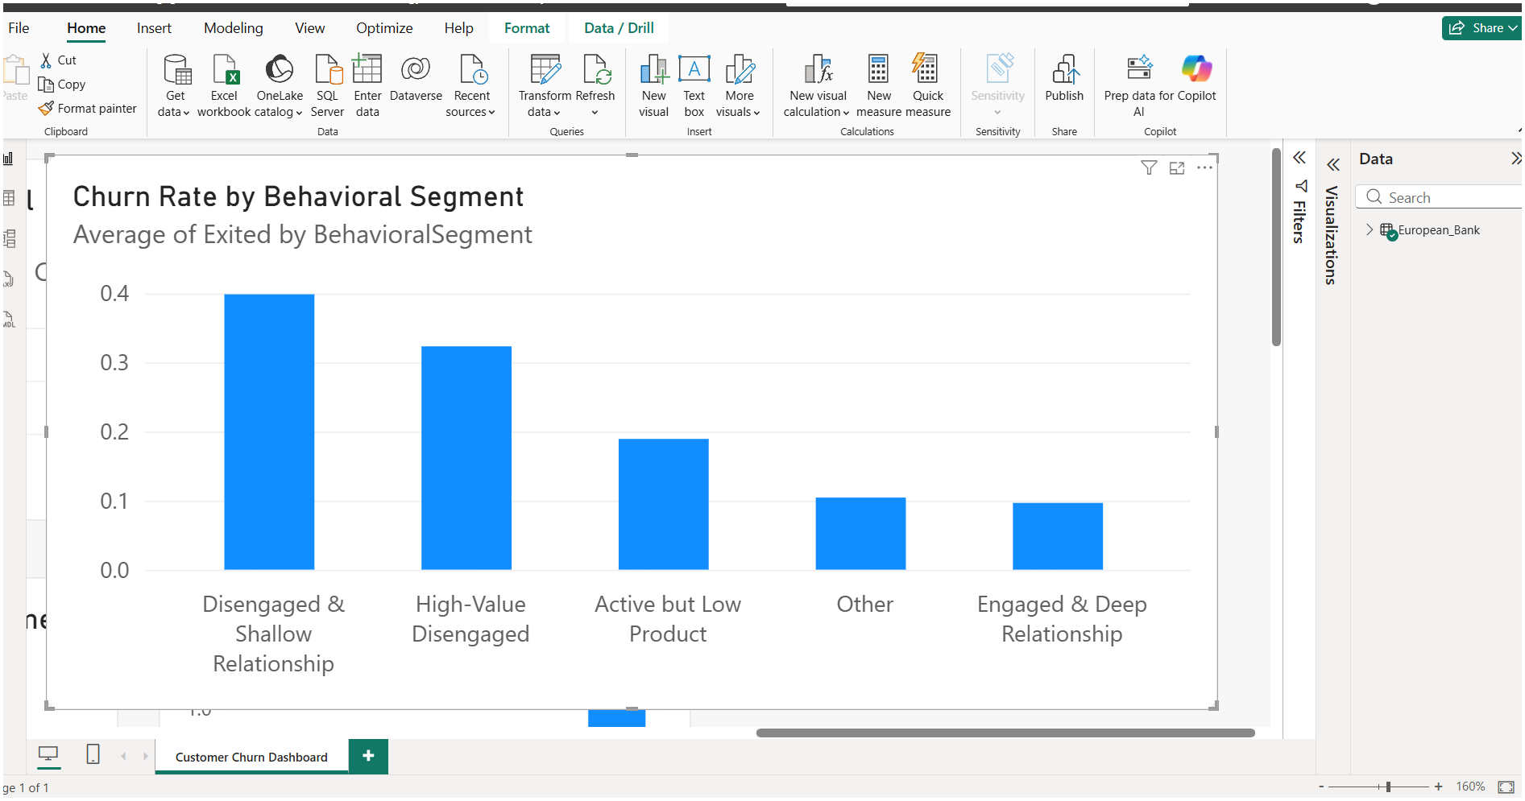
Caption:
Figure 2 shows the variation in churn rates across the five customer behavioral segments. Disengaged & Shallow Relationship and High-Value Disengaged customers show higher observed churn rates than the other segments.
Figure 3: High-Value Disengaged Customers vs Overall Churn
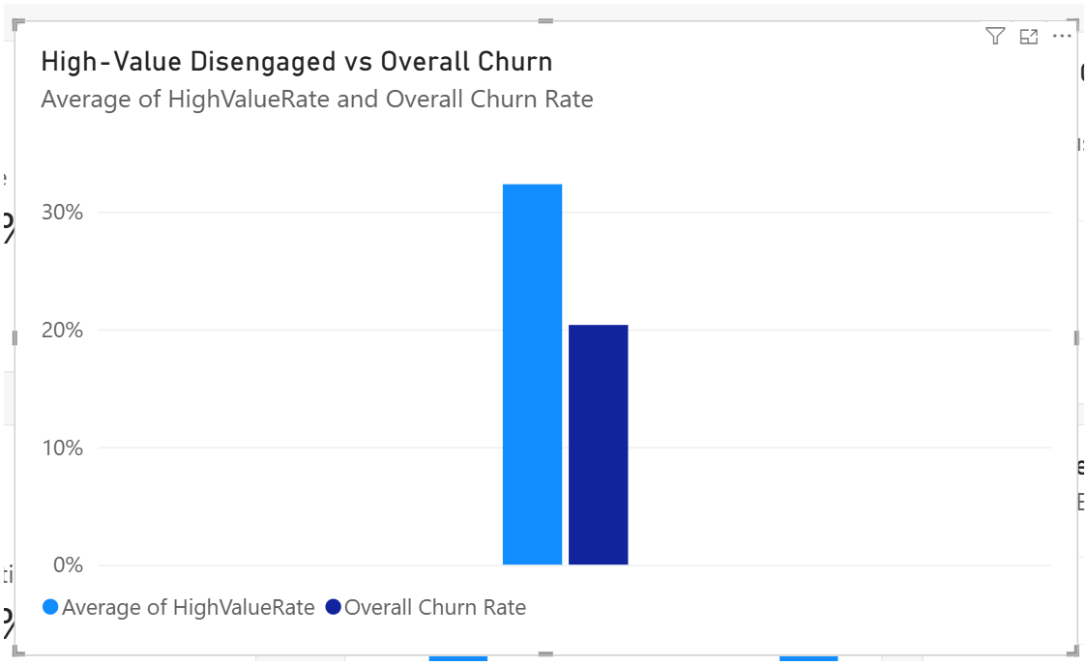
Caption:
Figure 3 compares the observed churn rate of High-Value Disengaged customers with the overall customer churn rate.

Figure 4: Churn Rate by Number of Products
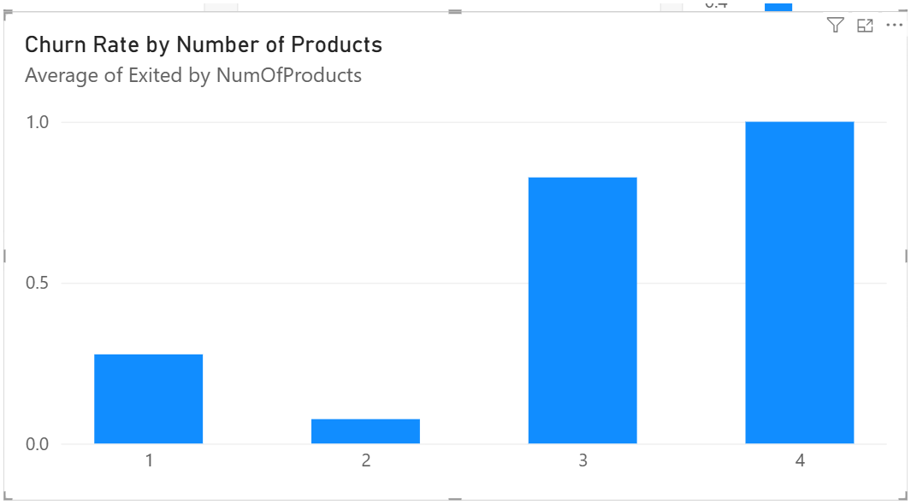
Caption:
Figure 4 shows the observed churn rate across customers holding one, two, three and four banking products.
Figure 5: Churn Rate by Customer Engagement.
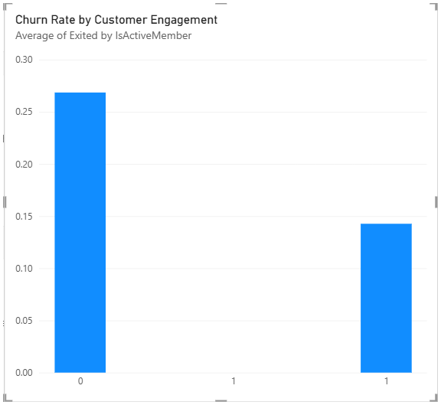
Caption:
Customer engagement is represented by IsActiveMember, where 0 = Inactive and 1 = Active. The chart compares the observed churn rates between the two groups.

Figure 6: Churn Rate by Geography
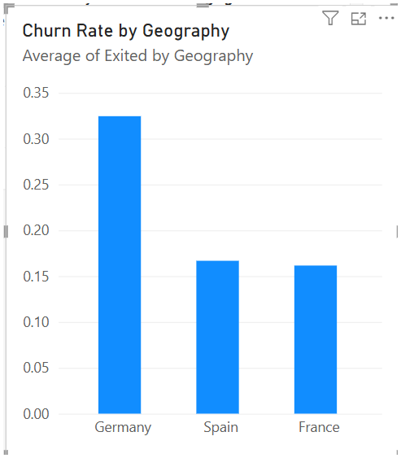
Caption:
Figure 6 shows the observed churn rate across customers from France, Germany and Spain.

