Kedeng Pan

NetID: KPZ150

Project A: Space Exploratory Utilities

This project demonstrates a scene about space travel including a flying rocket and a lunar rover with camera installed. Three individual “parts/shapes” are designed and their vertex calculated: a cone, a cylinder and a trapezoidal shape. Each shape consists more than three colors on its surface and is rasterized from vertex to vertex.

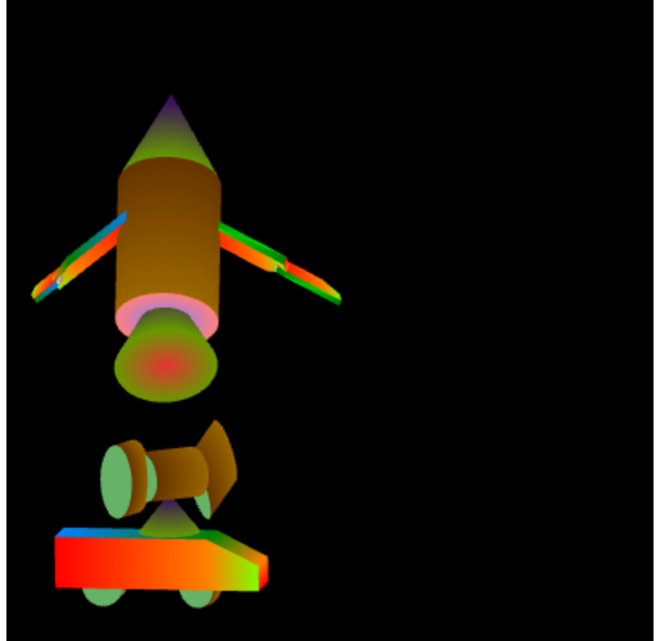

**Figure 1. Initial display of the scene.**

**User Guide**

**Rocket**

The rocket is consistently “flying” and the users are able to drag to change its location anywhere. There are two sequential joints on each wing of the rocket which are rotating at different rates.

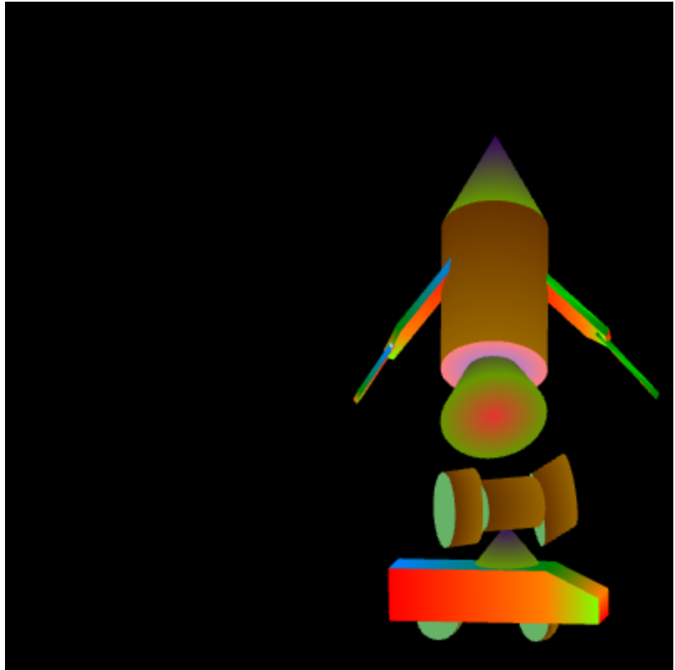

**Figure 2. Rocket position after mouse drag**

**Lunar Rover**

The lunar rover is originally moving horizontally back and forth at a constant speed. Its camera hinge is rotating clockwise with two cameras attached, one scanning up and down and the other scanning left to right.

Users can perform multiple tasks:

1. Single mouse click to change the size of the lunar rover. The automobile will swell througout a period of time and shrink back to its original size when the max size is reached. Users are able to mouse click again to stop the resizing process. (Note: a valid mouse click is verified when the time between mouse down and mouse up in 100ms).
2. The users can press “W” or “S” to apply an upward or downward force to the automobile and make it travel vertically. The lunar rover will starts “bouncing” in a range and the speed depends on the number of times “W” or “S” is pressed. If both are pressed once, the forces will cancel out and the vertical speed will be zero again.
3. The horizontal speed can be altered with HTML buttons “drive faster” and “drive slower”. Intuitively, “drive faster” will increase the speed no matter which direction the car is going and “drive slower” will decrease it. If the speed reaches negative, the car will starts going the other direction.
4. The camera installed on top of the car is set to rotate clockwise originally. Users can alter its rotation by pressing “Q” or “E” to rotate clockwise or counter clockwise. Double click to stop rotation.

**Other Controls**

1. Press P or click on run/pause button to pause or unpause the animation.
2. Click on the reset button to reset all the parameters and the animation.

**Other Results**

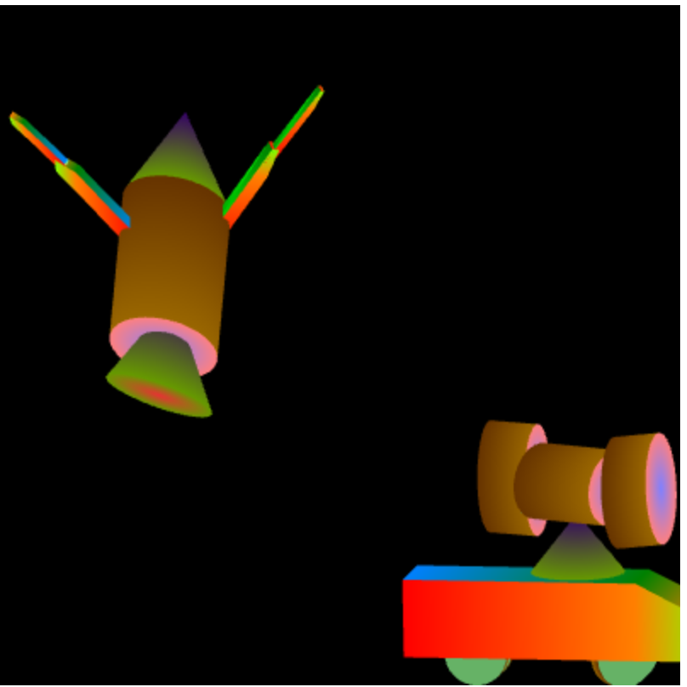

**Fig 3. Scale of the lunar rover increased to maximum.**

A single mouse click will make the lunar rover change in scale and shrink back after the maximum scale is reached.

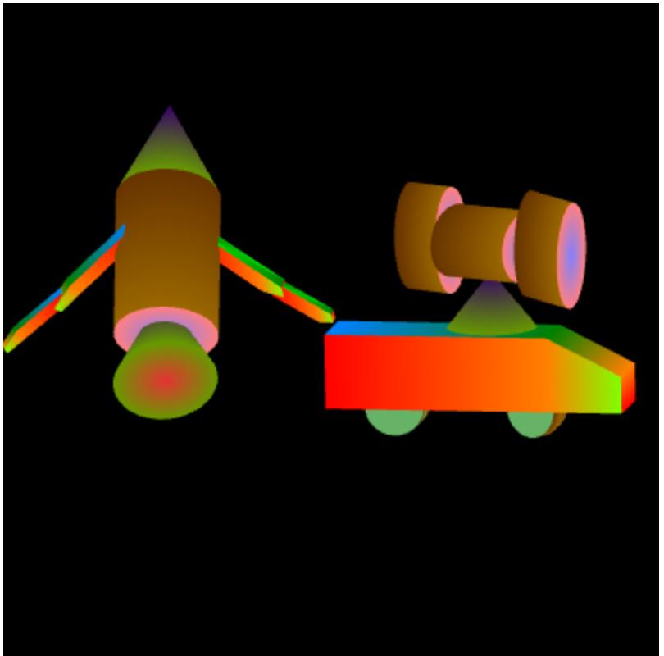

**Fig 4. Lunar rover travels upward with its scale increased as well.**

W is pressed and besides moving horizontally, the automobile starts moving upwards. It will “bounce” back after hitting the designated “roof top”.