Name : Keder Nath Mallick

Roll No. : 18700119104(C.S.E. -b)

OPERATING SYSTEM LAB

Date : 1.12.2021

**Question :**

8.1 Write a program in C, which pauses until it receives a key like Ctrl+C when pressed with a suitable warning massage.

[ Hint: Refer manual page for SIGINT ]

**Answer :**

**Code :**

#include<stdio.h>

#include<stdlib.h>

#include<signal.h>

#include<unistd.h>

void fun(int a){

printf("CTRL have pressed\n");

fflush(stdout);

}

int main(){

signal(SIGINT,fun);

for(;;){

pause();

}

}

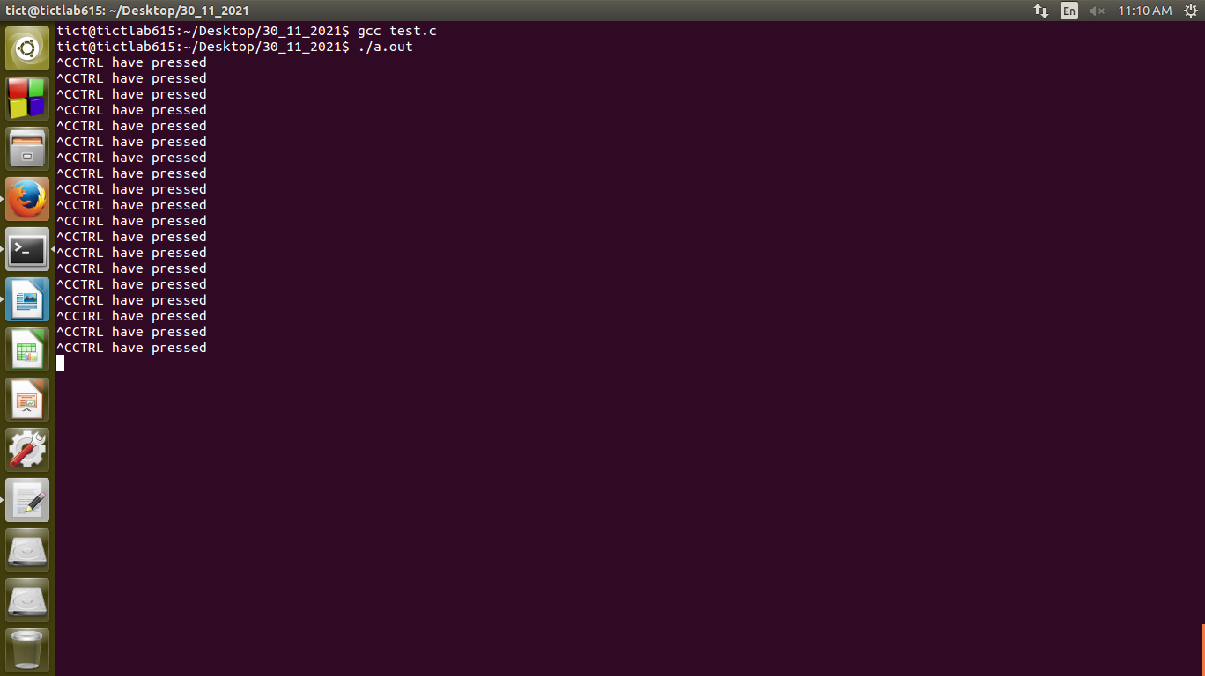**Output Screenshot :-**