Benjamin Santaus  
Erythraean Phase 2 Executive Summary  
10 February 2019

**Deliverable Description:**

The deliverables for this phase built on each other. The first deliverable was demonstration of motor control. The working prototype for Phase 2A was a set of two motors that could be programmed to spin both forward and backward.

The second part of this phase was motion control – using the motor control from the first part of the phase to actually move a proto-bot fixture. The deliverable for this phase was a demonstration that the team could propel a bot forward, backward, left, and right. The turns were done in two different manners – one done by stopping one wheel and moving the other, and the other by moving both wheels in opposite directions (differentiated by calling the latter a “spin”).

**Phase Schedule:**

Phase 2A:

* Due Date Set: 1/31/2019
* Due Date Adjustments: N/A
* Date of Demo: 1/31/2019

Phase 2B:

* Due Date Set: 2/7/2019
* Due Date Adjustments: N/A
* Date of Demo: 2/5/2019

**Phase Activities:**

Phase 2 was initiated on January 28. Due to illness, the team was unable to meet, so the pre-studio for the first part of the phase was completed separately. The design portion of Phase 2A was started on Tuesday, January 30. The team was still split due to illness for that session, but regrouped the next morning. Over the following two days (1/30-1/31), the team was able to complete the design phase for the first part of Phase 2.

The pre-studio for Phase 2B was done both separately and as a team (started 2/2). Some questions required the team to be together to make decisions regarding the direction of the design. The design phase was started before the pre-studio. After completing Phase 2A (1/31), the team began to work on constructing an H-Bridge circuit out of MOSFETS. The design prototype was demonstrated on 2/5, and performed the required operations mentioned in the Deliverables section of this summary

**Technology Used:**

Phase 2A:

Constructed circuit seen on third page using 2 DC motors, DC power supply, Arduino, LED, capacitor, and NMOS transisitor. Capacitor and LED are used to prevent voltage spikes.

Phase 2B:

This phase required more equipment. The H-Bridge IC and foamcore were used to construct the final fixture. One IC has two bridges, so one was designated for the left motor, and one was used for the right motor. An omnidirectional roller was also used.

**Phase Experiments:**

* Connect motor, transistor, LED, capacitor, Arduino as shown in slides (1/29)
  + Observations: Connecting a circuit without understanding it does not go well. Getting frustrated with a simple circuit and making small errors does not help. Had speed control with potentiometer.
  + Started over, made a simpler circuit then built back up. Led to circuit used in demo for 2A – connected 2 motors in parallel with LED, capacitor.
* Construct H-Bridge with NMOS and PMOS transistors:
  + Observations: All gates, drains, sources seemed to line up with expectations, but the circuit did not work as expected (motor did not turn on). Switched to all NMOS and circuit was functional.
* Construct circuit with H-Bridge IC and moving fixture
  + Observations: Much easier to implement. Combined with software to move bot in specified directions, was sufficient to demo for 2B.

**Phase Assignments by Team Member:**

Benjamin Santaus:

* Assigned to work on software for phase. Software was not the issue in debugging MOSFET H-Bridge and was simple for IC circuit.
* Work Quality: Good. Code should be commented and cleaned up, but is functional.

Kelsey Foster:

* Assigned to lead hardware development. Hardware issues during Phase 2A, 2B not fault of engineer specifically – more team failures.
* Work Quality: Good. Wiring on final circuit for 2B was clean and clear, easy to debug.

**To-Date Cost of Bot:**

Parts Cost (including broken parts): $51.68  
 Labor Cost (Engineer, Manufacturing, Project Management): $3976.66  
 Total Cost of Bot: $4028.34  
 Previously Estimated Cost: N/A. The team had not made an estimate.*  
*\*The Phase 1 Executive Summary stated we would have an estimate – this was not communicated and therefore not completed. This is an area we need to do better in as a team*

**Team Stage Assessment:**

The team has done very well through Phase 2. We had to deal with some illness, which forced us to work separately for a short time, but we were able to finish the phase ahead of schedule despite that. We have kept up with our meetings and been on time (within 5 minutes) largely. We have been able to know when to give up on something, as well. We attempted to use both PMOS and NMOS transistors in the H-Bridge for longer than we should have, but were able to forfeit the idea and try all NMOS. As soon as we admitted failure in that design, the solution presented itself. Though meeting so frequently in the midst of busy schedules is taxing, we have not let our external frustrations impact our work or our teamwork, though it has been challenging. Any tensions that arise generally fall once we make progress and regain motivation to work.

**Recommendations:**

This phase went well. We did implement the changes recommended after the first phase. With the struggles we had with Phase 2, we were smart and asked other groups and the TA’s for advice. For the next phase, we need to be more diligent about doing the paperwork (pre-studios) and planning the design in advance.

**Appendix (Circuit Photos):**

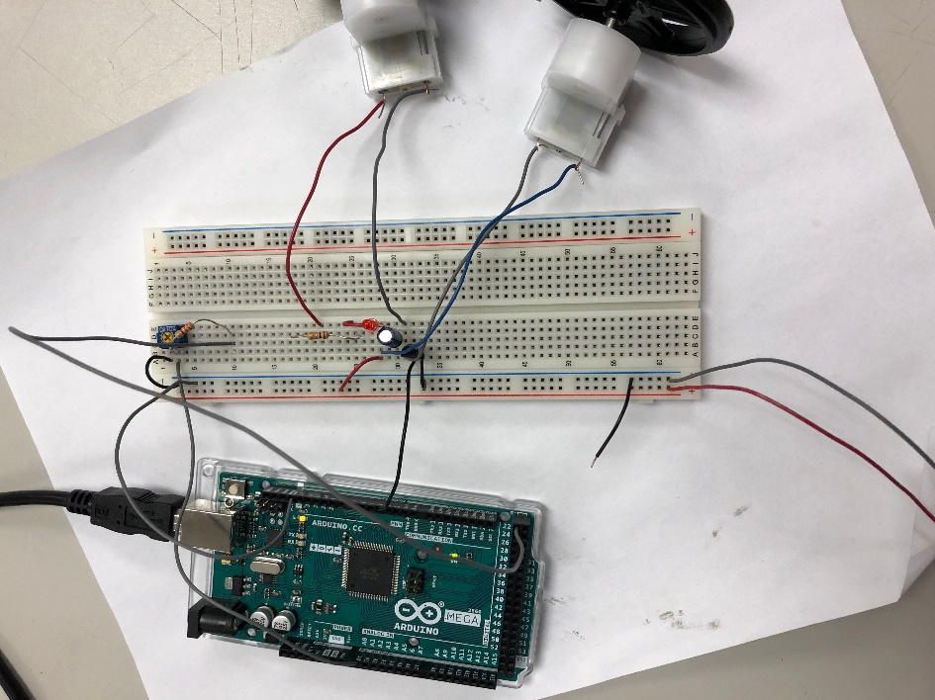**Phase 2A:**

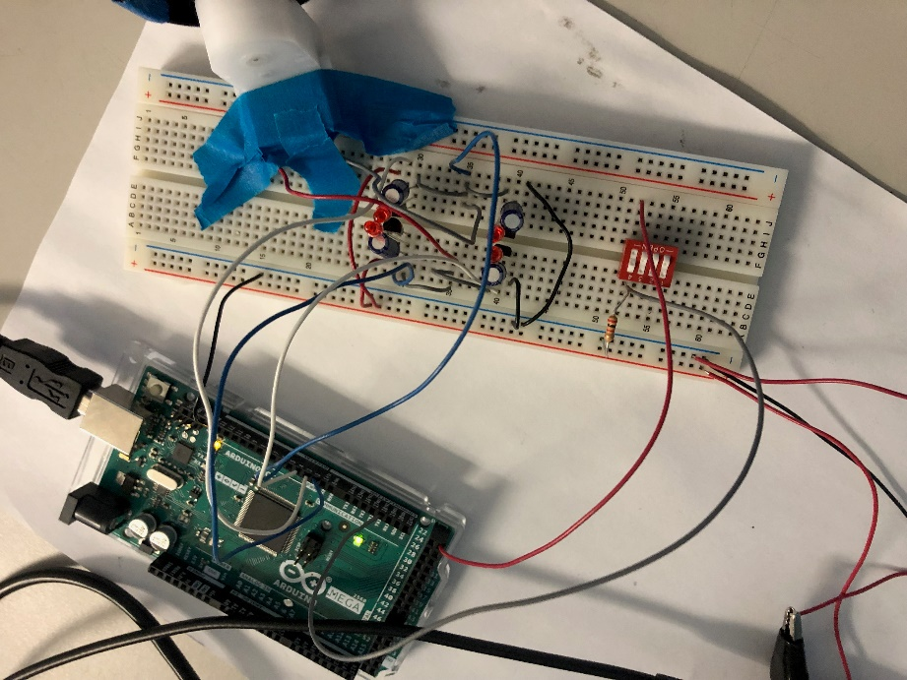**MOSFET H-Bridge:**

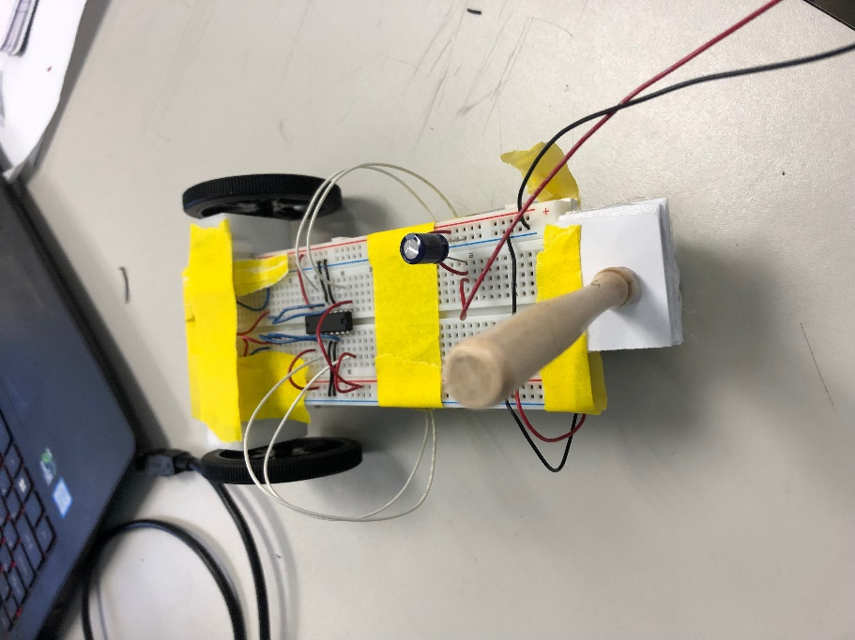**Phase 2B Final (The Batmobile):**