Abstract
Efficient IP routing is essential for high-performance network communication. Implementing a prefix tree (trie) based IP routing table enhances the speed and accuracy of Longest Prefix Match (LPM) operations, which are critical for determining optimal paths for data packets. This approach leverages the trie data structure to enable rapid insertion and lookup of IP prefixes, while Dijkstra's algorithm is utilized to compute the shortest paths between routers. The advantages of using tries for IP routing are discussed, accompanied by a detailed analysis of the time complexities of the underlying algorithms.

I. Introduction
In today's computer networks, sending data packets quickly and correctly is really important. Routers use routing tables to decide where to send these packets. As networks get bigger, regular routing tables can become slow and hard to manage. A prefix tree, or trie, can help organize IP addresses in a way that makes searching faster and easier.

II. Background
A. IP Routing and Longest Prefix Match
IP routing is about sending data from one place to another across different networks. Routers have tables that list paths to various network destinations. To decide where to send a packet, routers use the Longest Prefix Match (LPM) method. This means they look for the most specific route that matches the packet's destination IP address.

B. Trie Data Structure
A trie is a tree-like structure that stores information in a way that shares common parts of keys. For IP routing, the keys are the binary forms of IP address prefixes. Tries make it easy and fast to add and find these prefixes, which is why they are good for routing tables.
Why Tries are Good for IP Routing:
Fast Searches: Tries help quickly find the longest matching prefix.
Scalable: They work well even when there are a lot of prefixes.
Organized Storage: Tries store prefixes in a way that shows their hierarchy.
Easy Updates: Adding or removing prefixes is straightforward.
C. Dijkstra's Algorithm
Dijkstra's algorithm is a way to find the shortest path between nodes in a graph. In networking, it's used to find the best routes that cost the least in terms of distance or other factors. This helps in building efficient routing tables.

III. Methodology
A. Network Topology Setup
We set up a network with five routers connected in a specific way. Each router has its own local network:

RouterA: 192.168.1.0/24
RouterB: 192.168.2.0/24
RouterC: 192.168.3.0/24
RouterD: 192.168.5.0/24
RouterE: 192.168.0.0/16
The connections between these routers have different costs to mimic real network conditions.

Figure 1: Network Topology

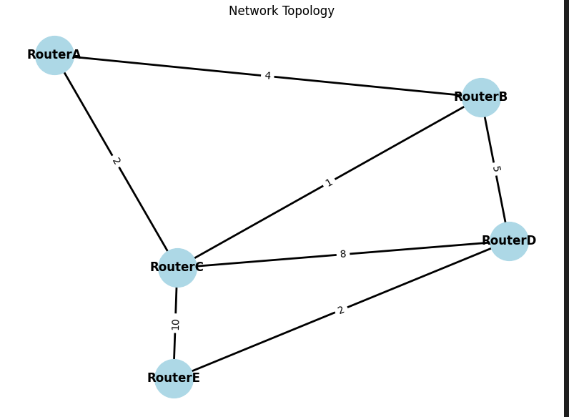

B. Building the Trie-Based Routing Table
Each router builds its own routing table using a trie. Here's how it works:
Adding IP Prefixes:

Each network destination is added to the trie with the next hop information.
The trie is navigated based on the bits of the IP prefix.
Trie Structure:

Each node in the trie represents a bit (0 or 1) from the IP address.
If a node marks the end of a prefix, it stores the next hop info.

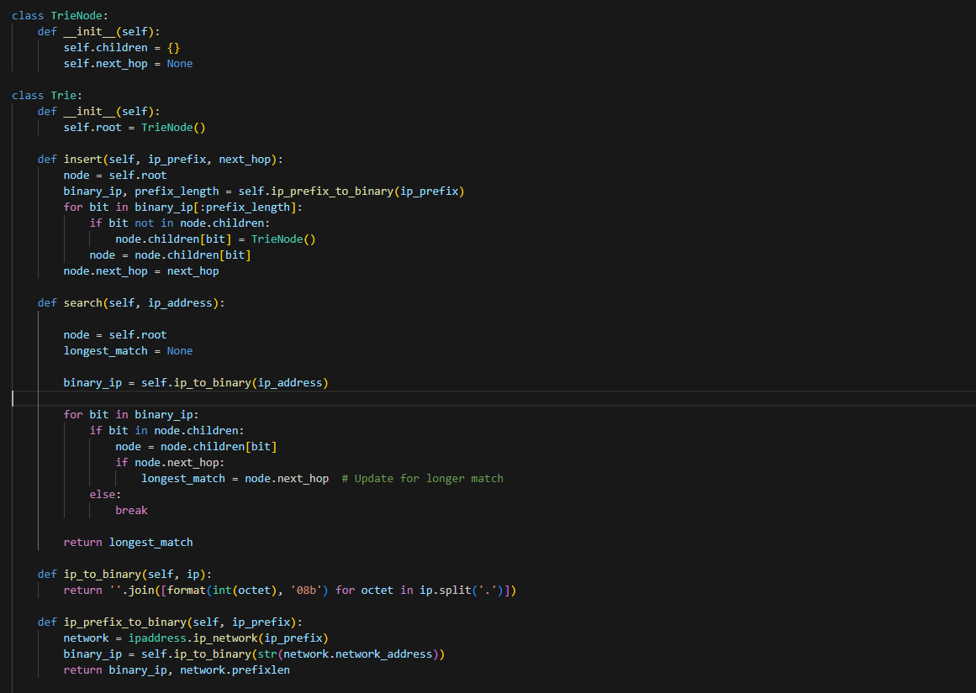

Time Complexity Analysis:

Insertion: Each bit of the IP prefix is looked at once.
Time Complexity: O(n), where n is the number of bits in the prefix (32 for IPv4).
C. Computing Shortest Paths with Dijkstra's Algorithm
Dijkstra's algorithm is used to find the best routes between routers:

It calculates the shortest path from one router to all others.
Takes into account the cost of each connection.
Helps in setting up the next hop for each route.

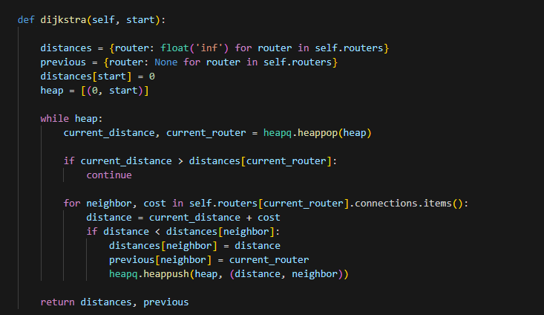

Time Complexity Analysis:

Dijkstra's Algorithm: Uses a heap to find the smallest distance node quickly.
Time Complexity: O(E log V), where E is the number of connections and V is the number of routers.
D. Packet Forwarding Simulation
We simulate sending a packet from RouterA to an IP address in RouterE's network. Here's how it goes:

Starting Point: Packet starts at RouterA.
Next Hop: RouterA uses the trie to find the best next hop.
Forwarding: The packet moves hop by hop until it reaches the destination or gets stuck.

Time Complexity Analysis:

Packet Forwarding: Depends on how many routers the packet goes through.
Time Complexity: O(h * m), where h is the number of hops and m is the number of bits in the IP address (32 for IPv4). Each hop does a search in the trie.

IV. Implementation
A. Trie Data Structure in Detail
The trie is used to store and manage the routing table:

Nodes (TrieNodes): Each node holds a bit from the IP prefix and has children for the next bits.
Edges: Connect nodes based on the bit values (0 or 1).
Next Hop Information: Stored in nodes that mark the end of a prefix.
Why Tries are Better for IP Routing Tables:

Fast Lookup Times: Searching takes time proportional to the number of bits in the IP address.
Efficient Memory Usage: Shared prefixes reduce the amount of memory needed.
Scalability: Handles many prefixes without slowing down.
Dynamic Updates: Easy to add or remove routes as the network changes.
B. Algorithms Used
1. Trie Insertion Algorithm
Purpose: Add an IP prefix and its next hop to the trie.
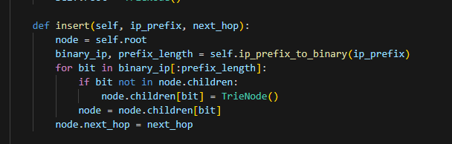

Time Complexity: O(n), where n is the number of bits in the prefix (32 for IPv4).

2. Trie Search Algorithm (Longest Prefix Match)
Purpose: Find the best matching prefix for a given IP address.

Implementation:
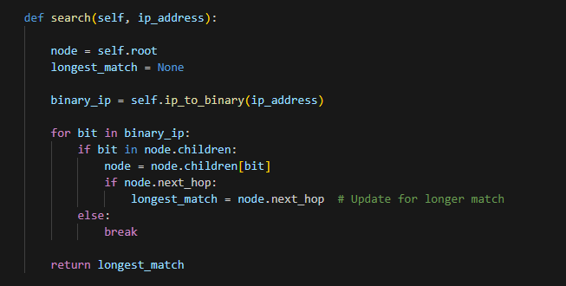

Time Complexity: O(m), where m is the number of bits in the IP address (32 for IPv4).

3. Dijkstra's Algorithm
Purpose: Find the shortest paths from one router to all others.

Implementation:
Time Complexity: O(E log V), where E is the number of connections and V is the number of routers.

V. Time Complexity Analysis
A. Trie Operations
1. Insertion
Operation: Adding an IP prefix to the trie.
Analysis: Each bit of the prefix is checked once.
Time Complexity: O(n), where n is the prefix length in bits (32 for IPv4).
2. Search (Longest Prefix Match)
Operation: Finding the best matching prefix in the trie.
Analysis: Each bit of the IP address is checked until no match is found.
Time Complexity: O(m), where m is the IP address length in bits (32 for IPv4).
B. Dijkstra's Algorithm
Operation: Finding the shortest paths from a starting router to all others.
Analysis: Uses a heap to efficiently get the next closest router.
Time Complexity: O(E log V), where E is the number of connections and V is the number of routers.
C. Overall Routing Table Construction
Trie Construction: For each router, adding all needed prefixes takes O(k * n) time, where k is the number of prefixes and n is the prefix length.
Shortest Path Calculation: Running Dijkstra's for each router takes O(V * E log V) time in total.

VI. Conclusion
Using a trie-based IP routing table makes routing faster and more efficient. Tries help quickly find the best route for packets, and Dijkstra's algorithm ensures the routes are the shortest possible. Compared to other methods, tries are better at handling lots of routes, use memory wisely, and are easy to update. This approach shows that tries are a great choice for managing IP routes in big networks.

