

23AID2021: MODELING, SIMULATION & ANALYSIS

PROJECT TITLE: SMART VACUUM CLEANER

Report by

TEAM -08
Allam Keerthana Chowdary – [CB.AI.U4AID23001]
Kota Kedharnadh – [CB.AI.U4AID23015]
M Sai Krishna – [CB.AI.U4AID23020]
M Rishitha – [CB.AI.U4AID23023]

Abstract
Robotic vacuum cleaners have become essential household appliances, offering automation and efficiency in cleaning with minimal human involvement. Their core functionality lies in navigation and obstacle avoidance systems, driven by advanced algorithms that enable efficient movement, obstacle navigation, and optimized cleaning coverage. This study analyzes multiple advanced navigation algorithms implemented on a robotic vacuum cleaner model within the Webots simulation environment. The algorithms evaluated include Breadth-First Search (BFS) Cleaning, Simultaneous Localization and Mapping (SLAM) combined with a Zigzag Pattern, Boustrophedon Motion, Wavefront Planning with the Potential Field Method, A* Path Planning, Probabilistic Harmonic Functions (PHF), Rapidly-Exploring Random Trees (RRT), and Random Walk. The study rigorously evaluates their performance based on cleaning coverage, path efficiency, and obstacle avoidance within a fixed benchmark period of 40 minutes. The findings highlight trade-offs between algorithm complexity, computational overhead, and cleaning effectiveness, paving the way for future advancements in robotic vacuum technology.
Introduction
Robotic vacuum cleaners have transformed home cleaning by automating processes and saving time. Their success depends on intelligent navigation systems that enable autonomous movement, obstacle detection, and efficient cleaning. While simpler navigation methods like Random Walk are easy to implement, they are less efficient. Advanced strategies, such as SLAM and A* Path Planning, significantly enhance efficiency but require greater computational resources and advanced hardware.
This paper examines various navigation algorithms, testing them within the Webots simulation environment. Webots provides a realistic, open-source platform for simulating robotic functionality and optimizing algorithms without requiring physical prototypes. The study focuses on algorithm performance in static environments, measuring metrics like cleaning coverage, distance traveled, and computational efficiency.
Methodology
The navigation algorithms were developed and implemented using Python in the Webots platform to evaluate their effectiveness in room coverage and obstacle avoidance. Integration with Webots was done by programming the algorithms in Python to utilize Webots’ robot control functions. This enabled seamless interaction with sensors and actuators modeled on the virtual robotic vacuum cleaner. Parameter optimization was crucial; parameters such as movement speed, sampling intervals, and sensor range were fine-tuned to enhance performance and ensure smooth operation within the simulation environment.
Simulation in Webots:
Webots, a very useful platform simulation, provided a comprehensive environment for modeling, programming, and simulating mobile robots. It offered realistic physics simulations, including dynamics, kinematics, and sensor feedback, which made it an ideal platform for testing and analyzing navigation algorithms.
Robot Specifications and environment :
The robotic vacuum cleaner model used in the simulations had specific features. It was 0.35 meters in diameter and 0.1 meters in height. It was equipped with infrared distance sensors for collision detection, LIDAR for mapping, bump sensors used for obstacle detection when it physically detects any obstacle, and wheel encoders for movement tracking. The differential drive system allowed independent wheel control, which was essential for flexible and efficient navigation. The simulated environment was set up as a 10m x 10m room, replicating a typical household space. This room has static obstacles, such as furniture, occupying around 15% of the total area. The floor was designed to be flat and uniform, allowing the robot to focus on efficient cleaning and obstacle avoidance.
Algorithms Development and Implementation
- Breadth-First Search (BFS): BFS Cleaning was used to create a grid-based map where the robot systematically explored all reachable cells in a breadth-first manner, ensuring complete coverage of the area. The environment was discretized into a grid where BFS explored by initializing a queue with the starting cell, marking visited cells, and enqueuing unvisited adjacent cells. Implementation in Webots involved dividing the environment into 0.5-meter cells and using PID-controlled wheel motors for robot movement. This method ensured full coverage but was inefficient due to potential backtracking.
- SLAM with Zigzag Pattern: It enables the robot to build a map while tracking its location and covers the area in a zigzag motion. The SLAM equations estimated the robot’s state and map using probabilistic models. The robot moved straight until reaching a boundary or obstacle and then shifted laterally. LIDAR data updated the occupancy grid map, while wheel encoders and sensor data estimated the robot’s position. This approach offered efficient coverage but required significant computational resources.
- Boustrophedon Motion: It divides the environment into cells, covering each in a back-and-forth pattern. The area was decomposed into simple cells, and the robot followed a planned path within each cell, using PID controllers for precise movement. This method was efficient in structured environments but became complex with irregular shapes.
- Wavefront Planning with Potential Field Method: It creates a cost map and used virtual forces to guide the robot. The cost map was generated through wavefront propagation, and virtual forces were computed from the potential field gradients. The robot moved in the direction of the resultant force. This method provided smooth navigation but could suffer from local minima issues.

- A* Path Planning: It is a path planning algorithm that finds the shortest path which minimizes the cost of the working. The environment was designed as a grid graph, and the heuristic was the Euclidean distance. This method guarantees the shortest path but requires complete knowledge of the environment and has high memory usage
- Probabilistic Harmonic Functions (PHF): PHF employed harmonic functions to model smooth paths that inherently avoided obstacles. The potential field is computed by solving Laplace’s equation numerically, with the robot navigating using the negative gradient of the field. This method produced smooth paths but was computationally expensive. Boundary conditions are set at obstacles and goals to compute the potential field.
- Rapidly-Exploring Random Trees (RRT): RRT rapidly explored high-dimensional spaces by building a random tree, sampling points, finding the nearest node, and extending the tree iteratively. The sampling space was defined by the occupancy grid, with collision checking to ensure paths did not intersect obstacles. The robot navigated through the generated tree nodes, which worked well in complex environments but could result in non-optimal paths.
- Random Walk: The Random Walk algorithm moved the robot in random directions, changing course upon collision. Each step involved selecting a random direction and moving forward. While simple to implement, this method was inefficient, often resulting in repeated paths and low coverage.
- CNN Model for Dirt Detection
Dataset Preparation
The simulated environment's camera was used to capture images of various surfaces. These images were manually labeled into two categories:
- Presence of Dirt: Areas requiring cleaning.
- Absence of Dirt: Areas already clean.
The dataset was divided into training and validation subsets to train the CNN model effectively.
Results and Discussion
The study evaluated eight navigation algorithms in Webots over 40 minutes. SLAM with Zigzag achieved the highest coverage (85%) but required significant computational resources. Boustrophedon Motion followed closely with 83% coverage, offering a balance of efficiency and practicality. Random Walk had the lowest performance, with only 72% coverage due to its unstructured approach. CNN integration improved cleaning precision, enabling the robot to focus on dirty areas, with a validation accuracy of 80%. Overall, SLAM with Zigzag and Boustrophedon were the most effective, highlighting trade-offs between complexity and efficiency. Future work can address real-time optimization and dynamic obstacle handling.

CNN model accuracy:
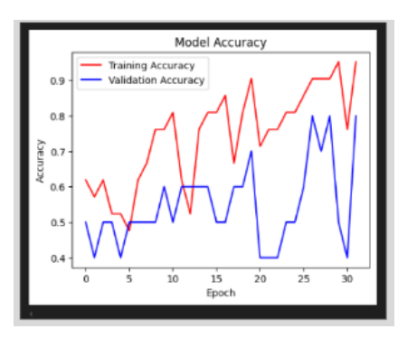
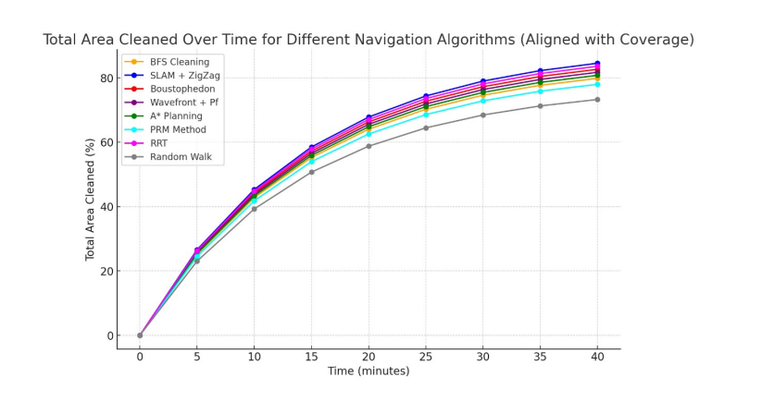
Conclusion
This study systematically evaluated the performance of eight navigation algorithms for robotic vacuum cleaners within the Webots simulation environment. Among the algorithms tested, SLAM combined with the Zigzag Pattern demonstrated the best cleaning coverage and efficiency, albeit at the cost of significant computational resources. Boustrophedon Motion emerged as a strong contender, providing robust performance with relatively lower computational demands. Conversely, simpler methods like Random Walk were computationally inexpensive but yielded poor coverage and inefficiency due to their lack of structured navigation.

