CS6500
Network Security
Programming Assignment – 1

Name: Harshit Kedia
Roll No: CS17B103

-----------------------------------------------------------------------------------------

Code explanation:
Implemented a class “RC4”, having arrays S, T along with which has 3 functions:
1) set seeding key,
2) the initial permutation,
3) outputs the stream key for i’th byte of message.

Used another class “Randomness” which has two instances of RC4. This class takes 2 parameters, one signifying the number of bits which will be different in the keys, and another denoting the length of stream cipher key to be generated for testing. The count of XOR of two steam cipher outpts is calculated in a function named frequency under the same class.
A few printing functions are also coded for debugging purposes.
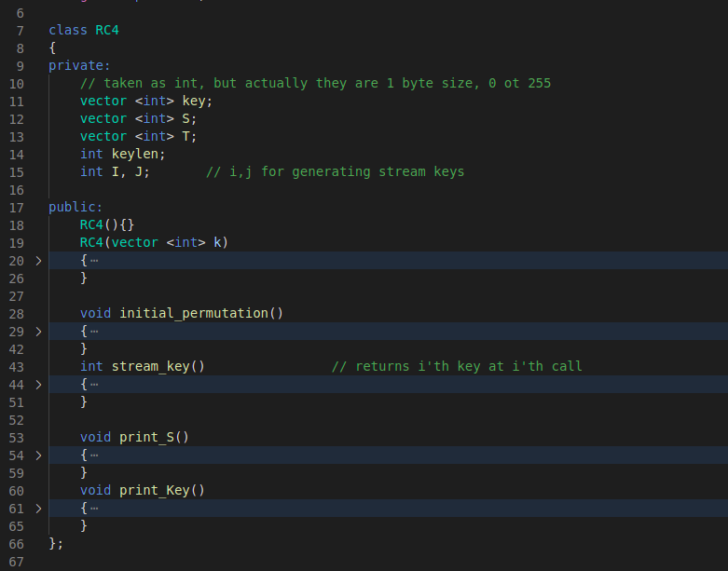

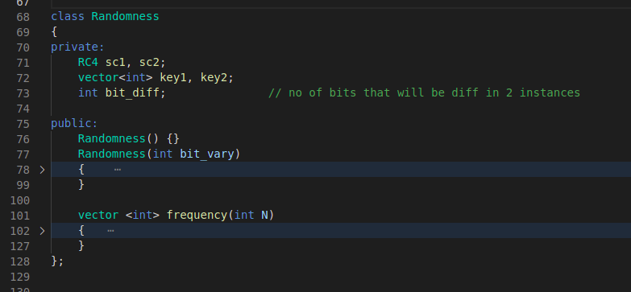

The main function has 2 loops, varying the number of bit difference and the output for consideration, each instance then calculates the randomness and prints it.

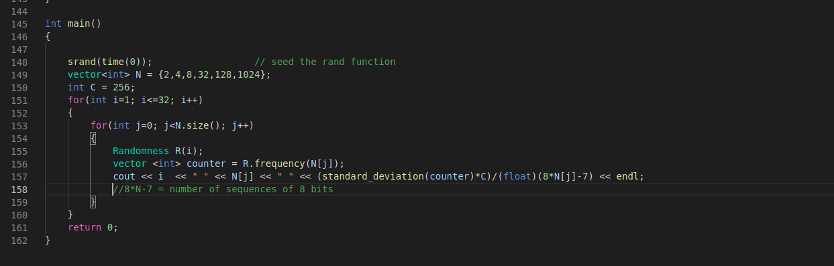

Sample output is pasted below (concatenated, full present in outputs folder):
1 2 6.05734
1 4 3.55978
1 8 3.0492
1 32 2.40921
1 128 0.600676
1 1024 0.208731
.
.
.
32 2 6.05734
32 4 3.55978
32 8 2.51067
32 32 1.1633
32 128 0.558838
32 1024 0.228767

Each line contains 3 values, #bits_different_in_keys, length_of_generated_keys, randomness on the data.
Observe that higher values of 1st and 2nd parameter result in better randomness.
The program is run 25 times and average values are used for plot generation.

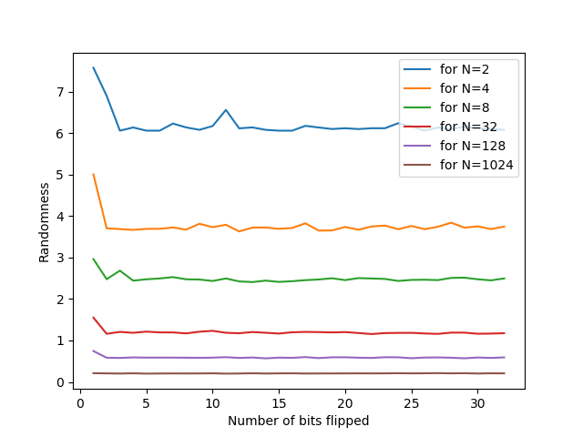

Fig: Ranomness vs Number of bits different in the initial seed key, for various sample sizes.

Observations:

1) When we have very less number of bits different in the two seeding keys, the outputs generated by the RC4 algorithm is not very different, as observed by sightly higher points in starting of lines.

2) On the contrary, having higher number of bits flipped, represents kind of a straight line, showing that it is sufficiently random, and better then smaller values, altough too much change doesnt make any significant difference.

3) Generating very less amount of data for checking (N bytes), will result in small sample, (eg: N=2 bytes means that only 9 consecutive sequences of 8-bits lenght is present), hence having a total of 256 values to count frequency automatically shows the data defecit, having very high variance, as well as small denomiator in the formula R = (C*D)/N, C being a constant. Hence, lines for smaller N values are considerably higher in the resulting plot.

4) Similarly, having large amount of data to calculate frequency represents the randomness better, hence larger values of N have small randomness and are close to each other.

5) Even if we flip just 1 bit, we see that randomness is higher(R value closer to 0) when more ciphers are generated (higher N), this is because the difference gets more time to propagate (avalanche effect).

Conclusion:
This assignment was helpful for in-depth unerstanding of the working and implementation of RC4 stream cipher. Also leant a new practical way to calculate the randomness in a set of data. Did cryptanalysis of the effects in change of key vs the output obtained from the RC4 algorithm. This assignment was coding intensive as well as helped obtain good theoritical grounds.

------------------------------------------------------------------------------------------------------------------------

