Assignment 4
Tensorflow
CS6847: Cloud Computing

Name: Harshit Kedia
Roll: CS17B103

Setup:
Input data was preprocessed for getting better result accuracy and faster convergence of neural network.
The time-stamp is converted into “hrs/mins/date/month/year” and then supplied into the neural network. (I think converting them to these parameters help learning better beacuse this information directly matters and affects the output instead of an ever increasing(non-repeating properties of UNIX time). Hence, I have input dimension=9.
Moreover, output for test data was not available. The train data was randomly split 90:10 for training and testing purposes. Since we need to predict the taxi fare, we dont use any activation function (i.e linear) in output layer. Also, output dimension=1.
Normalisation of the latitude and longitude about their mean was done, as entire data was from the city of new york, subtracting the metrics from the mean removes the constant bias from data.

Used learning rate=0.001, with Adam optimizer, as Adam is reputed to converge the fastest. Also, increasing the learning rate made the train error jump a lot without any visible convergence.

Experimented to epoch number to findout that any significant accuray boost was not available having very high epochs, hence settled for epochs = 1000.

Same code can be run on both CPU and GPU, however modifications need to be made for TPU (seperate code attached). All experiments are done with the same hyperparameters.

Experiments Done:

1) On CPU:
a ) Layers = [9, 10, 1] (green),
[9, 10, 10, 1](red),
[9, 10, 10, 10, 1] (blue)
This helps in capturing the effect of increasing the number of layers in the neural network.
Results:

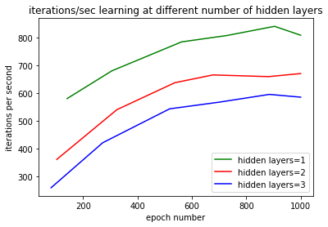
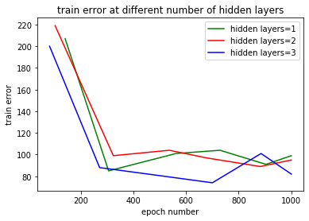

Observations: Quite clearly, training is faster when using less hidden layers as anyone would expect. Also, we see train error decreasing with more layers, this might be because more layers means more overfiting on train data. However, results on test data is very similar in all cases.

Root Mean squared error : 10.52, 9.39, 9.87 respectively.

b) Layers = [9, 10, 10, 1] , [9, 20, 20, 1]
This helps us understand the effect of having more nodes in hidden layers of neural network, i.e. having more weights / neurons to train.

Results:
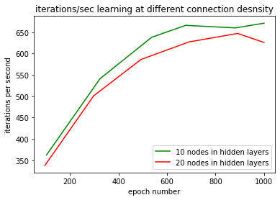
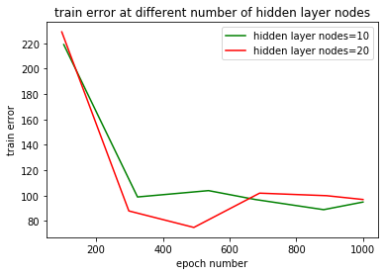

Observations: As expected, training more number of parameters is slower, but the difference is not so significant. Again, test accuracy is very close to each other.

Root Mean Squared Error: 9.39, 9.377 respectively.

2) CPU vs GPU vs TPU:

Layers [9,20,20,1] and [9,10,10,10,1] on all 3 devices
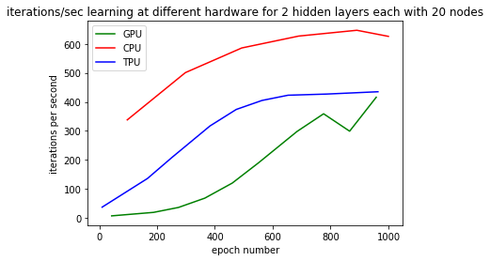
Result: For Setup 1-

For setup 2-
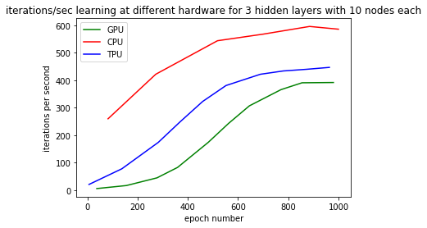
Observations:
Quite surprisingly, CPU outperforms both GPU and TPU, on searching, this is a common observation in google colab, because we didnot use any optimizations specificly suiting the GPU design due to lack of GPU knowledge. Moreover, as they supply free hardware to the public for learning, their devices are always busy and a single user doesnt get the dedicated costly hardware to use.
Also, as expected, TPU outperforms GPU significantly,even considerably when we have more number of neurons in hidden layers. This can be reasoned due the advanced parallelization and specialised design for tensor and machine learning in case of TPU’s.

Again, accuracy was very similar, because using different hardware to train the same model doesnot effect the training results, but completing the train process for huge networks and datasets in reasonable time.

Note: Attached the results in file results.py, plus zipped all the plots together.
Also attached both programs alongwith, with instructions in README.txt

