Time Series Analytics with Caching Layer

Big Data Architectures Project

Authors

Jane Kedina Imoke

Ricardo Ramos Morales

Table of Contents
Authors 1
Jane Kedina Imoke 1
Ricardo Ramos Morales 1
1. Introduction 4
2. Problem Statement and Project Objectives 4
2.1 Problem Statement 4
2.2 Project Objectives 5
3. System Architecture 5
3.1 Architectural Approach 5
Storage Layer 5
Speed Layer 5
Batch Layer 5
Serving Layer 5
3.2 Architecture Diagram 6
3.3 Data Flow 6
3.4 Architectural Justification 6
4. Technology Section 6
4.1 InfluxDB 6
4.2 Redis 6
4.3 Spark 7
4.4 Python 7
4.5 Docker 7
4.6 Streamlit 7
5. Data Model and Processing Logic 7
5.1 Sensor Data Model 7
5.2 InfluxDB Schema 8
5.3 Cache Key Design 8
5.4 Cache-Aside Query Logic 8
5.5 Data Validation and Cleaning 9
6. Historical Analytics with Apache Spark 9
6.1 Data Export Pipeline 9
6.2 Spark Analytics 9
6.3 Hybrid Anomaly Detection 9
6.3.1 Rule-Based Detection 10
6.3.2 Statistical Z-Score Detection 10
7. Dashboard Design 10
7.1 KPI Card Row 10
7.2 Time-Series Charts 11
7.3 Energy Consumption Panel 11
7.4 Anomaly Panel 11
7.5 Sensor Health Grid 11
8. Technical Challenges and Solutions 11
9. Evaluation and Reflection 12
9.1 Performance Evaluation 12
9.2 Performance Results and Interpretation 12
9.3 Scalability Discussion 12
9.3 Trade-Off Analysis 13
9.4 Reflection and Lessons Learned 13
10. Future Work 14
11. Conclusion 14
Additional Resources 14

1. Introduction
The rapid increase of Internet of Things (IoT) devices, cyber-physical systems and cloud-native applications has drastically transformed how organisations generate, store and analyse data. This has resulted in an unprecedented growth in time-series data. Unlike traditional transactional workloads, time-series applications generate continuous streams of timestamped observations that must be ingested, stored, analysed and visualised efficiently. Examples are industrial sensor networks, smart energy grids, healthcare monitoring systems, cloud infrastructure monitoring and environmental sensing platforms.
Managing such data, however, presents several challenges. Dense data generation can quickly lead to storage bottlenecks, repeated queries can increase latency and historical analysis often requires computationally efficient processing frameworks. In addition, modern monitoring systems require near real-time response to support overall operational decision-making.
This project presents the design and implementation of a Time-Series Analytics platform which integrates InfluxDB, Redis, Spark and other key technologies such as Python and Docker. The system simulates continuous IoT sensor activity, stores measurements in a specialised time-series database, accelerates data retrieval through in-memory caching layer, performs historical analysis through Spark and presents results through an interactive dashboard.
This project also demonstrates how specialised technologies can be integrated into a coherent Big Data Architecture capable of supporting both operational monitoring and analytical workloads.

2. Problem Statement and Project Objectives

2.1 Problem Statement
Traditional relational database management systems (RDBMS) are primarily designed for transactional, row-oriented access patterns and are often inefficient when handling high-volume time-series workloads. As data grows, organisations operating on RDBMS face increasing challenges such as:
- High write throughput: Thousands of systems may emit a measurement at every second, generating write loads that saturate a single RDBMS node.
- Timestamp sensitive queries: Queries require efficient temporal indexing that general-purpose databases do not natively optimise.
- Data volume growth: Historical archives grow continuously hence without automated retention and down sampling policies; storage costs escalate rapidly.
- Repeated query latency: Dashboard refresh cycles repeatedly execute the same or similar queries, placing unnecessary load on the primary database and degrading response times for end users.
- Anomaly detection at scale: Identifying statistical outliers or threshold violations across thousands of data streams in near real time requires distributed computation beyond RDBMS capabilities.
In summary, these challenges ask the overall question:
How can a Big Data Architecture efficiently ingest, store, analyse and retrieve continuously generated time-series data while maintaining low-latency access and supporting historical analytics?
These challenges motivate the selection of purpose-built components that collectively form a scalable time-series analytics system. To address these challenges, the system must:
- Efficiently store continuously generated data.
- Support rapid retrieval of frequently accessed observations.
- Perform historical analytics on accumulated datasets.
- Detect anomalous system behaviour.
- Provide real-time visualisation for operational monitoring.

2.2 Project Objectives
The project was scoped to achieve the following measurable objectives:
- Simulate realistic IoT sensor data streams.
- Store measurements using a specialised time-series database.
- Implement a caching layer to accelerate retrieval.
- Quantify the performance impact of caching.
- Perform historical analytics.
- Implement anomaly detection techniques.
- Develop a real-time monitoring dashboard.
- Demonstrate practical application of Big Data architecture concepts.

3. System Architecture

3.1 Architectural Approach
The system adopts a Lambda architecture, a widely-used design paradigm for systems that require simultaneous support low-latency real-time queries and high-throughput batch analytics. Lambda architecture separates storage, analytics and serving responsibilities into specialised layers.
The architecture consists of four logical layers:

Storage Layer
InfluxDB serves as the primary storage engine that feeds all layers and maintains all time-series data.

Speed Layer
This layer is implemented using Redis. It handles real-time, low-latency data access using in-memory storage.

Batch Layer
Implemented using Spark, this layer is responsible for recomputing analytics over the complete historical dataset.

Serving Layer
Through the Query service and an interactive dashboard using Python’s Streamlit technology, this layer merges results from the batch and speed layers and exposes this information to end users.

3.2 Architecture Diagram
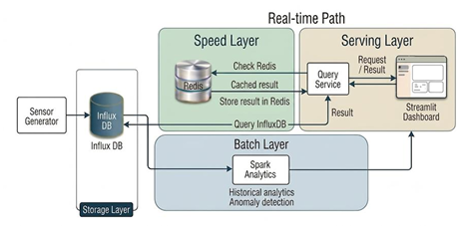

3.3 Data Flow
The end-to-end workflow is as follows:
- Sensor readings are continuously generated.
- Data is written into InfluxDB.
- Frequently requested records are cached in Redis.
- User requests are routed through the Query Service.
- Cache hits are served directly from Redis.
- Cache misses trigger retrieval from InfluxDB and cache population.
- Historical records are exported for Spark processing.
- Analytical results are visualised within the dashboard.

3.4 Architectural Justification
The Lambda architecture was selected because it effectively balances both operational and analytical requirements. Other alternative approaches such as a purely relational architecture are capable of simplifying deployment however, they would not provide the same level of optimisation for time-series storage and retrieval.
Separating storage, caching, analytics and visualisation responsibilities improves the basis of design and allows each component to be independently scaled.

4. Technology Section

InfluxDB
InfluxDB is an open-source database built for time-series workloads. Unlike general-purpose databases, it organises data around measurements, tags (i.e indexed metadata) and fields such as numeric or string values with the timestamp as the primary indexing dimension.

4.2 Redis
Redis is an open-source, in-memory data structure store that supports rich data types including strings, hashes, lists, sorted sets and streams. As a cache, it excels at absorbing repetitive read traffic that otherwise burden the primary database.

4.3 Spark
Spark is a unified analytics engine for large-scale data processing, providing APIs in Python (PySpark), Java, Scala and R. It executes distributed computations using a directed acyclic graph (DAG) scheduler that optimises task execution across a cluster.

4.4 Python
Python is a programming language which served as the connection between the various parts of the platform. It handled simulating continuous sensor readings, sending measurements to InfluxDB, managing the Redis caching logic, running queries, and coordinating the data processing workflow. Python was also used with PySpark for historical analysis and with Streamlit to create the interactive dashboard.

4.5 Docker
Docker, along with its compose elements, was used to containerise InfluxDB and Redis, providing environment consistency across development machines. Service dependencies, network configuration and environment variables are declared within a single docker-compose.yml file which enables the entire infrastructure to be started with a single command.

4.6 Streamlit
Streamlit is a Python framework for building data applications without requiring frontend development expertise. It converts Python scripts into interactive web applications using declarative widgets and automatic re-execution on state changes.

5. Data Model and Processing Logic

5.1 Sensor Data Model
Each virtual sensor emits a structured measurement at each tick. The measurement captures the sensor’s identity, its physical and computational readings, anomaly classification metadata and a timestamp. The table below describes each field:
Field | Type | Description | Example Value
Sensor_id | String (tag) | Unique sensor identifier | Sensor_1
location | String (tag) | Physical or logical location of the sensor | Server_room
temperature | Float (field) | Temperature reading in degree Celsius | 25.7
Humidity | Float (field) | Relative humidity percentage | 54.5
Cpu_usage | Float (field) | Simulated CPU utilisation percentage | 33.1
Energy_consumption | Float (field) | Power draw in watts | 132.5
Is_anomaly | Boolean (field) | Binary flag set by generator if ground-truth anomaly | True
Anomaly_type | String (field) | Category label for generated anomaly | Spike
Affected_metric | String (field) | Which metric the anomaly impacts | Temperature
timestamp | Timestamp | ISO 8601 UTC timestamp of measurement | 2026-06-22 13:13:10.719992+00:00

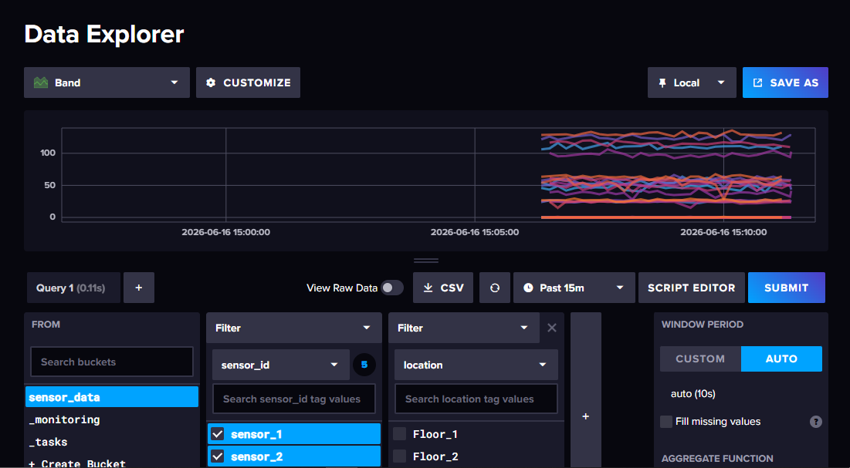

5.2 InfluxDB Schema
InfluxDB organises data into a single measurement named sensor_metrics. The schema leverages the distinction between tags and fields to maximise query performance.
Measurement: sensor_metrics
Tags (indexed): sensor_id, location.
Fields (stored): temperature, humidity, cpu_usage, energy_consumption, is_anomaly, anomaly_type, affected_metric.
This schema design ensures that filters on sensor identity execute against the tag index without full table scans while range queries on the timestamp dimension use InfluxDB’s built-in time index.

5.3 Cache Key Design
Redis keys are constructed through following the pattern:
Sensor : {sensor_id} : latest | e.g sensor : sensor_1 : latest
Each key stores a JSON-serialised object which contains the most recent field values for that sensor. A TTL of 60 seconds is configured which balances the freshness of the data with cache effectiveness for the dashboard’s refresh interval.

5.4 Cache-Aside Query Logic
The Query service implements the cache-aside (lazy loading) pattern. The decision logic takes the following steps:
Step 1: The service receives a request for the latest reading of a specific sensor.
Step 2: It constructs the Redis key and attempts a GET operation.
Step 3 (Cache Hit): If they key exists, the cached JSON is deserialised and returned immediately, InfluxDB is not contacted.
Step 4 (Cache Miss): If the key does not exist or has expired, the service queries InfluxDB for the latest measurement, serialises the result as JSON, stores in Redis with the configured TTL and returns the result to the caller.
This pattern ensures that InfluxDB is only contacted when the cache lacks a valid entry thereby significantly reducing database query volume under repeated dashboard refresh cycles.

5.5 Data Validation and Cleaning
Prior to processing via Spark, exported CSV records undergo validation to address heterogenous field structures which arise from optional anomaly metadata fields. Rows missing required numeric fields are filtered out and string-typed Boolean columns, such as is_anomaly exported as “true/false”, are cast to numeric indicators before aggregation.

6. Historical Analytics with Apache Spark

6.1 Data Export Pipeline
Historical sensor data is exported from InfluxDB to CSV format using the Flux query language. A configurable time window (defaulting to the past 24 hours) is specified in the query and the resulting records are written to a local file system path accessible to the Spark session. This pattern of “export-and-process” keeps the analytical workload decoupled from the operational database thereby preventing heavy batch queries from affecting dashboard responsiveness.

6.2 Spark Analytics
The Spark batch job computes four categories of analytics:
- Per-Sensor Average Temperature: The DataFrame is group by sensor_id and the mean of the temperature field is computed. The results are organised in a descending manner by average temperature to surface the hottest sensors for operator attention.
- CPU Usage Distribution Analysis: Sensors are classified by CPU usage level using the following thresholds: low (<30%), moderate (30 – 55%) and elevated (>55%). The count of time-steps spent in each tier is reported per sensor thereby enabling capacity planning and detection of persistently overloaded devices.
- Energy Consumption Aggregation: Average and total energy consumption is computed per sensor, providing input for power efficiency reporting. Sensors consuming unbalanced energy relative to their workload are flagged for further investigation.
- Sensor Performance Summary: A unified report combines the above aggregations into a single per-sensor summary table which combines temperature averages, CPU usage distributions, energy totals and anomaly counts into a single view suitable for dashboard display.

6.3 Hybrid Anomaly Detection
An essential contribution of this project is the implementation of a two-stage anomaly detection strategy that combines rule-based and statistical methods. This hybrid approach reduces both false positives, i.e. anomalies missed by overly narrow rules, and false positives, i.e. noise events flagged by sensitive statistical tests.

6.3.1 Rule-Based Detection
The first stage applies domain-informed threshold rules:
Condition | Threshold | Interpretation
Temperature too high | >27°C | Potential overheating or environmental failure
Temperature too low | <20°C | Possible cooling anomaly or a sensor malfunction
CPU usage elevated | >55% | Device under abnormal computational load
Any measurement violating one or more these conditions is immediately classified as anomalous and assigned an anomaly_type label.

6.3.2 Statistical Z-Score Detection
The second stage applies Z-score analysis to identify measurements that deviate significantly from the sensor’s historical mean, even when they do not violate absolute thresholds. For each sensor and each numeric field, the mean () and standard deviation () are computed over the analysis window. Any measurement whose field value satisfies:
Z =|x − μ| / σ
Is flagged as a statistical outlier.
The union of rule-based and statistical detections is reported as the final anomaly set. This ensures broad coverage across both predictable failure modes and unexpected distributional shifts.

7. Dashboard Design
The aim of the Streamlit dashboard is to serve as the primary human interface for the platform. The dashboard provides immediate situational awareness of the sensor fleet’s health, surface anomalies requiring operator attention, quantify the performance benefit of the caching layer and present historical analytics results in a readable format without requiring direct database access.
The dashboard is organised into the following panels:

7.1 KPI Card Row
The top row displays five summary metrics updated on each refresh cycle:
KPI Card | Description
Active Sensors | Count of distinct sensor IDs with a measurement in the last refresh window
Average Temperature (°C) | Fleet-wide temperature access across all sensors in the cache
Average CPU Usage (%) | Fleet-wide mean CPU utilisation
Anomaly Count | Number of sensors currently reporting at least one anomalous measurement
Cache Performance Gain | Ratio of cold-query latency to warm-query

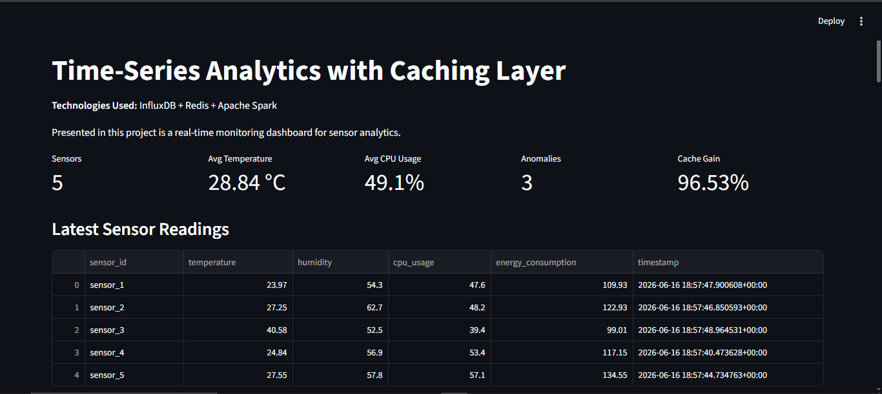

7.2 Time-Series Charts
Interactive line charts display temperature and CPU usage trends per sensor over the selected time window. Hover tooltips display exact timestamp and value while the chart legend allows individual sensors to be toggled on and off for focused analysis.

7.3 Energy Consumption Panel
A bar chart compares average energy consumption across sensors, enabling rapid identification of the most power-intensive devices. The chart is generated from Spark output and refreshed when new batch results are available.

7.4 Anomaly Panel
A dedicated table lists all sensors currently in an anomalous state, showing the affected metric, anomaly type, detection method (rule-based or statistical), and the measurement value that triggered the alert. Rows are colour-coded by severity.

7.5 Sensor Health Grid
A grid of status indicators provides a fleet-level health overview, classifying each sensor as Healthy (green) or Anomalous (red) based on the most recent measurement. This panel enables operators to instantly identify problem devices without reading individual metric values.

8. Technical Challenges and Solutions
Affected Section | Challenge | Solution
InfluxDB Query Structure  Cache Consistency and Data Freshness | InfluxDB stores measurements in a field-oriented format that is not immediately suitable for analytical processing. | Pivot transformations were applied to convert records into a tabular structure sutiable for Spark.
Cache Consistency and Data Freshness | Cached data may become stale over time. | Redis TTL expiration policies were implemented to balance freshness and performance.
Spark Schema Management | CSV exports contained heterogenous structures that complicated aggregation. | Data transformation and schema normalisation procedures were introduced prior to analysis.
Dashboard Resilience to Service Unavailability | Dashboard failures occurred when backend services were unavailable. | Additional error handling and connection validation mechanisms were implemented.

9. Evaluation and Reflection

9.1 Performance Evaluation
An evaluation script was developed to isolate and measure the performance impact of the Redis caching layer. The methodology proceeded as follows:
- A representative set of sensor query keys was identified covering all simulated sensors.
- The Redis cache was populated by executing a warm-up round that triggered a cache miss for each key, causing the results to be fetched from InfluxDB and stored in Redis.
- Fifty repeated GET requests were executed for each key against the warm cache (cache hits), and the average response time was recorded.
- The cache was flushed using FLUSHALL, and the same 50 requests were re-executed against the empty cache (cache misses), forcing each request to query InfluxDB.
- Both experiments were conducted on the same hardware device under identical load conditions to ensure compatibility.

9.2 Performance Results and Interpretation
Metric | Cold Query (Cache Miss) | Warm Query (Cache Hit) | Improvement
Average Latency | 0.052993 s | 0.001840 s | 96.53% reduction
The results demonstrate that the Redis caching layer reduces average query latency by 96.53% from approximately 53 milliseconds, (constrained by InfluxDB's query parsing, network round-trip, and serialisation overhead, to under 2 milliseconds, constrained only by Redis's in-memory lookup and network round-trip.

9.3 Scalability Discussion
The current implementation is designed for demonstration and educational purposes, running all components on a single host machine via Docker compose which the project well-suited for prototyping and proof-of-concept analytics pipelines, small-scale IoT deployments and educational demonstrations of Lambda Architecture concepts.
Future scalability can be achieved through:
Component | Scaling Strategy | Expected Benefit
InfluxDB | Horizontal scaling via InfluxDB Clustered (enterprise) or InfluxDB IOx (OSS v3) | Distributed writes and reads across multiple storage nodes
Redis | Redis Cluster mode with hash slot distribution and replica sets | Horizontal cache capacity, automatic failover, read scaling
Apache Spark | Deploy on Kubernetes or managed serviced (e.g AWS) | Parallel task execution across many nodes: handles terabyte-scale datasets
Sensor Ingestion | Replace direct HTTP writes with a message queue (Kafka) | Decouples sensor velocity from database write rate
Dashboard | Deploy on cloud-native infrastructure with a load balancer | Serves multiple concurrent users without resource contention

9.3 Trade-Off Analysis
Every architectural decision involves trade-offs between competing qualities such as cost, performance, complexity and consistency. The table below gives an overview analysis of the key trade-offs in this system:
Component/Decision | Benefit | Trade-Off
Redis caching layer | 96.5% latency reduction with reduced database load | Additional infrastructure with TTL-bounded staleness
InfluxDB | First-class temporal operations with appropriate time-windowing | Specialised query model with steep learning curve
Spark (batch-only) | Scalable, robust aggregation over large datasets | Not suitable for real-time streaming without structured streaming
Streamlit Dashboard | Very fast to develop because it is pure Python | Limited enterprise UI customisation with single threaded Python server
Docker Compose deployment | Single-command setup with reproducible environment | Not production-grade due to no automatic failover

9.4 Reflection and Lessons Learned
This project provided practical, hands-on experience integrating multiple specialised big data technologies into an end-to-end analytics pipeline. The following lessons emerged from the implementation experience:
- Time-series databases require different design strategies than relational systems.
- Caching can significantly improve user-facing performance.
- Batch analytics and operational monitoring address complementary requirements.
- Data transformation often consumes mor effort than analysis itself.
- Visualisation is critical for communicating analytical results effectively.
Given these lessons, it is noteworthy that the most significant lesson was the importance of architectural decisions. The overall performance and maintainability of the system depended less on any individual technology and more on how the technologies were integrated into a comprehensive architecture.

10. Future Work
There are several enhancements that would extend the platform’s capabilities towards production-grade deployment. Some of which are:
- Spark structured streaming for analytic lag reduction.
- Machine learning-based anomaly detection.
- Grafana integration for a richer, production-tested visualisation environment.
- Automated alerting mechanisms.
- Kubernetes deployment and orchestration.

11. Conclusion
This project successfully implemented a complete Time-Series Analytics Platform integrating InfluxDB, Redis and Spark within a Docker-orchestrated environment.
The system achieved all project objectives by providing an efficient time-series storage with accelerated retrieval through caching, historical analytics via Spark, hybrid anomaly detection and an interactive dashboard visualisation.
This project demonstrates how specialised technologies can be combined within a modern Big Data Architecture to support both operational and analytical workloads. The resulting platform provides a strong foundation for future expansion into large-scale, real-time analytics environments.

Additional Resources
Link to Project: time-series-analytics-with-caching-layer

