Changes from Version 1 to Version 2

The GSI pointed out some flaws of the Version 1 paper from Discussion section and General Writing. In the Discussion section, the Version 1 paper missed to explain the limitations of using linear regression as a primary tool and the implications of the result. In General Writing, the Version 1 paper did not clearly divide the paper into separate sections and included less explanation and too much calculation. In the Version 2 of the paper, the limitation of linear regression model and implications from the results would be explained in the discussion section and sections would be clarified. Also, some calculations would be removed from the paper.

In the peer review and peer’s paper, I decided to explain why your models were chosen and clarify the sections in the paper.

The most change would be the change of the alternative models. In Version 2 of the paper, I use the model (gmp) ~ (population) + (ict) since this model is more competitive to our supra-linear model than the previous alternative model. Analyzing method has been added to compare the new alternative model and supra-linear model in Version 2.

GMP and Population Size Mar. 19 Youngwoo Kwon

**Introduction**

GMP, gross metropolitan product, is the value of final goods and services produces within a metropolitan statistical area. Those metropolitan statistical areas, or MSAs, are determined by U.S. Statistical agencies and the U.S. Bureau of Economic Analysis estimates these MSAs’ to the country’s gross metropolitan products. In the paper by Bettencourt et al, the GMP and population size of the area has a special relationship,

$$\left(GMP\right)≈c*{\left(population size\right)}^{b}$$

for some rational number $c>0$ and $b>1$, which is also called “supra-linear power law scaling”.[1] Unlike the linear model, $y ≈a_{0}+a_{1}x$, or the quadratic model, $y ≈a_{0}+a_{1}x+a_{2}x^{2}$, supra-linear scaling model uses a positive rational number $b>1$ as an exponent. In this paper, we will first verify the previous theorem that ‘GMP and population size have supra-linear power law scaling relationship,’ and investigate the alternative linear model that uses population size and other variables as variables from the U.S. Bureau of Economic Analysis describing MSAs in 2006 consists of GMP, population size, finances, professional and technical services, information, communication and technology, and management of firms and enterprises for each area. Comparing to the previous supra-linear model, the alternative linear models can reflect more variables for estimation and will be easier to analyze intuitively because the models are linear.

**Methods**

Supra-linear power law scaling model can be easily converted into a linear model using variable transformation. From the equation provided above we can get,

$$log\left(GMP\right)≈log⁡(c)+b*log\left(population size\right)$$

which represents the linear relationship between log-scale GMP and log-scale population size. We used the squared-error loss on a log scale as a loss function,

$$L\left(z,θ\right)={\left[{\log\left(Y\right)}^{2}-μ_{θ}(N)\right]}^{2}$$

where Y is GMP or Per-Capita GMP and N ais the population to calculate the in-sample loss and evaluate the supra-linear model. Not only used the loss function, but we also used the adjusted $R^{2}$ to evaluate how the model fits well to the data. If we find that model is competitive, we can check the F-statistics to compare the models.

For alternative models, we used multi-variable linear models to predict the response. There are two types of alternative models. First, the alternative models with hypothesis basically assumes the linear relationship between per-capita GMP and population size, as well as using finances, information, communication and technology as additional variables that helps to determine the per-capita GMP. Second, the alternative model with hypothesis basically assumes the linear relationship between GMP and population size, as well as using information, communication and technology as an additional variable. These alternative models are chosen because of the association between additional variables and population & GMP described in figure 2,3,4.

**Results**

We used log scale GMP versus log scale population size model instead of using normal GMP versus population size to evaluate the supra-linear law scaling model, from the mathematical backgrounds described above. On the figure 1, the first model, supra-linear law scaling model, showed clear linear relationship when we transformed the variables and responses into log scale. Typically, most of the data were clustered in the lower left corner of the figure 1. The estimate intercept for the linear model was 8.796 and the slope of the log-scale population was 1.123. From the estimates, we can calculate the c and b in the previous equation,

$$log\left(GMP\right)≈log⁡(c)+b*log\left(population size\right)$$

where $c=e^{8.796}=6607.76$, $b=1.123$. If we wanted to see the relationship between per-capita GMP and population size

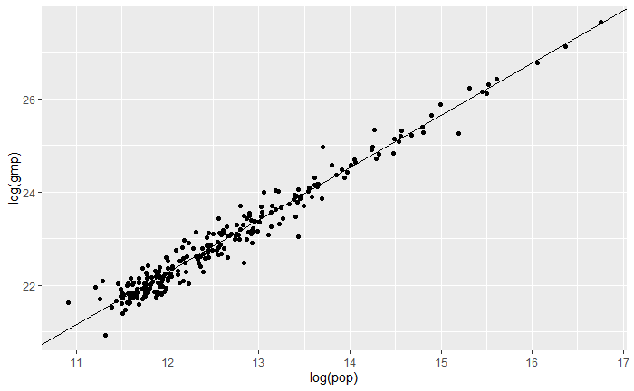

Figure 1. The scatter plot of log-scale GMP by log-scale population size, with linear model through data.

$$log\left(per-caita GMP\right)=\log\left(\frac{(GMP)}{(population size)}\right)$$

$$≈log⁡(c)+(b-1)*log\left(population size\right)$$

so we can easily check that log scale per-capita GMP also has a linear relationship with log-scale population size, with coefficients $c=e^{8.796}=6607.76$, $b^{'}=b-1=0.123$. t-value for each estimation was 47.94 and 77.54, the variance of residuals was $5.64*{10}^{-2}$, and the adjusted $R^{2}$ value for the model was 0.961. Since our log-scale population size had high t-value, we cannot reject the null hypothesis: ‘log-scale population size is not a meaningless variable to estimate the log-scale GMP’. From high adjusted $R^{2}$ value, we can trust the model. Double-checking with the loss function, the in-sample loss for the model was $5.62*{10}^{-2}$, which is quite low. Therefore, we can definitely say that the supra-linear law scaling model is plausible.

Figure 2, 3 and 4 represents the relationship between log scale population and log scale GMP, coloring the points with finances, finances, professional and technical services, and information, communication and technology. Typically, a considerable number of data was Missing Value; 3.69% of the finances data, 32.79% of the professional and technical services data, and 16.80% of the information, communication and technology data were missing values. We were not able to find the characteristic properties of professional and technical services data on the graph in figure 3. However, the higher finances data tends to have higher log-scale population value and higher log-scale GMP in figure 2, and the higher information, communication and technology data tends to have higher log-scale population value and higher log-scale GMP in figure 4. This is the reason why we chose the finances and information, communication and technology as additional variables for the alternative models.

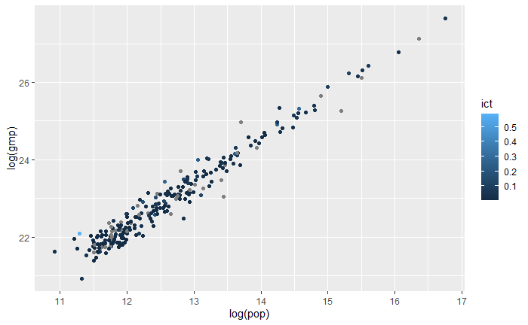

Figure 4. The scatter plot of log-scale GMP by log-scale population size, with points colored according to the level of information, communication and technology.

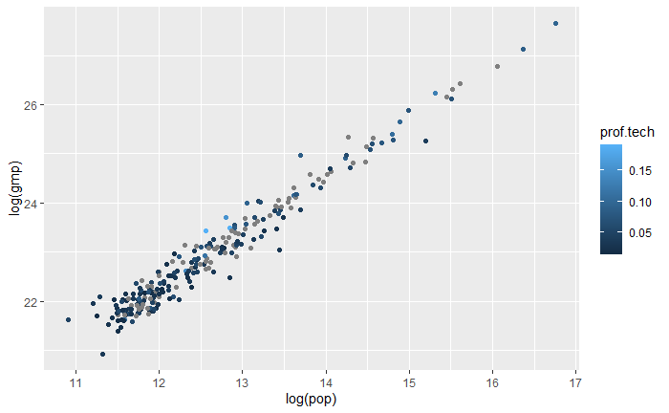

Figure 3. The scatter plot of log-scale GMP by log-scale population size, with points colored according to the level of professional and technical services.

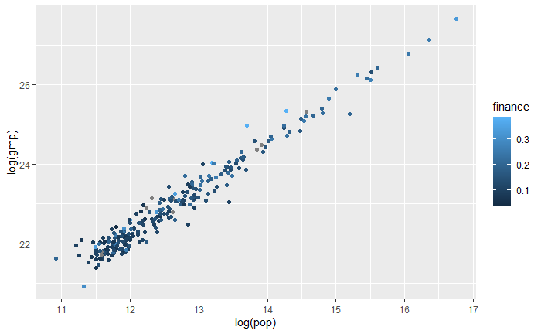

Figure 2. The scatter plot of log-scale GMP by log-scale population size, with points colored according to the level of finances.

For the first alternative linear model (per-capita GMP) ~ (population size) + (finances), the estimated intercept was $2.365*{10}^{4}$, estimate coefficient for population size was $1.249*{10}^{-3}$, and estimate coefficient for finances was $5.189*{10}^{4}$. t-values for each coefficient were 18.109, 4.056, and 6.159 which are quite high so that we cannot reject any variables in the model. However, the residual standard error was 7821, which is quite large even considering the graph is not a log-scale, and the adjusted R-square value is 0.2615. Moreover, the in-sample loss for the model was $6.038*{10}^{8}$; Comparing quickly in terms of scale, its log value is 17.916, and our supra-linear model's in-sample loss value was 0.056. These results support that we cannot trust our first alternative model.

For the second alternative linear model (per-capita GMP) ~ (population size) + (information, communication and technology) had estimate intercept $2.915*{10}^{4}$, estimated coefficient for population size was $1.990*{10}^{-3}$, and estimated coefficient for information, communication and technology was $5.236*{10}^{4}$. t-value for each coefficient was 45.703, 6.350 and 6.126 so we cannot reject any variables in the model. The residual standard error was 7378 and the adjusted R-square value was 0.296. In sample loss for the model was $5.364*{10}^{8}$. So, we cannot trust our second alternative model.

The third alternative model (GMP) ~ (population size) + (information, communication and technology) had estimate intercept $-6.681*{10}^{9}$, estimated coefficient for population size was $5.145*{10}^{4}$, and estimated coefficient for information, communication and technology was $4.220*{10}^{9}$. t-value for each coefficient was -8.581, 134.478 and 0.405 so we may reject the variable information, communication and technology from our model. The residual standard error was $9.006*{10}^{9}$ and the adjusted R-square value was 0.989. In sample loss for the model was $7.991*{10}^{19}$. Although our in sample loss is very high, we know our results have different scale. From the high adjusted R-square value of our third alternative model, it is worth checking which is the better model between our supra-linear model and the third alternative model.

We changed the supra-linear model into linear model,

$$\left(GMP\right)≈a_{1}*(scaled population)$$

where scaled population equals to the population powered by $b=1.123$ to compare the result in same scale. The F-statistic of this supra-linear model was $2.465*{10}^{4}$ with degree of freedoms 1 and 243, and the F-statistic of the third alternative model was 9148 with degree of freedoms 2 and 200. From the F-statistics, the p-values for this supra-linear model was $2.745*{10}^{-246}$ and the p-values for the third alternative model was $2.484*{10}^{-197}$. Therefore, F-test supports that the supra-linear model is slightly better.

In conclusion, the supra-linear law scaling model performed much better than the first and second alternative models we considered. It showed a higher adjusted R-square value and lower in-sample loss. However, the supra-linear law scaling model performed slightly better than the third alternative model, according to the F-test.

**Discussion**

We decided to use F-tests to compare the two models, supra-linear model and the third alternative model, because some are the predictions from the third alternative models were negative. Those are stark results, not computational errors, so we thought we could not calculate the in-sample loss from just ignoring them.

The results support that our supra-linear model performs the best. Since the basic linear model cannot directly consider the supra linear relationship, using the linear regression as a primary tool may cause an biased output. Also, the supra-linear model supports that if we want to increase the GMP, the most efficient way is to increase the population size.

One concern we had was whether to include graphs that express the relationship between per-capita GMP and other variables. Those relationships are approximately described in figure 2,3,4 by coloring points with other variables, but there is a lack of an intuitive understanding of the relationship between response and those variables. But we decided not to contain those graphs since we have roughly confirmed that the relationships between those do not exist strongly with figure 2, 3, 4. Also, these relationships only has an indirect connection with the models we consider; In the multi-variable linear model Y ~ X1+X2, even if we find the strong relationship between Y and X2 in the model Y ~ X2, this does not guarantee the relationship between Y and X2 in the model Y ~ X1+X2.

In addition, the in-sample loss value through loss function was only comparable to the absolute number in the supra-linear model and the alternative models, and it was really hard to determine how much difference this really was, because one was log scale, and others were normal scale. To solve this problem, we manipulated the variable from the result of the supra-linear model to create a new model so that the two models, a new supra-linear model, and the third alternative model, have the same response.

References

[1] Luís M. A. Bettencourt, José Lobo, Dirk Helbing, Christian Kühnert, Geoffrey B. West, *Growth, innovation, scaling, and the pace of life in cities*, Proceedings of the National Academy of Sciences Apr 2007, 104 (17) 7301-7306; DOI: 10.1073/pnas.0610172104