部署ES集群

准备服务器
系统 | 节点名称 | IP地址
Centos7 | es-node1 | 10.0.1.193
Centos7 | es-node2 | 10.0.1.194
Centos7 | es-node3 | 10.0.1.195

初始化系统
在所有服务器上执行：
- 修改文件打开数
# vim /etc/security/limits.conf //在最后追加
* soft nofile 65535
* hard nofile 65535
* soft nproc 65535
* hard nproc 65535

- 修改sysctl
# vim /etc/sysctl.conf
vm.max_map_count=655360
fs.file-max=655360
# sysctl -p

- 重启机器
# reboot

安装elasticsearch
官方文档：https://www.elastic.co/guide/en/elasticsearch/reference/7.13/rpm.html#rpm-repo

以下操作需要在所有服务器上执行：
- 导入验证密钥
# rpm --import https://artifacts.elastic.co/GPG-KEY-elasticsearch

- 添加yum源
# vim /etc/yum.repos.d/elasticsearch.repo
[elasticsearch]
name=Elasticsearch repository for 7.x packages
baseurl=https://artifacts.elastic.co/packages/7.x/yum
gpgcheck=1
gpgkey=https://artifacts.elastic.co/GPG-KEY-elasticsearch
enabled=0
autorefresh=1
type=rpm-md
# yum makecache

- 安装elasticsearch
# yum install --enablerepo=elasticsearch elasticsearch
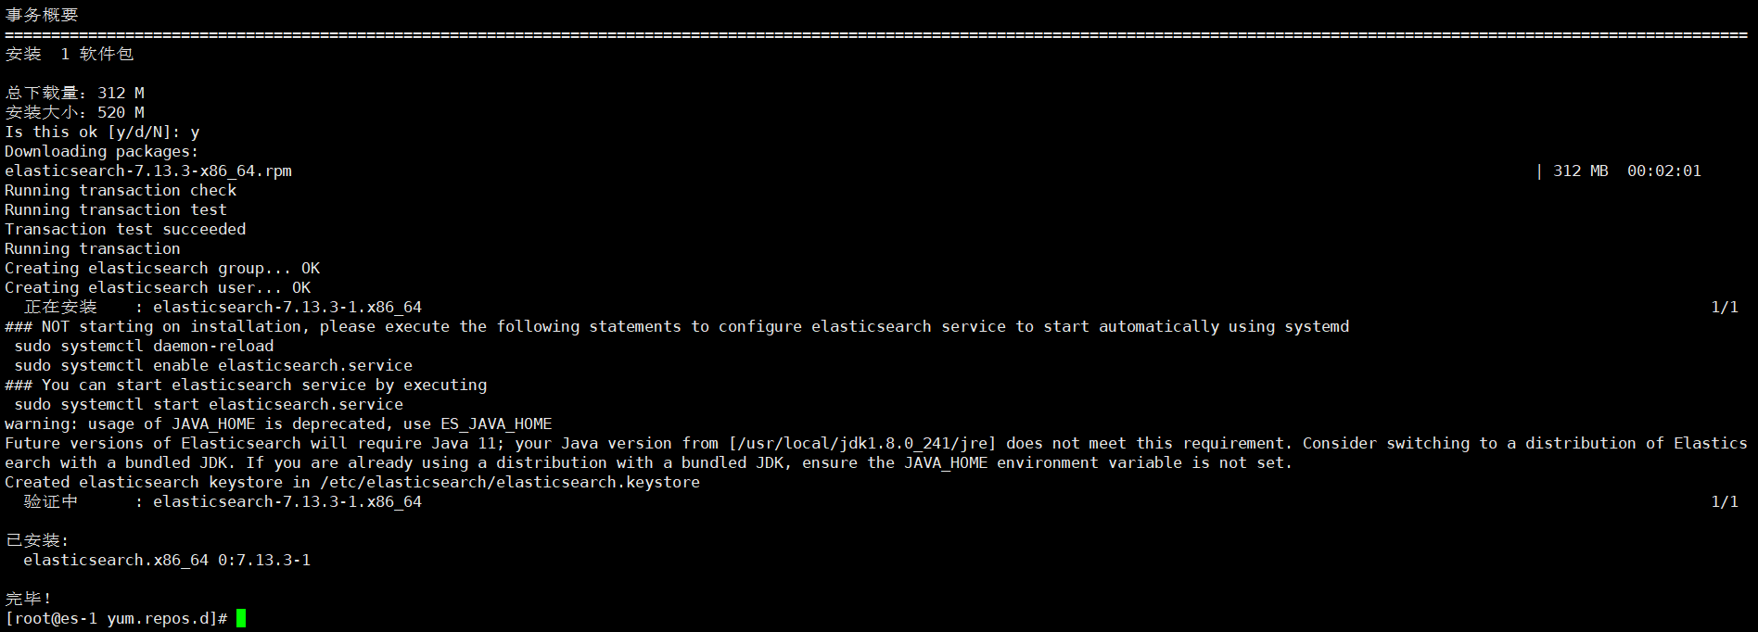

创建数据目录和日志目录
在所有服务器上创建目录：
# mkdir -p /data/elasticsearch/{data,logs}
# chown -R elasticsearch.elasticsearch /data/elasticsearch

配置elasticsearch
配置文件路径 | 配置作用
/etc/elasticsearch/elasticsearch.yml | Elasticsearch主配置文件
/etc/elasticsearch/jvm.options | JVM相关的配置，内存大小等
/etc/elasticsearch/log4j2.properties | 日志系统定义
/usr/share/elasticsearch | 默认安装目录
/data/elasticsearch/data | 数据存储目录

- 修改elasticsearch.yml
Node-1
# vim /etc/elasticsearch/elasticsearch.yml
cluster.name: ssy-es
node.name: es-node-1
path.data: /data/elasticsearch/data
path.logs: /data/elasticsearch/logs
network.host: 10.0.1.193
http.port: 9200
discovery.seed_hosts: ["10.0.1.193", "10.0.1.194", "10.0.1.195"]
cluster.initial_master_nodes: ["es-node-1", "es-node-2", "es-node-3"]

Node-2
# vim /etc/elasticsearch/elasticsearch.yml
cluster.name: ssy-es
node.name: es-node-2
path.data: /data/elasticsearch/data
path.logs: /data/elasticsearch/logs
network.host: 10.0.1.194
http.port: 9200
discovery.seed_hosts: ["10.0.1.193", "10.0.1.194", "10.0.1.195"]
cluster.initial_master_nodes: ["es-node-1", "es-node-2", "es-node-3"]

Node-3
# vim /etc/elasticsearch/elasticsearch.yml
cluster.name: ssy-es
node.name: node-3
path.data: /data/elasticsearch/data
path.logs: /data/elasticsearch/logs
network.host: 10.0.1.195
http.port: 9200
discovery.seed_hosts: ["10.0.1.193", "10.0.1.194", "10.0.1.195"]
cluster.initial_master_nodes: ["es-node-1", "es-node-2", "es-node-3"]

- 修改vim jvm.options
# vim /etc/elasticsearch/jvm.options
-Xms2g
-Xmx2g

- 启动elasticsearch
# systemctl start elasticsearch
# systemctl status elasticsearch
# systemctl enable elasticsearch
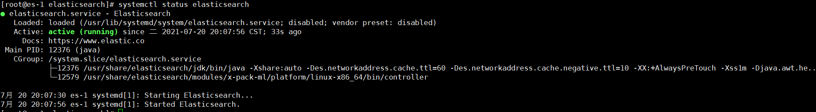

- 查看集群是否启动成功
# curl http://10.0.1.193:9200/_cat/nodes?v
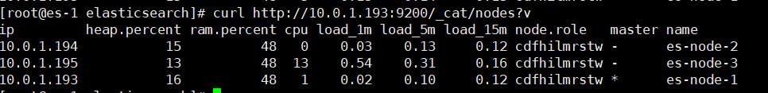

开启elasticsearch集群认证
- 生成证书(在其中一台上执行)
# /usr/share/elasticsearch/bin/elasticsearch-certutil cert -out /etc/elasticsearch/elastic-certificates.p12 -pass ""
# chown elasticsearch.elasticsearch /etc/elasticsearch/elastic-certificates.p12

设置为空密码，这是集群安全认账，成功生成的证书默认在/usr/share/elasticsearch/elastic-certificates.p12下，分别copy到其他节点的/etc/elasticsearch/目录下,并添加属主和属主,chown elasticsearch.elasticsearch /etc/elasticsearch/elastic-certificates.p12

- 添加elasticsearch.yml配置(所有节点)
# vim /etc/elasticsearch/elasticsearch.yml
xpack.security.enabled: true
xpack.license.self_generated.type: basic
xpack.security.transport.ssl.enabled: true
xpack.security.transport.ssl.verification_mode: certificate
xpack.security.transport.ssl.keystore.path: elastic-certificates.p12
xpack.security.transport.ssl.truststore.path: elastic-certificates.p12

- 重启elasticsearch
# systemctl restart elasticsearch
# systemctl status elasticsearch
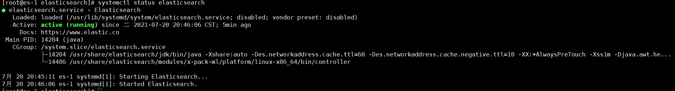

- 查看集群是否启动成功(报错)
# curl http://10.0.1.193:9200/_cat/nodes?v
Elasticsearch在开启xpack认证之后，直接通过curl访问接口会报错，curl需要带上认证的用户面，下面是创建用户和密码

- 给认证的集群创建用户和密码
# /usr/share/elasticsearch/bin/elasticsearch-setup-passwords interactive
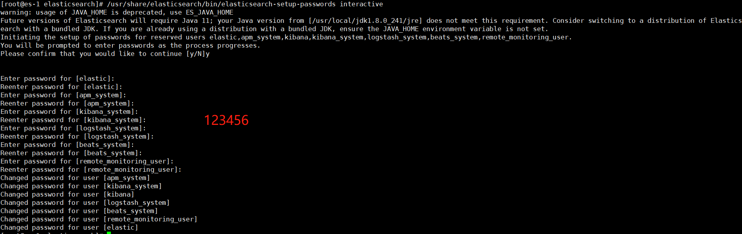

- elastic 账号：拥有 superuser 角色，是内置的超级用户。
- kibana 账号：拥有 kibana_system 角色，用户 kibana 用来连接 elasticsearch 并与之通信。Kibana 服务器以该用户身份提交请求以访问集群监视 API 和 .kibana 索引。不能访问 index。
- logstash_system 账号：拥有 logstash_system 角色。用户 Logstash 在 Elasticsearch 中存储监控信息时使用。
- beats_system账号：拥有 beats_system 角色。用户 Beats 在 Elasticsearch 中存储监控信息时使用。

- 查看集群是否启动成功
# curl --user elastic:123456 -XGET '10.0.1.193:9200/_cat/nodes?v'

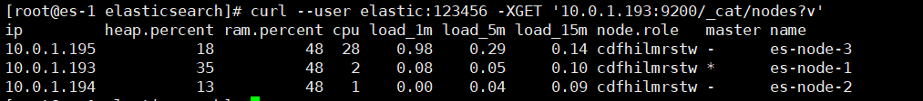

部署Kibana

配置yum源
- 导入验证密钥
# rpm --import https://artifacts.elastic.co/GPG-KEY-elasticsearch

- 添加yum源
# vim /etc/yum.repos.d/kibana.repo
[kibana-7.x]
name=Kibana repository for 7.x packages
baseurl=https://artifacts.elastic.co/packages/7.x/yum
gpgcheck=1
gpgkey=https://artifacts.elastic.co/GPG-KEY-elasticsearch
enabled=1
autorefresh=1
type=rpm-md
# yum makecache

安装kibana
- 安装kibana
# yum -y install kibana

- 修改kibana配置
# vim /etc/kibana/kibana.yml
server.port: 5601
server.host: "0.0.0.0"
elasticsearch.hosts: ["http://10.0.1.193:9200", "http://10.0.1.194:9200", "http://10.0.1.195:9200"]
elasticsearch.username: "elastic"
elasticsearch.password: "123456"
i18n.locale: "zh-CN"

- 重启kibana
# systemctl restart kibana

- 验证kibana



访问成功

部署Logstash

1、配置yum源
(1) 导入验证密钥
# rpm --import https://artifacts.elastic.co/GPG-KEY-elasticsearch

(2) 添加yum源
# vim /etc/yum.repos.d/logstash.repo
[logstash-7.x]
name=Elastic repository for 7.x packages
baseurl=https://artifacts.elastic.co/packages/7.x/yum
gpgcheck=1
gpgkey=https://artifacts.elastic.co/GPG-KEY-elasticsearch
enabled=1
autorefresh=1
type=rpm-md

2、安装Logstash
(1) 安装logstash
# yum -y install logstash

(2) 创建数据目录和日志目录
# mkdir -p /data/logstash/{data,logs}
# chown -R logstash.logstash /data/logstash

(3) 配置logstash主配置文件
# vim /etc/logstash/logstash.yml
path.data: /data/logstash/data
path.logs: /data/logstash/logs

(4) 配置logstash的输入和输出
# vim /etc/logstash/conf.d/logstash.conf
input {
beats {
port => 5044
}
}
filter {
grok {
match => { "message" => "%{TIMESTAMP_ISO8601:timestamp} %{LOGLEVEL:level} %{JAVALOGMESSAGE:msg}" }
}
date {
match => [ "timestamp", "ISO8601" ]
target => [ "@timestamp" ]
timezone => "Asia/Shanghai"
}
}
output {
elasticsearch {
hosts => ["http://127.0.0.1:9200"]
index => "%{[fields][doc_type]}-%{+YYYY.MM.dd}"
user => "elastic"
password => "123456"
}
}

(5) 启动logstash
# systemctl enable logstash
# systemctl start logstash

四、部署Filebeat
在需要收集的日志的服务器安装filebeat，并配置收集日志的路径

1、配置yum源
(1) 导入验证密钥
# rpm --import https://artifacts.elastic.co/GPG-KEY-elasticsearch

(2) 添加yum源
# vim /etc/yum.repos.d/elastic.repo
[elastic-7.x]
name=Elastic repository for 7.x packages
baseurl=https://artifacts.elastic.co/packages/7.x/yum
gpgcheck=1
gpgkey=https://artifacts.elastic.co/GPG-KEY-elasticsearch
enabled=1
autorefresh=1
type=rpm-md

2、安装filebeat
(1) 安装filebeat
# yum -y install filebeat

(2) 配置filebeat收集的目录
# vim /etc/filebeat/filebeat.yml
- type: log
enabled: true
paths:
- /data/yxc-test/gateway-service/gateway-service.log
multiline:
pattern: ^\d{4}
negate: true
match: after
fields:
doc_type: gateway
close_older: 30m
force_close_files: true

output.logstash:
# The Logstash hosts
hosts: ["10.0.1.191:5044"]

(3) 启动filebeat
# systemctl enable filebeat
# systemctl start filebeat

五、验证日志是否收集成功

1、登录kibana查看
(1) 访问kibana UI界面登录查看
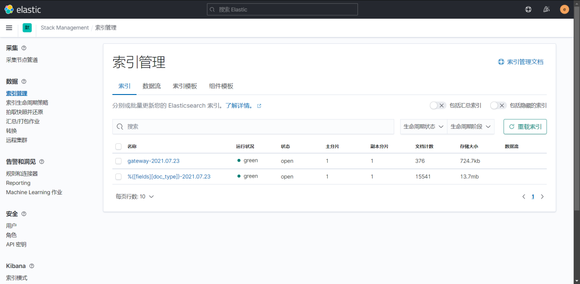

(2) 添加索引模式

