Ls

Ubuntu部署K8S集群

修改DNS
由于Ubuntu默认的DNS地址写了127.0.0.53，强行修改/etc/resolv.conf并没有什么用，只能通过一下方式进行修改
查看/run/systemd/resolve/resolv.conf配置文件下的DNS服务器地址
# cat /run/systemd/resolve/resolv.conf
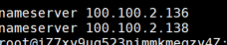
进入所有ubuntu的机器上修改公网的DNS
# vim /etc/systemd/resolved.conf //将DNS配置修改成上面的地址
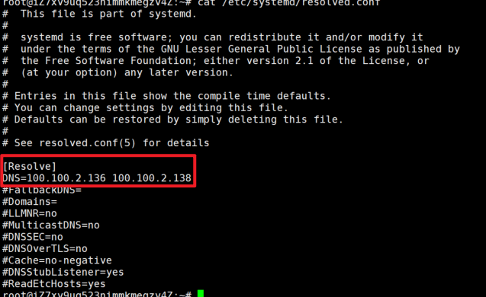
# systemctl restart systemd-resolved
# systemctl enable systemd-resolved
# rm -rf /etc/resolv.conf
# ln -s /run/systemd/resolve/resolv.conf /etc/
# cat /etc/resolv.conf

下载sealos工具
# apt-get install iptables //如果有则不需要
# wget https://github.com/labring/sealos/releases/download/v4.0.0/sealos_4.0.0_linux_amd64.tar.gz
# tar zxvf sealos_4.0.0_linux_amd64.tar.gz sealos && chmod +x sealos && mv sealos /usr/bin

# wget https://ssy-ops.oss-cn-shenzhen.aliyuncs.com/software/K8S/kube1.22.0.tar.gz
# wget https://ssy-ops.oss-cn-shenzhen.aliyuncs.com/software/K8S/sealos
# mv sealos /usr/bin/

# chmod +x /usr/bin/sealos
# sealos init --passwd Sunn2018 --master 172.17.0.239 --node 172.17.0.241 --node 172.17.0.240 --pkg-url /root/kube1.22.0.tar.gz --version v1.22.0 --podcidr 10.93.0.0/12 --svccidr 10.244.0.0/16

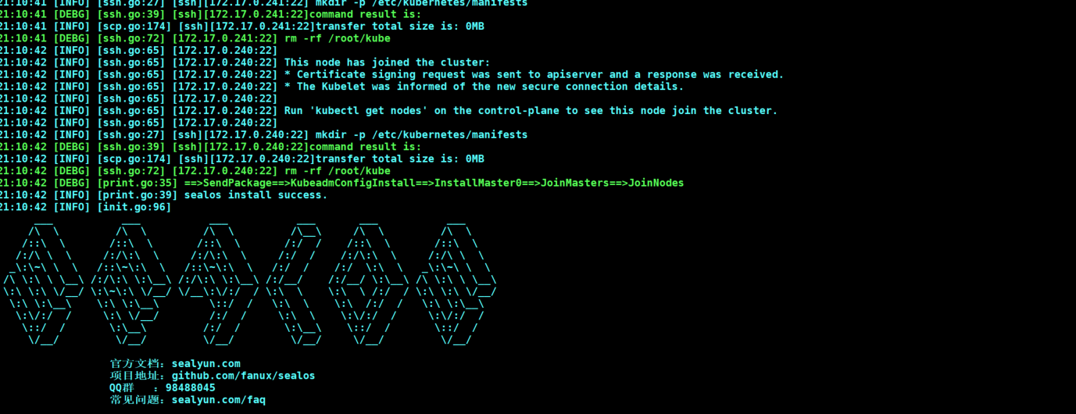

查看节点是否都正常
# kubectl get node
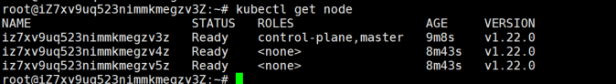

部署pod测试dns是否能够正常解析：
# vim demo.yaml
apiVersion: v1
kind: Pod
metadata:
name: pod-demo
namespace: default
labels:
app: myapp
tier: frontend
spec:
containers:
- name: myapp
image: ikubernetes/myapp:v1
# kubectl apply -f demo.yaml
# kubectl exec -it pod/pod-demo -- sh
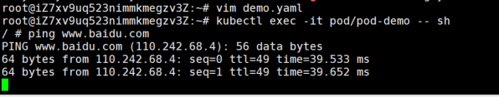

相关文档：
- Ubuntu搭建K8S集群内的Pod无法解析公网地址
https://blog.51cto.com/zhangxueliang/2969918

部署Kuboard

使用docker部署
# docker run -d --restart=unless-stopped --name=kuboard -p 8080:80/tcp -p 10081:10081/tcp -e KUBOARD_ENDPOINT="http://IP:8080" -e KUBOARD_AGENT_SERVER_TCP_PORT="10081" -e KUBOARD_ADMIN_DERAULT_PASSWORD="Kuboard2022" -v /data/kuboard-data:/data swr.cn-east-2.myhuaweicloud.com/kuboard/kuboard:v3

