Seata分布式事务TC协调者搭建

目录
前提准备 2
1. 编译包安装Seata-1.6.0 2
2. docker-compose 部署Seata-1.6.0 9
3. Kubernetes 部署 Seata1.4.2 15
4. Kubernetes 部署 Seata1.6.0 18

在使用微服务中，单体事务注解@Transactional 就不适用了，需要采用分布式事务解决方案，本文介绍分布式事务Seata的安装。Seata一款开源的分布式事务解决方案，致力于在微服务架构下提供高性能和简单易用的分布式事务服务。
seata版本: 1.6.0

前提准备
Seata是一个分布式事务，seata服务端也是一个微服务，需要和其他微服务一样需要注册中心和配置中心。同时事务回滚，需要数据库日志记录。
- 注册中心和配置中心: nacos
- 数据库: pgsql

编译包安装Seata-1.6.0

下载
公司的oss下载地址：https://ssy-ops.oss-cn-shenzhen.aliyuncs.com/packages/seata-server-1.6.0.zip
进入Seata官网下载: https://github.com/seata/seata/releases/tag/v1.6.0,找到seata-server-1.6.0.zip下载。解压文件后进入seata文件夹，目录结构如下：
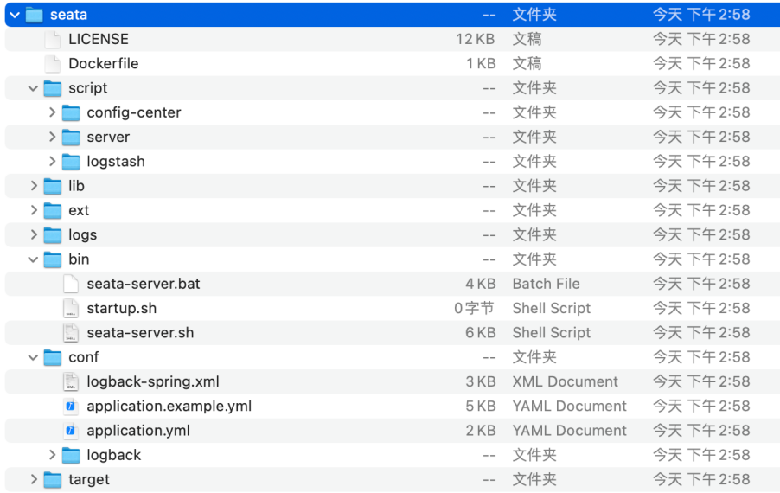

建表
在10.0.0.11实例上，新建数据库：项目_版本_seata，然后在seata文件夹里面的script文件，找到server —> db —> postgresql.sql，在数据库中执行sql语句。每个环境都得单独一个seata库，不然服务名会重复
全局事务会话由：全局事务、分支事务、全局锁，对应表分别为global_table、branch_table、lock_table。

配置Nacos
在nacos控制台添加新的命名空间:
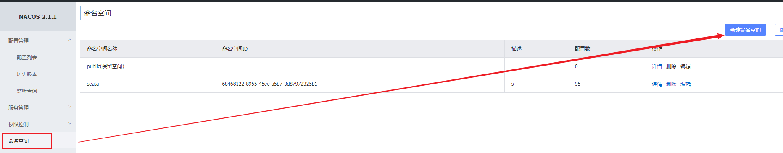
添加一条seata，命名空间ID在后面需要用到：

修改配置参数
进到seata目录中，找到config.txt文件，路径：script -> config-center -> config.txt，修改以下配置，并将没有参数的值注释掉

#Transaction routing rules configuration, only for the client
service.vgroupMapping.default_tx_group=default
方便后面排查问题，改成：
service.vgroupMapping.order_tx_group=default
service.vgroupMapping.product_tx_group=default
service.vgroupMapping.bussiness_tx_group=default
#Transaction storage configuration, only for the server. The file, db, and redis configuration values are optional.
store.mode=file
store.lock.mode=file
store.session.mode=file
改成：
store.mode=db
store.lock.mode=db
store.session.mode=db
#These configurations are required if the `store mode` is `db`. If `store.mode,store.lock.mode,store.session.mode` are not equal to `db`, you can remove the configuration block.
store.db.datasource=druid
store.db.dbType=mysql
store.db.driverClassName=com.mysql.jdbc.Driver
store.db.url=jdbc:mysql://127.0.0.1:3306/seata?useUnicode=true&rewriteBatchedStatements=true
store.db.user=username
store.db.password=password
改成：
#These configurations are required if the `store mode` is `db`. If `store.mode,store.lock.mode,store.session.mode` are not equal to `db`, you can remove the configuration block.
store.db.datasource=druid
store.db.dbType=postgresql
store.db.driverClassName=org.postgresql.Driver
store.db.url=jdbc:postgresql://10.0.1.182:5432/yongsheng_sbb_seata?stringtype=unspecified
store.db.user=jfzx_pgsql_test
store.db.password=jfzx_pgsql_test

上传配置至Nacos配置中心
进到seata/script/config-center/nacos目录中，找到nacos-config.sh文件，路径：script -> config-center -> nacos -> nacos-config.sh。执行nacos-config.sh脚本：
sh nacos-config.sh -h 127.0.0.1 -p 8848 -g SEATA_GROUP -t xxxx -u username -w password
参数详解:
-h nacos服务IP
-p nacos服务端口
-u nacos登录名
-w nacos登录密码
-g nacos 配置的分组名称，默认设置SEATA_GROUP
-t 上一步配置的命名空间ID

- 执行脚本之后, 看到输出以下脚本，代表成功了
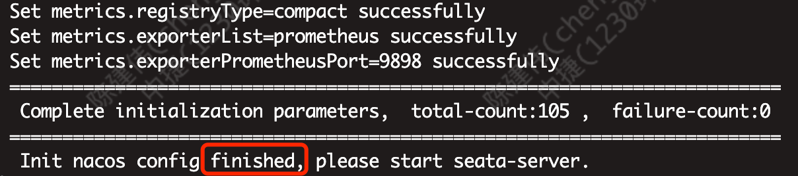

- 如果出现以下这种，说明config.txt文件中有些不需要的值是空的，需要注释掉
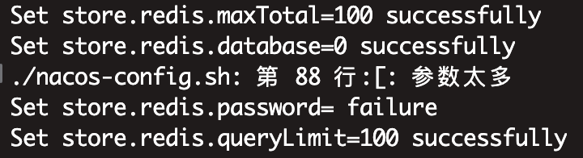

- 再去nacos控制台查看配置：
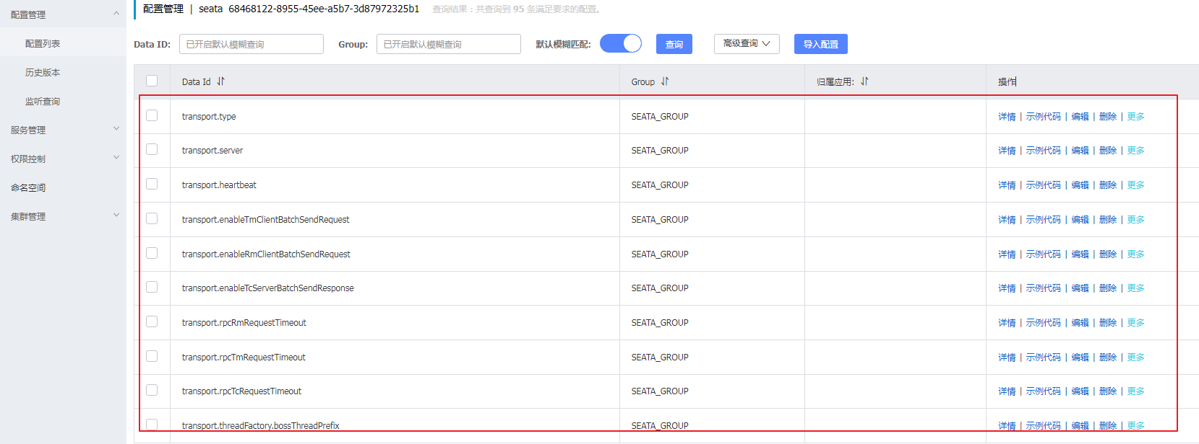
说明配置上传成功。上传不成功，大部分原因是配置没有配置成功，比如命名空间ID等没配置正确。

修改 appplication.yml
找到appplication.yml文件，路径为：seata -> conf -> application.yml，以下三个小节分别配置store、config、registry:
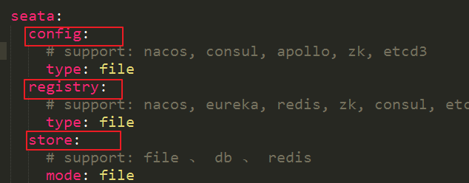

seata.store
修改数据库连接，将 seata -> conf -> application.example.yml中附带额外配置，将其db相关配置复制至application.yml,修改store.db相关属性。数据库是步骤一配置的数据库:
store:
# support: file 、 db 、 redis
mode: db
db:
datasource: druid
db-type: postgresql
driver-class-name: org.postgresql.Driver
url: jdbc:postgresql://10.0.1.182:5432/v2-zhongjie_test_221230?stringtype=unspecified
user: jfzx_pgsql_test
password: jfzx_pgsql_test
min-conn: 5
max-conn: 100
global-table: global_table
branch-table: branch_table
lock-table: lock_table
distributed-lock-table: distributed_lock
query-limit: 100
max-wait: 5000

seata.config
seata.config是配置nacos配置中心相关的配置。将seata.config.type修改成nacos：
config:
# support: nacos, consul, apollo, zk, etcd3
type: nacos
nacos:
server-addr: 127.0.0.1:8848
group: SEATA_GROUP
namespace: c0484d13-70aa-4629-b37a-7e2f4c275917
cluster: default
username: nacos
password: nacos
context-path:
##if use MSE Nacos with auth, mutex with username/password attribute
# #access-key: ""
# #secret-key: ""

seata.registry
seata.registry是配置注册中心相关字段，将seata服务作为一个微服务注册到注册中心。将registry.type改成nacos,配置如下：

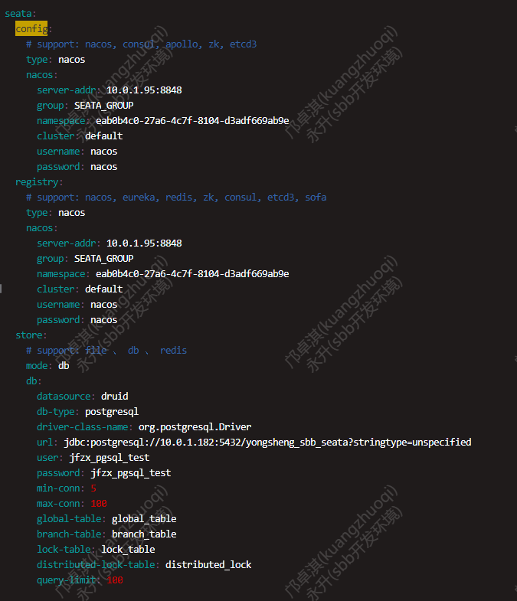
registry:
# support: nacos, eureka, redis, zk, consul, etcd3, sofa
type: nacos
nacos:
application: seata-server
server-addr: 127.0.0.1:8848
group: SEATA_GROUP
namespace: c0484d13-70aa-4629-b37a-7e2f4c275917
cluster: default
username: nacos
password: nacos
context-path:
##if use MSE Nacos with auth, mutex with username/password attribute
# # #access-key: ""
# # #secret-key: ""

启动
找到seata文件中的bin目录，执行启动命令：
seata-server.sh 或者seata-server.sh -h 127.0.0.1 -p 7091 -m db

控制台输出：
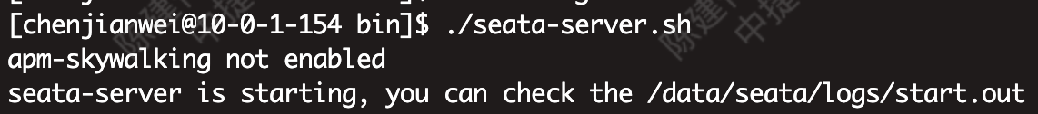

打开start.out日志:
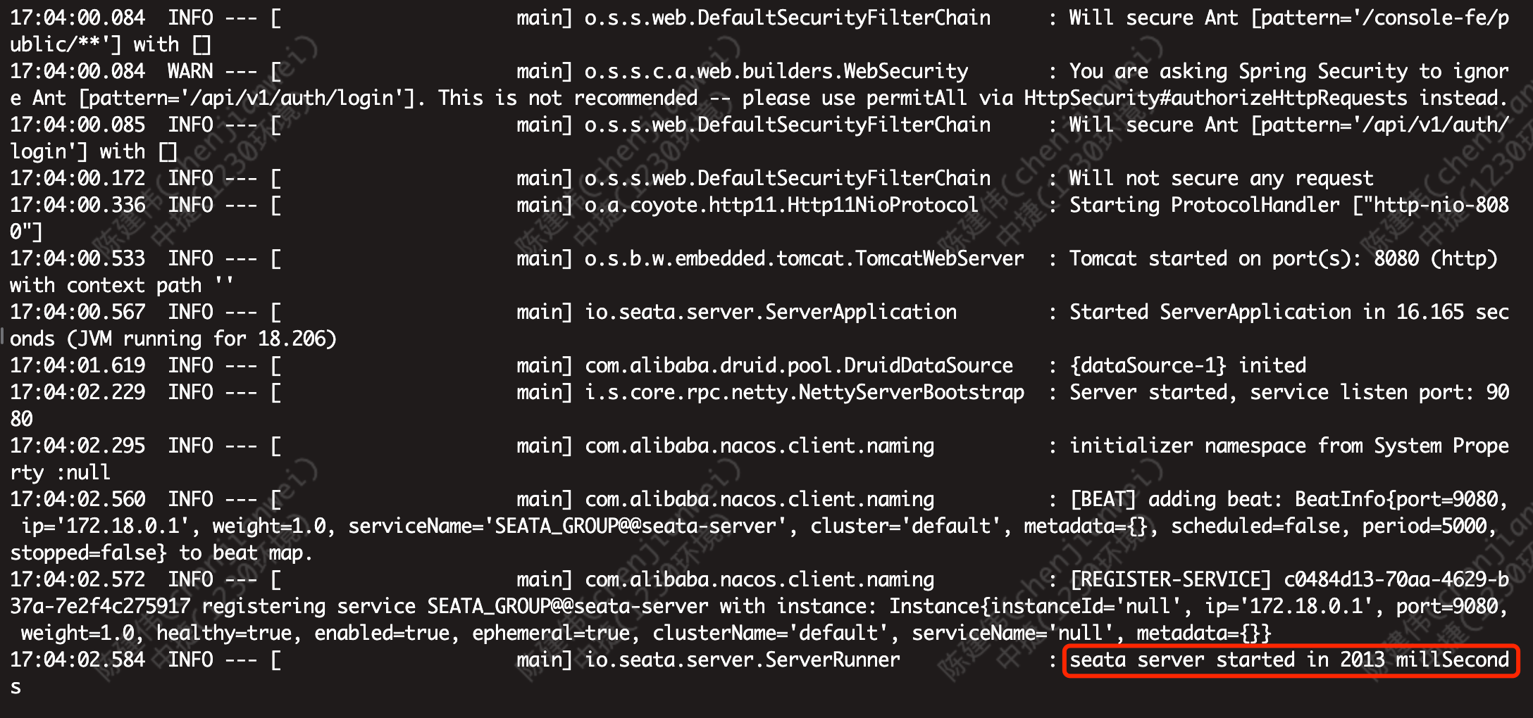

系统启动成功,再登录 http://127.0.0.1:7091，就能看到seata控制台信息。
默认账号密码：seata/seata
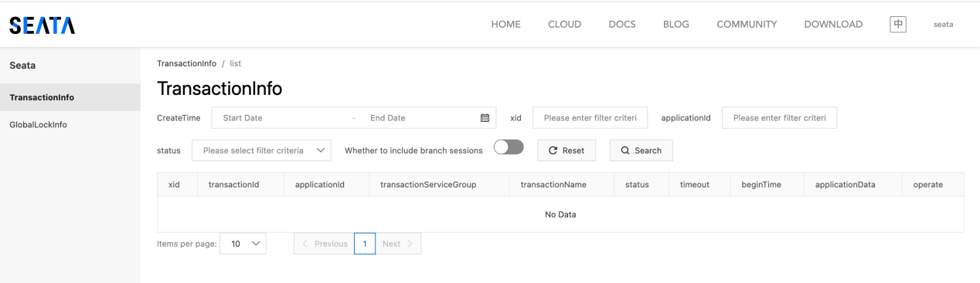

nacos控制台服务列表新增了一个服务，说明seata服务成功注册到了nacos注册中心：
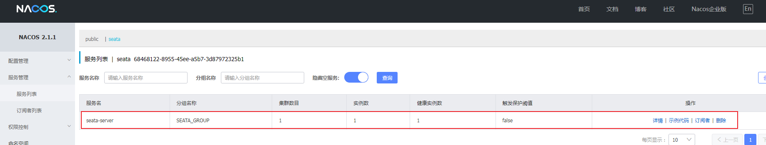

Client端
每个客户端服务都需要新增一张undo_log日志表，将以下sql 执行到新库上

进入github：https://github.com/seata/seata/tree/develop/script/client/at/db 下载
公司地址下载：https://ssy-ops.oss-cn-shenzhen.aliyuncs.com/packages/seata-postgresql.sql

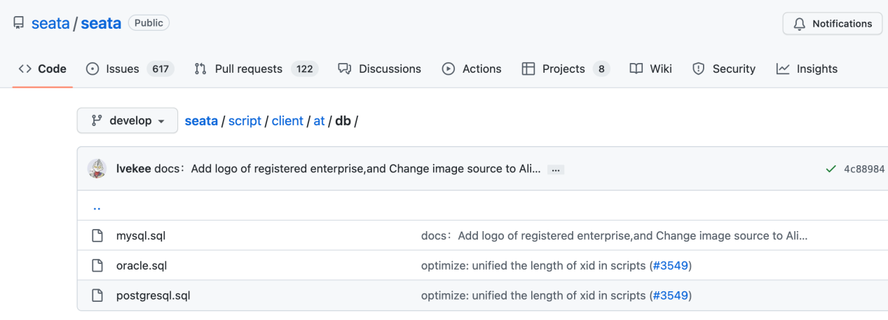
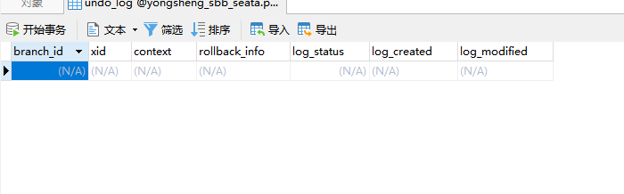

总结
- seata安装版本是1.6.0，版本不同，安装流程也可能不同，这里的版本需要保持一致
- 执行sql创建数据表
- 修改配置，使用脚本添加配置到nacos配置中心
- 修改application.yml文件，分别修改store、config、registry相关配置。
- 启动服务，成功登陆seata控制台。
- 查看nacos控制台，服务列表新增seata服务。
- 新建日志表

docker-compose 部署Seata-1.6.0

建表
新建新库，并执行建表脚本
脚本下载地址：https://github.com/seata/seata/tree/develop/script/server/db

准备Nacos 配置中心的配置
新建Nacos命名空间,并记录namespace id
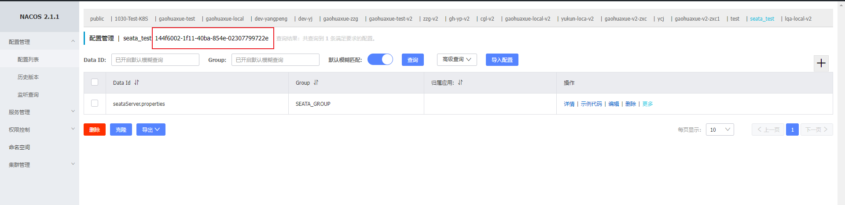

在Nacos 新建配置，此处dataid 为seataServer.properties
store.mode=db
#-----db-----
store.db.datasource=druid
store.db.dbType=postgresql
store.db.driverClassName=org.postgresql.Driver
store.db.url=jdbc:postgresql://10.0.0.11:5432/seata_test?stringtype=unspecified
store.db.user=用户名
store.db.password=密码
# 数据库初始连接数
store.db.minConn=1
# 数据库最大连接数
store.db.maxConn=20
# 获取连接时最大等待时间 默认5000，单位毫秒
store.db.maxWait=5000
# 全局事务表名 默认global_table
store.db.globalTable=global_table
# 分支事务表名 默认branch_table
store.db.branchTable=branch_table
# 全局锁表名 默认lock_table
store.db.lockTable=lock_table
# 查询全局事务一次的最大条数 默认100
store.db.queryLimit=100

# undo保留天数 默认7天,log_status=1（附录3）和未正常清理的undo
server.undo.logSaveDays=7
# undo清理线程间隔时间 默认86400000，单位毫秒
server.undo.logDeletePeriod=86400000
# 二阶段提交重试超时时长 单位ms,s,m,h,d,对应毫秒,秒,分,小时,天,默认毫秒。默认值-1表示无限重试
# 公式: timeout>=now-globalTransactionBeginTime,true表示超时则不再重试
# 注: 达到超时时间后将不会做任何重试,有数据不一致风险,除非业务自行可校准数据,否者慎用
server.maxCommitRetryTimeout=-1
# 二阶段回滚重试超时时长
server.maxRollbackRetryTimeout=-1
# 二阶段提交未完成状态全局事务重试提交线程间隔时间 默认1000，单位毫秒
server.recovery.committingRetryPeriod=1000
# 二阶段异步提交状态重试提交线程间隔时间 默认1000，单位毫秒
server.recovery.asynCommittingRetryPeriod=1000
# 二阶段回滚状态重试回滚线程间隔时间 默认1000，单位毫秒
server.recovery.rollbackingRetryPeriod=1000
# 超时状态检测重试线程间隔时间 默认1000，单位毫秒，检测出超时将全局事务置入回滚会话管理器
server.recovery.timeoutRetryPeriod=1000

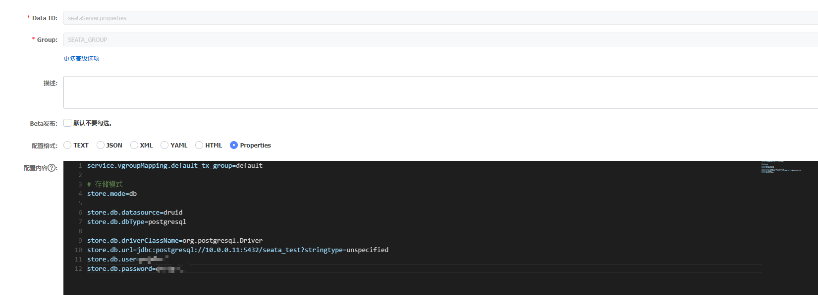

其它详细参数参考：https://github.com/seata/seata/blob/develop/script/config-center/config.txt

修改application.yml 文件
Nacos 注册中心
server:
port: 7091

spring:
application:
name: seata-server

logging:
config: classpath:logback-spring.xml
file:
path: ${user.home}/logs/seata
extend:
logstash-appender:
destination: 127.0.0.1:4560
kafka-appender:
bootstrap-servers: 127.0.0.1:9092
topic: logback_to_logstash

console:
user:
username: seata
password: seata

seata:
config:
# support: nacos, consul, apollo, zk, etcd3
type: nacos
nacos:
server-addr: nacos_ip:nacos_port
namespace: seata-server
group: SEATA_GROUP
username: nacos
password: nacos
data-id: seataServer.properties

registry:
# support: nacos, eureka, redis, zk, consul, etcd3, sofa
type: nacos
nacos:
application: seata-server
server-addr: nacos_ip:nacos_port
group: SEATA_GROUP
namespace: seata-server
# tc集群名称
cluster: default
username: nacos
password: nacos
# server:
# service-port: 8091 #If not configured, the default is '${server.port} + 1000'
security:
secretKey: SeataSecretKey0c382ef121d778043159209298fd40bf3850a017
tokenValidityInMilliseconds: 1800000
ignore:
urls: /,/**/*.css,/**/*.js,/**/*.html,/**/*.map,/**/*.svg,/**/*.png,/**/*.ico,/console-fe/public/**,/api/v1/auth/login

准备docker-compose.yaml 文件
version: "3"
services:
seata-server:
image: seataio/seata-server:1.6.0
ports:
- "7091:7091"
- "8091:8091"
environment:
- STORE_MODE=db
# 以SEATA_IP作为host注册seata server
- SEATA_IP=seata_ip
- SEATA_PORT=8091
volumes:
- "/usr/share/zoneinfo/Asia/Shanghai:/etc/localtime" #设置系统时区
- "/usr/share/zoneinfo/Asia/Shanghai:/etc/timezone" #设置时区
- "/data/seata/application.yml:/seata-server/resources/application.yml" #设置映射文件路径

启动
切换到seata 目录
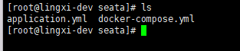

执行 docker-compose -d up

进入nacos 查看是否已经注册，使用7091 端口查看是否正常启动
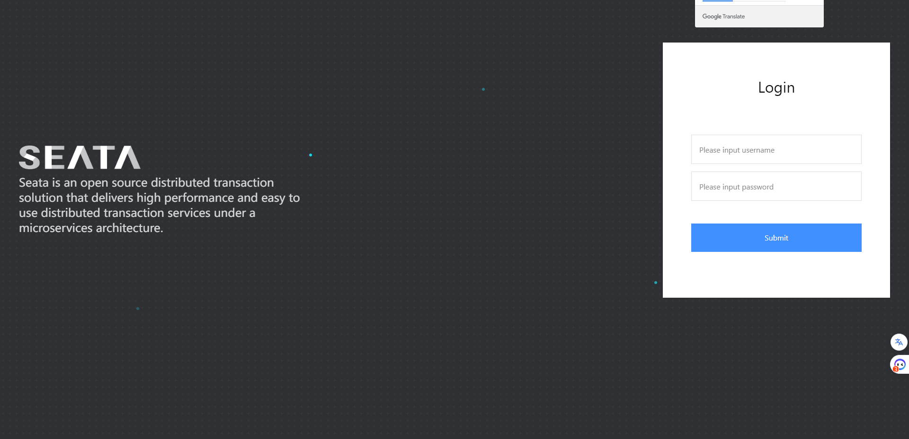

测试seata集群的可用性

创建例子所需要的表
-- ----------------------------
-- Table structure for account
-- ----------------------------
DROP TABLE IF EXISTS `account`;
CREATE TABLE `account` (
`id` bigint(20) NOT NULL AUTO_INCREMENT COMMENT 'id',
`user_id` bigint(20) NULL DEFAULT NULL COMMENT '用户id',
`total` decimal(10, 0) NULL DEFAULT NULL COMMENT '总额度',
`used` decimal(10, 0) NULL DEFAULT NULL COMMENT '已用余额',
`residue` decimal(10, 0) NULL DEFAULT 0 COMMENT '剩余可用额度',
`is_deleted` int(11) NULL DEFAULT NULL COMMENT '删除状态：0-未删除，1-已删除',
`update_user` bigint(20) NULL DEFAULT NULL COMMENT '更新人',
`update_time` datetime NULL DEFAULT NULL COMMENT '更新时间',
`create_user` bigint(20) NULL DEFAULT NULL COMMENT '创建人',
`create_time` datetime NULL DEFAULT NULL COMMENT '创建时间',
PRIMARY KEY (`id`) USING BTREE
) ENGINE = InnoDB AUTO_INCREMENT = 2 CHARACTER SET = utf8 COLLATE = utf8_general_ci ROW_FORMAT = DYNAMIC;

-- ----------------------------
-- Table structure for order_info
-- ----------------------------
DROP TABLE IF EXISTS `order_info`;
CREATE TABLE `order_info` (
`id` bigint(20) NOT NULL AUTO_INCREMENT,
`user_id` bigint(20) NULL DEFAULT NULL COMMENT '用户id',
`product_id` bigint(20) NULL DEFAULT NULL COMMENT '产品id',
`count` int(11) NULL DEFAULT NULL COMMENT '数量',
`money` decimal(11, 0) NULL DEFAULT NULL COMMENT '金额',
`status` int(11) NULL DEFAULT NULL COMMENT '订单状态：0：创建中；1：已完结',
`is_deleted` int(11) NULL DEFAULT NULL COMMENT '删除状态：0-未删除，1-已删除',
`update_user` bigint(20) NULL DEFAULT NULL COMMENT '更新人',
`update_time` timestamp NULL DEFAULT NULL COMMENT '更新时间',
`create_user` bigint(20) NULL DEFAULT NULL COMMENT '创建人',
`create_time` timestamp NULL DEFAULT NULL COMMENT '创建时间',
PRIMARY KEY (`id`) USING BTREE
) ENGINE = InnoDB AUTO_INCREMENT = 16 CHARACTER SET = utf8 COLLATE = utf8_general_ci ROW_FORMAT = DYNAMIC;

-- ----------------------------
-- Table structure for storage
-- ----------------------------
DROP TABLE IF EXISTS `storage`;
CREATE TABLE `storage` (
`id` bigint(20) NOT NULL AUTO_INCREMENT,
`product_id` bigint(20) NULL DEFAULT NULL COMMENT '产品id',
`total` int(11) NULL DEFAULT NULL COMMENT '总库存',
`used` int(11) NULL DEFAULT NULL COMMENT '已用库存',
`residue` int(11) NULL DEFAULT NULL COMMENT '剩余库存',
`is_deleted` int(11) NULL DEFAULT NULL COMMENT '删除状态：0-未删除，1-已删除',
`update_user` bigint(20) NULL DEFAULT NULL COMMENT '更新人',
`update_time` datetime NULL DEFAULT NULL COMMENT '更新时间',
`create_user` bigint(20) NULL DEFAULT NULL COMMENT '创建人',
`create_time` datetime NULL DEFAULT NULL COMMENT '创建时间',
PRIMARY KEY (`id`) USING BTREE
) ENGINE = InnoDB AUTO_INCREMENT = 2 CHARACTER SET = utf8 COLLATE = utf8_general_ci ROW_FORMAT = DYNAMIC;

Kubernetes 部署 Seata1.4.2
Ps: 仍需要执行2.1 2.2 步骤
apiVersion: v1
kind: Service
metadata:
name: seata-ha-server
namespace: default
labels:
app.kubernetes.io/name: seata-ha-server
spec:
type: ClusterIP
ports:
- port: 8091
protocol: TCP
name: http
selector:
app.kubernetes.io/name: seata-ha-server

---

apiVersion: apps/v1
kind: Deployment
metadata:
name: seata-ha-server
namespace: default
labels:
app.kubernetes.io/name: seata-ha-server
spec:
replicas: 3
selector:
matchLabels:
app.kubernetes.io/name: seata-ha-server
template:
metadata:
labels:
app.kubernetes.io/name: seata-ha-server
spec:
containers:
- name: seata-ha-server
image: docker.io/seataio/seata-server:1.4.2
imagePullPolicy: IfNotPresent
env:
- name: SEATA_CONFIG_NAME
value: file:/root/seata-config/registry
- name: SEATA_IP
valueFrom:
fieldRef:
apiVersion: v1
fieldPath: status.hostIP
ports:
- name: http
containerPort: 8091
protocol: TCP
volumeMounts:
- name: seata-config
mountPath: /root/seata-config
volumes:
- name: seata-config
configMap:
name: seata-ha-server-config

---
apiVersion: v1
kind: ConfigMap
metadata:
name: seata-ha-server-config
data:
registry.conf: |
registry {
type = "nacos"
nacos {
application = "seata-server"
serverAddr = "192.168.242.112:81"
namespace = "5a4e4c1f-beda-4ae5-a3d7-428950e7473b"
group = "SEATA_GROUP"
cluster = "default"
username = "nacos"
password = "nacos123"
}
}
config {
type = "nacos"
nacos {
serverAddr = "192.168.242.112:81"
namespace = "5a4e4c1f-beda-4ae5-a3d7-428950e7473b"
group = "SEATA_GROUP"
username = "nacos"
password = "nacos123"
dataId: "seataServer.properties"
}
}

Kubernetes 部署 Seata1.6.0
Ps: 仍需要执行2.1 2.2 步骤

创建两份 ConfigMap

seata-server-log-config：

apiVersion: v1
kind: ConfigMap
metadata:
name: seata-server-log-config
namespace: default
data:
console-appender.xml: |
<?xml version="1.0" encoding="UTF-8"?>
<included>
<!-- console-appender properties -->
<springProperty name="CONSOLE_LOG_PATTERN" source="logging.pattern.console"
defaultValue="%clr(%d{HH:mm:ss.SSS}){faint} %clr(%5p) %clr(---){faint} %clr([%25.25t]){faint} %clr(%-40.40logger{39}){cyan} %clr(:){faint} %m%n%wEx2"/>

<appender name="CONSOLE" class="ch.qos.logback.core.ConsoleAppender">
<encoder>
<Pattern>${CONSOLE_LOG_PATTERN}</Pattern>
<charset>UTF-8</charset>
</encoder>
</appender>
</included>

file-appender.xml: |
<?xml version="1.0" encoding="UTF-8"?>
<included>
<!-- file-appender properties -->
<springProperty name="LOG_FILE_PATH" source="logging.file.path"
defaultValue="${user.home}/logs/seata"/>
<springProperty name="FILE_LOG_PATTERN" source="logging.pattern.file"
defaultValue="%d{yyyy-MM-dd HH:mm:ss.SSS} %5p --- [%30.30t] %-40.40logger{39} : %m%n%wEx2"/>

<!--ALL-->
<appender name="FILE_ALL" class="ch.qos.logback.core.rolling.RollingFileAppender">
<file>${LOG_FILE_PATH}/${APPLICATION_NAME:-seata-server}.${RPC_PORT}.all.log</file>
<append>true</append>
<rollingPolicy class="ch.qos.logback.core.rolling.SizeAndTimeBasedRollingPolicy">
<fileNamePattern>${LOG_FILE_PATH}/history/${APPLICATION_NAME:-seata-server}.${RPC_PORT}.all.%d{yyyy-MM-dd}.%i.log.gz</fileNamePattern>
<maxFileSize>2GB</maxFileSize>
<MaxHistory>7</MaxHistory>
<totalSizeCap>7GB</totalSizeCap>
<cleanHistoryOnStart>true</cleanHistoryOnStart>
</rollingPolicy>
<encoder>
<Pattern>${FILE_LOG_PATTERN}</Pattern>
<charset>UTF-8</charset>
</encoder>
</appender>

<!--WARN-->
<appender name="FILE_WARN" class="ch.qos.logback.core.rolling.RollingFileAppender">
<filter class="ch.qos.logback.classic.filter.LevelFilter">
<level>WARN</level>
<onMatch>ACCEPT</onMatch>
<onMismatch>DENY</onMismatch>
</filter>
<file>${LOG_FILE_PATH}/${APPLICATION_NAME:-seata-server}.${RPC_PORT}.warn.log</file>
<append>true</append>
<rollingPolicy class="ch.qos.logback.core.rolling.SizeAndTimeBasedRollingPolicy">
<fileNamePattern>${LOG_FILE_PATH}/history/${APPLICATION_NAME:-seata-server}.${RPC_PORT}.warn.%d{yyyy-MM-dd}.%i.log.gz</fileNamePattern>
<maxFileSize>2GB</maxFileSize>
<MaxHistory>7</MaxHistory>
<totalSizeCap>7GB</totalSizeCap>
<cleanHistoryOnStart>true</cleanHistoryOnStart>
</rollingPolicy>
<encoder>
<Pattern>${FILE_LOG_PATTERN}</Pattern>
<charset>UTF-8</charset>
</encoder>
</appender>

<!--ERROR-->
<appender name="FILE_ERROR" class="ch.qos.logback.core.rolling.RollingFileAppender">
<filter class="ch.qos.logback.classic.filter.LevelFilter">
<level>ERROR</level>
<onMatch>ACCEPT</onMatch>
<onMismatch>DENY</onMismatch>
</filter>
<file>${LOG_FILE_PATH}/${APPLICATION_NAME:-seata-server}.${RPC_PORT}.error.log</file>
<append>true</append>
<rollingPolicy class="ch.qos.logback.core.rolling.SizeAndTimeBasedRollingPolicy">
<fileNamePattern>${LOG_FILE_PATH}/history/${APPLICATION_NAME:-seata-server}.${RPC_PORT}.error.%d{yyyy-MM-dd}.%i.log.gz</fileNamePattern>
<maxFileSize>2GB</maxFileSize>
<MaxHistory>7</MaxHistory>
<totalSizeCap>7GB</totalSizeCap>
<cleanHistoryOnStart>true</cleanHistoryOnStart>
</rollingPolicy>
<encoder>
<Pattern>${FILE_LOG_PATTERN}</Pattern>
<charset>UTF-8</charset>
</encoder>
</appender>
</included>

kafka-appender.xml: |
<?xml version="1.0" encoding="UTF-8"?>
<included>
<!-- kafka-appender properties -->
<springProperty name="KAFKA_BOOTSTRAP_SERVERS" source="logging.extend.kafka-appender.bootstrap-servers"
defaultValue="127.0.0.1:9092"/>
<springProperty name="KAFKA_TOPIC" source="logging.extend.kafka-appender.topic"
defaultValue="logback_to_logstash"/>

<appender name="KAFKA" class="com.github.danielwegener.logback.kafka.KafkaAppender">
<encoder>
<!--<pattern>%d{yyyy-MM-dd HH:mm:ss.SSS}|%p|${APPLICATION_NAME:-seata-server}|${RPC_PORT:-0}|%t|%logger|%X{X-TX-XID:-}|%X{X-TX-BRANCH-ID:-}|%m|%wex</pattern>-->
<pattern>{
"@timestamp": "%d{yyyy-MM-dd HH:mm:ss.SSS}",
"level":"%p",
"app_name":"${APPLICATION_NAME:-seata-server}",
"PORT": ${RPC_PORT:-0},
"thread_name": "%t",
"logger_name": "%logger",
"X-TX-XID": "%X{X-TX-XID:-}",
"X-TX-BRANCH-ID": "%X{X-TX-BRANCH-ID:-}",
"message": "%m",
"stack_trace": "%wex"
}
</pattern>
</encoder>
<topic>${KAFKA_TOPIC}</topic>
<keyingStrategy class="com.github.danielwegener.logback.kafka.keying.NoKeyKeyingStrategy"/>
<deliveryStrategy class="com.github.danielwegener.logback.kafka.delivery.AsynchronousDeliveryStrategy"/>
<producerConfig>bootstrap.servers=${KAFKA_BOOTSTRAP_SERVERS}</producerConfig>
<producerConfig>acks=0</producerConfig>
<producerConfig>linger.ms=1000</producerConfig>
<producerConfig>max.block.ms=0</producerConfig>
</appender>
</included>

logstash-appender.xml: |
<?xml version="1.0" encoding="UTF-8"?>
<included>
<!-- logstash-appender properties -->
<springProperty name="LOGSTASH_DESTINATION" source="logging.extend.logstash-appender.destination"
defaultValue="127.0.0.1:4560"/>

<appender name="LOGSTASH" class="net.logstash.logback.appender.LogstashTcpSocketAppender">
<!-- the TCP address of the logstash -->
<destination>${LOGSTASH_DESTINATION}</destination>

<!--<encoder charset="UTF-8" class="net.logstash.logback.encoder.LogstashEncoder">-->
<encoder charset="UTF-8" class="io.seata.server.logging.logback.appender.EnhancedLogstashEncoder">
<!-- the global custom fields -->
<customFields>
{
"app_name": "${APPLICATION_NAME:-seata-server}"
}
</customFields>

<!-- Exclude the provider of data `@version` -->
<excludeProvider>net.logstash.logback.composite.LogstashVersionJsonProvider</excludeProvider>
<!-- Exclude providers that are not currently needed, reduce some performance loss. -->
<excludeProvider>net.logstash.logback.composite.loggingevent.JsonMessageJsonProvider</excludeProvider>
<excludeProvider>net.logstash.logback.composite.loggingevent.TagsJsonProvider</excludeProvider>
<excludeProvider>net.logstash.logback.composite.loggingevent.LogstashMarkersJsonProvider</excludeProvider>
<excludeProvider>net.logstash.logback.composite.loggingevent.ArgumentsJsonProvider</excludeProvider>
</encoder>
</appender>
</included>

seata-server-config：

apiVersion: v1
kind: ConfigMap
metadata:
name: seata-server-config
namespace: default
data:
application.yml: |
server:
port: 7091 #修改控制台端口

spring:
application:
name: seata-server

logging:
config: classpath:logback-spring.xml
file:
path: ${user.home}/logs/seata

console:
user:
username: seata
password: seata

seata:
config:
type: nacos
nacos:
server-addr: 10.0.1.185:8848
namespace: 144f6002-1f11-40ba-854e-02307799722e
group: SEATA_GROUP
data-id: seataServer.properties
username: nacos
password: nacos
registry:
type: nacos
nacos:
application: seata-server
server-addr: 10.0.1.185:8848
namespace: 144f6002-1f11-40ba-854e-02307799722e
group: SEATA_GROUP
cluster: default-1
username: nacos
password: nacos
security:
secretKey: SeataSecretKey0c382ef121d778043159209298fd40bf3850a017
tokenValidityInMilliseconds: 1800000
ignore:
urls: /,/**/*.css,/**/*.js,/**/*.html,/**/*.map,/**/*.svg,/**/*.png,/**/*.ico,/console-fe/public/**,/api/v1/auth/login

logback-spring.xml: |
<?xml version="1.0" encoding="UTF-8"?>
<configuration scan="true" scanPeriod="60 seconds" debug="false">
<!-- Context listeners -->
<contextListener class="io.seata.server.logging.listener.SystemPropertyLoggerContextListener"/>

<!-- The conversion rules are copied from `defaults.xml` in the `spring-boot-xxx.jar` -->
<conversionRule conversionWord="clr" converterClass="org.springframework.boot.logging.logback.ColorConverter" />
<conversionRule conversionWord="wex" converterClass="org.springframework.boot.logging.logback.WhitespaceThrowableProxyConverter" />
<conversionRule conversionWord="wEx" converterClass="org.springframework.boot.logging.logback.ExtendedWhitespaceThrowableProxyConverter" />
<!-- The custom conversion rules -->
<conversionRule conversionWord="wEx2" converterClass="io.seata.server.logging.logback.ExtendedWhitespaceThrowableProxyConverter"/>

<!-- common properties -->
<springProperty name="PORT" source="server.port" defaultValue="7091"/>
<springProperty name="APPLICATION_NAME" source="spring.application.name" defaultValue="seata-server"/>

<!-- console-appender -->
<include resource="logback/console-appender.xml"/>

<!-- file-appender -->
<include resource="logback/file-appender.xml"/>

<!-- logstash-appender: off by default -->
<!--<include resource="logback/logstash-appender.xml"/>-->

<!-- kafka-appender: off by default -->
<!--<include resource="logback/kafka-appender.xml"/>-->

<root level="INFO">
<!-- console-appender -->
<appender-ref ref="CONSOLE"/>

<!-- file-appender -->
<appender-ref ref="FILE_ALL"/>
<appender-ref ref="FILE_WARN"/>
<appender-ref ref="FILE_ERROR"/>

<!-- logstash-appender: off by default -->
<!--<appender-ref ref="LOGSTASH"/>-->

<!-- kafka-appender: off by default -->
<!--<appender-ref ref="KAFKA"/>-->
</root>
</configuration>

创建Deployment和service:
apiVersion: apps/v1
kind: Deployment
metadata:
name: seata-server
namespace: default
labels:
k8s-app: seata-server
spec:
replicas: 1
selector:
matchLabels:
k8s-seata-node: seata-server
template:
metadata:
labels:
k8s-seata-node: seata-server
k8s-app: seata-server
spec:
containers:
- name: seata-server
image: registry.cn-guangzhou.aliyuncs.com/keetest/seata:1.6 #docker.io/seataio/seata-server:1.6.0
env:
- name: SEATA_PORT
value: "8091"
volumeMounts:
- name: seata-config
mountPath: /seata-server/conf
- name: seata-log
mountPath: /seata-server/conf/logback
volumes:
- name: seata-config
configMap:
name: seata-server-config
- name: seata-log
configMap:
name: seata-server-log-config
---

# service
apiVersion: v1
kind: Service
metadata:
name: seata-server
namespace: gaohuaxue-test
labels:
k8s-app: seata-server
spec:
type: NodePort
ports:
- port: 8091
nodePort: 30000
targetPort: 8091
protocol: TCP
name: http1
- port: 7091
nodePort: 30001 #for seata 控制台
targetPort: 7091
protocol: TCP
name: http2
selector:
k8s-app: seata-server

查看是否成功注册：
