一、Nginx
#yum install -y gcc pcre pcre-devel openssl-devel libxml2-devel libxslt-devel gd-devel perl-devel perl-ExtUtils-Embed GeoIP-devel
#tar -xf tengine-2.2.0.tar.gz
#cd tengine-2.2.0
#./configure --enable-mods-static=all --prefix=/usr/local/nginx --with-ipv6
#make && make install
#useradd www
#cd /usr/local/nginx/conf
#vim nginx.conf

#vim conf.d/service.conf
测试：
server {
listen 80;
server_name localhost;
root /usr/local/nginx/html;
index index.html index.htm ;
}

#cd /etc/init.d
#rz -y nginx

#chmod +x nginx
#chkconfig --add nginx
#chkconfig nginx on
#sevice nginx start

二、Jenkins
添加逻辑卷
#fdisk -l
#pvcreate /dev/vdb
#vgcreate jenkins-vg1 /dev/vdb
#lvcreate -l 25599 -n jenkins-lv1 jenkins-vg1
#mkfs.ext4 /dev/jenkins-vg1/jenkins-lv1
#vim /etc/fstab
/dev/jenkins-vg1/jenkins-lv1 /data/ ext4 defaults 0 0
#mount -a
#df -HT

下载jenkins安装包jenkins-2.277.3-1.1.noarch.rpm
#yum -y install jenkins-2.277.3-1.1.noarch.rpm
#mdir /data/.jenkins
#vim /etc/sysconfig/jenkins
修改：
JENKINS_HOME="/data/.jenkins"
JENKINS_USER="jenkins"
JENKINS_PORT="8080"
#systemctl start jenkins
#cd /data/.jenkins/updates
#sed -i 's/http:\/\/updates.jenkins-ci.org\/download/https:\/\/mirrors.tuna.tsinghua.edu.cn\/jenkins/g' default.json && sed -i 's/http:\/\/www.google.com/https:\/\/www.baidu.com/g' default.json
#systemctl restart jenkins

三、Postgresql 12
添加逻辑卷
#fdisk -l
#pvcreate /dev/vdb
#vgcreate pgsql-vg1 /dev/vdb
#lvcreate -l 51199 -n pgsql-lv1 pgsql-vg1
#mkfs.ext4 /dev/pgsql-vg1/pgsql-lv1
#vim /etc/fstab
/dev/pgsql-vg1/pgsql-lv1 /data ext4 defaults 0 0
#mount -a
#df -HT

安装PostgreSQL 12
#yum install -y readline readline-devel openssl openssl-devel zlib zlib-devel
#yum -y install https://download.postgresql.org/pub/repos/yum/reporpms/EL-7-x86_64/pgdg-redhat-repo-latest.noarch.rpm
#yum -y install postgresql12
#yum -y install postgresql12-server
#mkdir -p /data/postgresql/data
#chown -R postgres.postgres /data/postgresql/data
#su - postgres
-bash-4.2$ /usr/pgsql-12/bin/initdb -D /data/postgresql/data/
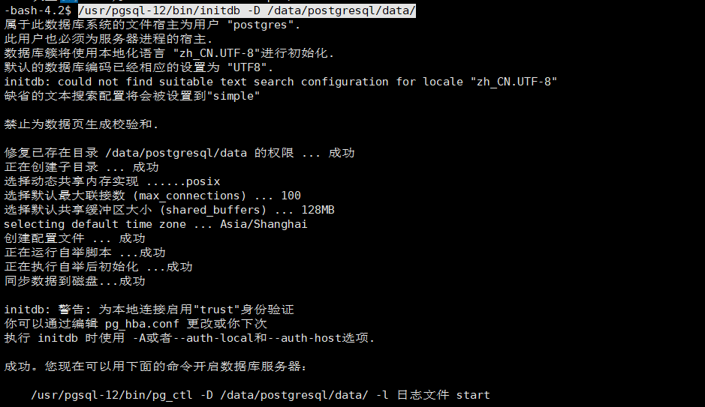
切换到root用户：
#vim /usr/lib/systemd/system/postgresql-12.service
修改Environment=PGDATA=/data/postgresql/data/
#systemctl daemon-reload
#systemctl start postgresql-12
#systemctl enable postgresql-12
#systemctl status postgresql-12

切换用户修改配置文件
#su - postgres
-bash-4.2$ vim /data/postgresql/data/postgresql.conf
listen_addresses = '*'
max_connections = 500
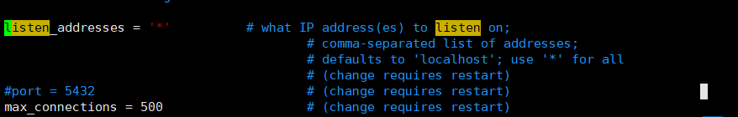
-bash-4.2$ vim /data/postgresql/data/pg_hba.conf
追加host all all 0.0.0.0/0 md5
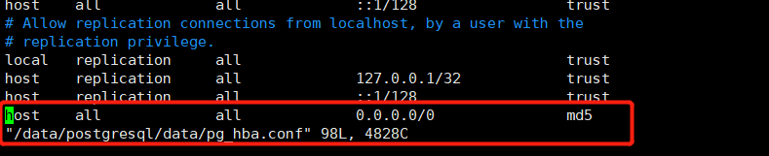
切换root重启
#systemctl restart postgresql-12
#systemctl status postgresql-12
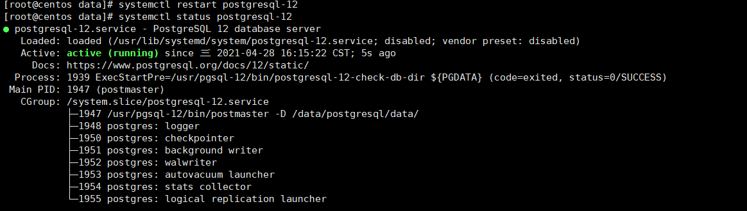

#su - postgres
-bash-4.2$ psql
修改postgres密码
postgres=# alter user postgres ENCRYPTED PASSWORD 'Shushangyun520';
ALTER ROLE
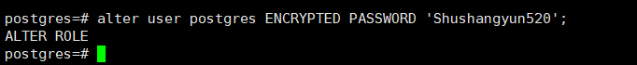

测试连接：
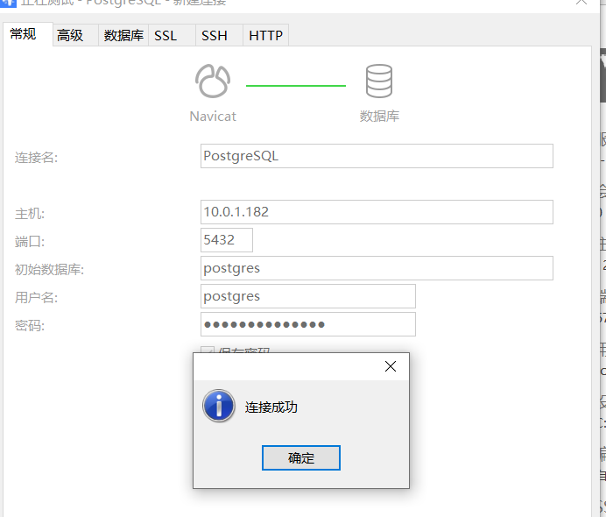

创建数据库：
postgres=# create user zhongshi_test with password 'zhongshi_test';
CREATE ROLE
postgres=# create database zhongshi_test_db owner zhongshi_test;
CREATE DATABASE
postgres=# create database zhongshi_pass_test_db owner zhongshi_test;
CREATE DATABASE
postgres=# grant all privileges on database zhongshi_test_db to zhongshi_test;
GRANT
postgres=# grant all privileges on database zhongshi_pass_test_db to zhongshi_test;
GRANT

- 部署应用
添加逻辑卷
#fdisk -l
#pvcreate /dev/vdb
#vgcreate test-vg1 /dev/vdb
#lvcreate -l 51199 -n test-lv1 test-vg1 //-l后面跟PE数量
#mkfs.ext4 /dev/test-vg1/test-lv1
#vim /etc/fstab
/dev/test-vg1/test-lv1 /data ext4 defaults 0 0
#mkdir /data
#mount -a
#df -HT

安装docker
#yum install -y yum-utils device-mapper-persistent-data lvm2
#yum-config-manager --add-repo http://mirrors.aliyun.com/docker-ce/linux/centos/docker-ce.repo
#yum install docker-ce
#systemctl start docker
#systemctl enable docker

修改内网harbor的host
#vim /etc/hosts
10.0.1.211 lingxi-harbor.shushangyun.com //由于部署在内网只能通过加hosts

登录harbor仓库
#docker login 10.0.1.211 lingxi-harbor.shushangyun.com
账号：admin
密码：Shushangyun520

安装docker-compose
#cd /usr/local/bin/
#rz docker-compose
#chmod +x docker-compose
#docker-compose -v
docker-compose version 1.28.4, build cabd5cfb

- docker-compose安装rabbitmq、zipkin、consul、es、kibana、redis、kibana
(1)上传docker-compose文件：
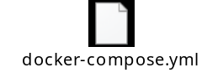
如果是内网部署的话2、3步骤可以忽略，外网部署才需要导出导入镜像

(2)打包镜像并上传：
#docker save lingxi-harbor.shushangyun.com/lingxi/elasticsearch -o es.tar
#docker save lingxi-harbor.shushangyun.com/lingxi/redis -o redis.tar
#docker save lingxi-harbor.shushangyun.com/lingxi/consul -o consul.tar
#docker save lingxi-harbor.shushangyun.com/lingxi/rabbitmq -o rabbitmq.tar
#docker save lingxi-harbor.shushangyun.com/lingxi/openzipkin/zipkin -o zipkin.tar
#docker save lingxi-harbor.shushangyun.com/lingxi/kibana -o kibana.tar

(3)导入镜像：
#docker load -i es.tar
#docker load -i redis.tar
#docker load -i consul.tar
#docker load -i rabbitmq.tar
#docker load -i zipkin.tar
#docker load -i kibana.tar

- 启动容器
#cd /data
#mkdir {es,rabbitmq,redis}
#chmod 775 -R es //es目录需要775权限不然启动的时候会报权限错误
#cd redis //上传redis.conf 修改配置文件里的密码

#docker-compose up -d

- 安装LibreOffice
(1)下载安装包LibreOffice_6.4.6_Linux_x86-64_rpm.tar.gz
(2)解压并安装
#tar -zxvf LibreOffice_6.4.6_Linux_x86-64_rpm.tar.gz
#cd LibreOffice_6.4.6.2_Linux_x86-64_rpm/RPMS/
#yum localinstall *.rpm
安装完成后，程序默认安装路径为/opt/libreoffice6.4
- 安装libreoffice依赖库
#yum -y install ibus
- 配置环境变量
#vim /etc/profile
export LibreOffice_PATH=/opt/libreoffice6.4/program
export PATH=$LibreOffice_PATH:$PATH
- 拷贝中文字体
#将字体压缩包中的字体文件拷贝到/opt/libreoffice6.4/share/fonts目录下的truetype下，可以先做备份再复制

- 安装NodeJS
(1)下载nodejs
下载地址：https://nodejs.org/dist/
# wget https://nodejs.org/dist/v16.5.0/node-v16.5.0-linux-x64.tar.gz
(2)解压
# tar -xf node-v16.5.0-linux-x64.tar.gz
# mv node-v16.5.0-linux-x64 /usr/local/
# ln -s /usr/local/node-v16.5.0-linux-x64/ /usr/local/node
# node -v
# npm -v
(3)安装pm2
# npm install pm2 -g
# ln -s /usr/local/node/bin/pm2 /usr/bin/pm2
# pm2 -v
# pm2 startup //设置开机启动
# pm2 list

