It’s repository with plugins for MASS application.
To use this plugins, download and prepare MASS first: https://gitlab.com/c4rb0n_un1t/MASS
git clone https://gitlab.com/c4rb0n_un1t/MASS
When MASS is loaded open MASS folder and download this repository inside.
cd MASS
git clone https://gitlab.com/c4rb0n_un1t/MASS-Plugins
After this you’re ready to use existing and add new plugins.

How to create plugin
Create symlink of QtCreator wizard directory “MASS/MASS-Plugins/Resources/QtCreatorWizard/Plugin” inside of “[your Qt installation directory]/share/qtcreator/templates/wizards” directory.
On Linux you can do it by calling “MASS/MASS-Plugins/Resources/QtCreatorWizard/create_symlink.sh”.
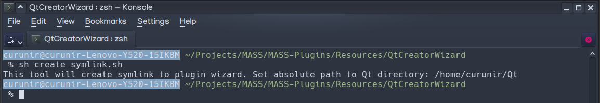
Select «New file or project...» and choose «MASS plugin» project.
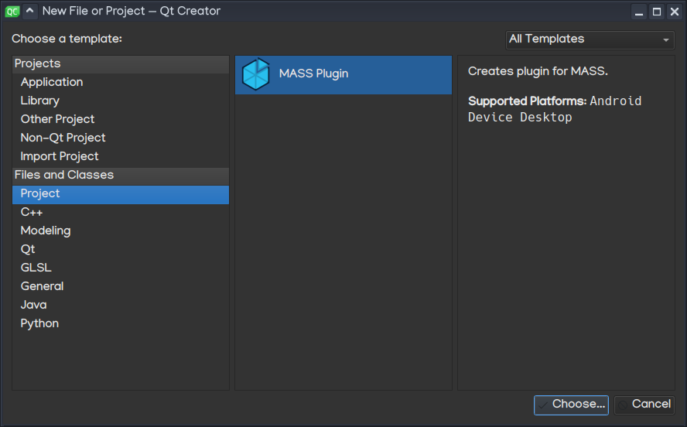

Set project fields.
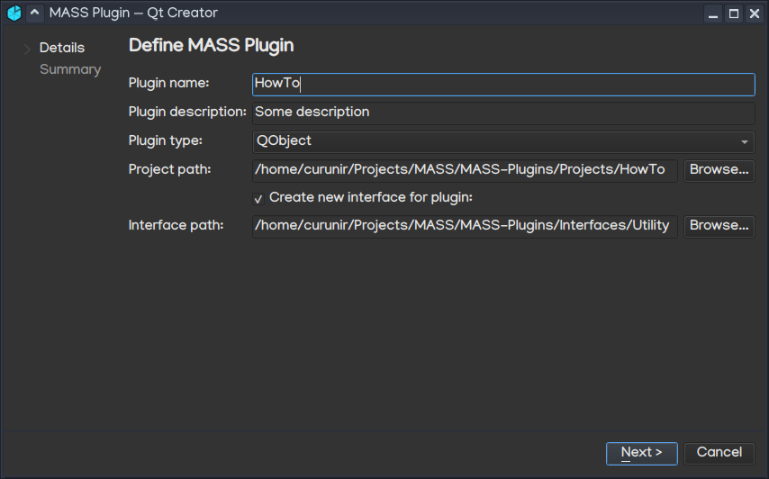

Name | Description
Class name | Name of your plugin
Plugin type | Possible types:  - QtObject – it’s business logic plugin and it won’t contain any UI.  - QWidget – it’s UI plugin that uses QWidgets. Pick if you want to use QWidgets.  - QWidget with QML – it’s UI plugin with QWidget that wraps QML. Pick this if you want to use QML.
Project path | Path where plugin files will be created. Create new folder inside “MASS/MASS-Plugins/Projects” directory and set path to this folder.
Create new interface for plugin | Toggle if you want to create new interface for your plugin
Interface path | Path where interface file will be created. Pick one of folders inside “MASS/MASS-Plugins/Interfaces” directory.
Hit “Next” and “Finish”.
In result you’ll have these files:
- plugin.h
- plugin.cpp
- PluginMeta.json
- ihowto.h (if you’ve chosen “Create new interface for plugin”)
- howto.h (if you’ve chosen “Create new interface for plugin”)
- howto.cpp (if you’ve chosen “Create new interface for plugin”)

Plugin header
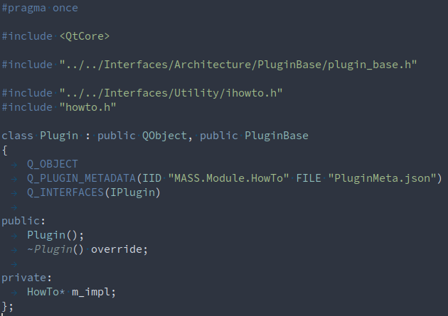
You can see 3 included paths:
- plugin_base.h – file that provides PluginBase class from which your Plugin is inherited. It’s purpose is to provide management of references to other plugins (we’ll get to this);
- ihowto.h – file with interface that you’ve created for your plugin. All plugins interact through interfaces, so other plugin will interact with you through yours;
- howto.h – implementation of class that inherits from your plugin interface. You may ask why Plugin class doesn’t inherited from this interface – it’s made that way because of 2 reasons:
  - if your Plugin class will be inherited from 2 interfaces that have same method name and signature, you’ll have no way to implement them separately inside Plugin class;
  - Qt prohibits multiple inheritance of QObject-based classes: https://doc.qt.io/archives/qq/qq15-academic.html

Plugin source
Also you have source file of your plugin.
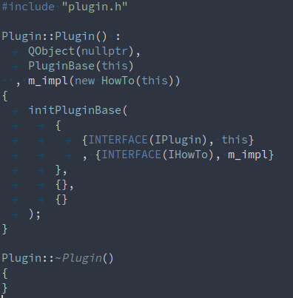
Most important thing here is initPluginBase() method. It initializes all runtime information for your plugin:
- first parameter – QMap with plugin interfaces, where key is Interface instance (INTERFACE is macros that creates Interface instance) and value is instance that inherited from this interface;
- second parameter – QMap with plugin references, where key is Interface instance and value is ReferenceInstancePtr (it’s used to handle references to other plugins);
- third parameter – QMap with lists of plugin references, where key is Interface instance and value is ReferenceInstancesListPtr that holds list of ReferenceInstancePtr (it used if your plugin requires more than one reference of specific interface).

Plugin meta data
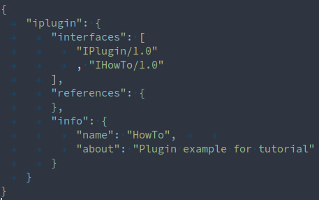
Plugin meta data is JSON file that describes your plugin. Someone could opened without instantiating your plugin to decide that they need it or not. It has these fields:
- interfaces – list of interfaces that your plugin provides. Number after “/” stands for version of interface;
- references – map of references (we’ll get to this);
- info – human readable info about plugin.

Adding plugin reference
Now, when we’ve covered basics, we can check how to add reference to our plugin.
First you need to pick interface of reference that you want to use. For now it’s manual process – you need to search for it inside “Interfaces” directory, but later on we’ll add tool for searching interfaces and plugins based on your requirements.
Let’s assume that you’ve picked IPluginLinker interface – it can provide you with list of plugins that currently loaded in the app.
IPluginInterface file is here: “MASS/MASS-Plugins/Interfaces/Middleware/ipluginlinker.h”. Here is how it looks like:
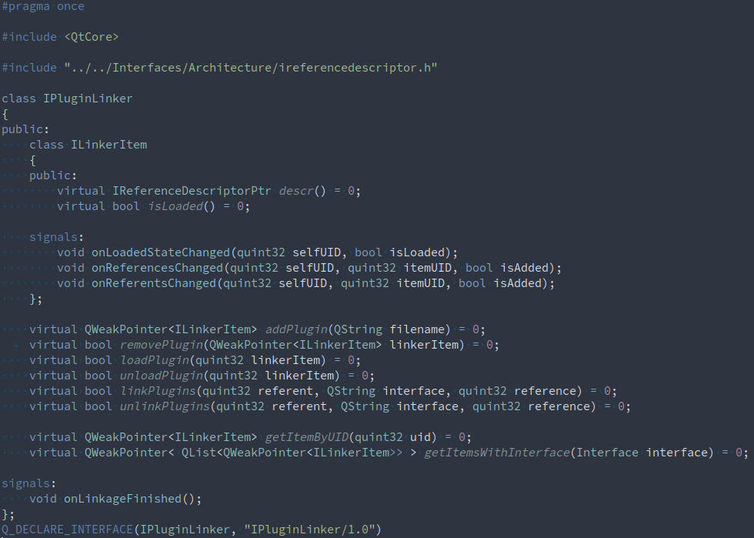
To add reference of this interface you need make changes in header, source and meta data of your plugin.

Plugin header changes
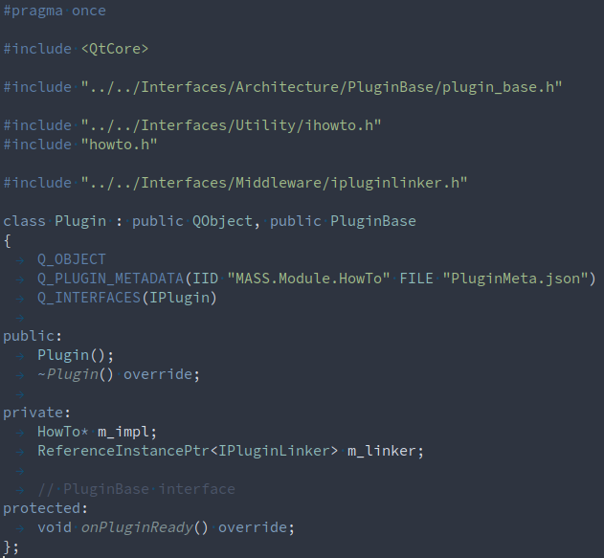
Include interface file in your plugin header and add attribute of ReferenceInterfacePtr to your Plugin class.
Because references are always set dynamically to plugin, you can’t just use them straightaway. Instead you need special state, when you’ll be able to use them. All states that plugin is passed represented by following methods of PluginBase that you can override:
- onInited – called when your plugin will be instantiated and assigned to id that uniquely identifies it among all other plugins;
- onReferencesSet – called when all references for your plugin is set, but none of them is not ready;
- onReady – called when your references are ready and you can start to call them;
- onReferencesListUpdated – called if your plugin require multiple references of same interface. Each call marks that new plugins were added to your ReferenceInstancesListPtr.
For purpose of this tutorial we’ll use only onReady method, so we’ll call some method of our reference.

Plugin source changes
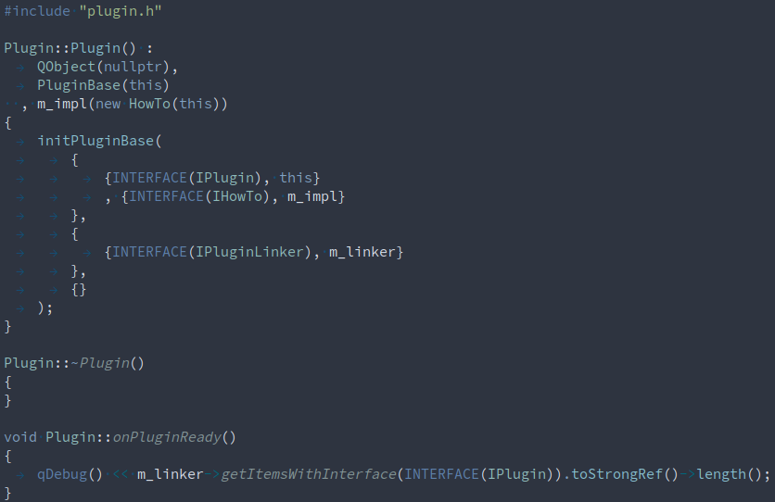
ReferenceInterfacePtr instance into initPluginBase.
Inside overridden onPluginReady method we will output total count of plugins that inherits IPlugin interface (common interface for all plugins).

Meta data changes
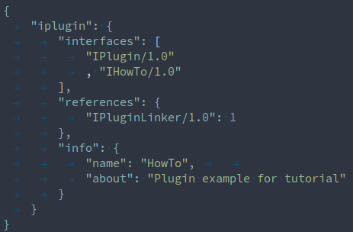
Add reference interface to “references” map.
Key must be interface with version, that you can pick from interface file in Q_DECLARE_INTERFACE macro (check at the bottom of the “MASS/MASS-Plugins/Interfaces/Middleware/ipluginlinker.h” file).
Value is number that represents how many references of this interface your plugin require, it could be:
- 0 – means that references value isn’t specified and that any amount (from zero to 2147483647) of references could be added to your plugin (use ReferenceInstancesListPtr for it);
- 1 – means that your plugin requires only one reference of this interface (use ReferenceInterfacePtr for it);
- from 2 to 2147483647 – means that your plugin requires specific amount of references that you’ve set (use ReferenceInstancesListPtr for it).

Running your plugin
Open “MASS/Application/MASS.pro” project. On opening of “MASS.pro” toggle off “Shadow build” setting.
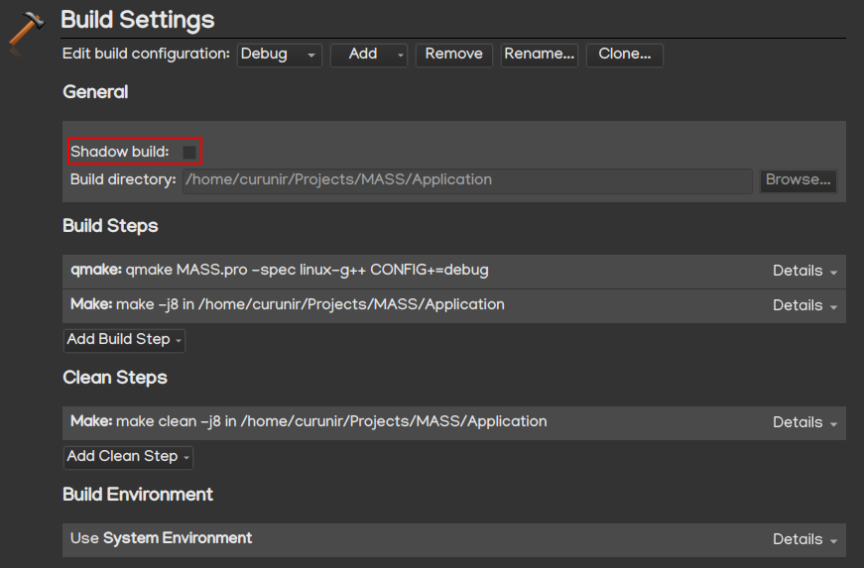
Open “MASS/MASS-Plugins/plugins.pro” project, you’ll see that your plugin is among other plugins.
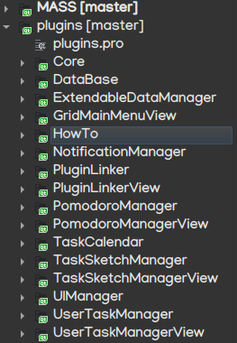
Run building of plugins project, you’ll see that plugin libraries will appear inside “MASS/Application/Plugins” directory.
Run MASS application, you’ll see your plugin output.
