Step1:Start with mockup
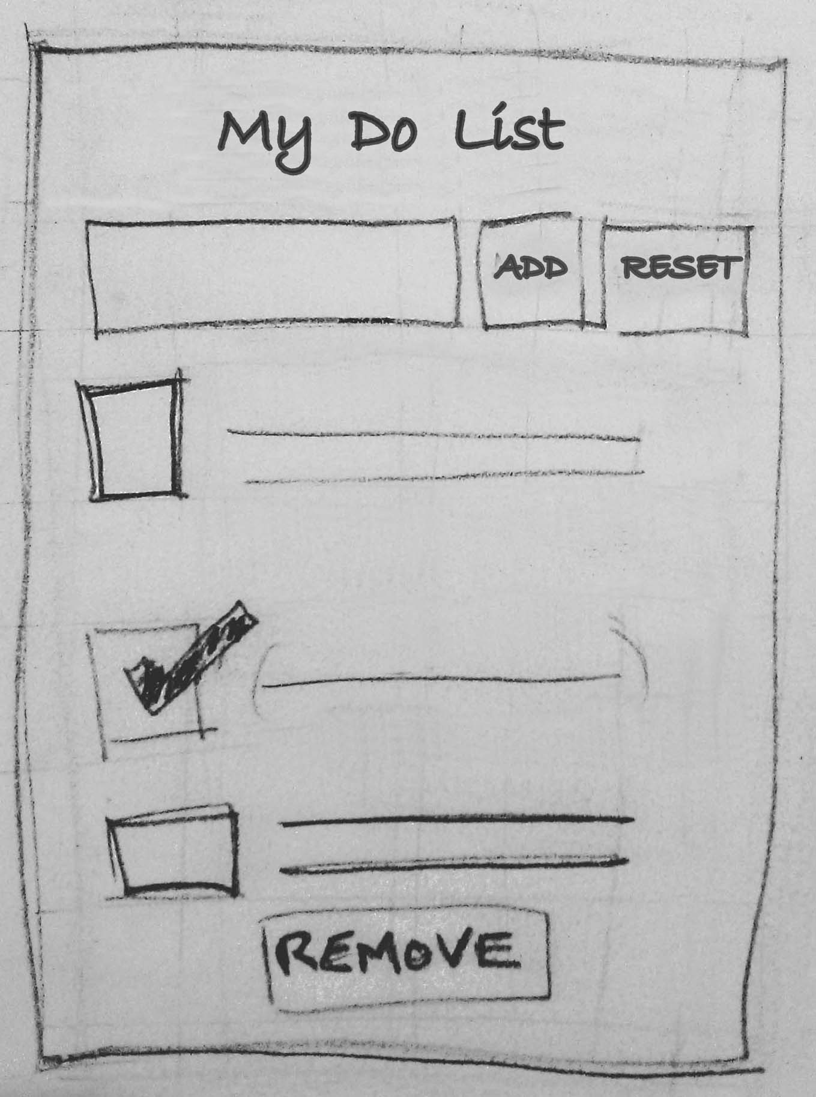

Step 2: Break down of UI into Component hierarchy, Layout containers and Interactions
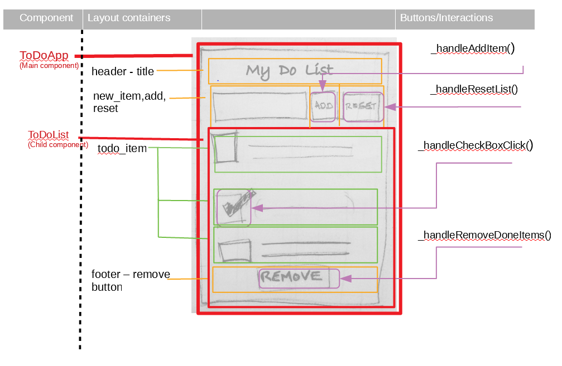

Step 3: Create Master Layout (markup and CSS)
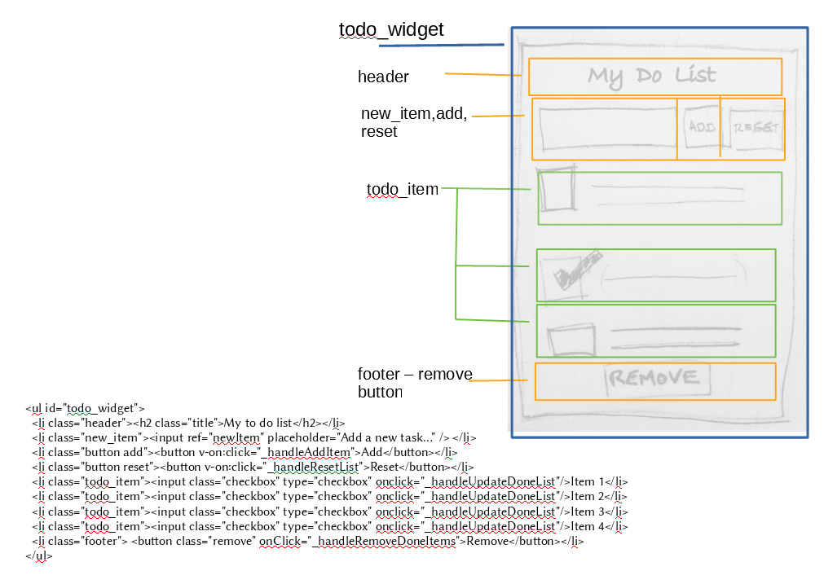

Step 4: Create skeleton code – main ingredients

The trend is that most front end frame work apps consist of:
Css
<style>
Constructorand initial data
constructor()
Interaction handlers
ie code to
handle button clicks etc
<button click=’’doStuff”/>
Framework specific life cycle
hooks.Ie. Code to run before
Render and after render
beforeRender(){...}
Framework specific rendering code ie JSX or some
sort of templating engine code
<input>{mydata}</input>

Step 4: Create skeleton code – React.js
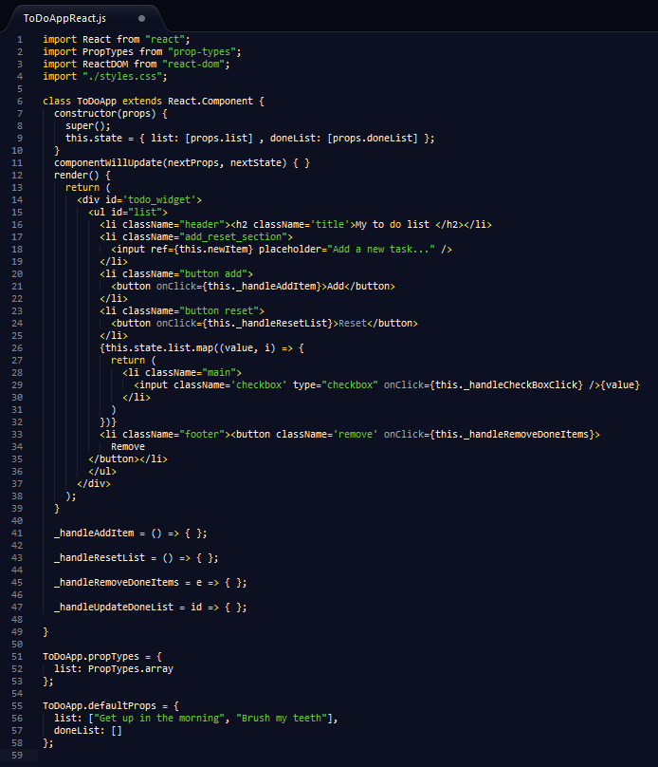

css styles constructor/initial data

rendering code

interaction handlers

default data
life cycle hook

Step 4: Create skeleton code – Vue.js
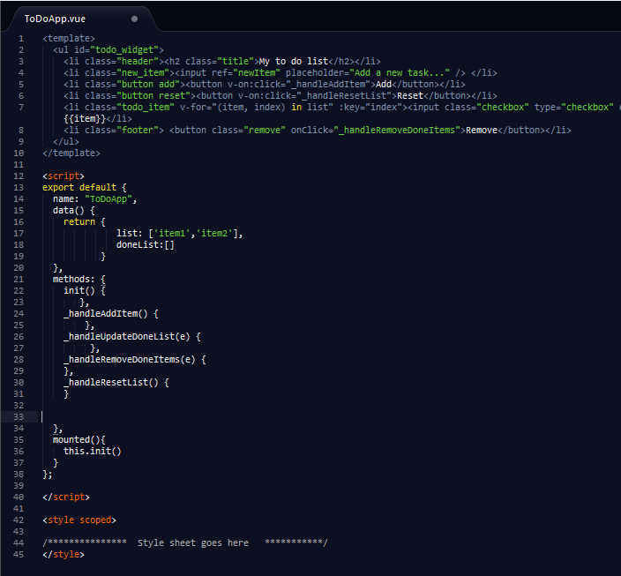

rendering code

initialise data

interaction handlers

life cycle hooks + constructor

css styles

