***Streptomyces* Quality Control**

FASTQC (v0.11.2) was used for the analysis on CSC

The quality of the reads was manually inspected even though a5 does it automatically.

**Quality Scores** (based on position in the read)

* The average quality dropped dramatically after ~200bp probably due to the high GC content 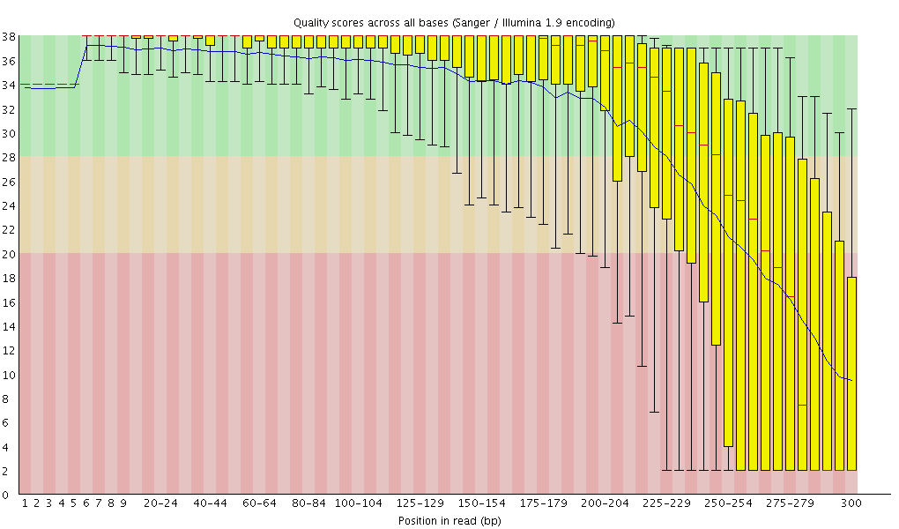
  + These low quality regions were trimmed away (a5/TRIMMOMATIC)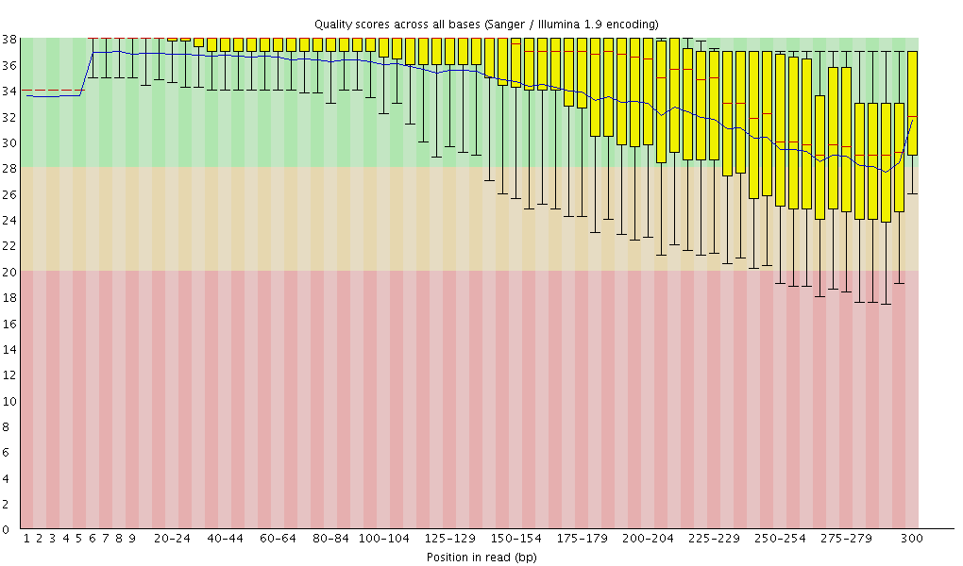

**Adapter Content**

* Adapter sequences were found towards the end of up to ~10% of the reads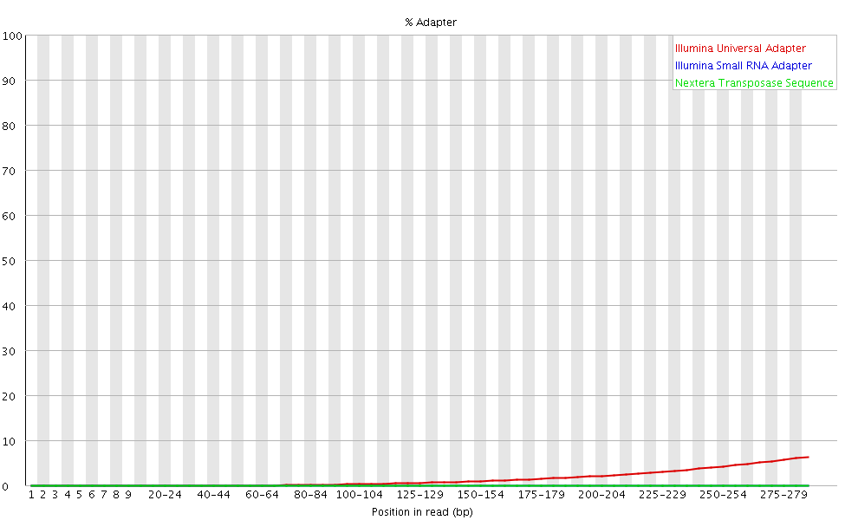
* This is probably because some of the inserts were shorter than the read length causing the sequencer to read through the insert into the adapter sequence

[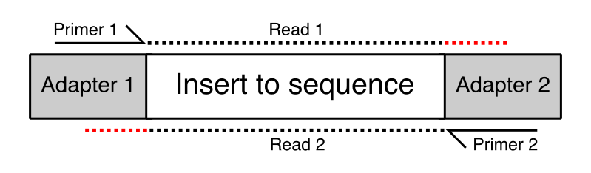](https://sequencing.qcfail.com/articles/read-through-adapters-can-appear-at-the-ends-of-sequencing-reads/)

* The adapter sequences were trimmed away 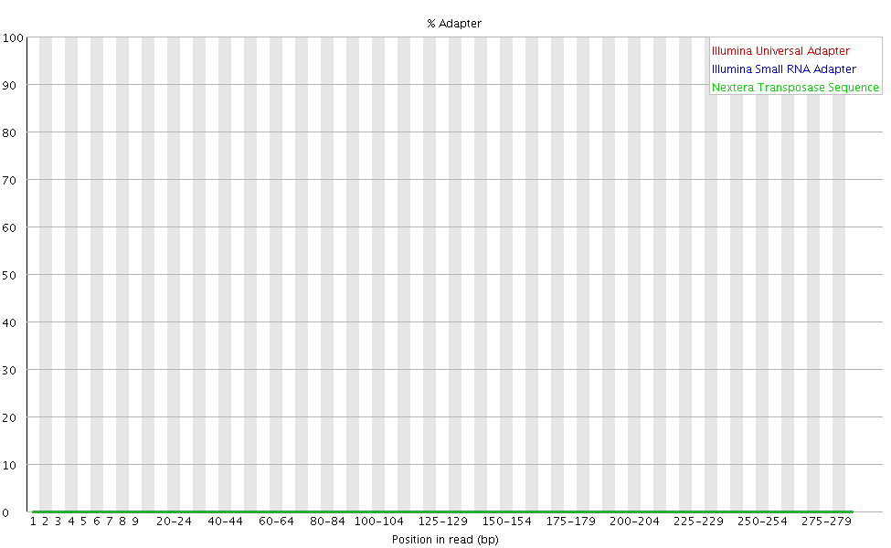

All other modules in FASTQC were acceptable.

All FASTQC reports were very similar; ATCC_31615 is shown above as an example.

The statistics for the number of reads/bases passing QC are shown in a separate file (strep_assembly_stats).