Gel Protocol and Analysis

0.5% agarose gel (0.25g agarose + 50ml 1xTAE buffer)

Load each lane with 2μl DNA + 8 μl H2O + 2 μl Loading Dye

Except Lambda DNA (0.5 μl λDNA + 9.5 μl H2O + 2 μl LD)

Run for approximately 45 mins

gDNA_isolation_040516.tif

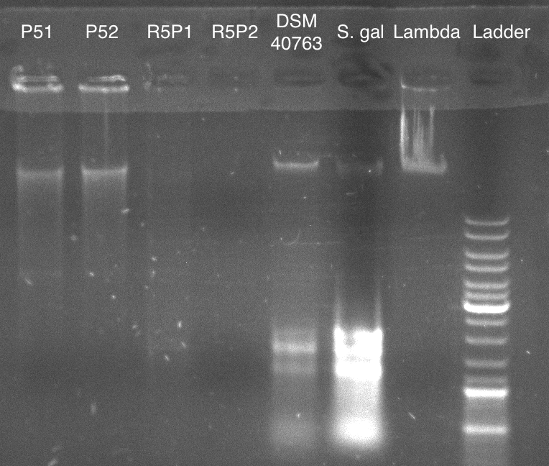

* P51 and P52 show high MW (possibly more DNA than indicated previously)
* Almost nothing shown for R5P1 and R5P2
* DSM and S.gal probably contain RNA since RNase wasn’t added originally

gDNA_isolation_100516.jpg

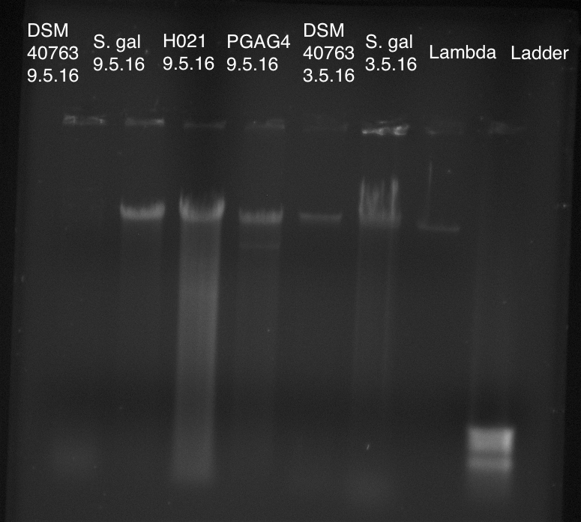

* RNase was added to the DSM and S.gal samples extracted on 3.5.16; it appears the lower bands from the previous image were RNA since they are now gone
* All samples appear to contain very high MW DNA